TASK 1

JOB#1

If Developer push to dev branch then Jenkins will fetch from dev and deploy on dev-docker environment.

JOB#2

If Developer push to master branch then Jenkins will fetch from master and deploy on master-docke environment.

both dev-docker and master-docker environment are on different docker containers.

JOB#3

Jenkins will check for the website running in dev-docker environment. If it is running fine then Jenkins will merge the dev branch to master branch

Setup

Setup can be done both on Windows(Build 2004) or any distro

Windows-

for setting up wsl 2(windows susbsystem for linux) follow the following youtube video [video](https://www.youtube.com/watch?v=nKCe9UE-quA) its for wsl 1 but still relevant only a small edit is required i.e

In the start batch file for export DISPLAY and export PULSE_SERVER commands provide the IP addr which can be found under etc/resolv.conf. Provide the same IP to 'load-module module-native-protocol-tcp auth-ip-acl' property in default.pa file.

also add an additional parameter '-ac’ to xlaunch configuration to make it work flawlessly on wsl 2

and

if you get 'xfce4-session: Cannot open display: :0.0' then update the localhost or 127.0.0.1 in startx script to your Ethernet adapter vEthernet (WSL) IP (you can check that in ipconfig)

if firefox crashes remove it and reinstall

Download ubuntu or other distro available on microsoft store just open then up directly or via the new terminal (run as admininistrator)

then rest follow the steps in the video

linux distro-

Download

-git

-jenkins

-docker

setup these tools (will require stopping of firewall)

then

Start the Jenkins and download plugins for git & docker

Task

for the foll project we are creating two different branches test and master

Job1

1. Running docker container

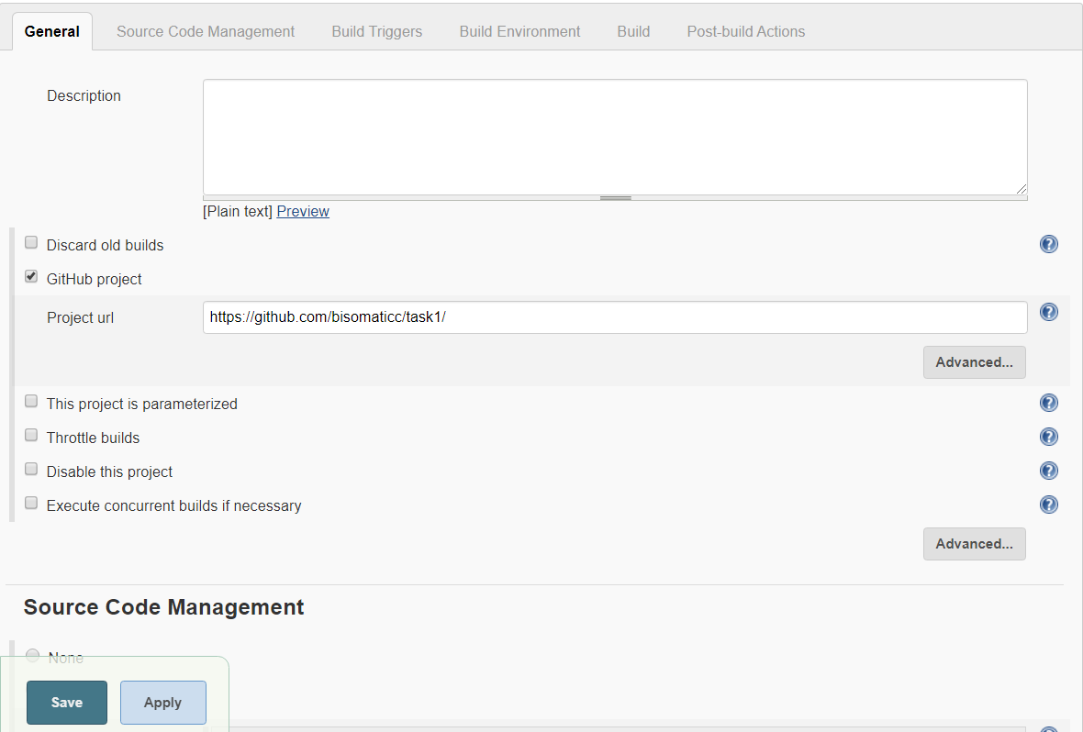

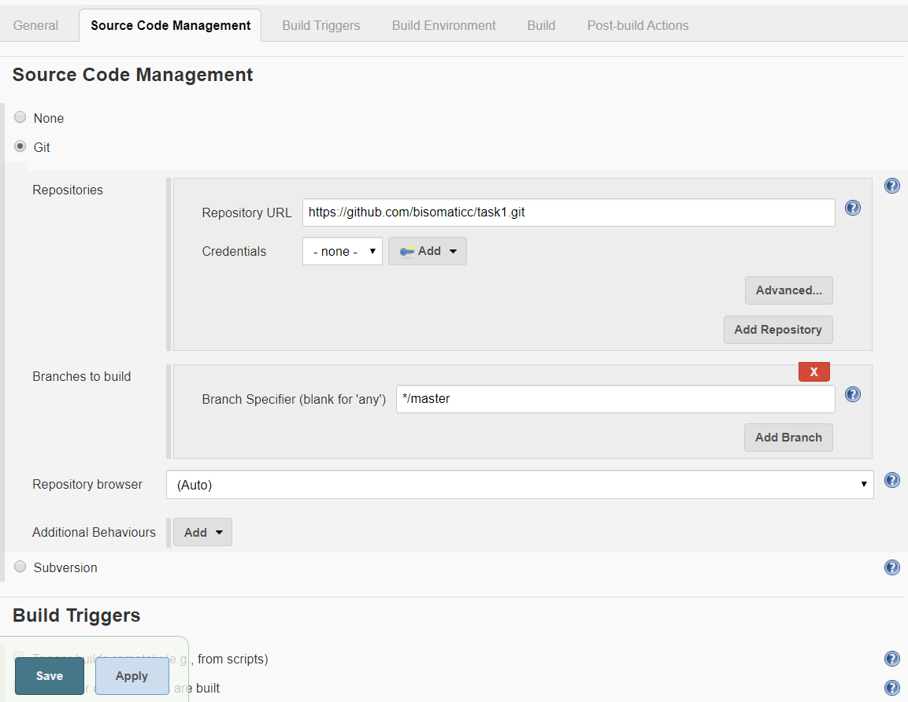

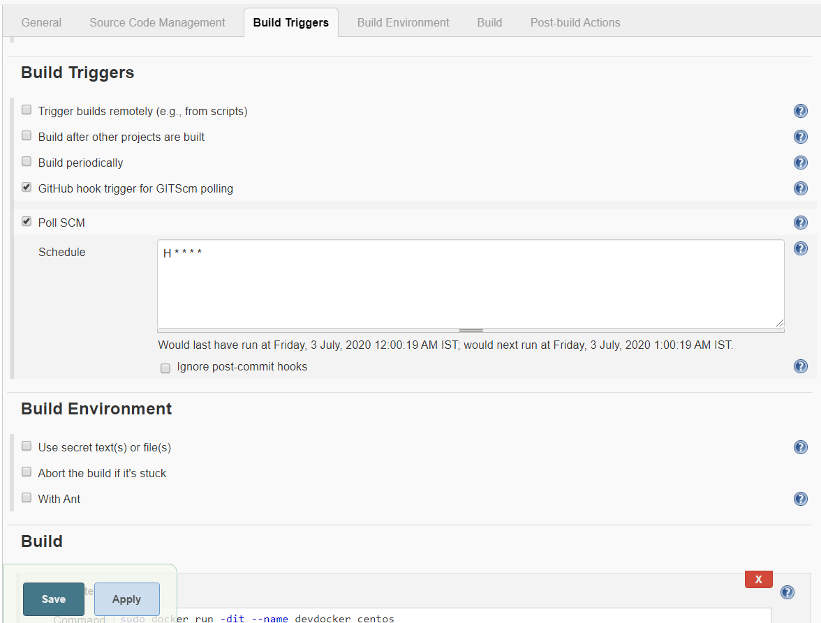

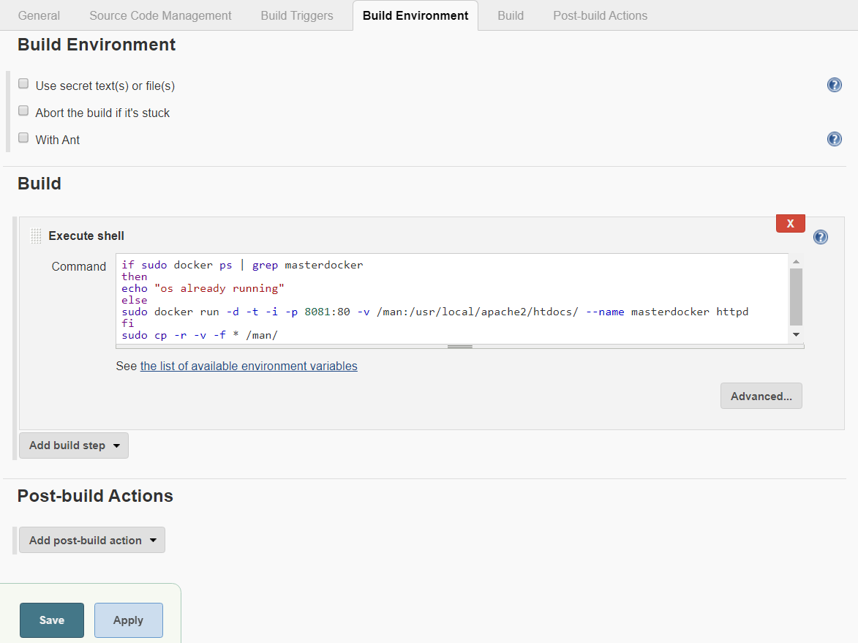

Job 2

2.docker container test branch

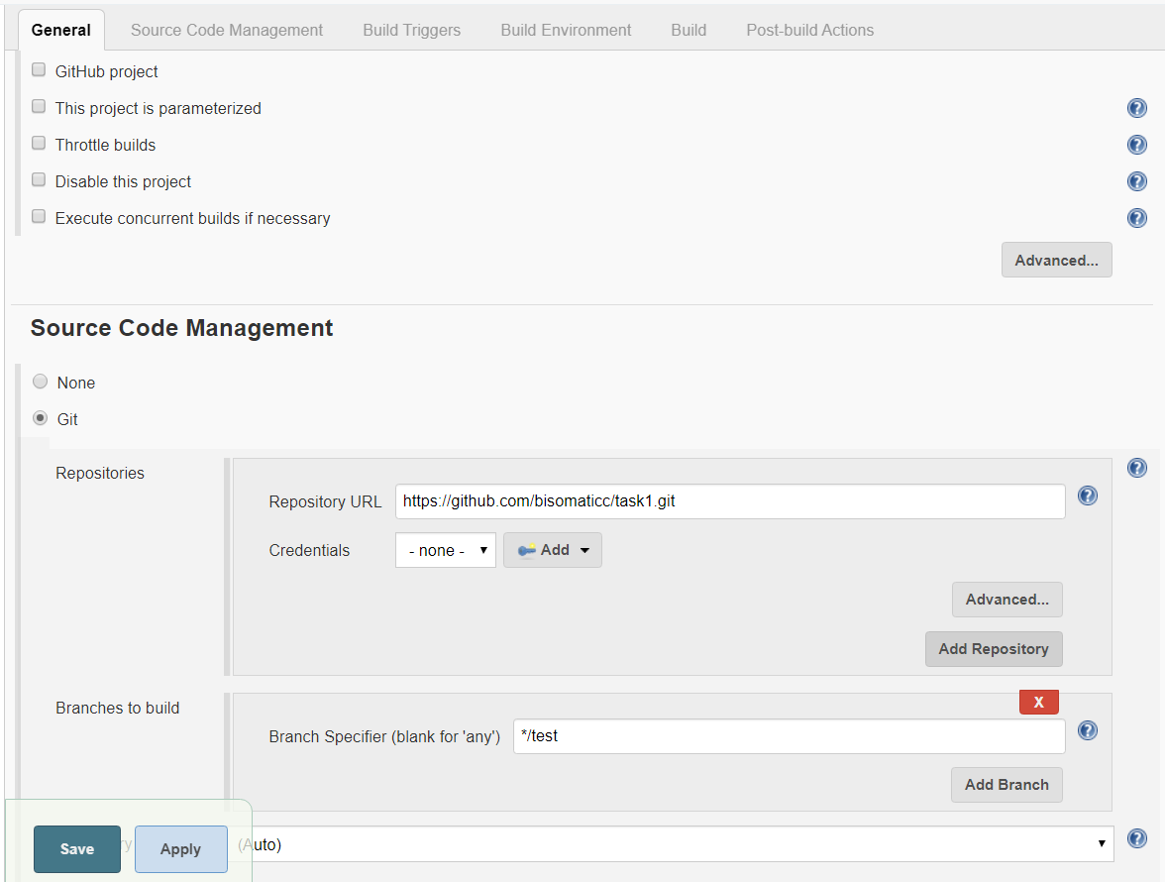

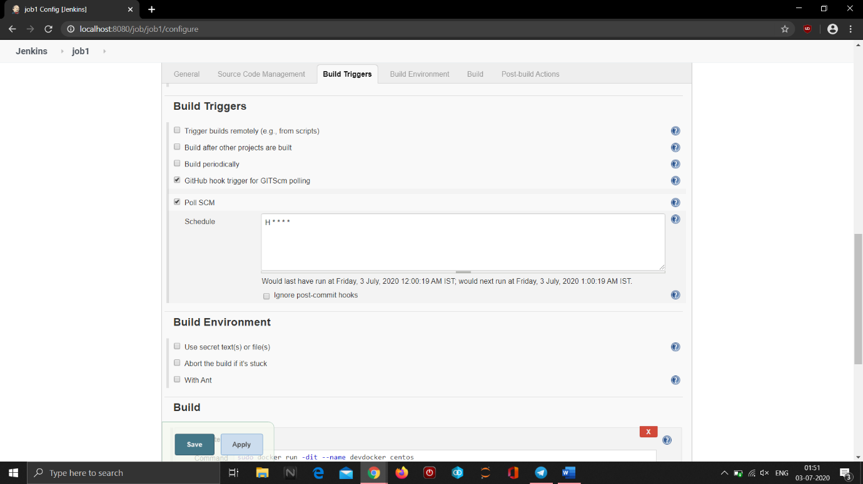

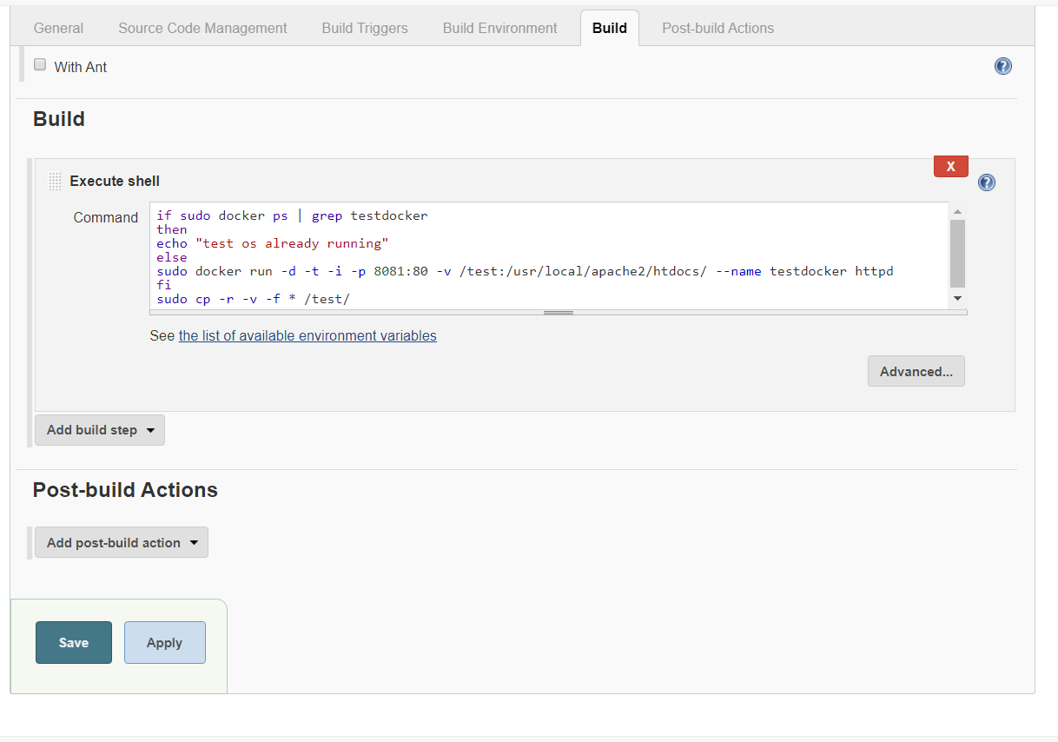

Job 3

This job will look out for web page if it works flawlessly then it will merge both branches i.e test and master

