1、

## 1、配置用户信息

git config --global user.name "username" //绿色部分为GitHub用户名

git config --global user.email "user_email@qq.com" //这里用GitHub的注册邮箱

## 2、创建本地ssh

ssh-key -t rsa -C "coiggahou@foxmail.com" //此处“C”要大写，邮箱使用GitHub注册邮箱

## 3、将ssh配置到GitHub

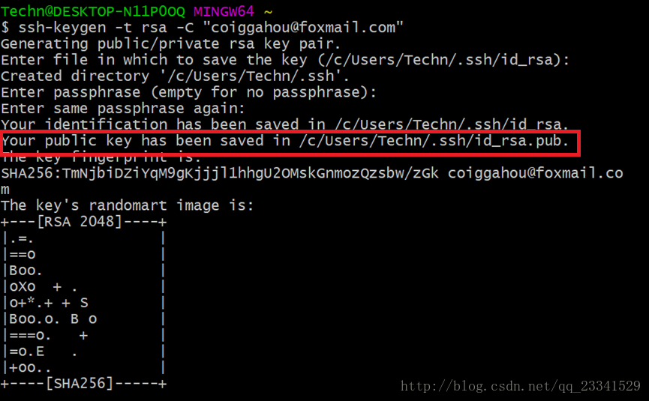

生成ssh-key后命令行会提示保存的路径。如上图。   
我们找到这个路径下的id_rsa.pub并用文本编辑软件打开

复制该文件内所有文本内容

登录GitHub，点击Settings——SSH and GPG keys——点击右侧Add SSH key 如下图

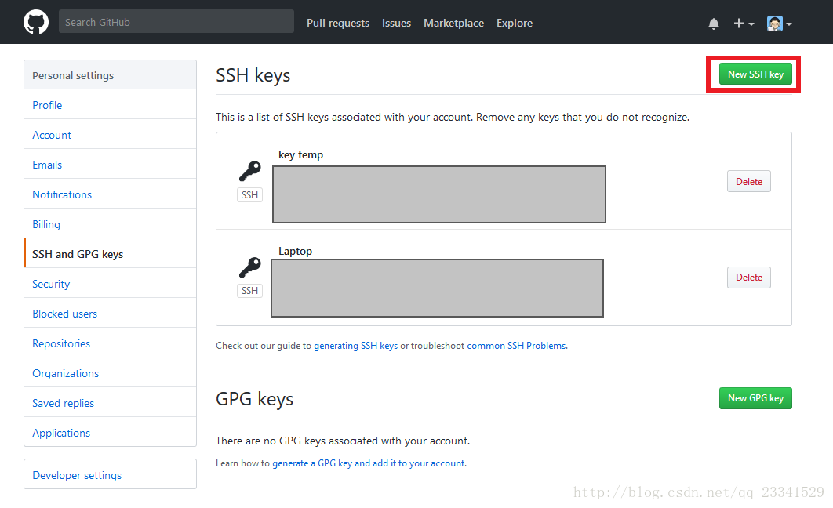

**Title随意，将所复制内容粘贴至Key**

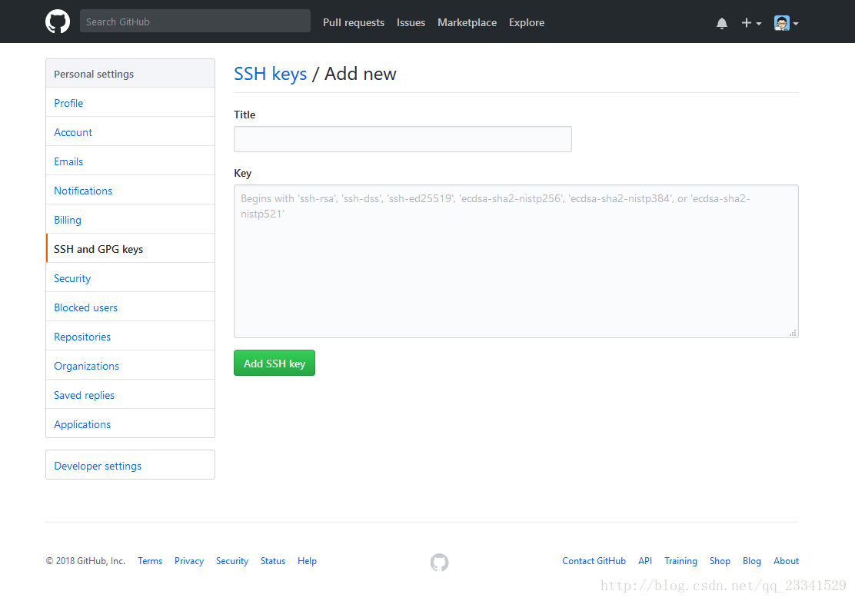

测试是否成功：   
**打开Git Bash终端（不是命令行或Powershell）**输入

ssh -T [git@github.com](mailto:git@github.com)

返回如下信息表示成功

The authenticity of host 'github.com (192.30.255.112)' an't be established.

RSA key fingerprint is SHA256:nThbg6kXUpJWGl7E1IGOCspRoTxdCARLviKw6E5SY8.

Are you sure you want to continue connecting (yes/no)? es

Warning: Permanently added 'github.com,192.30.255.112' RSA) to the list of known hosts.

Hi coiggahou! You've successfully authenticated, but GiHub does not provide shell access.