Mips交叉编译环境的搭建
The following is steps to build cross compilers. So far, I tried only for PowerPC and MIPS.
Basically, all you have to do is to follow the following 9 steps.
- Download sources
- Set environment variables
- Build binutils
- Build bootstrap gcc
- Build newlib
- Build gcc again with newlib
- GDB with PSIM
- Compile your code
- Run

1. What do you need?
First, you have to obtain the following source codes
- binutils http://www.gnu.org/software/binutils/ (binutils-2.16.tar.gz)
- GCC http://www.gnu.org/software/gcc/gcc.html (gcc-4.1.1.tar.gz)
- newlib http://sources.redhat.com/newlib/ (newlib-1.14.0.tar.gz)
- GDB http://www.gnu.org/software/gdb/gdb.html (gdb-6.3.tar.gz)
- Gxemul http://gavare.se/gxemul/download.html (gxemul-0.4.7.tar.gz)

2. Set environment variables
First, choose your taget such as powerpc-eabi, powerpc-elf, mips-elf, and so on
For bash simply type
% export TARGET=powerpc-eabi
% export PREFIX=/usr/local/$TARGET
% export PATH=$PATH:$PREFIX/bin

3. Build binutils
% tar xjfv binutils-2.17.tar.bz2
% mkdir build-binutils
% cd build-binutils
% ../binutils-2.17/configure --target=$TARGET --prefix=$PREFIX
% make all
% make install

4. Build bootstrap GCC
% tar xjfv gcc-4.1.1.tar.bz2
% mkdir build-gcc
% cd build-gcc
% ../gcc-4.1.1/configure --target=$TARGET --prefix=$PREFIX --without-headers --with-newlib --with-gnu-as --with-gnu-ld
% make all-gcc
% make install-gcc
--with-gnu-as --with-gnu-ld prevents native assembler on certain architectures. (for others, these do not have any effects)

5. Build newlib
Newlib provides standard C library for embedded systems
% tar xzfv newlib-1.14.0.tar.gz
% mkdir build-newlib
% cd build-newlib
% ../newlib-1.14.0/configure --target=$TARGET --prefix=$PREFIX
% make all
% make install

6. Build GCC again with newlib
% cd build-gcc
% ../gcc-4.1.1/configure --target=$TARGET --prefix=$PREFIX --with-newlib --with-gnu-as --with-gnu-ld --disable-shared --disable-libssp
% make all
% make install

7. GDB with PSIM
% tar xjfv gdb-6.3.tar.bz2
% mkdir build-gdb
% cd build-gdb
% ../gdb-6.3/configure --target=$TARGET --prefix=$PREFIX --enable-sim-mips --enable-sim-stdio
% make all
% make install

8. GXEMUL for mips
% tar zxf gxemul-0.4.7.tar.gz
% cd gxemul-0.4.7
% ./configure
% make
Note that there is no make install functionality

9.Run Test program
% cd gxemul-0.4.7/demos/ hello
% (modify Makefile file as README file discribed)
% make
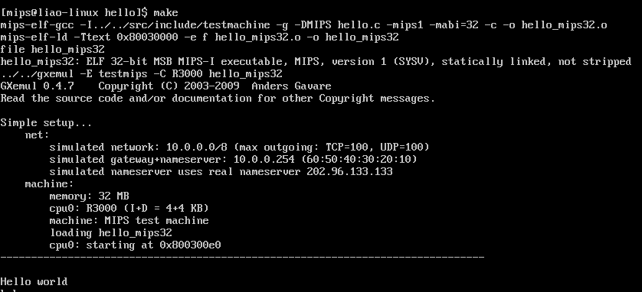
IT WORKS!

