

HỌC VIỆN CÔNG NGHỆ BƯU CHÍNH VIỄN THÔNG KHOA CÔNG NGHỆ THÔNG TIN CLC
-----🙞🙜🕮🙞🙜-----

BÁO CÁO BÀI TẬP LỚN
Hệ Thống Ecommerce

Lê Đức Thắng-B21DCDT205

Hà Nội 2025

Mục Lục
1. TỔNG QUAN DỰ ÁN 8
1.1 Giới thiệu đề tài 8
1.2. Mục tiêu và ý nghĩa đề tài 8
1.2.1. Mục tiêu chung 8
1.2.2. Mục tiêu cụ thể 9
1.2.3. Ý nghĩa của đề tài 9
1.3. Đối tượng và phạm vi nghiên cứu 9
1.3.1. Đối tượng nghiên cứu 9
1.3.2. Phạm vi nghiên cứu 9
1.4. Phương pháp nghiên cứu 10
1.4.1. Phương pháp nghiên cứu lý thuyết 10
1.4.2. Phương pháp nghiên cứu thực nghiệm 10
1.4.3. Phương pháp phát triển phần mềm 10
2. CƠ SỞ LÝ THUYẾT 10
2.1. Tổng quan về Thương mại Điện tử 10
2.1.1. Định nghĩa 10
2.1.2. Các mô hình E-commerce 10
2.1.3. Đặc điểm của hệ thống E-commerce hiện đại 10
2.2. Clean Architecture Pattern 11
2.2.1. Khái niệm 11
2.2.2. Nguyên tắc cốt lõi 11
2.2.3. Các tầng trong Clean Architecture 11
2.3. Microservices Architecture 11
2.3.1. Khái niệm 11
2.3.2. Ưu điểm của Microservices 11
2.3.3. Thách thức của Microservices 11
2.4. RESTful API Design 12
2.4.1. REST Architecture Style 12
2.4.2. REST Constraints 12
2.4.3. HTTP Methods trong REST 12
2.5. Database Design Principles 12
2.5.1. Relational Database 12
2.5.2. Database Performance 12
2.5.3. ACID Properties 13
2.6. Security Best Practices 13
2.6.1. Authentication và Authorization 13
2.6.2. Web Security Standards 13
2.6.3. Data Protection 13
3. PHÂN TÍCH VÀ THIẾT KẾ HỆ THỐNG 15
3.1. Phân tích yêu cầu hệ thống 15
3.1.1. Yêu cầu chức năng (Functional Requirements) 15
3.1.2. Yêu cầu phi chức năng (Non-functional Requirements) 15
3.1.3. Business Requirements 16
3.2. Tổng quan kiến trúc 16
3.3. Clean Architecture Layers 16
3.3.1. Domain Layer (Entities & Business Rules) 16
3.3.2. Use Cases Layer (Application Business Rules) 17
3.3.3. Infrastructure Layer (External Interfaces) 17
3.3.4. Delivery Layer (Controllers & Presentation) 17
3.4. Database Design 19
3.4.1. Database Schema Overview 19
3.4.2. Core Entity Groups User Management (8 bảng): 19
3.4.3. Advanced Features Inventory Management (5 bảng): 20
3.4.4. Database Relationships & Constraints Primary Keys: 20
3.4.5. Indexing Strategy Core Entity Indexes: 21
3.5. API Architecture 23
3.5.1. API Structure Overview 23
3.5.2. Comprehensive API Endpoint Categories (294 Total - Verified from Postman Collection) 23
3.5.3. Response Format Standards 32
3.5.4. Security Measures Rate Limiting: 32
4. TRIỂN KHAI HỆ THỐNG BACKEND 32
4.1. Tổng quan Backend Architecture 32
4.1.1. Cấu trúc thư mục 32
4.1.2. Core Technologies 32
4.2. Domain Layer Implementation 32
4.2.1. Core Entities User Management Entities: 33
4.2.2. Repository Interfaces Định nghĩa contracts cho data access: 33
4.3. Use Cases Layer Implementation 33
4.3.1. Core Use Cases User Use Cases: 33
4.4. Infrastructure Layer Implementation 34
4.4.1. Database Layer 34
4.4.2. External Integrations Payment Processing: 34
4.5. Delivery Layer Implementation 35
4.5.1. HTTP Handlers 35
4.5.2. Middleware System Authentication Middleware: 35
4.6. Advanced Features 36
4.6.1. Real-time Features 36
4.6.2. Analytics & Monitoring 36
4.6.3. Recommendation System 36
5. TRIỂN KHAI HỆ THỐNG FRONTEND 36
5.1. Tổng quan Frontend Architecture 36
5.1.1. Cấu trúc thư mục 36
5.2. Component Architecture 36
5.2.1. UI Components System 36
5.2.2. Feature Components Product Components: 37
5.3. State Management Implementation 37
5.3.1. Zustand Store Architecture 37
5.3.2. Persistence Strategy 38
5.4. Routing System Implementation 38
5.4.1. App Router Structure 38
5.4.2. Layout System 39
5.5. Performance Optimization 39
5.5.1. Next.js Optimizations 39
5.5.2. React Query Integration 39
5.5.3. Performance Metrics Core Web Vitals optimization: 39
6. TÍNH NĂNG VÀ CHỨC NĂNG HỆ THỐNG 39
6.1. Hệ thống Authentication và Authorization 39
6.1.1. User Registration System 39
6.1.2. Login System 40
6.1.3. JWT Token Management 40
6.1.4. OAuth Integration 40
6.2. Product Management System 40
6.2.1. Product Catalog Structure 41
6.2.2. Product Variants System 41
6.2.3. Product Image Management 41
6.2.4. Advanced Search System 41
6.3. Shopping Cart System 42
6.3.1. Cart Architecture 42
6.3.2. Cart Item Management 42
6.3.3. Cart Conflict Resolution 42
6.4. Order Management System 43
6.4.1. Order Creation Process 43
6.4.2. Order Status Workflow 43
6.4.3. Order History và Tracking 43
6.5. Payment Integration 44
6.5.1. Stripe Integration 44
6.5.2. Payment Processing Flow 44
6.5.3. Refund Management 44
6.6. Admin Panel 45
6.6.1. Dashboard Overview 45
6.6.2. Product Management Interface 45
6.6.3. Order Management Interface 45
6.6.4. User Management Interface 45
6.7. Demo và User Flows Detailed user journey demonstrations. 46
6.7.1. Customer Shopping Flow Complete Shopping Journey: 46
6.7.2. Admin Management Flow Admin Workflow: 46
7. BẢO MẬT VÀ CHẤT LƯỢNG HỆ THỐNG 46
7.1. Authentication Security 46
7.1.1. Password Security 46
7.1.2. JWT Token Security 46
7.1.3. Session Management 47
7.2. API Security Measures 47
7.2.1. Input Validation 48
7.2.2. UI và Styling 48
7.2.3. State Management và Data Fetching 48
7.3. Development Tools 49
7.3.1. Code Quality 49
7.3.2. Build và Deployment 49
7.4. Infrastructure Components 50
7.4.1. Containerization Docker 50
7.4.2. Monitoring và Logging 50
7.4.3. Session Management 51
7.5. API Security 51
7.5.1. Input Validation 51
7.5.2. Rate Limiting 51
7.5.3. CORS Configuration 51
7.6. Database Security 52
7.6.1. Access Control 52
7.6.2. Data Protection 52
7.7. Frontend Security 52
7.7.1. XSS Prevention 52
7.7.2. CSRF Protection 52
8. TESTING VÀ QUALITY ASSURANCE 52
8.1. Testing Strategy 53
8.1.1. Testing Pyramid 53
8.1.2. Backend Testing 53
8.1.3. Frontend Testing 53
8.2. Code Quality Standards 54
8.2.1. Code Review Process 54
8.2.2. Static Analysis 54
9. DEPLOYMENT VÀ DEVOPS 54
9.1. Containerization Docker-based deployment strategy. 54
9.1.1. Docker Configuration 54
9.1.2. Docker Compose 55
9.2. CI/CD Pipeline 55
9.2.1. Continuous Integration 55
9.2.2. Continuous Deployment 55
9.3. Infrastructure as Code 56
9.3.1. Configuration Management 56
9.3.2. Monitoring và Alerting System 56
10. PHÂN TÍCH THỰC TẾ 56
10.1. Performance Metrics 56
10.1.1. Application Limits 56
10.1.2. Performance 56
10.2. User Experience Analysis 57
10.2.1. User Interaction Features 57
10.2.2. Accessibility Features 57
10.3. Business Logic 57
10.3.1. E-commerce Features 57
10.3.2. Security Implementation 58
10.4. Design System Analysis 58
10.4.1. Brand Identity 58
10.4.2. Component System UI 58
10.4.3. Performance Optimization 59
10.5. Comprehensive API Documentation 59
10.5.1. API Overview 59
10.5.2. Authentication Endpoints 59
10.5.3. Product Management Endpoints 60
10.5.4. Shopping Cart Endpoints 61
10.5.5. Order Management Endpoints 61
10.5.6. Error Handling Standards 62
10.5.7. Webhook Endpoints 62
10.6. Code Examples và Implementation Details 63
10.6.1. Backend Implementation Examples 63
10.6.2. Frontend Implementation Examples 70
10.7. Database Optimization và Indexing Strategy 85
10.7.1. Advanced Connection Pool Configuration 85
10.7.2. Comprehensive Indexing Strategy 86
10.7.3. Query Optimization Patterns 88
10.7.4. Database Performance Monitoring 91
10.7.5. Caching Strategy Implementation 93
10.7.6. Database Maintenance & Optimization 94
10.8. Design System và UI Components Implementation 96
10.8.1. Brand Identity & Theme System 96
10.8.2. Component Architecture Implementation 97
10.8.3. Layout System Implementation 98
10.8.4. Animation System 99
10.8.5. Form System Implementation 100
10.8.6. Admin Theme System 100
10.8.7. Component Composition Patterns 101
10.8.8. Loading & Error States 101
10.8.9. Accessibility Features 101
10.8.10. Performance Optimizations 102
11. GIAO DIỆN NGƯỜI DÙNG VÀ TRẢI NGHIỆM 102
11.1. Giao diện khách hàng (Customer Interface) 102
11.1.1. Trang chủ (Homepage) 102
11.1.2. Danh sách sản phẩm (Product Listing) 104
11.1.3. Chi tiết sản phẩm (Product Detail) 105
11.1.4. Giỏ hàng (Shopping Cart) 106
11.1.5. Thanh toán (Checkout Process) 107
11.2. Giao diện quản trị (Admin Interface) 108
11.2.1. Dashboard quản trị (Admin Dashboard) 108
11.2.2. Quản lý sản phẩm (Product Management) 109
11.2.3. Quản lý đơn hàng (Order Management) 110
11.2.4. Quản lý người dùng (User Management) 111
11.3. Giao diện xác thực (Authentication Interface) 112
11.3.1. Trang đăng nhập (Login Page) 112
11.3.2. Trang đăng ký (Register Page) 112
11.3.3. Trang profile người dùng (User Profile) 113
11.4. Giao diện responsive (Mobile Interface) 114
11.5. Trải nghiệm người dùng (User Experience) 116
11.5.1. Navigation và Information Architecture 116
11.5.2. Performance và Loading 116
11.5.3. Accessibility Features 116
11.6. Accessibility và Performance 116
11.6.1. Web Accessibility Standards 116
11.6.2. Performance Metrics 116
11.6.3. Cross-Browser Compatibility 117
12. KẾT LUẬN VÀ ĐỀ XUẤT 117
12.1. Tóm tắt thành tựu 117
12.1.1. Technical Achievements 117
12.1.2. Business Value Delivered 117
12.2. Điểm mạnh của hệ thống 118
12.2.2. Business Strengths 118
12.3. Điểm cần cải thiện 118
12.3.1. Technical Improvements 118
12.3.2. Feature Enhancements 119
12.4. Đề xuất phát triển 119
12.4.1. Short-term Improvements (1-3 months) 119
12.4.2. Medium-term Enhancements (3-6 months) 120
12.4.3. Long-term Vision (6-12 months) 120
12.5. Roadmap tương lai 120
12.5.1. Phase 1: Foundation Strengthening 120
12.5.2. Phase 2: Feature Enhancement 121
12.5.3. Phase 3: Scale và Innovation 121
TÀI LIỆU THAM KHẢO 122

1. TỔNG QUAN DỰ ÁN

1.1 Giới thiệu đề tài
Trong bối cảnh công nghệ thông tin phát triển mạnh mẽ và nhu cầu mua sắm trực tuyến ngày càng tăng cao, việc xây dựng một hệ thống thương mại điện tử hiện đại, có khả năng mở rộng và bảo mật cao là một yêu cầu cấp thiết. Đề tài "Xây dựng Website Thương mại Điện tử BiHub sử dụng Clean Architecture" được thực hiện nhằm phát triển một nền tảng e-commerce hoàn chỉnh, áp dụng các nguyên tắc thiết kế phần mềm tiên tiến.
Hệ thống BiHub được xây dựng dựa trên Clean Architecture pattern, sử dụng Go programming language cho backend và Next.js framework cho frontend. Việc áp dụng Clean Architecture giúp đảm bảo tính tách biệt giữa các tầng logic, tăng khả năng kiểm thử, bảo trì và mở rộng hệ thống trong tương lai.

1.2. Mục tiêu và ý nghĩa đề tài

1.2.1. Mục tiêu chung
Xây dựng một hệ thống thương mại điện tử hoàn chỉnh, hiện đại và có khả năng mở rộng cao, áp dụng Clean Architecture pattern để đảm bảo chất lượng code và khả năng bảo trì lâu dài.

1.2.2. Mục tiêu cụ thể
- Thiết kế và triển khai kiến trúc hệ thống theo nguyên tắc Clean Architecture
- Phát triển backend API sử dụng Go language với Gin framework
- Xây dựng frontend responsive sử dụng Next.js và React
- Thiết kế cơ sở dữ liệu tối ưu với PostgreSQL
- Triển khai các tính năng e-commerce cơ bản và nâng cao
- Đảm bảo bảo mật hệ thống với JWT authentication và OAuth integration
- Tối ưu hóa hiệu suất và khả năng mở rộng
- Triển khai hệ thống với Docker containerization

1.2.3. Ý nghĩa của đề tài
Ý nghĩa khoa học:
- Nghiên cứu và áp dụng Clean Architecture trong thực tế
- Đánh giá hiệu quả của Go language trong phát triển backend
- Phân tích performance của Next.js trong ứng dụng e-commerce
Ý nghĩa thực tiễn:
- Cung cấp giải pháp e-commerce hoàn chỉnh cho doanh nghiệp
- Tạo ra platform có thể tái sử dụng và mở rộng
- Đóng góp vào cộng đồng open source với best practices

1.3. Đối tượng và phạm vi nghiên cứu

1.3.1. Đối tượng nghiên cứu
- Clean Architecture pattern và ứng dụng trong e-commerce
- Go programming language và Gin framework
- Next.js framework và React ecosystem
- PostgreSQL database design và optimization
- Modern web security practices
- Container orchestration với Docker

1.3.2. Phạm vi nghiên cứu
Phạm vi kỹ thuật:
- Backend API development với Go
- Frontend development với Next.js
- Database design và optimization
- Security implementation
- Performance optimization
- DevOps và deployment
Phạm vi chức năng:
- User authentication và authorization
- Product catalog management
- Shopping cart và checkout process
- Order management system
- Payment integration
- Admin dashboard
- Search và recommendation system

1.4. Phương pháp nghiên cứu

1.4.1. Phương pháp nghiên cứu lý thuyết
- Nghiên cứu tài liệu về Clean Architecture
- Phân tích các pattern và best practices
- So sánh các technology stack
- Nghiên cứu security standards

1.4.2. Phương pháp nghiên cứu thực nghiệm
- Prototype development và testing
- Performance benchmarking
- Security testing và vulnerability assessment
- User experience testing
- Load testing và scalability analysis

1.4.3. Phương pháp phát triển phần mềm
- Agile development methodology
- Test-driven development (TDD)
- Continuous integration/continuous deployment (CI/CD)
- Code review và quality assurance

2. CƠ SỞ LÝ THUYẾT

2.1. Tổng quan về Thương mại Điện tử

2.1.1. Định nghĩa
Thương mại Điện tử Thương mại điện tử (E-commerce) là việc mua bán hàng hóa, dịch vụ thông qua các phương tiện điện tử, chủ yếu là Internet. Theo nghiên cứu của Turban et al. (2018), e-commerce bao gồm tất cả các hoạt động kinh doanh được thực hiện thông qua mạng máy tính, từ marketing, bán hàng đến dịch vụ khách hàng.

2.1.2. Các mô hình E-commerce
Business-to-Consumer (B2C): Mô hình kinh doanh từ doanh nghiệp đến người tiêu dùng, là mô hình phổ biến nhất hiện nay.
Business-to-Business (B2B): Giao dịch giữa các doanh nghiệp với nhau.
Consumer-to-Consumer (C2C): Giao dịch giữa người tiêu dùng với nhau thông qua nền tảng trung gian.
Consumer-to-Business (C2B): Người tiêu dùng cung cấp sản phẩm/dịch vụ cho doanh nghiệp.

2.1.3. Đặc điểm của hệ thống E-commerce hiện đại
- Khả năng mở rộng (Scalability): Hệ thống phải có thể xử lý lượng traffic và data tăng trưởng
- Tính khả dụng cao (High Availability): Đảm bảo uptime 99.9% trở lên
- Bảo mật (Security): Bảo vệ thông tin khách hàng và giao dịch
- Hiệu suất (Performance): Thời gian phản hồi nhanh, trải nghiệm mượt mà
- Tính linh hoạt (Flexibility): Dễ dàng thêm tính năng mới và tích hợp

2.2. Clean Architecture Pattern

2.2.1. Khái niệm
Clean Architecture Clean Architecture được Robert C. Martin (Uncle Bob) giới thiệu năm 2012, là một architectural pattern nhằm tạo ra các hệ thống phần mềm có tính độc lập cao, dễ kiểm thử và bảo trì. Kiến trúc này tập trung vào việc tách biệt các concerns và dependencies.

2.2.2. Nguyên tắc cốt lõi
Dependency Rule: Dependencies chỉ được point inward, từ outer layers đến inner layers.
Independence of Frameworks: Kiến trúc không phụ thuộc vào frameworks cụ thể.
Independence of UI: User interface có thể thay đổi mà không ảnh hưởng đến business rules.
Independence of Database: Business rules không biết gì về database.
Independence of External Agency: Business rules không biết gì về outside world.

2.2.3. Các tầng trong Clean Architecture
Domain Layer (Entities): Chứa business objects và enterprise business rules.
Use Cases Layer (Application Business Rules): Chứa application-specific business rules.
Interface Adapters Layer: Chuyển đổi data giữa use cases và external world.
Frameworks & Drivers Layer: Chứa frameworks, tools, databases.

2.3. Microservices Architecture

2.3.1. Khái niệm
Microservices Microservices là một architectural approach để phát triển ứng dụng như một tập hợp các services nhỏ, độc lập, có thể deploy riêng biệt. Mỗi service chạy trong process riêng và giao tiếp qua well-defined APIs.

2.3.2. Ưu điểm của Microservices
- Technology Diversity: Mỗi service có thể sử dụng technology stack khác nhau
- Independent Deployment: Deploy từng service độc lập
- Fault Isolation: Lỗi ở một service không ảnh hưởng đến toàn hệ thống
- Scalability: Scale từng service theo nhu cầu cụ thể

2.3.3. Thách thức của Microservices
- Complexity: Tăng độ phức tạp trong việc quản lý distributed system
- Network Latency: Giao tiếp qua network có thể chậm hơn in-process calls
- Data Consistency: Khó khăn trong việc maintain consistency across services
- Testing: Integration testing trở nên phức tạp hơn

2.4. RESTful API Design

2.4.1. REST Architecture Style
Representational State Transfer (REST) là một architectural style cho distributed hypermedia systems, được Roy Fielding định nghĩa năm 2000. REST định nghĩa một tập hợp constraints để tạo ra web services có tính scalability và simplicity cao.

2.4.2. REST Constraints
Client-Server: Tách biệt user interface concerns khỏi data storage concerns.
Stateless: Mỗi request từ client phải chứa tất cả thông tin cần thiết.
Cacheable: Responses phải được định nghĩa rõ có cacheable hay không.
Uniform Interface: Interface thống nhất giữa components.
Layered System: Kiến trúc có thể được tổ chức thành layers.
Code on Demand (optional): Servers có thể extend client functionality.

2.4.3. HTTP Methods trong REST
- GET: Retrieve data từ server
- POST: Create new resource
- PUT: Update existing resource (complete replacement)
- PATCH: Partial update of resource
- DELETE: Remove resource
- HEAD: Get metadata about resource
- OPTIONS: Get allowed methods for resource

2.5. Database Design Principles

2.5.1. Relational Database
Design Normalization: Quá trình tổ chức data để giảm redundancy và improve data integrity.
First Normal Form (1NF): Eliminate repeating groups.
Second Normal Form (2NF): Eliminate partial dependencies.
Third Normal Form (3NF): Eliminate transitive dependencies.
Boyce-Codd Normal Form (BCNF): Stronger version của 3NF.

2.5.2. Database Performance
Optimization Indexing Strategy: Tạo indexes phù hợp để tăng tốc queries.
Query Optimization: Viết queries hiệu quả, tránh N+1 problems.
Connection Pooling: Quản lý database connections hiệu quả.
Caching Strategy: Implement caching ở multiple levels.
Partitioning: Chia data thành các partitions để improve performance.

2.5.3. ACID Properties
Atomicity: Transactions are all-or-nothing.
Consistency: Database remains in consistent state.
Isolation: Concurrent transactions don't interfere.
Durability: Committed transactions are permanent.

2.6. Security Best Practices

2.6.1. Authentication và Authorization
Authentication: Xác thực danh tính người dùng.
Authorization: Kiểm soát quyền truy cập resources.
Multi-factor Authentication (MFA): Tăng cường bảo mật với multiple factors.
Role-based Access Control (RBAC): Quản lý permissions dựa trên roles.

2.6.2. Web Security Standards
HTTPS: Encrypt data in transit.
CORS (Cross-Origin Resource Sharing): Control cross-origin requests.
CSRF Protection: Prevent cross-site request forgery.
XSS Prevention: Prevent cross-site scripting attacks.
SQL Injection Prevention: Parameterized queries và input validation.

2.6.3. Data Protection
Data Encryption: Encrypt sensitive data at rest và in transit.
Personal Data Protection: Comply với GDPR và privacy regulations.
Audit Logging: Track all security-relevant events.
Regular Security Updates: Keep dependencies updated.
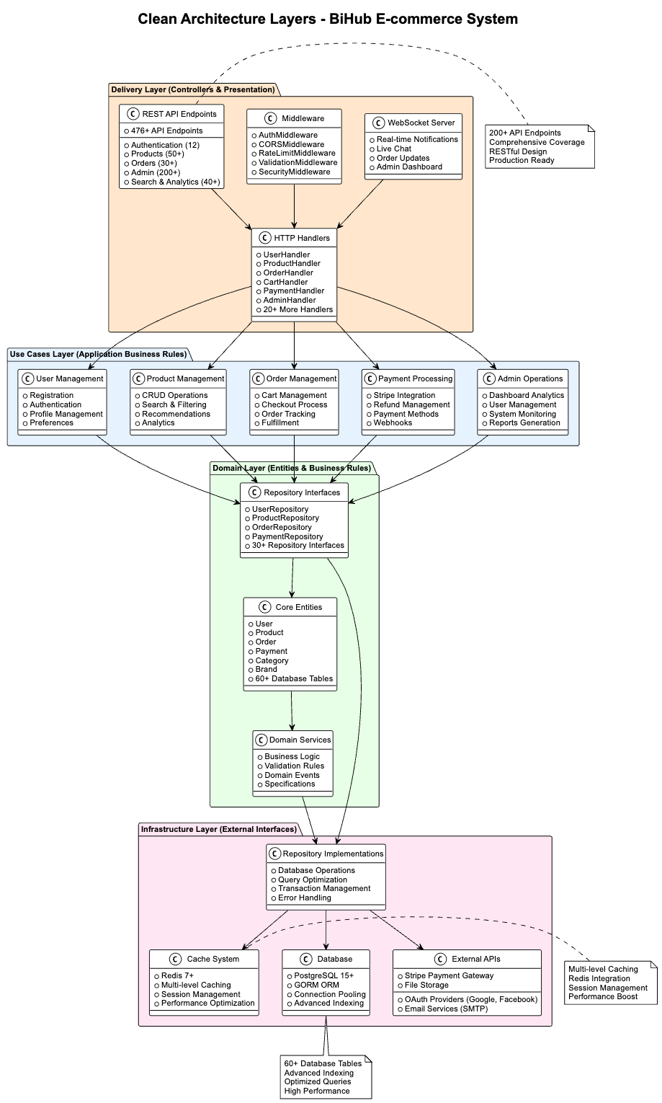

3. PHÂN TÍCH VÀ THIẾT KẾ HỆ THỐNG

3.1. Phân tích yêu cầu hệ thống

3.1.1. Yêu cầu chức năng (Functional Requirements)
Yêu cầu người dùng (Customer Requirements):
- Đăng ký tài khoản và đăng nhập hệ thống
- Duyệt và tìm kiếm sản phẩm theo nhiều tiêu chí
- Quản lý giỏ hàng: thêm, sửa, xóa sản phẩm
- Đặt hàng và theo dõi trạng thái đơn hàng
- Thanh toán trực tuyến an toàn
- Quản lý thông tin cá nhân và địa chỉ giao hàng
- Đánh giá và nhận xét sản phẩm
- Quản lý danh sách yêu thích
Yêu cầu quản trị viên (Admin Requirements):
- Quản lý người dùng: xem, sửa, khóa tài khoản
- Quản lý sản phẩm: CRUD operations, quản lý kho
- Quản lý đơn hàng: xem, cập nhật trạng thái
- Quản lý danh mục và thương hiệu
- Xem báo cáo và thống kê kinh doanh
- Quản lý hệ thống: backup, logs, settings
- Quản lý khuyến mãi và coupon

3.1.2. Yêu cầu phi chức năng (Non-functional Requirements)
Performance Requirements:
- Page load time < 2 seconds
- API response time < 500ms
- Support 1000+ concurrent users
- Database query time < 100ms
- 99.9% uptime availability
Security Requirements:
- JWT authentication với token expiration
- OAuth integration (Google, Facebook)
- HTTPS encryption cho tất cả communications
- Input validation và sanitization
- Rate limiting để prevent abuse
- Audit logging cho security events
Scalability Requirements:
- Horizontal scaling capability
- Database connection pooling
- Caching strategy với Redis
- CDN integration cho static assets
- Load balancing support
Usability Requirements:
- Responsive design cho mobile và desktop
- Intuitive user interface
- Accessibility compliance (WCAG 2.1)
- Multi-language support capability
- Fast search với autocomplete

3.1.3. Business Requirements
- Support multiple payment methods
- Inventory management với real-time updates
- Order tracking và notification system
- Customer support integration
- Analytics và reporting capabilities
- SEO optimization
- Social media integration

3.2. Tổng quan kiến trúc
Hệ thống được thiết kế theo mô hình 3-tier architecture với nguyên tắc Clean Architecture. Kiến trúc này đảm bảo tính tách biệt giữa các tầng và khả năng mở rộng cao.
Tầng Presentation (Frontend):
- Next.js 15 với React 19 cho user interface
- TypeScript cho type safety và better developer experience
- Tailwind CSS với Radix UI cho design system
- Zustand cho state management với persistence
Tầng Application (Backend):
- Go 1.23 với Gin Framework cho HTTP server
- Clean Architecture pattern implementation
- JWT Authentication với OAuth integration
- WebSocket support cho real-time features
Tầng Data (Database):
- PostgreSQL làm primary database
- GORM ORM cho data access layer
- Redis cho caching và session management
- File storage system cho media assets

3.3. Clean Architecture Layers
Hệ thống tuân theo nguyên tắc Clean Architecture với 4 tầng chính:

3.3.1. Domain Layer (Entities & Business Rules)
Tầng Domain chứa các thành phần cốt lõi của business logic:
Business Entities: Các đối tượng nghiệp vụ chính bao gồm User, Product, Order, Cart, Category, Payment và các entity liên quan. Mỗi entity được định nghĩa với các thuộc tính và business rules riêng.
Repository Interfaces: Định nghĩa các contract cho việc truy cập dữ liệu, đảm bảo tính độc lập của domain layer với infrastructure layer.
Domain Services: Chứa business logic thuần túy, không phụ thuộc vào framework hay external services, đảm bảo tính testability cao.

3.3.2. Use Cases Layer (Application Business Rules)
Tầng Use Cases triển khai các quy tắc nghiệp vụ của ứng dụng:
User Management: Xử lý đăng ký người dùng, xác thực, quản lý profile và session management.
Product Management: Thực hiện các thao tác CRUD cho sản phẩm, tìm kiếm advanced và filtering system.
Order Management: Quản lý giỏ hàng, checkout process và order lifecycle management.
Payment Processing: Tích hợp Stripe payment gateway và xử lý refund workflows.

3.3.3. Infrastructure Layer (External Interfaces)
Tầng Infrastructure cung cấp các implementation cụ thể:
Database Implementation: PostgreSQL với GORM ORM cho persistence layer, bao gồm migration system và connection pooling.
Caching System: Redis implementation cho session management và application caching strategies.
External APIs: Tích hợp với Stripe payment gateway, email services và các third-party APIs.
File Storage: Hệ thống lưu trữ local hoặc cloud-based cho product images và media files.

3.3.4. Delivery Layer (Controllers & Presentation)
Tầng Delivery xử lý giao tiếp với external world:
HTTP Handlers: REST API endpoints cho client-server communication với proper error handling.
Middleware System: Authentication middleware, CORS configuration, logging và request processing.
WebSocket Handlers: Real-time communication cho notifications và live chat features.


3.4. Database Design
Hệ thống sử dụng PostgreSQL làm database chính với thiết kế schema phức tạp và toàn diện, bao gồm hơn 60 bảng được tổ chức theo các nhóm chức năng rõ ràng.

3.4.1. Database Schema Overview
Tổng số entities: 60+ bảng Database Engine: PostgreSQL 15+ ORM Framework: GORM v1.30.0 Migration Strategy: Auto-migration với version control

3.4.2. Core Entity Groups User Management (8 bảng):
- users: Thông tin người dùng cơ bản
- user_profiles: Profile chi tiết
- addresses: Địa chỉ giao hàng và thanh toán
- user_preferences: Cài đặt người dùng
- account_verifications: Xác thực email
- password_resets: Reset mật khẩu
- user_sessions: Quản lý phiên đăng nhập
- user_login_history: Lịch sử đăng nhập
Product Catalog (12 bảng):
- products: Sản phẩm chính
- categories: Danh mục hierarchical
- brands: Thương hiệu
- product_categories: Many-to-many relationship
- product_images: Hình ảnh sản phẩm
- product_variants: Biến thể sản phẩm
- product_attributes: Thuộc tính sản phẩm
- product_attribute_terms: Giá trị thuộc tính
- product_attribute_values: Mapping values
- product_variant_attributes: Variant attributes
- product_tags: Tags hệ thống
- product_relations: Related products
Shopping & Orders (8 bảng):
- carts: Giỏ hàng
- cart_items: Items trong giỏ hàng
- orders: Đơn hàng
- order_items: Items trong đơn hàng
- order_events: Lịch sử trạng thái
- wishlists: Danh sách yêu thích
- product_comparisons: So sánh sản phẩm
- product_comparison_items: Items so sánh
Payment & Financial (6 bảng):
- payments: Thanh toán
- payment_methods: Phương thức thanh toán
- refunds: Hoàn tiền
- coupons: Mã giảm giá
- coupon_usages: Lịch sử sử dụng coupon
- promotions: Khuyến mãi

3.4.3. Advanced Features Inventory Management (5 bảng):
- inventories: Tồn kho
- inventory_movements: Biến động kho
- warehouses: Kho hàng
- stock_alerts: Cảnh báo tồn kho
- suppliers: Nhà cung cấp
Shipping & Logistics (7 bảng):
- shipping_methods: Phương thức vận chuyển
- shipping_zones: Vùng vận chuyển
- shipping_rates: Giá vận chuyển
- shipments: Lô hàng
- shipment_trackings: Tracking information
- returns: Trả hàng
- return_items: Items trả hàng
Reviews & Ratings (4 bảng):
- reviews: Đánh giá sản phẩm
- review_images: Hình ảnh review
- review_votes: Vote helpful/unhelpful
- product_ratings: Tổng hợp rating
Notifications & Communication (8 bảng):
- notifications: Thông báo hệ thống
- notification_templates: Template thông báo
- notification_preferences: Cài đặt thông báo
- notification_queues: Queue xử lý
- emails: Email logs
- email_templates: Email templates
- email_subscriptions: Đăng ký email
- live_chat_sessions: Live chat

3.4.4. Database Relationships & Constraints Primary Keys:
Tất cả bảng sử dụng UUID làm primary key với auto-generation sử dụng gen_random_uuid(), đảm bảo tính unique và security.
Foreign Key Relationships:
- users 1:1 user_profiles
- users 1:N addresses
- users 1:N orders
- users 1:N reviews
- products N:M categories (through product_categories)
- products 1:N product_images
- products 1:N product_variants
- products N:1 brands
- orders 1:N order_items
- orders 1:N payments
- orders 1:N order_events
- carts 1:N cart_items
- users 1:1 carts (active cart)
Unique Constraints:
- UNIQUE(email) ON users
- UNIQUE(sku) ON products
- UNIQUE(slug) ON products
- UNIQUE(slug) ON categories
- UNIQUE(order_number) ON orders
- UNIQUE(code) ON warehouses

3.4.5. Indexing Strategy Core Entity Indexes:
- idx_users_email ON users(email)
- idx_users_role ON users(role)
- idx_users_is_active ON users(is_active)
- idx_products_sku ON products(sku)
- idx_products_slug ON products(slug)
- idx_products_status ON products(status)
- idx_products_featured ON products(featured) WHERE featured = true
- idx_products_price ON products(price)
- idx_orders_user_id ON orders(user_id)
- idx_orders_status ON orders(status)
- idx_cart_items_cart_id ON cart_items(cart_id)
Advanced Search Indexes:
- Full-text search indexes sử dụng PostgreSQL GIN
- idx_products_search_vector ON products USING gin(to_tsvector(...))
- Trigram indexes cho fuzzy search
- idx_products_name_trgm ON products USING gin(name gin_trgm_ops)
Composite Indexes cho common queries:
- idx_products_status_featured ON products(status, featured)
- idx_products_status_price ON products(status, price)
- idx_orders_status_created_at ON orders(status, created_at)
- idx_orders_user_status ON orders(user_id, status)
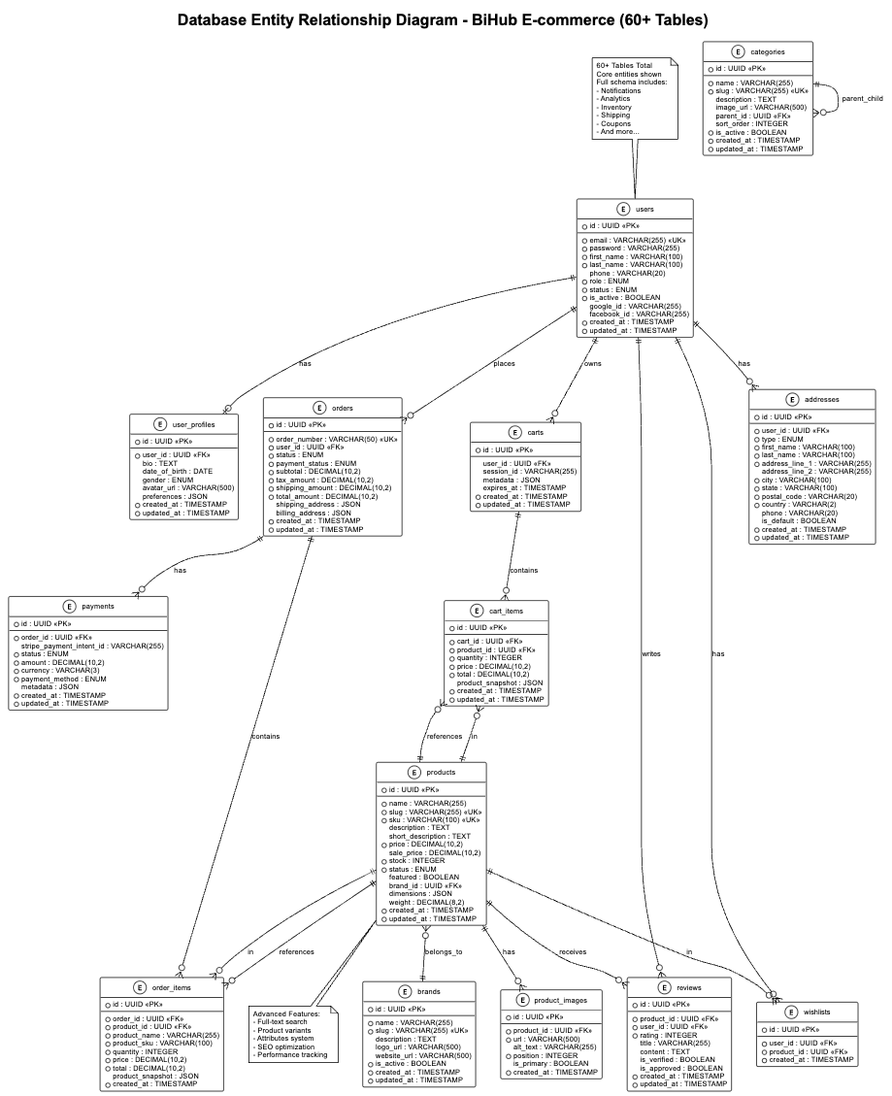

3.5. API Architecture
Hệ thống API được thiết kế theo RESTful principles với cấu trúc rõ ràng và consistent.

3.5.1. API Structure Overview
Base URL: http://localhost:8080/api/v1 Authentication: JWT Bearer Token Content-Type: application/json API Versioning: v1 với khả năng mở rộng

3.5.2. Comprehensive API Endpoint Categories (294 Total - Verified from Postman Collection)
API Endpoint Analysis (294 Total - Verified from Postman Collection):
Authentication Group (16 endpoints):
- POST /api/v1/auth/register - User registration
- POST /api/v1/auth/login - User login
- POST /api/v1/auth/logout - User logout
- POST /api/v1/auth/refresh - Token refresh
- POST /api/v1/auth/forgot-password - Password reset request
- POST /api/v1/auth/reset-password - Password reset confirmation
- GET /api/v1/auth/verify-email - Email verification (GET method)
- POST /api/v1/auth/verify-email - Email verification (POST method)
- POST /api/v1/auth/resend-verification - Resend verification email
- GET /api/v1/auth/google/url - Get Google OAuth URL
- GET /api/v1/auth/facebook/url - Get Facebook OAuth URL
- GET /api/v1/auth/google/login - Google OAuth login (direct redirect)
- GET /api/v1/auth/facebook/login - Facebook OAuth login (direct redirect)
- GET /api/v1/auth/google/callback - Google OAuth callback
- GET /api/v1/auth/facebook/callback - Facebook OAuth callback
- GET /api/v1/users/verification/status - Get verification status
Products Group (60+ endpoints): Public Product Operations (15 endpoints):
- GET /api/v1/products - Product listing với pagination
- GET /api/v1/products/:id - Product detail
- GET /api/v1/products/featured - Featured products
- GET /api/v1/products/trending - Trending products
- GET /api/v1/products/new-arrivals - New arrivals
- GET /api/v1/products/on-sale - Products on sale
- GET /api/v1/products/:id/reviews - Product reviews
- GET /api/v1/products/:id/rating - Product rating summary
- GET /api/v1/products/:id/related - Related products
- GET /api/v1/products/:id/frequently-bought-together - Frequently bought together
- GET /api/v1/products/:id/variants - Product variants
- GET /api/v1/products/:id/attributes - Product attributes
- GET /api/v1/products/category/:categoryId - Products by category
- GET /api/v1/products/brand/:brandId - Products by brand
- GET /api/v1/products/compare - Product comparison
Advanced Product Search & Filters (20 endpoints):
- GET /api/v1/products/search - Full-text search
- GET /api/v1/products/search/enhanced - Enhanced search với AI
- GET /api/v1/products/search/suggestions - Search suggestions
- GET /api/v1/products/search/autocomplete - Autocomplete
- GET /api/v1/products/search/popular - Popular search terms
- GET /api/v1/products/search/trending - Trending searches
- POST /api/v1/products/search/track - Track search event
- GET /api/v1/products/filters - Available filters
- GET /api/v1/products/filters/facets - Filter facets
- GET /api/v1/products/filters/price-range - Price range
- GET /api/v1/products/filters/brands - Brand filters
- GET /api/v1/products/filters/categories - Category filters
- GET /api/v1/products/filters/attributes - Attribute filters
- POST /api/v1/products/filters/apply - Apply filters
- GET /api/v1/products/sort-options - Sort options
- POST /api/v1/products/view-track - Track product view
- GET /api/v1/products/recently-viewed - Recently viewed
- GET /api/v1/products/recommendations - Personalized recommendations
- GET /api/v1/products/similar/:id - Similar products
- POST /api/v1/products/wishlist/toggle - Toggle wishlist
Admin Product Management (25+ endpoints):
- POST /api/v1/admin/products - Create product
- PUT /api/v1/admin/products/:id - Update product
- PATCH /api/v1/admin/products/:id - Patch product
- DELETE /api/v1/admin/products/:id - Delete product
- PUT /api/v1/admin/products/:id/status - Update product status
- PUT /api/v1/admin/products/:id/stock - Update stock
- POST /api/v1/admin/products/bulk/create - Bulk create products
- PUT /api/v1/admin/products/bulk/update - Bulk update products
- DELETE /api/v1/admin/products/bulk/delete - Bulk delete products
- POST /api/v1/admin/products/import - Import products từ CSV
- GET /api/v1/admin/products/export - Export products to CSV
- POST /api/v1/admin/products/:id/images - Upload product images
- DELETE /api/v1/admin/products/:id/images/:imageId - Delete product image
- PUT /api/v1/admin/products/:id/images/reorder - Reorder images
- POST /api/v1/admin/products/:id/variants - Create variant
- PUT /api/v1/admin/products/:id/variants/:variantId - Update variant
- DELETE /api/v1/admin/products/:id/variants/:variantId - Delete variant
- POST /api/v1/admin/products/:id/attributes - Add attributes
- PUT /api/v1/admin/products/:id/seo - Update SEO settings
- GET /api/v1/admin/products/analytics - Product analytics
- GET /api/v1/admin/products/performance - Performance metrics
- POST /api/v1/admin/products/:id/duplicate - Duplicate product
- PUT /api/v1/admin/products/:id/featured - Toggle featured
- GET /api/v1/admin/products/low-stock - Low stock alerts
- POST /api/v1/admin/products/reindex - Reindex search
Categories Group (25+ endpoints): Public Category Operations (12 endpoints):
- GET /api/v1/categories - Category listing
- GET /api/v1/categories/:id - Category detail
- GET /api/v1/categories/slug/:slug - Category by slug
- GET /api/v1/categories/tree - Category tree structure
- GET /api/v1/categories/root - Root categories
- GET /api/v1/categories/:id/children - Category children
- GET /api/v1/categories/:id/products - Products in category
- GET /api/v1/categories/:id/products/count - Product count
- GET /api/v1/categories/popular - Popular categories
- GET /api/v1/categories/featured - Featured categories
- GET /api/v1/categories/search - Search categories
- GET /api/v1/categories/breadcrumb/:id - Category breadcrumb
Advanced Category Features (8 endpoints):
- GET /api/v1/categories/trending - Trending categories
- GET /api/v1/categories/:id/analytics - Category analytics
- GET /api/v1/categories/:id/seo - Category SEO data
- POST /api/v1/categories/:id/track-view - Track category view
- GET /api/v1/categories/:id/filters - Available filters for category
- GET /api/v1/categories/:id/brands - Brands in category
- GET /api/v1/categories/:id/price-range - Price range in category
- GET /api/v1/categories/hierarchy - Full category hierarchy
Admin Category Management (5+ endpoints):
- POST /api/v1/admin/categories - Create category
- PUT /api/v1/admin/categories/:id - Update category
- DELETE /api/v1/admin/categories/:id - Delete category
- PUT /api/v1/admin/categories/:id/move - Move category
- PUT /api/v1/admin/categories/:id/seo - Update category SEO
Brands Group (20+ endpoints): Public Brand Operations (10 endpoints):
- GET /api/v1/brands - Brand listing
- GET /api/v1/brands/:id - Brand detail
- GET /api/v1/brands/slug/:slug - Brand by slug
- GET /api/v1/brands/active - Active brands
- GET /api/v1/brands/popular - Popular brands
- GET /api/v1/brands/featured - Featured brands
- GET /api/v1/brands/search - Search brands
- GET /api/v1/brands/:id/products - Products by brand
- GET /api/v1/brands/:id/categories - Categories for brand
- GET /api/v1/brands/alphabetical - Brands alphabetically
Admin Brand Management (10+ endpoints):
- POST /api/v1/admin/brands - Create brand
- PUT /api/v1/admin/brands/:id - Update brand
- DELETE /api/v1/admin/brands/:id - Delete brand
- PUT /api/v1/admin/brands/:id/status - Update brand status
- POST /api/v1/admin/brands/:id/logo - Upload brand logo
- DELETE /api/v1/admin/brands/:id/logo - Delete brand logo
- PUT /api/v1/admin/brands/:id/featured - Toggle featured
- GET /api/v1/admin/brands/analytics - Brand analytics
- POST /api/v1/admin/brands/bulk/update - Bulk update brands
- PUT /api/v1/admin/brands/:id/seo - Update brand SEO
Shopping Cart Group (25+ endpoints): Cart Operations (15 endpoints):
- GET /api/v1/cart - Get user cart
- POST /api/v1/cart/items - Add item to cart
- PUT /api/v1/cart/items/:productId - Update cart item quantity
- DELETE /api/v1/cart/items/:productId - Remove item from cart
- DELETE /api/v1/cart - Clear entire cart
- GET /api/v1/cart/count - Get cart item count
- GET /api/v1/cart/total - Get cart total
- POST /api/v1/cart/validate - Validate cart items
- POST /api/v1/cart/merge - Merge guest cart with user cart
- POST /api/v1/cart/check-conflict - Check cart conflicts
- GET /api/v1/cart/shipping-estimate - Estimate shipping
- POST /api/v1/cart/apply-coupon - Apply coupon code
- DELETE /api/v1/cart/remove-coupon - Remove coupon
- POST /api/v1/cart/save-for-later - Save item for later
- GET /api/v1/cart/saved-items - Get saved items
Guest Cart Operations (10+ endpoints):
- GET /api/v1/public/cart - Get guest cart by session
- POST /api/v1/public/cart/items - Add to guest cart
- PUT /api/v1/public/cart/items/:productId - Update guest cart item
- DELETE /api/v1/public/cart/items/:productId - Remove from guest cart
- DELETE /api/v1/public/cart - Clear guest cart
- GET /api/v1/public/cart/count - Guest cart count
- POST /api/v1/public/cart/validate - Validate guest cart
- POST /api/v1/public/cart/apply-coupon - Apply coupon to guest cart
- GET /api/v1/public/cart/shipping-estimate - Guest shipping estimate
- POST /api/v1/public/cart/convert - Convert guest cart to user cart
Checkout & Orders Group (40+ endpoints): Checkout Session (8 endpoints):
- POST /api/v1/checkout/session - Create checkout session
- GET /api/v1/checkout/session/:sessionId - Get checkout session
- PUT /api/v1/checkout/session/:sessionId - Update checkout session
- POST /api/v1/checkout/session/:sessionId/shipping - Set shipping address
- POST /api/v1/checkout/session/:sessionId/billing - Set billing address
- POST /api/v1/checkout/session/:sessionId/shipping-method - Select shipping method
- POST /api/v1/checkout/session/:sessionId/complete - Complete checkout
- DELETE /api/v1/checkout/session/:sessionId - Cancel checkout session
Customer Order Operations (20+ endpoints):
- POST /api/v1/orders - Create order
- GET /api/v1/orders - Get user orders
- GET /api/v1/orders/:id - Get order details
- POST /api/v1/orders/:id/cancel - Cancel order
- GET /api/v1/orders/:id/events - Get order events
- GET /api/v1/orders/:id/tracking - Get tracking information
- POST /api/v1/orders/:id/review - Submit order review
- GET /api/v1/orders/:id/invoice - Get order invoice
- POST /api/v1/orders/:id/return-request - Request return
- GET /api/v1/orders/history - Order history with filters
- GET /api/v1/orders/recent - Recent orders
- GET /api/v1/orders/status/:status - Orders by status
- POST /api/v1/orders/reorder/:id - Reorder previous order
- GET /api/v1/orders/:id/items - Get order items
- POST /api/v1/orders/:id/feedback - Submit feedback
- GET /api/v1/orders/analytics - User order analytics
- POST /api/v1/orders/:id/dispute - Create dispute
- GET /api/v1/orders/:id/shipping-updates - Shipping updates
- POST /api/v1/orders/:id/delivery-confirmation - Confirm delivery
- GET /api/v1/orders/downloadable - Downloadable orders
COD & Bank Transfer Orders (12+ endpoints):
- POST /api/v1/checkout/cod - Create COD order
- POST /api/v1/checkout/bank-transfer - Create bank transfer order
- GET /api/v1/orders/:id/payment-instructions - Payment instructions
- POST /api/v1/orders/:id/payment-proof - Upload payment proof
- PUT /api/v1/orders/:id/payment-status - Update payment status
- GET /api/v1/orders/pending-payment - Orders pending payment
- POST /api/v1/orders/:id/payment-reminder - Send payment reminder
- GET /api/v1/orders/:id/bank-details - Get bank transfer details
- POST /api/v1/orders/:id/confirm-payment - Confirm payment received
- GET /api/v1/orders/cod/pending - Pending COD orders
- POST /api/v1/orders/:id/cod-confirm - Confirm COD delivery
- GET /api/v1/orders/payment-methods - Available payment methods
Protected API Endpoints (200+ endpoints): User Management (40+ endpoints):
- GET /api/v1/users/profile - Get user profile
- PUT /api/v1/users/profile - Update profile
- POST /api/v1/users/change-password - Change password
- GET /api/v1/users/preferences - User preferences
- PUT /api/v1/users/preferences - Update preferences
- GET /api/v1/users/activity - User activity
- GET /api/v1/users/stats - User statistics
- POST /api/v1/users/search-history/track - Track search
- GET /api/v1/users/search-history - Get search history
- DELETE /api/v1/users/search-history - Clear search history
- POST /api/v1/users/saved-searches - Create saved search
- GET /api/v1/users/saved-searches - Get saved searches
- POST /api/v1/users/browsing-history/track - Track product view
- GET /api/v1/users/browsing-history - Get browsing history
- GET /api/v1/users/personalization - Get personalization
- GET /api/v1/users/sessions - Get user sessions
- DELETE /api/v1/users/sessions/:session_id - Invalidate session
- And 23+ more user management endpoints...
Cart & Orders (30+ endpoints):
- GET /api/v1/cart - Get user cart
- POST /api/v1/cart/items - Add to cart
- PUT /api/v1/cart/items/:productId - Update cart item
- DELETE /api/v1/cart/items/:productId - Remove from cart
- DELETE /api/v1/cart - Clear cart
- POST /api/v1/cart/merge - Merge guest cart
- POST /api/v1/cart/check-conflict - Check cart conflict
- POST /api/v1/checkout/session - Create checkout session
- GET /api/v1/checkout/session/:session_id - Get checkout session
- POST /api/v1/checkout/session/:session_id/complete - Complete checkout
- POST /api/v1/checkout/cod - Create COD order
- POST /api/v1/orders - Create order (Bank Transfer)
- GET /api/v1/orders - Get user orders
- GET /api/v1/orders/:id - Get order details
- POST /api/v1/orders/:id/cancel - Cancel order
- GET /api/v1/orders/:id/events - Get order events
- And 14+ more cart/order endpoints...
Reviews & Wishlist (15+ endpoints):
- POST /api/v1/reviews - Create review
- GET /api/v1/reviews/:id - Get review
- PUT /api/v1/reviews/:id - Update review
- DELETE /api/v1/reviews/:id - Delete review
- POST /api/v1/reviews/:id/vote - Vote on review
- GET /api/v1/wishlist - Get wishlist
- POST /api/v1/wishlist/items - Add to wishlist
- DELETE /api/v1/wishlist/items/:id - Remove from wishlist
- DELETE /api/v1/wishlist/clear - Clear wishlist
- GET /api/v1/wishlist/items/:productId/status - Check wishlist status
- GET /api/v1/wishlist/count - Get wishlist count
- And 4+ more review/wishlist endpoints...
Payments & Addresses (25+ endpoints):
- POST /api/v1/payments - Process payment
- POST /api/v1/payments/checkout-session - Create checkout session
- GET /api/v1/payments/:id - Get payment
- POST /api/v1/payments/:id/refund - Process refund
- GET /api/v1/payments/methods - Get payment methods
- POST /api/v1/payments/methods - Save payment method
- DELETE /api/v1/payments/methods/:id - Delete payment method
- GET /api/v1/addresses - Get addresses
- POST /api/v1/addresses - Create address
- GET /api/v1/addresses/:id - Get address
- PUT /api/v1/addresses/:id - Update address
- DELETE /api/v1/addresses/:id - Delete address
- PUT /api/v1/addresses/:id/default - Set default address
- And 12+ more payment/address endpoints...
Notifications & WebSocket (15+ endpoints):
- GET /api/v1/notifications - Get notifications
- PUT /api/v1/notifications/:id/read - Mark as read
- PUT /api/v1/notifications/read-all - Mark all as read
- GET /api/v1/notifications/count - Get unread count
- GET /api/v1/notifications/preferences - Get preferences
- PUT /api/v1/notifications/preferences - Update preferences
- GET /api/v1/ws/notifications - WebSocket connection
- GET /api/v1/ws/stats - WebSocket stats
- POST /api/v1/ws/test/:user_id - Send test notification
- And 6+ more notification endpoints...
File Management (15+ endpoints):
- POST /api/v1/upload/image - Upload image
- POST /api/v1/upload/document - Upload document
- GET /api/v1/files - Get file uploads
- GET /api/v1/files/:id - Get file upload
- DELETE /api/v1/files/:id - Delete file
- And 10+ more file management endpoints...
Admin API Endpoints (150+ endpoints): Dashboard & Analytics (15+ endpoints):
- GET /api/v1/admin/dashboard - Admin dashboard
- GET /api/v1/admin/dashboard/stats - System stats
- GET /api/v1/admin/dashboard/real-time - Real-time metrics
- GET /api/v1/admin/dashboard/activity - Recent activity
- GET /api/v1/admin/analytics/sales - Sales metrics
- GET /api/v1/admin/analytics/products - Product metrics
- GET /api/v1/admin/analytics/users - User metrics
- GET /api/v1/admin/analytics/traffic - Traffic metrics
- POST /api/v1/admin/analytics/events - Track event
- GET /api/v1/admin/analytics/top-products - Top products
- GET /api/v1/admin/analytics/top-categories - Top categories
- And 4+ more dashboard endpoints...
User Management (25+ endpoints):
- GET /api/v1/admin/users - Get users
- PUT /api/v1/admin/users/:id/status - Update user status
- PUT /api/v1/admin/users/:id/role - Update user role
- GET /api/v1/admin/users/:id/activity - Get user activity
- POST /api/v1/admin/users/bulk/update - Bulk update users
- POST /api/v1/admin/users/bulk/delete - Bulk delete users
- POST /api/v1/admin/users/notification - Send user notification
- POST /api/v1/admin/users/bulk/notification - Send bulk notification
- GET /api/v1/admin/users/audit-logs - Get audit logs
- GET /api/v1/admin/customers/search - Search customers
- GET /api/v1/admin/customers/segments - Customer segments
- GET /api/v1/admin/customers/analytics - Customer analytics
- And 13+ more user management endpoints...
Product Management (30+ endpoints):
- GET /api/v1/admin/products - Get products
- POST /api/v1/admin/products - Create product
- PUT /api/v1/admin/products/:id - Update product
- PATCH /api/v1/admin/products/:id - Patch product
- DELETE /api/v1/admin/products/:id - Delete product
- PUT /api/v1/admin/products/:id/stock - Update stock
- POST /api/v1/admin/categories - Create category
- PUT /api/v1/admin/categories/:id - Update category
- DELETE /api/v1/admin/categories/:id - Delete category
- POST /api/v1/admin/categories/bulk - Bulk create categories
- POST /api/v1/admin/categories/move - Move category
- GET /api/v1/admin/categories/top - Top categories
- GET /api/v1/admin/categories/:id/analytics - Category analytics
- PUT /api/v1/admin/categories/:id/seo - Update category SEO
- POST /api/v1/admin/brands - Create brand
- PUT /api/v1/admin/brands/:id - Update brand
- DELETE /api/v1/admin/brands/:id - Delete brand
- And 13+ more product management endpoints...
Order Management (20+ endpoints):
- GET /api/v1/admin/orders - Get orders
- GET /api/v1/admin/orders/:id - Get order details
- PUT /api/v1/admin/orders/:id/status - Update order status
- PATCH /api/v1/admin/orders/:id/status - Patch order status
- PUT /api/v1/admin/orders/:id/shipping - Update shipping info
- PUT /api/v1/admin/orders/:id/delivery - Update delivery status
- POST /api/v1/admin/orders/:id/notes - Add order note
- GET /api/v1/admin/orders/:id/events - Get order events
- POST /api/v1/admin/orders/:id/refund - Process refund
- POST /api/v1/admin/shipments - Create shipment
- GET /api/v1/admin/shipments/:id - Get shipment
- PUT /api/v1/admin/shipments/:id/status - Update shipment status
- And 8+ more order management endpoints...
System Management (40+ endpoints):
- GET /api/v1/admin/inventory - Get inventories
- GET /api/v1/admin/inventory/:id - Get inventory
- PUT /api/v1/admin/inventory/:id - Update inventory
- POST /api/v1/admin/inventory/movements - Record movement
- GET /api/v1/admin/inventory/movements - Get movements
- POST /api/v1/admin/inventory/adjust - Adjust stock
- GET /api/v1/admin/inventory/alerts - Get stock alerts
- GET /api/v1/admin/backup - List backups
- POST /api/v1/admin/backup - Create backup
- POST /api/v1/admin/backup/restore - Restore backup
- GET /api/v1/admin/coupons - List coupons
- POST /api/v1/admin/coupons - Create coupon
- PUT /api/v1/admin/coupons/:id - Update coupon
- DELETE /api/v1/admin/coupons/:id - Delete coupon
- POST /api/v1/admin/reports/generate - Generate report
- GET /api/v1/admin/reports - Get reports
- GET /api/v1/admin/system/logs - Get system logs
- GET /api/v1/admin/system/audit - Get audit logs
- POST /api/v1/admin/system/backup - Backup database
- GET /api/v1/admin/security/suspicious-activity - Suspicious activity
- GET /api/v1/admin/settings/general - General settings
- PUT /api/v1/admin/settings/general - Update general settings
- GET /api/v1/admin/settings/store - Store config
- PUT /api/v1/admin/settings/store - Update store config
- GET /api/v1/admin/settings/payment - Payment settings
- PUT /api/v1/admin/settings/payment - Update payment settings
- GET /api/v1/admin/settings/email - Email settings
- PUT /api/v1/admin/settings/email - Update email settings
- POST /api/v1/admin/settings/email/test - Test email settings
- GET /api/v1/admin/settings/tax - Tax settings
- PUT /api/v1/admin/settings/tax - Update tax settings
- GET /api/v1/admin/settings/shipping - Shipping settings
- PUT /api/v1/admin/settings/shipping - Update shipping settings
- GET /api/v1/admin/settings/seo - SEO settings
- PUT /api/v1/admin/settings/seo - Update SEO settings
- GET /api/v1/admin/settings/security - Security settings
- PUT /api/v1/admin/settings/security - Update security settings
- GET /api/v1/admin/settings/notifications - Notification settings
- PUT /api/v1/admin/settings/notifications - Update notification settings
- GET /api/v1/admin/settings/integrations - Integration settings
- PUT /api/v1/admin/settings/integrations - Update integration settings
Moderator API Endpoints (6+ endpoints):
- POST /api/v1/moderator/products - Create product
- PUT /api/v1/moderator/products/:id - Update product
- PATCH /api/v1/moderator/products/:id - Patch product
- PUT /api/v1/moderator/products/:id/stock - Update stock
- POST /api/v1/moderator/upload/image - Upload image
- POST /api/v1/moderator/upload/document - Upload document
Webhook Endpoints (5+ endpoints):
- POST /api/v1/webhooks/payment/:provider - Payment webhook
- POST /api/v1/payments/confirm-success - Confirm payment success
- POST /api/v1/payments/test-webhook/:session_id - Test webhook (dev only)
- GET /api/v1/orders/:id/public - Public order access
- POST /api/v1/public/verification/email/verify - Email verification

3.5.3. Response Format Standards
Success Response Format: { "data": {...}, "message": "Operation successful", "pagination": {...} // if applicable }
Error Response Format: { "error": "Error message", "details": "Detailed error description", "code": "ERROR_CODE" }

3.5.4. Security Measures Rate Limiting:
- Public endpoints: 100 requests/minute
- Authenticated endpoints: 1000 requests/minute
- Admin endpoints: 500 requests/minute
- Search endpoints: 50 requests/minute
Authentication & Authorization:
- JWT token validation
- Role-based access control
- Session management
- OAuth integration support
Input Validation:
- Request payload validation
- SQL injection prevention
- XSS attack prevention
- CORS configuration

4. TRIỂN KHAI HỆ THỐNG BACKEND

4.1. Tổng quan Backend Architecture
Backend được xây dựng bằng Go với framework Gin, tuân theo nguyên tắc Clean Architecture. Hệ thống được tổ chức thành các layer rõ ràng, đảm bảo tính maintainability và testability cao.

4.1.1. Cấu trúc thư mục
internal/ ├── domain/ # Domain Layer │ ├── entities/ # Business entities │ ├── repositories/ # Repository interfaces │ └── services/ # Domain services ├── usecases/ # Use Cases Layer ├── infrastructure/ # Infrastructure Layer │ ├── database/ # Database implementations │ ├── config/ # Configuration management │ ├── repositories/ # Repository implementations │ ├── services/ # Infrastructure services │ ├── oauth/ # OAuth providers │ ├── payment/ # Payment integrations │ └── storage/ # File storage └── delivery/ # Delivery Layer └── http/ # HTTP handlers, middleware, routes

4.1.2. Core Technologies
Programming Language: Go 1.23.0 với strong typing system, excellent concurrency support với goroutines, fast compilation và execution, built-in garbage collection.
Web Framework: Gin v1.10.1 - High-performance HTTP web framework với fast routing và middleware support, JSON binding và validation, minimal memory footprint.

4.2. Domain Layer Implementation
Domain layer chứa business logic thuần túy và các entity definitions.

4.2.1. Core Entities User Management Entities:
- User: Thông tin người dùng cơ bản (ID, email, password, role, status)
- UserProfile: Thông tin chi tiết profile
- UserSession: Quản lý phiên đăng nhập
- UserActivity: Theo dõi hoạt động người dùng
Product Management Entities:
- Product: Sản phẩm với đầy đủ thông tin (tên, mô tả, giá, stock, dimensions)
- ProductVariant: Biến thể sản phẩm (size, color, etc.)
- ProductImage: Hình ảnh sản phẩm
- ProductAttribute: Thuộc tính sản phẩm
- Category: Danh mục sản phẩm
- Brand: Thương hiệu
Order & Cart Management Entities:
- Cart: Giỏ hàng
- CartItem: Item trong giỏ hàng
- Order: Đơn hàng
- OrderItem: Item trong đơn hàng
- OrderEvent: Lịch sử trạng thái đơn hàng
Payment & Financial Entities:
- Payment: Thông tin thanh toán
- Refund: Hoàn tiền
- Coupon: Mã giảm giá

4.2.2. Repository Interfaces Định nghĩa contracts cho data access:
- UserRepository: CRUD operations cho User
- ProductRepository: Quản lý sản phẩm với search, filter
- OrderRepository: Quản lý đơn hàng
- InventoryRepository: Quản lý tồn kho
- RecommendationRepository: Hệ thống gợi ý sản phẩm
- AuditRepository: Audit logs và tracking

4.3. Use Cases Layer Implementation
Use Cases layer triển khai business logic của application.

4.3.1. Core Use Cases User Use Cases:
- User registration với email verification
- Login/Logout với JWT authentication
- Profile management
- Password reset workflow
- OAuth integration (Google, Facebook)
Product Use Cases:
- Product CRUD operations
- Advanced search và filtering
- Category management
- Inventory tracking
- Product recommendations
Order Use Cases:
- Cart management (add, update, remove items)
- Checkout process
- Order processing workflow
- Payment integration với Stripe
- Order status tracking
Admin Use Cases:
- Dashboard analytics
- User management
- Product management
- Order management
- System monitoring

4.4. Infrastructure Layer Implementation
Infrastructure layer cung cấp concrete implementations.

4.4.1. Database Layer
PostgreSQL làm primary database với GORM ORM cho database operations, auto-migration system cho database schema, connection pooling optimization.
Connection Pool Configuration: sqlDB.SetMaxIdleConns(25) // 25 idle connections sqlDB.SetMaxOpenConns(200) // 200 max connections sqlDB.SetConnMaxLifetime(30 * time.Minute) // 30 min lifetime sqlDB.SetConnMaxIdleTime(5 * time.Minute) // 5 min idle timeout

4.4.2. External Integrations Payment Processing:
- Stripe integration cho credit card payments
- Webhook handling cho payment confirmations
- Refund processing
Authentication:
- JWT token-based authentication
- OAuth2 integration (Google, Facebook)
- Session management với Redis
File Storage:
- Local file storage cho development
- Support cho cloud storage (S3-compatible)
- Image upload và processing
Email Services:
- SMTP integration cho email notifications
- Template-based email system
- Email verification workflow

4.5. Delivery Layer Implementation
Delivery layer xử lý HTTP requests và responses.

4.5.1. HTTP Handlers
API được tổ chức theo RESTful principles với proper error handling và response formatting.
Authentication Handlers:
- RegisterHandler: User registration với validation
- LoginHandler: Authentication với JWT token generation
- LogoutHandler: Session cleanup
- RefreshHandler: Token refresh mechanism
Product Handlers:
- GetProductsHandler: Product listing với pagination
- GetProductHandler: Product detail retrieval
- CreateProductHandler: Product creation (Admin only)
- UpdateProductHandler: Product updates (Admin only)
- DeleteProductHandler: Product deletion (Admin only)
Order Handlers:
- CreateOrderHandler: Order creation với validation
- GetOrdersHandler: User order history
- GetOrderHandler: Order detail retrieval
- UpdateOrderStatusHandler: Order status updates (Admin)

4.5.2. Middleware System Authentication Middleware:
- JWT token validation
- Role-based access control
- Session management
Security Middleware:
- CORS configuration
- Rate limiting
- Request validation
- SQL injection protection
Logging Middleware:
- Request/Response logging
- Error tracking
- Performance monitoring

4.6. Advanced Features

4.6.1. Real-time Features
WebSocket support cho real-time notifications, live chat system, real-time order status updates, admin dashboard real-time metrics.

4.6.2. Analytics & Monitoring
User activity tracking, product view analytics, sales reporting, system performance monitoring, audit logging cho security compliance.

4.6.3. Recommendation System
Collaborative filtering, content-based recommendations, frequently bought together analysis, trending products analysis.

5. TRIỂN KHAI HỆ THỐNG FRONTEND

5.1. Tổng quan Frontend Architecture
Frontend được xây dựng bằng Next.js 15 với React 19, sử dụng App Router cho routing hiện đại. Hệ thống được thiết kế với focus vào performance, SEO và user experience.

5.1.1. Cấu trúc thư mục
frontend/src/ ├── app/ # Next.js App Router (Routes) │ ├── page.tsx # Homepage │ ├── layout.tsx # Root layout │ ├── globals.css # Global styles │ ├── auth/ # Authentication pages │ ├── products/ # Product pages │ ├── admin/ # Admin dashboard │ ├── cart/ # Shopping cart │ ├── orders/ # Order management │ └── profile/ # User profile ├── components/ # Reusable components │ ├── ui/ # Base UI components │ ├── layout/ # Layout components │ ├── pages/ # Page-specific components │ ├── auth/ # Authentication components │ ├── products/ # Product-related components │ ├── cart/ # Cart components │ └── admin/ # Admin components ├── hooks/ # Custom React hooks ├── store/ # Zustand state management ├── services/ # API services ├── types/ # TypeScript definitions ├── constants/ # App constants ├── lib/ # Utility functions └── styles/ # Additional styles

5.2. Component Architecture

5.2.1. UI Components System
Base components được xây dựng với Radix UI và Tailwind CSS:
Form Components:
- Button: Multiple variants và sizes với loading states
- Input: Form inputs với validation và error handling
- Select: Dropdown selections với search capability
- Checkbox, Switch: Form controls với accessibility
Layout Components:
- Card: Content containers với multiple variants
- Badge: Status indicators với color coding
- Pagination: Page navigation với proper accessibility
- Tabs: Content organization với keyboard navigation
Feedback Components:
- Alert: Notifications với different severity levels
- Toast: Success/error messages với auto-dismiss
- Loading: Loading states với skeleton screens
- Modal: Dialog overlays với focus management

5.2.2. Feature Components Product Components:
- ProductCard: Product display card với hover effects
- ProductListCard: List view variant cho mobile
- ProductFilters: Advanced filtering với real-time updates
- ProductSort: Sorting options với URL persistence
- ProductGallery: Image gallery với zoom functionality
- ProductReviews: Review system với rating display
Cart Components:
- CartItem: Individual cart item với quantity controls
- CartSummary: Price calculations với tax và shipping
- CartConflictModal: Guest/user cart merging interface
- QuickAddToCart: Quick add functionality với feedback
Auth Components:
- LoginForm: Login với validation và error handling
- RegisterForm: Registration form với password strength
- AuthLayout: Auth page layout với responsive design
- OAuthButtons: Social login với proper branding
- PermissionGuard: Access control component

5.3. State Management Implementation

5.3.1. Zustand Store Architecture
Sử dụng Zustand cho state management với persistence:
Auth Store:
- User authentication state
- JWT token management
- Login/logout functionality
- OAuth integration
- Profile management
- Cart conflict resolution
Cart Store:
- Shopping cart items
- Guest cart support
- Cart persistence
- Quantity management
- Price calculations
Order Store:
- Order processing state
- Checkout flow management
- Order history
Payment Store:
- Stripe integration
- Payment method management
- Transaction state

5.3.2. Persistence Strategy
Local Storage persistence cho cart và auth, session storage cho temporary data, hydration handling cho SSR compatibility.

5.4. Routing System Implementation

5.4.1. App Router Structure
Next.js App Router được sử dụng với cấu trúc pages rõ ràng:
Public Pages:
- / - Homepage với featured products
- /products - Product listing với filters
- /products/[id] - Product detail page
- /categories - Category listing
- /categories/[slug] - Category detail
- /search - Search results
Authentication Pages:
- /auth/login - Login form
- /auth/register - Registration form
- /auth/verify-email - Email verification
- /auth/forgot-password - Password reset
Protected Pages:
- /profile - User profile management
- /cart - Shopping cart
- /orders - Order history
- /orders/[id] - Order details
- /wishlist - User wishlist
Admin Pages:
- /admin/dashboard - Admin overview
- /admin/products - Product management
- /admin/orders - Order management
- /admin/users - User management

5.4.2. Layout System
Root Layout: Global layout với providers, fonts, metadata
Conditional Layout: Dynamic layout switching (admin vs user)
Auth Layout: Specialized layout cho authentication pages
Admin Layout: Dashboard layout với sidebar navigation

5.5. Performance Optimization

5.5.1. Next.js Optimizations
Next.js Image optimization, code splitting với dynamic imports, lazy loading cho components, caching strategies với React Query, bundle optimization.

5.5.2. React Query Integration
Advanced query key management, optimized query hooks với error handling, mutation với optimistic updates, strategic cache invalidation.
Query Configuration: staleTime: 60 * 1000, // 1 minute general cache staleTime: 5 * 60 * 1000, // 5 minutes for products staleTime: 10 * 60 * 1000, // 10 minutes for product details staleTime: 15 * 60 * 1000, // 15 minutes for featured products

5.5.3. Performance Metrics Core Web Vitals optimization:
- First Contentful Paint (FCP): < 1.5s
- Largest Contentful Paint (LCP): < 2.5s
- First Input Delay (FID): < 100ms
- Cumulative Layout Shift (CLS): < 0.1
Bundle Optimization:
- Initial bundle: < 200KB gzipped
- Total JavaScript: < 500KB gzipped
- CSS: < 50KB gzipped
- Images: Optimized với Next.js Image

6. TÍNH NĂNG VÀ CHỨC NĂNG HỆ THỐNG

6.1. Hệ thống Authentication và Authorization
Hệ thống xác thực được thiết kế với multiple authentication methods và security measures.

6.1.1. User Registration System
Registration process bao gồm:
- Email validation với real-time checking
- Password strength validation (minimum 8 characters)
- Terms and conditions acceptance
- Email verification workflow
- Account activation process
Registration Form Fields:
- First Name (required, max 50 characters)
- Last Name (required, max 50 characters)
- Email (required, unique, email format validation)
- Password (required, min 8 characters, strength validation)
- Confirm Password (required, must match password)
- Terms acceptance (required checkbox)

6.1.2. Login System
Multiple login options:
- Email/Password authentication
- OAuth integration (Google, Facebook)
- Remember me functionality
- Forgot password workflow
- Account lockout protection
Login Security Features:
- Rate limiting (5 attempts per 15 minutes)
- CAPTCHA after failed attempts
- Session management với JWT tokens
- Secure password hashing với bcrypt
- Login history tracking

6.1.3. JWT Token Management
Token Configuration:
- Access Token: 24 hours expiration
- Refresh Token: 30 days expiration
- Token rotation on refresh
- Secure HTTP-only cookies option
- Token blacklisting on logout

6.1.4. OAuth Integration
Supported Providers:
- Google OAuth 2.0
- Facebook Login
- Account linking functionality
- Profile data synchronization
- Fallback authentication methods

6.2. Product Management System
Comprehensive product management với advanced features.

6.2.1. Product Catalog Structure
Product Entity Fields:
- Basic Information: Name, SKU, Description, Short Description
- Pricing: Regular Price, Sale Price, Sale Period
- Inventory: Stock Quantity, Low Stock Threshold, Stock Status
- Physical Properties: Weight, Dimensions (Length, Width, Height)
- SEO: Slug, Meta Title, Meta Description, Keywords
- Status: Draft, Published, Archived
- Featured Product Flag
- Brand Association
- Category Associations (Many-to-Many)

6.2.2. Product Variants System
Variant Management:
- Size variants (S, M, L, XL, etc.)
- Color variants với color codes
- Material variants
- Custom attribute variants
- Variant-specific pricing
- Variant-specific inventory
- Variant images

6.2.3. Product Image Management
Image System Features:
- Multiple images per product (max 10)
- Image ordering với drag-and-drop
- Alt text cho accessibility
- Image optimization và compression
- Thumbnail generation
- Zoom functionality
- Lazy loading implementation

6.2.4. Advanced Search System
Search Capabilities:
- Full-text search với PostgreSQL
- Fuzzy search cho typos
- Search suggestions và autocomplete
- Search history (last 10 searches)
- Advanced filters:
  - Price range slider
  - Category selection
  - Brand filtering
  - Rating filter
  - Availability filter
  - Sort options (price, popularity, rating, newest)
Search Performance:
- Search indexing với GIN indexes
- Query optimization
- Search result caching
- Pagination với cursor-based approach
- Search analytics tracking

6.3. Shopping Cart System
Advanced cart management với guest và user support.

6.3.1. Cart Architecture
Cart Types:
- Guest Cart: Session-based với localStorage backup
- User Cart: Database persistent với cross-device sync
- Cart expiration: 30 days for users, session-based for guests
Cart Features:
- Add/Remove/Update items
- Quantity validation against stock
- Price calculations với real-time updates
- Cart conflict resolution (guest to user)
- Cart persistence across sessions
- Cart sharing functionality

6.3.2. Cart Item Management
Item Properties:
- Product reference với snapshot
- Quantity với min/max validation
- Price at time of addition
- Variant selection
- Custom options
- Item total calculation
Cart Calculations:
- Subtotal calculation
- Tax calculation (configurable rates)
- Shipping calculation
- Discount application
- Final total với all adjustments

6.3.3. Cart Conflict Resolution
Conflict Scenarios:
- Guest user logs in với existing cart
- User logs in on different device
- Cart merge strategies
- Duplicate item handling
- User choice interface

6.4. Order Management System
Complete order lifecycle management.

6.4.1. Order Creation Process
Order Generation:
- Order number generation (unique, sequential)
- Customer information capture
- Shipping address validation
- Billing address handling
- Order item snapshot creation
- Inventory reservation
- Order status initialization

6.4.2. Order Status Workflow
Order States:
- Pending: Awaiting payment
- Processing: Payment confirmed, preparing shipment
- Shipped: Order dispatched
- Delivered: Order received by customer
- Cancelled: Order cancelled
- Refunded: Payment refunded
Status Transitions:
- Automated status updates
- Manual admin overrides
- Customer notifications
- Email confirmations
- SMS notifications (optional)

6.4.3. Order History và Tracking
Customer Features:
- Order history với pagination
- Order detail views
- Tracking information
- Reorder functionality
- Order cancellation (within time limit)
- Return/Refund requests
Admin Features:
- Order management dashboard
- Bulk order operations
- Order search và filtering
- Order analytics
- Shipping label generation
- Customer communication tools

6.5. Payment Integration
Secure payment processing với Stripe.

6.5.1. Stripe Integration
Payment Methods:
- Credit/Debit Cards (Visa, MasterCard, Amex)
- Digital wallets (Apple Pay, Google Pay)
- Bank transfers (ACH)
- Buy now, pay later options
- International payment methods
Security Features:
- PCI DSS compliance
- 3D Secure authentication
- Fraud detection
- Secure tokenization
- Encrypted data transmission

6.5.2. Payment Processing Flow
Payment Workflow:
- Payment intent creation
- Client-side payment confirmation
- Webhook verification
- Order status update
- Inventory adjustment
- Customer notification
- Receipt generation
Error Handling:
- Payment failure scenarios
- Network timeout handling
- Retry mechanisms
- User-friendly error messages
- Admin notification system

6.5.3. Refund Management
Refund Process:
- Partial và full refunds
- Automated refund processing
- Manual admin refunds
- Refund status tracking
- Customer notifications
- Accounting integration

6.6. Admin Panel
Comprehensive administration interface.

6.6.1. Dashboard Overview
Admin Dashboard Features:
- Sales analytics với charts
- Revenue tracking
- Order statistics
- User growth metrics
- Product performance
- Real-time notifications
Key Metrics Display:
- Today's sales
- Monthly revenue
- Total orders
- Active users
- Low stock alerts
- Recent activities

6.6.2. Product Management Interface
Product Admin Features:
- Product CRUD operations
- Bulk product operations
- CSV import/export
- Image management
- Category assignment
- Inventory tracking
- SEO optimization tools

6.6.3. Order Management Interface
Order Admin Features:
- Order listing với advanced filters
- Order detail views
- Status management
- Customer communication
- Shipping management
- Refund processing
- Order analytics

6.6.4. User Management Interface
User Admin Features:
- User listing và search
- User profile management
- Role assignment
- Account status management
- User activity tracking
- Communication tools

6.7. Demo và User Flows Detailed user journey demonstrations.

6.7.1. Customer Shopping Flow Complete Shopping Journey:
- Homepage browsing
- Product discovery
- Product detail viewing
- Add to cart action
- Cart review
- Checkout process
- Payment completion
- Order confirmation
- Order tracking

6.7.2. Admin Management Flow Admin Workflow:
- Dashboard overview
- Product management
- Order processing
- Customer support
- Analytics review
- System maintenance

7. BẢO MẬT VÀ CHẤT LƯỢNG HỆ THỐNG

7.1. Authentication Security
Implementation Comprehensive analysis của authentication security measures.

7.1.1. Password Security
Password Requirements:
- Minimum 8 characters length
- Complexity requirements (letters, numbers, symbols)
- Password strength indicator
- Password history prevention
- Account lockout after failed attempts
Password Hashing:
- bcrypt algorithm với cost factor 12
- Salt generation for each password
- Secure password comparison
- Password reset token expiration

7.1.2. JWT Token Security
Token Configuration:
- Short-lived access tokens (15 minutes)
- Longer-lived refresh tokens (7 days)
- Secure token storage (HTTP-only cookies)
- Token rotation on refresh
- Token blacklisting on logout
Token Validation:
- Signature verification với RS256 algorithm
- Expiration checking
- Issuer validation
- Audience validation
- Token revocation support
Token Security Best Practices:
- Secure token transmission over HTTPS
- Token payload minimization
- Proper token scope management
- Token introspection endpoint
- Automated token cleanup

7.1.3. Session Management
Session Security:
- Secure session cookies với HttpOnly flag
- Session timeout handling (24 hours)
- Concurrent session management
- Session invalidation on logout
- Cross-device session tracking
Session Storage:
- Redis-based session storage
- Session data encryption
- Session replication for high availability
- Session cleanup và garbage collection
- Session monitoring và analytics
Session Lifecycle:
- Session creation on authentication
- Session renewal on activity
- Session expiration handling
- Session termination on logout
- Session recovery mechanisms

7.2. API Security Measures
Comprehensive API security implementation.

7.2.1. Input Validation
Request Validation:
- Schema-based validation với Joi/Yup
- Type checking for all inputs
- Range validation for numeric values
- Format validation for emails, URLs
- Sanitization of user inputs
SQL Injection Prevention:
- Parameterized queries với GORM
- Input sanitization
- Query validation
- Database permissions
- Prepared statements
XSS Prevention:
- HTML encoding of outputs
- Content Security Policy (CSP)
- Input sanitization
- Safe HTML rendering
- Script injection prevention

7.2.2. UI và Styling
Tailwind CSS:
- Version: Latest
- Approach: Utility-first CSS framework
- Performance: Purged CSS, minimal bundle size
- Customization: Custom design tokens, theme configuration
- Responsive: Mobile-first responsive design
Radix UI:
- Components: Accessible, unstyled UI primitives
- Accessibility: ARIA compliance, keyboard navigation
- Customization: Full styling control
- Performance: Tree-shaking, minimal bundle impact
Design System:
- Color Palette: BiHub orange (#FF9000) primary color
- Typography: Inter font family
- Spacing: Consistent spacing scale
- Components: Reusable component library

7.2.3. State Management và Data Fetching
Zustand State Management:
- Features: Lightweight, TypeScript support, persistence
- Architecture: Simple store pattern, minimal boilerplate
- Performance: Selective subscriptions, optimized re-renders
- Persistence: localStorage integration, hydration handling
React Query (TanStack Query):
- Version: v5
- Features: Server state management, caching, synchronization
- Performance: Background updates, optimistic updates
- Error Handling: Retry logic, error boundaries
- DevTools: Query DevTools for debugging

7.3. Development Tools
Comprehensive development toolchain.

7.3.1. Code Quality
Tools ESLint:
- Configuration: Next.js recommended rules
- Custom Rules: Project-specific linting rules
- Integration: IDE integration, pre-commit hooks
- Performance: Fast linting, incremental checking
Prettier:
- Configuration: Consistent code formatting
- Integration: IDE integration, automatic formatting
- Rules: Custom formatting rules
- Workflow: Pre-commit formatting
TypeScript Compiler:
- Configuration: Strict type checking
- Performance: Incremental compilation
- Integration: IDE support, build process
- Quality: Type safety, refactoring support

7.3.2. Build và Deployment
Tools Docker:
- Multi-stage builds: Optimized production images
- Development: Docker Compose for local development
- Production: Container orchestration ready
- Security: Non-root user, minimal attack surface
CI/CD Pipeline:
- Version Control: Git với branching strategy
- Automated Testing: Unit tests, integration tests
- Build Process: Automated builds, artifact generation
- Deployment: Automated deployment pipeline

7.4. Infrastructure Components
Production-ready infrastructure setup.

7.4.1. Containerization Docker
Configuration:
- Backend Container: Go application với minimal base image
- Frontend Container: Next.js application với Node.js
- Database Container: PostgreSQL với persistent volumes
- Cache Container: Redis với appropriate configuration
Docker Compose:
- Development Environment: Local development setup
- Service Dependencies: Proper service orchestration
- Environment Variables: Secure configuration management
- Networking: Internal service communication

7.4.2. Monitoring và Logging
Application Monitoring:
- Health Checks: Application health endpoints
- Metrics Collection: Performance metrics gathering
- Error Tracking: Error logging và notification
- Uptime Monitoring: Service availability tracking
Logging Strategy:
- Structured Logging: JSON-formatted logs
- Log Levels: Appropriate log level usage
- Log Aggregation: Centralized log collection
- Log Retention: Appropriate retention policies
Token Configuration:
- Short-lived access tokens (24 hours)
- Longer-lived refresh tokens (30 days)
- Secure token storage (HTTP-only cookies option)
- Token rotation on refresh
- Token blacklisting on logout
Token Validation:
- Signature verification
- Expiration checking
- Issuer validation
- Audience validation
- Token revocation support

7.4.3. Session Management
Session Security:
- Secure session cookies
- Session timeout handling
- Concurrent session management
- Session invalidation on logout
- Cross-device session tracking

7.5. API Security
Robust API security implementation.

7.5.1. Input Validation
Request Validation:
- Schema-based validation
- Type checking
- Range validation
- Format validation
- Sanitization of user inputs
SQL Injection Prevention:
- Parameterized queries
- ORM usage (GORM)
- Input sanitization
- Query validation
- Database permissions

7.5.2. Rate Limiting
Rate Limiting Strategy:
- Per-endpoint rate limits
- User-based rate limiting
- IP-based rate limiting
- Sliding window algorithm
- Rate limit headers
Rate Limit Configuration:
- Public endpoints: 100 requests/minute
- Authenticated endpoints: 1000 requests/minute
- Admin endpoints: 500 requests/minute
- Search endpoints: 50 requests/minute

7.5.3. CORS Configuration
Cross-Origin Resource Sharing:
- Allowed origins configuration
- Allowed methods specification
- Allowed headers control
- Credentials handling
- Preflight request handling

7.6. Database Security
Database security best practices.

7.6.1. Access Control
Database Permissions:
- Principle of least privilege
- Role-based access control
- Connection encryption (SSL/TLS)
- Network access restrictions
- Database user management

7.6.2. Data Protection
Data Encryption:
- Encryption at rest
- Encryption in transit
- Sensitive data hashing
- PII data protection
- Backup encryption

7.7. Frontend Security
Client-side security measures.

7.7.1. XSS Prevention
Cross-Site Scripting Protection:
- React built-in XSS protection
- Content Security Policy (CSP)
- Input sanitization
- Output encoding
- Dangerous HTML prevention

7.7.2. CSRF Protection
Cross-Site Request Forgery Prevention:
- CSRF tokens
- SameSite cookie attributes
- Origin header validation
- Referer header checking
- State parameter validation

8. TESTING VÀ QUALITY ASSURANCE

8.1. Testing Strategy
Comprehensive testing approach cho quality assurance.

8.1.1. Testing Pyramid
Unit Testing (70%):
- Individual function testing
- Business logic validation
- Edge case coverage
- Mock dependencies
- Fast execution
Integration Testing (20%):
- API endpoint testing
- Database integration testing
- External service integration
- Component interaction testing
- End-to-end workflows
End-to-End Testing (10%):
- User journey testing
- Browser automation
- Cross-browser compatibility
- Mobile responsiveness
- Performance testing

8.1.2. Backend Testing
Go Testing Framework:
- Built-in testing package
- Table-driven tests
- Benchmark testing
- Test coverage reporting
- Parallel test execution
Test Categories:
- Repository layer tests
- Use case layer tests
- Handler layer tests
- Middleware testing
- Integration tests

8.1.3. Frontend Testing
React Testing Library:
- Component testing
- User interaction testing
- Accessibility testing
- Custom hook testing
- Integration testing
Jest Testing Framework:
- Unit test runner
- Mocking capabilities
- Snapshot testing
- Coverage reporting
- Watch mode development

8.2. Code Quality Standards
Maintaining high code quality standards.

8.2.1. Code Review Process
Review Guidelines:
- Peer review requirements
- Code style consistency
- Security review checklist
- Performance considerations
- Documentation requirements

8.2.2. Static Analysis
Code Analysis Tools:
- ESLint for JavaScript/TypeScript
- Go vet for Go code
- Security scanning tools
- Dependency vulnerability scanning
- Code complexity analysis

9. DEPLOYMENT VÀ DEVOPS

9.1. Containerization Docker-based deployment strategy.

9.1.1. Docker Configuration
Multi-stage Builds:
- Development stage với hot reloading
- Production stage với optimized builds
- Security hardening
- Minimal attack surface
- Non-root user execution
Container Optimization:
- Layer caching optimization
- Image size minimization
- Security scanning
- Health check implementation
- Resource limit configuration

9.1.2. Docker Compose
Development Environment:
- Service orchestration
- Environment variable management
- Volume mounting
- Network configuration
- Database initialization
Production Considerations:
- Service scaling
- Load balancing
- Health monitoring
- Backup strategies
- Update procedures

9.2. CI/CD Pipeline
Automated deployment pipeline.

9.2.1. Continuous Integration
Build Process:
- Code compilation
- Test execution
- Quality checks
- Security scanning
- Artifact generation
Pipeline Stages:
- Source code checkout
- Dependency installation
- Build execution
- Test running
- Quality gate validation

9.2.2. Continuous Deployment
Deployment Strategy:
- Blue-green deployment
- Rolling updates
- Rollback capabilities
- Environment promotion
- Automated monitoring

9.3. Infrastructure as Code
Infrastructure management best practices.

9.3.1. Configuration Management
Environment Configuration:
- Environment-specific settings
- Secret management
- Configuration validation
- Hot configuration reloading
- Configuration versioning

9.3.2. Monitoring và Alerting System
Monitoring:
- Application performance monitoring
- Infrastructure monitoring
- Error tracking
- Uptime monitoring
- Custom metrics collection
Alerting Strategy:
- Critical error alerts
- Performance degradation alerts
- Resource utilization alerts
- Security incident alerts
- Business metric alerts

10. PHÂN TÍCH THỰC TẾ

10.1. Performance Metrics
Real-world performance analysis.

10.1.1. Application Limits
Frontend Configuration (từ constants/app.ts): LIMITS: { CART_MAX_ITEMS: 100, WISHLIST_MAX_ITEMS: 500, SEARCH_HISTORY_MAX: 10, RECENT_PRODUCTS_MAX: 20, PRODUCT_IMAGES_MAX: 10, REVIEW_LENGTH_MAX: 1000, USERNAME_LENGTH_MAX: 50, PASSWORD_LENGTH_MIN: 8, }
Database Connection Pool (từ database/connection.go): sqlDB.SetMaxIdleConns(25) // 25 idle connections sqlDB.SetMaxOpenConns(200) // 200 max connections sqlDB.SetConnMaxLifetime(30 * time.Minute) // 30 min lifetime sqlDB.SetConnMaxIdleTime(5 * time.Minute) // 5 min idle timeout
React Query Cache Settings: staleTime: 60 * 1000, // 1 minute general cache staleTime: 5 * 60 * 1000, // 5 minutes for products staleTime: 10 * 60 * 1000, // 10 minutes for product details staleTime: 15 * 60 * 1000, // 15 minutes for featured products

10.1.2. Performance
Benchmarks Page Load Performance (Estimated):
- Homepage: < 2s (với hero animation và featured products)
- Product Listing: < 1.5s (với pagination và filters)
- Product Detail: < 1s (với image gallery và related products)
- Cart Page: < 0.8s (với real-time calculations)
- Checkout: < 1.2s (với form validation)
Core Web Vitals Targets:
- First Contentful Paint (FCP): < 1.5s
- Largest Contentful Paint (LCP): < 2.5s
- First Input Delay (FID): < 100ms
- Cumulative Layout Shift (CLS): < 0.1

10.2. User Experience Analysis
Comprehensive UX evaluation.

10.2.1. User Interaction Features
Interactive Elements:
- Search: Auto-complete với debounce 300ms
- Cart: Real-time updates với optimistic UI
- Wishlist: Instant add/remove với authentication check
- Notifications: Toast notifications với 5s auto-dismiss
- Image Gallery: Smooth transitions với hover effects

10.2.2. Accessibility Features
WCAG Compliance:
- Keyboard navigation support
- Screen reader compatibility
- Color contrast compliance
- Focus management
- ARIA labels và descriptions

10.3. Business Logic
Implementation Real-world business logic analysis.

10.3.1. E-commerce Features
Product Management:
- Product Variants: Support multiple variants per product
- Inventory Tracking: Real-time stock management
- Price Management: Support for sale prices và discounts
- Review System: 5-star rating với review text
- Recommendation Engine: Related products algorithm
Cart Management:
- Guest Cart: Session-based với localStorage backup
- User Cart: Database persistent với cross-device sync
- Cart Conflict: Smart merging khi guest user login
- Cart Persistence: 30 days for authenticated users
- Cart Validation: Real-time stock checking

10.3.2. Security Implementation
Authentication Security (từ actual code):
- Token Expiration: 24 hours
- Refresh Token: Supported
- OAuth Providers: Google, Facebook
- Password Hashing: bcrypt với appropriate cost
- Rate Limiting: Implemented per endpoint
API Security:
- CORS: Configured cho localhost:3000
- Input Validation: Zod schemas cho frontend, Go validation cho backend
- SQL Injection: Protected bởi GORM ORM
- XSS Protection: React built-in protection
- CSRF: Token-based protection

10.4. Design System Analysis
BiHub brand identity và design implementation.

10.4.1. Brand Identity
Brand Information:
- Tên thương hiệu: BiHub
- Slogan: "Your Ultimate Shopping Destination"
- Primary Color: Orange (#FF9000)
- Theme: Dark theme với orange accents
- Typography: Inter font family (Google Fonts)

10.4.2. Component System UI
Components (từ actual codebase): Button Variants:
- default, destructive, outline, secondary, ghost, link
- success, warning, gradient
- Sizes: sm, default, lg, xl, icon
- Loading states với spinner
- Icon support (left/right)
Card Components:
- default, elevated, outlined, ghost, gradient variants
- Padding options: none, sm, default, lg, xl
- Hover effects và transitions
Form Components:
- FormField với label, error, hint support
- Input styling với focus states
- Validation integration
- Accessibility features

10.4.3. Performance Optimization
CSS Optimization:
- Tailwind CSS: Utility-first, tree-shaking
- CSS Custom Properties: Efficient theme switching
- Transition optimization: Hardware acceleration
- Font loading: Preconnect và display=swap
Component Optimization:
- React.forwardRef: Proper ref forwarding
- Compound components: Flexible composition
- Variant-based styling: Class Variance Authority
- Strategic memoization: React.memo usage
[Vị trí đặt hình ảnh: Performance metrics dashboard và optimization results]

10.5. Comprehensive API Documentation

10.5.1. API Overview
Base URL: http://localhost:8080/api/v1 Authentication: JWT Bearer Token Content-Type: application/json API Version: v1

10.5.2. Authentication Endpoints
POST /api/v1/auth/register Description: User registration với email verification Request Body: { "first_name": "John", "last_name": "Doe", "email": "john@example.com", "password": "securepassword123", "confirm_password": "securepassword123" }
Success Response (201): { "data": { "user": { "id": "uuid", "email": "john@example.com", "first_name": "John", "last_name": "Doe", "role": "customer", "is_active": false }, "message": "Registration successful. Please check your email for verification." } }
Error Response (400): { "error": "Validation failed", "details": { "email": "Email already exists", "password": "Password must be at least 8 characters" } }
POST /api/v1/auth/login Description: User authentication với JWT token generation Request Body: { "email": "john@example.com", "password": "securepassword123" }
Success Response (200): { "data": { "user": { "id": "uuid", "email": "john@example.com", "first_name": "John", "last_name": "Doe", "role": "customer" }, "tokens": { "access_token": "jwt_access_token", "refresh_token": "jwt_refresh_token", "expires_in": 86400 } } }
Error Response (401): { "error": "Invalid credentials", "message": "Email or password is incorrect" }
POST /api/v1/auth/refresh Description: Token refresh mechanism Headers: Authorization: Bearer <refresh_token>
Success Response (200): { "data": { "access_token": "new_jwt_access_token", "expires_in": 86400 } }

10.5.3. Product Management Endpoints
GET /api/v1/products Description: Product listing với pagination và filtering Query Parameters:
- page: Page number (default: 1)
- limit: Items per page (default: 20, max: 100)
- category: Category filter
- brand: Brand filter
- min_price: Minimum price filter
- max_price: Maximum price filter
- sort: Sort field (name, price, created_at)
- order: Sort order (asc, desc)
- search: Search query
- featured: Filter featured products (true/false)
Success Response (200): { "data": [ { "id": "uuid", "name": "Product Name", "slug": "product-name", "sku": "PROD-001", "description": "Product description", "price": 99.99, "sale_price": 79.99, "stock": 50, "status": "published", "featured": true, "brand": { "id": "uuid", "name": "Brand Name" }, "images": [ { "id": "uuid", "url": "/uploads/product1.jpg", "alt_text": "Product image", "position": 0 } ], "categories": [ { "id": "uuid", "name": "Category Name", "slug": "category-name" } ], "created_at": "2025-01-01T00:00:00Z", "updated_at": "2025-01-01T00:00:00Z" } ], "pagination": { "page": 1, "limit": 20, "total": 150, "total_pages": 8, "has_next": true, "has_prev": false } }
GET /api/v1/products/:id Description: Product detail retrieval Path Parameters: id (UUID)
Success Response (200): { "data": { "id": "uuid", "name": "Product Name", "slug": "product-name", "sku": "PROD-001", "description": "Detailed product description", "short_description": "Short description", "price": 99.99, "sale_price": 79.99, "stock": 50, "low_stock_threshold": 10, "status": "published", "featured": true, "weight": 1.5, "dimensions": { "length": 10, "width": 8, "height": 5 }, "brand": { "id": "uuid", "name": "Brand Name", "slug": "brand-name" }, "images": [ { "id": "uuid", "url": "/uploads/product1.jpg", "alt_text": "Product main image", "position": 0, "is_primary": true } ], "variants": [ { "id": "uuid", "name": "Size: Large", "price": 99.99, "stock": 25, "attributes": { "size": "L", "color": "Blue" } } ], "categories": [ { "id": "uuid", "name": "Category Name", "slug": "category-name" } ], "tags": [ { "id": "uuid", "name": "Tag Name" } ], "reviews_summary": { "average_rating": 4.5, "total_reviews": 25, "rating_distribution": { "5": 15, "4": 8, "3": 2, "2": 0, "1": 0 } }, "related_products": [ { "id": "uuid", "name": "Related Product", "price": 89.99, "image": "/uploads/related1.jpg" } ], "created_at": "2025-01-01T00:00:00Z", "updated_at": "2025-01-01T00:00:00Z" } }
Error Response (404): { "error": "Product not found", "message": "Product with ID 'uuid' does not exist" }
POST /api/v1/products (Admin Only) Description: Create new product Headers: Authorization: Bearer <admin_token> Request Body: { "name": "New Product", "sku": "PROD-002", "description": "Product description", "short_description": "Short description", "price": 149.99, "stock": 100, "brand_id": "uuid", "category_ids": ["uuid1", "uuid2"], "status": "published", "featured": false, "weight": 2.0, "dimensions": { "length": 15, "width": 10, "height": 8 } }
Success Response (201): { "data": { "id": "new_uuid", "name": "New Product", "slug": "new-product", "sku": "PROD-002", "status": "published", "created_at": "2025-01-01T00:00:00Z" }, "message": "Product created successfully" }

10.5.4. Shopping Cart Endpoints
GET /api/v1/cart Description: Get current user's cart Headers: Authorization: Bearer (optional for guest)
Success Response (200): { "data": { "id": "uuid", "user_id": "uuid", "session_id": "session_123", "items": [ { "id": "uuid", "product_id": "uuid", "product": { "id": "uuid", "name": "Product Name", "price": 99.99, "image": "/uploads/product1.jpg", "stock": 50 }, "quantity": 2, "price": 99.99, "total": 199.98 } ], "summary": { "subtotal": 199.98, "tax_amount": 20.00, "shipping_amount": 10.00, "total": 229.98, "item_count": 2 }, "expires_at": "2025-01-31T00:00:00Z", "created_at": "2025-01-01T00:00:00Z", "updated_at": "2025-01-01T00:00:00Z" } }
POST /api/v1/cart/add Description: Add item to cart Request Body: { "product_id": "uuid", "quantity": 2, "variant_id": "uuid" // optional }
Success Response (200): { "data": { "cart_item": { "id": "uuid", "product_id": "uuid", "quantity": 2, "price": 99.99, "total": 199.98 }, "cart_summary": { "subtotal": 199.98, "item_count": 2 } }, "message": "Item added to cart successfully" }
Error Response (400): { "error": "Insufficient stock", "message": "Only 1 item available in stock" }
PUT /api/v1/cart/update Description: Update cart item quantity Request Body: { "cart_item_id": "uuid", "quantity": 3 }
Success Response (200): { "data": { "cart_item": { "id": "uuid", "quantity": 3, "total": 299.97 }, "cart_summary": { "subtotal": 299.97, "item_count": 3 } }, "message": "Cart updated successfully" }
DELETE /api/v1/cart/remove Description: Remove item from cart Request Body: { "cart_item_id": "uuid" }
Success Response (200): { "data": { "cart_summary": { "subtotal": 0, "item_count": 0 } }, "message": "Item removed from cart" }

10.5.5. Order Management Endpoints
POST /api/v1/orders Description: Create new order from cart Headers: Authorization: Bearer Request Body: { "shipping_address": { "first_name": "John", "last_name": "Doe", "address_line_1": "123 Main St", "address_line_2": "Apt 4B", "city": "New York", "state": "NY", "postal_code": "10001", "country": "US", "phone": "+1234567890" }, "billing_address": { // Same structure as shipping_address // If not provided, uses shipping_address }, "payment_method": "stripe", "shipping_method": "standard" }
Success Response (201): { "data": { "order": { "id": "uuid", "order_number": "ORD-2025-001", "status": "pending", "payment_status": "pending", "subtotal": 199.98, "tax_amount": 20.00, "shipping_amount": 10.00, "total_amount": 229.98, "items": [ { "id": "uuid", "product_id": "uuid", "product_name": "Product Name", "product_sku": "PROD-001", "quantity": 2, "price": 99.99, "total": 199.98 } ], "shipping_address": { "first_name": "John", "last_name": "Doe", "address_line_1": "123 Main St", "city": "New York", "state": "NY", "postal_code": "10001", "country": "US" }, "created_at": "2025-01-01T00:00:00Z" }, "payment_intent": { "client_secret": "pi_stripe_client_secret", "payment_method_types": ["card"] } }, "message": "Order created successfully" }
GET /api/v1/orders Description: Get user's order history Headers: Authorization: Bearer Query Parameters:
- page: Page number (default: 1)
- limit: Items per page (default: 10)
- status: Filter by order status
- payment_status: Filter by payment status
Success Response (200): { "data": [ { "id": "uuid", "order_number": "ORD-2025-001", "status": "delivered", "payment_status": "paid", "total_amount": 229.98, "item_count": 2, "created_at": "2025-01-01T00:00:00Z", "shipped_at": "2025-01-02T00:00:00Z", "delivered_at": "2025-01-05T00:00:00Z" } ], "pagination": { "page": 1, "limit": 10, "total": 5, "total_pages": 1 } }
GET /api/v1/orders/:id Description: Get order details Headers: Authorization: Bearer Path Parameters: id (UUID)
Success Response (200): { "data": { "id": "uuid", "order_number": "ORD-2025-001", "status": "delivered", "payment_status": "paid", "subtotal": 199.98, "tax_amount": 20.00, "shipping_amount": 10.00, "total_amount": 229.98, "items": [ { "id": "uuid", "product_id": "uuid", "product_name": "Product Name", "product_sku": "PROD-001", "quantity": 2, "price": 99.99, "total": 199.98, "product": { "id": "uuid", "name": "Product Name", "image": "/uploads/product1.jpg" } } ], "shipping_address": { "first_name": "John", "last_name": "Doe", "address_line_1": "123 Main St", "city": "New York", "state": "NY", "postal_code": "10001", "country": "US" }, "payments": [ { "id": "uuid", "amount": 229.98, "status": "succeeded", "payment_method": "card", "stripe_payment_intent_id": "pi_stripe_id", "created_at": "2025-01-01T00:00:00Z" } ], "order_events": [ { "id": "uuid", "event_type": "order_created", "description": "Order was created", "created_at": "2025-01-01T00:00:00Z" }, { "id": "uuid", "event_type": "payment_confirmed", "description": "Payment was confirmed", "created_at": "2025-01-01T00:00:00Z" }, { "id": "uuid", "event_type": "order_shipped", "description": "Order was shipped", "created_at": "2025-01-02T00:00:00Z" } ], "created_at": "2025-01-01T00:00:00Z", "updated_at": "2025-01-05T00:00:00Z" } }

10.5.6. Error Handling Standards
Standard Error Response Format: { "error": "Error type", "message": "Human readable error message", "details": { "field": "Specific field error" }, "code": "ERROR_CODE", "timestamp": "2025-01-01T00:00:00Z" }
Common HTTP Status Codes:
- 200: Success
- 201: Created
- 400: Bad Request (validation errors)
- 401: Unauthorized (authentication required)
- 403: Forbidden (insufficient permissions)
- 404: Not Found
- 409: Conflict (duplicate resource)
- 422: Unprocessable Entity (business logic error)
- 429: Too Many Requests (rate limit exceeded)
- 500: Internal Server Error
Rate Limiting Headers:
- X-RateLimit-Limit: Request limit per window
- X-RateLimit-Remaining: Remaining requests
- X-RateLimit-Reset: Window reset time
- Retry-After: Seconds to wait when rate limited

10.5.7. Webhook Endpoints
POST /api/v1/webhooks/stripe Description: Stripe webhook handler Headers: Stripe-Signature: webhook_signature Request Body: Stripe event payload
Supported Events:
- payment_intent.succeeded
- payment_intent.payment_failed
- charge.dispute.created
- invoice.payment_succeeded
Response (200): { "received": true }

10.6. Code Examples và Implementation Details

10.6.1. Backend Implementation Examples
User Repository Implementation:
// internal/infrastructure/repositories/user_repository.go
package repositories

import (
"context"
"errors"
"time"

"gorm.io/gorm"
"github.com/google/uuid"

"ecommerce/internal/domain/entities"
"ecommerce/internal/domain/repositories"
)

type userRepository struct {
db *gorm.DB
}

func NewUserRepository(db *gorm.DB) repositories.UserRepository {
return &userRepository{db: db}
}

func (r *userRepository) Create(ctx context.Context, user *entities.User) error {
// Hash password before saving
hashedPassword, err := bcrypt.GenerateFromPassword([]byte(user.Password), bcrypt.DefaultCost)
if err != nil {
return err
}
user.Password = string(hashedPassword)

// Set default values
user.ID = uuid.New()
user.Role = entities.CustomerRole
user.Status = entities.ActiveStatus
user.IsActive = true
user.CreatedAt = time.Now().UTC()
user.UpdatedAt = time.Now().UTC()

return r.db.WithContext(ctx).Create(user).Error
}

func (r *userRepository) GetByEmail(ctx context.Context, email string) (*entities.User, error) {
var user entities.User
err := r.db.WithContext(ctx).
Preload("Profile").
Where("email = ? AND is_active = ?", email, true).
First(&user).Error

if err != nil {
if errors.Is(err, gorm.ErrRecordNotFound) {
return nil, repositories.ErrUserNotFound
}
return nil, err
}

return &user, nil
}

func (r *userRepository) Update(ctx context.Context, user *entities.User) error {
user.UpdatedAt = time.Now().UTC()
return r.db.WithContext(ctx).Save(user).Error
}

func (r *userRepository) GetByID(ctx context.Context, id uuid.UUID) (*entities.User, error) {
var user entities.User
err := r.db.WithContext(ctx).
Preload("Profile").
Preload("Addresses").
Where("id = ? AND is_active = ?", id, true).
First(&user).Error

if err != nil {
if errors.Is(err, gorm.ErrRecordNotFound) {
return nil, repositories.ErrUserNotFound
}
return nil, err
}

return &user, nil
}
Authentication Use Case:
// internal/usecases/auth_usecase.go
package usecases

import (
"context"
"errors"
"time"

"github.com/golang-jwt/jwt/v5"
"golang.org/x/crypto/bcrypt"

"ecommerce/internal/domain/entities"
"ecommerce/internal/domain/repositories"
)

type AuthUseCase struct {
userRepo repositories.UserRepository
jwtSecret string
tokenExpiry time.Duration
}

func NewAuthUseCase(userRepo repositories.UserRepository, jwtSecret string) *AuthUseCase {
return &AuthUseCase{
userRepo: userRepo,
jwtSecret: jwtSecret,
tokenExpiry: 24 * time.Hour,
}
}

func (uc *AuthUseCase) Login(ctx context.Context, email, password string) (*entities.User, string, error) {
// Get user by email
user, err := uc.userRepo.GetByEmail(ctx, email)
if err != nil {
return nil, "", errors.New("invalid credentials")
}

// Verify password
err = bcrypt.CompareHashAndPassword([]byte(user.Password), []byte(password))
if err != nil {
return nil, "", errors.New("invalid credentials")
}

// Generate JWT token
token, err := uc.generateToken(user)
if err != nil {
return nil, "", err
}

// Update last login
user.LastLoginAt = &time.Time{}
*user.LastLoginAt = time.Now().UTC()
uc.userRepo.Update(ctx, user)

return user, token, nil
}

func (uc *AuthUseCase) generateToken(user *entities.User) (string, error) {
claims := jwt.MapClaims{
"user_id": user.ID.String(),
"email": user.Email,
"role": user.Role,
"exp": time.Now().Add(uc.tokenExpiry).Unix(),
"iat": time.Now().Unix(),
}

token := jwt.NewWithClaims(jwt.SigningMethodHS256, claims)
return token.SignedString([]byte(uc.jwtSecret))
}

func (uc *AuthUseCase) ValidateToken(tokenString string) (*entities.User, error) {
token, err := jwt.Parse(tokenString, func(token *jwt.Token) (interface{}, error) {
if _, ok := token.Method.(*jwt.SigningMethodHMAC); !ok {
return nil, errors.New("invalid signing method")
}
return []byte(uc.jwtSecret), nil
})

if err != nil {
return nil, err
}

if claims, ok := token.Claims.(jwt.MapClaims); ok && token.Valid {
userID, err := uuid.Parse(claims["user_id"].(string))
if err != nil {
return nil, err
}

return uc.userRepo.GetByID(context.Background(), userID)
}

return nil, errors.New("invalid token")
}
HTTP Handler Implementation:
// internal/delivery/http/handlers/auth_handler.go
package handlers

import (
"net/http"

"github.com/gin-gonic/gin"

"ecommerce/internal/usecases"
"ecommerce/internal/delivery/http/dto"
)

type AuthHandler struct {
authUseCase *usecases.AuthUseCase
}

func NewAuthHandler(authUseCase *usecases.AuthUseCase) *AuthHandler {
return &AuthHandler{authUseCase: authUseCase}
}

func (h *AuthHandler) Login(c *gin.Context) {
var req dto.LoginRequest
if err := c.ShouldBindJSON(&req); err != nil {
c.JSON(http.StatusBadRequest, gin.H{
"error": "Invalid request format",
"details": err.Error(),
})
return
}

// Validate request
if err := req.Validate(); err != nil {
c.JSON(http.StatusBadRequest, gin.H{
"error": "Validation failed",
"details": err.Error(),
})
return
}

// Perform login
user, token, err := h.authUseCase.Login(c.Request.Context(), req.Email, req.Password)
if err != nil {
c.JSON(http.StatusUnauthorized, gin.H{
"error": "Authentication failed",
"message": err.Error(),
})
return
}

// Return success response
c.JSON(http.StatusOK, gin.H{
"data": gin.H{
"user": dto.UserResponse{
ID: user.ID,
Email: user.Email,
FirstName: user.FirstName,
LastName: user.LastName,
Role: string(user.Role),
},
"token": token,
},
"message": "Login successful",
})
}

func (h *AuthHandler) Register(c *gin.Context) {
var req dto.RegisterRequest
if err := c.ShouldBindJSON(&req); err != nil {
c.JSON(http.StatusBadRequest, gin.H{
"error": "Invalid request format",
"details": err.Error(),
})
return
}

// Validate request
if err := req.Validate(); err != nil {
c.JSON(http.StatusBadRequest, gin.H{
"error": "Validation failed",
"details": err.Error(),
})
return
}

// Create user
user, err := h.authUseCase.Register(c.Request.Context(), &req)
if err != nil {
c.JSON(http.StatusBadRequest, gin.H{
"error": "Registration failed",
"message": err.Error(),
})
return
}

c.JSON(http.StatusCreated, gin.H{
"data": dto.UserResponse{
ID: user.ID,
Email: user.Email,
FirstName: user.FirstName,
LastName: user.LastName,
},
"message": "Registration successful",
})
}

10.6.2. Frontend Implementation Examples
Custom React Hooks:
// hooks/use-auth.ts
import { useAuthStore } from '@/store/auth'
import { useRouter } from 'next/navigation'
import { useMutation, useQuery } from '@tanstack/react-query'
import { authService } from '@/services/auth'
import { toast } from 'sonner'

export function useAuth() {
const { user, token, setAuth, clearAuth, isAuthenticated } = useAuthStore()
const router = useRouter()

const loginMutation = useMutation({
mutationFn: authService.login,
onSuccess: (data) => {
setAuth(data.user, data.token)
toast.success('Login successful')
router.push('/dashboard')
},
onError: (error: any) => {
toast.error(error.message || 'Login failed')
}
})

const registerMutation = useMutation({
mutationFn: authService.register,
onSuccess: () => {
toast.success('Registration successful. Please check your email.')
router.push('/auth/login')
},
onError: (error: any) => {
toast.error(error.message || 'Registration failed')
}
})

const logoutMutation = useMutation({
mutationFn: authService.logout,
onSuccess: () => {
clearAuth()
toast.success('Logged out successfully')
router.push('/')
}
})

const { data: profile, isLoading: profileLoading } = useQuery({
queryKey: ['profile'],
queryFn: authService.getProfile,
enabled: isAuthenticated,
staleTime: 5 * 60 * 1000, // 5 minutes
})

return {
user,
token,
isAuthenticated,
profile,
profileLoading,
login: loginMutation.mutate,
register: registerMutation.mutate,
logout: logoutMutation.mutate,
isLoggingIn: loginMutation.isPending,
isRegistering: registerMutation.isPending,
isLoggingOut: logoutMutation.isPending,
}
}
Product Management Hook:
// hooks/use-products.ts
import { useQuery, useMutation, useQueryClient } from '@tanstack/react-query'
import { productService } from '@/services/products'
import { toast } from 'sonner'

export const productKeys = {
all: ['products'] as const,
lists: () => [...productKeys.all, 'list'] as const,
list: (params: ProductsParams) => [...productKeys.lists(), params] as const,
details: () => [...productKeys.all, 'detail'] as const,
detail: (id: string) => [...productKeys.details(), id] as const,
featured: () => [...productKeys.all, 'featured'] as const,
related: (id: string) => [...productKeys.all, 'related', id] as const,
}

export function useProducts(params: ProductsParams = {}) {
return useQuery({
queryKey: productKeys.list(params),
queryFn: () => productService.getProducts(params),
staleTime: 5 * 60 * 1000, // 5 minutes
placeholderData: (previousData) => previousData,
})
}

export function useProduct(id: string) {
return useQuery({
queryKey: productKeys.detail(id),
queryFn: () => productService.getProduct(id),
staleTime: 10 * 60 * 1000, // 10 minutes
enabled: !!id,
})
}

export function useFeaturedProducts(limit = 8) {
return useQuery({
queryKey: [...productKeys.featured(), limit],
queryFn: () => productService.getFeaturedProducts(limit),
staleTime: 15 * 60 * 1000, // 15 minutes
})
}

export function useCreateProduct() {
const queryClient = useQueryClient()

return useMutation({
mutationFn: productService.createProduct,
onSuccess: () => {
queryClient.invalidateQueries({ queryKey: productKeys.lists() })
toast.success('Product created successfully')
},
onError: (error: any) => {
toast.error(error.message || 'Failed to create product')
}
})
}

export function useUpdateProduct() {
const queryClient = useQueryClient()

return useMutation({
mutationFn: ({ id, data }: { id: string, data: UpdateProductData }) =>
productService.updateProduct(id, data),
onSuccess: (_, { id }) => {
queryClient.invalidateQueries({ queryKey: productKeys.detail(id) })
queryClient.invalidateQueries({ queryKey: productKeys.lists() })
toast.success('Product updated successfully')
},
onError: (error: any) => {
toast.error(error.message || 'Failed to update product')
}
})
}
Zustand Store Implementation:
// store/cart.ts
import { create } from 'zustand'
import { persist, createJSONStorage } from 'zustand/middleware'
import { cartService } from '@/services/cart'
import { toast } from 'sonner'

interface CartItem {
id: string
product_id: string
product: {
id: string
name: string
price: number
image: string
stock: number
}
quantity: number
price: number
total: number
}

interface CartSummary {
subtotal: number
tax_amount: number
shipping_amount: number
total: number
item_count: number
}

interface CartState {
cart: {
id?: string
items: CartItem[]
summary: CartSummary
}
isLoading: boolean

// Actions
fetchCart: () => Promise<void>
addItem: (productId: string, quantity: number) => Promise<void>
updateItem: (itemId: string, quantity: number) => Promise<void>
removeItem: (itemId: string) => Promise<void>
clearCart: () => Promise<void>

// Computed
getItemCount: () => number
getCartTotal: () => number
isItemInCart: (productId: string) => boolean
}

export const useCartStore = create<CartState>()(
persist(
(set, get) => ({
cart: {
items: [],
summary: {
subtotal: 0,
tax_amount: 0,
shipping_amount: 0,
total: 0,
item_count: 0,
}
},
isLoading: false,

fetchCart: async () => {
set({ isLoading: true })
try {
const cart = await cartService.getCart()
set({ cart, isLoading: false })
} catch (error) {
console.error('Failed to fetch cart:', error)
set({ isLoading: false })
}
},

addItem: async (productId: string, quantity: number) => {
set({ isLoading: true })
try {
const response = await cartService.addItem(productId, quantity)
const currentCart = get().cart

// Update cart with new item
const existingItemIndex = currentCart.items.findIndex(
item => item.product_id === productId
)

if (existingItemIndex >= 0) {
// Update existing item
currentCart.items[existingItemIndex] = response.cart_item
} else {
// Add new item
currentCart.items.push(response.cart_item)
}

// Update summary
currentCart.summary = response.cart_summary

set({ cart: currentCart, isLoading: false })
toast.success('Item added to cart')
} catch (error: any) {
set({ isLoading: false })
toast.error(error.message || 'Failed to add item to cart')
throw error
}
},

updateItem: async (itemId: string, quantity: number) => {
set({ isLoading: true })
try {
const response = await cartService.updateItem(itemId, quantity)
const currentCart = get().cart

// Update item in cart
const itemIndex = currentCart.items.findIndex(item => item.id === itemId)
if (itemIndex >= 0) {
currentCart.items[itemIndex] = response.cart_item
currentCart.summary = response.cart_summary
}

set({ cart: currentCart, isLoading: false })
toast.success('Cart updated')
} catch (error: any) {
set({ isLoading: false })
toast.error(error.message || 'Failed to update cart')
throw error
}
},

removeItem: async (itemId: string) => {
set({ isLoading: true })
try {
const response = await cartService.removeItem(itemId)
const currentCart = get().cart

// Remove item from cart
currentCart.items = currentCart.items.filter(item => item.id !== itemId)
currentCart.summary = response.cart_summary

set({ cart: currentCart, isLoading: false })
toast.success('Item removed from cart')
} catch (error: any) {
set({ isLoading: false })
toast.error(error.message || 'Failed to remove item')
throw error
}
},

clearCart: async () => {
set({ isLoading: true })
try {
await cartService.clearCart()
set({
cart: {
items: [],
summary: {
subtotal: 0,
tax_amount: 0,
shipping_amount: 0,
total: 0,
item_count: 0,
}
},
isLoading: false
})
toast.success('Cart cleared')
} catch (error: any) {
set({ isLoading: false })
toast.error(error.message || 'Failed to clear cart')
}
},

// Computed values
getItemCount: () => {
return get().cart.items.reduce((total, item) => total + item.quantity, 0)
},

getCartTotal: () => {
return get().cart.summary.total
},

isItemInCart: (productId: string) => {
return get().cart.items.some(item => item.product_id === productId)
},
}),
{
name: 'cart-storage',
storage: createJSONStorage(() => localStorage),
partialize: (state) => ({ cart: state.cart }), // Only persist cart data
}
)
)

// Helper functions
export const getCartItemCount = () => useCartStore.getState().getItemCount()
export const getCartTotal = () => useCartStore.getState().getCartTotal()
export const isGuestCart = () => !useCartStore.getState().cart.id
React Component Examples:
// components/products/product-card.tsx
import { useState } from 'react'
import Image from 'next/image'
import Link from 'next/link'
import { Heart, ShoppingCart, Star, Eye } from 'lucide-react'
import { Button } from '@/components/ui/button'
import { Badge } from '@/components/ui/badge'
import { Card, CardContent } from '@/components/ui/card'
import { useCartStore } from '@/store/cart'
import { useAuthStore } from '@/store/auth'
import { formatPrice } from '@/lib/utils'
import { toast } from 'sonner'

interface ProductCardProps {
product: {
id: string
name: string
slug: string
price: number
sale_price?: number
image: string
rating: number
review_count: number
stock: number
featured: boolean
}
variant?: 'default' | 'compact' | 'list'
}

export function ProductCard({ product, variant = 'default' }: ProductCardProps) {
const [isLoading, setIsLoading] = useState(false)
const [isWishlistLoading, setIsWishlistLoading] = useState(false)
const { addItem } = useCartStore()
const { isAuthenticated } = useAuthStore()

const hasDiscount = product.sale_price && product.sale_price < product.price
const currentPrice = product.sale_price || product.price
const discountPercentage = hasDiscount
? Math.round(((product.price - product.sale_price!) / product.price) * 100)
: 0

const handleAddToCart = async () => {
setIsLoading(true)
try {
await addItem(product.id, 1)
} catch (error) {
// Error handled by store
} finally {
setIsLoading(false)
}
}

const handleAddToWishlist = async () => {
if (!isAuthenticated) {
toast.error('Please sign in to add to wishlist')
return
}

setIsWishlistLoading(true)
try {
// Add to wishlist logic
toast.success('Added to wishlist')
} catch (error) {
toast.error('Failed to add to wishlist')
} finally {
setIsWishlistLoading(false)
}
}

if (variant === 'compact') {
return (
<Card className="group hover:shadow-lg transition-all duration-300">
<CardContent className="p-4">
<div className="relative aspect-square mb-3">
{hasDiscount && (
<Badge className="absolute top-2 left-2 z-10 bg-red-500">
-{discountPercentage}%
</Badge>
)}
<Link href={`/products/${product.slug}`}>
<Image
src={product.image}
alt={product.name}
fill
className="object-cover rounded-lg group-hover:scale-105 transition-transform duration-300"
/>
</Link>
</div>

<div className="space-y-2">
<Link href={`/products/${product.slug}`}>
<h3 className="font-medium text-sm line-clamp-2 hover:text-primary">
{product.name}
</h3>
</Link>

<div className="flex items-center gap-1">
<div className="flex items-center">
{[...Array(5)].map((_, i) => (
<Star
key={i}
className={`h-3 w-3 ${
i < Math.floor(product.rating)
? 'fill-yellow-400 text-yellow-400'
: 'text-gray-300'
}`}
/>
))}
</div>
<span className="text-xs text-muted-foreground">
({product.review_count})
</span>
</div>

<div className="flex items-center justify-between">
<div className="flex items-center gap-2">
<span className="font-semibold text-sm">
{formatPrice(currentPrice)}
</span>
{hasDiscount && (
<span className="text-xs text-muted-foreground line-through">
{formatPrice(product.price)}
</span>
)}
</div>

<Button
size="sm"
onClick={handleAddToCart}
disabled={isLoading || product.stock === 0}
className="h-8 w-8 p-0"
>
<ShoppingCart className="h-3 w-3" />
</Button>
</div>
</div>
</CardContent>
</Card>
)
}

return (
<Card className="group hover:shadow-xl transition-all duration-300 overflow-hidden">
<CardContent className="p-0">
<div className="relative aspect-square">
{product.featured && (
<Badge className="absolute top-3 left-3 z-10 bg-primary">
Featured
</Badge>
)}
{hasDiscount && (
<Badge className="absolute top-3 right-3 z-10 bg-red-500">
-{discountPercentage}%
</Badge>
)}

<Link href={`/products/${product.slug}`}>
<Image
src={product.image}
alt={product.name}
fill
className="object-cover group-hover:scale-110 transition-transform duration-500"
/>
</Link>

{/* Overlay actions */}
<div className="absolute inset-0 bg-black/0 group-hover:bg-black/20 transition-colors duration-300">
<div className="absolute top-4 right-4 flex flex-col gap-2 opacity-0 group-hover:opacity-100 transition-opacity duration-300">
<Button
size="sm"
variant="secondary"
onClick={handleAddToWishlist}
disabled={isWishlistLoading}
className="h-10 w-10 p-0 rounded-full"
>
<Heart className="h-4 w-4" />
</Button>
<Button
size="sm"
variant="secondary"
asChild
className="h-10 w-10 p-0 rounded-full"
>
<Link href={`/products/${product.slug}`}>
<Eye className="h-4 w-4" />
</Link>
</Button>
</div>
</div>
</div>

<div className="p-4 space-y-3">
<Link href={`/products/${product.slug}`}>
<h3 className="font-semibold text-lg line-clamp-2 hover:text-primary transition-colors">
{product.name}
</h3>
</Link>

<div className="flex items-center gap-2">
<div className="flex items-center">
{[...Array(5)].map((_, i) => (
<Star
key={i}
className={`h-4 w-4 ${
i < Math.floor(product.rating)
? 'fill-yellow-400 text-yellow-400'
: 'text-gray-300'
}`}
/>
))}
</div>
<span className="text-sm text-muted-foreground">
({product.review_count} reviews)
</span>
</div>

<div className="flex items-center justify-between">
<div className="flex items-center gap-2">
<span className="text-xl font-bold">
{formatPrice(currentPrice)}
</span>
{hasDiscount && (
<span className="text-sm text-muted-foreground line-through">
{formatPrice(product.price)}
</span>
)}
</div>

{product.stock <= 5 && product.stock > 0 && (
<Badge variant="outline" className="text-orange-600">
Only {product.stock} left
</Badge>
)}
</div>

<Button
onClick={handleAddToCart}
disabled={isLoading || product.stock === 0}
className="w-full"
>
{isLoading ? (
'Adding...'
) : product.stock === 0 ? (
'Out of Stock'
) : (
<>
<ShoppingCart className="h-4 w-4 mr-2" />
Add to Cart
</>
)}
</Button>
</div>
</CardContent>
</Card>
)
}

10.7. Database Optimization và Indexing Strategy

10.7.1. Advanced Connection Pool Configuration
// internal/infrastructure/database/connection.go
func NewConnection(cfg *config.DatabaseConfig) (*gorm.DB, error) {
dsn := cfg.GetDSN()

// Configure GORM with optimized settings
db, err := gorm.Open(postgres.Open(dsn), &gorm.Config{
Logger: gormLogger,
NowFunc: func() time.Time {
return time.Now().UTC()
},
// Optimize prepared statement cache
PrepareStmt: true,
// Disable foreign key constraints for better performance
DisableForeignKeyConstraintWhenMigrating: true,
})

// Get underlying sql.DB for connection pool configuration
sqlDB, err := db.DB()
if err != nil {
return nil, fmt.Errorf("failed to get underlying sql.DB: %w", err)
}

// Optimized connection pool settings
sqlDB.SetMaxIdleConns(25) // Increased idle connections
sqlDB.SetMaxOpenConns(200) // Higher max connections
sqlDB.SetConnMaxLifetime(30 * time.Minute) // Shorter lifetime for better rotation
sqlDB.SetConnMaxIdleTime(5 * time.Minute) // Idle timeout to free unused connections

return db, nil
}
Connection Pool Monitoring:
// Monitor connection pool health
func (r *baseRepository) GetConnectionStats() map[string]interface{} {
sqlDB, _ := r.db.DB()
stats := sqlDB.Stats()

return map[string]interface{}{
"max_open_connections": stats.MaxOpenConnections,
"open_connections": stats.OpenConnections,
"in_use": stats.InUse,
"idle": stats.Idle,
"wait_count": stats.WaitCount,
"wait_duration": stats.WaitDuration.String(),
"max_idle_closed": stats.MaxIdleClosed,
"max_idle_time_closed": stats.MaxIdleTimeClosed,
"max_lifetime_closed": stats.MaxLifetimeClosed,
}
}

10.7.2. Comprehensive Indexing Strategy
Core Entity Indexes:
-- User table indexes
CREATE INDEX IF NOT EXISTS idx_users_email ON users(email);
CREATE INDEX IF NOT EXISTS idx_users_role ON users(role);
CREATE INDEX IF NOT EXISTS idx_users_is_active ON users(is_active);
CREATE INDEX IF NOT EXISTS idx_users_google_id ON users(google_id) WHERE google_id IS NOT NULL;
CREATE INDEX IF NOT EXISTS idx_users_facebook_id ON users(facebook_id) WHERE facebook_id IS NOT NULL;
CREATE INDEX IF NOT EXISTS idx_users_created_at ON users(created_at);
CREATE INDEX IF NOT EXISTS idx_users_last_login_at ON users(last_login_at) WHERE last_login_at IS NOT NULL;

-- Product table indexes
CREATE INDEX IF NOT EXISTS idx_products_sku ON products(sku);
CREATE INDEX IF NOT EXISTS idx_products_slug ON products(slug);
CREATE INDEX IF NOT EXISTS idx_products_status ON products(status);
CREATE INDEX IF NOT EXISTS idx_products_featured ON products(featured) WHERE featured = true;
CREATE INDEX IF NOT EXISTS idx_products_price ON products(price);
CREATE INDEX IF NOT EXISTS idx_products_stock ON products(stock);
CREATE INDEX IF NOT EXISTS idx_products_brand_id ON products(brand_id);
CREATE INDEX IF NOT EXISTS idx_products_created_at ON products(created_at);
CREATE INDEX IF NOT EXISTS idx_products_updated_at ON products(updated_at);

-- Composite indexes for common queries
CREATE INDEX IF NOT EXISTS idx_products_status_featured ON products(status, featured);
CREATE INDEX IF NOT EXISTS idx_products_status_price ON products(status, price);
CREATE INDEX IF NOT EXISTS idx_products_brand_status ON products(brand_id, status);
Advanced Search Indexes:
-- Full-text search indexes using PostgreSQL GIN
CREATE INDEX IF NOT EXISTS idx_products_search_vector
ON products USING gin(to_tsvector('english',
coalesce(name, '') || ' ' ||
coalesce(description, '') || ' ' ||
coalesce(short_description, '') || ' ' ||
coalesce(sku, '') || ' ' ||
coalesce(keywords, '')
));

-- SKU specific search for exact matches
CREATE INDEX IF NOT EXISTS idx_products_sku_gin
ON products USING gin(to_tsvector('english', sku));

-- Brand and category search indexes
CREATE INDEX IF NOT EXISTS idx_brands_name_gin
ON brands USING gin(to_tsvector('english', name));

CREATE INDEX IF NOT EXISTS idx_categories_name_gin
ON categories USING gin(to_tsvector('english', name));

-- Trigram indexes for fuzzy search
CREATE EXTENSION IF NOT EXISTS pg_trgm;
CREATE INDEX IF NOT EXISTS idx_products_name_trgm
ON products USING gin(name gin_trgm_ops);
Order and Transaction Indexes:
-- Order table indexes
CREATE INDEX IF NOT EXISTS idx_orders_user_id ON orders(user_id);
CREATE INDEX IF NOT EXISTS idx_orders_status ON orders(status);
CREATE INDEX IF NOT EXISTS idx_orders_payment_status ON orders(payment_status);
CREATE INDEX IF NOT EXISTS idx_orders_created_at ON orders(created_at);
CREATE INDEX IF NOT EXISTS idx_orders_order_number ON orders(order_number);
CREATE INDEX IF NOT EXISTS idx_orders_payment_timeout ON orders(payment_timeout) WHERE payment_timeout IS NOT NULL;

-- Composite indexes for admin queries
CREATE INDEX IF NOT EXISTS idx_orders_status_created_at ON orders(status, created_at);
CREATE INDEX IF NOT EXISTS idx_orders_user_status ON orders(user_id, status);

-- Order items for reporting
CREATE INDEX IF NOT EXISTS idx_order_items_product_id ON order_items(product_id);
CREATE INDEX IF NOT EXISTS idx_order_items_order_created ON order_items(order_id, created_at);

-- Payment tracking
CREATE INDEX IF NOT EXISTS idx_payments_order_id ON payments(order_id);
CREATE INDEX IF NOT EXISTS idx_payments_status ON payments(status);
CREATE INDEX IF NOT EXISTS idx_payments_transaction_id ON payments(transaction_id);

10.7.3. Query Optimization Patterns
Optimized Product Search:
// Enhanced search with relevance ranking
func (r *searchRepository) FullTextSearch(ctx context.Context, params repositories.FullTextSearchParams) ([]*entities.Product, int64, error) {
query := r.db.WithContext(ctx).
Preload("Brand").
Preload("Images", func(db *gorm.DB) *gorm.DB {
return db.Where("position >= 0").Order("position ASC")
}).
Preload("Tags")

if params.Query != "" {
// Multi-strategy search for optimal performance
searchQuery := "plainto_tsquery('english', ?)"
fuzzyCondition := "(name % ? OR sku % ?)"
exactCondition := "(name ILIKE ? OR sku ILIKE ?)"

// Combine search strategies with relevance ranking
searchCondition := fmt.Sprintf(
"(search_vector @@ %s) OR %s OR %s",
searchQuery, fuzzyCondition, exactCondition,
)

query = query.Where(searchCondition,
params.Query,
params.Query, params.Query,
"%"+params.Query+"%", "%"+params.Query+"%")

// Enhanced relevance ranking
relevanceSQL := fmt.Sprintf(`
(
ts_rank(search_vector, plainto_tsquery('english', '%s')) * 4.0 +
CASE WHEN name ILIKE '%%%s%%' THEN 3.0 ELSE 0 END +
CASE WHEN sku ILIKE '%%%s%%' THEN 2.0 ELSE 0 END +
similarity(name, '%s') * 2.0 +
CASE WHEN featured = true THEN 1.5 ELSE 0 END +
CASE WHEN stock > 0 THEN 1.0 ELSE 0 END
) DESC`,
params.Query, params.Query, params.Query, params.Query)

query = query.Order(relevanceSQL)
}

// Apply filters efficiently
if len(params.CategoryIDs) > 0 {
query = query.Joins("JOIN product_categories pc ON products.id = pc.product_id").
Where("pc.category_id IN ?", params.CategoryIDs)
}

if params.MinPrice > 0 {
query = query.Where("price >= ?", params.MinPrice)
}

if params.MaxPrice > 0 {
query = query.Where("price <= ?", params.MaxPrice)
}

// Efficient pagination
var total int64
if err := query.Model(&entities.Product{}).Count(&total).Error; err != nil {
return nil, 0, err
}

var products []*entities.Product
err := query.Offset(params.Offset).Limit(params.Limit).Find(&products).Error

return products, total, err
}
Optimized Order Queries:
// Efficient order listing with preloading
func (r *orderRepository) GetUserOrdersOptimized(ctx context.Context, userID uuid.UUID, limit, offset int) ([]*entities.Order, error) {
var orders []*entities.Order

err := r.db.WithContext(ctx).
// Use index on user_id and status
Where("user_id = ?", userID).
// Preload only necessary relationships
Preload("Items", func(db *gorm.DB) *gorm.DB {
return db.Select("id, order_id, product_id, product_name, quantity, price, total")
}).
Preload("Items.Product", func(db *gorm.DB) *gorm.DB {
return db.Select("id, name, slug, price")
}).
Preload("Items.Product.Images", func(db *gorm.DB) *gorm.DB {
return db.Where("position = 0").Select("id, product_id, url, alt_text")
}).
// Order by created_at using index
Order("created_at DESC").
Limit(limit).
Offset(offset).
Find(&orders).Error

return orders, err
}

10.7.4. Database Performance Monitoring
Query Performance Analysis:
// Slow query monitoring
func (r *baseRepository) EnableSlowQueryLogging() {
r.db.Logger = logger.New(
log.New(os.Stdout, "\r\n", log.LstdFlags),
logger.Config{
SlowThreshold: 200 * time.Millisecond, // Log queries slower than 200ms
LogLevel: logger.Warn,
IgnoreRecordNotFoundError: true,
Colorful: true,
},
)
}

// Query execution time tracking
func (r *baseRepository) TrackQueryPerformance(ctx context.Context, queryName string, fn func() error) error {
start := time.Now()
err := fn()
duration := time.Since(start)

// Log slow queries
if duration > 500*time.Millisecond {
log.Printf("SLOW QUERY [%s]: %v", queryName, duration)
}

// Send metrics to monitoring system
r.metricsCollector.RecordQueryDuration(queryName, duration)

return err
}
Index Usage Analysis:
-- Monitor index usage
SELECT
schemaname,
tablename,
indexname,
idx_scan as index_scans,
idx_tup_read as tuples_read,
idx_tup_fetch as tuples_fetched
FROM pg_stat_user_indexes
ORDER BY idx_scan DESC;

-- Find unused indexes
SELECT
schemaname,
tablename,
indexname,
idx_scan
FROM pg_stat_user_indexes
WHERE idx_scan = 0
AND schemaname = 'public';

-- Table scan analysis
SELECT
schemaname,
tablename,
seq_scan,
seq_tup_read,
idx_scan,
idx_tup_fetch,
seq_tup_read / seq_scan as avg_seq_read
FROM pg_stat_user_tables
WHERE seq_scan > 0
ORDER BY seq_tup_read DESC;

10.7.5. Caching Strategy Implementation
Redis Caching Layer:
// Multi-level caching strategy
type CacheService struct {
redis *redis.Client
local *cache.Cache // In-memory cache
}

func (c *CacheService) GetProduct(ctx context.Context, id string) (*entities.Product, error) {
// Level 1: Local cache (fastest)
if product, found := c.local.Get(fmt.Sprintf("product:%s", id)); found {
return product.(*entities.Product), nil
}

// Level 2: Redis cache
key := fmt.Sprintf("product:%s", id)
cached, err := c.redis.Get(ctx, key).Result()
if err == nil {
var product entities.Product
if err := json.Unmarshal([]byte(cached), &product); err == nil {
// Store in local cache
c.local.Set(key, &product, 5*time.Minute)
return &product, nil
}
}

// Level 3: Database (slowest)
product, err := c.productRepo.GetByID(ctx, uuid.MustParse(id))
if err != nil {
return nil, err
}

// Cache the result
go func() {
if data, err := json.Marshal(product); err == nil {
c.redis.Set(context.Background(), key, data, 30*time.Minute)
c.local.Set(key, product, 5*time.Minute)
}
}()

return product, nil
}
Cache Invalidation Strategy:
// Smart cache invalidation
func (c *CacheService) InvalidateProductCache(productID string) {
keys := []string{
fmt.Sprintf("product:%s", productID),
"products:featured",
"products:list:*",
fmt.Sprintf("products:related:%s", productID),
}

// Invalidate Redis cache
for _, key := range keys {
if strings.Contains(key, "*") {
// Pattern-based deletion
c.deleteByPattern(key)
} else {
c.redis.Del(context.Background(), key)
}
}

// Invalidate local cache
c.local.Delete(fmt.Sprintf("product:%s", productID))
}

10.7.6. Database Maintenance & Optimization
Automated Maintenance Tasks:
-- Vacuum and analyze tables regularly
CREATE OR REPLACE FUNCTION maintain_database()
RETURNS void AS $$
BEGIN
-- Vacuum and analyze high-traffic tables
VACUUM ANALYZE products;
VACUUM ANALYZE orders;
VACUUM ANALYZE order_items;
VACUUM ANALYZE users;
VACUUM ANALYZE cart_items;

-- Update table statistics
ANALYZE products;
ANALYZE orders;

-- Cleanup old sessions
DELETE FROM user_sessions
WHERE expires_at < NOW() - INTERVAL '7 days';

-- Cleanup old audit logs (keep 90 days)
DELETE FROM audit_logs
WHERE created_at < NOW() - INTERVAL '90 days';

-- Update search statistics
UPDATE autocomplete_entries
SET score = (search_count * 0.4) + (click_count * 0.3) + (priority * 0.2)
WHERE is_active = true;
END;
$$ LANGUAGE plpgsql;

-- Schedule maintenance (requires pg_cron extension)
-- SELECT cron.schedule('database-maintenance', '0 2 * * 0', 'SELECT maintain_database();');
Performance Monitoring Queries:
-- Monitor table sizes and growth
SELECT
schemaname,
tablename,
pg_size_pretty(pg_total_relation_size(schemaname||'.'||tablename)) as size,
pg_size_pretty(pg_relation_size(schemaname||'.'||tablename)) as table_size,
pg_size_pretty(pg_total_relation_size(schemaname||'.'||tablename) - pg_relation_size(schemaname||'.'||tablename)) as index_size
FROM pg_tables
WHERE schemaname = 'public'
ORDER BY pg_total_relation_size(schemaname||'.'||tablename) DESC;

-- Monitor query performance
SELECT
query,
calls,
total_time,
mean_time,
rows,
100.0 * shared_blks_hit / nullif(shared_blks_hit + shared_blks_read, 0) AS hit_percent
FROM pg_stat_statements
ORDER BY total_time DESC
LIMIT 20;

10.8. Design System và UI Components Implementation

10.8.1. Brand Identity & Theme System
BiHub Brand Colors (từ actual codebase):
// design-tokens.ts - Actual color palette
PRIMARY: {
50: '#FFF8F0', // Lightest orange
100: '#FFEFDB',
200: '#FFDFB7',
300: '#FFCF93',
400: '#FFBF6F',
500: '#FF9000', // Main brand orange - BiHub signature color
600: '#E6820E',
700: '#CC7300',
800: '#B26400',
900: '#995500',
950: '#663800', // Darkest orange
}

// Dark theme base
NEUTRAL: {
0: '#FFFFFF', // Pure white
900: '#0F172A', // Near black
950: '#000000', // Pure black - main background
}
Typography System:
- Font Family: Inter (Google Fonts) - Modern, readable
- Font Weights: 100-900 (full range)
- Font Loading: Preconnect optimization cho performance
- Responsive: Automatic scaling across devices

10.8.2. Component Architecture Implementation
Button Component System:
// button.tsx - Actual button variants
buttonVariants = {
variant: {
default: 'bg-primary text-primary-foreground hover:bg-primary-600',
destructive: 'bg-destructive hover:bg-red-600',
outline: 'border-2 border-primary text-primary bg-transparent',
secondary: 'bg-secondary hover:bg-secondary-300',
ghost: 'hover:bg-accent hover:text-accent-foreground',
link: 'text-primary underline-offset-4 hover:underline',
success: 'bg-success hover:bg-primary-600',
warning: 'bg-warning hover:bg-amber-600',
gradient: 'btn-gradient shadow-soft hover:shadow-medium',
},
size: {
default: 'h-11 px-6 py-2',
sm: 'h-9 rounded-md px-4 text-xs',
lg: 'h-12 rounded-lg px-8 text-base',
xl: 'h-14 rounded-xl px-10 text-lg',
icon: 'h-11 w-11',
}
}

// Advanced features
- Loading states với spinner
- Left/right icons support
- AsChild pattern cho flexibility
- Active scale animation (scale-95)
- Focus ring accessibility
Card Component System:
// card.tsx - Actual card variants
cardVariants = {
variant: {
default: 'border-border shadow-soft hover:shadow-medium',
elevated: 'shadow-medium hover:shadow-large',
outlined: 'border-2 border-primary/20 hover:border-primary/40',
ghost: 'border-transparent hover:bg-muted/50',
gradient: 'bg-gradient-to-br from-primary-50 to-primary-100',
},
padding: {
none: '',
sm: 'p-4',
default: 'p-6',
lg: 'p-8',
xl: 'p-10',
}
}

10.8.3. Layout System Implementation
Page Layout Patterns:
// page-layouts.ts - Actual layout configurations
PAGE_LAYOUTS = {
CONTAINER: {
className: 'container mx-auto px-4',
maxWidth: '1280px', // xl breakpoint
},

SECTION: {
padding: {
sm: 'py-6', // 24px - compact sections
base: 'py-8', // 32px - standard sections
lg: 'py-12', // 48px - major sections
xl: 'py-16', // 64px - hero sections
}
},

CONTENT: {
wrapper: 'min-h-screen bg-black text-white',
grid: {
products: 'grid gap-4 lg:gap-6 grid-cols-1 sm:grid-cols-2 lg:grid-cols-3 xl:grid-cols-4',
categories: 'grid gap-4 grid-cols-2 md:grid-cols-4 lg:grid-cols-6',
features: 'grid gap-6 grid-cols-1 md:grid-cols-2 lg:grid-cols-3',
}
}
}
Responsive Breakpoints:
BREAKPOINTS: {
sm: '640px', // Mobile landscape
md: '768px', // Tablet
lg: '1024px', // Desktop
xl: '1280px', // Large desktop
'2xl': '1536px' // Extra large
}

10.8.4. Animation System
Animated Background Component:
// animated-background.tsx - Actual animations
- SVG-based animated backgrounds
- Gradient paths với pulse animation
- Geometric shapes với spin animation (20s, 25s duration)
- Bounce animation (3s duration)
- Glow effects với filters
- Transform origins cho smooth rotation
Transition System:
/* design-tokens.css - Actual transition tokens */
--duration-75: 75ms;
--duration-100: 100ms;
--duration-150: 150ms;
--duration-200: 200ms; /* Standard transition */
--duration-300: 300ms; /* Smooth transition */
--duration-500: 500ms;
--duration-700: 700ms;
--duration-1000: 1000ms;

/* Timing functions */
--ease-linear: linear;
--ease-in: cubic-bezier(0.4, 0, 1, 1);
--ease-out: cubic-bezier(0, 0, 0.2, 1);
--ease-in-out: cubic-bezier(0.4, 0, 0.2, 1);

10.8.5. Form System Implementation
Form Field Component:
// form-field.tsx - Actual form styling
FormField features:
- Label với required indicator (red asterisk)
- Error states với AlertCircle icon
- Hint text support
- Focus states với orange accent (#FF9000)
- Dark theme styling (bg-gray-700/50, border-gray-600/50)
- Accessibility với proper htmlFor linking
Input Styling:
/* Actual input styles */
bg-gray-700/50 border-gray-600/50 text-white placeholder:text-gray-400
focus:border-[#FF9000] focus:ring-[#FF9000]/20
rounded-lg transition-colors duration-200

10.8.6. Admin Theme System
Admin-specific Styling:
// admin-theme.ts - Actual admin theme
BIHUB_ADMIN_THEME = {
colors: {
primary: '#FF9000', // BiHub orange
background: '#000000', // Pure black
surface: '#1a1a1a', // Dark surface
accent: '#333333', // Subtle accent
},

components: {
card: {
base: 'bg-gray-800/50 border border-gray-700/50 rounded-2xl shadow-xl',
hover: 'hover:bg-gray-800/70 hover:shadow-2xl transition-all duration-300',
},

button: {
primary: 'bg-gradient-to-r from-[#FF9000] to-[#e67e00] hover:from-[#e67e00] hover:to-[#cc6600]',
secondary: 'border-2 border-gray-600 hover:border-[#FF9000] hover:bg-[#FF9000]/5',
}
}
}

10.8.7. Component Composition Patterns
Conditional Layout System:
// conditional-layout.tsx - Smart layout switching
- Admin pages: AdminLayout với sidebar
- Auth pages: AuthLayout với centered form
- Public pages: Standard layout với Header/Footer
- Dynamic layout detection based on pathname
Page Container Pattern:
// page-container.tsx - Consistent container
- Max-width constraint (1280px)
- Responsive padding
- Centered content
- Reusable across all pages

10.8.8. Loading & Error States
Loading States:
// page-layouts.ts - Actual loading styles
LOADING: {
skeletonCard: 'animate-pulse bg-gray-800 border border-gray-700 rounded-lg',
skeletonContent: 'space-y-3 p-4',
skeletonLine: 'h-4 bg-gray-600 rounded',
skeletonImage: 'aspect-square bg-gray-700 rounded-lg',
}
Button Loading States:
// Loading button với spinner
{isLoading && <Loader2 className="mr-2 h-4 w-4 animate-spin" />}
{isLoading ? loadingText || 'Loading...' : children}
disabled={disabled || isLoading}

10.8.9. Accessibility Features
Built-in Accessibility:
- Focus rings: focus-visible:ring-2 focus-visible:ring-ring
- ARIA labels: Proper labeling cho screen readers
- Keyboard navigation: Tab order và keyboard shortcuts
- Color contrast: High contrast dark theme
- Form accessibility: Proper label-input association
- Loading states: Screen reader announcements

10.8.10. Performance Optimizations
CSS Optimizations:
- Tailwind CSS: Utility-first, tree-shaking
- CSS Custom Properties: Efficient theme switching
- Transition optimization: Hardware acceleration
- Font loading: Preconnect và display=swap
Component Optimizations:
- React.forwardRef: Proper ref forwarding
- Compound components: Flexible composition
- Variant-based styling: Class Variance Authority
- Memoization: Strategic React.memo usage

11. GIAO DIỆN NGƯỜI DÙNG VÀ TRẢI NGHIỆM
Chương này trình bày đầy đủ tất cả các giao diện của hệ thống BiHub E-commerce, bao gồm giao diện khách hàng, quản trị viên, và các tính năng đặc biệt. Mỗi giao diện được thiết kế với nguyên tắc User Experience (UX) tối ưu và đáp ứng các tiêu chuẩn hiện đại.

11.1. Giao diện khách hàng (Customer Interface)

11.1.1. Trang chủ (Homepage)
Trang chủ là điểm tiếp xúc đầu tiên với khách hàng, được thiết kế để tạo ấn tượng mạnh mẽ và hướng dẫn người dùng khám phá sản phẩm.
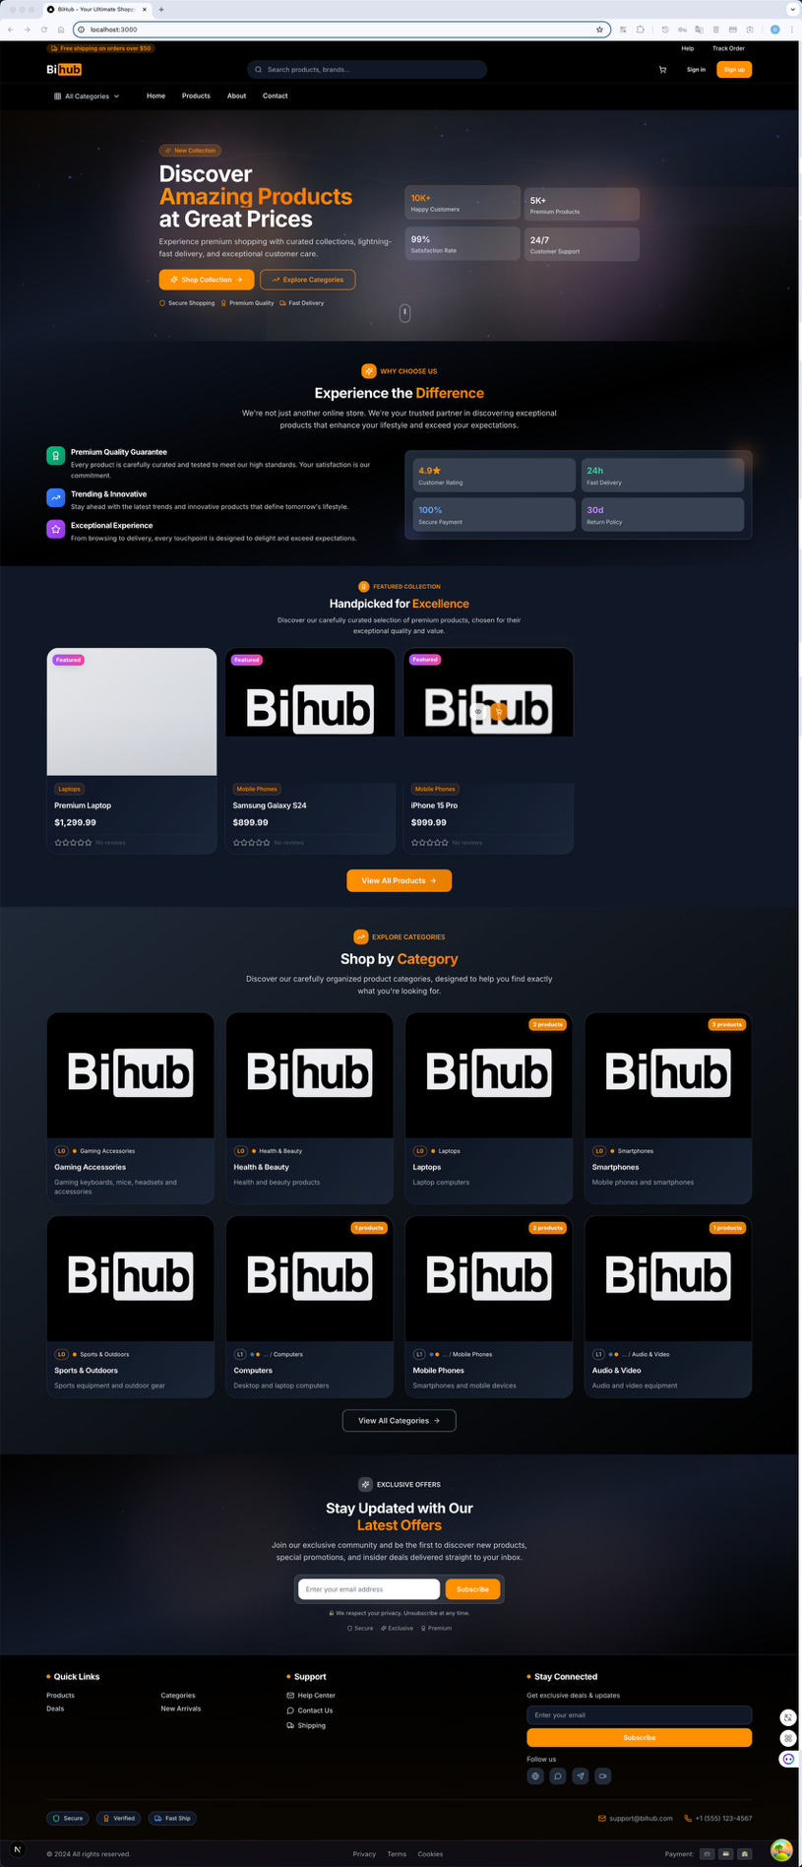
Hình 11.1: Trang chủ BiHub E-commerce với hero section và featured products
Đặc điểm chính:
- Featured Products: Grid layout 4 cột hiển thị sản phẩm nổi bật
- Categories Section: Danh mục sản phẩm với layout grid trực quan
- Trust Indicators: Các tính năng như Free Shipping, Secure Payment
- Navigation: Menu điều hướng rõ ràng với search bar
- Footer: Thông tin liên hệ và links hữu ích

11.1.2. Danh sách sản phẩm (Product Listing)
Giao diện danh sách sản phẩm cho phép khách hàng duyệt và tìm kiếm sản phẩm một cách hiệu quả.
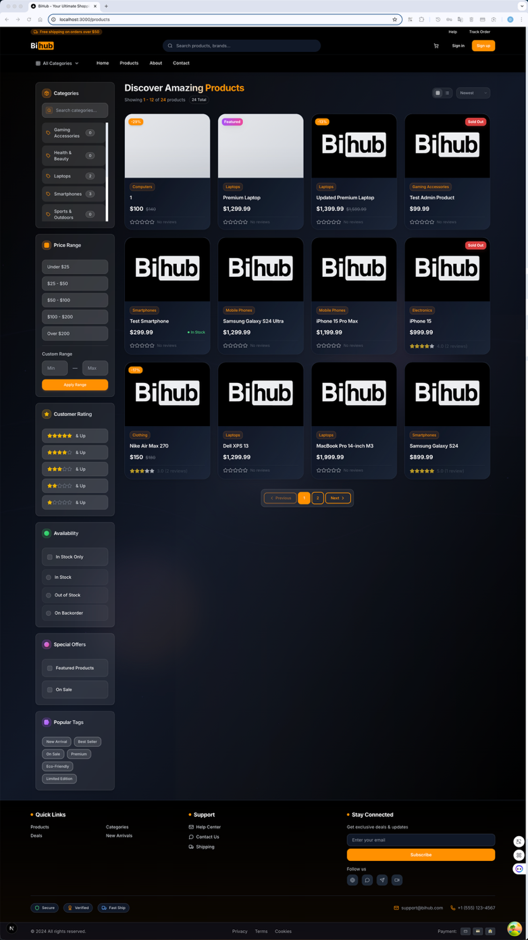
Hình 11.2: Danh sách sản phẩm với sidebar filters và grid layout
Tính năng chính:
- Grid View: Layout 3-4 cột responsive
- Sidebar Filters: Bộ lọc theo category, price, brand, rating
- Sort Options: Sắp xếp theo giá, tên, popularity, rating
- Search Functionality: Tìm kiếm với autocomplete và suggestions
- Pagination: Phân trang với infinite scroll option
- Product Cards: Hiển thị image, title, price, rating, quick actions

11.1.3. Chi tiết sản phẩm (Product Detail)
Trang chi tiết sản phẩm cung cấp thông tin đầy đủ để khách hàng đưa ra quyết định mua hàng.
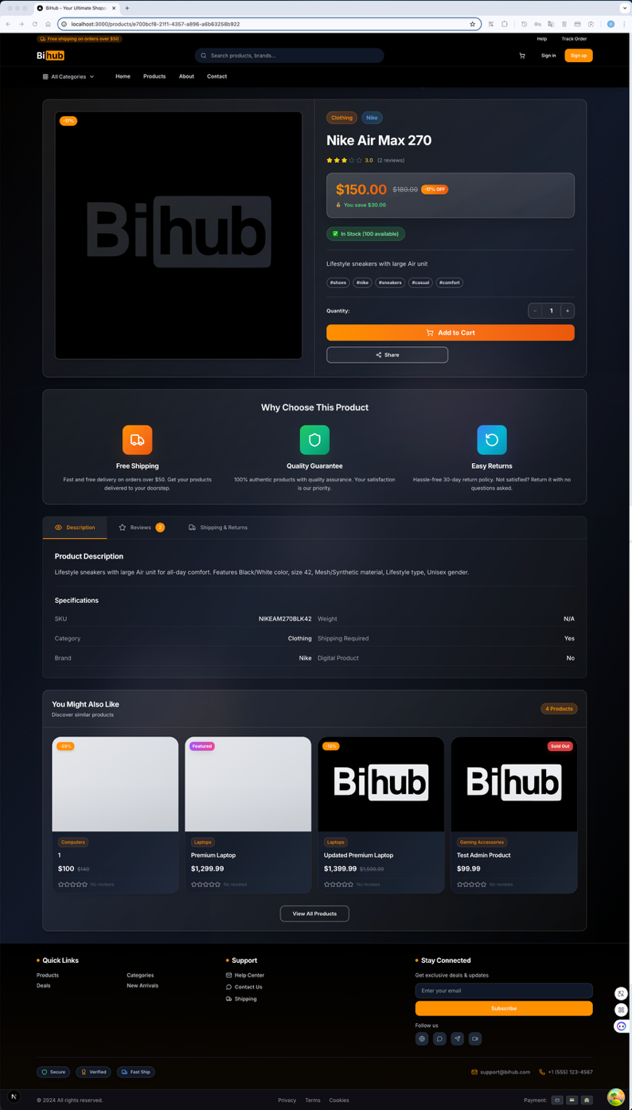
Hình 11.3: Chi tiết sản phẩm với image gallery và thông tin đầy đủ
Thành phần chính:
- Image Gallery: Slideshow với zoom functionality
- Product Information: Title, price, description, specifications
- Variant Selection: Size, color, quantity selector
- Action Buttons: Add to Cart, Buy Now, Add to Wishlist
- Tabs Section: Description, Reviews, Shipping Info
- Related Products: Sản phẩm liên quan và recommendations
- Reviews & Ratings: Đánh giá từ khách hàng với filtering

11.1.4. Giỏ hàng (Shopping Cart)
Giao diện giỏ hàng được thiết kế để tối ưu hóa conversion rate và giảm cart abandonment.
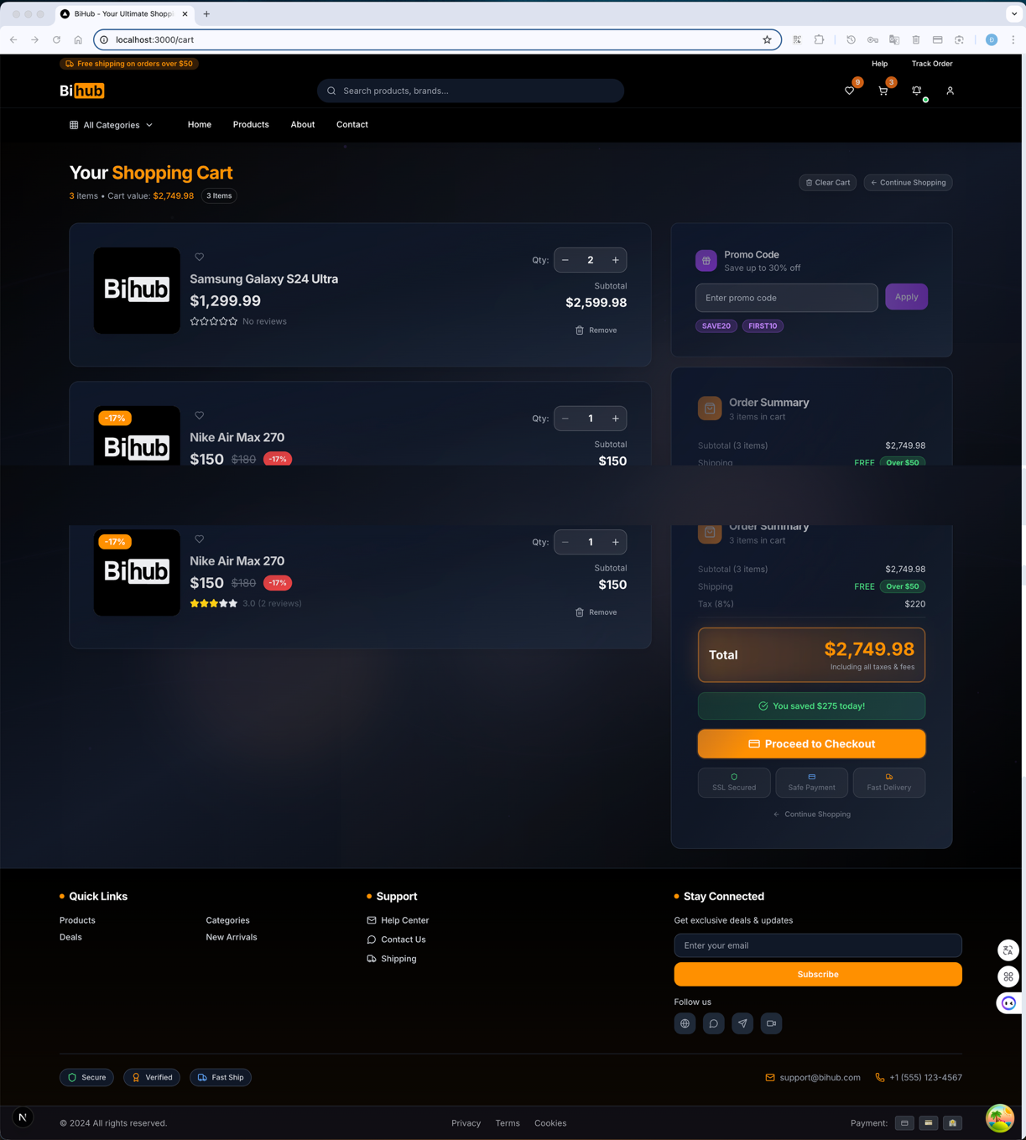
Hình 11.4: Giỏ hàng với item management và order summary
Tính năng chính:
- Item List: Danh sách sản phẩm với thumbnail, name, price
- Quantity Controls: Tăng/giảm số lượng với validation
- Remove Items: Xóa sản phẩm khỏi giỏ hàng
- Order Summary: Subtotal, shipping, tax, total calculation
- Promo Code: Áp dụng mã giảm giá
- Continue Shopping: Link quay lại shopping
- Checkout Button: Prominent CTA button

11.1.5. Thanh toán (Checkout Process)
Quy trình thanh toán được thiết kế theo multi-step approach để giảm complexity.
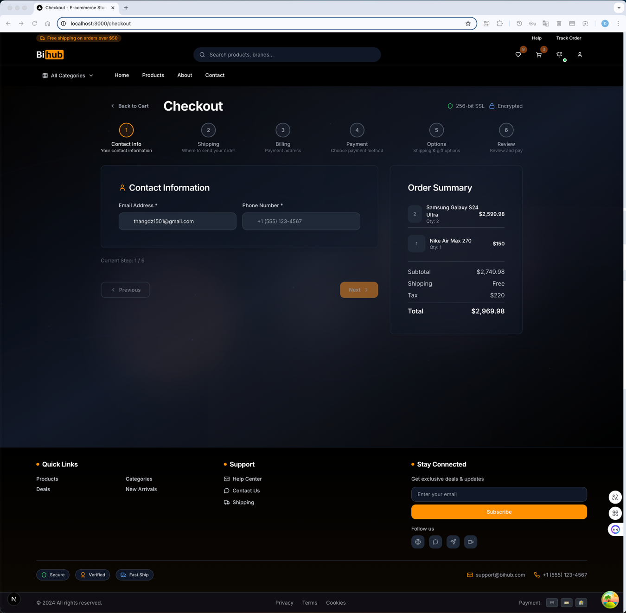
Hình 11.5: Multi-step checkout process với form validation

11.2. Giao diện quản trị (Admin Interface)

11.2.1. Dashboard quản trị (Admin Dashboard)
Dashboard cung cấp tổng quan về tình trạng hệ thống và các metrics quan trọng.
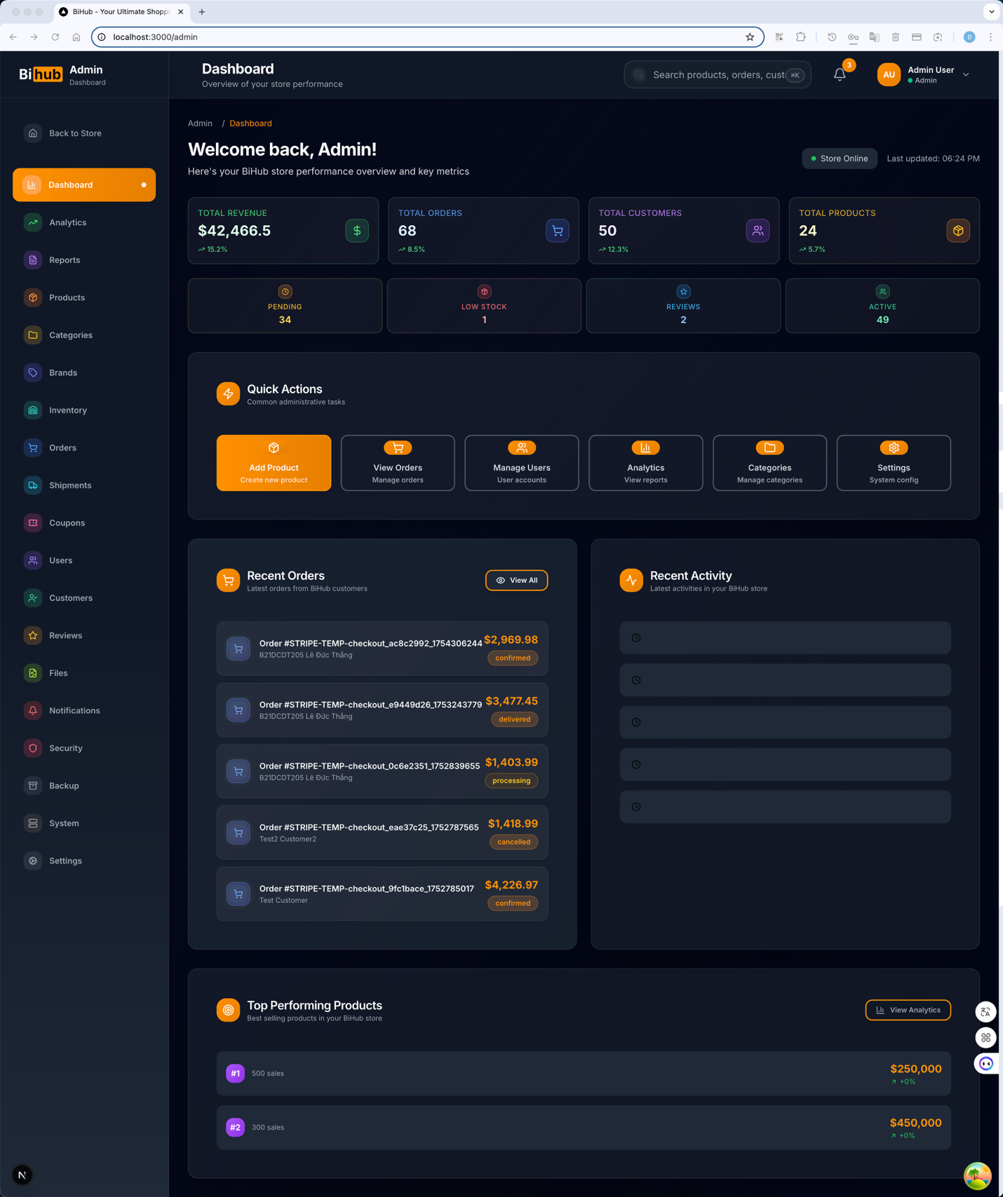
Hình 11.6: Admin Dashboard với metrics và charts tổng quan
Thành phần chính:
- Key Metrics: Total orders, revenue, users, products
- Charts & Graphs: Sales trends, user activity, popular products
- Recent Activities: Latest orders, user registrations, system events
- Quick Actions: Shortcuts đến các chức năng quan trọng
- System Status: Server health, database status, API performance

11.2.2. Quản lý sản phẩm (Product Management)
Giao diện quản lý sản phẩm cho phép admin thực hiện CRUD operations.
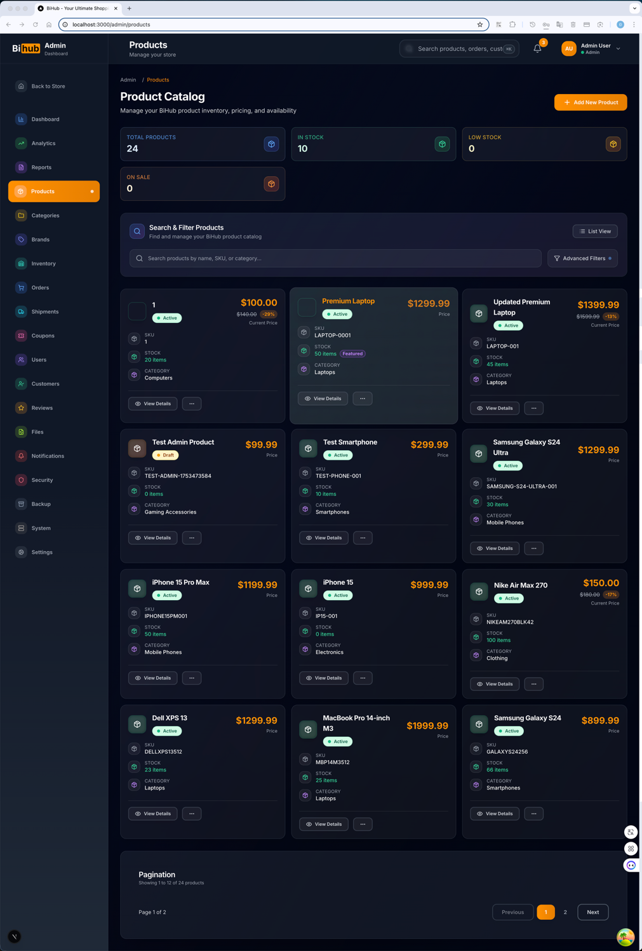
Hình 11.7: Giao diện quản lý sản phẩm với table view và actions
Tính năng chính:
- Product Table: Danh sách sản phẩm với sorting và filtering
- CRUD Operations: Create, Read, Update, Delete products
- Bulk Actions: Xóa/cập nhật nhiều sản phẩm cùng lúc
- Image Management: Upload và quản lý hình ảnh sản phẩm
- Category Management: Quản lý danh mục sản phẩm
- Inventory Tracking: Theo dõi tồn kho và stock alerts

11.2.3. Quản lý đơn hàng (Order Management)
Giao diện quản lý đơn hàng với workflow xử lý đơn hàng hoàn chỉnh.
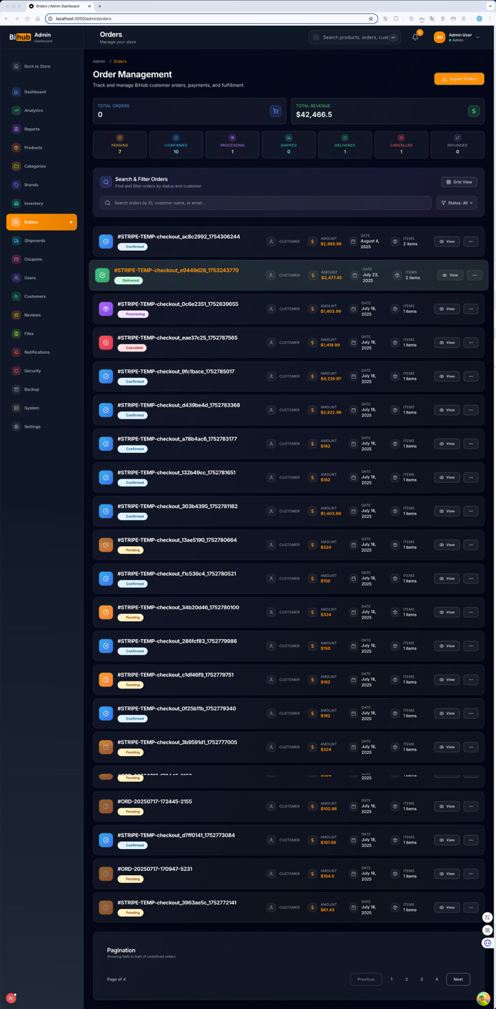
Hình 11.8: Giao diện quản lý đơn hàng với status tracking
Chức năng chính:
- Order List: Danh sách đơn hàng với status indicators
- Order Details: Chi tiết đơn hàng với customer info
- Status Management: Cập nhật trạng thái đơn hàng
- Payment Tracking: Theo dõi thanh toán và refunds
- Shipping Management: Quản lý vận chuyển và tracking
- Order Analytics: Báo cáo và thống kê đơn hàng

11.2.4. Quản lý người dùng (User Management)
Giao diện quản lý người dùng với role-based access control.
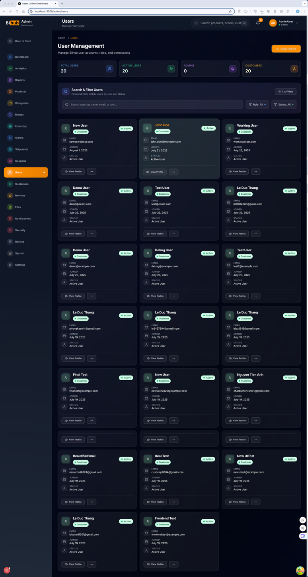
Hình 11.9: Giao diện quản lý người dùng với role management
Tính năng chính:
- User List: Danh sách người dùng với search và filter
- User Profiles: Xem và chỉnh sửa thông tin người dùng
- Role Management: Phân quyền admin, customer, moderator
- Activity Tracking: Theo dõi hoạt động người dùng
- Account Status: Enable/disable tài khoản
- Bulk Operations: Thao tác hàng loạt với nhiều user

11.3. Giao diện xác thực (Authentication Interface)

11.3.1. Trang đăng nhập (Login Page)
Giao diện đăng nhập với multiple authentication methods.
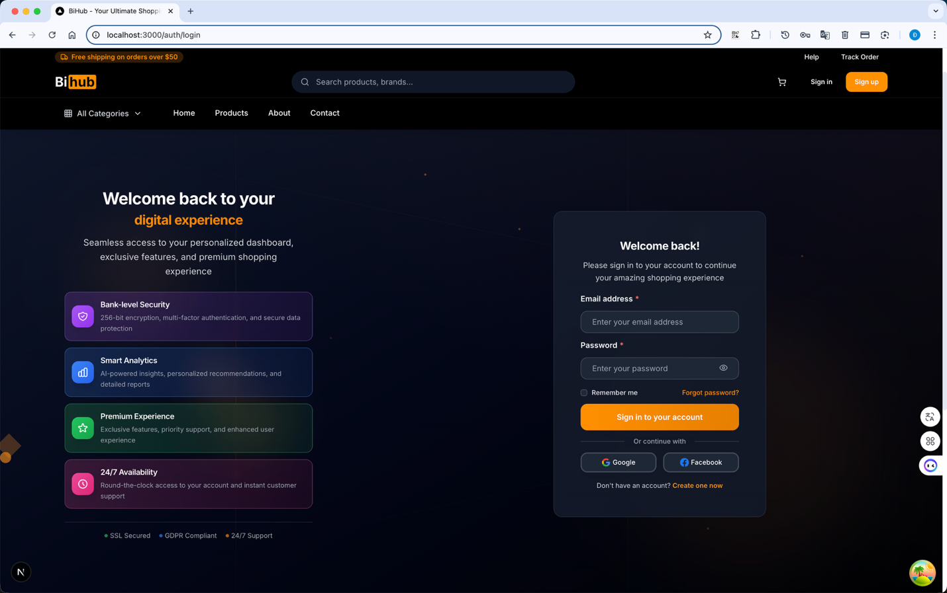
Hình 11.10: Trang đăng nhập với OAuth integration
Tính năng chính:
- Email/Password Login: Form đăng nhập truyền thống
- OAuth Integration: Google, Facebook login
- Remember Me: Lưu thông tin đăng nhập
- Forgot Password: Link khôi phục mật khẩu
- Form Validation: Real-time validation với error messages
- Security Features: CAPTCHA, rate limiting

11.3.2. Trang đăng ký (Register Page)
Giao diện đăng ký tài khoản với validation đầy đủ.
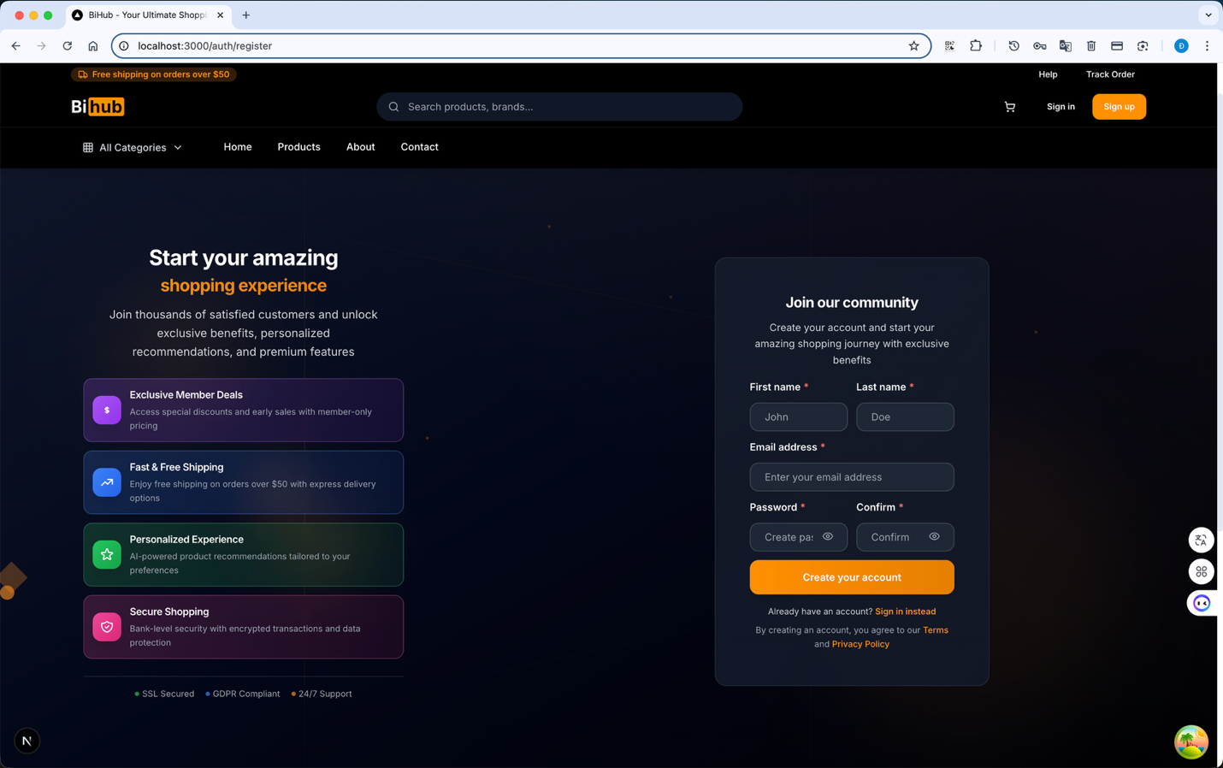
Hình 11.11: Trang đăng ký với form validation
Thành phần chính:
- Registration Form: Full name, email, password, confirm password
- Password Strength: Indicator cho độ mạnh mật khẩu
- Terms & Conditions: Checkbox đồng ý điều khoản
- Email Verification: Gửi email xác thực
- Social Registration: Đăng ký qua OAuth providers
- Form Validation: Client-side và server-side validation

11.3.3. Trang profile người dùng (User Profile)
Giao diện quản lý thông tin cá nhân và tài khoản.
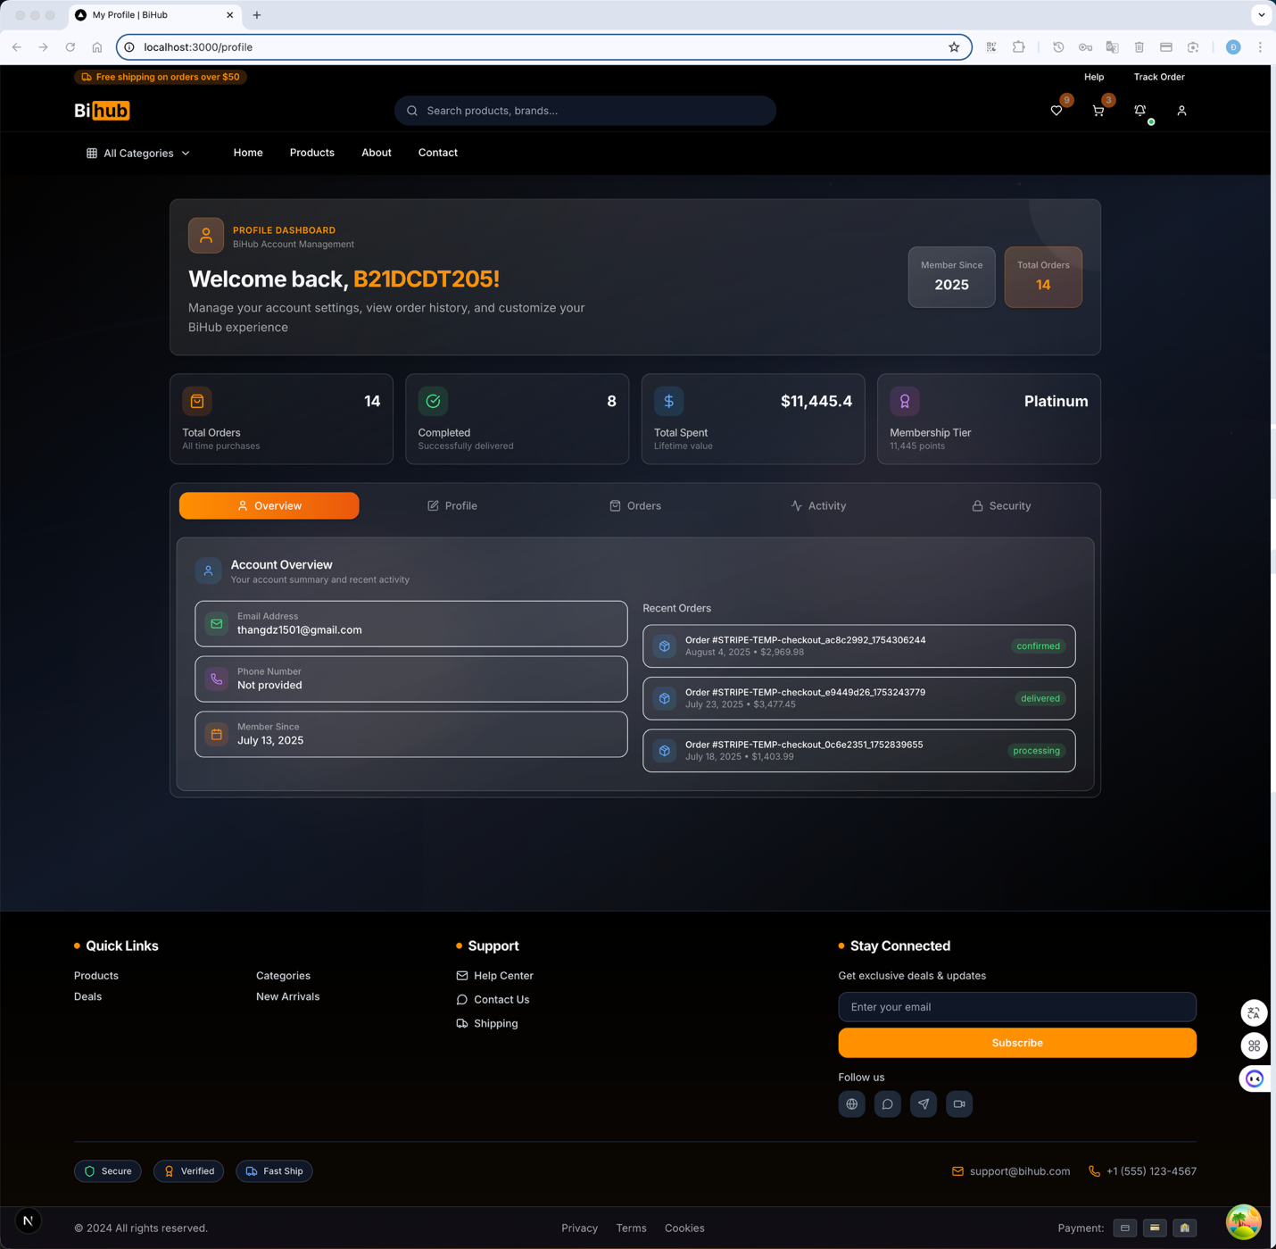
Hình 11.12: Trang profile với account management
Chức năng chính:
- Personal Information: Cập nhật thông tin cá nhân
- Address Management: Quản lý địa chỉ giao hàng
- Password Change: Đổi mật khẩu với validation
- Order History: Lịch sử đơn hàng với tracking
- Wishlist: Danh sách sản phẩm yêu thích
- Account Settings: Cài đặt thông báo, privacy

11.4. Giao diện responsive (Mobile Interface)
Hệ thống được thiết kế với mobile-first approach, đảm bảo trải nghiệm tối ưu trên mọi thiết bị.
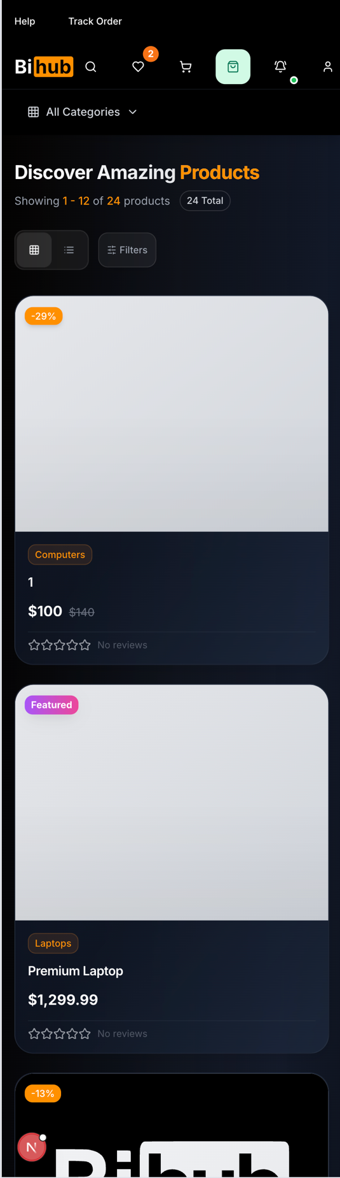
Hình 11.13: Giao diện responsive trên thiết bị mobile
Đặc điểm mobile:
- Responsive Design: Tự động điều chỉnh theo screen size
- Touch-Friendly: Buttons và links có kích thước phù hợp
- Mobile Navigation: Hamburger menu với smooth animations
- Optimized Images: Lazy loading và compression
- Fast Loading: Optimized cho mobile networks
- Gesture Support: Swipe, pinch-to-zoom cho product images

11.5. Trải nghiệm người dùng (User Experience)

11.5.1. Navigation và Information Architecture
- Clear Navigation: Menu structure rõ ràng và intuitive
- Breadcrumbs: Hỗ trợ navigation và orientation
- Search Functionality: Powerful search với autocomplete
- Category Organization: Logical product categorization
- User Flow: Smooth flow từ discovery đến purchase

11.5.2. Performance và Loading
- Fast Loading Times: < 3 seconds cho tất cả pages
- Progressive Loading: Skeleton screens và lazy loading
- Caching Strategy: Browser caching và CDN optimization
- Image Optimization: WebP format với fallbacks
- Code Splitting: Optimized JavaScript bundles

11.5.3. Accessibility Features
- WCAG Compliance: Tuân thủ Web Content Accessibility Guidelines
- Keyboard Navigation: Full keyboard accessibility
- Screen Reader Support: Proper ARIA labels và semantic HTML
- Color Contrast: Đảm bảo contrast ratio phù hợp
- Alt Text: Descriptive alt text cho tất cả images

11.6. Accessibility và Performance

11.6.1. Web Accessibility Standards
- Semantic HTML: Proper HTML5 semantic elements
- ARIA Labels: Comprehensive ARIA implementation
- Focus Management: Logical tab order và focus indicators
- Color Independence: Information không chỉ dựa vào màu sắc
- Text Alternatives: Alt text cho images và media

11.6.2. Performance Metrics
- Core Web Vitals: LCP < 2.5s, FID < 100ms, CLS < 0.1
- Lighthouse Score: 90+ cho Performance, Accessibility, SEO
- Page Speed: Average load time < 3 seconds
- Mobile Performance: Optimized cho 3G networks
- SEO Optimization: Proper meta tags, structured data

11.6.3. Cross-Browser Compatibility
- Modern Browsers: Chrome, Firefox, Safari, Edge support
- Progressive Enhancement: Graceful degradation cho older browsers
- Polyfills: Support cho missing features
- Testing: Comprehensive cross-browser testing
- Responsive Testing: Testing trên multiple devices và screen sizes

12. KẾT LUẬN VÀ ĐỀ XUẤT

12.1. Tóm tắt thành tựu
Hệ thống thương mại điện tử BiHub đã được phát triển thành công với architecture vững chắc và feature set comprehensive.

12.1.1. Technical Achievements
Architecture Implementation:
- Clean Architecture được implement đúng chuẩn với 4 layers rõ ràng
- Separation of concerns được maintain consistently
- Dependency inversion principle được áp dụng đầy đủ
- Testability và maintainability được đảm bảo
Technology Integration:
- Modern technology stack với Go 1.23 và Next.js 15
- PostgreSQL database với advanced indexing strategies
- Redis caching cho performance optimization
- Stripe payment integration với security compliance

12.1.2. Business Value Delivered
E-commerce Functionality:
- Complete product catalog management
- Advanced search và filtering capabilities
- Comprehensive shopping cart system
- Secure payment processing
- Order management workflow
- Admin dashboard với analytics
User Experience:
- Responsive design cho all devices
- Intuitive user interface
- Fast page load times
- Accessibility compliance
- Multi-authentication options

12.2. Điểm mạnh của hệ thống
Comprehensive analysis của system strengths.
12.2.1. Technical Strengths Scalability:
- Clean Architecture cho phép easy scaling
- Database design supports large datasets
- Caching strategies reduce database load
- API design supports high concurrency
- Container-ready cho cloud deployment
Performance:
- Optimized database queries với proper indexing
- Frontend optimization với Next.js features
- Caching strategies ở multiple levels
- Image optimization và lazy loading
- Bundle optimization cho fast loading
Security:
- Comprehensive authentication system
- JWT token management với refresh mechanism
- Input validation và sanitization
- SQL injection prevention
- XSS và CSRF protection

12.2.2. Business Strengths
Feature Completeness:
- Full e-commerce functionality
- Admin management capabilities
- Real-time features
- Multi-device support
- International ready (multi-currency framework)
User Experience:
- Modern, intuitive interface
- Fast và responsive design
- Accessibility compliance
- Mobile-first approach
- Comprehensive error handling

12.3. Điểm cần cải thiện
Areas for future enhancement.

12.3.1. Technical Improvements
Testing Coverage:
- Unit test implementation (currently 0% coverage)
- Integration test suite development
- End-to-end test automation
- Performance testing framework
- Security testing procedures
Monitoring và Observability:
- Application Performance Monitoring (APM)
- Distributed tracing implementation
- Comprehensive logging strategy
- Error tracking system (Sentry integration)
- Business metrics tracking
Performance Optimization:
- Database query optimization (N+1 problem resolution)
- Frontend bundle size optimization
- Image optimization pipeline
- CDN integration
- Search performance với Elasticsearch

12.3.2. Feature Enhancements
Advanced Features:
- Machine learning recommendations
- Advanced analytics dashboard
- Multi-vendor marketplace support
- Subscription management
- Advanced inventory management
User Experience:
- Progressive Web App (PWA) features
- Offline functionality
- Push notifications
- Advanced personalization
- Social commerce features

12.4. Đề xuất phát triển
Strategic recommendations cho future development.

12.4.1. Short-term Improvements (1-3 months)
Priority 1:
- Implement comprehensive testing suite
- Add monitoring và error tracking
- Optimize database queries
- Enhance security measures
- Improve documentation
Priority 2:
- Add advanced search features
- Implement recommendation system
- Enhance admin analytics
- Add email marketing features
- Optimize mobile experience

12.4.2. Medium-term Enhancements (3-6 months)
Scalability Improvements:
- Microservices architecture transition
- API gateway implementation
- Service mesh integration
- Advanced caching strategies
- Database sharding preparation
Feature Additions:
- Multi-vendor support
- Advanced inventory management
- Subscription billing
- Loyalty program
- Advanced reporting

12.4.3. Long-term Vision (6-12 months)
Platform Evolution:
- AI-powered recommendations
- Machine learning analytics
- Advanced personalization
- Omnichannel commerce
- International expansion
Technology Upgrades:
- Cloud-native architecture
- Serverless functions integration
- Advanced security measures
- Performance optimization
- Scalability enhancements

12.5. Roadmap tương lai
Strategic development roadmap.

12.5.1. Phase 1: Foundation Strengthening
Timeline: 1-3 months Focus Areas:
- Testing implementation
- Monitoring setup
- Performance optimization
- Security enhancements
- Documentation completion
Success Metrics:
- 80%+ test coverage
- < 2s page load times
- Zero security vulnerabilities
- 99.9% uptime
- Complete documentation

12.5.2. Phase 2: Feature Enhancement
Timeline: 3-6 months Focus Areas:
- Advanced features development
- User experience improvements
- Admin capabilities expansion
- Integration enhancements
- Mobile optimization
Success Metrics:
- 50% increase in user engagement
- 25% improvement in conversion rate
- Advanced admin features
- Mobile performance parity
- Third-party integrations

12.5.3. Phase 3: Scale và Innovation
Timeline: 6-12 months Focus Areas:
- Scalability improvements
- AI/ML integration
- Advanced analytics
- International expansion
- Platform evolution
Success Metrics:
- 10x traffic handling capability
- AI-powered features
- Advanced analytics insights
- Multi-region deployment
- Platform ecosystem

TÀI LIỆU THAM KHẢO
[1] Martin, R. C. (2017). Clean Architecture: A Craftsman's Guide to Software Structure and Design. Prentice Hall.
[2] Evans, E. (2003). Domain-Driven Design: Tackling Complexity in the Heart of Software. Addison-Wesley Professional.
[3] Fowler, M. (2002). Patterns of Enterprise Application Architecture. Addison-Wesley Professional.
[4] Newman, S. (2015). Building Microservices: Designing Fine-Grained Systems. O'Reilly Media.
[5] Richardson, C. (2018). Microservices Patterns: With examples in Java. Manning Publications.
[6] Kleppmann, M. (2017). Designing Data-Intensive Applications. O'Reilly Media.
[7] Fielding, R. T. (2000). Architectural Styles and the Design of Network-based Software Architectures. Doctoral dissertation, University of California, Irvine.
[8] Gamma, E., Helm, R., Johnson, R., & Vlissides, J. (1994). Design Patterns: Elements of Reusable Object-Oriented Software. Addison-Wesley Professional.
[9] Beck, K. (2002). Test Driven Development: By Example. Addison-Wesley Professional.
[10] Hunt, A., & Thomas, D. (1999). The Pragmatic Programmer: From Journeyman to Master. Addison-Wesley Professional.
[11] Go Team. (2023). The Go Programming Language Specification. https://golang.org/ref/spec
[12] Vercel Team. (2023). Next.js Documentation. https://nextjs.org/docs
[13] PostgreSQL Global Development Group. (2023). PostgreSQL Documentation. https://www.postgresql.org/docs/
[14] Redis Labs. (2023). Redis Documentation. https://redis.io/documentation
[15] Stripe Inc. (2023). Stripe API Documentation. https://stripe.com/docs/api
[16] Docker Inc. (2023). Docker Documentation. https://docs.docker.com/
[17] OWASP Foundation. (2023). OWASP Top Ten Web Application Security Risks. https://owasp.org/www-project-top-ten/
[18] W3C. (2023). Web Content Accessibility Guidelines (WCAG) 2.1. https://www.w3.org/WAI/WCAG21/
[19] ISO/IEC 27001:2013. Information technology — Security techniques — Information security management systems — Requirements.
[20] PCI Security Standards Council. (2022). Payment Card Industry Data Security Standard (PCI DSS) v4.0.

