What is Monitoring

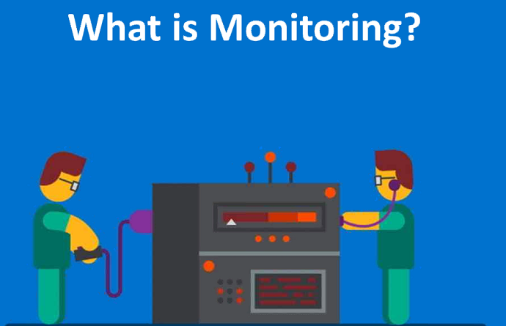

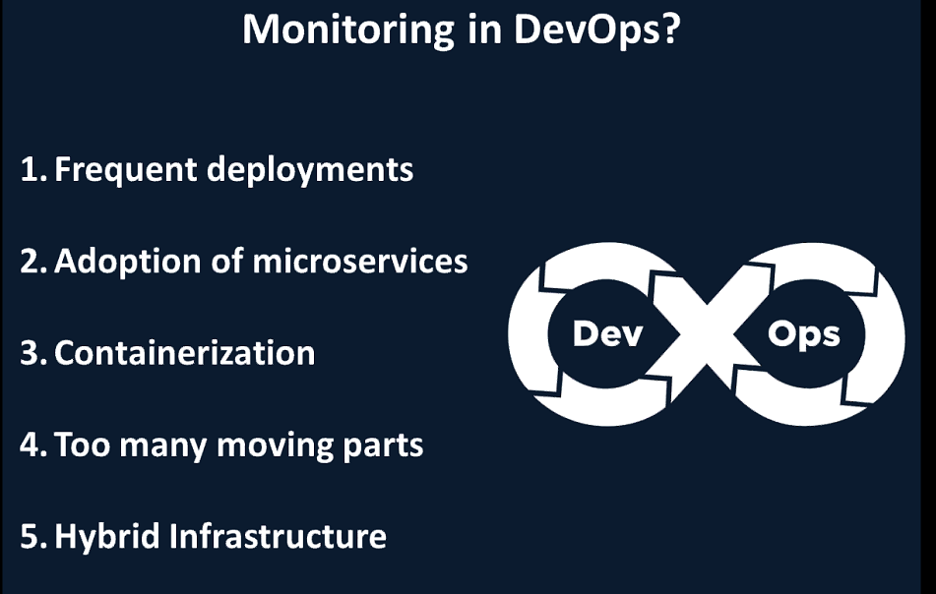

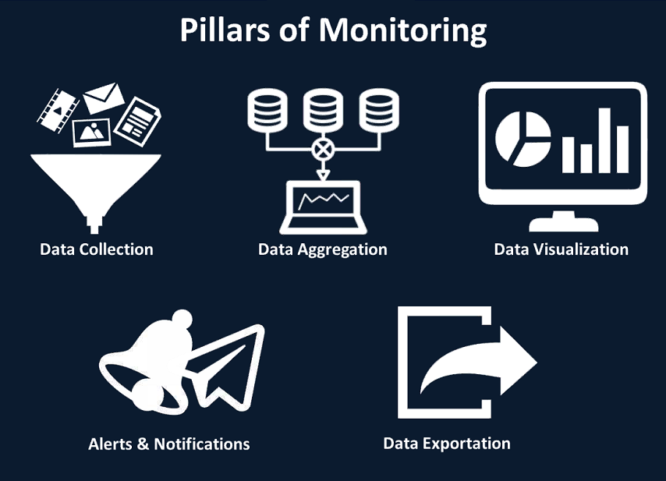

Data Collection🡪Pull and Push based Monitoring System

Data Visualization🡪 Data driven document tool

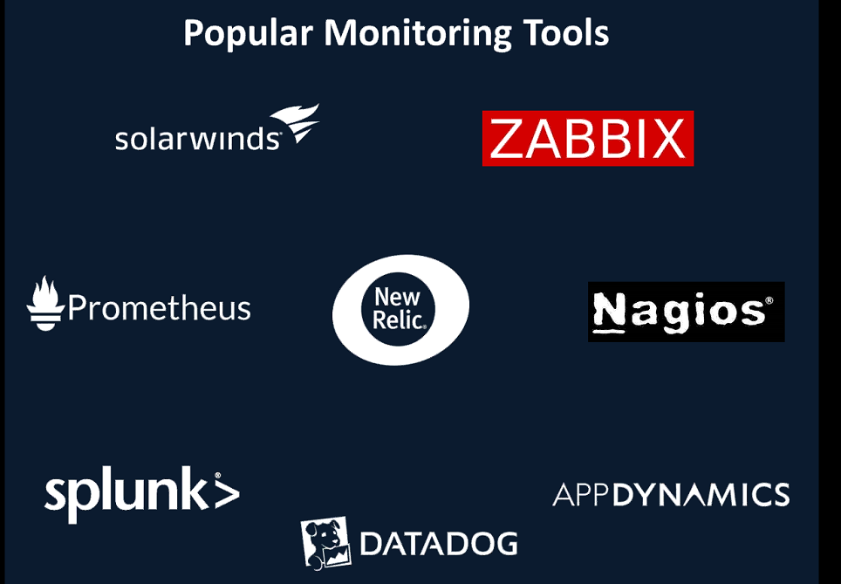

Typical Monitoring Tools:

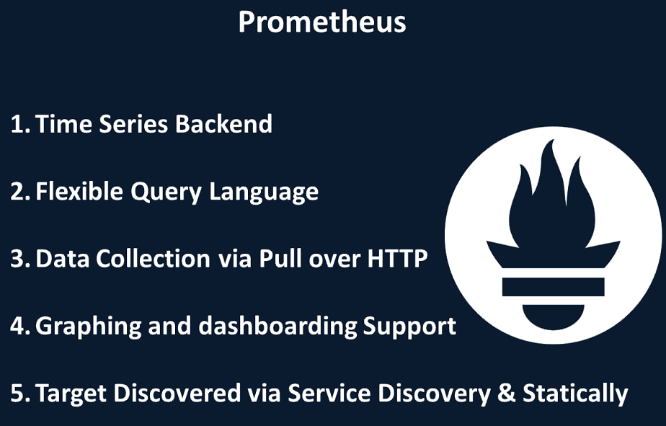

Service Discovery: Eureka acts as a register. Any new servers will be registered.

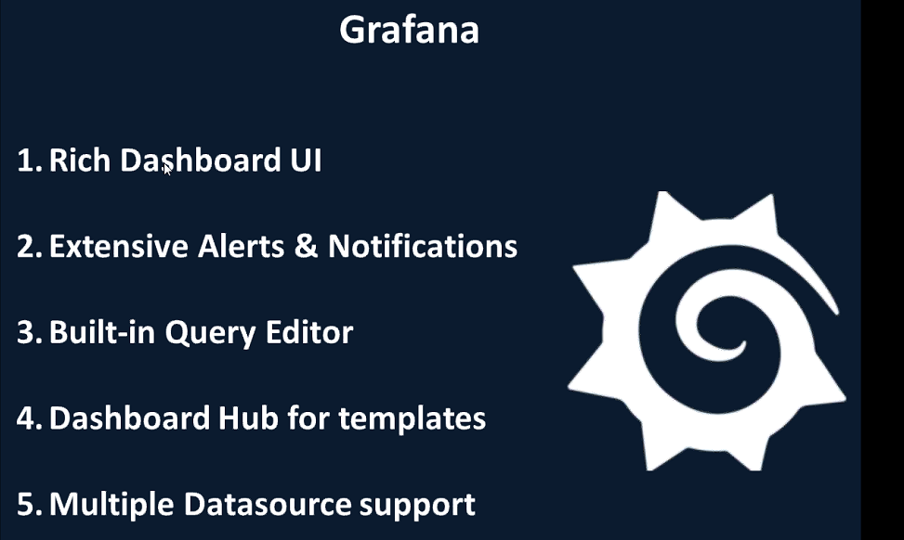

Prometheus for Windows: <https://github.com/prometheus/prometheus/releases/download/v2.3.2/prometheus-2.3.2.windows-amd64.tar.gz>

Grafana for windows: <https://s3-us-west-2.amazonaws.com/grafana-releases/release/grafana-5.2.3.windows-amd64.zip>

WMI exporter: <https://github.com/martinlindhe/wmi_exporter/releases/download/v0.4.3/wmi_exporter-0.4.3-386.msi>

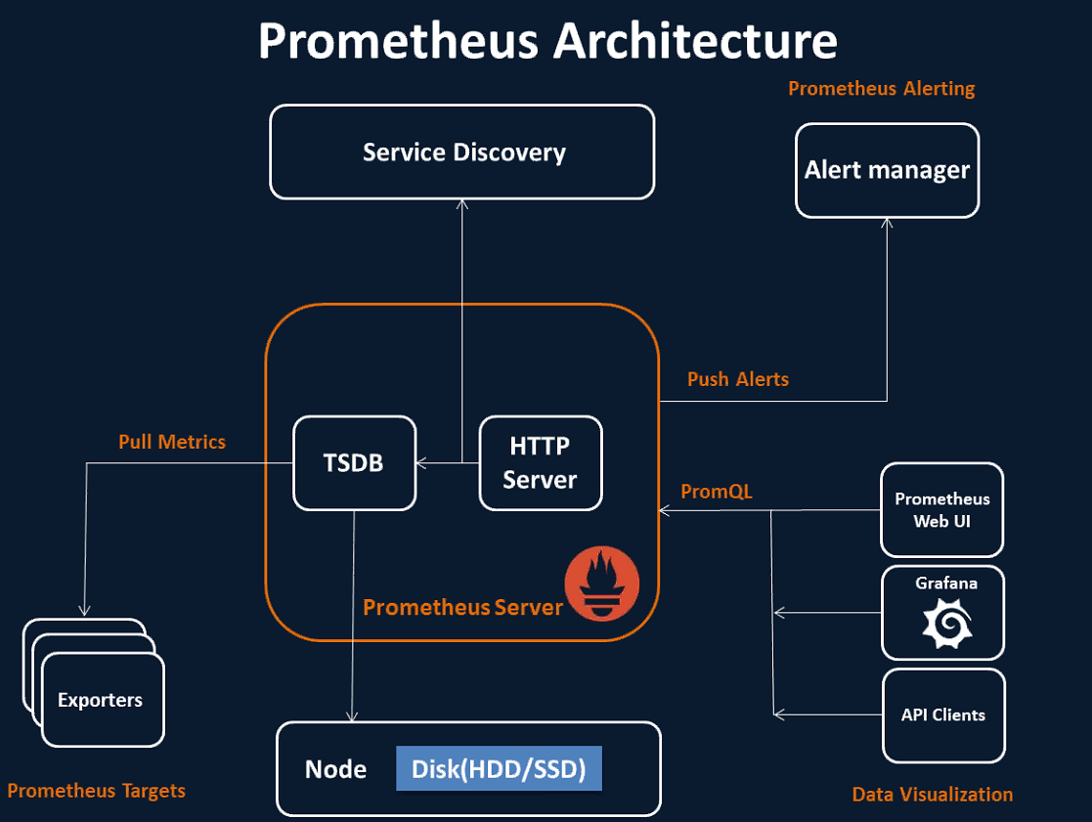

TSDB : Time Series DataBase

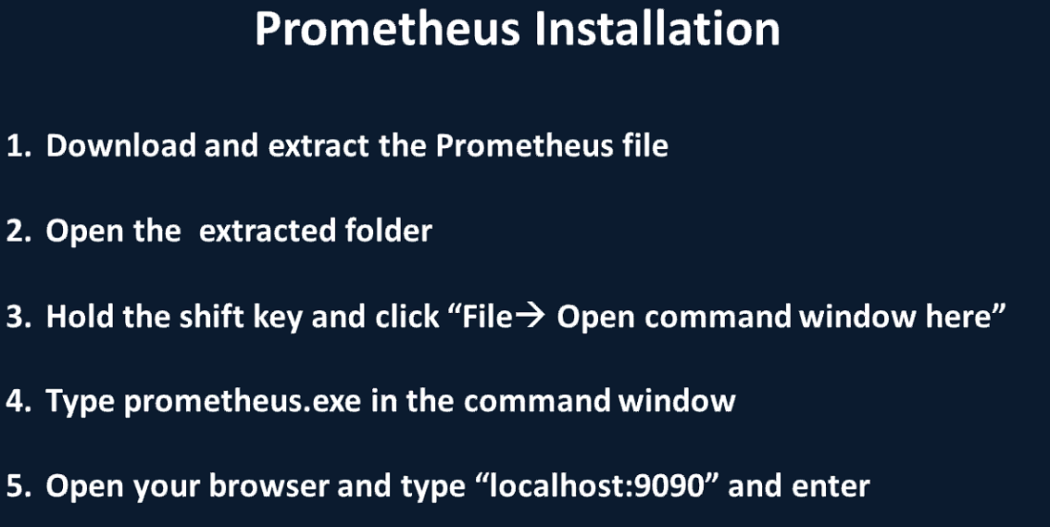

Link: <https://github.com/prometheus/prometheus/releases/download/v2.3.2/prometheus-2.3.2.windows-amd64.tar.gz>

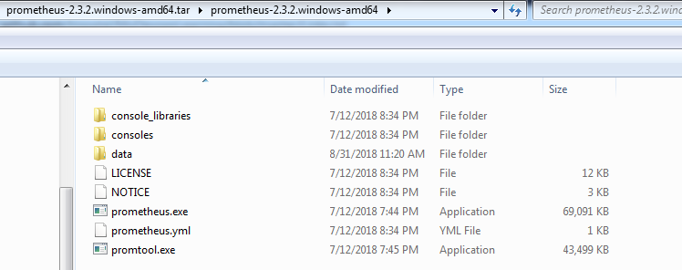

Execute the Prometheus.exe

Default port: 9090

It can be changed from prometheus.yml

Exporter does dedicated job for dedicated server

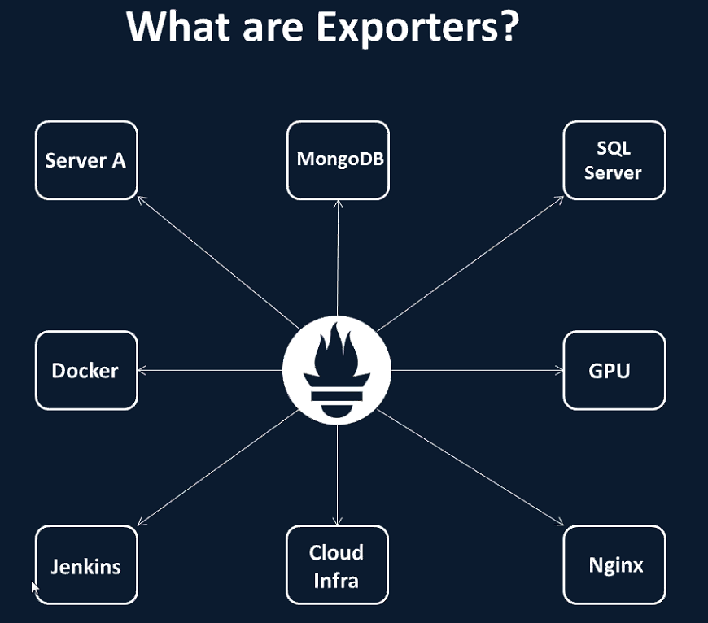

A application i.e. being monitored or required to be monitored is target

Wmi exporter:

wmi_exporter-0.4.3-386.msi

<https://github.com/martinlindhe/wmi_exporter/releases/download/v0.4.3/wmi_exporter-0.4.3-386.msi>

Default Port: 9182

Edit the Prometheus.yml file to configure exporter.

To configure the WMI exporter in prometheus

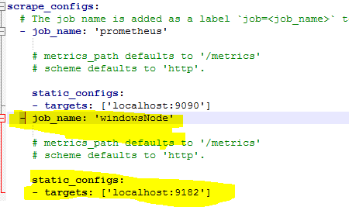

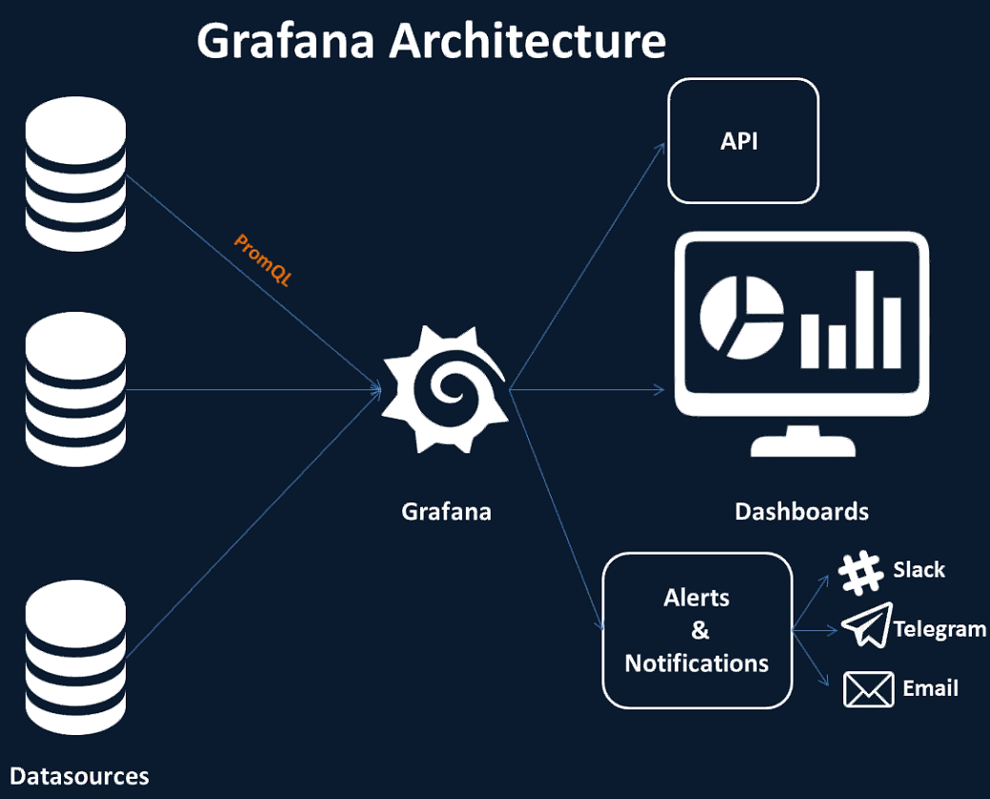

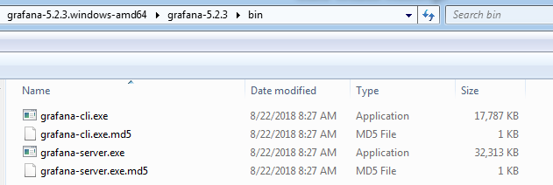

grafana-server.exe

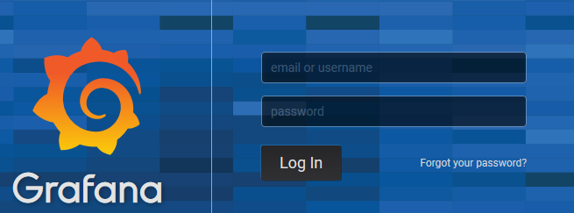

Default Credentials: admin/admin

Go to Add

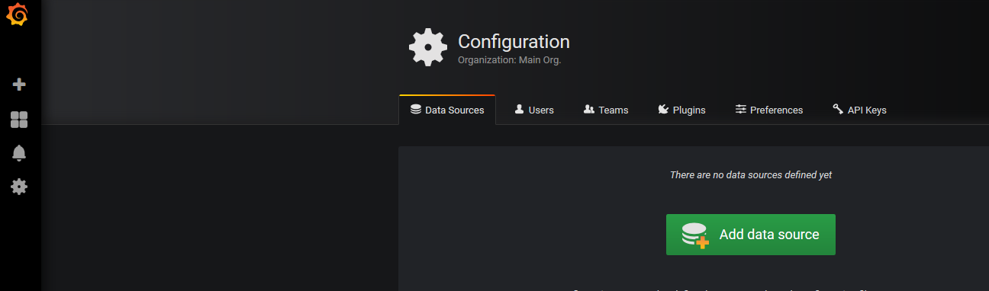

**To connect Grafana with Prometheus**

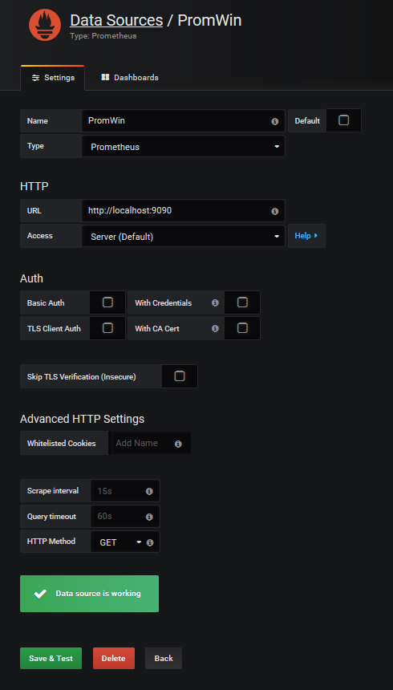

To see data in Dashboard click Find Dashboard on Graphana.com

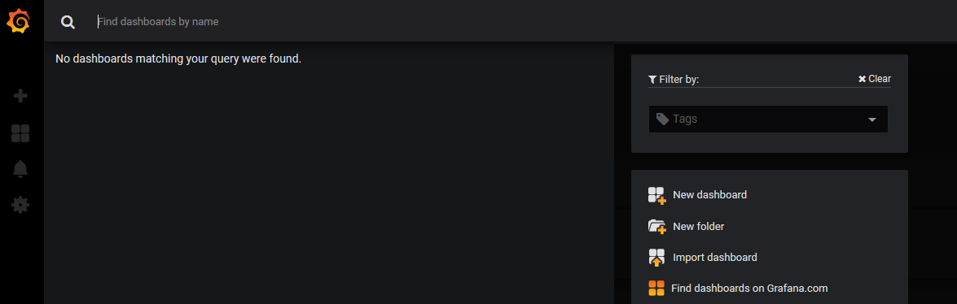

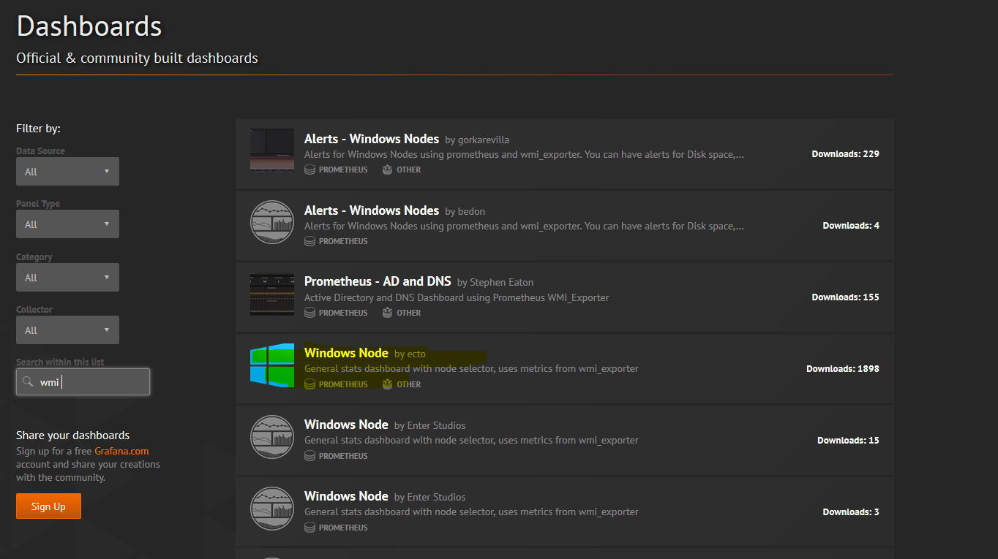

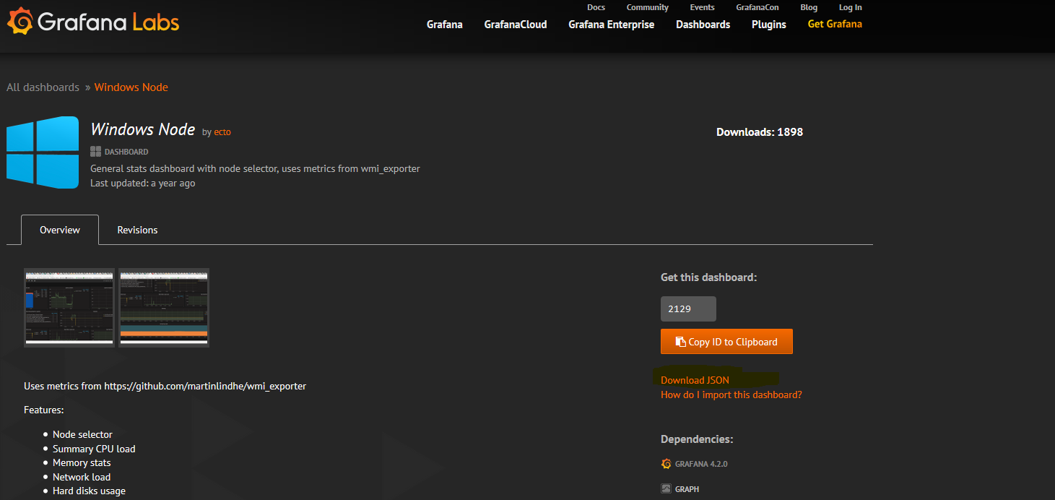

After downloading the json place it in the Grafana folder

To import the Dash board the home🡪 Import Dashboard

