**3rd September 2018**

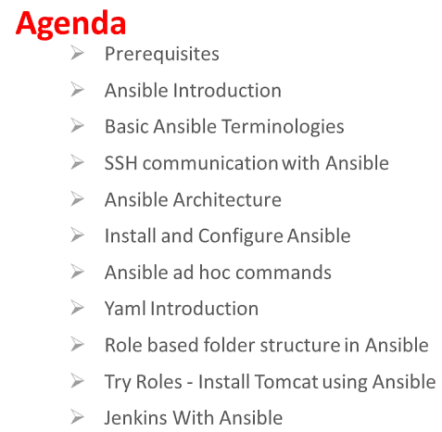

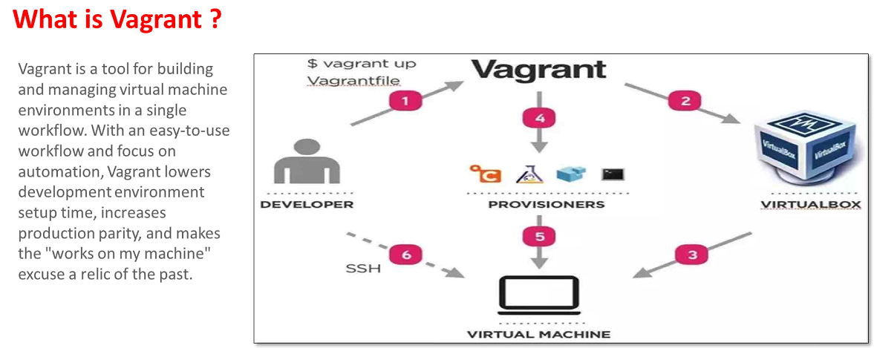

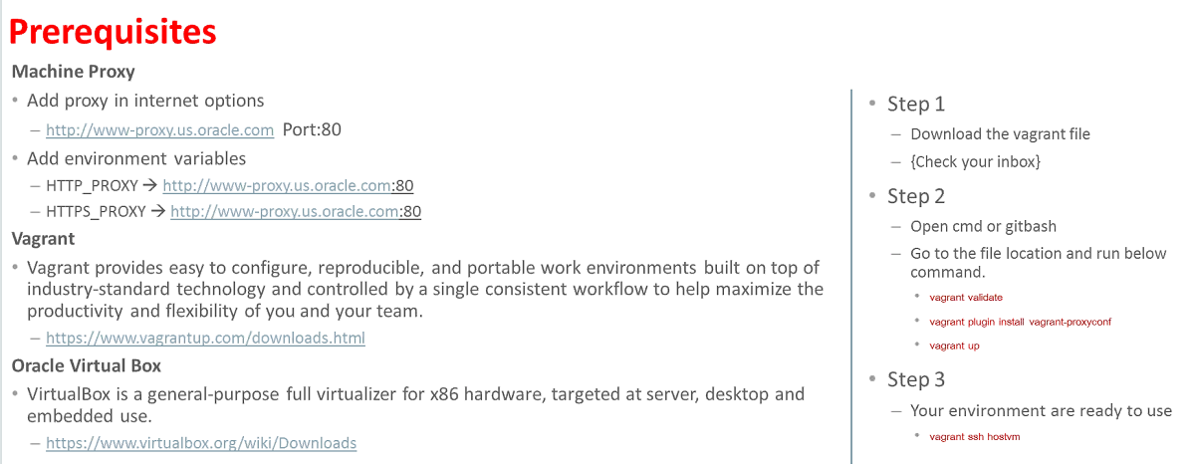



**For Power Shell Upgradation from Version 2 to 3**

<https://www.microsoft.com/en-us/download/details.aspx?id=34595>

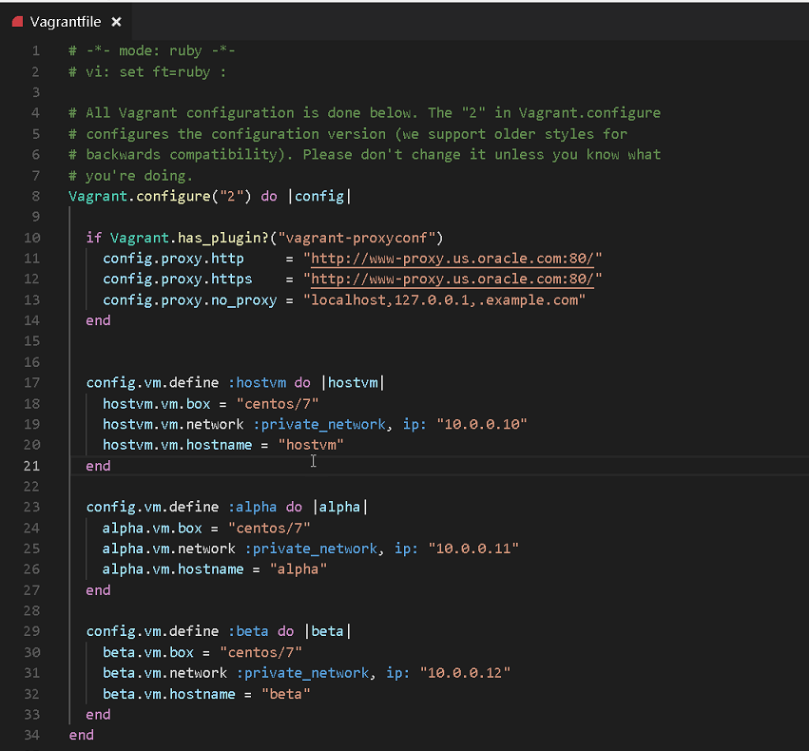

After vagrant up run **vagrant plugin install vagrant-proxyconf**

To reload the machine with proxy: **vagrant reload hostvm**

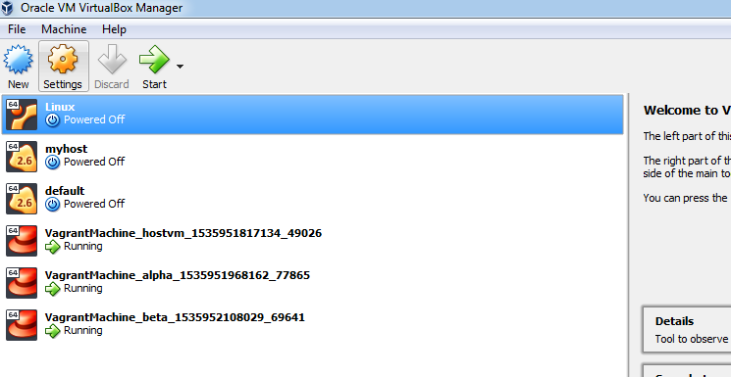

To Know PowerShell version: $PSVersionTable.PSVersion



To avoid repetitive work Ansible is helpful.

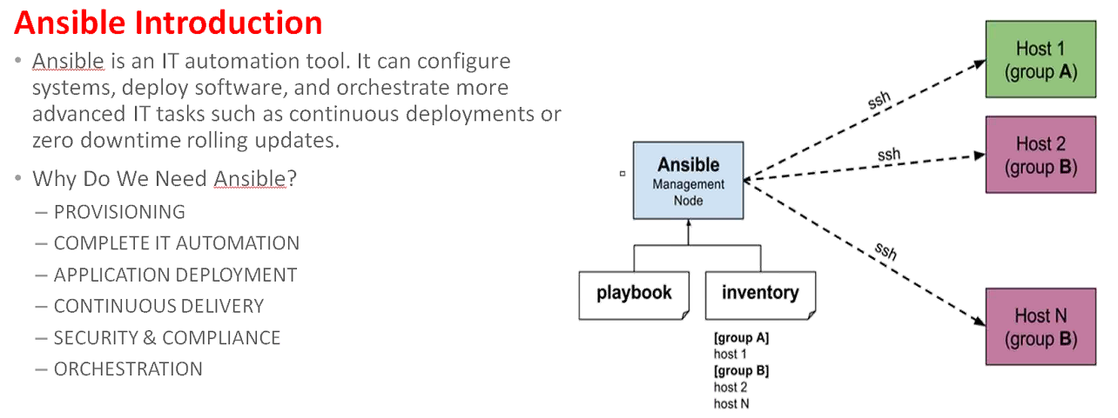

It should be installed in a dedicated system where playbook and inventory should be installed

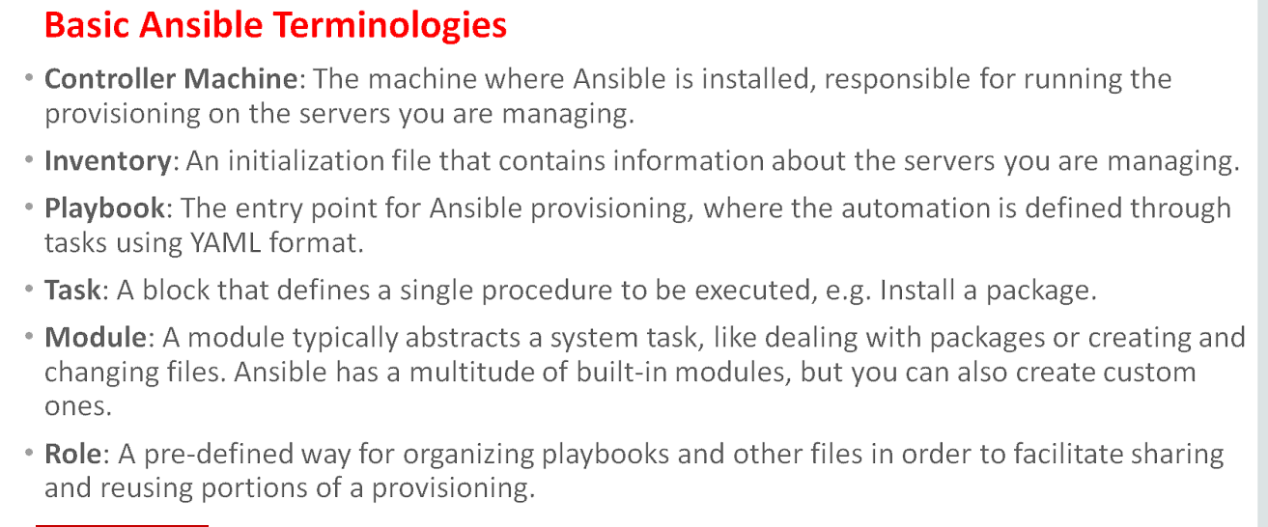

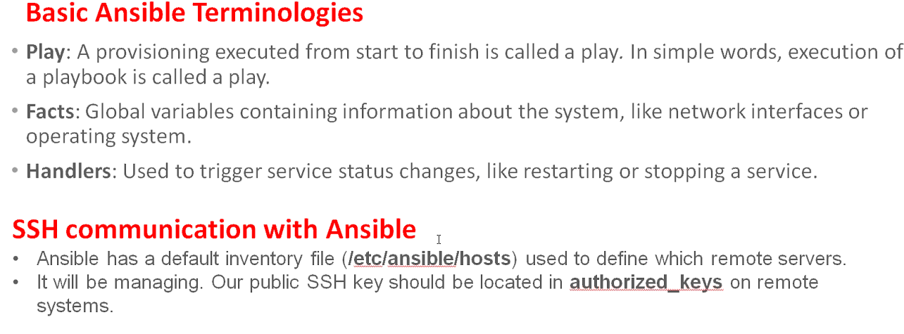

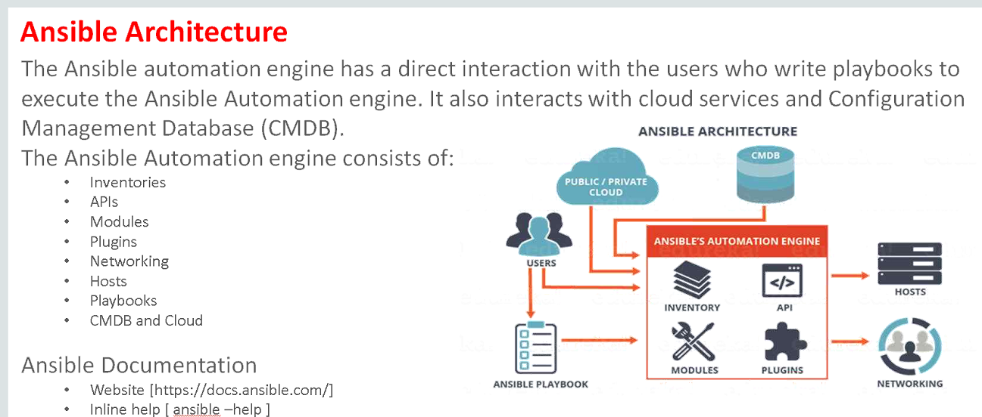

**Installation of Ansible**

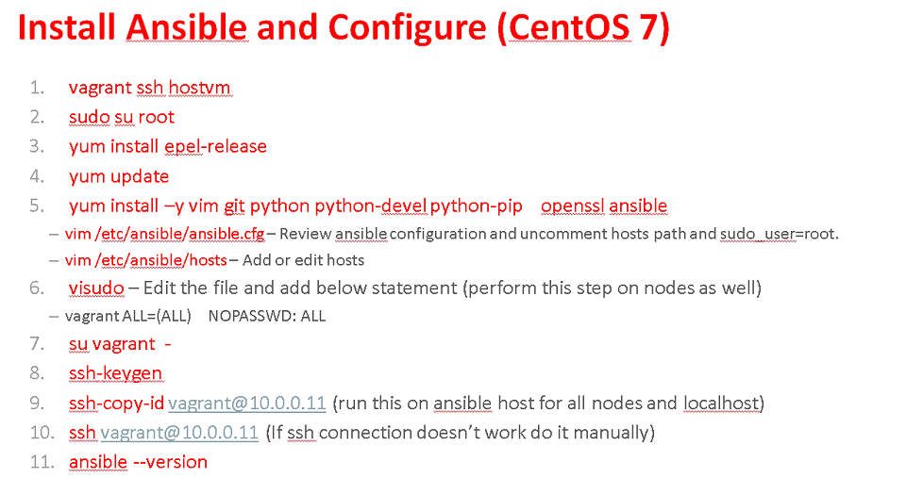

1. To go inside any machine:

vagrant ssh <MachineName>

Ex: vagrant ssh hostvm

1. Sudo su root 🡪 Skip this step
2. Installing a repository:

sudo yum install epel-release

1. sudo yum update
2. sudo yum install -y vim git python python-devel python-pip openssl ansible
3. Go to /etc/ansible folder

sudo vim ansible.cfg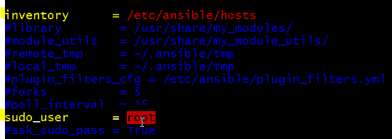

Click insert to edit. To save a file**: wq!**

**In the host file:** sudo vim hosts

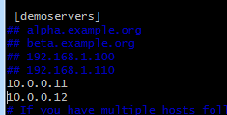

Click insert to edit. To save a file**: wq!**

1. **Skip this step**
2. **Go to /home/vagrant/.ssh/**
3. **sudo su vagrant -**
4. **ssh-keygen** to generate key. Make sure key is generated in /home/vagrant/.ssh/id_rsa.pub

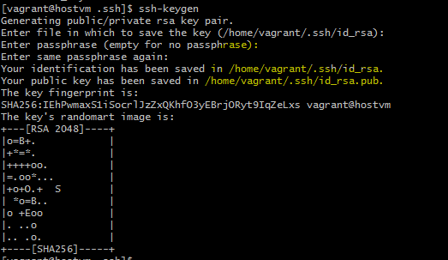

Make sure key is generated in home/vagrant/.ssh folder not in root

Copy the generated key from host vm by going to **/home/vagrant/.ssh/id_rsa.pub**:

Copy the generated key

Login to alpha and beta machine to paste the generated key in the respective VM

1. vagrant ssh alpha
2. sudo vi /home/vagrant/.ssh/authorized_keys

Edit the file to save the generated key

Login to beta machine to paste the generated key in the respective VM

1. vagrant ssh beta
2. sudo vi /home/vagrant/.ssh/authorized_keys

Edit the file to save the generated key

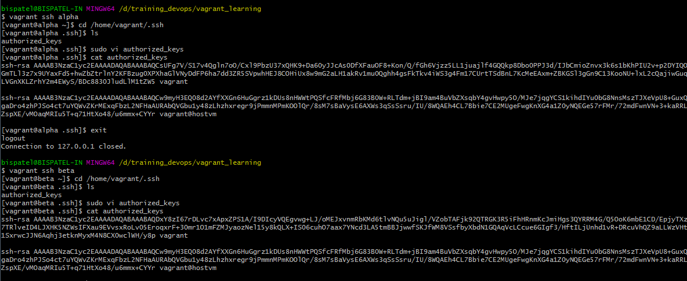

1. In location /home/vagrant/.ssh/

ssh-copy-id [vagrant@10.0.0.11](mailto:vagrant@10.0.0.11)

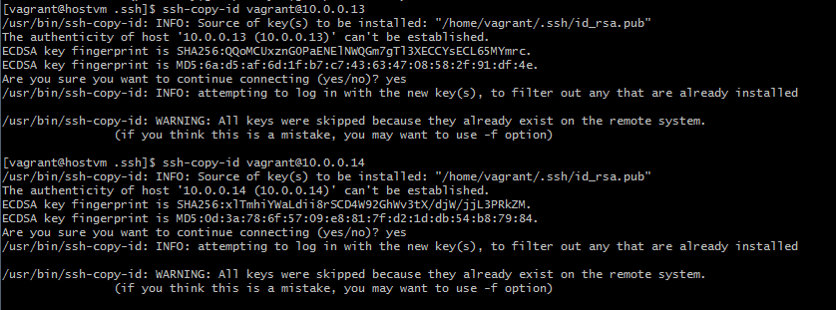

1. ssh [vagrant@10.0.0.11](mailto:vagrant@10.0.0.11)

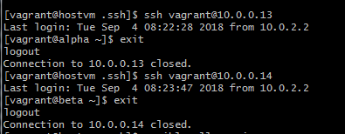

1. ansible --help

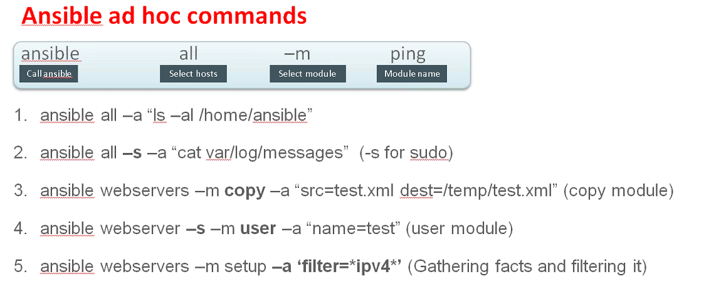

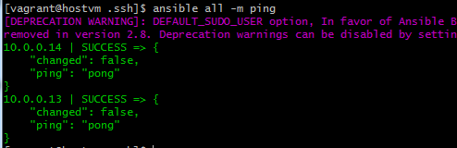

Execute the above commands in hostvm

**To create User:**

ansible demoservers -s -m user -a "name=test"

ansible all -s -a "cat /var/log/messages"

ansible all -s -a "cat /vagrant/Vagrantfile"

ansible demoservers -m setup -a 'filter=*ipv4*'

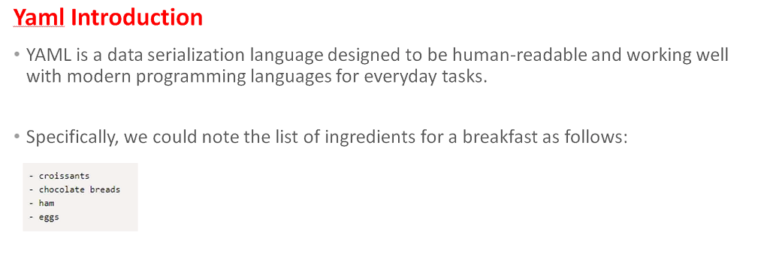

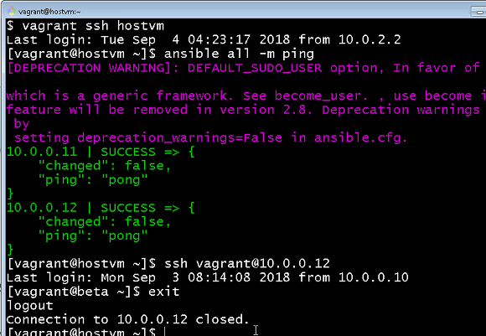

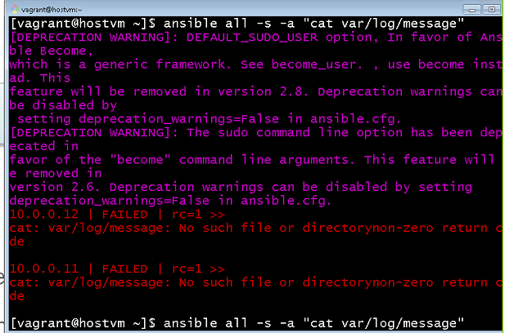

Creating a playbook create a yml file in /etc/ansible folder:

1. sudo vim hello-world.yml

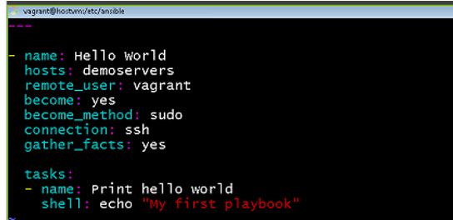

Run the playbook

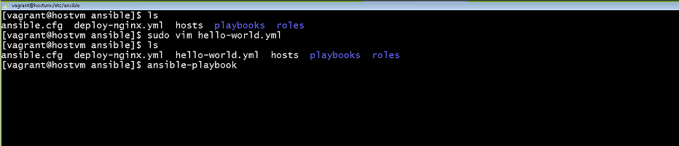

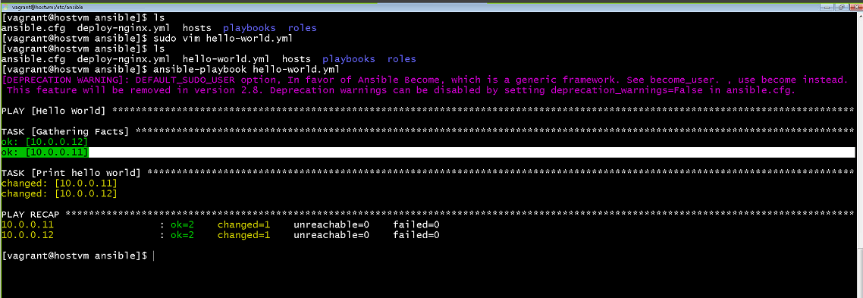

Creating advanced Playbook: **YAML FILE**

---- name: Install Apache hosts: demoservers remote_user: vagrant become: yes become_method: sudo connection: ssh gather_facts: yes tasks: - name: Print hello world shell: echo "My first playbook" - name: Install httpd yum: name: httpd state: latest notify: startservice handlers: - name: startservice service: name: httpd state: restarted

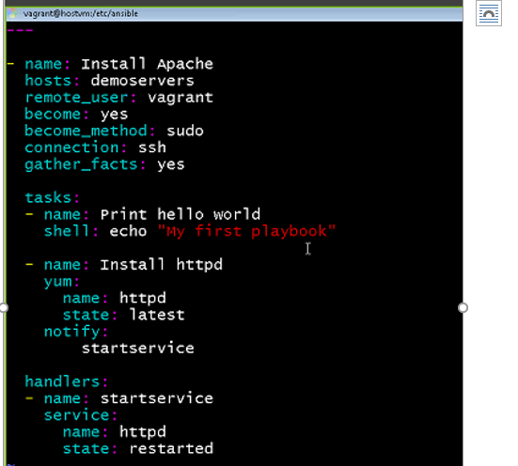

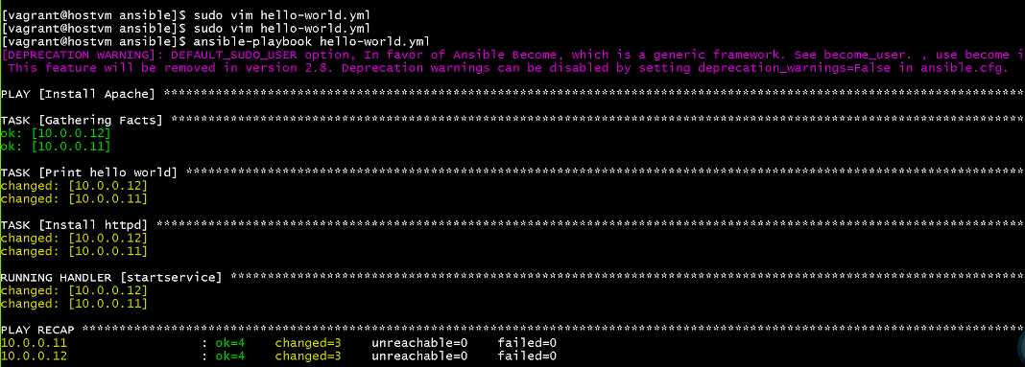

Command: **ansible-playbook hello-world.yml**

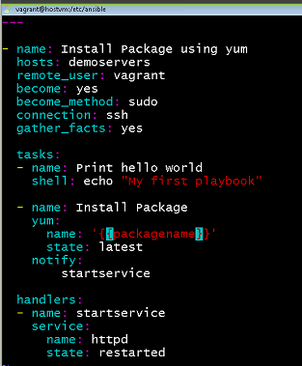Parameterizing the packages:

**To supply parameters to file**



Command: **ansible-playbook hello-world.yml --extra-vars “packagename=httpd”**

**Roles:**

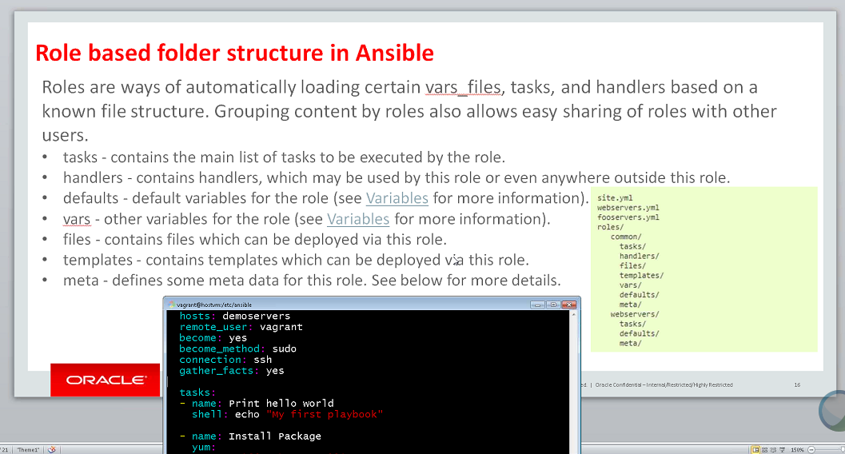

Task is the compulsory folder

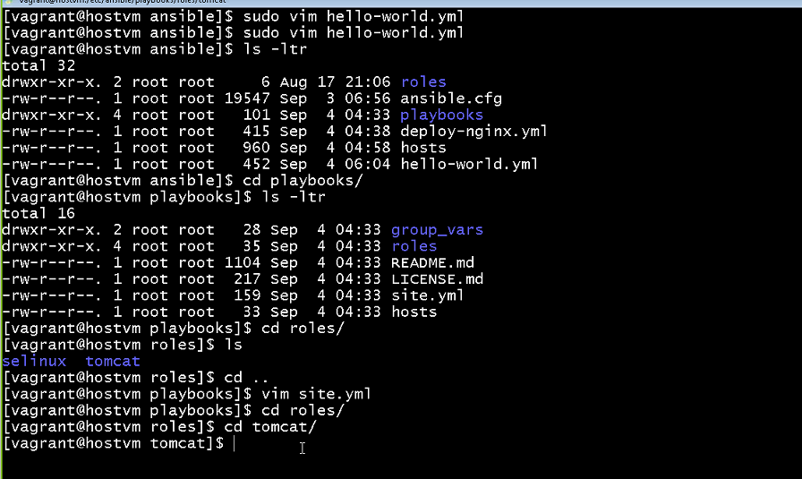

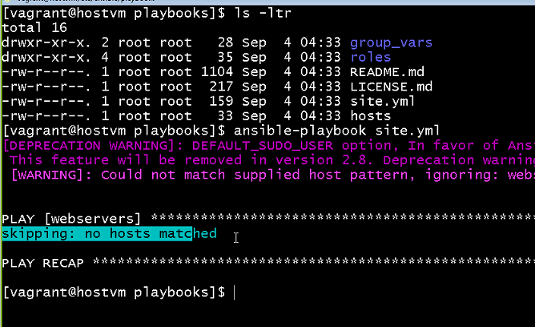

**To validate the YML file:**

[http://www.yamllint.com](http://www.yamllint.com/)

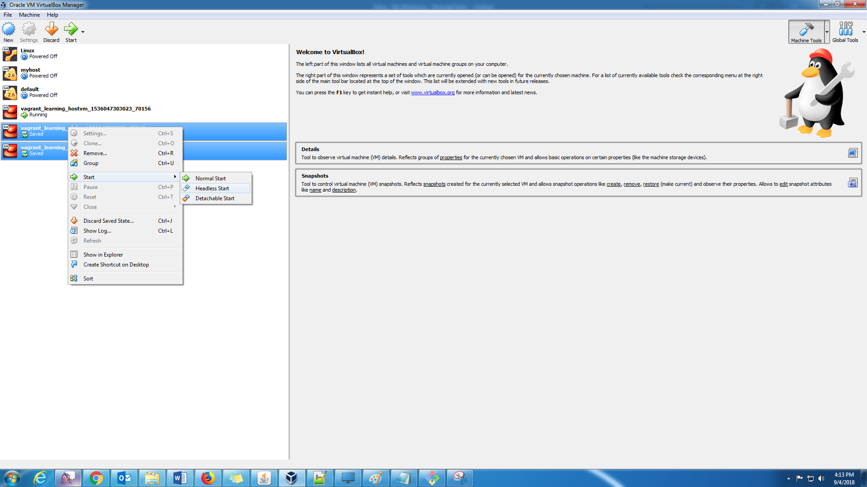

Always do Headless start

**Ansible setup in Jenkins:**

Ansible plugin



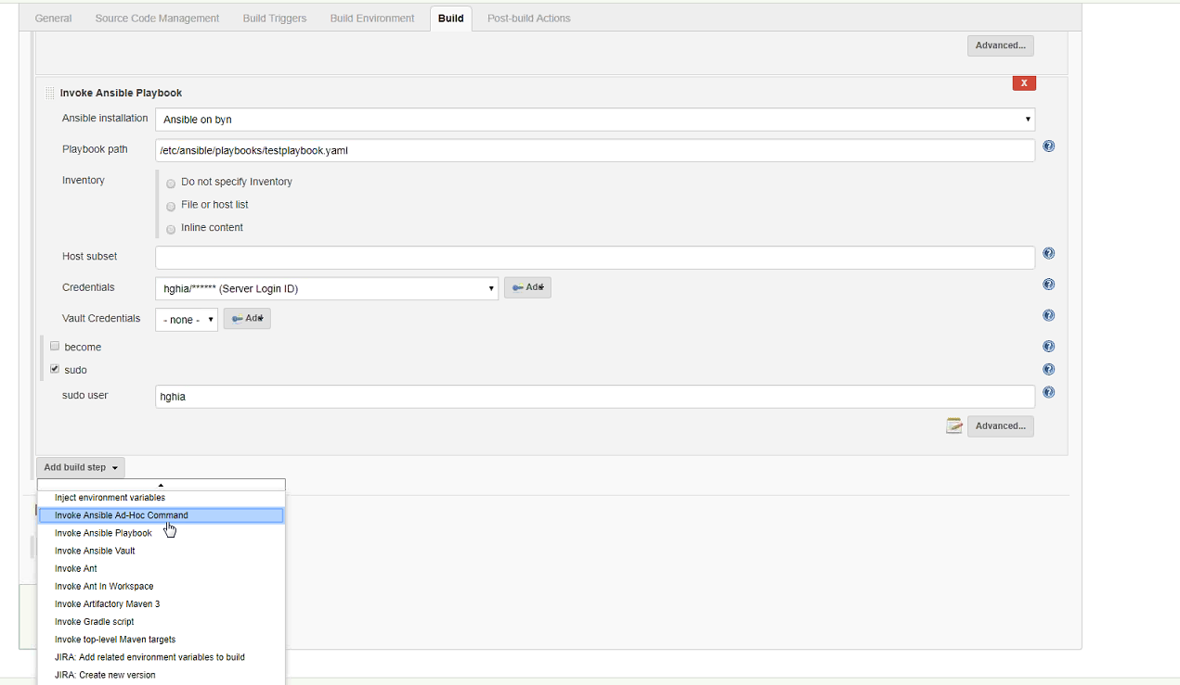

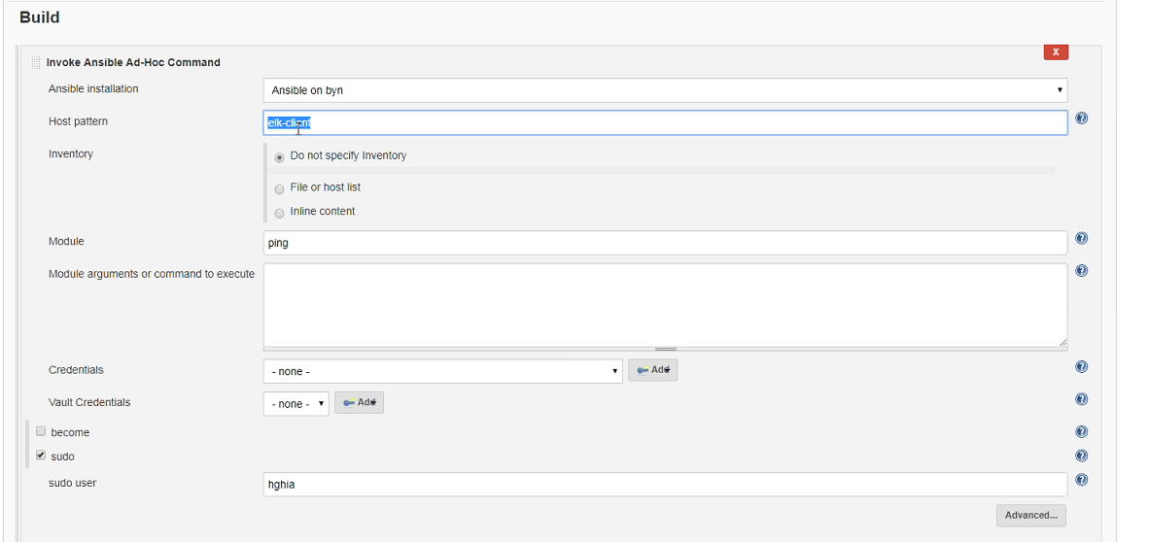

How to share files from windows: Create a folder in vagrant folder and it will be shared with vm