**Source:** [**https://www.guru99.com/angularjs-filter.html**](https://www.guru99.com/angularjs-filter.html)

**What is AngularJS?**

AngularJS is an open source Model-View-Controller framework which is similar to the [JavaScript](https://www.guru99.com/interactive-javascript-tutorials.html) framework.

## **AngularJS Features**

1. **MVC**: The division into different sections is done so that each one could be managed more easily.
2. **Data Model Binding:** We don't need to write special code to bind data to the HTML controls.  This can be done by Angular by just adding a few snippets of code.
3. **Writing less code**
4. **Unit**[**Testing**](https://www.guru99.com/software-testing.html)**ready**: Testing framework called "Karma" which helps in designing unit tests for AngularJS applications.

## **AngularJS Architecture**

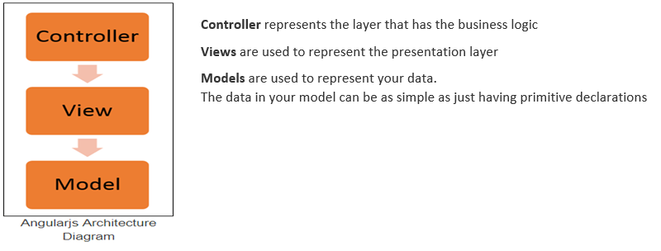

## **AngularJS Advantages**

1. **Two-way binding** – Angular.js keeps the data and presentation layer in sync. Now you don't need to write additional JavaScript code to keep the data in your HTML code and your data later in sync. Angular.js will automatically do this for you. You just need to specify which control is bound to which part of your model.
2. **Routing** – Angular can take care of routing which means moving from one view to another. This is the key fundamental of single page applications; wherein you can move to different functionalities in your web application based on user interaction but still stay on the same page.

**Starting Angular Application:**

1. The **"ng-app"** keyword is used to denote that this application should be considered as an angular js application. Any name can be given to this application.
2. The controller is what is used to hold the business logic. In the h1 tag, we want to access the controller, which will have the logic to display "HelloWorld", so we can say, in this tag we want to access the controller named "HelloWorldCtrl".
3. We are using a member variable called "message" which is nothing but a placeholder to display the "Hello World" message.
4. The "script tag" is used to reference the angular.js script which has all the necessary functionality for angular js. Without this reference, if we try to use any AngularJS functions, they will not work.
5. "Controller" is the place where we are creating our business logic, which is our controller. The specifics of each keyword will be explained in the subsequent chapters. What is important to note that we are defining a controller method called 'HelloWorldCtrl' which is being referenced in Step2.
6. We are creating a "function" which will be called when our code calls this controller. The $scope object is a special object in AngularJS which is a global object used within Angular.js. The $scope object is used to manage the data between the controller and the view.
7. We are creating a member variable called "message", assigning it the value of "HelloWorld" and attaching the member variable to the scope object.

**NOTE:** The ng-controller directive is a keyword defined in AngularJS (step#2) and is used to define controllers in your application. Here in our application, we have used the ng-controller keyword to define a controller named 'HelloWorldCtrl'. The actual logic for the controller will be created in (step#5).

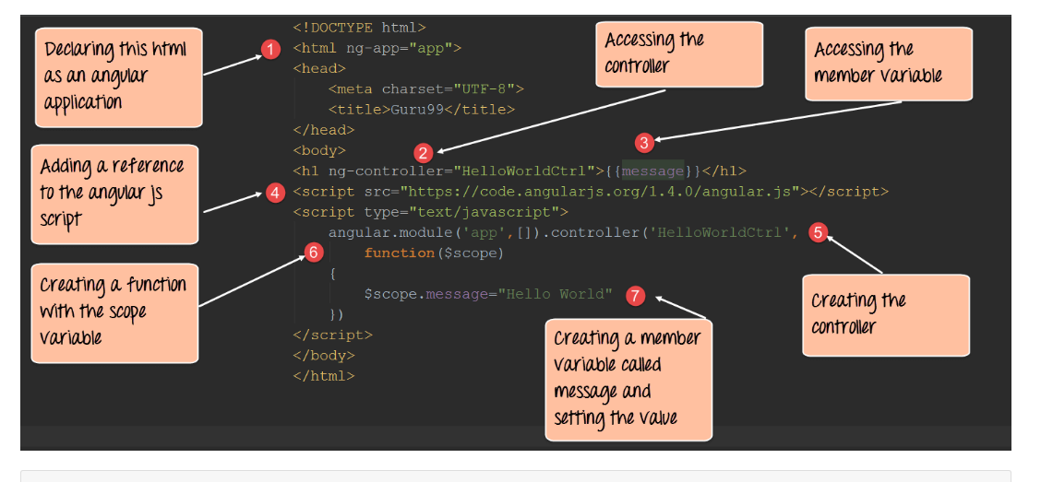

## **What Controller does from Angular's perspective**

The controller's primary responsibility is to control the data which gets passed to the view. The scope and the view have two-way communication.

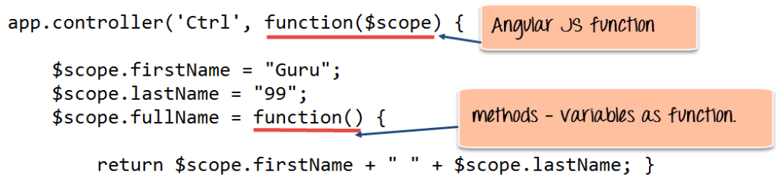

Data in this way pass from the controller to the scope, and then the data passes back and forth from the scope to the view.

The scope is used to expose the model to the view. The model can be modified via methods defined in the scope which could be triggered via events from the view. We can define two-way model binding from the scope to the model.

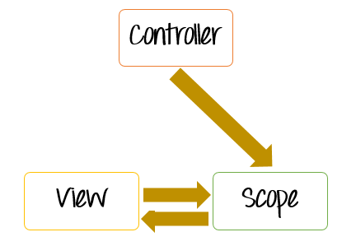

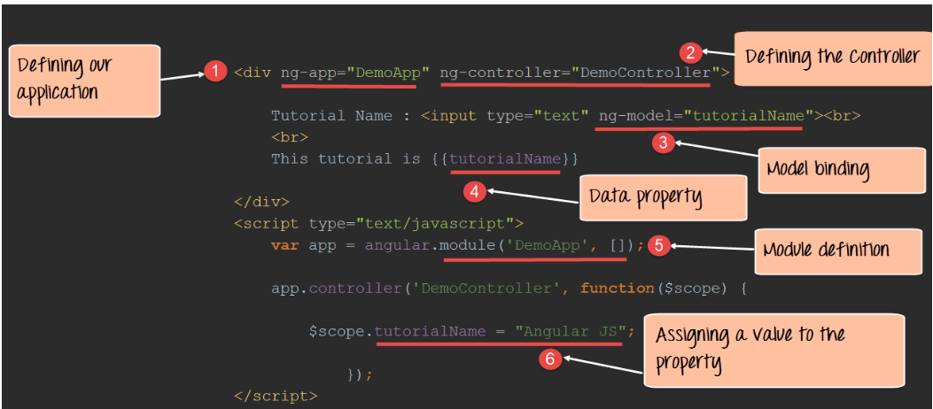

**Code Explanation:**

* The **ng-app**keyword is used to denote that this application should be considered as an angular application. Anything that starts with the prefix **'ng'**is known as a directive. "DemoApp" is the name given to our Angular.JS application.
* We have created a div tag and in this tag, we have added an ng-controller directive along with the name of our Controller "DemoController". This basically makes our div tag the ability to access the contents of the Demo Controller. You need to mention the name of the controller under the directive to ensure that you can access the functionality defined within the controller.
* We are creating a model binding using the ng-model directive. What this does is that it binds the text box for Tutorial Name to be bound to the member variable "tutorialName".
* We are creating a member variable called "tutorialName" which will be used to display the information which the user types in the text box for Tutorial Name.

## **Using ng-controller in External Files**

* 1. Define a module called "app" which will hold the controller along with the controller functionality.
  2. Create a controller with the name "HelloWorldCtrl". This controller will be used to have a functionality to display a "Hello World" message.
  3. The scope object is used to pass information from the controller to the view. So, in our case, the scope object will be used to hold a variable called "message".
  4. We are defining the variable message and assigning the value "Hello World" to it.

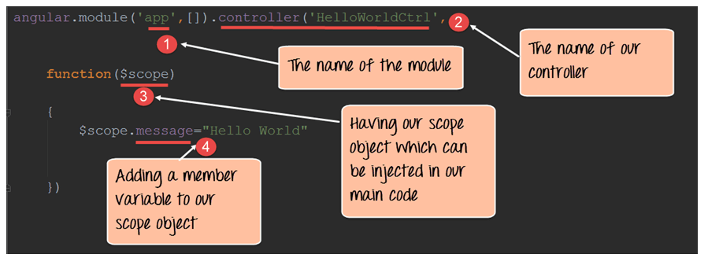The controller's primary responsibility is to create a scope object which in turn gets passed to the view.

## **Angular JS Multiple Controllers**

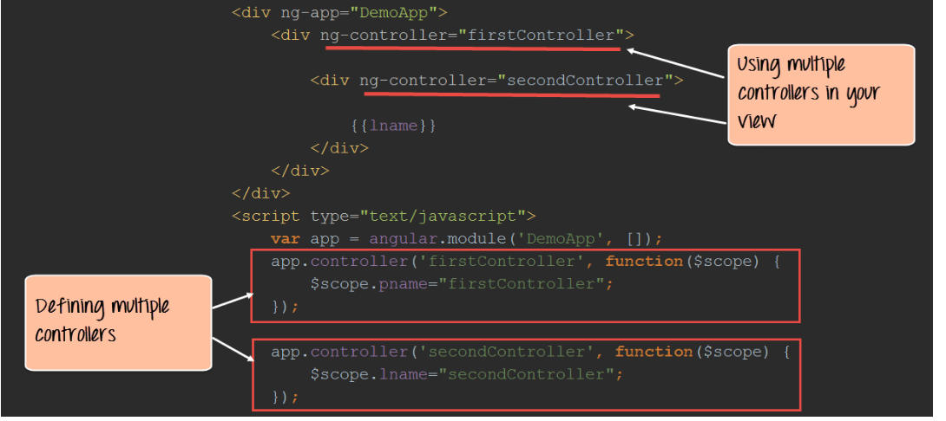

## **What is $scope in AngularJS?**

The scope is a JavaScript object which basically binds the "controller" and the "view". One can define member variables in the scope within the controller which can then be accessed by the view.

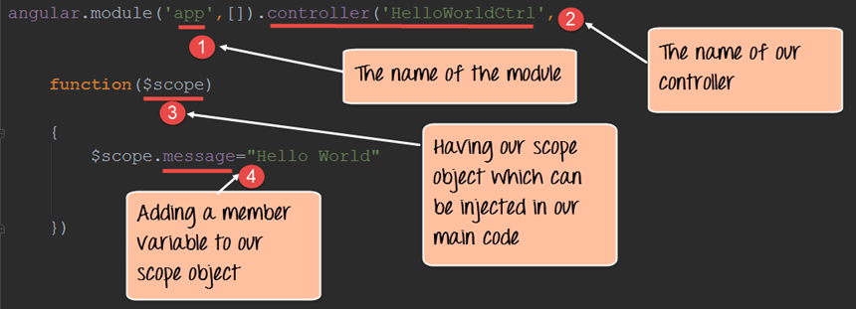

## **Setting up or adding Behavior**

* 1. To react to events or execute some sort of computation/processing in the View, we must provide behavior to the scope.
  2. Behaviors are added to scope objects to respond to specific events that may be triggered by the View. Once the behavior is defined in the controller, it can be accessed by the view.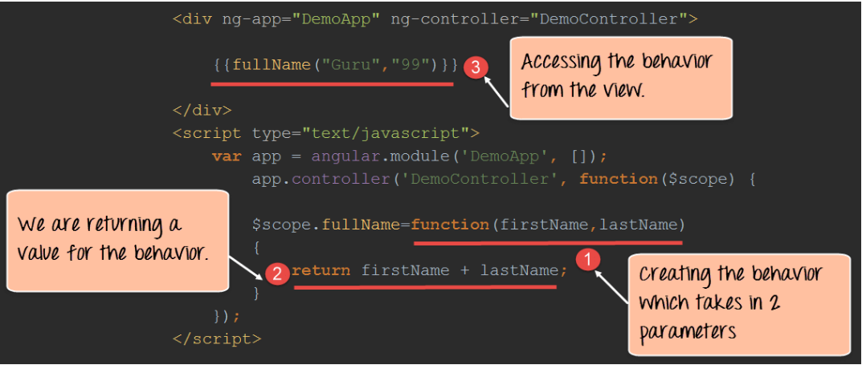

# **AngularJS ng-repeat Directive with Example**

Angular provides a directive called "ng-repeat" which can be used to display repeating values defined in our controller.

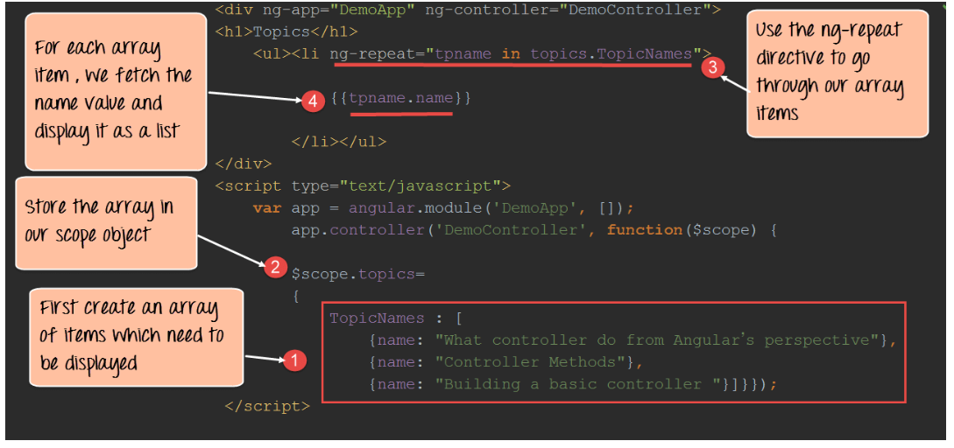

# **The ng-model Attribute**

1. Binding controls such as input, text area and selects in the view into the model.
2. Provide a validation behavior - for example, a validation can be added to a text box that only numeric characters can be entered the text box.
3. The ng-model attribute maintains the state of the control (By state, we mean that the control and the data is bound to be always kept in sync. If the value of our data changes, it will automatically change the value in the control and vice versa)

## **What is a View?**

A view is the content which is shown to the user. Basically, what the user wants to see, accordingly that view of the application will be shown to the user.

The combination of views and Routes helps one into dividing an application in logical views and bind different views to Controllers.

The "ngView" is a directive that complements the $route service by including the rendered template of the current route into the main layout (index.html) file.

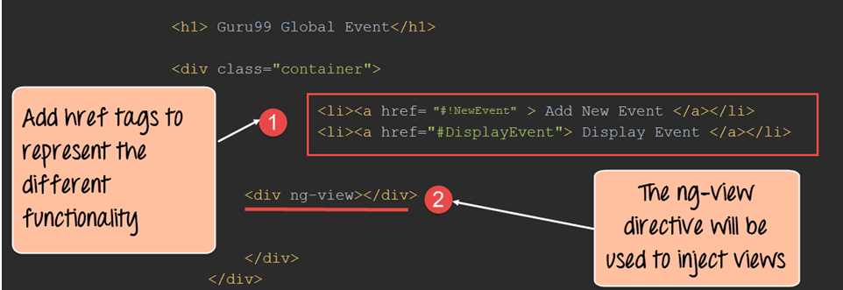

**Routing JS:**

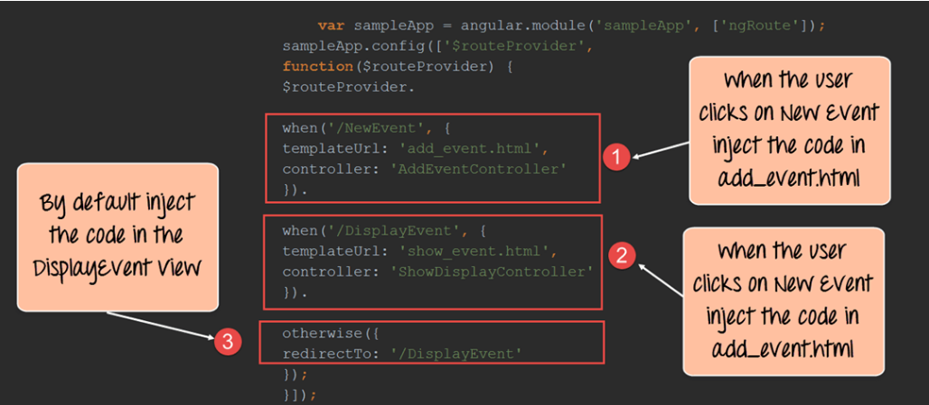

Controller Setup:

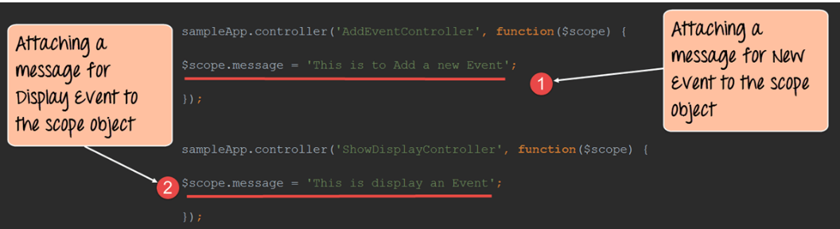

### What is Angular JS Expressions?

### Expressions are variables which were defined in the double braces {{}}.

### Angular.JS Numbers

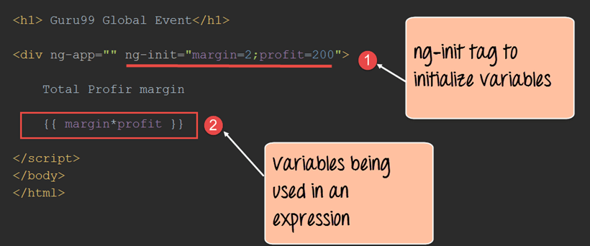

### The ng-init directive is used in angular.js to define variables and their corresponding values in the view itself. It's somewhat like defining local variables to code in any programming language.

### Difference between expression and $eval

The $eval function allows one to evaluate expressions from within the controller itself. So, while expressions are used for evaluation in the view, the $eval is used in the controller function.

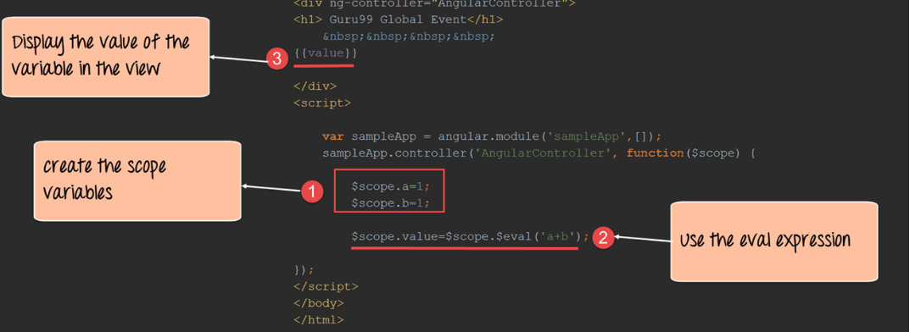

**What is Filter in AngularJS?**

* Filters are used to change the way the output is displayed to the user.
* Angular provides built-in filters such as the lowercase and uppercase filters to change the output of strings to lower and uppercase respectively.
* There is also a provision for changing the way numbers are displayed by using the number filter by specifying the number of decimal points to be displayed in the number.

# **AngularJS Custom Filter with Example**

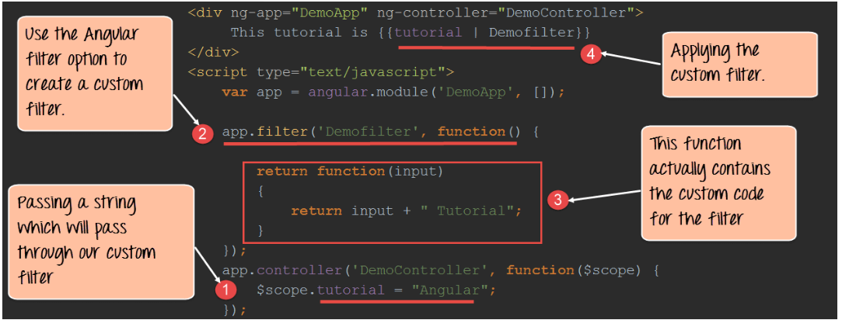

## **How to Create Directive**

* ng-app – This is used to initialize an angular application.
* ng-init – This is used to create application variables
* ng-model – This is used to bind HTML controls to application data
* ng-repeat – Used to repeat elements using angular.

## How to Create a Custom Directive?

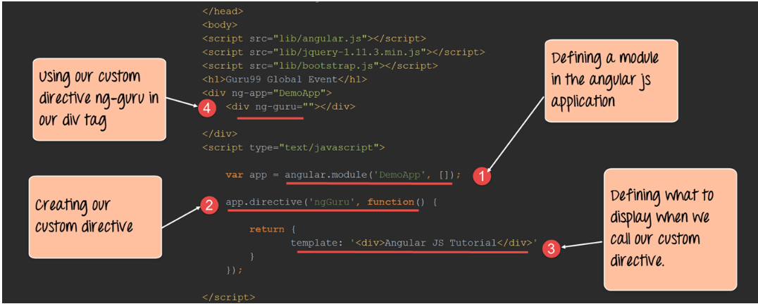

### What is an AngularJS Module?

A module defines the application functionality that is applied to the entire HTML page using the ng-app directive.

**ng-app=""**

* This basically means that all controllers which are called within the context of the ng-app directive can be accessed globally. There is no boundary which separates multiple controllers from each other.
* Modules are used to create that separation of boundaries and assist in separating controllers based on functionality.
* Without the use of AngularJS modules, controllers start having a global scope which leads to bad programming practices.
* Modules are used to separate business logic. Multiple modules can be created to have logically separated within these different modules.

**Angular JS event Listener:**

* ng-blur
* ng-change
* ng-click
* ng-copy
* ng-cut
* ng-dblclick
* ng-focus
* ng-keydown
* ng-keypress
* ng-keyup
* ng-mousedown
* ng-mouseenter
* ng-mouseleave
* ng-mousemove
* ng-mouseover
* ng-mouseup
* ng-paste

### What is Single Page Applications?

Single page applications or (SPAs) are web applications that load a single HTML page and dynamically update the page based on the user interaction with the web application.

**What is Routing in AngularJS?**

In AngularJS, routing is what allows you to create Single Page Applications.

* AngularJS routes enable you to create different URLs for different content in your application.
* AngularJS routes allow one to show multiple contents depending on which route is chosen.
* A route is specified in the URL after the **# sign**.

Routing is done on the same HTML page so that the user has the experience that he has not left the page.

**Syntax for using Routing:**

var module = angular.module("sampleApp", ['ngRoute']);

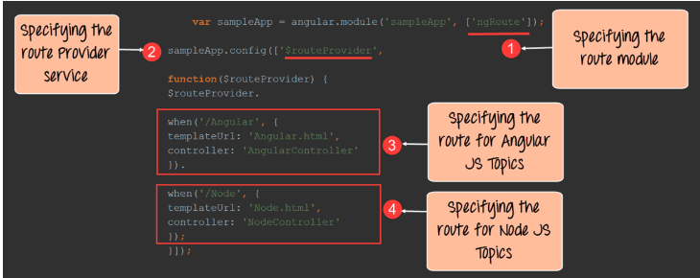

* The first step is to ensure to include the "ngRoute module." With this in place, Angular will automatically handle the routing in your application.
* The $routeprovider is a service that angular uses to listen in the background to the routes which are called. So, when the user clicks a link, the route provider will detect this and then decide on which route to take.