In old languages like C++ programmer is responsible to create new object and to destroy useless objects. Usually programmer takes care while creating an object. However, they forget to destroy the objects.

Due to this negligence, sometimes sufficient memory may not be available as unwanted objects are filled in the memory. New object creation may not be possible because of out of memory error.

In Java programmer are not responsible to destroy unused objects. Sun people provided assistance to destroy useless object. It always runs in the background (Daemon thread) and destroy useless objects.

Just because of this assistant the chance of failing program with memory problems is very low. This assistant is nothing but garbage collector.

**Hence, main objective of garbage collector is to destroy useless objects.**

**Ways to make an object eligible for GC:**

Even though programmer is not responsible to destroy useless objects, it is highly recommended to make an object eligible for GC, if it is no longer required. An object is said to be eligible for GC if and only if it does not contain any reference variable.

The following are various ways to make an object eligible for GC:

1. **Nullifying the reference variable**

If an object is no longer required then assign null to all its reference variables. Then that object automatically eligible for garbage collection.

This approach is called Nullifying the reference variable.

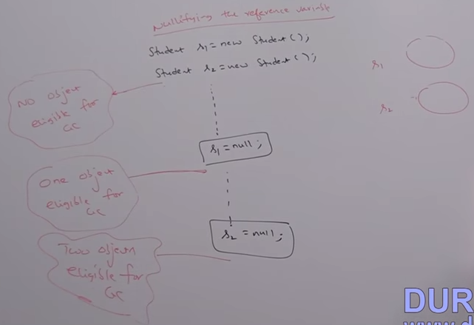

1. **Reassign the reference variable:**

If an object is no longer required, then reassign its reference variable to some other object. Then old object is by default eligible for garbage collection.

