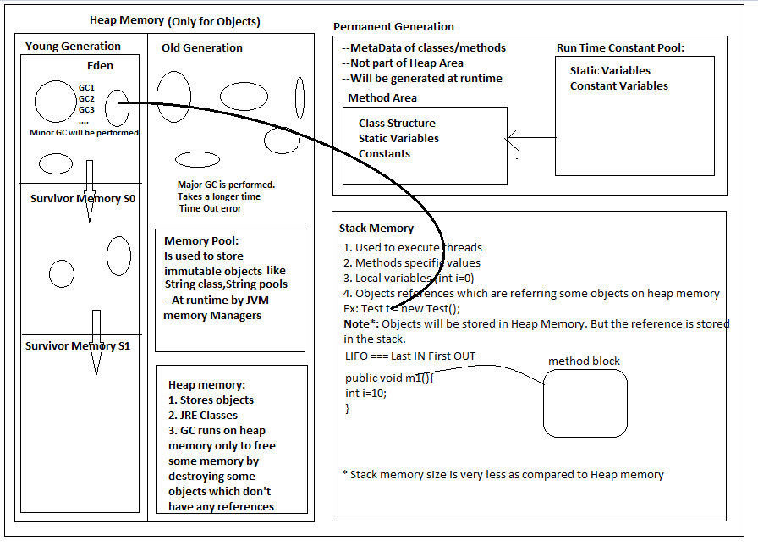

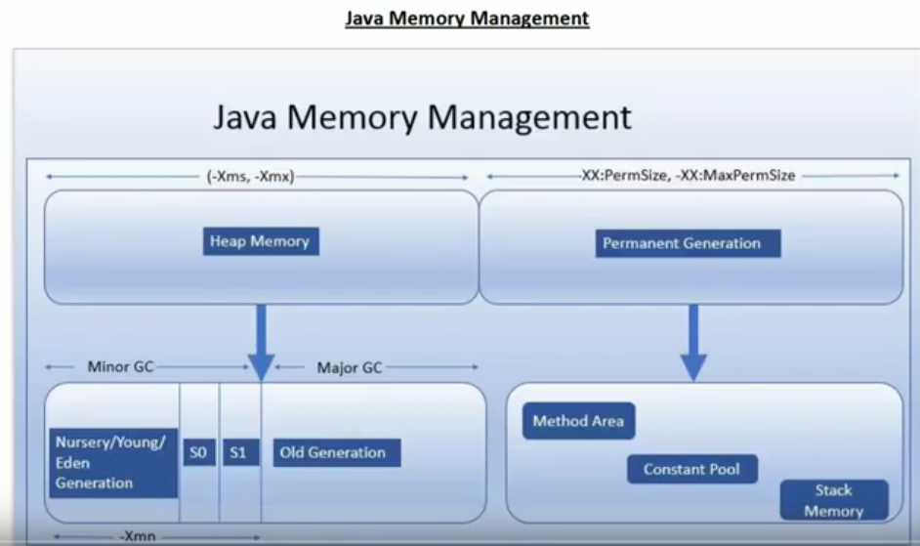

New objects will be created in Eden space. If it is full then JVM will run the minor GC on Eden space. Survival objects are places in S0 and S1. At any point of time either S0 or S1 is empty.

After so many cycles of minor GC the objects will be moved to old generation. Once old generation is full JVM will run Major GC.

Garbage collector keeps checking young and old generations in the background.

Garbage collection process:

1. Mark🡪Sweep (Delete all unreferenced object)🡪Compact

Minor GC takes very less time.

Major GC takes a lot of time. It causes the application unresponsive.

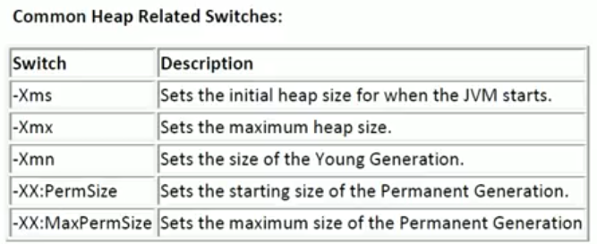

Permanent Generation:

It has 3 parts:

1. Method Area
2. Constant Pool
3. Stack Memory

**Garbage Collection Algorithm:**

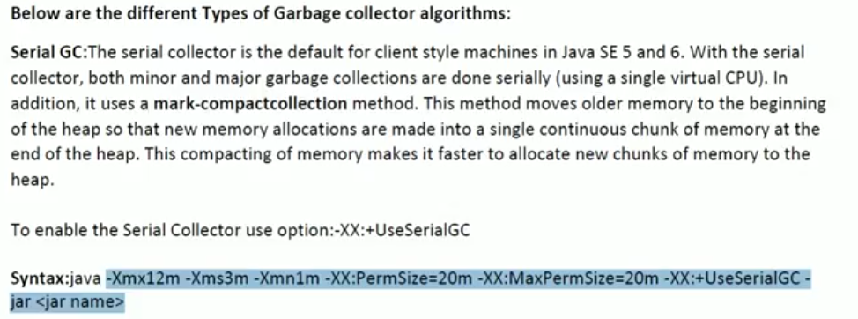

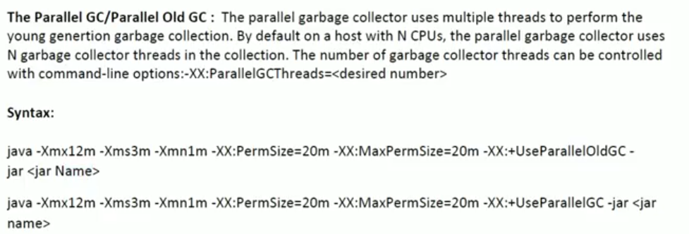

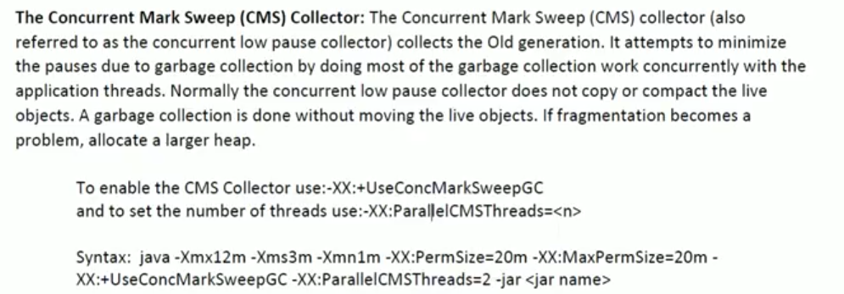

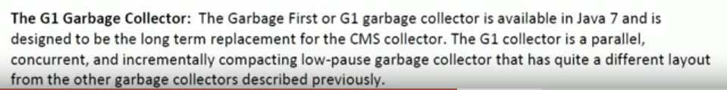

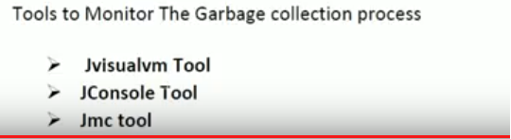

All tools come as part of JDK.

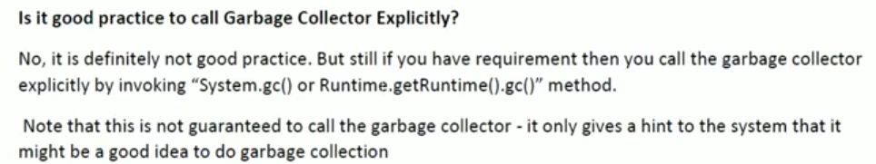

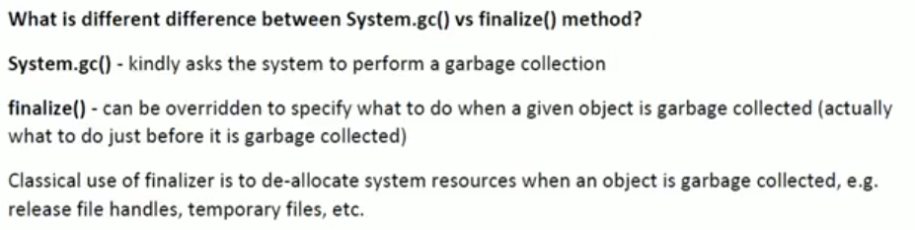

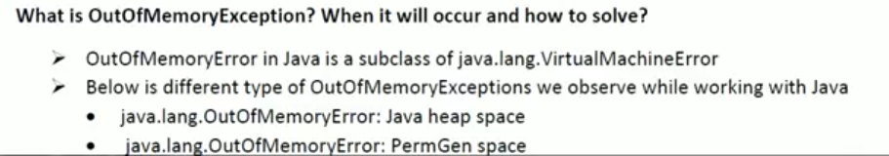

Every thread has its own Stack.