**Hash Map**:

Map is not child interface of collection. If we want to represent a group of objects as key/value pair—map. Duplicate keys are not allowed. Values can be duplicated. Each key value pair is called **Entry**.

**Map Interface methods:**

1. **Object put (Object key, Object value);**

To add one key value pair to the map. If the key is already present then old value will be replaced will be replaced with new value and returns old value.

Ex:

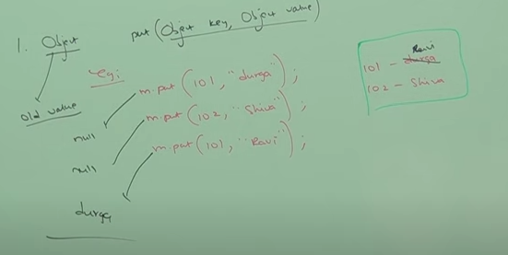

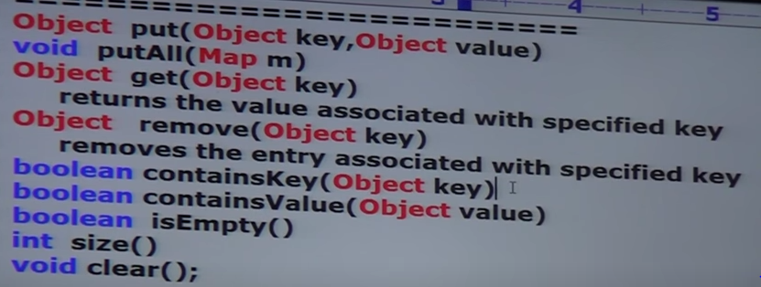

**Collection Views of Map**

1. Set KeySet ()
2. Collection values ()
3. Set entrySet ()

**Entry**:

Map is a group of key value pair. Each key/value pair is called an Entry. Hence, map is considered as a collection of entry objects. Without existing Map object there is no existence of Entry object.

So, Entry interface is defined within Map interface.

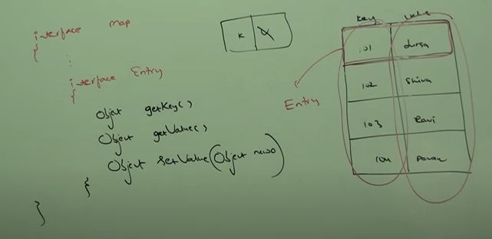

Above 3 methods are Entry specific methods and can be applied only in Entry objects

**Hash-Map:**

1. Underlying data structure is Hash Table.
2. Insertion order is not preserved and it is based on hash code of Keys
3. Duplicate Keys==not allowed, Duplicate Values == Allowed
4. Heterogeneous objects are allowed for both key and value.
5. Null is allowed for key (Only once).
6. Null is allowed for values (Any number of times).
7. Hash Map implements Serializable and Cloneable interface but not Random access.
8. Best choice if our frequent operation is search.

HashMap m =new HashMap ();

It creates an empty Hash Map object with default initial capacity 16 and default fill ration 0.75.

HashMap m = new HashMap (int initCapacity);

Creates an empty HashMap object with specified initial capacity and default fill ratio 0.75.

HashMap m = new HashMap (int initCapacity, float fillRatio);

HashMap m = new HashMap (Map m);

**Difference between Hash Map and Hash Table**

|  |  |
| --- | --- |
| **Hash Map** | **Hash Table** |
| Every method present in Hash Map is not Synchronized | Every method in Hash Table is Synchronized |
| Relatively performance is high because threads are not required to wait to operate on HashMap object | Relatively performance is low because threads are required to wait to operate on Hash Table Object. |
| Not Thread safe. Multiple thread can access at a time on Hash Map object | Thread Safe. Only one thread can operate at a time. |
| Null is allowed for both key and value | Null is not allowed for keys and values. Otherwise, we will get Null Pointer exception |
| Introduced in 1.2 version and it is not legacy | Introduced in 1.0 version and it is legacy |

**Synchronized version of Hash Map**

By default, Hash Map is Non- Synchronized. But we can get the Synchronized version of Hash Map by using synchronized Map method of collections class.

