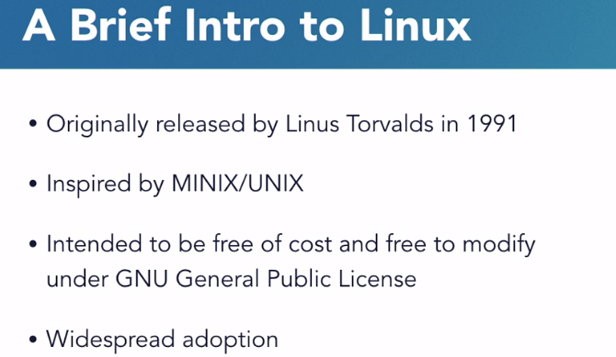

Linux is a general-purpose computer operating system, originally released in 1991 by Linus Torvalds. Linux is defined by its kernel, which is the core component of the system. The kernel interacts with the computer hardware to allow software and other hardware to exchange information. Linux was inspired by MINIX which, in turn, was inspired by UNIX. And Linux is based on a philosophy that software and operating systems should be free. Both, free of cost and freely modifiable.

The software license which allows this, in the case of the Linux kernel, is called the GNU General Public License.

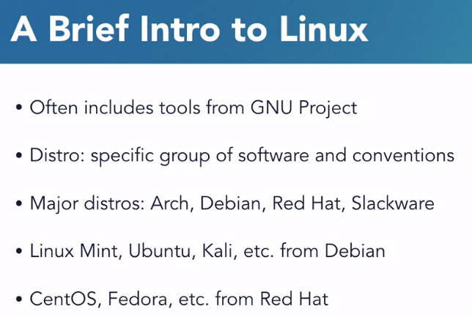

While the Linux kernel is the same across nearly all these installations of Linux, the software that surrounds the kernel that provides capabilities like software package management, control of services, and the location of configuration files differs between them. Many of the tools that come packaged with Linux come from the GNU Project and aren't a part of Linux. And so, taken together, the combination of the kernel and these common tools is often referred to as GNU Linux. Different groups of software and configuration choices that are maintained by individuals or groups of people are called distributions, or distro's.

Most major distributions of Linux fall into four categories based on the original distribution from which they were derived. There's **Arch, Debian, Red Hat, and Slackware**, and any number of other smaller distributions.

Linux Mint, Ubuntu, Elementary OS, and Kali Linux are all derived from Debian.

CentOS, Fedora, and Red Hat Enterprise Linux are derived from Red Hat.



**To install git:**

sudo apt install git

**To clone a repository from git:**

Example: git clone git;//github.com /scottsimpson/commandlinebasics

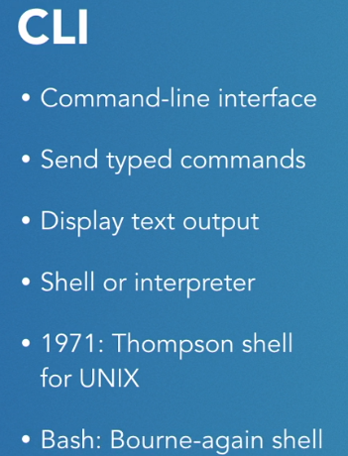

Command is the program that we are running

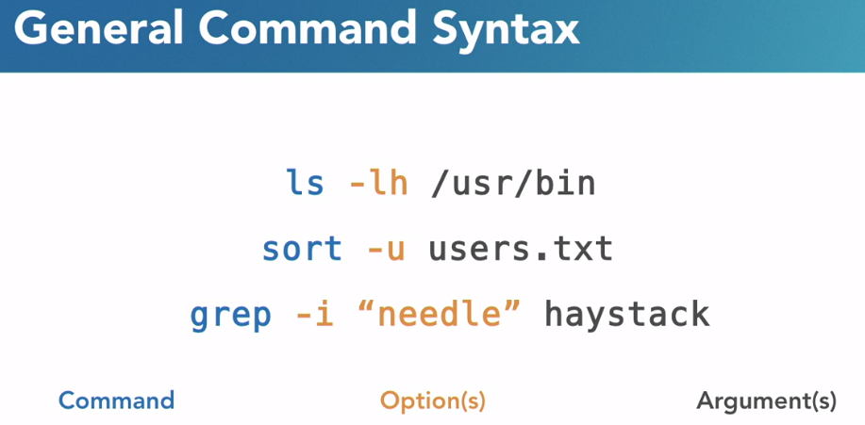

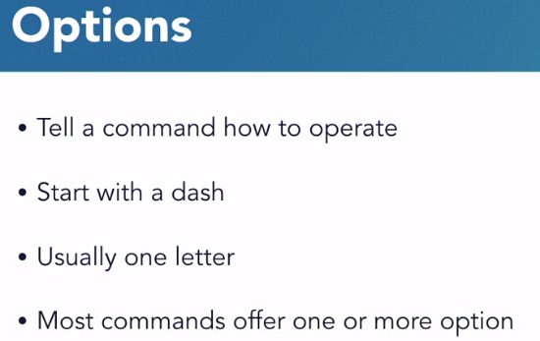

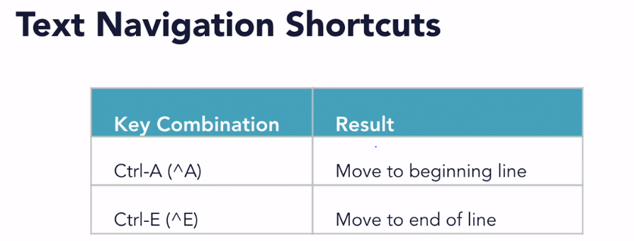

If we don’t know any command. We can type **apropos** to find the details of all command

Ex: apropos “list”

All commands with description containing list.

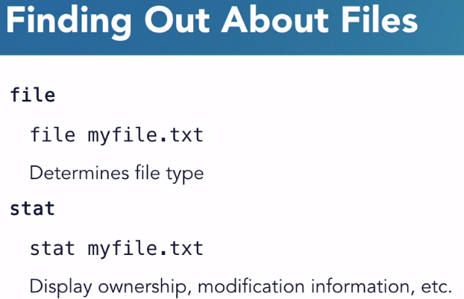

p-w-d, for print working directory

To escape a character **“\”** is used.

**ls -R folder_name**: Recursively print the subfolder details inside folder_name

**cd -**: Previously used folder. So, we ca switch back from current and last used folder

**ls -lh**: To know the size of the file

**mkdir -p folder1/folder2/folder3**: It will create nested folder. Within current folder first it will create folder1, inside that folder2 and inside that folder3.

**Copy a file**

cp poems.txt poems2.txt

**Move a file:**

mv folder1\file1.txt folder2\file2.txt

**Rename a file:**

mv file1.txt file2.txt

**Single dot (.) means current directory. To move a file from others directory to current directory:**



*: Any number of character

?: Single character

**To move all files ending with .txt to other folder:**



**To move everything from other folders to current folder:**



**Delete the files using? Exactly 1 character.**



**To delete directory within a directory:**

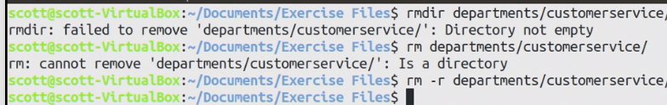

**Find Files from the command line**

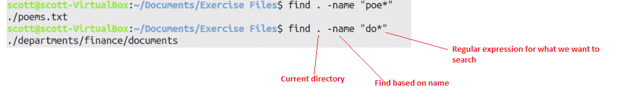

Shell is a program that takes command from keyboard and give it to OS.

CLI-Command Line Interface

Terminal is a tool that is used to Shell command.

|  |  |
| --- | --- |
| Command Name | Comments |
| CTRL+ALT+T | Command to Open Terminal |
| pwd | Current working directory |
| cd / | Move to root directory |
| ls | List Directory contents |
| clear | Clear the command line. Just scroll up to see the contents |
| ls ~ | List contents of my home directory |
| .. | One folder Back |
| ls -l | List all files in long format. |
| ls -a | List all the hidden files |
| ls -al | Long list and hidden file combinedly |
| ls -lS | Sort the file in descending order of size |
| * | Everything |
| ls -lS > out.txt | Create a file out.txt and save the results of ls -lS |
| ls -d */ | Display only the list of directories |
| man ls | Display all the commands available for ls. |
| ~ | Home Directory |
| / | Root Directory |
| .. | One folder above. Parent of the current folder |
| \ | Escape character |
| cat filename | Display the content of file |
| cat -b filename | Enter line number to nonblank row |
| cat -n filename | Enter line number to all the row |
| cat -s filename | Squeeze the blank rows to single blank row |
| cat -E filename | Add $ at the end of the line |

writes of owner: drwxr

d-directory

r-read

w-write

x-execute

r-read

Writes of group: xr