<https://www.mongodb.com>

Mongo DB documentation can be found here: <https://docs.mongodb.com/manual/>

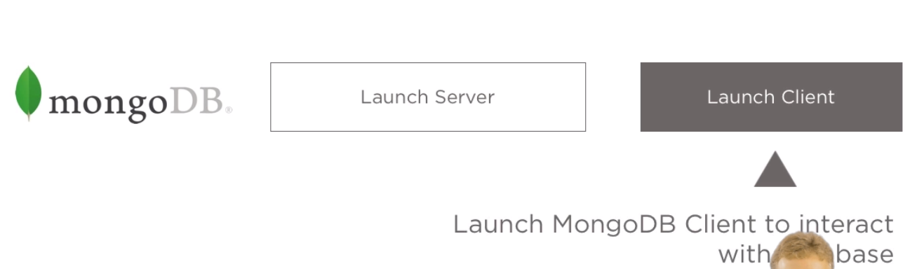

Create the data/db directory in the c: folder

**Step1**: Start the Mongo DB server by selecting the **mongod** from bin folder.

**Step2**: Start the Mongo DB client by selecting **mongo** from bin folder.

**Step3**: To use a specific database use the command:

Use <dbname>

**Step4:** To access collection use the command:

Show collections: Displays the list of collections

db.<collection_name>.find()

**Step5**: To connect the Node JS with Mongo Db use the mongoose client. Command:

npm install --save mongoose

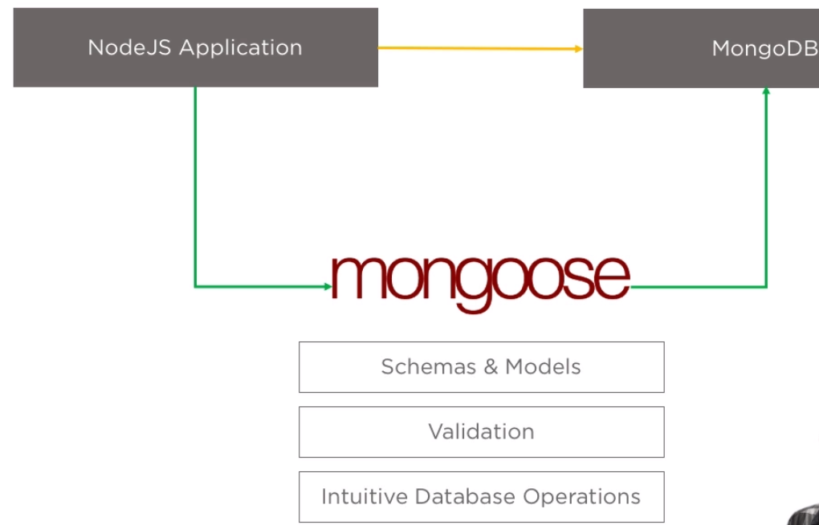

Code to connect mongoose:

1. var mongoose = require(‘mongoose’);
2. mongoose.connect(‘localhost:27017/<db-name>

Advantage of Mongoose:

1. We can create Models
2. We can use this models to create Objects and the Object will access the database.

**Step6:** Create any module which will be server side changes.

Import of mongoose is required wherever it is required.

To create a model the code snippet:

var mongoose = require('mongoose');

var Schema = mongoose.Schema;

var schema = new Schema({

content:{type:String,required:true},

user : {type:Schema.Types.ObjectId}

});

module.exports = mongoose.model('Message',schema);

**Step7:** To validate unique value install the following package:

npm i --save mongoose-unique-validator

This 3rd party package allows us to do some extra validations.

var mongoose = require('mongoose');

var Schema = mongoose.Schema;

var mongooseUniqueValidator = require('mongoose-unique-validator');

var schema = new Schema({

firstName:{type:String,required:true},

lastName:{type:String,required:true},

password:{type:String,required:true},

email:{type:String,required:true,unique:true},

messages:[{type:Schema.Types.ObjectId,ref:'Message'}]

});

schema.plugin(mongooseUniqueValidator);

module.exports = mongoose.model('User',schema);

//The collection name will be automatically 'users'

To link a module with another module we use the ref keyword.

To get one value from Mongo:

User.findOne({},function(err,doc){

if(err){

return res.send('Error!');

}else{

res.render('node',{email:doc.email});

}

});

To Save a record:

router.post('/', function(req, res, next) {

var email = req.body.email;

var user = new User({

firstName:'Bishwa',

lastName:'Patel',

password:'test',

email:email

});

user.save();

res.redirect('/');

});

Official MongoDB Page: <https://www.mongodb.com/>

Setup Instructions on Official Page (choose your OS):

<https://docs.mongodb.com/manual/administration/install-community/>

Mongoose Docs: <http://mongoosejs.com/docs/guide.html>