**Customized Exception:**

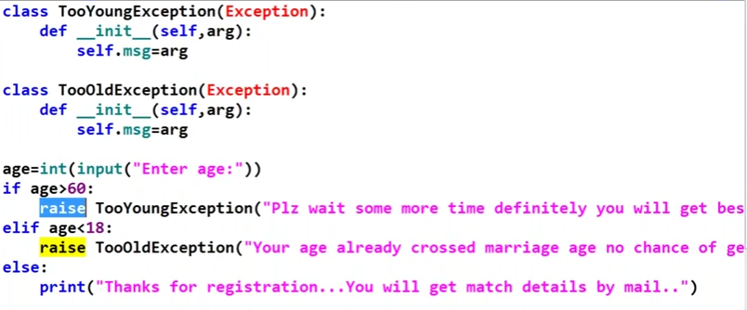

**Implement Logging:**