Team Name/Project Name | Team 4 / Whack Whack Math Attack
Document | Product Design Document Rev 1.11
Date of Last Revision | 11/07/2006

Architectural Model
This diagram represents the major subsystems of the product. Initially focus on the domain layer and its components before decomposing the user interface component. This model has been updated for R2.
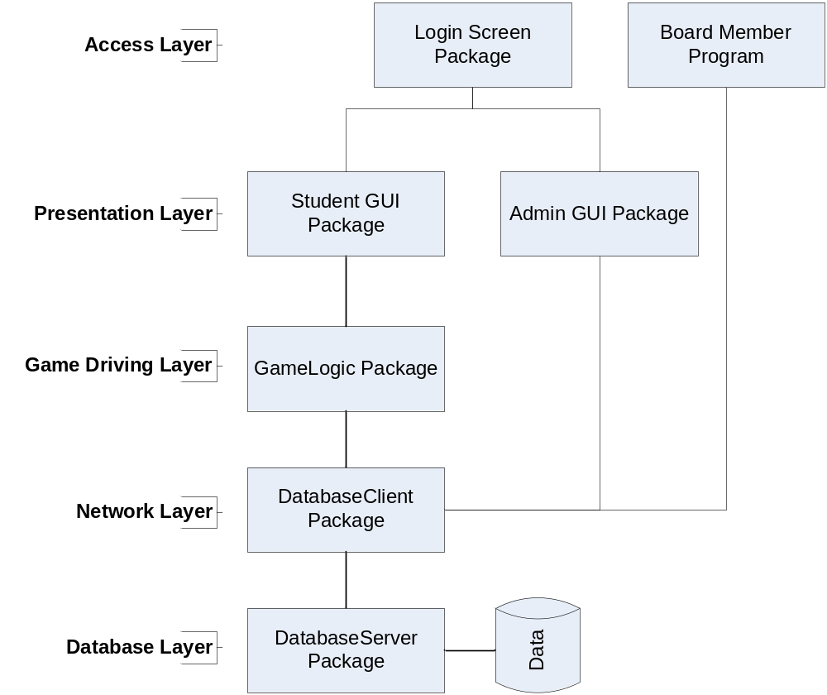

Components and Services
Login Package | - Student selects name from side-scrolling list which offers access to different game types.  - “Teacher Login” button on the login screen allows a teacher to login based on with his/her name and password.  - Quit button ends the game.  - If program has not been configured yet (no class or IP), ask the user for the IP address of the server and the name of the class that the computer is located in. These are stored locally.
Board Member Program | - Distributed only to board members, does not include any game or login code.  - Lists classes with brief summaries of overall student performance.
Student Graphical User Interface (GUI) Package | - Environment displays the correct background and characters.  - Instructions are shown at the beginning of each session.  - Level is shown at the beginning of each game.  - Characters animate themselves.  - Plays sounds in response to events.  - Try counter shows tries remaining in round.  - Timer shows time remaining.  - Correct or incorrect screen overlays at end of round show the correct answer.  - Score box shows running game score.  - User interacts by clicking objects in the game screen.  - Bonus moles are loaded for the bonus round.
Teacher Graphical User Interface (GUI) Package | - Teacher can view a list of students which allows loading of individual student summary and progress history.  - Teacher can add new questions to a list of mandatory questions.  - Teacher can change password.  - Teacher can change server IP address.  - Teacher can click Save to save changes to the database.  - Teacher can quit directly from any admin screen.
GameLogic Package | - RoundManager controls a single round by triggering GUI events and listening for mouse clicks.  - GameManager controls the progression of rounds, tracking user score and level. Reports back to the database when the game is complete.  - QuestionGenerator generates valid questions to be used after the teacher’s specified problems have been answered.  - AnswerGenerator takes a question and finds the correct answer. Also generates incorrect answers based on the question.  - Question holds a question to be interpreted by the AnswerGenerator.  - DivisionRemainderExceptions and PositionQuestionExceptions are generated when a teacher enters a problem incorrectly.  - Student objects store the overall statistics for each student, while their detailed game statistics are stored in an array of GameHistory objects.
DatabaseClient Package | - Server remains running and waits for new data from the game code to send to the database.  - Client computers connect to server based on IP address or hostname.  - Client can get any needed student information and can also store updated information.  - Teachers can get a detailed student history of all games that their students played.  - The school board members can view class statistics. They will not be able to change or modify any data in the database.
DatabaseServer Package | - Receives and stores all data related to student progress, teacher added problems, and classes.  - Can function locally or on a remote server.  - One centralized server will be set up by the school's I.T Department.

Product Design
Please see R2_administrationUML.png, R2_databaseUML.png, R2_GameLogicUML.png, and R2_GameUIUML.png in the doc.technical repository directory for class diagrams.
Please see “Add User Sequence Diagram.vsd” for a sequence diagram of the “Add User” user story in the doc.technical repository directory.
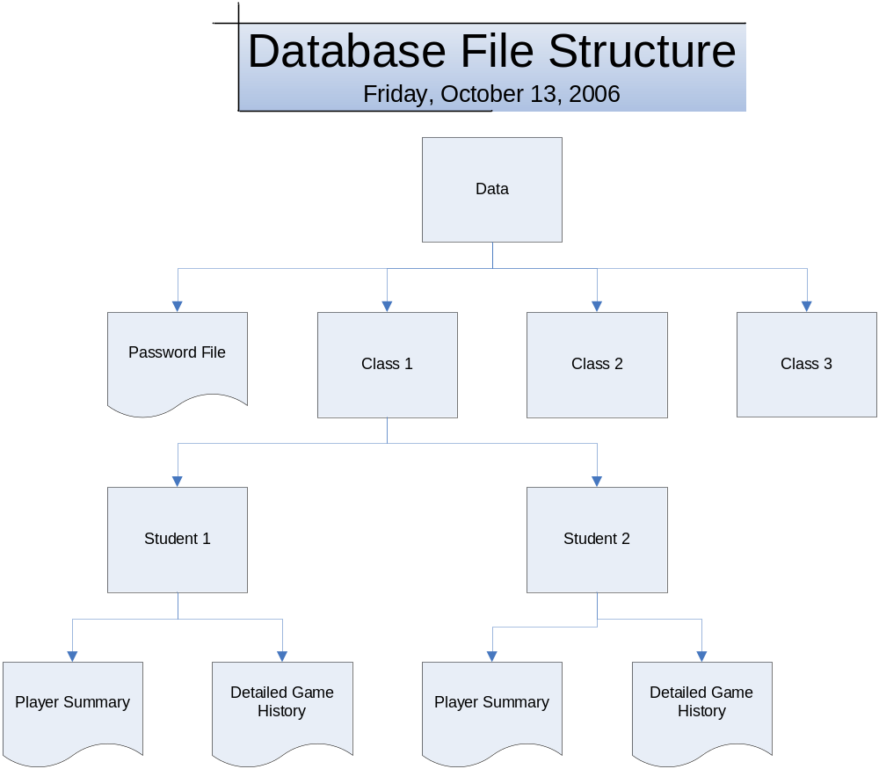
Design Notes
  - 09/26/2006 – Brainstorming session concludes with Whack-A-Mole game concept. The final product will also feature a networked server backend that stores information about every class and every student.
  - 10/13/2006 – Decided that the difficulty level would not affect the questions given to the player. Instead, the difficulty level will affect the number of tries given to the player, as well as the duration of the overall game timer and how long the moles stay up for.
  - 10/13/2006 – Each teacher will have his or her own personal login, which is automatically connected by the database to the class they teach. This is a change from earlier plans that would have only created one admin account for all the teachers to share. See “mockup” images in technical documents.
  - 10/20/2006 – Removed the requirement that stated the teacher must be able to export the database to a CSV file.
  - 10/27/2006 – A game session will now consist of a set number of rounds, instead of lasting until the player decides to stop playing. This decision was made to simplify the bonus round requirement, because otherwise the player would only be presented with the bonus round option when he or she decided to quit. That could have also been exploited by repeatedly starting game sessions and quitting in the first round.
  - 10/27/2006 – During bonus rounds the moles will wear hats and other comical items.
  - 11/03/07 – The passwords for newly created teachers will be the same as their usernames. There will also be a default “Admin” user for every server that can be used to set up the system initially.

