INSERT INTO Position Table – Bisrat Belay

Screenshot before

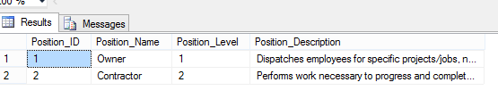

Screenshot of SQL

Screenshot after

