UPDATE Position Table – Bisrat Belay

Screenshot before

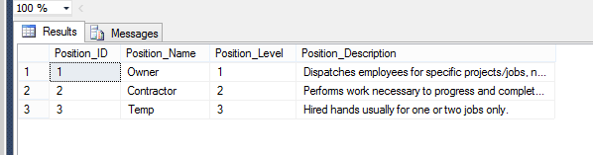

Screenshot of SQL

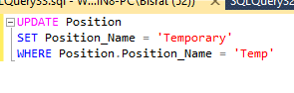

Screenshot after

