DELETE FROM Vendor Table – Bisrat Belay

Screenshot before
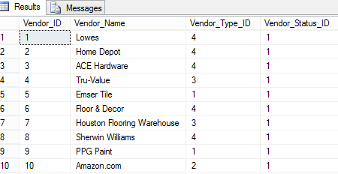

Screenshot of SQL

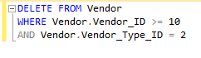

Screenshot after

