# Overview

The purpose of this analysis is to create a model that will predict whether or not an applicant will be successful in their ventures. Funding would be denied to applicants that are predicted to be unsuccessful.

# Results

## Data Processing

Historical data was provided to use for training and testing the model. Variable(s) that are removed because they are neither targets nor features are:

* EIN
* NAME

The variable(s) used as feature(s), or independent variables, are:

* APPLICATION_TYPE
* AFFILIATION
* CLASSIFICATION
* USE_CASE
* ORGANIZATION
* STATUS
* INCOME_AMT
* SPECIAL_CONSIDERATIONS
* ASK_AMT

The variable used as a target, or dependent variable, is IS_SUCCESSFUL.

Categorical data was changed to numeric data – zeros and ones. Then the data was split between testing data (25%) and training data (75%). Finally, the variable data was scaled.

## Compiling, Training, and Evaluating the Model

The initial combination of neurons, layers, and activation functions used were:

* Hidden Layer 1
  + Neurons: 80
  + Activation Function: ReLu
* Hidden Layer 2
  + Neurons: 30
  + Activation Function: ReLu
* Output Layer
  + Neurons: 1
  + Activation Function: Sigmoid

With this initial model, I was not able to achieve the target model performance of 75% accuracy. I made several attempts at optimizing the model. Some changes that I implemented were:

* Adjusting cutoff values for the binning of less used APPLICATION_TYPE values.
* Adjusting cutoff values for the binning of less used CLASSIFICATION values.
* Changing the default testing/training split to 20%/80%.
* Increasing and decreasing hidden layers.
* Increasing and decreasing the neurons in hidden layers 1 and 2.
* Changing the activation functions in hidden layers 1 and 2.
* Increasing the number of epochs.

In the many different combinations that I created; I was never able to get a model that was more accurate than 74.18%. The model that reached this accuracy, after re-ran, was unable to reach that high again.

Here are some examples of changes made to the hidden layers and accuracy results for those models. All of these examples were with the default testing/training split and 100 epochs.

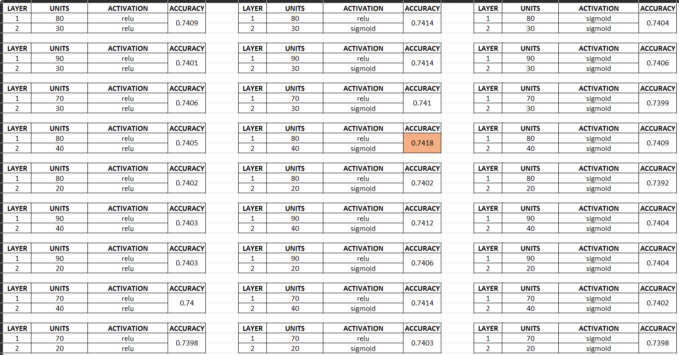

# Summary

In summary, the overall the deep learning model is not able to reach 75% accuracy without additional modifications.