电 子 科 技 大 学
UNIVERSITY OF ELECTRONIC SCIENCE AND TECHNOLOGY OF CHINA

学士学位论文
BACHELOR THESIS



论文题目

学 院
专 业
学 号
作者姓名
指导教师

电 子 科 技 大 学
20 级本科毕业设计（论文）任务书

拟题单位 审题人（签名）

题目及副标题

题目来源: 1.科研 2.生产 3.教学（含实验） 4.创新创业 （选择其中一种）

主要任务：

预期成果或目标：

预期成果形式： 1.硬件 2.硬件+软件 3.软件 4.理论研究 （选择其中一种）

指导教师签名:

起止时间： 年 月 日至 年 月 日

学生姓名 专业 学号

指导单位

指导教师姓名、职称

设计地点

年 月 日

备注：1.此任务书应由指导教师填写，签名处须由教师亲笔签名。
2.此任务书必须在学生毕业设计开始前下达给学生。

电 子 科 技 大 学
20 级本科毕业设计（论文）开题报告表
学号： |  |  | 姓名： | 学院： | 专业：
论文题目
题目来源： 1.科研 2.生产 3.教学（含实验） 4.创新创业
（在选项上打勾选择）
成果形式： 1.硬件 2.硬件+软件 3.软件 4.理论研究
（在选项上打勾选择）
学位论文  研究内容 |  | 1500-2000字，主要从以下五个方面进行阐述（参考毕业论文正文格式：宋体小4号，英文字体为Times New Rome，行间距固定20磅，可另加页）：  1．研究现状及发展态势  2．选题依据及意义  3．课题研究内容  4. 拟解决的关键问题和最终目标，以及拟采取的主要理论、技术路线和实施方案等  5．论文特色或创新点
导师审查  意见 |  | 签名：  日期： 年 月 日
电 子 科 技 大 学
20 级本科毕业设计（论文）进度计划表
学院名称： 填表日期： 年 月 日
学生姓名 |  |  | 论文题目  (含副标题)
学 号 |  |  | 论文题目  (含副标题)
周 次 |  | 主要工作计划  （内容） |  |  | 完成情况 | 指导教师签字 | 备 注
说明: 1.此表由指导教师填写，并与毕业设计任务书同时下达给学生；
2.该表作为专家组或指导教师对学生毕业设计进度检查的参考依据。
电 子 科 技 大 学
20 级本科毕业设计（论文）初期检查表
学院名称： 填表日期： 年 月 日
以下内容由学生本人填写
学生姓名 |  |  |  | 题目名称
学号 |  |  |  | 题目性质 | 科研 生产 教学（含实验） 创新创业
指导教师 |  |  |  | 工作地点 | 校内： |  |  |  |  |  | 校外：
设计时间 | 20 年 月 日至 20 年 月 日
以下内容由检查教师填写
对课题的基本评价 （在备选项后面划勾） |  | 课题工作量 |  |  |  | 饱满 |  |  | 适中 |  |  |  | 不够
 |  | 课题难度 |  |  |  | 大 |  |  | 适中 |  |  |  | 不够
 |  | 涉及知识点 |  |  |  | 丰富 |  |  | 比较丰富 |  |  |  | 较少
 |  | 课题价值 |  |  |  | 很有价值 |  |  | 价值一般 |  |  |  | 价值不大
检查评语  （学生毕业设计的准备工作及对设计任务的认识） |  | 检查教师签名：
当期完成情况成绩 | 优 秀 |  | 良 好 |  |  |  | 中 等 |  |  | 合 格 |  |  |  | 不合格
说明：1、本表内容应如实填写；
2、本表应妥善保管，以便装订在毕业论文中；
3、学院教务科对检查情况分类汇总后，报送教务处实践教学科备案。
电 子 科 技 大 学
20 级本科毕业设计（论文）中期检查表
学院名称： 填表日期： 年 月 日
以下内容由学生本人填写
学生姓名 |  |  |  |  | 题目名称
学号 |  |  |  |  | 题目性质 | 科研 生产 教学（含实验） 创新创业
指导教师 |  |  |  |  | 工作地点 | 校内： |  |  | 校外：
设计时间 |  | 20 年 月 日至 20 年 月 日
以下内容由检查教师填写
课题核心
课题进展情况
存在困难
解决办法  或  建议 | 检查教师签名：
当期完成情况成绩 |  |  | 优 秀 | 良 好 |  |  | 中 等 | 合 格 |  | 不合格
说明：1、本表内容应如实填写；
2、本表应妥善保管，以便装订在毕业论文中；
3、学院教务科对检查情况分类汇总后，报送教务处实践教学科备案。
电 子 科 技 大 学
20 级本科毕业设计（论文）答辩提问记录表

学生姓名 学号

学 院 专业

回答问题情况记录：

答辩组提问一：

学生回答情况(请打勾)： 1.好（ ） 2.较好（ ） 3.一般（ ） 4.差（ ）

答辩组提问二：

学生回答情况(请打勾)： 1.好（ ） 2.较好（ ） 3.一般（ ） 4.差（ ）

答辩组提问三：

学生回答情况(请打勾)： 1.好（ ） 2.较好（ ） 3.一般（ ） 4.差（ ）

答辩组提问四：

学生回答情况(请打勾)： 1.好（ ） 2.较好（ ） 3.一般（ ） 4.差（ ）

答辩组提问五：

学生回答情况(请打勾)： 1.好（ ） 2.较好（ ） 3.一般（ ） 4.差（ ）

答辩组组长签名：______________

年 月 日
电 子 科 技 大 学
20 级本科毕业设计（论文）成绩考核表

学生姓名 专业 学号

题目全称

指导单位

指导教师

一、指导教师评语

1．课题工作量、难度及软硬件等方面能力锻炼

2．学生工作态度、进度执行及毕业设计任务完成等情况

3．论文中英文摘要、目录、正文、参考文献撰写及外文资料翻译情况

4．对论文全文的总体评价（注明是否达到答辩要求）

指导教师签名：_____________

年 月 日
二、论文评阅教师评语：

1．论文中英文摘要、目录、正文、参考文献及译文等内容的文法及逻辑思路

2．论文内容所反映出的学生本人的工作量、难度及任务完成等情况

3．对论文全文的总体评价（注明是否达到答辩要求）

评阅教师签名：____________
年 月 日

三、毕业答辩专家组评语：

1．答辩报告的逻辑思路、语言表达、学生本人的工作量、难度及任务完成等情况

2．学生回答问题时所反映的逻辑思维、基本知识、基本技能和知识面等情况

答辩专家签名：_____________
年 月 日

四、毕业设计（论文）成果形式认定：

1.硬件 2.硬件+软件 3.软件 4.理论研究 （请选择其中一种）

学院授权专家签名：_____________
年 月 日
五、毕业设计（论文）成绩（总分100分）：
设计过程  （30分） | 毕业论文（40分） |  | 毕业答辩  （30分） | 总分  （100分）
指导教师打分 | 指导教师打分（20分） | 论文评阅教师打分（20分） | 答辩组打分 | 总分  （100分）

年 月 日

注：成绩考核表要求如实填写，填写内容必须由教师亲笔手写。

摘 要
为了适应日益增长的宽带信号和非线性系统的工程应用，用于分析瞬态电磁散射问题的时域积分方程方法研究日趋活跃。本文以时域积分方程时间步进算法及其快速算法为研究课题，重点研究了时间步进算法的数值实现技术、后时稳定性问题以及两层平面波算法加速计算等，主要研究内容分为四部分。
……

关键词：时域电磁散射，时域积分方程，时间步进算法，后时不稳定性，时域平面波算法

ABSTRACT
Revealed by the Calderόn relation and the Calderόn identities in electromagnetic theory, the properties and relation of different integral operators in the computational electromagnetics (CEM) are utilized to construct the Calderόn preconditioning techniques, which are applied in the integral-equation-based methods in this thesis. A thorough and systematic research has been accomplished to cover the Calderόn preconditioning techniques for the perfect electric conductor (PEC) and the dielectric cases. For the PEC case, the Calderόn preconditioning for the electric-field integral equation (EFIE) at mid, low, and high frequencies are constructed and studied. For the dielectric cases, the Calderόn preconditioning for the Poggio-Miller-Chang-Harrington-Wu-Tsai (PMCHWT) integral equation are investigated, and the Calderόn technique for the N-Müller integral equation is developed. Moreover, the accuracy improving technique for the second-kind Fredholm integral equation for both PEC and dielectric cases is also studied in this thesis.
…

Keywords: Electromagnetic scattering and radiation, surface-integral-equation-based Methods, Calderόn preconditioning methods, numerical accuracy, Fred-
holm integral equations of the second kind

Contents
Chapter 1 Introduction 1
1.1 Research Background and Significance 1
1.2 State of Arts 1
1.3 Contents and Innovations of the Thesis 2
1.4 Outline of the Thesis 2
Chapter 2 Theoretical Basics 3
2.1 Integral Equations in Electromagnetics 3
2.2 270 MHz Plan Wave Excitation 3
2.3 The Solution of Integral Equations in Electromagnetics 4
2.3.1 General Principle of the Method of Moments 4
2.3.2 Geometrical Modeling and Discretization of Object 4
2.3.2.1 Planar Triangular Model 4
2.3.2.2 Curvilinear Triangular Model 4
2.3.3 The Choice of Basis Functions 5
2.3.3.1 Planar RWG Basis Functions 5
2.3.3.2 Curvilinear RWG Basis Functions 6
2.3.4 The Solution of Matrix Equations 6
2.3.4.1 Direct Algorithms 6
2.3.4.2 Iterative Algorithms 6
2.4 Conclusion 6
Chapter 3 Calderόn Preconditioner at Mid Frequencies 7
3.1 Introduction 7
3.2 Calderόn Relation and Calderόn Identities 7
3.3 Calderόn Preconditioner at Mid Frequencies 7
3.4 Numerical Examples 7
3.5 Conclusion 7
Chapter 4 Calderόn Preconditioning Technique for N-Müller 8
4.1 Introduction 8
4.2 N-Müller Integral Equations 8
4.3 The Derivation of N-Müller Equations 8
4.4 The Discretization of N-Müller Equations 8
4.5 Numerical Examples 8
4.6 Conclusion 8
Chapter 5 Conclusions 9
5.1 Concluding Remarks 9
5.2 Future Work 9
Acknowledgements 10
References 11
Research Results Obtained During the Study for Master Degree 12

Chapter 1 Introduction

1.1 Research Background and Significance
Integral-equation-based numerical methods combined with fast algorithms are capable of solving electromagnetic problems of complex structures and material properties with a good accuracy and a high efficiency. They are widely used in a variety of engineering applications, such as the efficient analysis of three dimensional radar scattering problems, the simulation of the input impedance and the radiation properties of antenna systems, the calculation of the input response and the transmission efficiency of microwave circuits, the evaluation of the electromagnetic interference (EMI) between complex electromagnetic systems, and the computer aided electromagnetic compatibility (EMC) designs. The versatility, capability, accuracy and efficiency of the integral-equation-based methods have made them an important and cost effective approach in the analysis and design of electromagnetic problems and applications.
…

1.2 State of Arts
From the 1960s, the numerical methods of electromagnetic analysis have been fast developed because of their versatility and flexibility. Many well-known numerical methods have been introduced during that time, including the finite element method (FEM) ^{[1]} and the finite difference time domain method (FDTD) ^{[2,3]}, which are based on the solution to the Maxwell’s equations in differential form, and the method of moments (MoM) ^{[2, 4-6]}, which is based on the solution to the Maxwell’s equations in integral form. Especially from 1990s, with the fast developments of high performance computing systems, the theories and methods of computational electromagnetics have been advanced dramatically. The increases of the clock speed and the memory size of computer systems and the developments of highly efficient electromagnetic computing algorithms make the numerical methods capable of solving electromagnetic engineering problems.
…

1.3 Contents and Innovations of the Thesis
Based on the Calderόn relation and the Calderόn identities, this thesis has developed several Calderόn preconditioning techniques and investigated their applications in the integral-equation-based computational electromagnetic methods. The research content has covered the Calderόn preconditioning techniques for the perfect electric conductor (PEC) and dielectric cases. For the PEC case, the Calderόn preconditions at mid, low, and high frequencies are investigated. For the dielectric case, the Calderόn preconditioning techniques for the PMCHWT and N-Müller integral equations are developed. The numerical accuracy of the second-kind Fredholm integral equations are investigated and improved in this thesis.
…

1.4 Outline of the Thesis
This thesis is organized as follows.
…

Chapter 2 Theoretical Basics
In this chapter, the general methods of constructing the commonly used integral equations in electromagnetics are introduced based on the surface equivalence principle and the volume equivalence principle.
…

2.1 Integral Equations in Electromagnetics
In the integral-equation-based computational electromagnetic methods, the unknown functions in the electromagnetic problems such as the scattering or radiation fields are modeled in terms of the equivalent surface or volume electric/magnetic sources by applying the surface or volume equivalence principles, respectively.
…

2.2 270 MHz Plan Wave Excitation
In order to investigate the its performance in handling electrically very large problems with over one million unknowns, the same numerical example is repeated again by increasing the frequency to 270 MHz, and keeping the incident angle and polarization of the plane wave unchanged. To have a better insight, the memory consumption and CPU time requirements of the EFIE, the CP-CFIE(0.8), and the CP-AEFIE algorithms are given in Table 2-1.
Table 2-1 Comparison of Computational Data of Different Algorithms
 | Total Memory (Mb) | CPU Time
 | Total Memory (Mb) | Setup (h) | Solution Time
 | Total Memory (Mb) | Setup (h) | Iter. (m) | Tol. (h)
EFIE | 3215.84 | 1.14 | 3.18 | >63
CP-CFIE(0.8) | 6386.12 | 7.84 | 7.04 | 27.69
CP-AEFIE | 5750.43 | 6.71 | 7.47 | 19.05
All the calculations are carried out on a HP Z400 workstation with a Fedora 10 operating system.
…

2.3 The Solution of Integral Equations in Electromagnetics

2.3.1 General Principle of the Method of Moments
The integral equations constructed in the preceding section can be solved with adequate numerical methods. One of the most commonly used methods in solving integral equations is the method of moments (MoM) introduced by R. F. Harrington in 1968^{[5]}. The general principle and key points of MoM will be reviewed in this section.
…

2.3.2 Geometrical Modeling and Discretization of Object
From the description in the preceding section, it is clear that in order to solve for the unknown equivalent electromagnetic currents defined on the surface or in the volume of an obstruction, the definition domain of the unknown currents, which is the geometry, needs to be described mathematically. This is the so-called geometrical modeling. In computational electromagnetics, geometrical modeling is the basic of electromagnetic modeling and numerical calculation, and its quality will affect the accuracy of the numerical solution directly.
…

2.3.2.1 Planar Triangular Model
The simplest and most commonly used element in the geometrical modeling is the planar triangle, which is defined by its three vertices (nodes).
…

2.3.2.2 Curvilinear Triangular Model
The curved surface of an object can be better modeled with curvilinear triangular elements which are the second-order curved surfaces. A curvilinear triangle can be defined by six nodes, three of which are the vertices of the triangle, the other three are the midpoints of three curved edges. Shown in Figure 2-1 is the sketch of a curvilinear triangular element.
The curved surface of an object can be better modeled with curvilinear triangular elements which are the second-order curved surfaces. A curvilinear triangle can be defined by six nodes, three of which are the vertices of the triangle, the other three are the midpoints of three curved edges. Shown in Figure 2-1 is the sketch of a curvilinear triangular element.
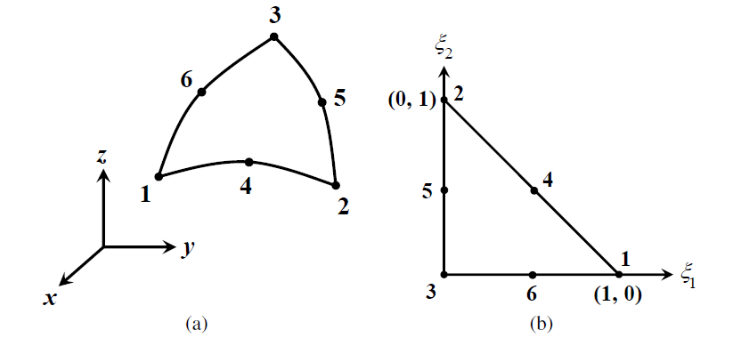

Figure 2-1 The sketch of a curvilinear triangular element. (a)The curvilinear triangle in the coordinate system; (b) The curvilinear triangle in the coordinate system
Using the following coordinate transformation, the curvilinear triangle in the rectangular coordinate system, as shown in Figure 2-1(a), can be mapped onto the triangle defined in a parametric coordinate system, as shown in Figure 2-1(b)
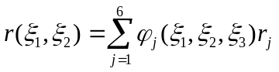 (2-1)
where denote the rectangular coordinates of the six controlling nodes in Figure 2-1a, 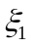，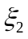，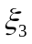are the parametric coordinates varying from 0 to 1, and they satisfy the relation
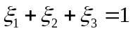 (2-2)
From (2-2), it is clear that only two variables out of these three are independent.
…

2.3.3 The Choice of Basis Functions
After the geometrical discretization of the object surface using planar or curvilinear triangular elements, basis functions can be defined on these triangular elements to expand the unknown vector functions.
…

2.3.3.1 Planar RWG Basis Functions
Introduced by Rao Wilton, and Glisson in 1982, the RWG basis function ^{[6]} is defined over two adjacent triangular elements.
…

2.3.3.2 Curvilinear RWG Basis Functions
In order to give a better representation of curved surfaces, the curvilinear triangular elements can be used. Correspondingly, the curvilinear RWG basis functions ^{[7]} can be defined on the curvilinear triangular elements.
…

2.3.4 The Solution of Matrix Equations
The matrix equation can be solved with two types of algorithms, the direct algorithms and the iterative algorithms. They will be introduced briefly in this subsection ^{[8]}.
…

2.3.4.1 Direct Algorithms
The commonly used direct algorithms include the Gaussian elimination, the LU decomposition, and the singular value decomposition (SVD) ^{[9-10]}.
…

2.3.4.2 Iterative Algorithms
When the dimension of the impedance matrix is very large, the direct solution becomes very expensive.
…

2.4 Conclusion
…

Chapter 3 Calderόn Preconditioner at Mid Frequencies

3.1 Introduction
The integral equations (IEs) are used to model the electromagnetic scattering,
…

3.2 Calderόn Relation and Calderόn Identities
In a scattering problem, according to the surface equivalence principle,
…

3.3 Calderόn Preconditioner at Mid Frequencies
Based on the discussion in the preceding section,
…

3.4 Numerical Examples
Two simple examples are given to demonstrate the fast convergence of the Calderόn preconditioner at mid frequencies.
…

3.5 Conclusion
The Calderόn preconditioner for the EFIE at mid frequencies is reviewed in this chapter.
…

Chapter 4 Calderόn Preconditioning Technique for N-Müller

4.1 Introduction
Analysis of low-frequency electromagnetic problems has received more attention,
…

4.2 N-Müller Integral Equations
Consider the problem of electromagnetic wave scattering by a conducting surface,
…
Theorem 1 …
Proof:
Consider the problem of electromagnetic wave scattering by a conducting surface,
…
the problem is proved. ■

4.3 The Derivation of N-Müller Equations
The derivation begins from the preconditioning of the EFIE,
…

4.4 The Discretization of N-Müller Equations
The derivation begins from the preconditioning of the EFIE,
…

4.5 Numerical Examples
In this section, the performance of the N-M¨uller equations is investigated.
…

4.6 Conclusion
In this chapter,
…

Chapter 5 Conclusions

5.1 Concluding Remarks
The accurate and efficient numerical solutions of the Maxwell’s equations have important significance to the analysis of electromagnetic scattering and radiation problems.
…

5.2 Future Work
The researches reported in this dissertation have covered most important areas including the convergence acceleration of the first-kind integral equations and the accuracy improvement of the second-kind integral equations for both the PEC and the dielectric cases. Nevertheless, due to the time limitation, there are still spaces for the future development of the Calder´on-technique-related methods.
…

Acknowledgements
On the completion of this thesis,
…

References
- W. C. Chew, J. M. Jin, E. Michielssen, et al. Fast and efficient algorithms in computational electromagnetics[M]. Boston: Artech House, 2000
- 盛新庆.计算电磁学要论[M].北京:科学出版社, 2004
- 王秉中.计算电磁学[M].北京:科学出版社, 2001
- 吕英华.计算电磁学的数值方法[M].北京:清华大学出版社, 2006
- 王长清.现代计算电磁学基础[M].北京:北京大学出版社, 2005
- 潘小敏.计算电磁学中的并行技术及其应用[D]. 北京:中国科学院电子学研究所, 2006
- 中华人民共和国国家技术监督局.GB3100-3102. 中华人民共和国国家标准--量与单位[S]. 北京:中国标准出版社, 1994年11月1日
- W. C. Gibson. The method of moments in electromagnetics[M]. New York: Chapman and Hall/CRC, 2008
- 胡俊.复杂目标矢量电磁散射的高效算法——快速多极子方法及其应用[D].成都:电子科技大学, 2000
- H. C. Martin, G. F. Carey. Introduction to finite element analysis: theory and application [M]. New York: McGraw Hill, 1973

外文资料原文
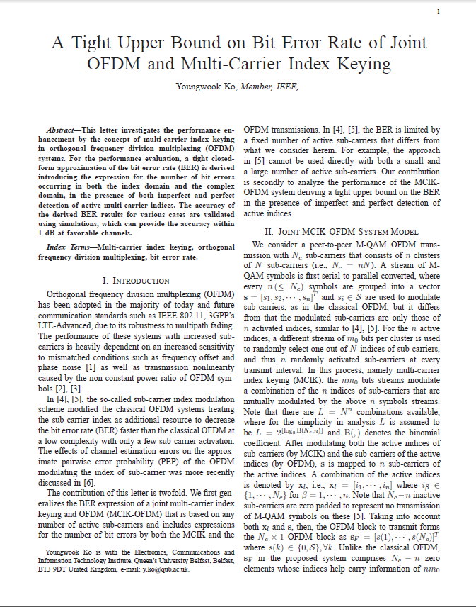

外文资料译文
基于多载波索引键控的正交多路复用系统的误码率上界
二．基于多载波索引键控的正交频分多路复用系统模型
我们考虑一个端到端的M-QAM，Nc子载波的基于多载波索引键控的正交频分多路复用系统有n个簇，每个簇有N个子载波（Nc=nN）。M-QAM的符号流经过串并转换之后每n个符号组成一个相量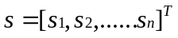，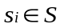是和传统正交频分多路复用一样是用来调制子载波的，但是不同的是只有这n个活跃子载波进行了调制。……
……

