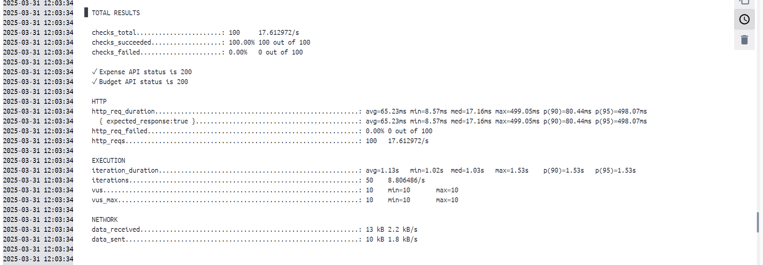

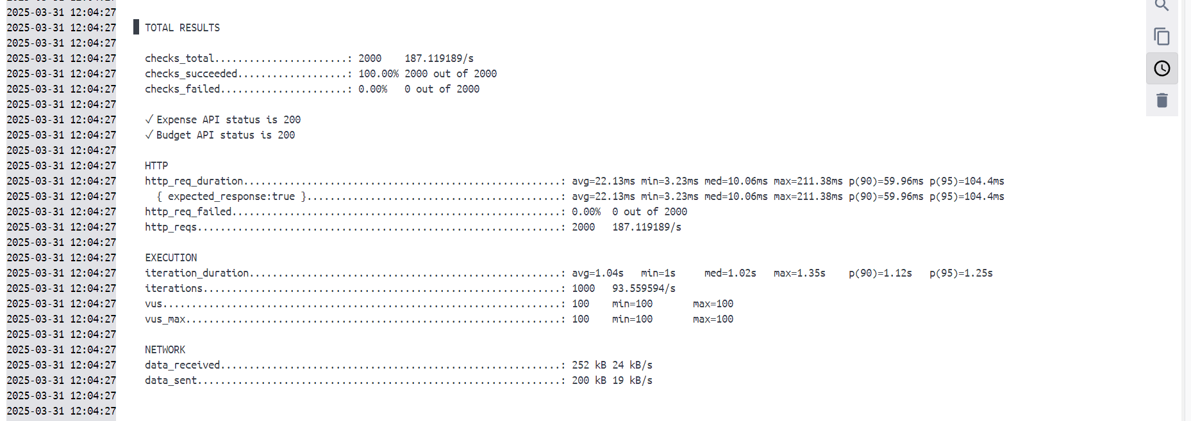

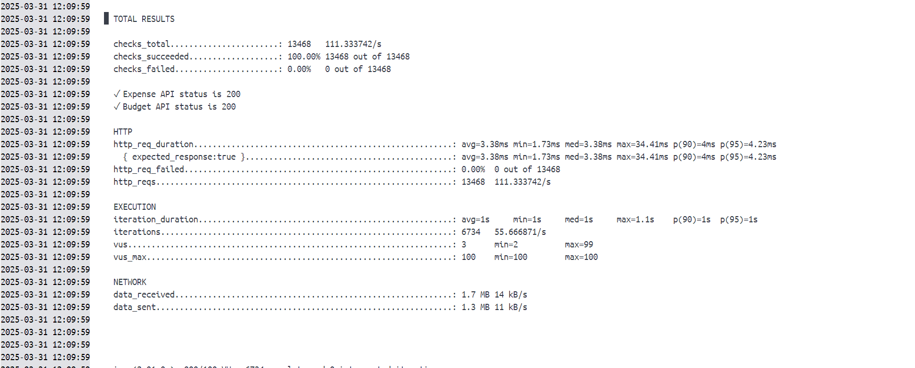

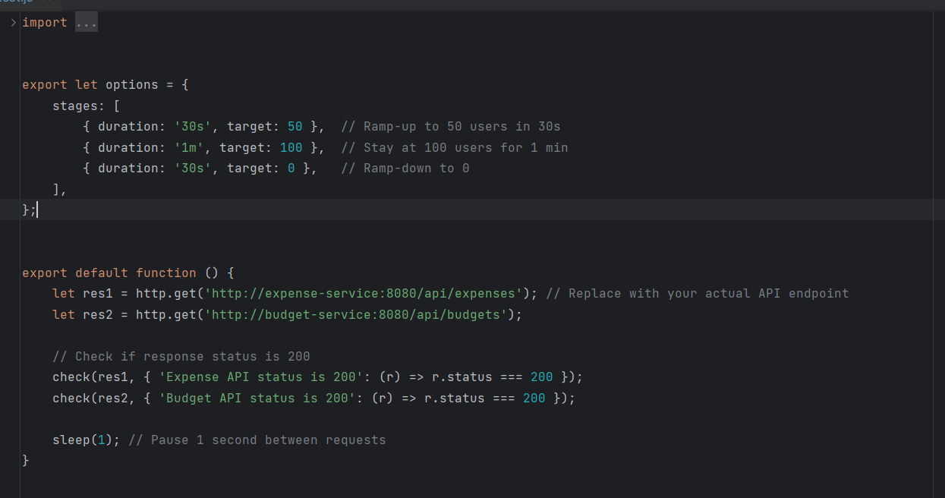

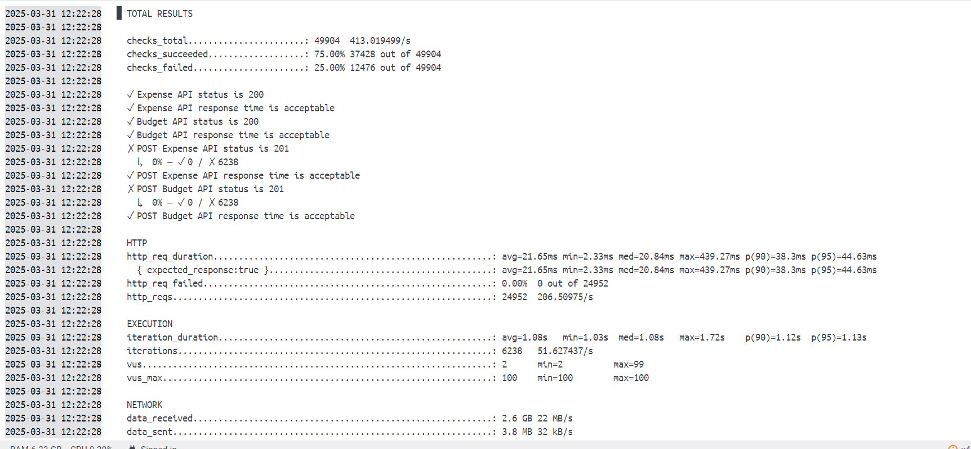

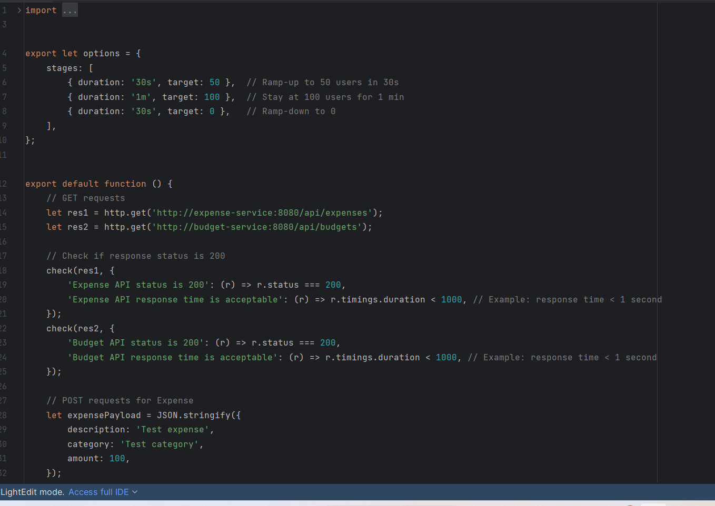

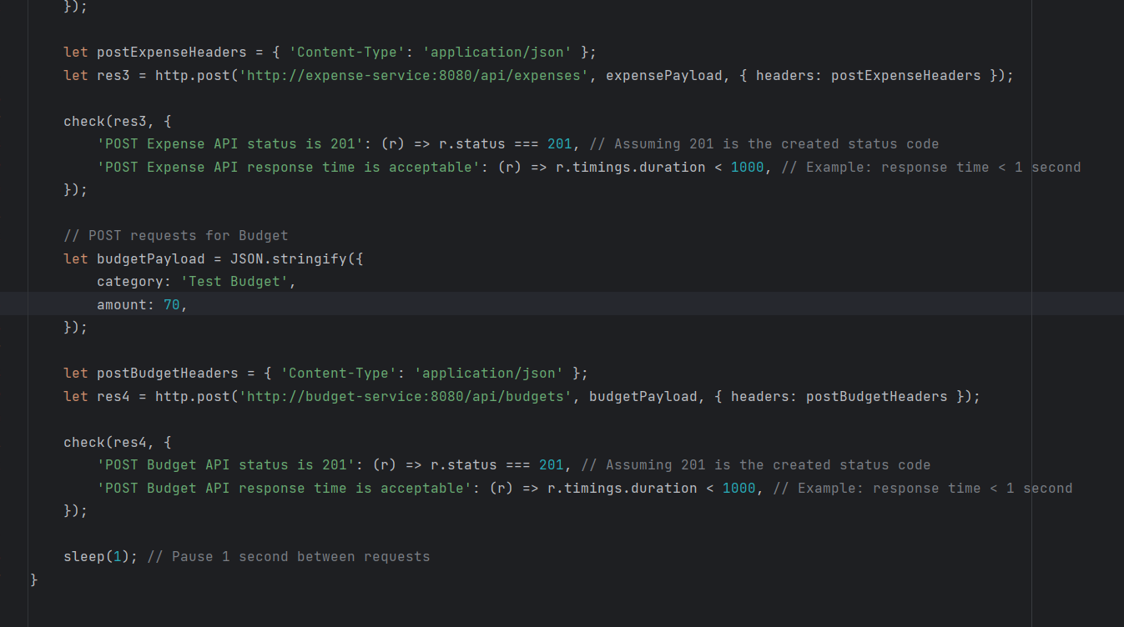

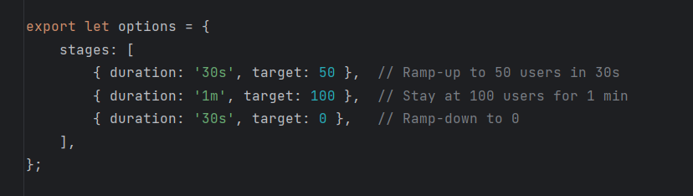

Checks POST and GET requests for Expenses and Budgets

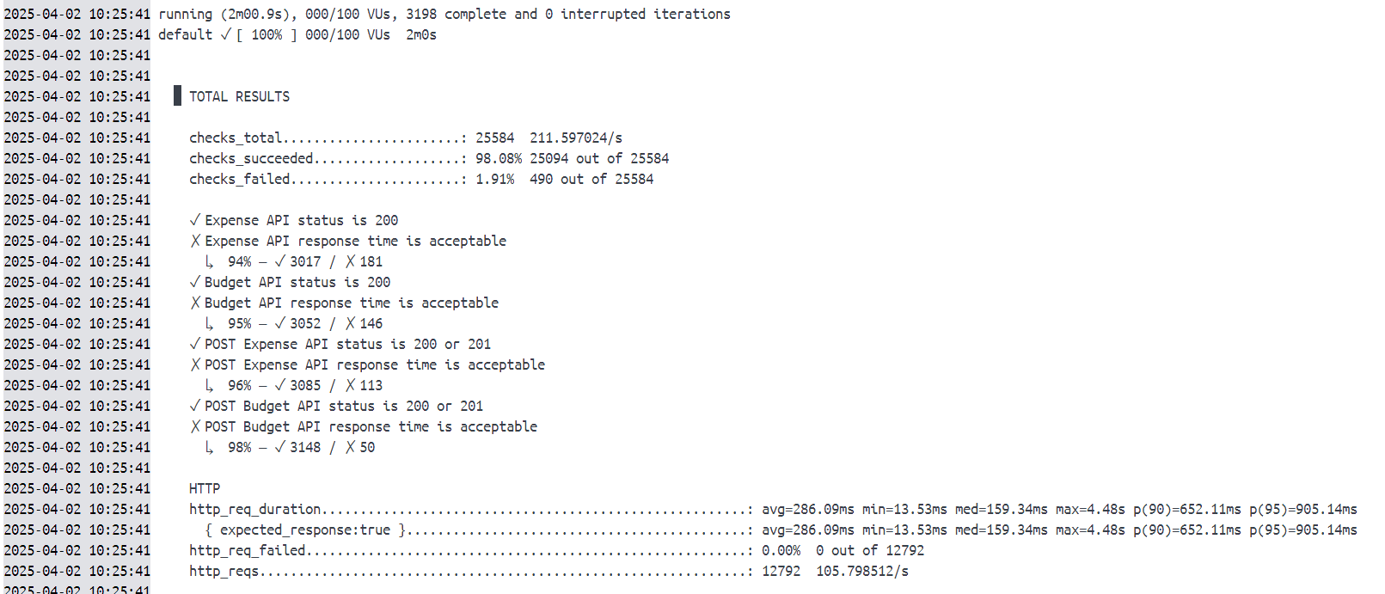

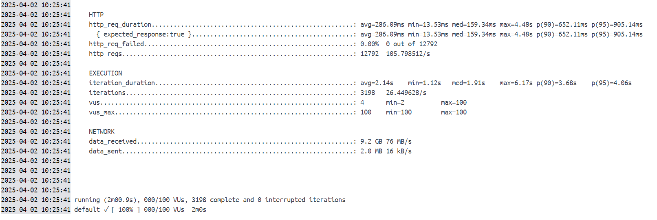

1. **Response Times Are Too High (4.48s max, 905ms at p95)**
   * **Expected:** Under **1s**
   * **Reality:** Some requests take up to **4.48s**
   * This means your API is **struggling under load.**
2. **1.91% of requests failed the response time check**
   * Mostly **POST requests**
   * This suggests a **scalability** issue