1.

#include <stdio.h>

#define PRINT(i, limit) do

                        {

                            if (i++ < limit)

                            {

                                printf("C Programming");

                                continue; //break; ?

                            }

                        }while(1)

int main()

{

    PRINT(0, 3);

    return 0;

}

2. Will take the recent value

#include <stdio.h>

#if X == 3

    #define Y 3

#else

    #define Y 5

#endif

int main()

{

    printf("%d", Y);

    return 0;

}

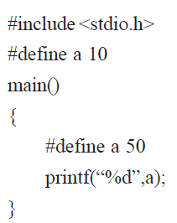

3.

#include <stdio.h>

#define ISEQUAL(X, Y) X == Y

int main()

{

    #if ISEQUAL(X, 0)

        printf("C Programming");

    #else

        printf("Quiz");

    #endif

    return 0;

}

4.

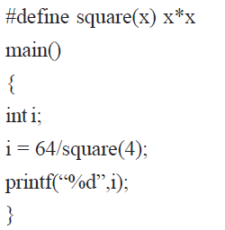



5.

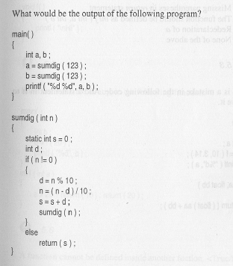

6 12

6.

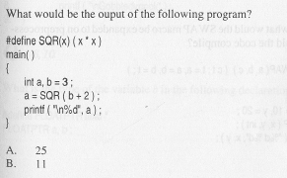

11



7.

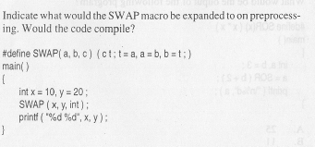





8.

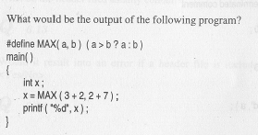



9.

Write a C program to swap to two numbers using call by value and call by reference.

10.

Write a C program returning structure to a main function

Write a C program to implement function returning pointers