Kuramoto Model: Understanding time evolution and synchronization in all-to-all coupled oscillators

Many natural systems contain a large number of interacting oscillators (e.g., Neurons in the brain, flashing fireflies, power grid generators). A remarkable phenomenon that one can observe in such systems is synchronization, where individual oscillators with different natural frequencies come together to oscillate with a common phase. The Kuramoto Model (proposed by Yoshiki Kuramoto in 1975) is a theoretical model that can be used to study synchronization in systems of coupled oscillators.
The goal of the module is to simulate the all-to-all Kuramoto model with sine function coupling and study how synchronization develops as the coupling strength increases between oscillators.

The Kuramoto Model
The Kuramoto model describes a system of $N$coupled oscillators. Each oscillator is characterized by a phase $θ_{i}(t)$, which evolves over time according to the differential equation:
$$\frac{dθ_{i}}{dt}=ω_{i}+\frac{K}{N}\sum_{j=1}^{N}{sin⁡(}θ_{j}-θ_{i})$$
where:
- $θ_{i}$: phase of the $i^{th}$oscillator
- $ω_{i}$: natural frequency of the oscillator
- $K$: coupling strength between oscillators
- $N$: total number of oscillators
Interpretation
- Each oscillator tends to move at its natural frequency $ω_{i}$.
- The coupling term causes oscillators to adjust their phases relative to others.
- When the coupling strength $K$is small, oscillators behave independently.
- When $K$becomes large enough, oscillators begin to synchronize.

Order Parameter
To measure synchronization quantitatively, we use the order parameter $r$:
$$re^{iψ}=\frac{1}{N}\sum_{j=1}^{N}{e^{iθ_{j}}}$$
where:
- $r$is the degree of synchronization
- $ψ$is the average phase
Meaning of $r$
- $r≈0$→ oscillators are completely incoherent
- $r≈1$→ oscillators are fully synchronized
Thus, the order parameter serves as a measure of the system's collective behavior.

Order Parameter vs Time (Single Plot, for $K=1.5$)
We first studied how the order parameter $r$evolves with time for a fixed value of coupling strength $K$ (here 1.5).
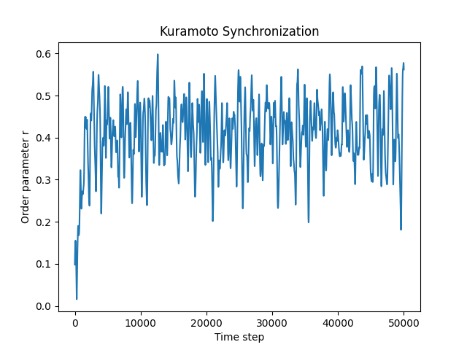
Figure 1: order parameter vs time
As can be seen, the graph starts with zero synchronization, but soon reaches a state where it is somewhat a periodic variation, indicating a common phase in the system, but the variation is too large, i.e., not properly synchronized. We will check by plotting how synchronization varies with coupling strength. Later, we will compare it for different values of $K$(ref section 6).

Synchronization Study
We varied the coupling strength and studied how the oscillators transition from incoherence to synchronization. This allowed us to observe the critical coupling strength at which synchronization begins to emerge.
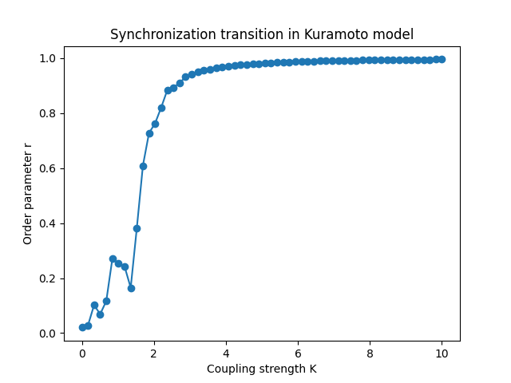
Figure 2: Order parameter (average value) vs Coupling strength
As can be seen, based on the parameters fixed by us (refer to the code), synchronization begins to emerge at around $K=2$. So, for small coupling strength there is almost negligible synchronization, but as $K reaches$ a critical value, $r rapidly increases, indicating$ a phase transition from incoherence to synchronization.

Oscillator on a Circle
Oscillators were visualized as points on a circle, where the angular position represents the phase $θ_{i}$. We can visualize synchronization behavior using it. For small values of K, oscillators are scattered randomly around the circle, but as K increases, clusters begin to form, and synchronization starts to happen.
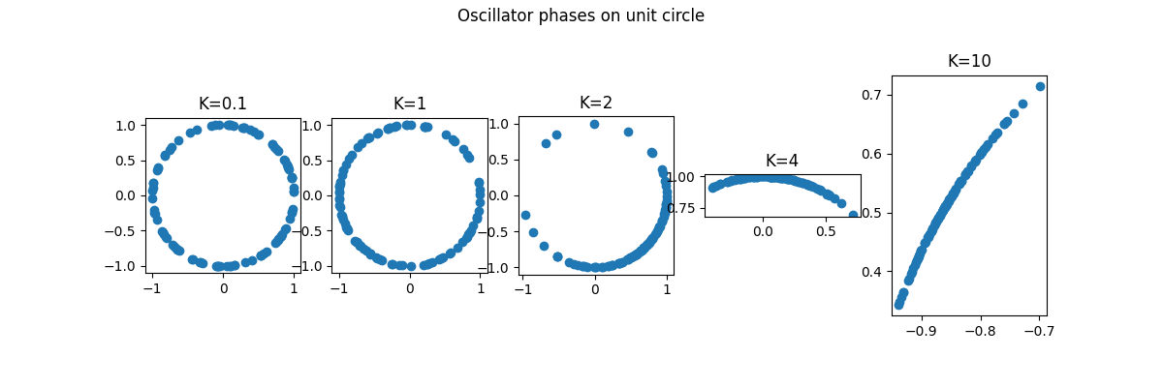
Figure 3: Oscillator phases plotted on a unit circle with different coupling strengths.

Heat Map Visualization and Order Parameter vs Time (for multiple K)
To observe the phase evolution of all oscillators simultaneously, a heatmap is used to represent oscillator phases as a function of time.
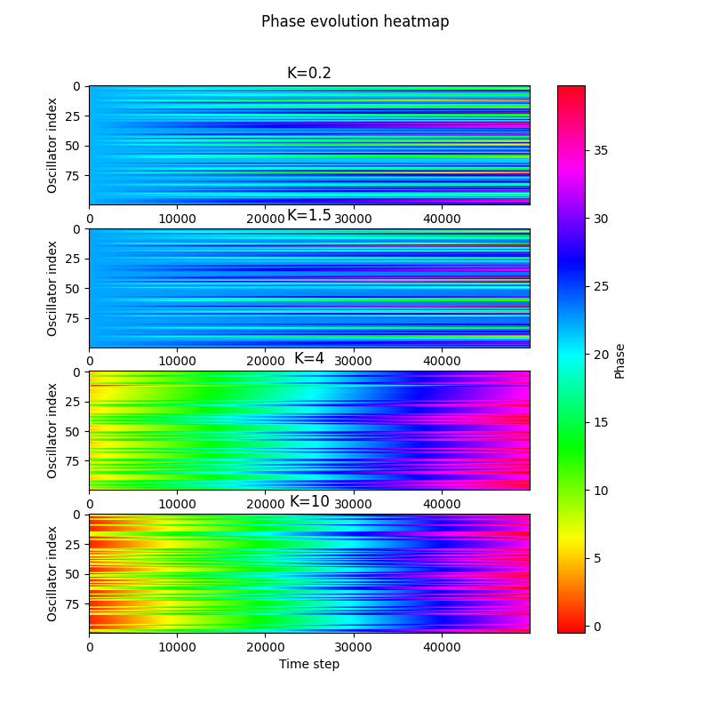
Figure 4: Phase evolution heatmap for different K
For weak coupling, the heatmap appears disordered. As K increased, a structured pattern emerged, indicating that the phases eventually align.
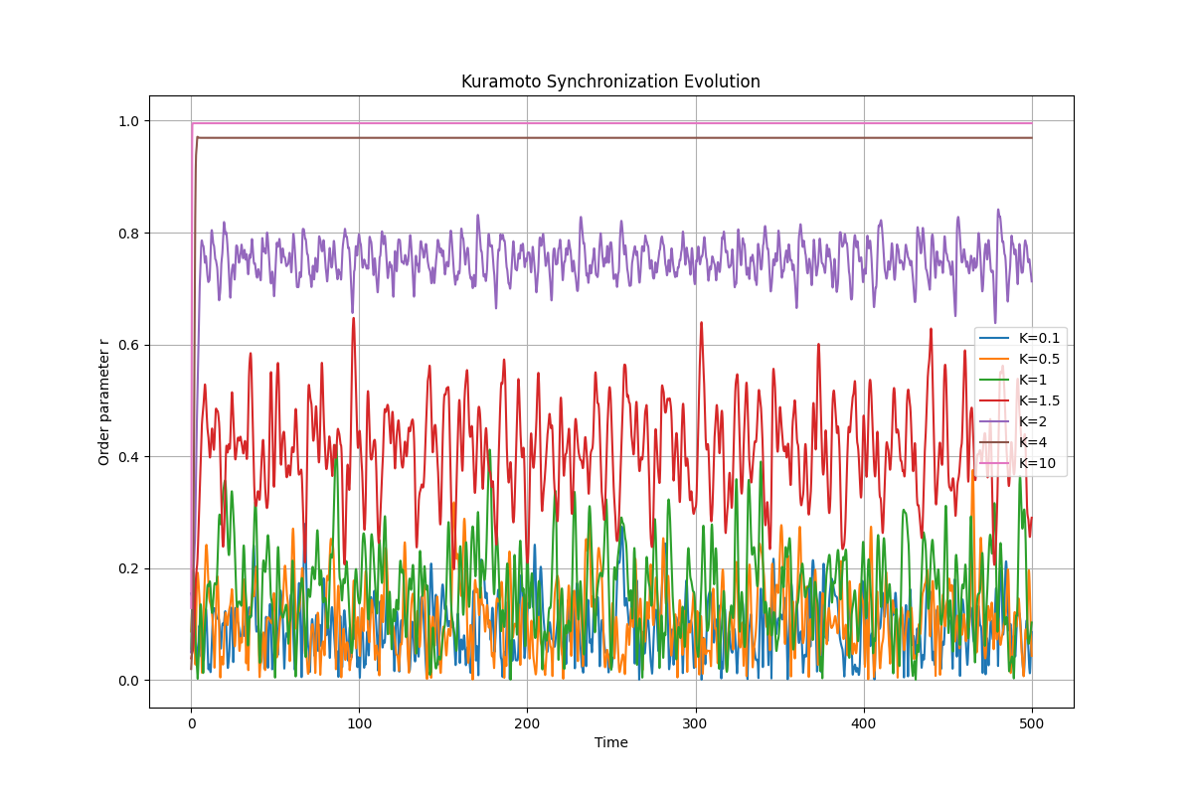
Figure 5: Phase evolution heatmap for different K
$r\left(t\right)$for several values of coupling strength $K$on the same graph, synchronization dynamics for different coupling strengths have been plotted to compare.

Conclusion
In this module, we studied synchronization phenomena using the Kuramoto model. Using numerical simulation and visualization techniques, we analyzed how a population of oscillators with different natural frequencies can spontaneously synchronize when coupled.
The key findings of the study are:
- Synchronization depends strongly on the coupling strength $K$.
- For small $K,$Oscillators behave independently.
- Beyond a critical coupling strength, oscillators gradually synchronize.
- The order parameter $r$provides an effective quantitative measure of synchronization.
Overall, the Kuramoto model provides a framework for understanding collective dynamics in complex systems. The results of this study demonstrate how simple interaction rules can lead to rich emergent behavior such as synchronization.

Link to GitHub repository
The GitHub repository https://github.com/biswa-03/Modelling-Complex-Systems/ contains the code for the above simulation in Jupyter Notebook format. Check for the folder “Kuramoto_model”.

References
Kuramoto, Y. (1975). Self-entrainment of a population of coupled nonlinear oscillators.

Author
This project has been developed by Biswa Ranjan Rout (MS23210) as part of the course requirements for IDC621: Modelling Complex Systems.

