Sandpile Model, Tracing Avalanche, Comparison with a Variant Model to Understand the Self-Organized Criticality

This project investigates Self-Organized Criticality (SOC) through numerical simulations of the 2D Abelian Sandpile Model. We implement both the standard slow-driving model and a modified increasing-drive variant, analyze avalanche statistics, study spatial avalanche footprints, and compare geometric scaling behavior.

Fundamental Definition
Grid (L × L lattice): A 2D square lattice where each site (i,j) stores an integer height h(i,j), representing the number of sand grains at that location.
Critical Height (h_{c} = 4): A site becomes unstable when h(i,j) ≥ 4.
Toppling Rule: When a site becomes unstable, it redistributes grains locally:
h(i,j) → h(i,j) − 4
h(i±1,j) → h(i±1,j) + 1
h(i,j±1) → h(i,j±1) + 1
Avalanche: The complete chain reaction of topplings triggered by a single grain addition at a random site, ending only when the system becomes stable again.
Avalanche Size (S): Total number of toppling events during one avalanche.
Avalanche Area (A): Number of unique lattice sites that toppled at least once during that avalanche.
Avalanche Footprint: A binary spatial map marking all sites that participated in an avalanche, that is, the set of all lattice sites that toppled at least once during that avalanche
Self‑Organized Criticality (SOC): A dynamical state where the system naturally evolves to a critical point without fine tuning of parameters. SOC systems exhibit scale-free power-law distributions.
Power-law distribution form:
P(S) ∝ S^{(−τ)}
Geometric scaling relation: A ∝ S^{D} → log(A) = D log(S)

Model Description
  - Standard Model: Grains are dropped one at a time, on a randomly selected site, and the next grain is only dropped after the relaxation (when no site with criticality remains).
  - Variant Model: To test robustness of SOC, we modify the driving rule. Instead of adding one grain each step, the number of grains added increases by one after every 100 drops. Let us say, we dropped 500 grains, so first 100 will be dropped as 1 grain at a time, the next hundred grains will be dropped 2 at a time, and so on. This weakens the strict slow-driving condition and allows us to observe how avalanche statistics and spatial structures change. Initially, when we were dropping one grain at a time, usually the avalanches were still not extremely large, and the variance was high. Increasing the drive increased the frequency of large avalanches.

3. Final Stable Heat Maps (Final grid plot)
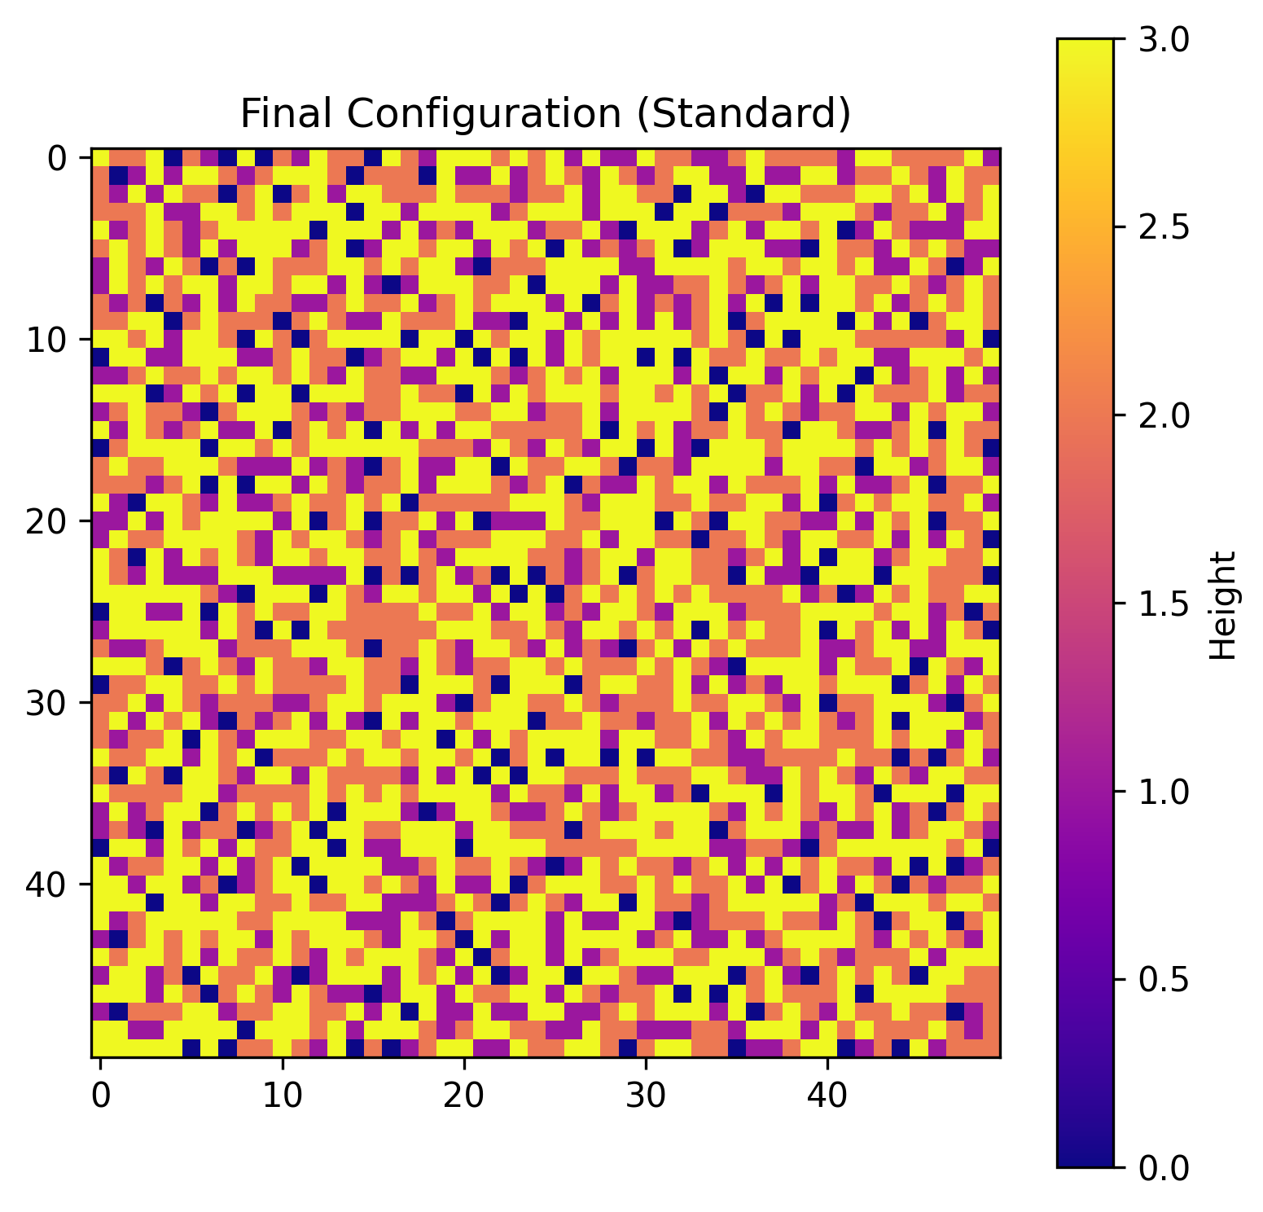 | 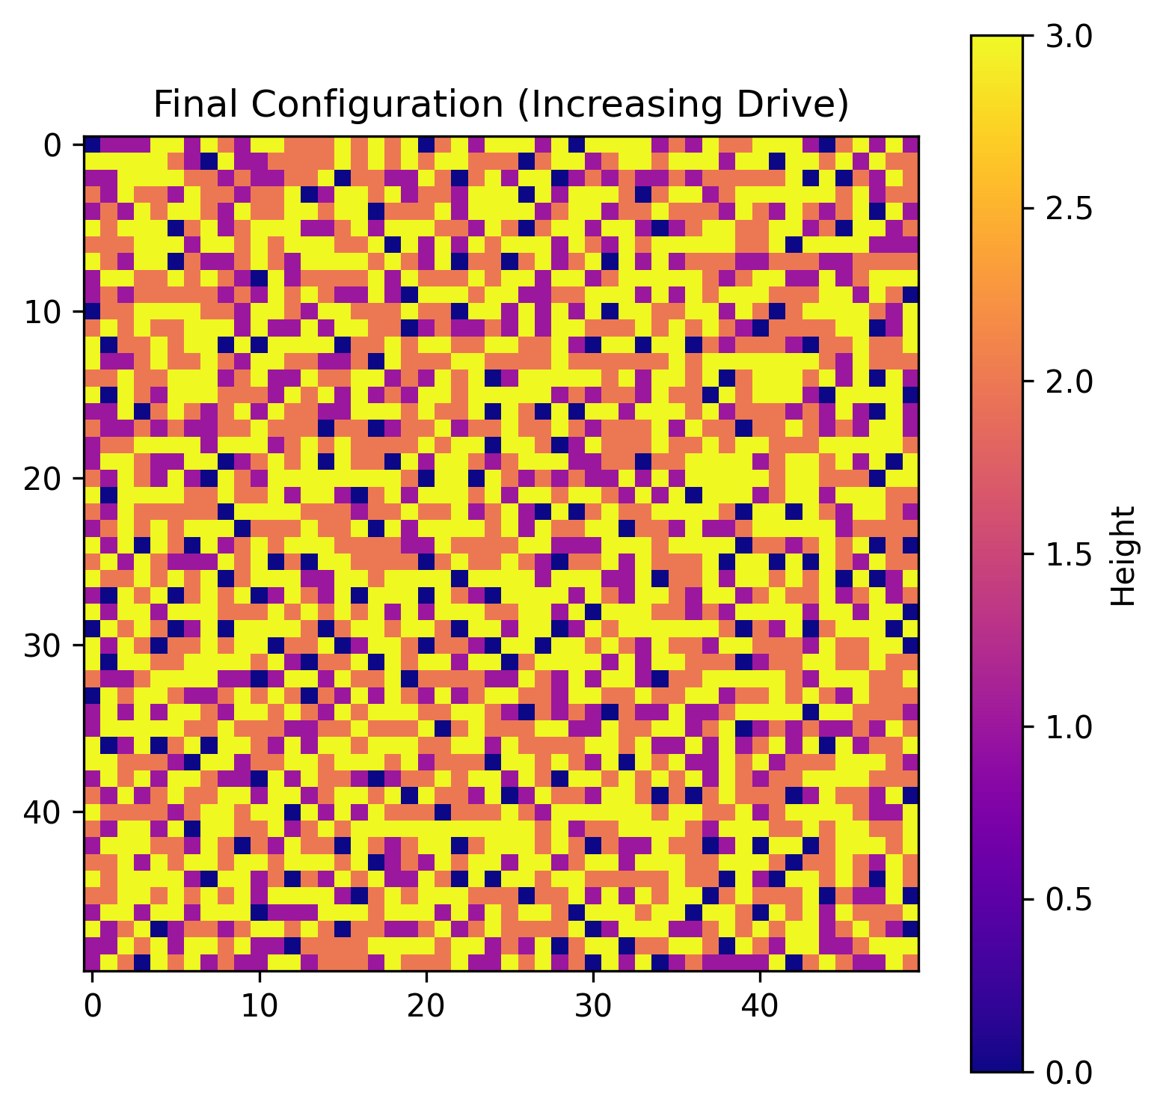
Figure 1: Final stable configurations (Standard vs Increasing Drive).
These heatmaps represent the stable height distribution after 7000 (this number can be chosen arbitrarily; we just have to make sure it is a large enough number to visualize criticality) grain additions. Since the system is stable, the heights range between 0 and 3.
In the Standard Model, the structure appears heterogeneous but statistically uniform. No characteristic cluster size dominates. This visual irregularity is a hallmark of criticality. Geometrically, the second heatmap appears more clustered and less fragmented, indicating stronger spatial correlation lengths. This difference will be better visible when we plot the log graphs, here it is difficult due to the size of the site and size of the grid.

4. Avalanche Size Distributions (All Comparison Plots)
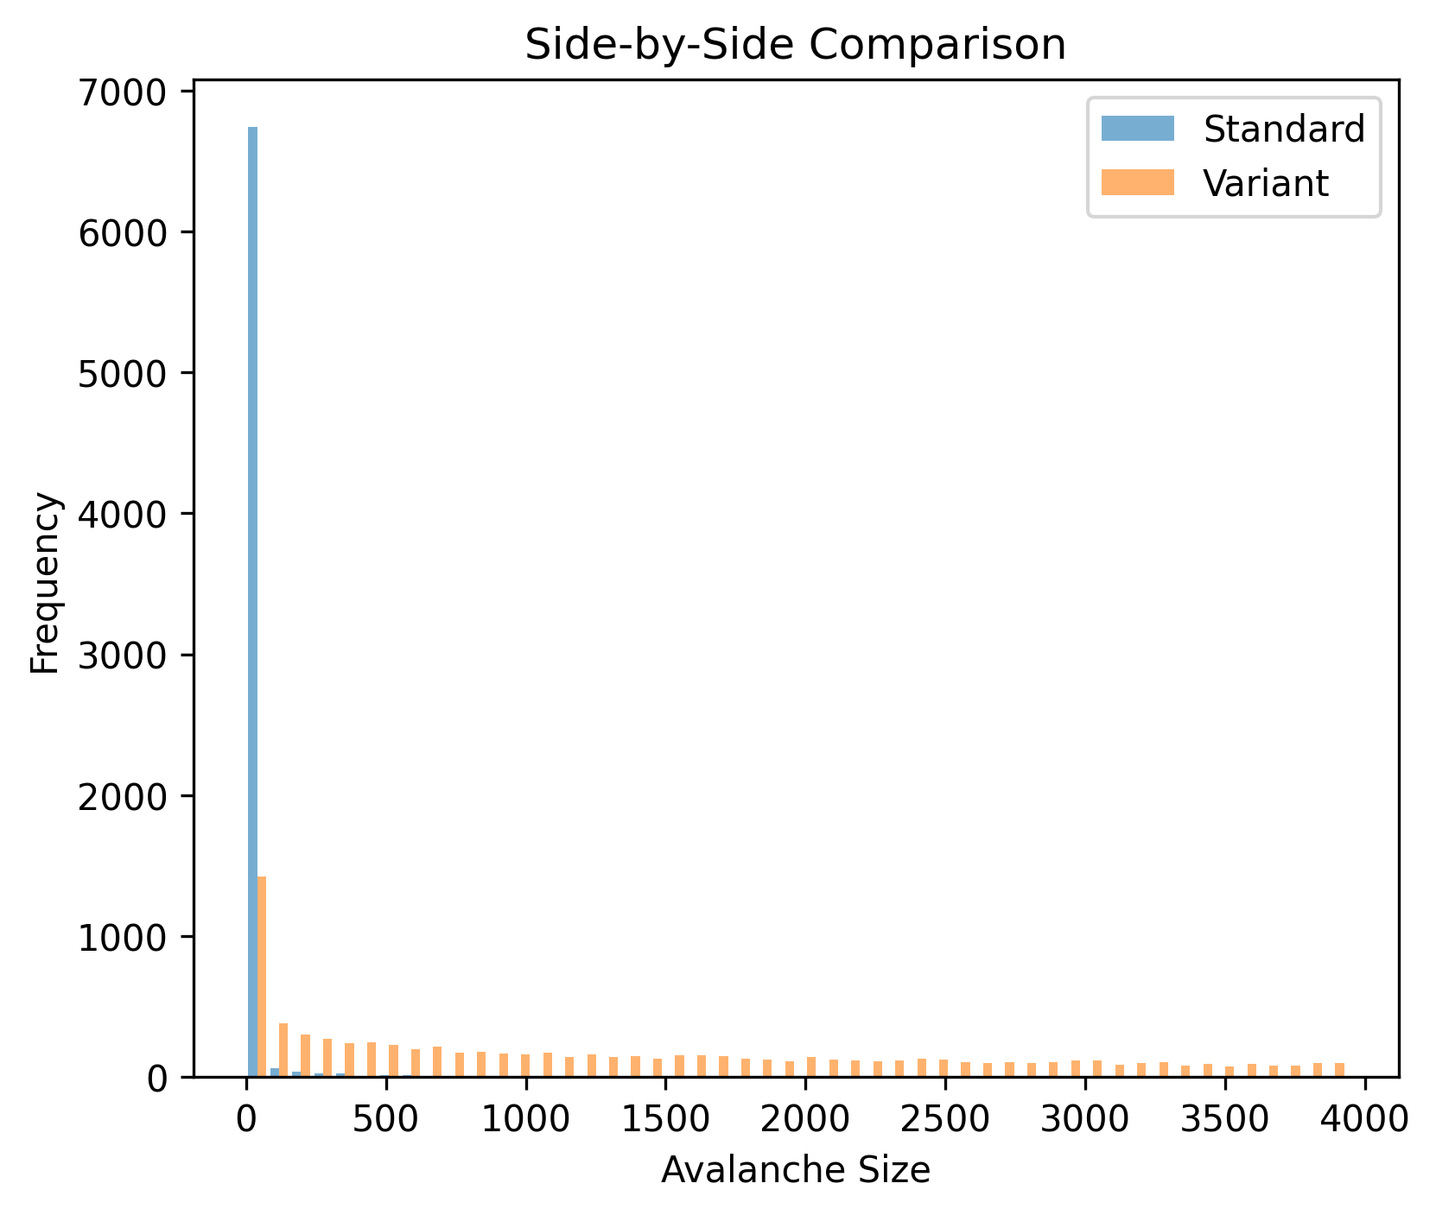
Figure 2: Direct comparison of avalanche distributions (overlay).
This overlay comparison shows how frequently avalanches of different sizes occur in both models. When plotted on logarithmic axes, a straight-line trend (refer to Fig. 3, log-log distribution (standard graph), where a straight line trend with decreasing slope can be observed) indicates power-law behavior.
The Increasing Drive model exhibits a heavier tail, meaning large avalanches occur more frequently compared to the Standard Model.
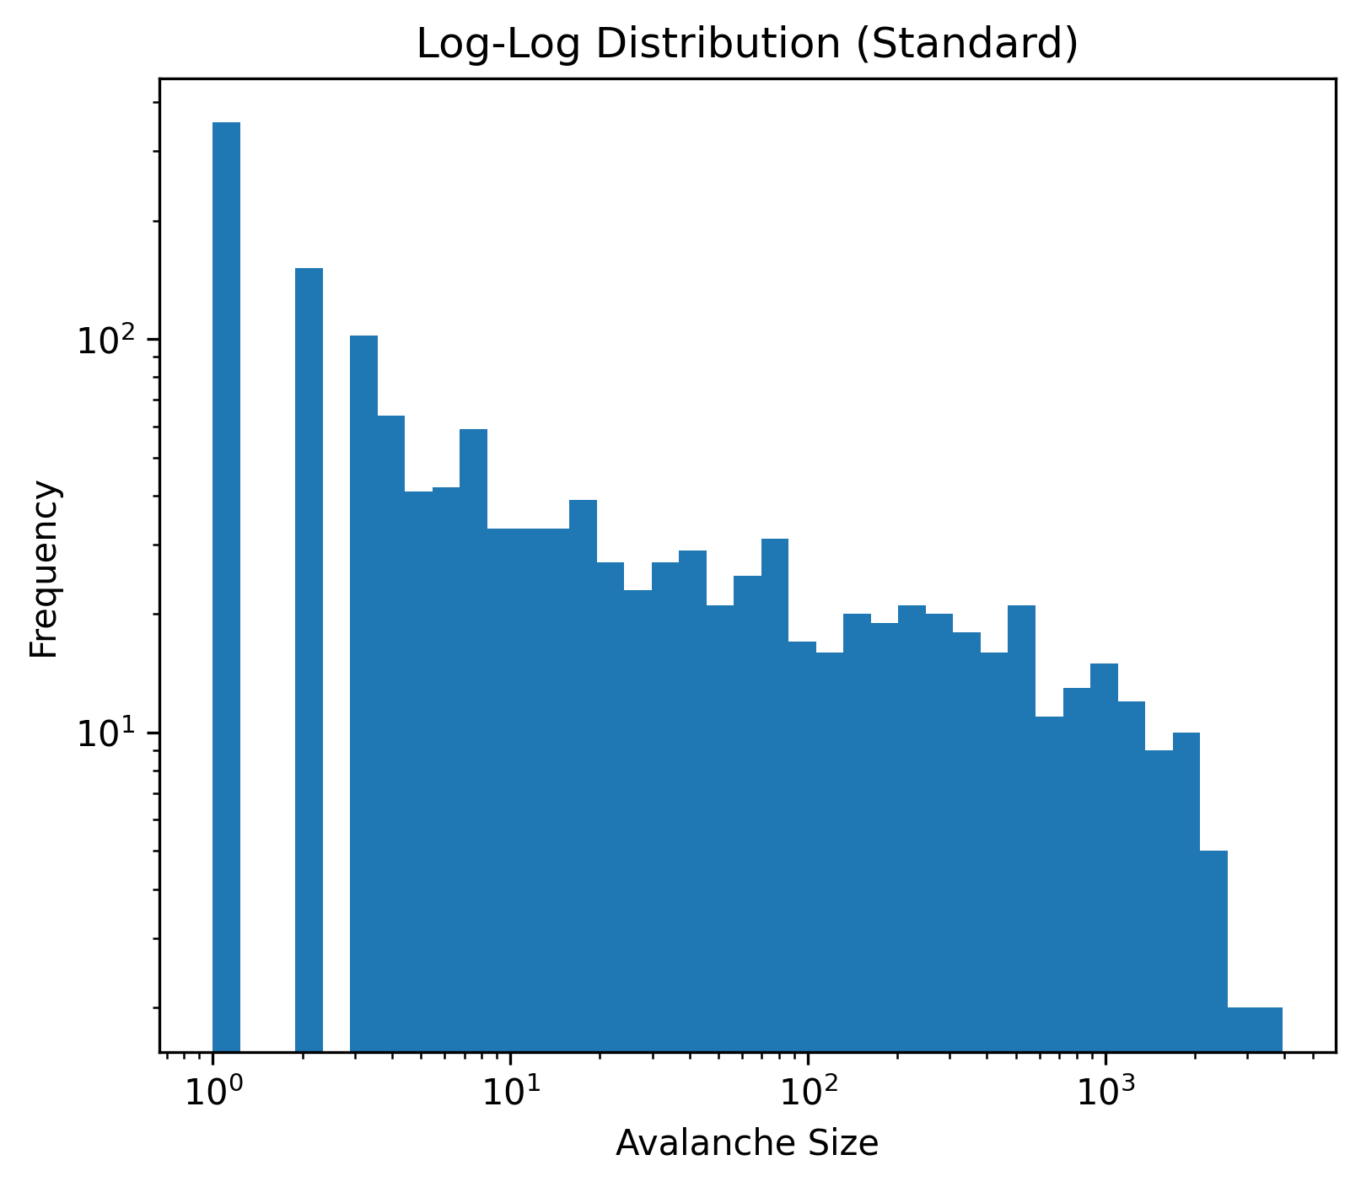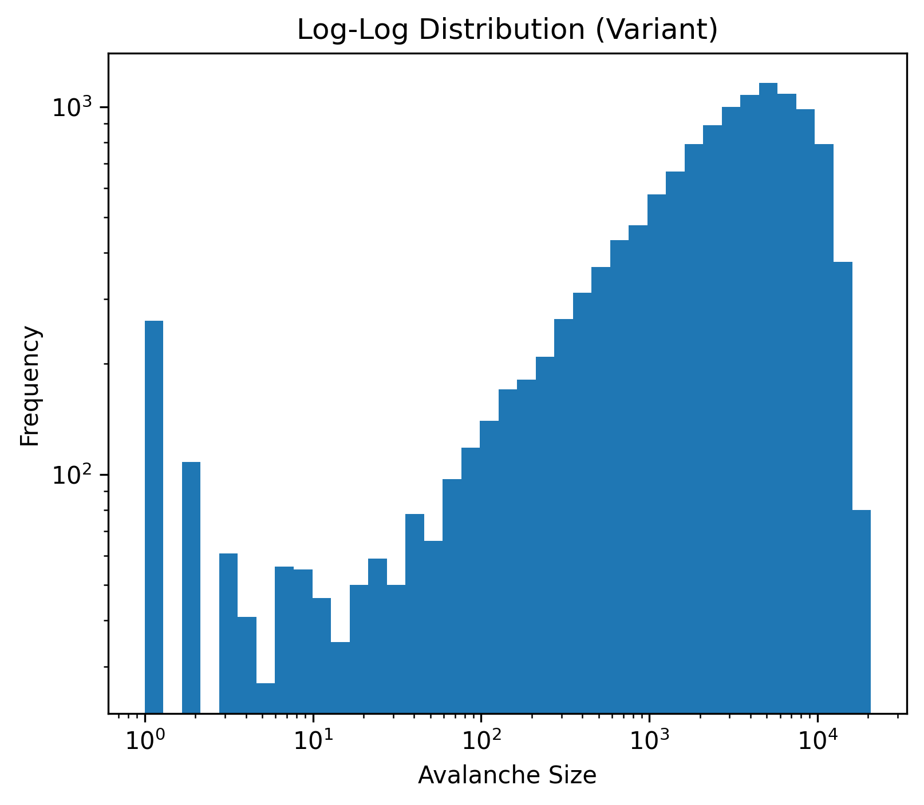

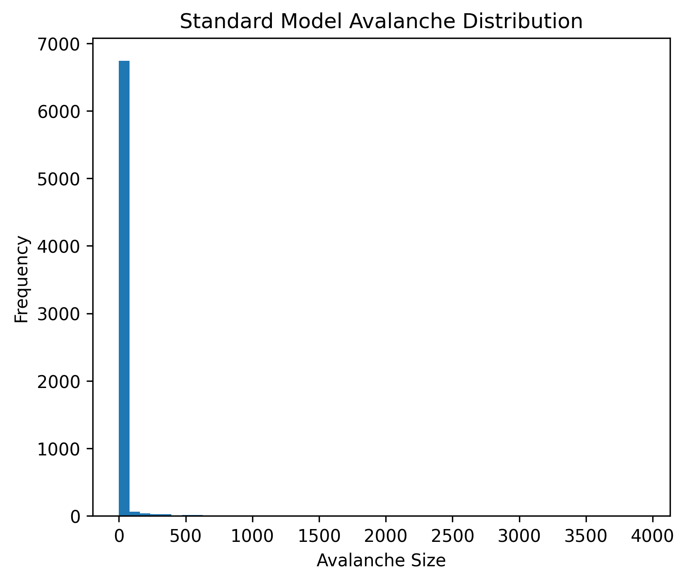  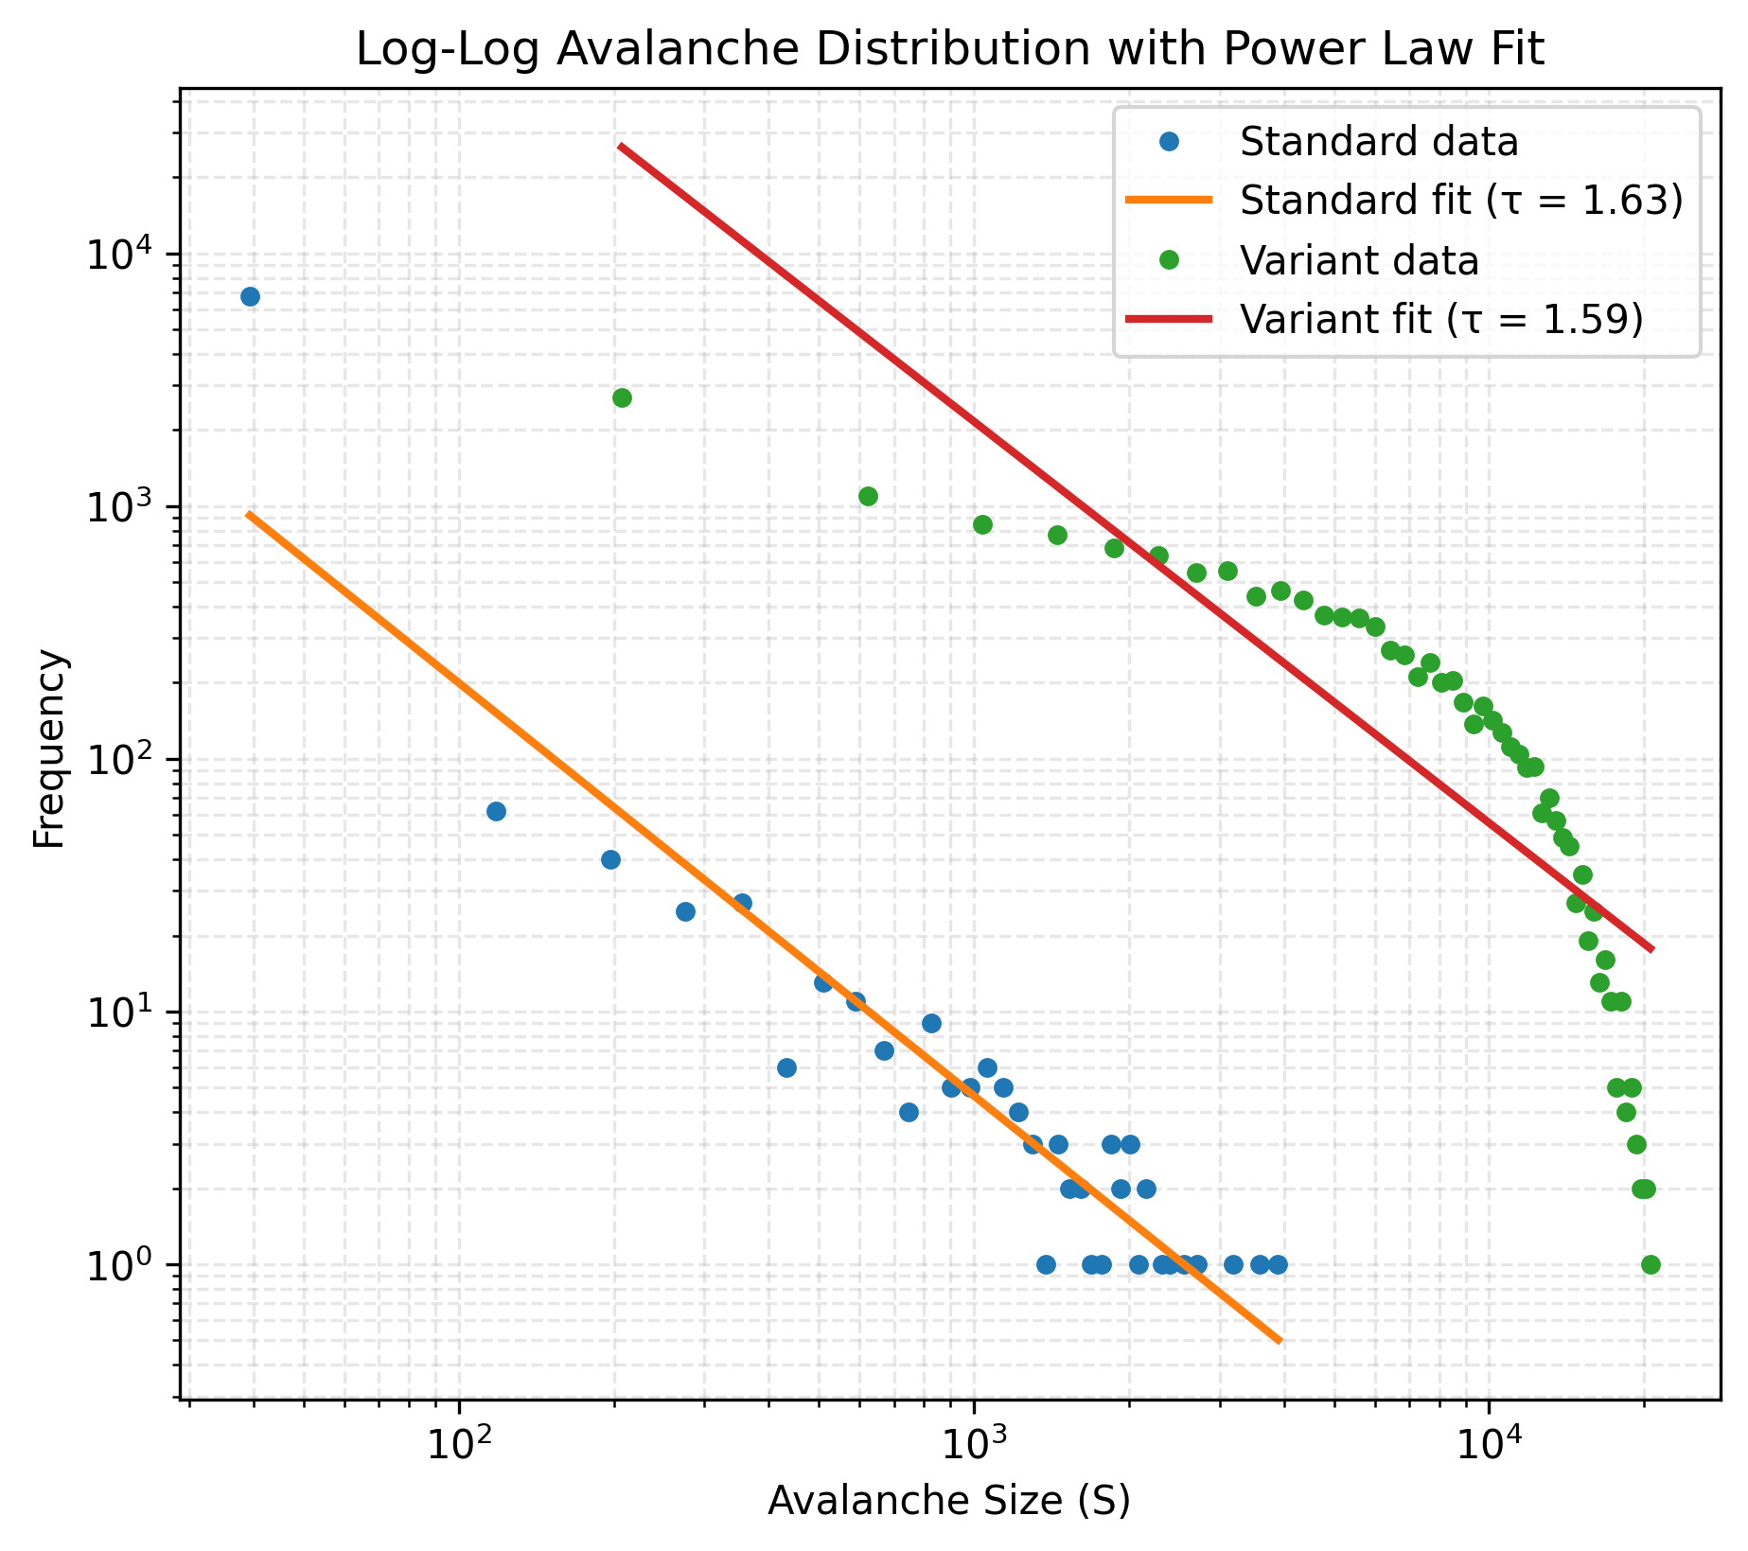 | 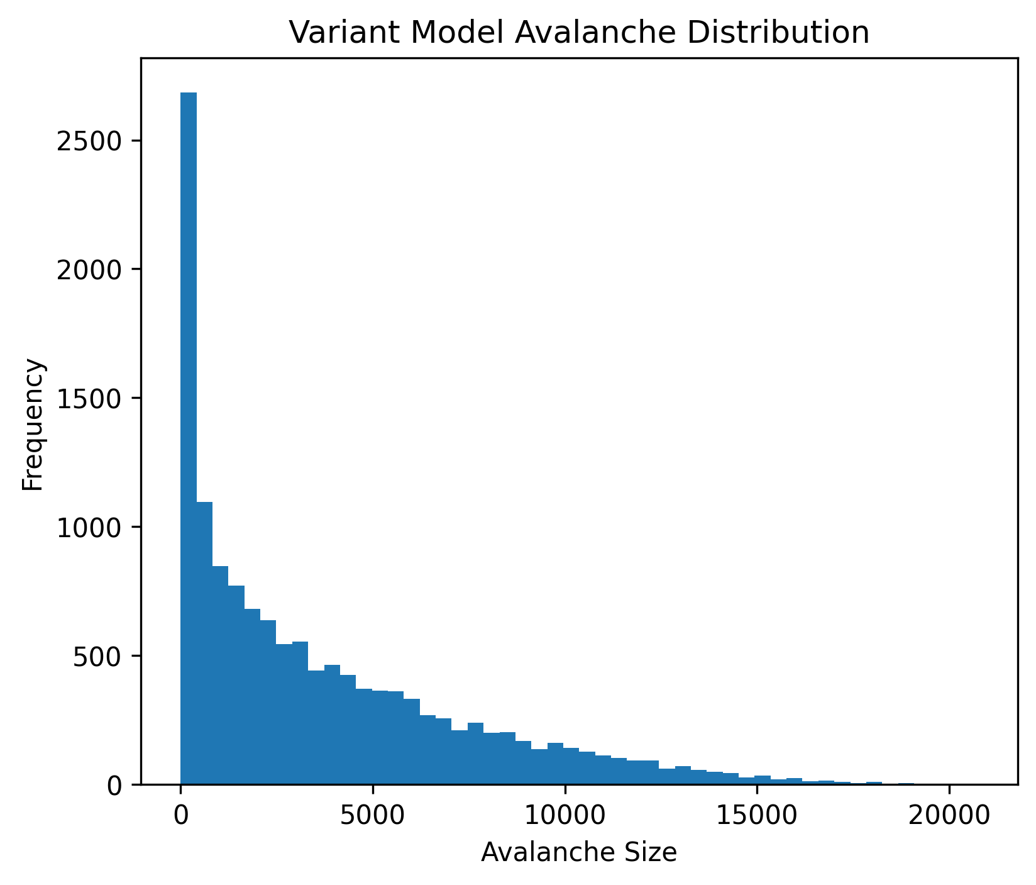  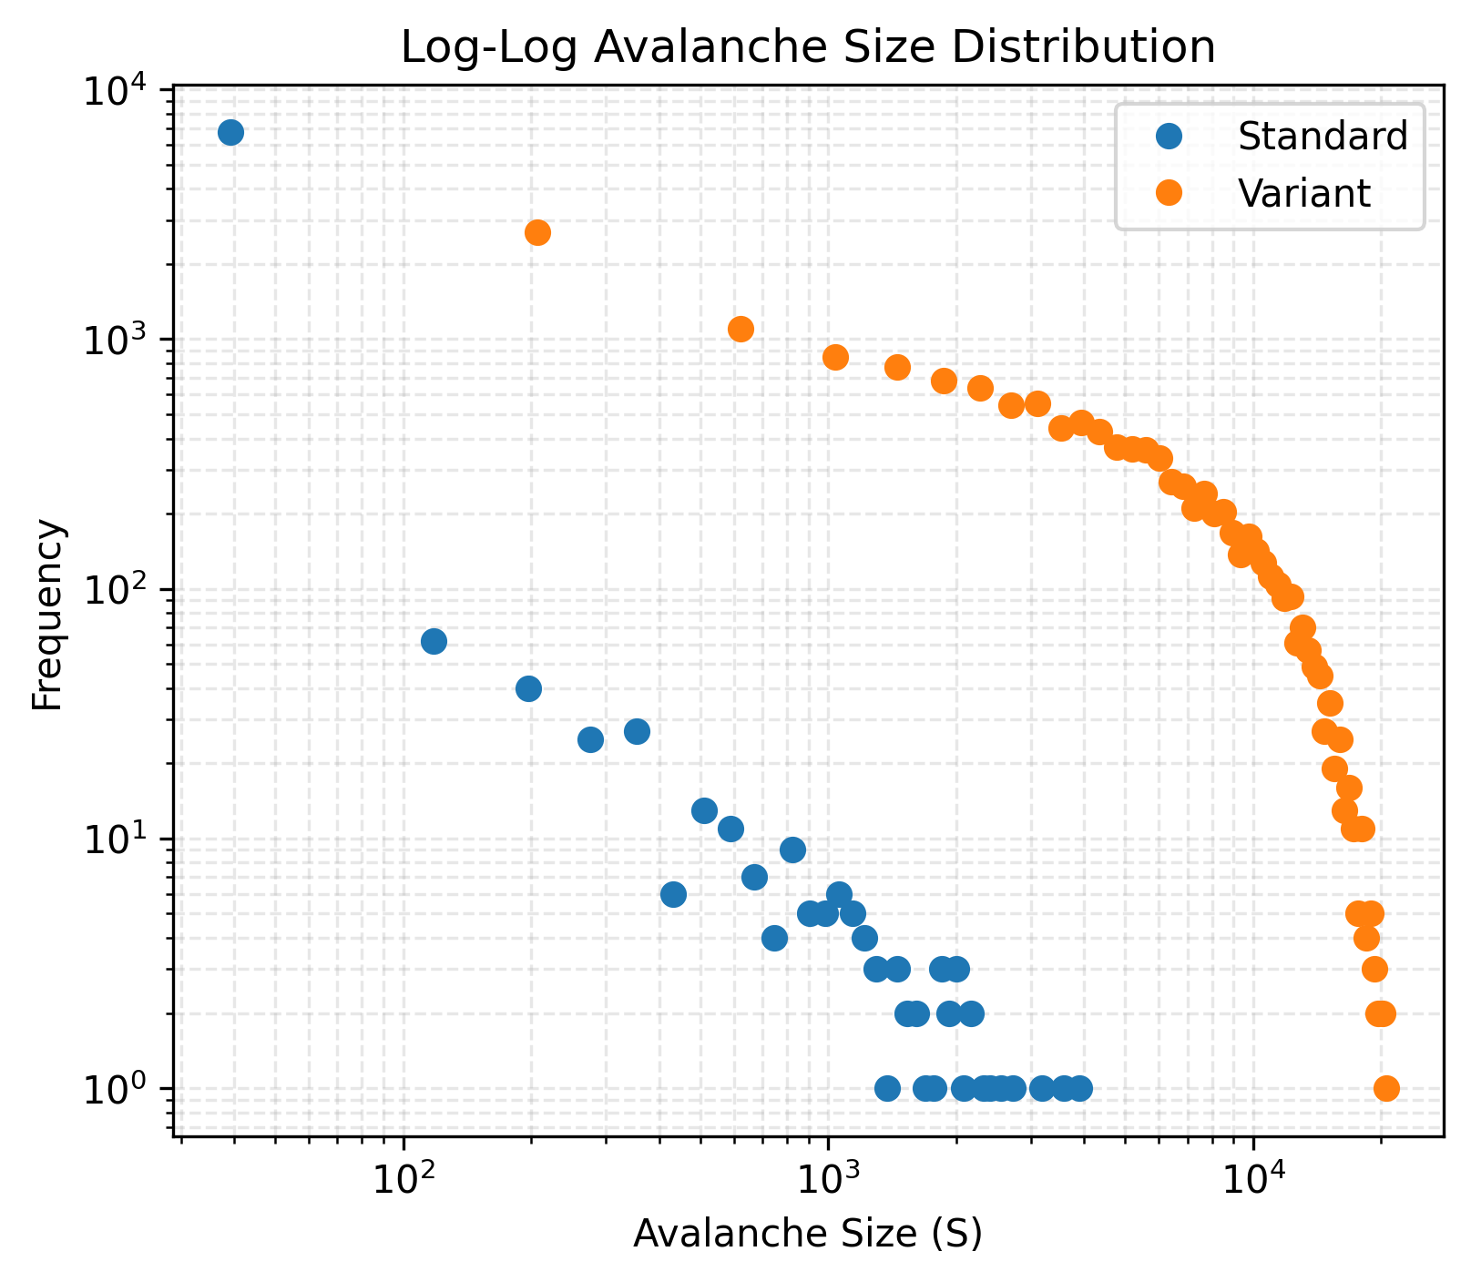
Figure 3: Individual avalanche size distributions, in log-log scale histograms, and as regular histograms
As can be observed in Fig. 3 (log-log avalanche distribution with power law fit), the standard data over a threshold can be fitted under a straight line variation, whereas this is not the case for the variant case.
The Standard Model shows dominance of small avalanches with rare large events. This broad distribution with no characteristic scale confirms SOC behavior.
The Increasing Drive model shifts probability weight toward larger events, indicating enhanced system-wide cascades.

5. Avalanche Footprints (Geometric Interpretation)
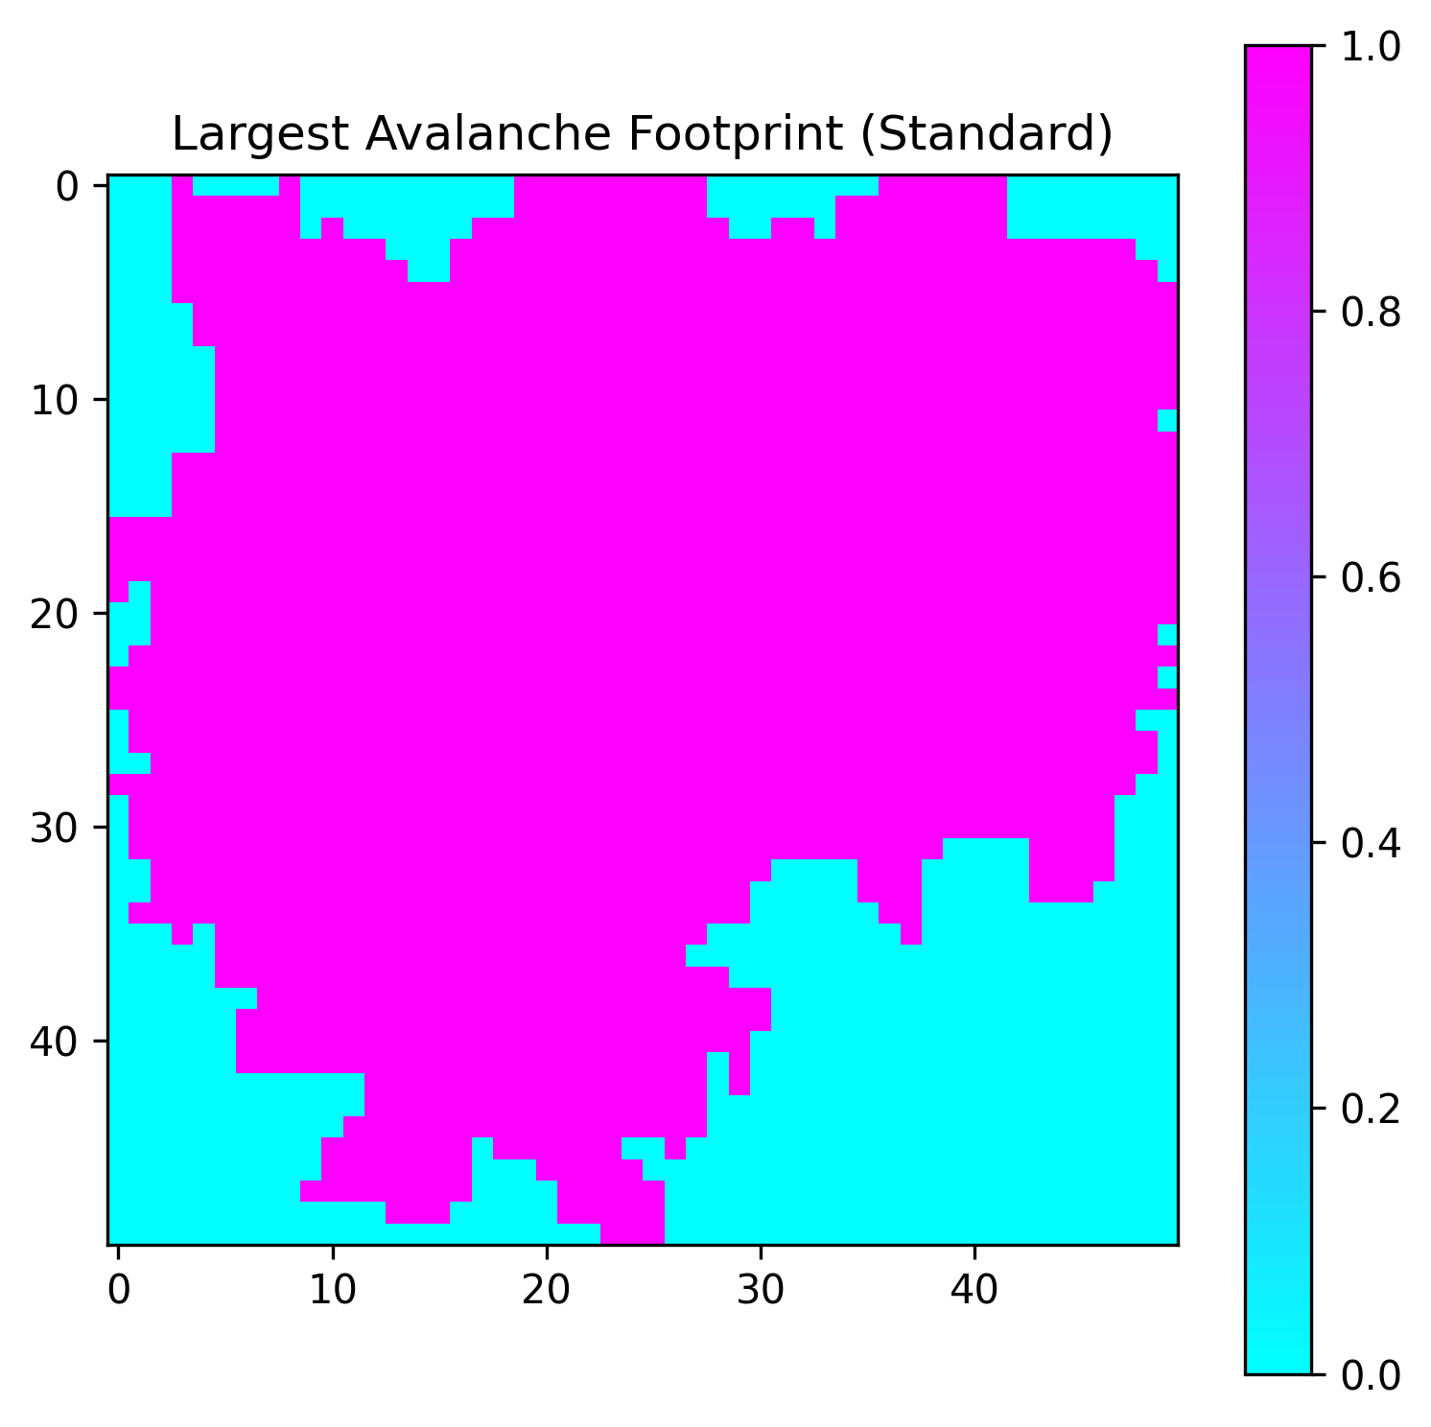 | 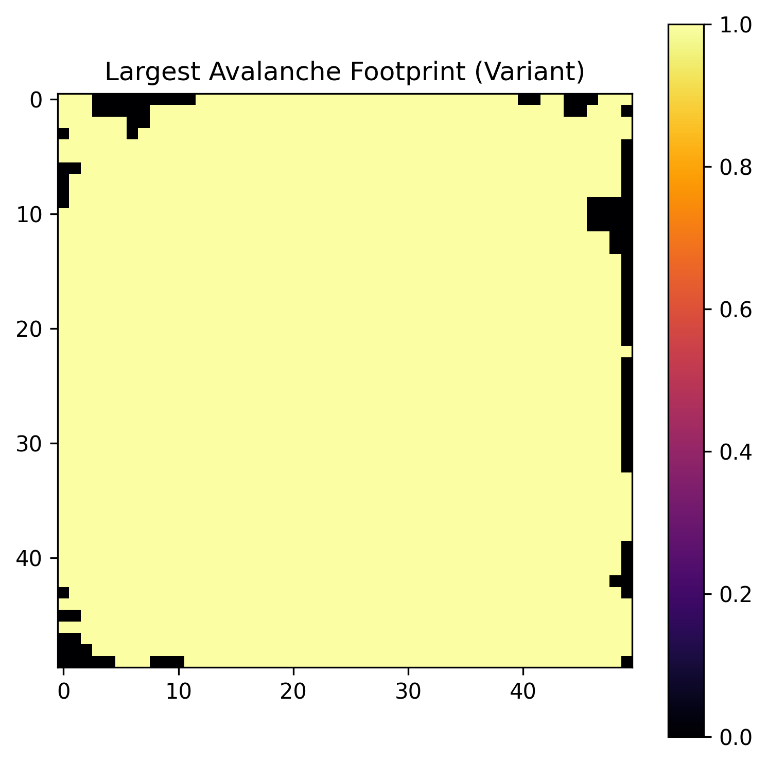
Figure 4: Largest avalanche footprints.
The avalanche footprint marks every site that toppled at least once during the largest avalanche.
In the Standard Model, the footprint is fragmented and branching-like. This suggests avalanches propagate through irregular pathways.
In the Increasing Drive Model, the footprint becomes denser and more space-filling, indicating stronger long-range connectivity.
These patterns visually resemble fractals, complex structures that display self-similarity and scale invariance.

6. Geometric Scaling and Fractal Dimension
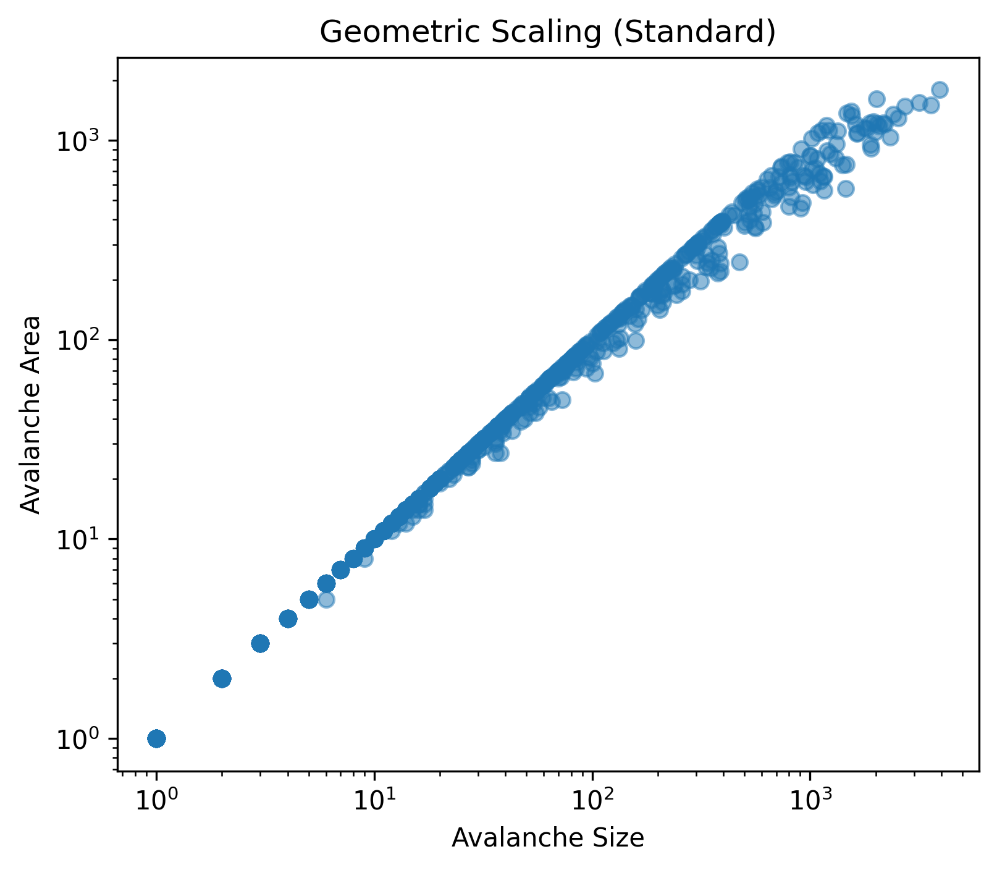 | 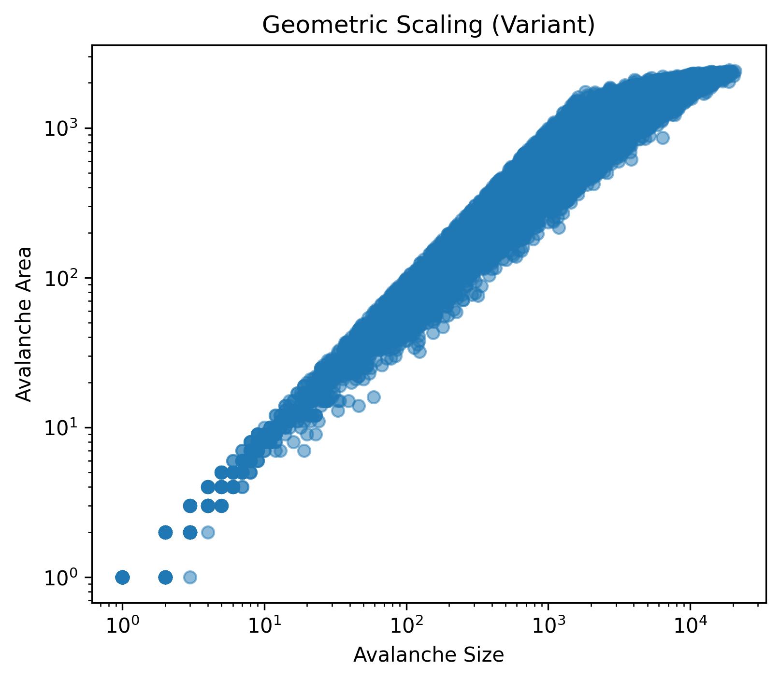
Figure 5: Log-log scaling of avalanche area vs size.
If the relationship log(A) vs log(S) forms a straight line, the slope corresponds to the fractal dimension D.
The near-linear structure confirms scale invariance: there is no characteristic avalanche size.
Small and large avalanches obey the same geometric scaling rule. This is the essence of criticality.

7. Conclusion
Standard Model:
- Displays classical SOC behavior
- Fragmented fractal footprints
- Broad power-law distribution
- Weak long-range spatial clustering
Variant Increasing Drive Model:
- Stronger spatial correlations
- Heavier-tailed avalanche distribution
- More space-filling avalanche geometry
- Increased probability of system-spanning events
Thus, modifying the driving mechanism significantly alters the macroscopic structure and statistical behavior of the system.

Link to GitHub repository
The GitHub repository https://github.com/biswa-03/Modelling-Complex-Systems/ contains the code for the above simulation in Jupyter Notebook format, additional toppling frequency graphs, and a video of a standard Sandpile Model evolving with the dropping of 15000 grains.

References
Bak, P., Tang, C., & Wiesenfeld, K. (1987). Self-Organized Criticality.
Christensen, K., & Moloney, N. (2005). Complexity and Criticality.

Author
This project has been developed by Biswa Ranjan Rout (MS23210) as part of the course requirements for IDC621: Modelling Complex Systems.

