Part 2: Coupled Map Lattice (CML) — Nonlinear Map Dynamics
This document presents Part 2 of the CML study, focusing on nonlinear map dynamics governed by the exponential map xₙ₊₁ = xₙ² e^(r − xₙ). Through bifurcation analysis, Lyapunov exponents, and network-based coupling, we investigate transitions from stable fixed points to chaos and the influence of coupling on spatiotemporal behaviour.
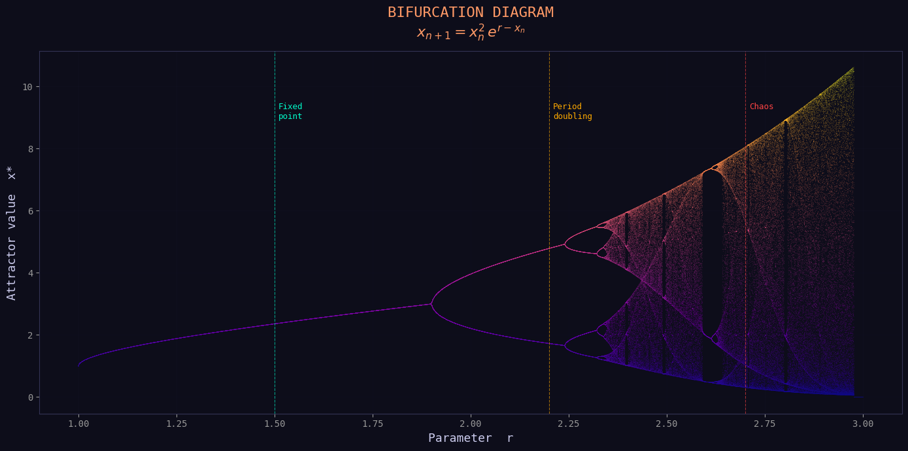
Bifurcation diagram showing the transition from a stable fixed point to period-doubling cascades and chaos as the control parameter r increases.
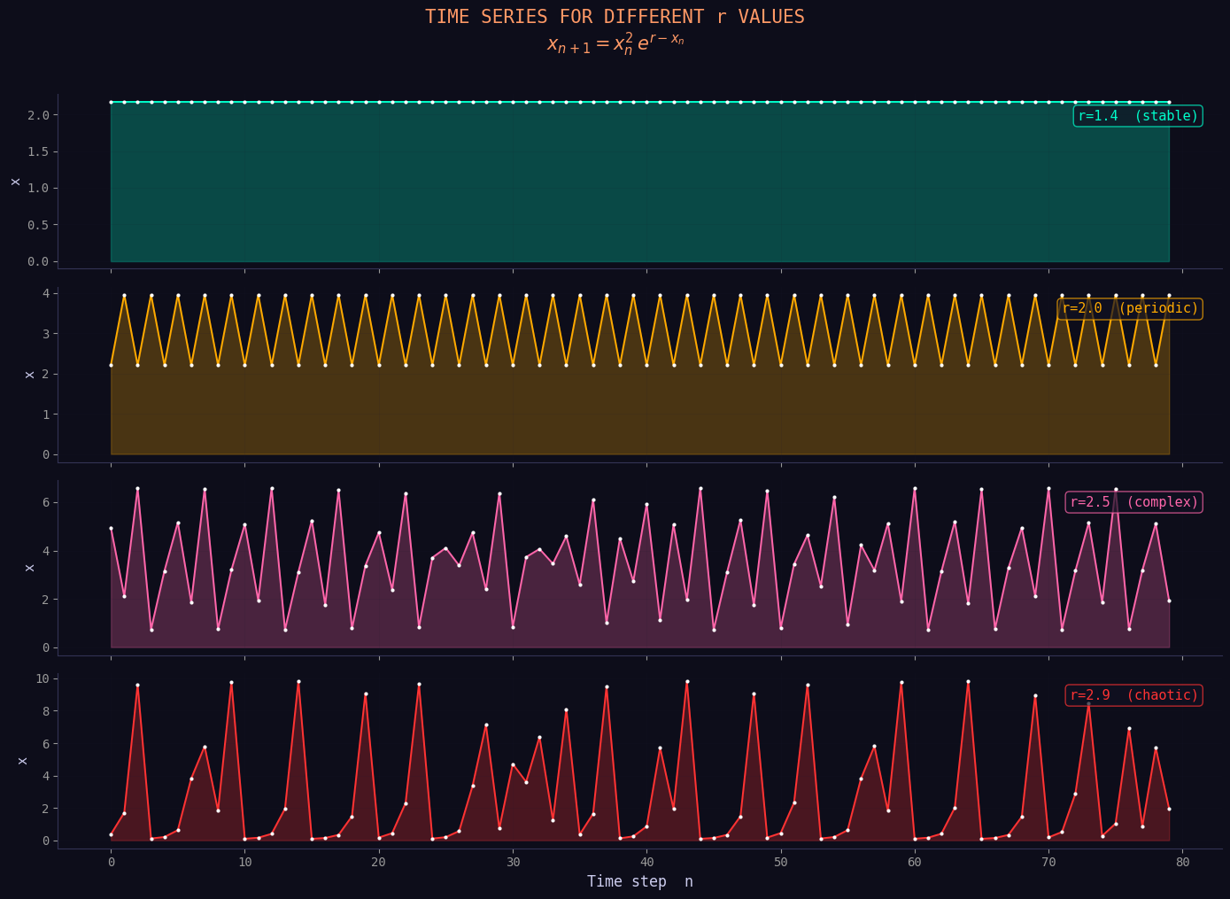
Time series for representative r values, illustrating stable, periodic, complex, and chaotic dynamical regimes.
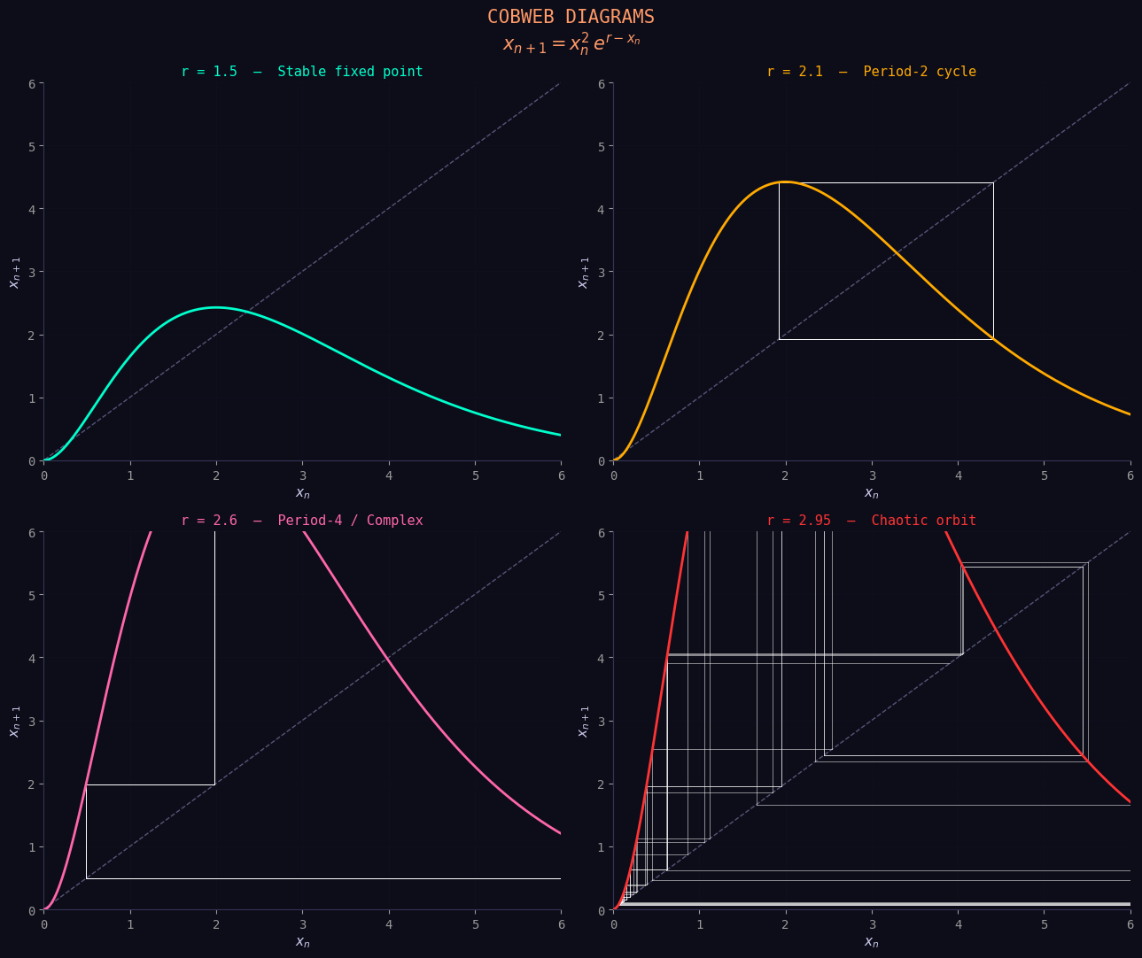
Cobweb diagrams visualising convergence to fixed points, periodic cycles, and chaotic orbits for different values of r.
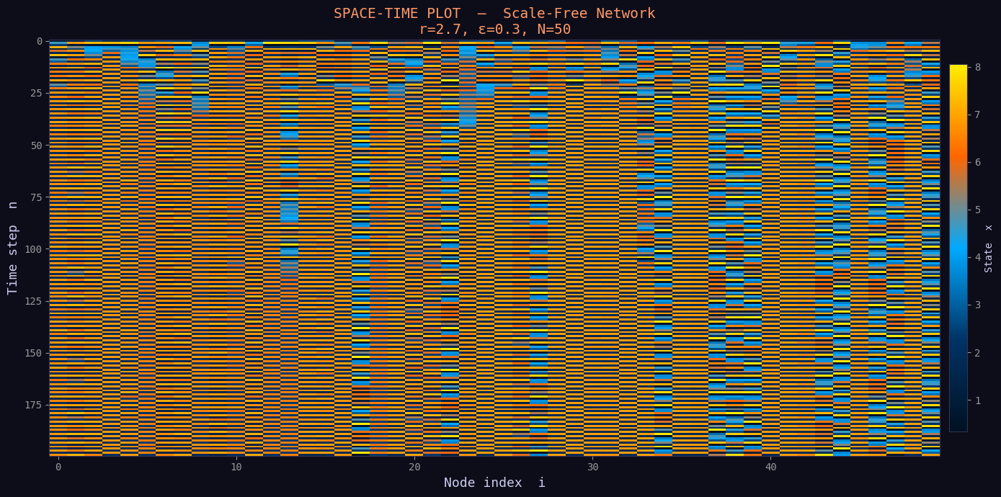
Space–time plot of a CML on a scale-free network, revealing heterogeneous spatiotemporal dynamics under chaotic local maps.
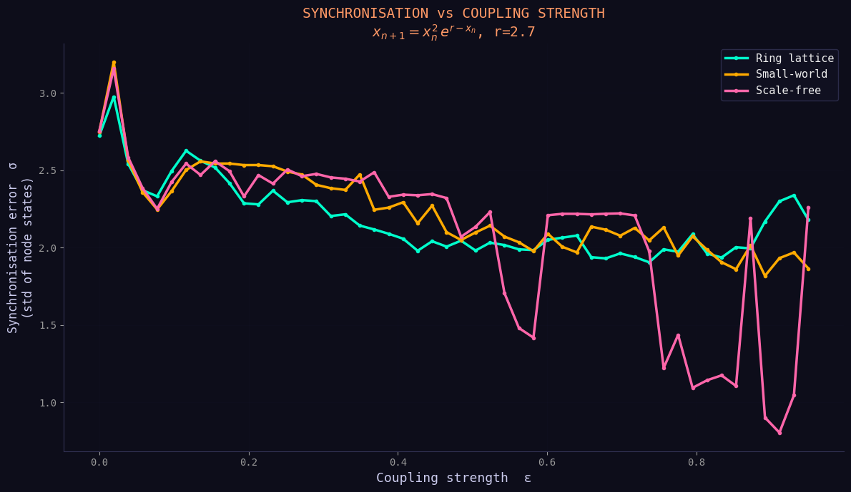
Synchronisation error versus coupling strength for different network topologies, highlighting topology-dependent coherence.
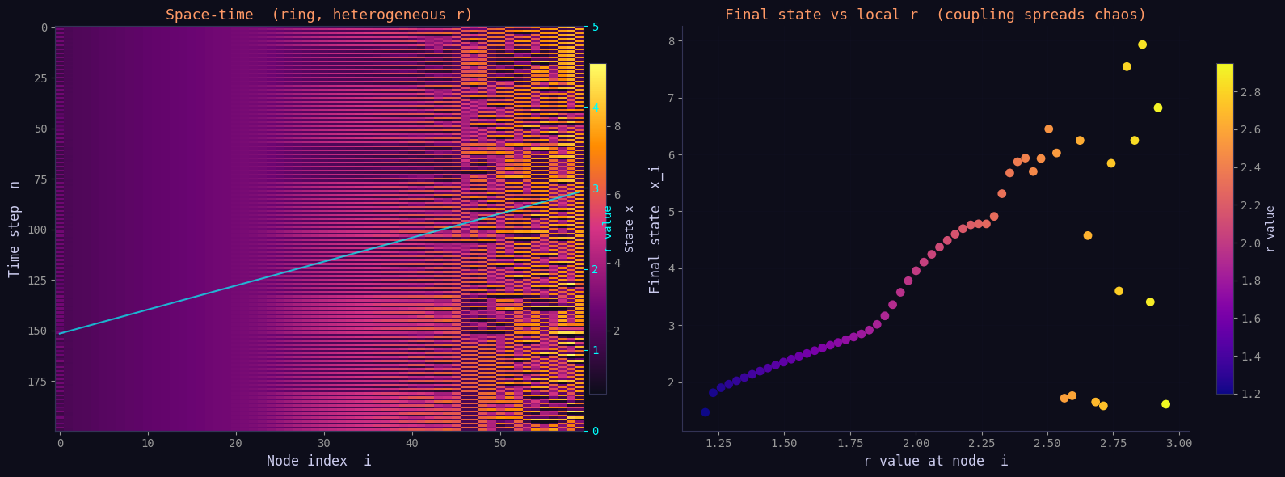
Space–time evolution on a ring lattice with heterogeneous local parameters r, demonstrating coupling-induced spreading of chaos.
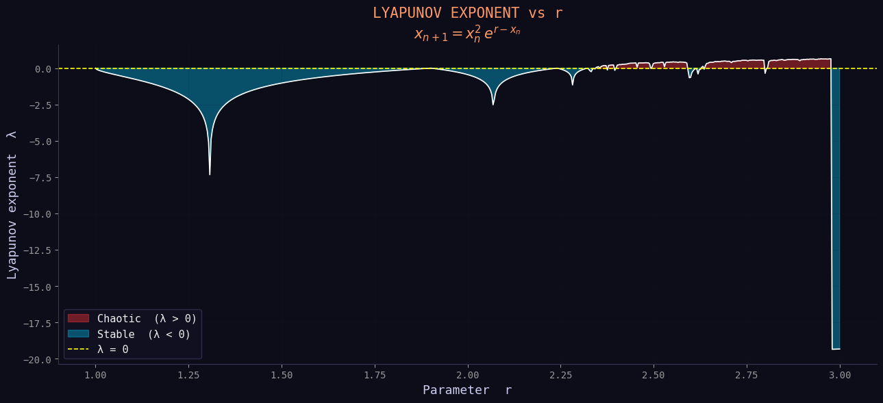
Lyapunov exponent as a function of r, distinguishing stable (λ < 0) and chaotic (λ > 0) regimes.
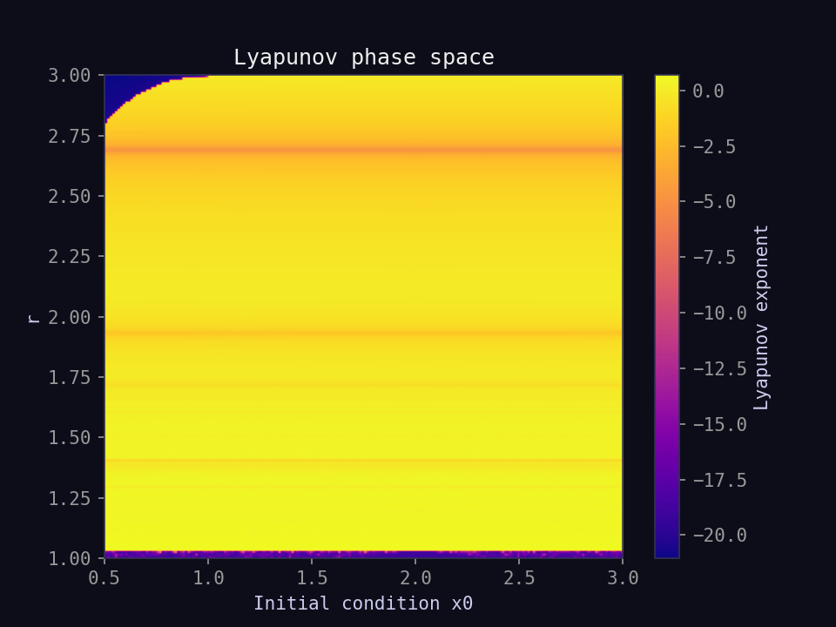
Lyapunov phase-space heatmap over initial conditions and control parameter r, showing regions of robust chaos and stability.
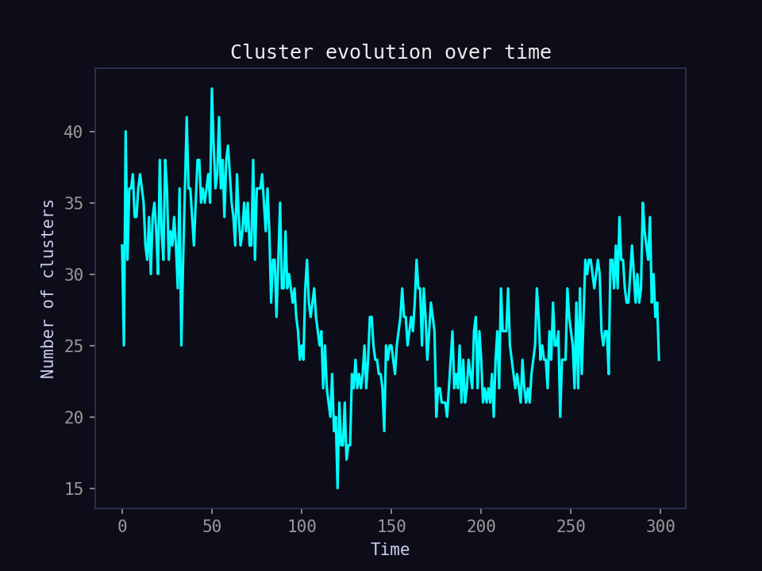
Temporal evolution of the number of dynamical clusters, indicating continual merging and fragmentation of coherent groups over time.

Reference
GitHub repository: https://github.com/biswa-03/Modelling-Complex-Systems
This report corresponds to Part 2 — CML (Nonlinear Maps).

