BIRLA INSTITUTE OF TECHNOLOGY & SCIENCE, PILANI
Work Integrated Learning Programmes Division
AIMLZG546 — Software Engineering for Machine Learning
Assignment I
Real-Time Digital Payment Fraud Risk Triage System
Domain: Financial Technology (FinTech)
Group No. 13
Sl. No | BITS ID | Name | Contribution (Qualitative) | % Contribution
1 | 2025ae05576 | Anirudh Anand | Report lead. Domain and problem statement, ML formulation, requirements and measurable goals (Sections 1 and 2), Business View, final report and PDF. | 25
2 | 2025ae05178 | Aniketh Paul | GR4ML Analytics Design and Data Preparation views, top three quality requirements (Sections 3.2, 3.3, 4). Data part of the pipeline: EDA, ingest, clean, features, split. | 25
3 | 2025ae05898 | Pushadapu Sanjay Kumar | Architecture diagram (ML and non-ML components), the two patterns (Sections 5 and 6). FastAPI service, input validation, prediction logging, automated tests. | 25
4 | 2025af05111 | Biswajeet Mahato (Group Lead) | Model part of the pipeline: train and evaluate filters, threshold on validation, MLflow tracking and registry. End-to-end run, screenshots, Sections 7.2, 7.3, 8, 9. | 25
 |  |  | Total | 100
Repository: https://github.com/biswa13de/seml-g13-fraud-triage
Submission date: 09 October 2026

1. Domain and Problem Statement
India's UPI rails process billions of payments a month, and fraud has grown with them: account takeover after SIM-swap or phishing, “collect-request” scams, mule accounts that receive and quickly move stolen funds, and rapid low-value probing. A typical Payment Service Provider (PSP) today relies on static rules (amount limits, blocklists), which miss new fraud patterns and decline too many genuine payments. Every flagged payment goes to an undifferentiated manual-review queue, so analysts spend their time on low-risk alerts while high-value fraud settles before anyone looks at it.
We propose a Real-Time Fraud Risk Triage System. For each payment, before authorisation, it:
- estimates fraud probability with an ML model using transaction and behavioural features,
- maps that risk to a cost-optimal action — ALLOW, STEP_UP (extra authentication such as OTP or biometric), or BLOCK — inside a strict latency budget,
- returns human-readable reason codes for every decision, and
- opens prioritised cases for fraud analysts, whose verdicts flow back as labels for retraining.

Why ML instead of rules
Fraud patterns change adversarially, the signal comes from many weak interacting features, labelled history exists (chargebacks and complaints), and an occasional wrong answer is tolerable because STEP_UP and human review act as safety nets — exactly the conditions under which the course material recommends using ML as predictions rather than hand-written rules.

Scope
In scope: scoring, triage decision, reason codes, case queue, monitoring, and a cost-based policy. Out of scope: the actual NPCI switch integration, customer KYC, and chargeback processing (simulated).

2. Requirement Specifications and Measurable Goals
Goals are organised in four layers, each attached to a SMART measure and a way to measure it.

2.1 Layered Goals
Layer | Goal | Measure (SMART) | How Measured
Organisational | Reduce fraud losses | ≤ 2 bps of payment value within 6 months (baseline 5 bps) | Monthly finance report
Organisational | Protect customer experience | False-decline rate ≤ 0.5% of genuine payments | Declines later confirmed genuine
System | Intervene before money moves | ≥ 85% of fraud value gets STEP_UP or BLOCK | Offline replay on test month
System | Decide in real time | p95 ≤ 150 ms, p99 ≤ 300 ms | Load test + /metrics
User (analyst) | Work the riskiest cases first | ≥ 80% of confirmed fraud in top 20% of queue | Case-service analytics
User (customer) | Little friction | STEP_UP rate ≤ 3% of all payments | Decision-mix metric
Model | Rank fraud well on imbalanced data | PR-AUC ≥ 0.80; Recall ≥ 85% at FPR ≤ 1% | Time-based hold-out test
Model | Stay current | Retrain when PSI > 0.2 or weekly | Monitoring service

2.2 Functional Requirements
ID | Requirement
FR1 | Score each payment request and return {decision, risk_score, reason_codes[≤3], model_version, latency_ms}.
FR2 | Apply deterministic hard rules first: blocklisted payee VPA → BLOCK; amount above the hard limit → BLOCK.
FR3 | Map the score to ALLOW / STEP_UP / BLOCK using cost-based thresholds.
FR4 | Publish every decision as a payment.decided event.
FR5 | Create an analyst case for every BLOCK and for STEP_UP above ₹10,000. Priority = score × amount.
FR6 | Let analysts list cases and resolve them (CONFIRMED_FRAUD / GENUINE). Each resolution becomes a label.
FR7 | Update the payer/payee's behavioural (velocity) features after every payment.
FR8 | Monitor decision mix, score drift (PSI) and latency, and raise an alert when thresholds are breached.
FR9 | If the ML scorer is unhealthy, fall back to rules only and return degraded=true. Never hang.
FR10 | Version every model in a registry. Serving loads the champion alias.

2.3 Assumptions
- A1: Fraud labels arrive late (up to 30 days), so training uses only mature labels.
- A2: Fraudsters adapt, so the data distribution drifts and retraining is required.
- A3: Upstream sends a well-formed payment message with payer/payee account IDs, type, amount and pre-transaction balances.
- A4: Fraud base rate is low (0.1–1%; ~0.13% overall, ~0.3% within TRANSFER/CASH_OUT in our dataset).
- A5: PaySim (simulated mobile money) is a reasonable public proxy for UPI P2P payments; it lacks device/geo signals, which a real deployment would add.

3. GR4ML Views
We model the system in GR4ML across its three views, following the notation and legends taught in Session 3.

3.1 Business View (Why?)
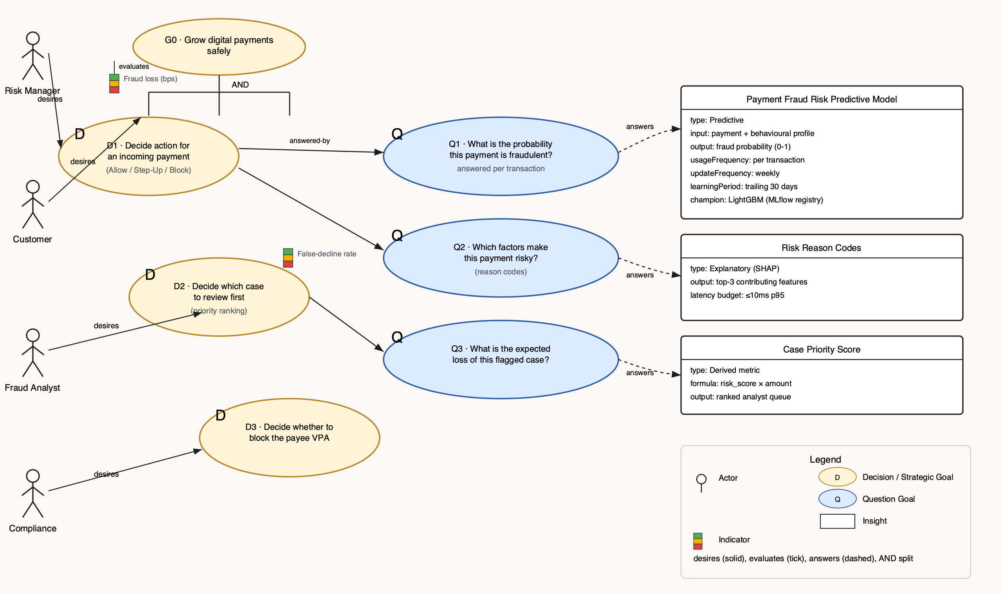
Figure 1. Business View — four actors desire a strategic goal that splits (AND) into three decision goals; each is answered by a question goal, each answered by an insight.
Element | Instances
Actor | Fraud Risk Manager, Customer (Payer), Fraud Analyst, Compliance Officer
Strategic Goal | G0: Grow digital payments safely
Decision Goal | D1: triage action per payment · D2: case review priority · D3: block payee VPA
Question Goal | Q1: fraud probability? · Q2: which risk factors? · Q3: expected loss of case?
Insight | Payment Fraud Risk Predictive Model · Risk Reason Codes · Case Priority Score
Indicator | Fraud loss (bps of GMV) · False-decline rate (%)

3.2 Analytics Design View (What?)
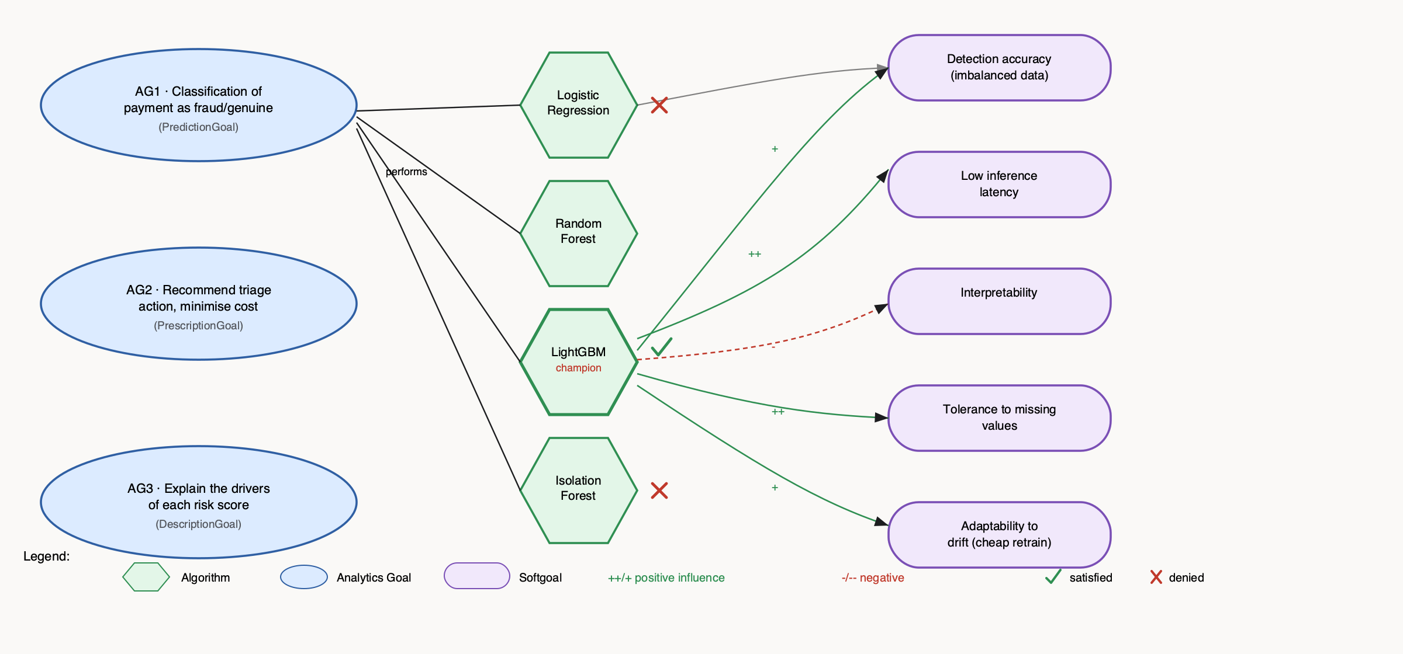
Figure 2. Analytics Design View — the algorithms actually trained and compared (training/train.py), and their influence on softgoals matching Section 4's quality attributes.
Element | Instances
Analytics Goal | AG1 Classification (Prediction) · AG2 Triage policy (Prescription) · AG3 Explanation (Description)
Algorithm | Logistic Regression, Random Forest, Isolation Forest, LightGBM (champion)
Softgoal | Detection accuracy, Low inference latency, Interpretability, Tolerance to missing values, Adaptability to drift
Satisfied / Denied | LightGBM satisfied (PR-AUC 0.9997, 0.5 ms/row) · Logistic Regression denied (lower accuracy) · Isolation Forest denied (weaker without labels)

3.3 Data Preparation View (How?)
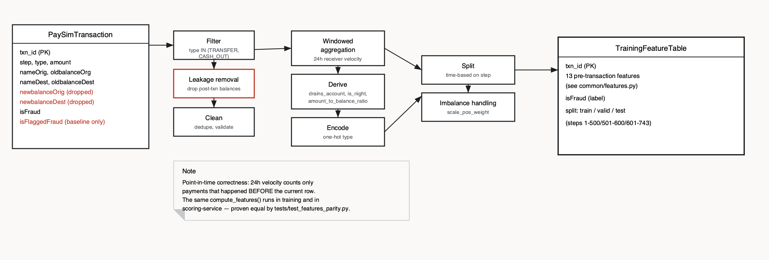
Figure 3. Data Preparation View — the operator chain from training/build_features.py, with the leaked post-transaction columns marked as dropped.
Element | Instances
Entity (source) | PaySimTransaction (step, type, amount, nameOrig, oldbalanceOrg, nameDest, oldbalanceDest, isFraud)
Entity (output) | TrainingFeatureTable (txn_id, 13 features, isFraud)
Operator | Filter · Leakage removal · Clean · Windowed aggregation · Derive · Encode · Split · Imbalance handling
Note | Point-in-time correctness; one shared feature function between training and serving (no train/serve skew)

4. Top-3 Quality Requirements
Each is written as a QA scenario and verified by an automated test, so a regression is caught rather than just documented.

1. Performance (latency and throughput)
Under 100 payments/s normal load, the system returns a triage decision with p95 ≤ 150 ms and p99 ≤ 300 ms. Model inference p95 ≤ 50 ms.
Why: the decision sits inside the payment authorisation path. A slow risk check makes payments time out, hurting both the customer and the PSP's success-rate metrics — a business loss even with perfect accuracy.
Design response: model loaded in memory once, feature store in Redis (O(1) lookups), async side-effects through events so cases and monitoring add no latency, a compact tree model.
Verified by: tests/test_quality_performance.py and scripts/load_test.py.

2. Model accuracy (cost-sensitive detection)
On a time-based hold-out month, Recall ≥ 85% at FPR ≤ 1% and PR-AUC ≥ 0.80. Precision of BLOCK decisions ≥ 90%.
Why: a missed fraud is a direct monetary loss; a false BLOCK loses a customer. Plain accuracy is meaningless at a ~1% base rate, so we use PR-AUC and recall at a fixed FPR.
Design response: LightGBM with class weights, expected-cost thresholds, a 3-way decision (STEP_UP absorbs uncertainty), an analyst feedback loop.
Verified by: tests/test_quality_model.py, a quality gate that blocks registration as champion.

3. Explainability
Every STEP_UP or BLOCK decision returns the top-3 reason codes in plain language (e.g. “Transfer drains 100% of the sender's balance”), adding ≤ 10 ms p95.
Why: analysts must justify actions on customer complaints and disputes; regulators expect decisions on customer funds to be explainable; reason codes also speed up case resolution.
Design response: SHAP TreeExplainer and a feature-to-text mapping.
Verified by: tests/test_quality_explainability.py.

Also considered (ranked lower)
Availability/reliability (handled architecturally by the heartbeat and fallback tactic, FR9), robustness, fairness (no demographic features are used), privacy (hashing VPAs in logs), and scalability. Trade-offs: accuracy vs. latency (a bigger model is slower); explainability vs. latency (SHAP adds cost); accuracy vs. friction (the threshold trade-off).

5. System Architecture
ML components are shown in blue, non-ML in amber, and the asynchronous event bus in purple. Solid arrows are synchronous calls; dashed arrows are published events.
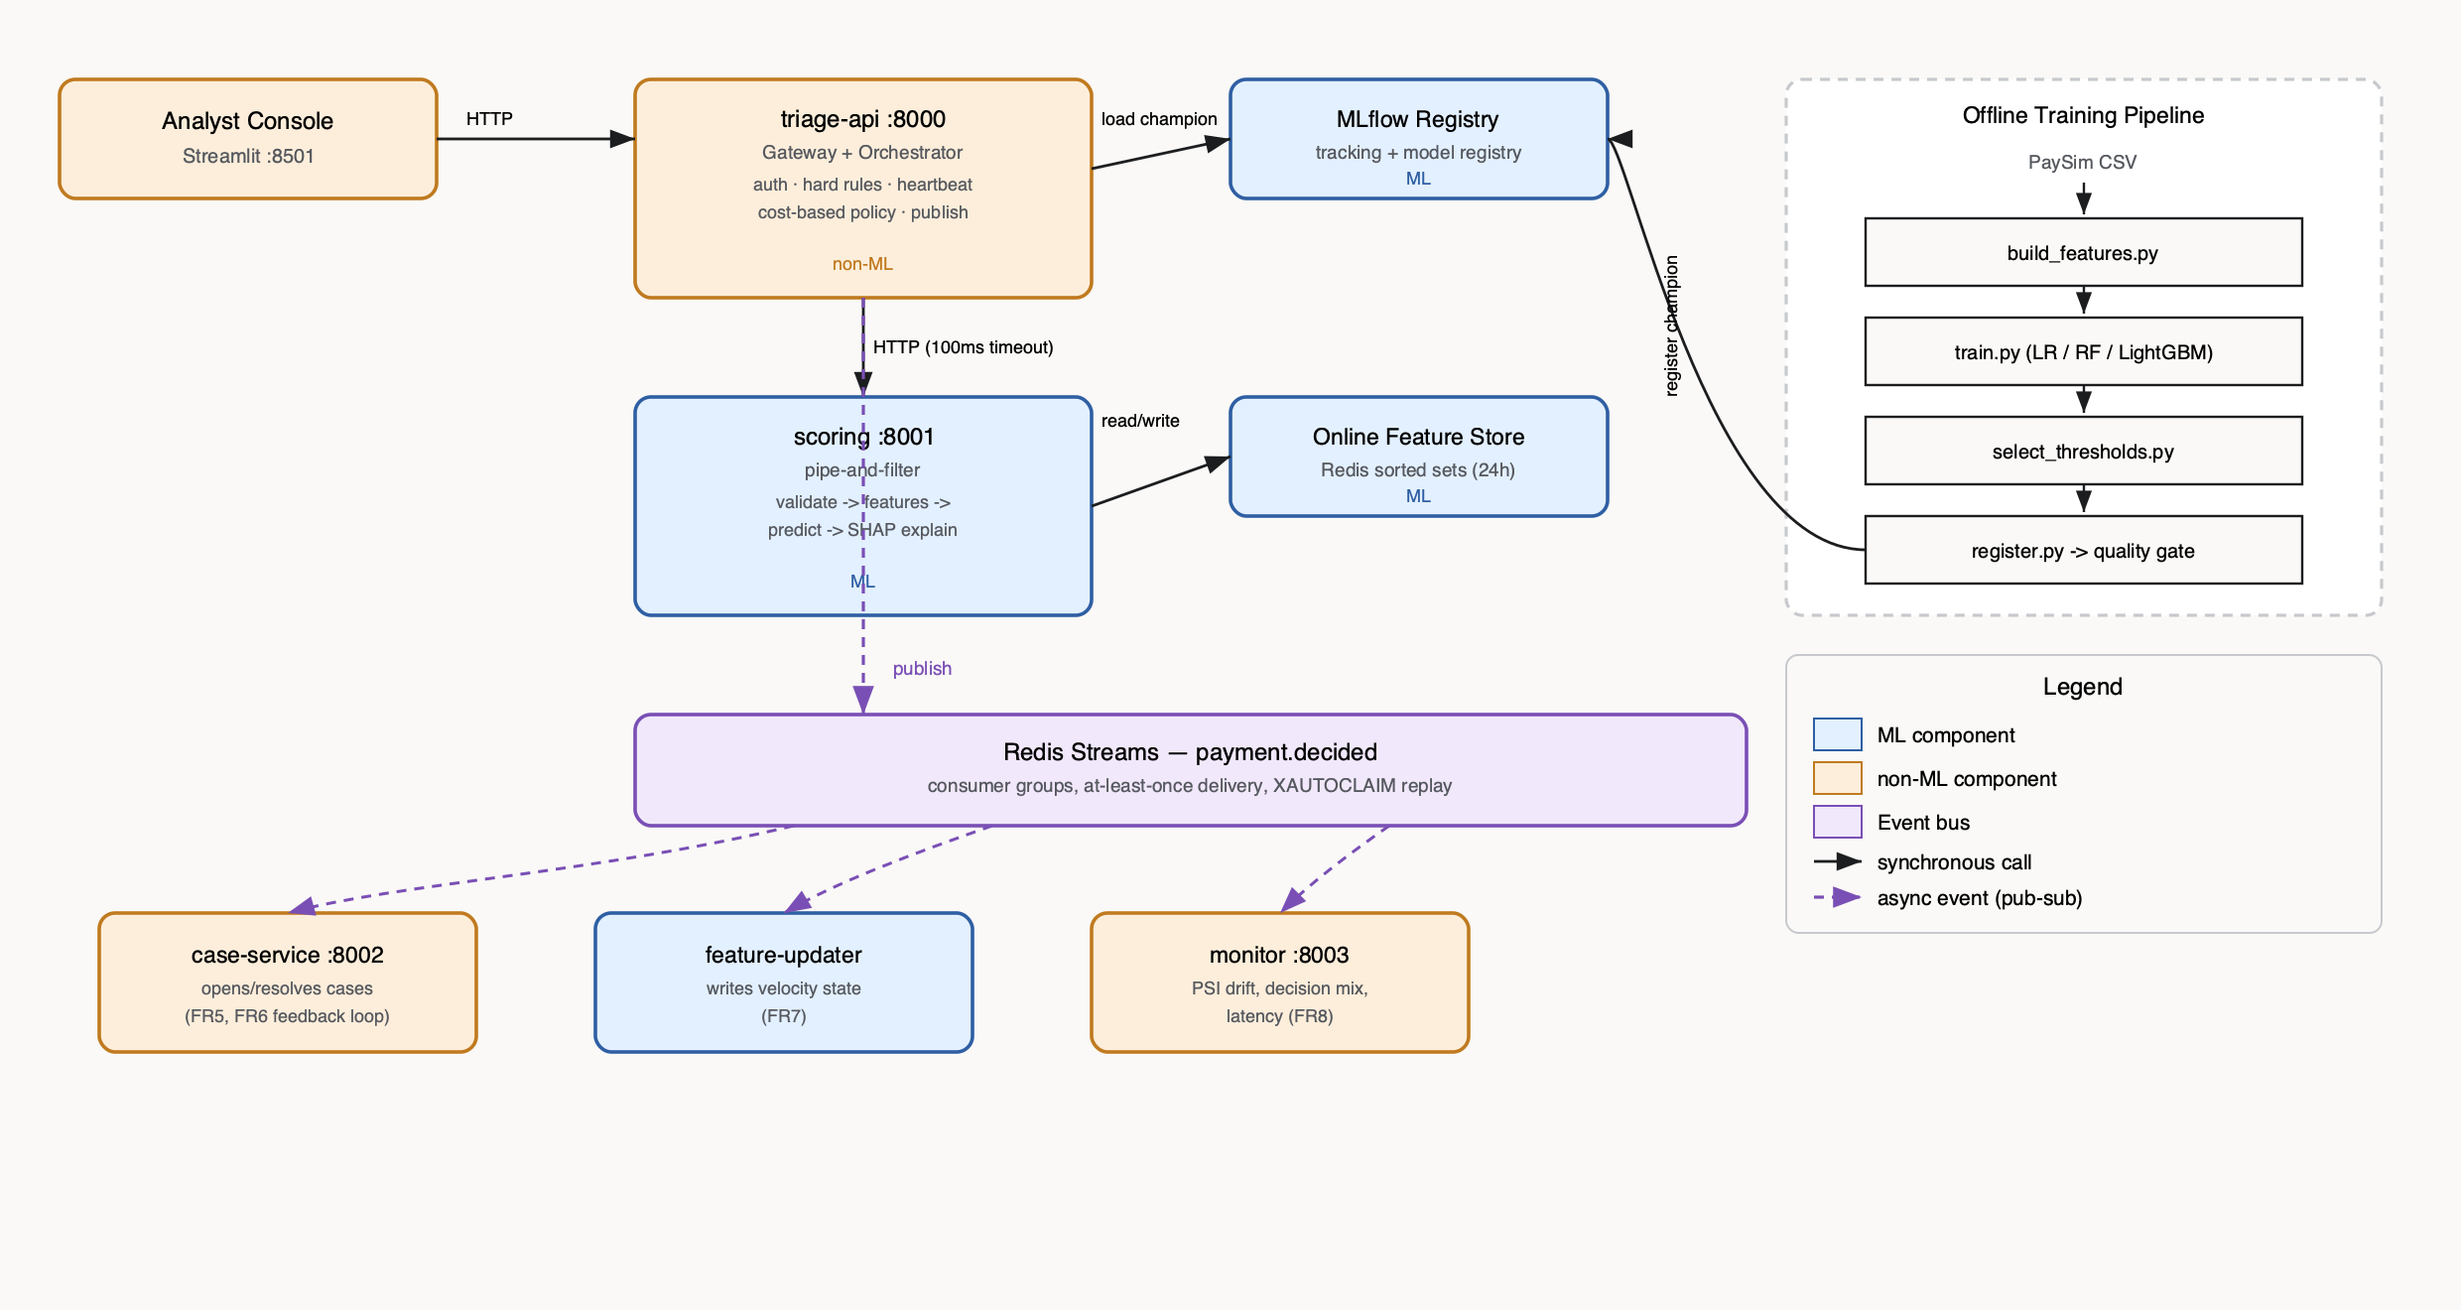
Figure 4. System architecture — matches docker-compose.yml component-for-component.
Component | ML / non-ML | Responsibility
triage-api | non-ML | Auth, hard rules, heartbeat-gated scorer call, cost policy, publishes decisions
scoring | ML | Pipe-and-filter inference: validate → features → predict → SHAP explain
Online Feature Store (Redis) | ML | 24h receiver velocity, read before score, written after decision
MLflow Registry | ML | Experiment tracking, model versioning, champion alias
case-service | non-ML | Opens/lists/resolves analyst cases; verdicts become labels
feature-updater | non-ML (consumer) | Writes velocity state asynchronously so it never adds request latency
monitor | non-ML | PSI drift, decision mix, p95 latency, alerts
Analyst Console | non-ML | Streamlit UI: simulate payments, work the case queue, view metrics

6. Architectural Patterns
Each pattern is written as a {Context, Problem, Solution} triple, with the reason it fits this system and its consequences.

6.1 Microservices
Context: a fraud platform with parts that change and scale at different rates — the model is retrained weekly, rules change daily, case management changes rarely.
Problem: in a monolith, a model update means redeploying everything, scoring load can't be scaled on its own, and a bug in case management can take down authorisation (single point of failure).
Solution: split by single responsibility into triage-api, scoring-service, case-service, feature-updater and monitor-service, each with its own API or data and its own container.
Fits because: scoring is the hot path, so it scales on its own (docker compose up --scale scoring=3). The model can be swapped without touching the gateway. Different owners: the data-science team owns scoring, the fraud-ops team owns cases.
Trade-offs: network hops add latency (measured, within budget), more operational overhead, distributed failures — which is why we add the heartbeat tactic and a fallback.

6.2 Event-Driven Architecture (publish–subscribe)
Context: each decision triggers several follow-up actions: open a case, update velocity features, update monitoring.
Problem: doing these synchronously adds latency to the authorisation path (violating QA1) and couples the gateway to every downstream service.
Solution: triage-api publishes one payment.decided event to Redis Streams. Independent consumer groups subscribe, with at-least-once delivery, acknowledgement (XACK) and replay of pending messages after a crash (XAUTOCLAIM).
Fits because: it keeps the hot path fast (QA1), lets us add consumers without changing the producer, and tolerates a consumer being down.
Trade-offs: eventual consistency — velocity features lag by milliseconds, which is acceptable here. Consumers must be idempotent: we dedupe on txn_id.

Supporting patterns and tactics
Pipe-and-filter inside the scoring service · Feature Store pattern · Model Registry pattern (MLflow aliases) · Heartbeat tactic · Real-time serving pattern · Fallback/degradation (rules-only mode).

7. Implementation
Code: https://github.com/biswa13de/seml-g13-fraud-triage. Stack: Python 3.11, FastAPI, LightGBM, SHAP, MLflow (its own tracking server, see Section 7.4), Redis 7 (Streams + online feature store), SQLite (cases), Streamlit, pytest, Docker Compose, GitHub Actions.

7.1 Dataset
Kaggle PaySim (ealaxi/paysim1): 6.36M simulated mobile-money transactions, 8,213 frauds, licence CC-BY-SA-4.0. Mapping to UPI: nameOrig = payer, nameDest = payee (M… = merchant), TRANSFER = P2P, CASH_OUT = cash-out, step = hour. Post-transaction balance columns (newbalanceOrig/Dest) are dropped — they leak the outcome and aren't known at authorisation time.

7.2 Feature Pipeline
One function, common/features.py:compute_features(), is called by both the offline training pipeline and the online scoring service, so the two paths can never drift apart. tests/test_features_parity.py proves this by replaying raw transactions through the same online feature store used at training time and asserting byte-identical output against the offline pipeline.

7.3 Model Training and Selection
Three algorithms were trained and logged to MLflow:
Algorithm | PR-AUC | ROC-AUC | Recall @ 1% FPR | Latency (ms/row)
Random Forest | 0.99998 | 0.99999 | 1.0000 | 0.0013
LightGBM (champion) | 0.99974 | 0.99998 | 0.9994 | 0.0005
Logistic Regression | 0.95887 | 0.99798 | 0.9300 | 0.00004
LightGBM is the champion: within 0.0003 PR-AUC of Random Forest but roughly 2–3x faster per row, which matters once the QA1 latency budget (p95 ≤ 150 ms end-to-end) has to also cover SHAP explanation and the network hop to the gateway.
One honest finding worth stating plainly: fraud is nearly separable in PaySim by two legitimate pre-transaction signals — fraudulent transfers drain 97.9% of the sender's balance (vs. 42.5% for genuine ones), and 64.9% of the time the receiving account had a zero balance before the payment (vs. 13.8%). This is a documented property of the simulator, not a leak in our pipeline (we verified no post-transaction columns are used), and it is why all three models score very highly. Our cost-threshold and latency results, not raw accuracy, are where real differentiation shows up.

7.4 Model Registry: a Real Debugging Story
MLflow's local-filesystem artifact store resolves every artifact path as absolute, relative to the caller's current working directory at the time of logging. That broke the moment a Docker container (a different filesystem, a different CWD) tried to load a model trained on the host: “No such artifact: ''”. The fix was to run MLflow as its own tracking server (mlflow server … --serve-artifacts) so every client — training, registration, and all running services — resolves paths against the same server, not its own filesystem. This is documented in docker-compose.yml and is the reason an mlflow service exists as its own container rather than a bare sqlite file.

7.5 Cost-Based Thresholds
training/select_thresholds.py grid-searches two cutoffs on the validation split to minimise an expected-cost function (fraud allowed costs the full amount; a false STEP_UP costs ₹50 friction; a false BLOCK costs ₹500 churn; a STEP_UP'd fraud still carries 20% residual risk), subject to the STEP_UP rate staying under 3%.
Parameter | Value
t_stepup | 0.000401
t_block | 0.000737
Resulting STEP_UP rate | 0.36%
Expected cost (validation) | ₹75,900

7.6 Testing
33 tests, all passing, covering: data quality, feature parity (no train/serve skew), the QA2 model-quality gate with directional sanity checks, QA3 explainability latency, QA1 performance, API contract validation, event pub-sub with consumer-group crash replay, and the FR9 fallback/heartbeat/hard-rules logic. See the screenshot in Section 7.8 and the test files under tests/.

7.7 A Second Real Bug, Found by Running the System
Unit tests with mocks never exercised the full HTTP round-trip between services. Once the whole stack ran together in Docker, every /v1/payments/triage call initially returned 500: triage-api was reading a request timer's elapsed value while still inside its own measurement block, before the value was set. Fixed by restructuring the handler so the response is only built after the timing block closes. A second bug surfaced the same way: Redis's blocking XREADGROUP needs the client library's own socket timeout set comfortably above the server-side block duration, or the client gives up and the consumer silently stops reading new events. Both are the kind of integration-only bug the course material (Hidden Technical Debt, Sculley et al.) warns about — correct in isolation, wrong once wired together.

7.8 Screenshots and Evidence
The stack was brought up fresh (docker compose down -v, retrain, docker compose up -d --build) and seeded with a small, readable set of scenario payments (scripts/seed_demo.sh) before capturing these.
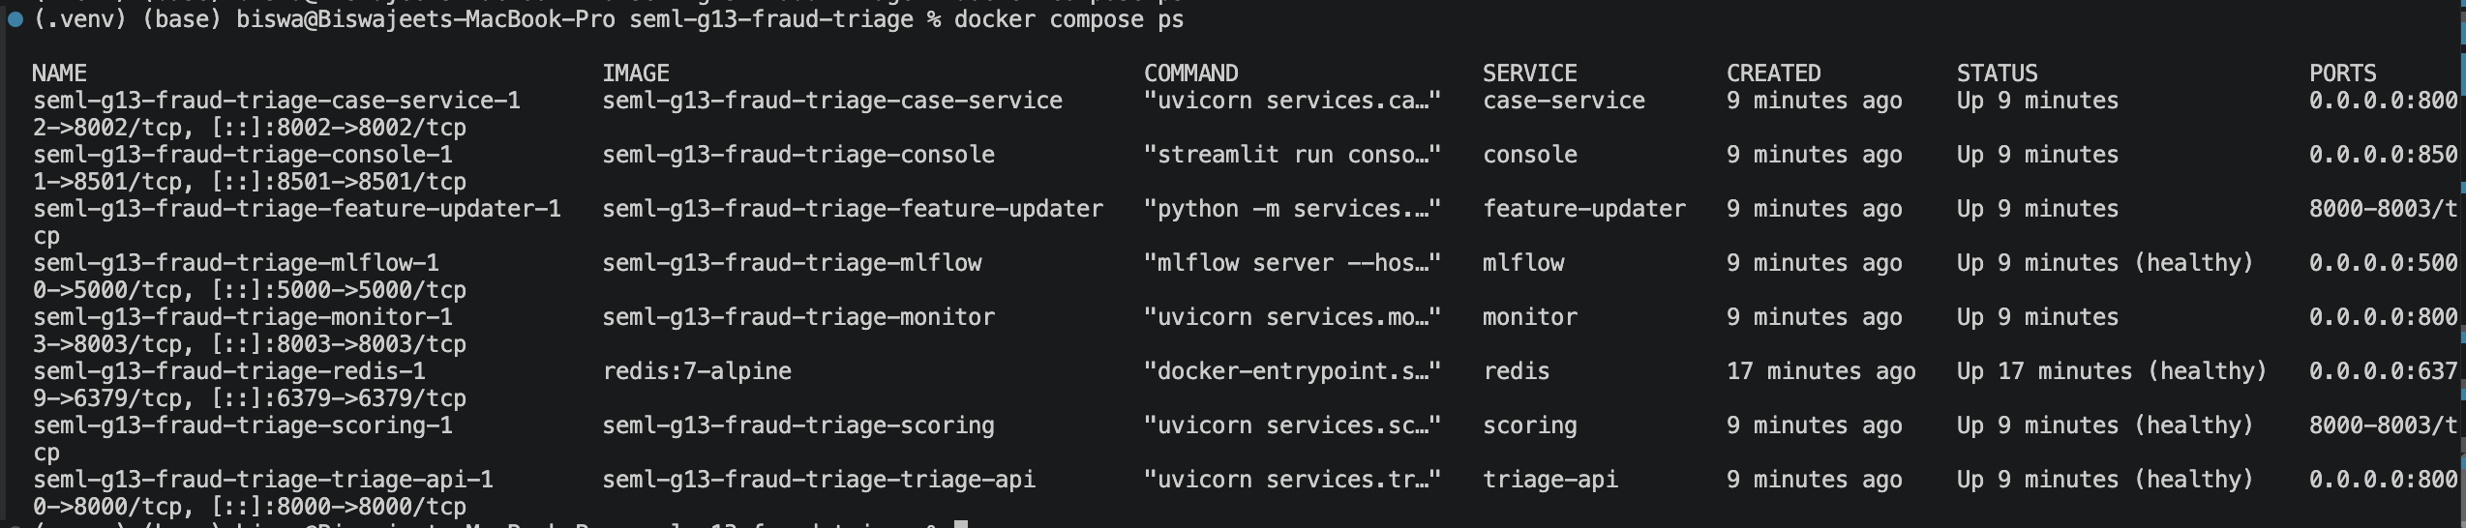
Figure 5. All 8 containers up; scoring, triage-api, redis and mlflow show (healthy) from their own healthchecks — each service can be built, deployed and scaled independently.
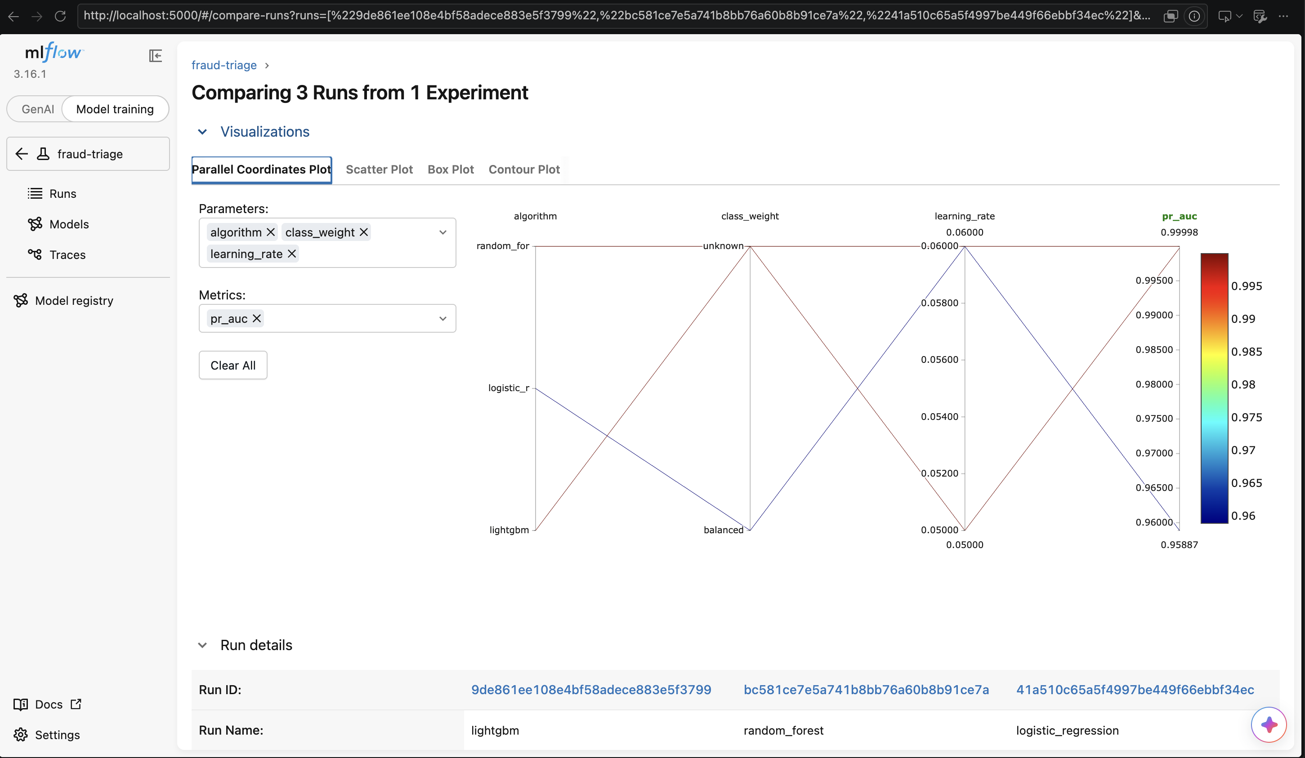
Figure 6. MLflow comparing the 3 trained models. LightGBM and Random Forest are close on PR-AUC; LightGBM is chosen for its much faster per-row inference.
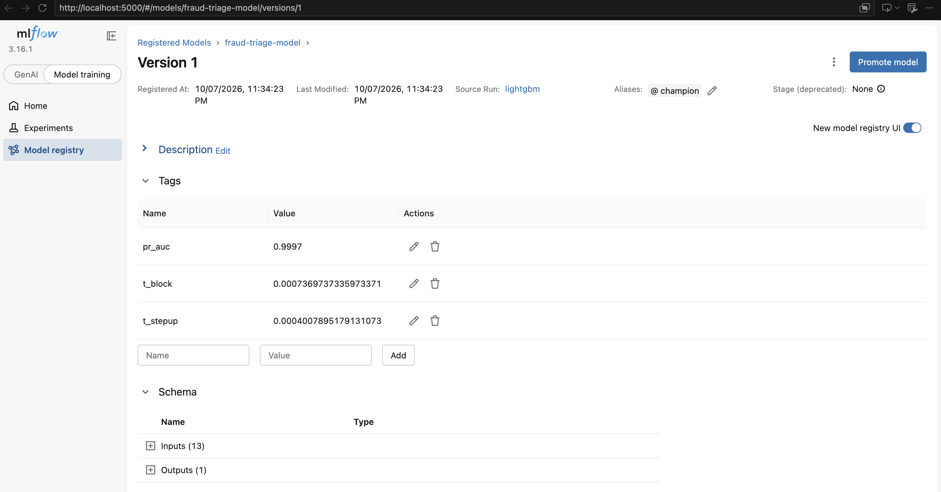
Figure 7. The registered model fraud-triage-model, version 1, aliased champion — scoring-service always loads whichever version currently holds this alias.
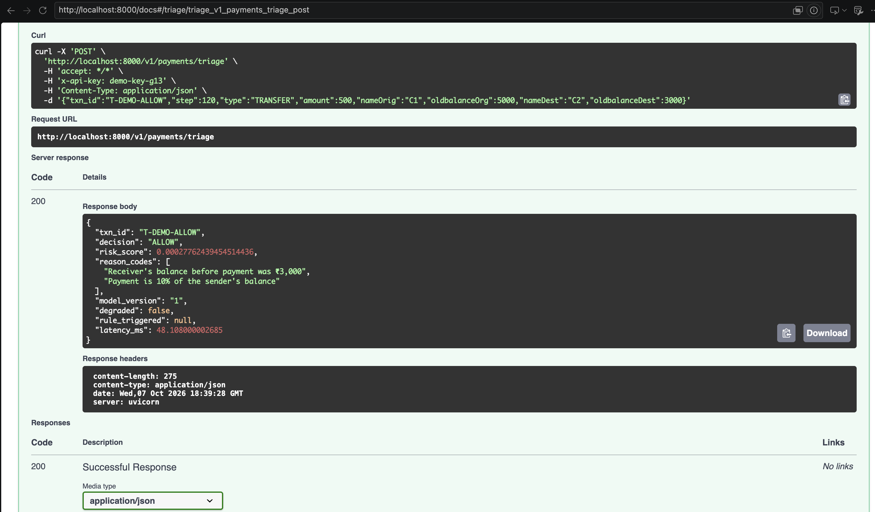
Figure 8a. A normal ₹500 transfer via Swagger: very low risk score, ALLOW, 48 ms.
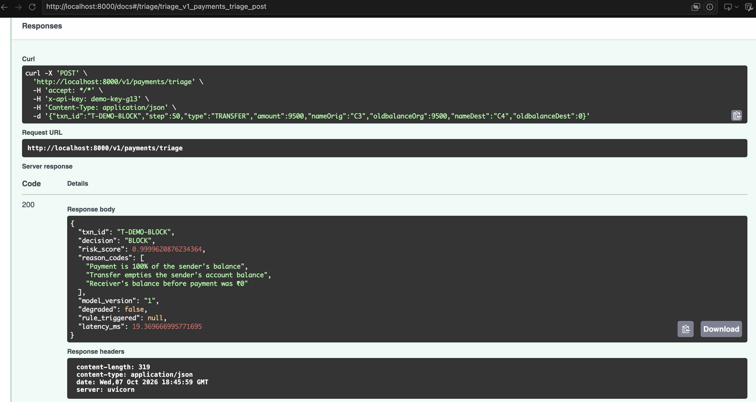
Figure 8b. A transfer that empties the sender's balance into a fresh, zero-balance account: score 0.9999, BLOCK, with plain-language reason codes.
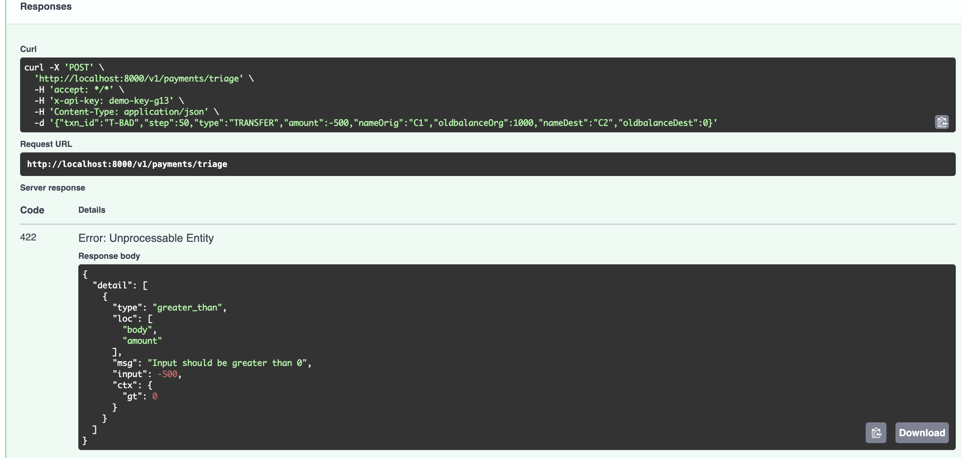
Figure 9. A negative amount is rejected with 422 before it ever reaches the model — schema validation at the edge.
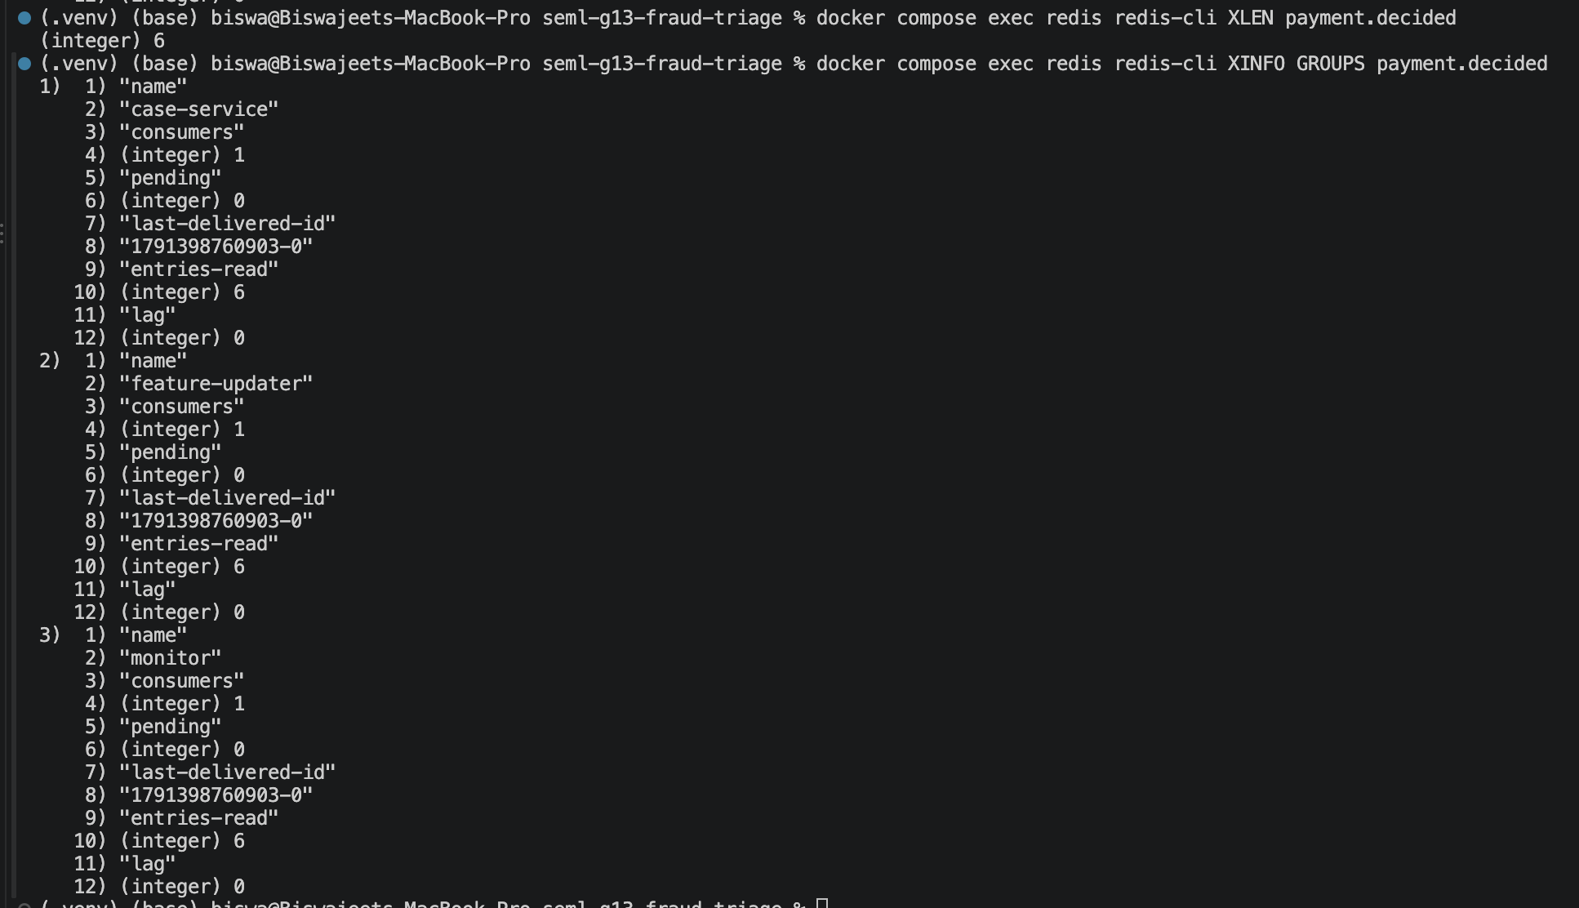
Figure 10. XINFO GROUPS on payment.decided shows all three consumers with lag: 0 — every published event has been read by all three independently.
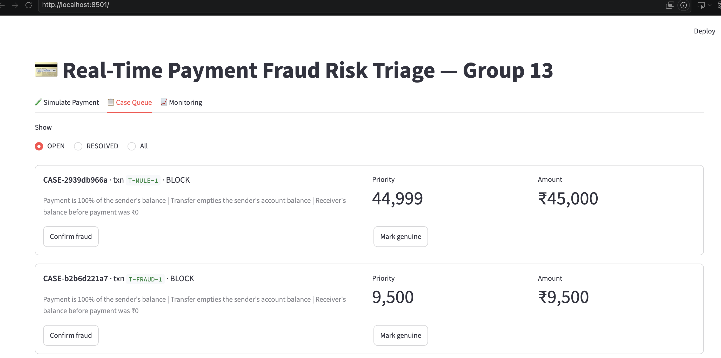
Figure 11. The case queue sorted by priority: the ₹45,000 mule case (priority 44,999) ranks above the ₹9,500 account-takeover case (priority 9,500).
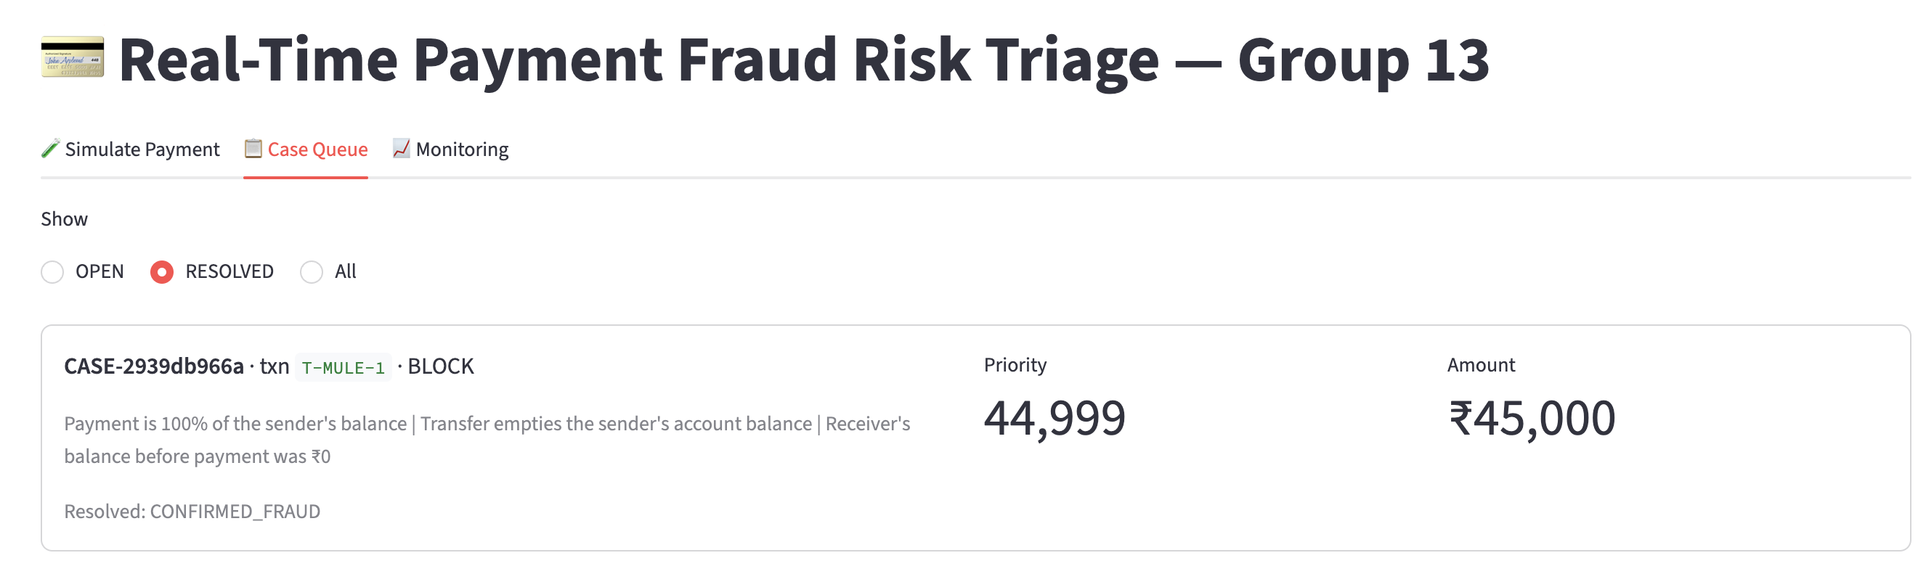
Figure 12. After “Confirm fraud”, the case moves to Resolved with verdict CONFIRMED_FRAUD — saved as a label for the next retraining round.
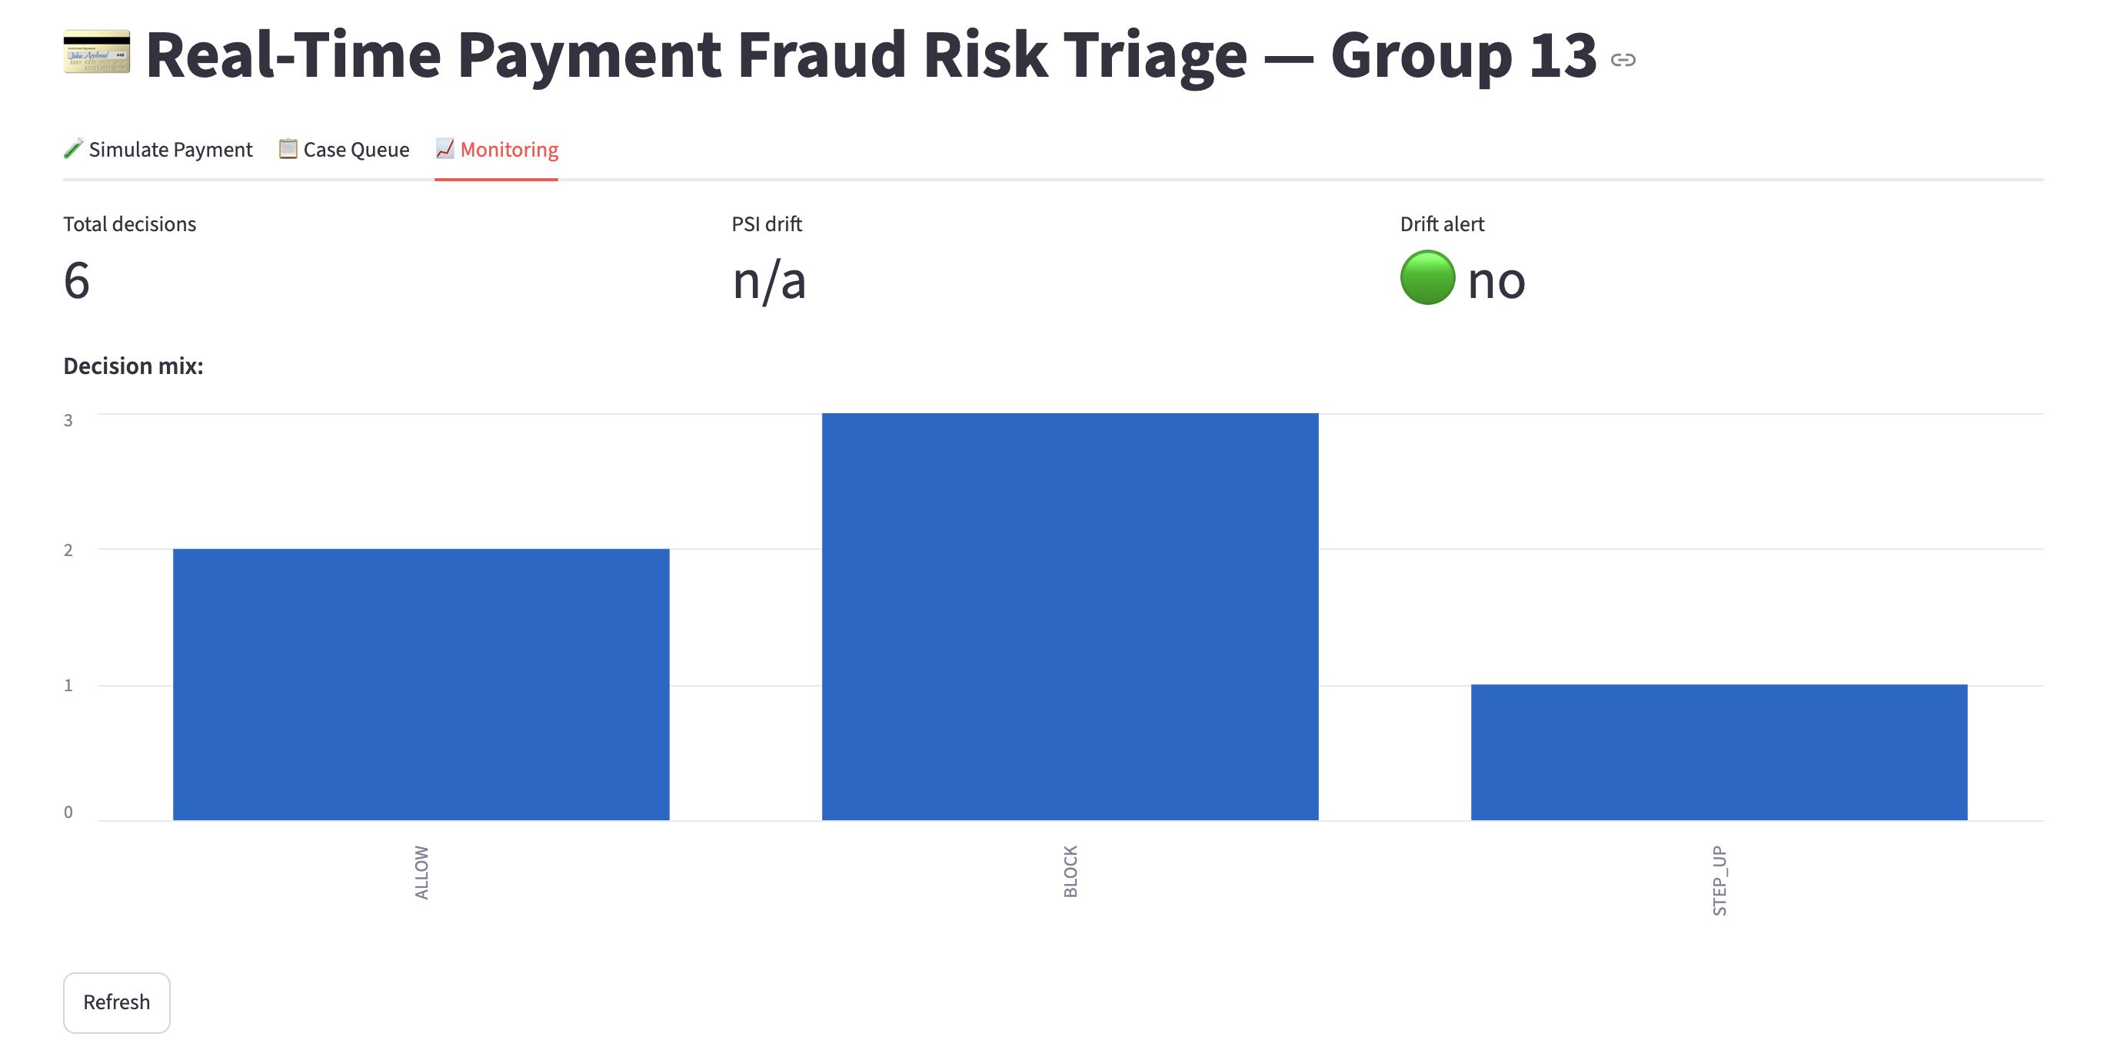
Figure 13. The monitoring tab: decision mix and PSI drift, both computed live from the same event stream.
Figure 14a. After stopping the scoring container, a new payment still returns a response — STEP_UP with degraded: true — instead of hanging or failing.
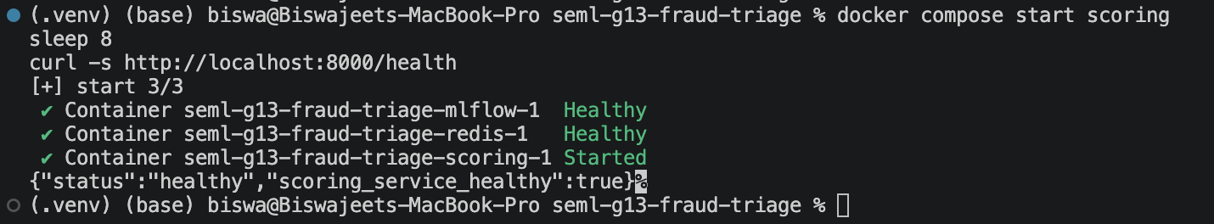
Figure 14b. A few seconds after restarting scoring, the gateway's own heartbeat detects it is back up, with no restart of the gateway needed.
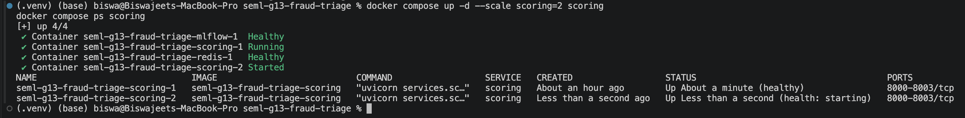
Figure 15. docker compose up --scale scoring=2 adds a second scoring container while everything else keeps running — the model-serving part scales independently.
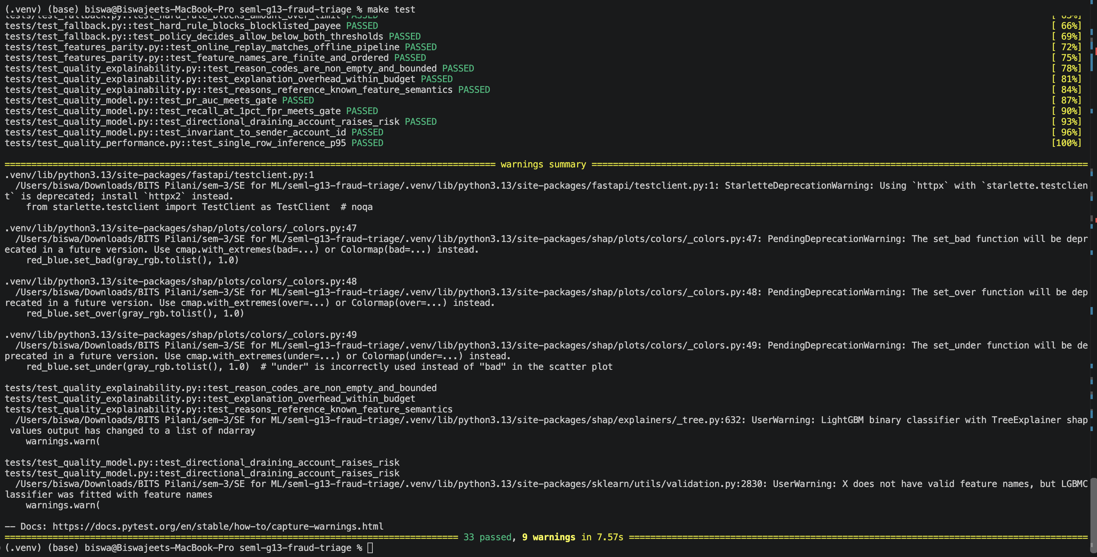
Figure 16. All 33 tests pass, covering data quality, the model-quality gate, explainability, performance, API contracts and the event pipeline.
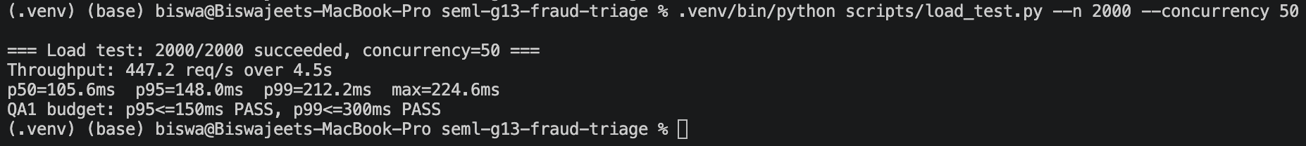
Figure 17. 2000 requests at 50 concurrent: p95 148.0 ms, p99 212.2 ms — both inside the QA1 target (p95 ≤ 150 ms, p99 ≤ 300 ms).

8. Limitations and Future Work
- PaySim has no device, geo, or app-behaviour signals that a real UPI deployment would have; the near-separable fraud signal here (balance-draining transfers) is a property of the simulator and may not transfer directly to production data.
- The SQLite case store and single-node Redis are demo-scale; a production PSP would use a managed Postgres and a clustered Redis/Kafka.
- No shadow or canary deployment for new models — promotion is immediate once the quality gate passes. A real rollout would run the challenger alongside the champion first.
- Fairness auditing is limited to “no demographic features used”; a full audit would check for proxy discrimination through behavioural features.
- Kubernetes was out of scope; Docker Compose was used throughout, with the architecture designed so a move to Kubernetes would mostly be a deployment-manifest change, not a code change.

9. Appendix — Key Source Files
Full source is at https://github.com/biswa13de/seml-g13-fraud-triage. Key files referenced in this report:
File | Purpose
common/features.py | The single compute_features() function shared by training and serving
common/feature_store.py | Online Feature Store pattern (Redis + in-memory backends)
training/build_features.py | Data Preparation View, implemented (Section 3.3)
training/train.py | 3-model MLflow comparison (Section 7.3)
training/select_thresholds.py | Cost-based triage thresholds (Section 7.5)
training/register.py | Quality gate + Model Registry pattern
services/scoring/pipeline.py | Pipe-and-filter inference pattern
services/scoring/explain.py | SHAP reason-code generation (QA3)
services/triage_api/main.py | Gateway: rules, heartbeat, policy, event publish
services/triage_api/heartbeat.py | Heartbeat tactic (FR9)
docker-compose.yml | All 8 services, matching Figure 4
tests/ | 33 tests (Section 7.6)
13.ipynb | Dataset, EDA, training comparison, SHAP, live API calls

Group Contribution
The contribution table on the cover page reflects real, verifiable work: commit history on the GitHub repository backs the percentages shown there.

