**Sweta Pragya Nayak**

**23BPTR143**

# Introduction to Passive Movements

* Passive movements are gentle, controlled motions performed by a healthcare provider to move a patient's joints and muscles without the patient's active participation. This helps maintain range of motion, prevent stiffness, and prepare the body for active exercises.

# Types of Passive Movements

## Joint Mobilizations

* Slow, rhythmic movements that gently stretch and mobilize specific joints.

## Passive Range of Motion

* The healthcare provider moves the patient's limb through its full range of
* motion.

## Stretching

* Lengthening muscles by slowly and carefully extending them.

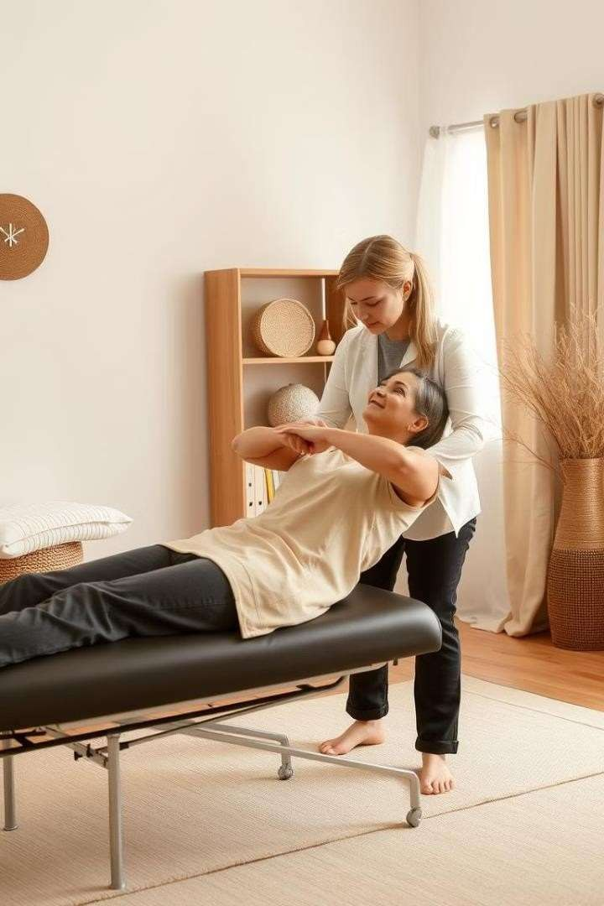

# Benefits of Passive Movements

1. Maintain Mobility

Prevents joint stiffness and muscle shortening during recovery.

1. Reduce Pain

Helps alleviate discomfort and promote relaxation in affected areas.

1. Prepare for Activity

Prepares the body for more active rehabilitation exercises.

1. Improve Circulation

Encourages blood flow to promote healing and tissue recovery.