**Project Overview**

To running this automation framework using Java and Selenium with the Page Object Model (POM). The framework includes Extent Reports for detailed test reports and a summary of test case results as well as HTML table to see how much testcase pass and fail. It also reads configuration data from a file, supports multiple browsers, and uses TestNG XML files for execution.

**Prerequisites**

* Java Development Kit (JDK) 8 or higher
* Apache Maven
* IntelliJ IDEA / Eclipse / Any other Java IDE
* Google Chrome

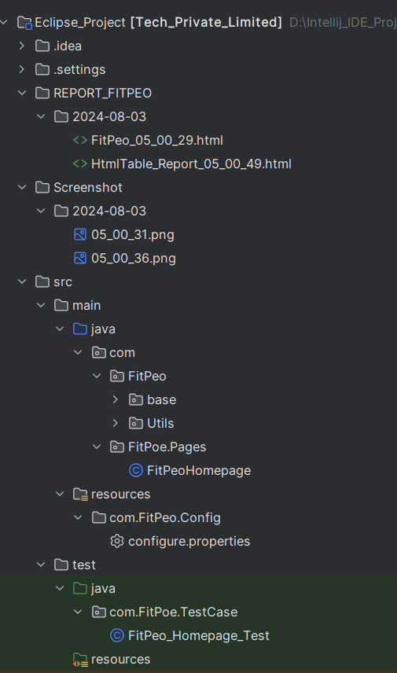

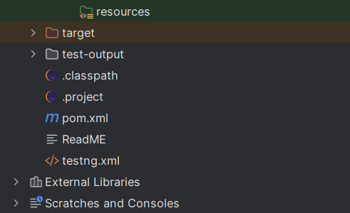

**Setup Instructions**

**1. Clone the Repository**

Clone the repository to your local machine using the following command:

git clone <https://github.com/biswa2000df/FitPeo-Tech-Private-Limited.git>

**2. Import the Project into IDE**

Open IntelliJ IDEA or Eclipse.

Import the project as a Maven project.

**3.Install Dependencies**

mvn clean install

**Automation Framework Documentation**

**Project Overview**

This document provides a comprehensive guide for setting up and running an automation framework using Java and Selenium with the Page Object Model (POM). The framework includes Extent Reports for detailed test reports and a summary of test case results. It also reads configuration data from a file, supports multiple browsers, and uses TestNG XML files for execution.

**Prerequisites**

* Java Development Kit (JDK) 8 or higher
* Apache Maven
* IntelliJ IDEA / Eclipse / Any other Java IDE
* Google Chrome / Mozilla Firefox / Any other supported browser

**Project Structure**

arduino

Copy code

AutomationFramework

│

├── src

│ ├── main

│ │ ├── java

│ │ │ ├── config

│ │ │ │ └── ConfigReader.java

│ │ │ ├── pages

│ │ │ │ ├── BasePage.java

│ │ │ │ ├── HomePage.java

│ │ │ │ └── LoginPage.java

│ │ │ ├── utils

│ │ │ │ ├── BrowserFactory.java

│ │ │ │ ├── ExtentManager.java

│ │ │ │ └── ExtentTestManager.java

│ │ │ └── tests

│ │ │ ├── BaseTest.java

│ │ │ └── LoginTest.java

│ └── test

│ └── resources

│ └── testng.xml

├── config.properties

├── pom.xml

└── README.md

**Setup Instructions**

**1. Clone the Repository**

Clone the repository to your local machine using the following command:

bash

Copy code

git clone <repository-url>

**2. Import the Project into IDE**

* Open IntelliJ IDEA or Eclipse.
* Import the project as a Maven project.

**3. Install Dependencies**

Run the following Maven command to install all necessary dependencies:

bash

Copy code

mvn clean install

**4. Configuration File**

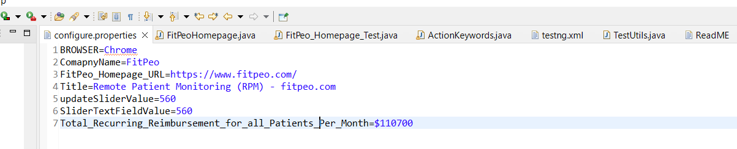

**5. TestNG XML File**

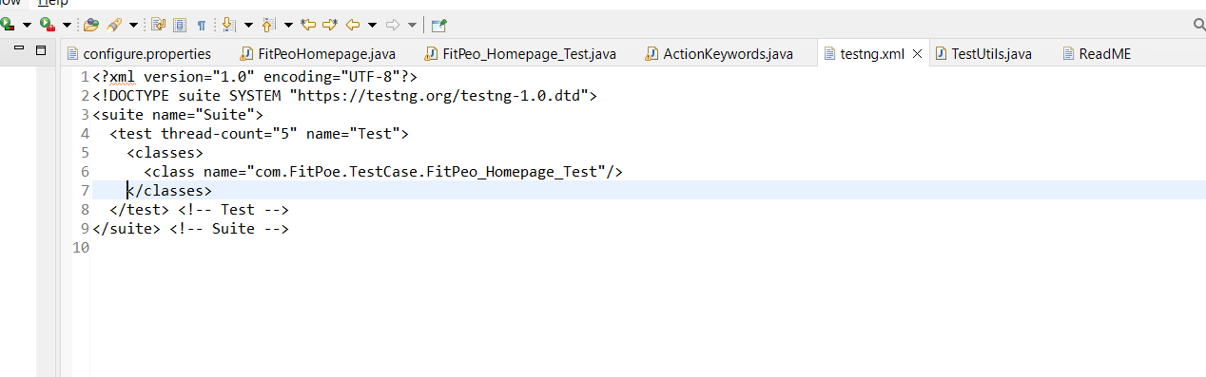

**Running the Tests**

**From IDE**

* Right-click on the testng.xml file.
* Select "Run As" -> "TestNG Suite".
* **Extent Reports and HTML Table**
* The framework generates Extent Reports that provide detailed information about the test execution. The report includes the number of test cases passed and failed, along with other relevant details and HTML Table to get the pass and Faile record.

**Location**

The Extent Reports are generated in the “**REPORT_FITPEO**”directory of the project.

“D:\Intellij_IDE_Project\Eclipse_Project\REPORT_FITPEO\2024-08-03\FitPeo_05_00_29.html”

The framework uses the Page Object Model (POM) design pattern to enhance test maintenance and reduce code duplication.

**Conclusion**

This automation framework is designed to be easily configurable and extendable. By following the above setup instructions, you should be able to quickly set up and run the tests in your environment. For any further assistance or customization, please refer to the source code and modify it as per your requirements.