1. Open <http://portal.azure.com>
2. Select your MSDN Subscription as per below:

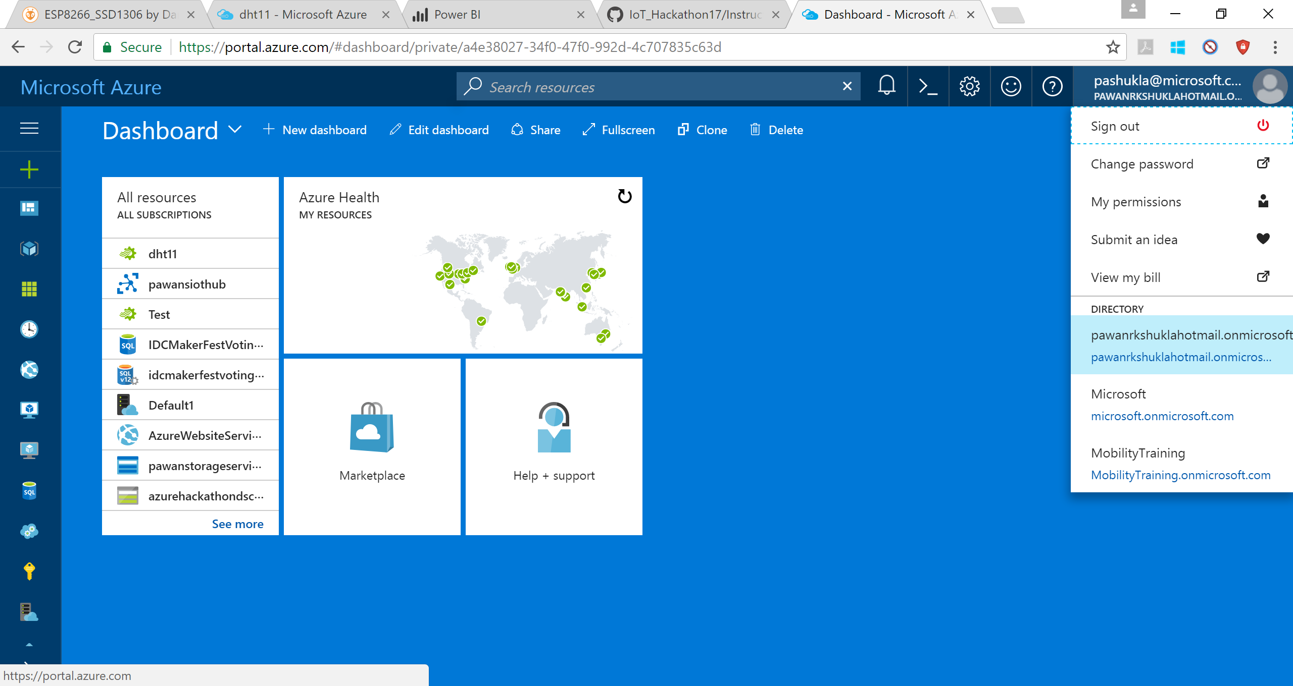

1. Create IoT Hub
   1. Click on + icon put “iot Hub” in search box and click on “IoT Hub”

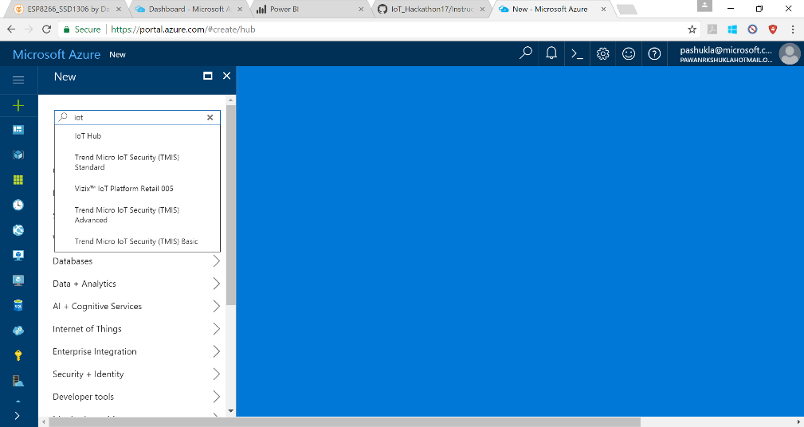

* 1. 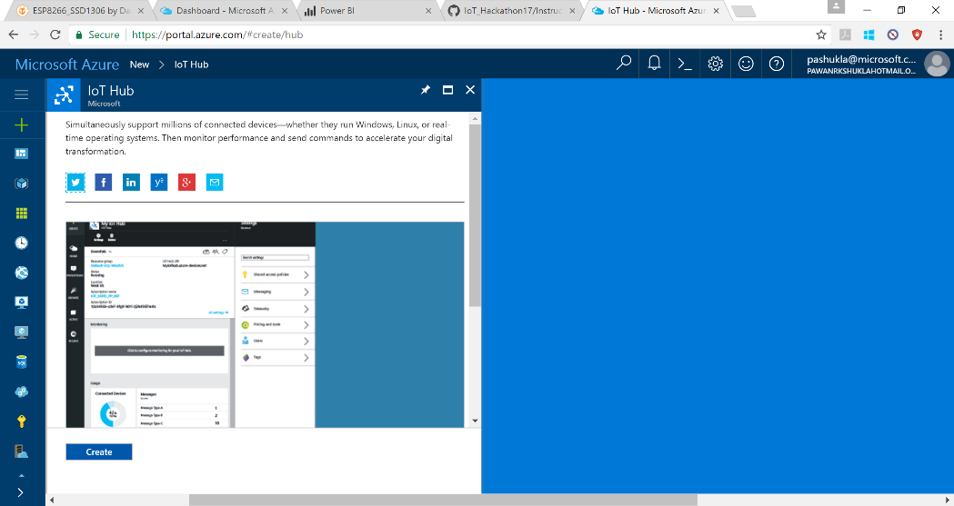Click on “Create” as per below
  2. Select Any IoT Hub name (1) and Pricing Tier (2)

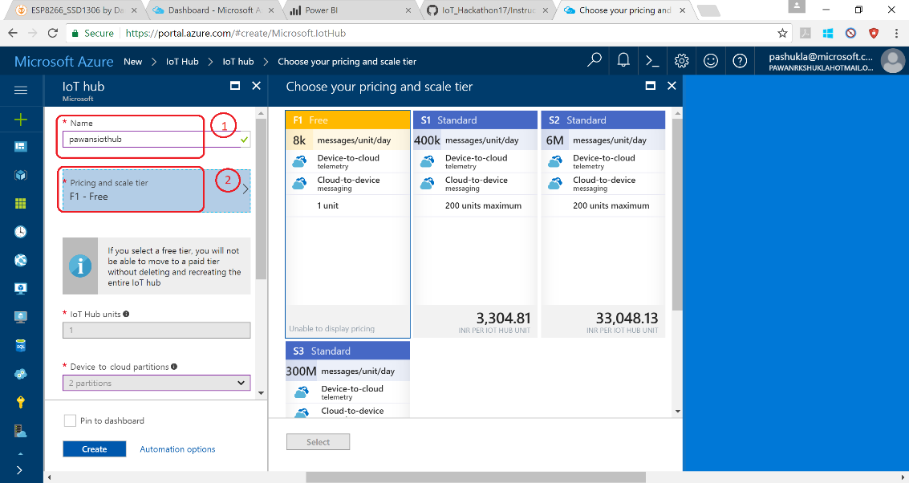

* 1. Select Subscription (3) and create/select Resource group (4) and Click Create:

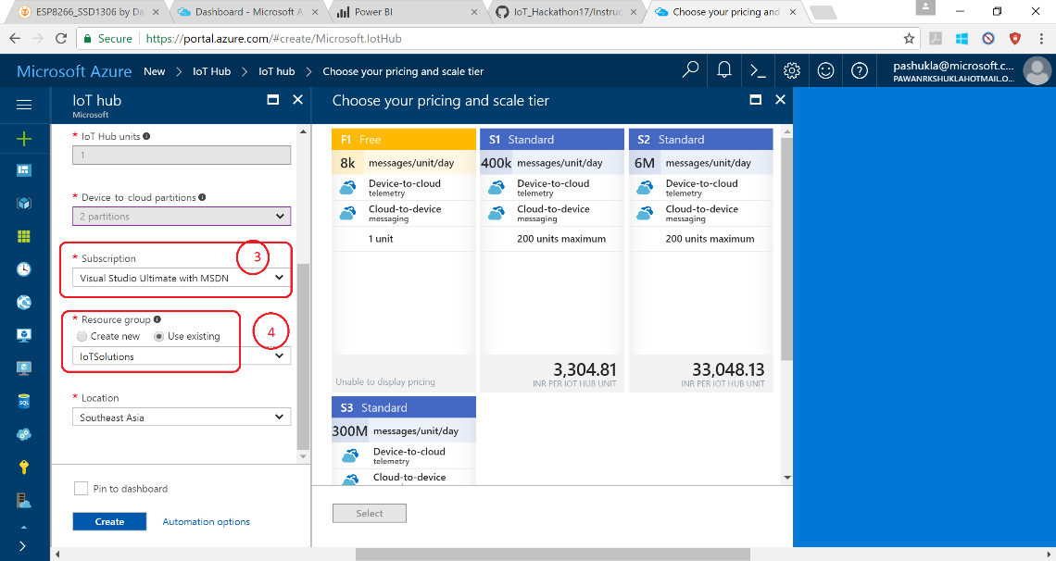

* 1. Deployment Successful:

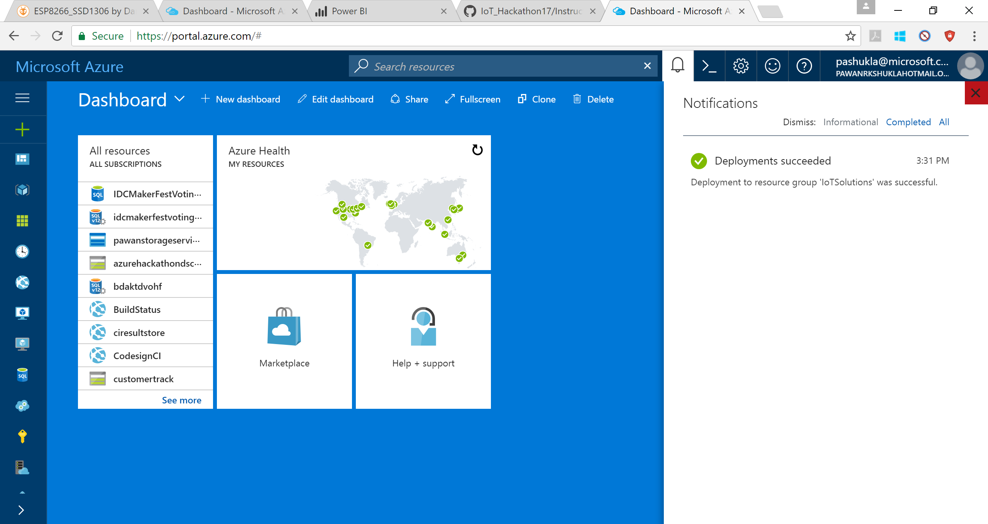

* 1. Go to new IoT Hub

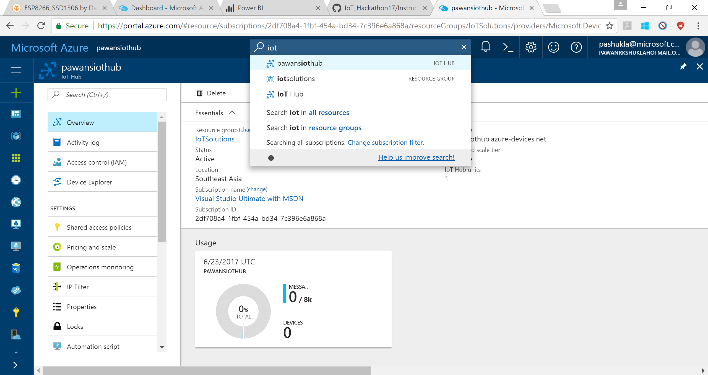

1. Create Devices
   1. Click on Device Explorer (1) and click Add (2)

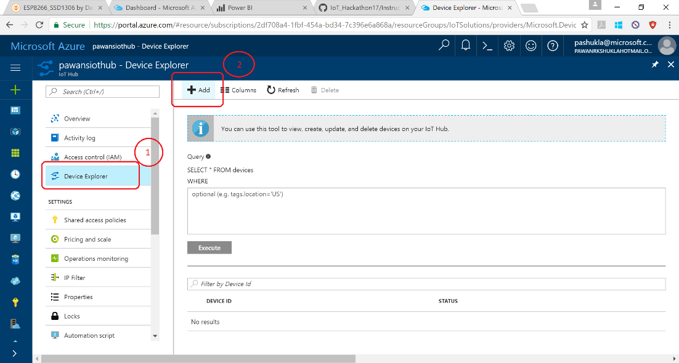

* 1. Give Device Id (1) and Save (2)

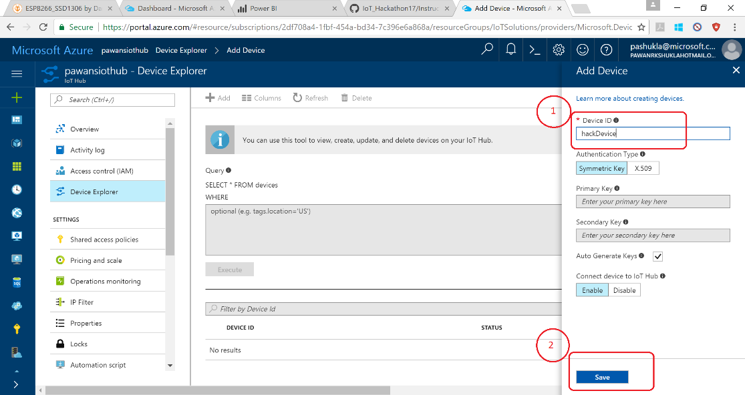

1. Get Shared Access Signature (SAS)
   1. Device Explorer <https://github.com/Azure/azure-iot-sdk-csharp/tree/master/tools/DeviceExplorer>
   2. Download: <https://github.com/Azure/azure-iot-sdk-csharp/releases>

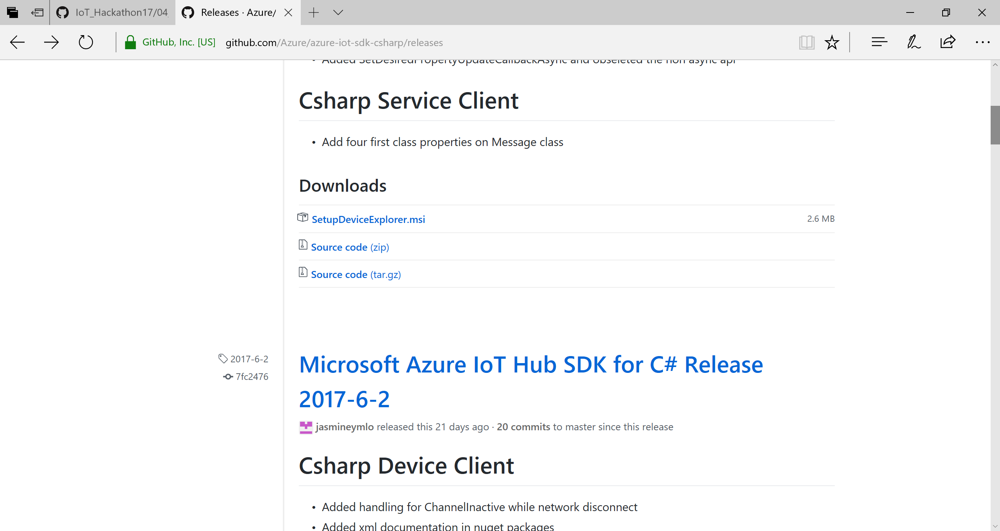

* 1. Get IoT Hub Connection string

Click in Sequence: (1)> (2) > Copy connection string – primary key (3)

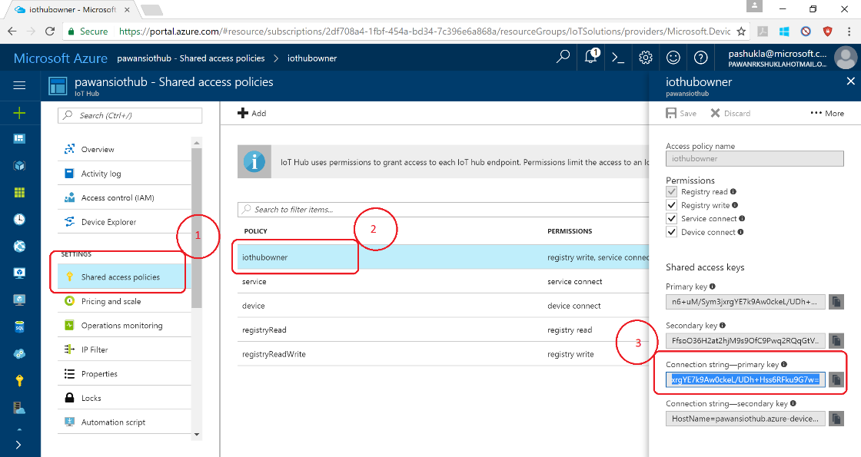

* 1. Follow Sequence
     + 1. Select tab
       2. Past connection string -primary
       3. Click update
       4. Click Generate SAS
       5. Copy SAS

