This repo houses all the examples that we will use for the IoT workshop. You will need VScode IDE along with Platform IO Core(which is a multiplatform build system).

******** Installation instructions *********

IDE Setup

1. Please Download the latest Python 2.7 and install it from <https://www.python.org/ftp/python/2.7.13/python-2.7.13.msi>. DON’T FORGET to select Add python.exe to Path feature on the “Customize” stage, otherwise Python Package Manager pip command will not be available.
2. Visit <https://code.visualstudio.com/> and download VS Code, if you don't have it.
3. Open VSCode Package Manager (Click on the extensions icon on the left panel in the IDE)

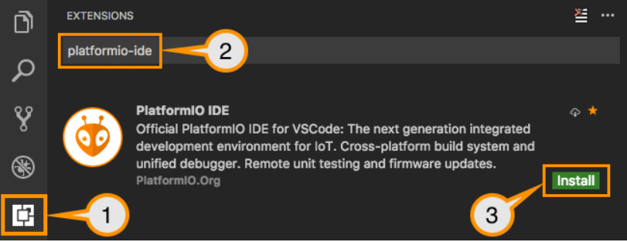

1. Search for official platformio-ide package (by PlatformIO.org) and install it.

Reference: <http://docs.platformio.org/en/latest/ide/vscode.html#installation>

Sample Project Setup

1. Clone the repository from [https://github.com/biswadipmaity/IoT_Hackathon17 /](https://github.com/biswadipmaity/IoT_Hackathon17%20/) or download and extract the contents to location of your choice.

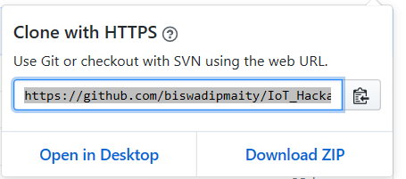

1. In VSCode, navigate to the folder in step 1. and select it in the file chooser dialog. (File>Open Folder> Select Folder)

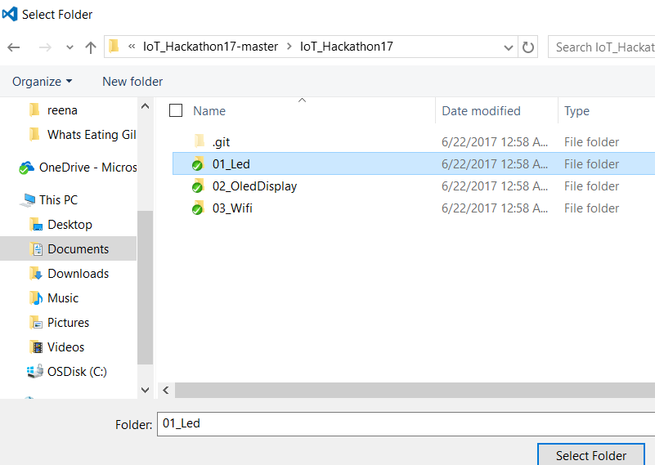

1. Extract the toolchain-xtensa.zip (143 MB) [[[ zip ]]](https://1drv.ms/u/s!Ao4PqnoADLq8g2emTIeFtJN9bWbz) (https://1drv.ms/u/s!Ao4PqnoADLq8g2emTIeFtJN9bWbz)   
   in C:\Users\%username%\.platformio\packages.­­­

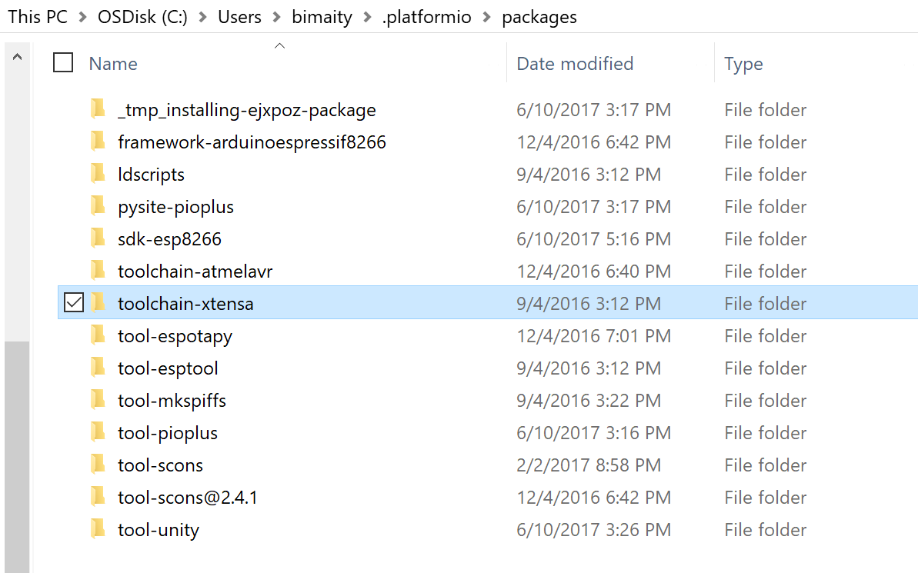  
(This package takes a lot of time to download, so we are directly copying the files)

1. Compile the project (Ctrl+Alt+B)
2. Upload the binary to your device (Ctrl+Alt+U)