AND GATE
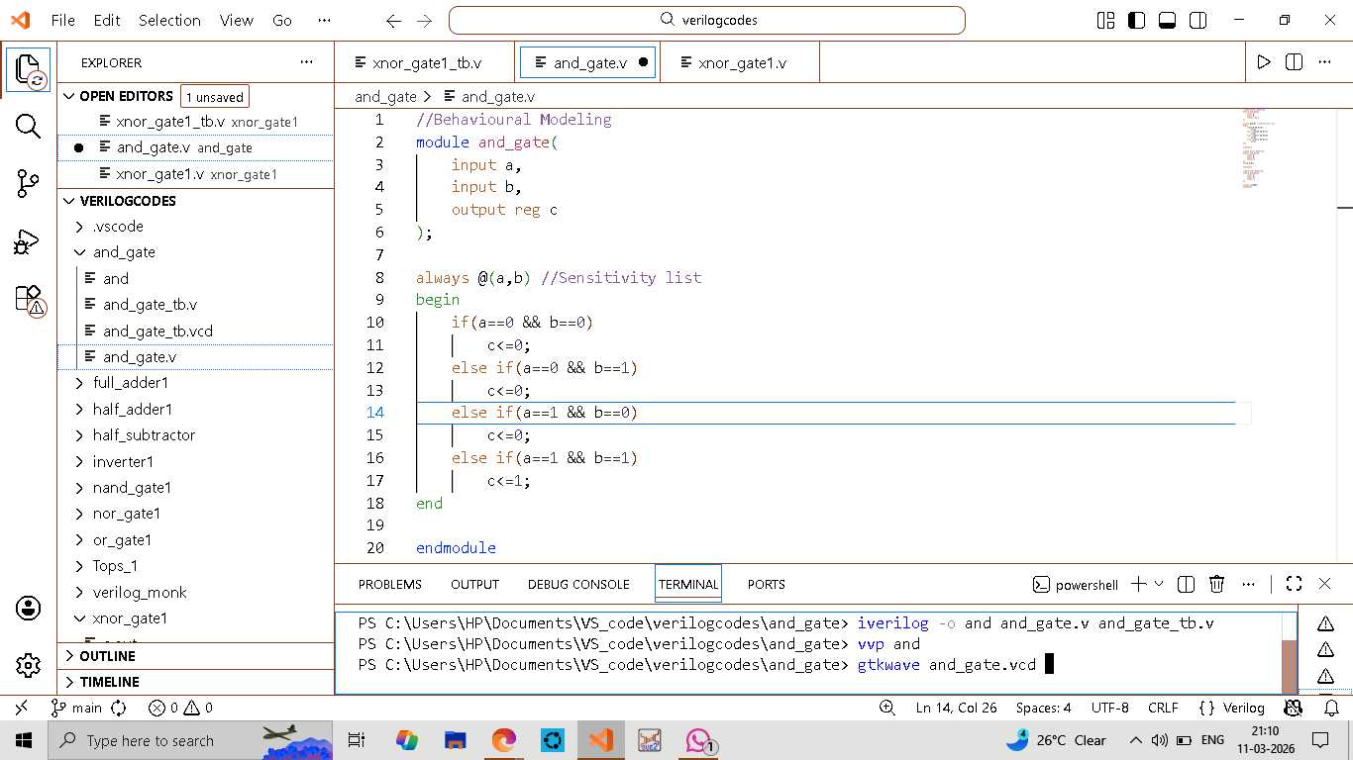
BEHAVIOURAL MODELING
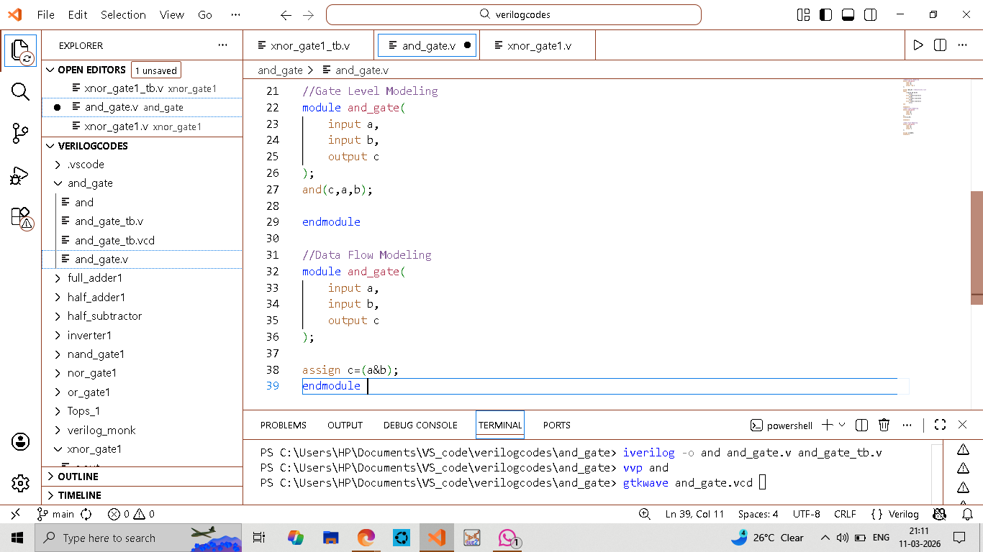
GATE LEVEL MODELING
&
DATAFLOW MODELING

Biswajeet Ganthia (ECE-A1; Roll-19)
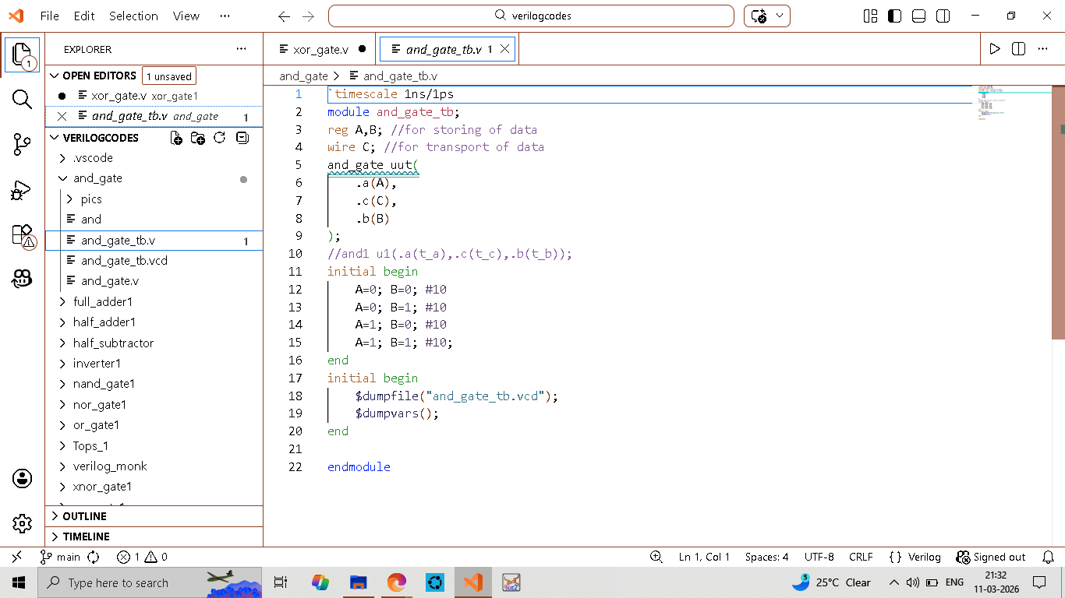
TESTBENCH
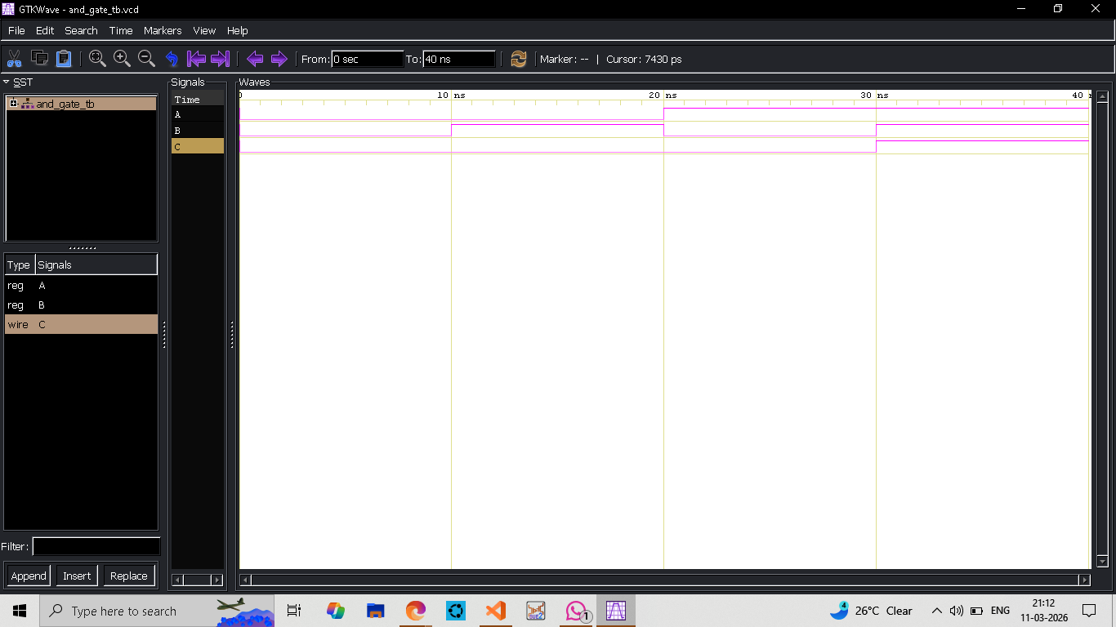
WAVEFORM

Biswajeet Ganthia (ECE-A1; Roll-19)
OR GATE
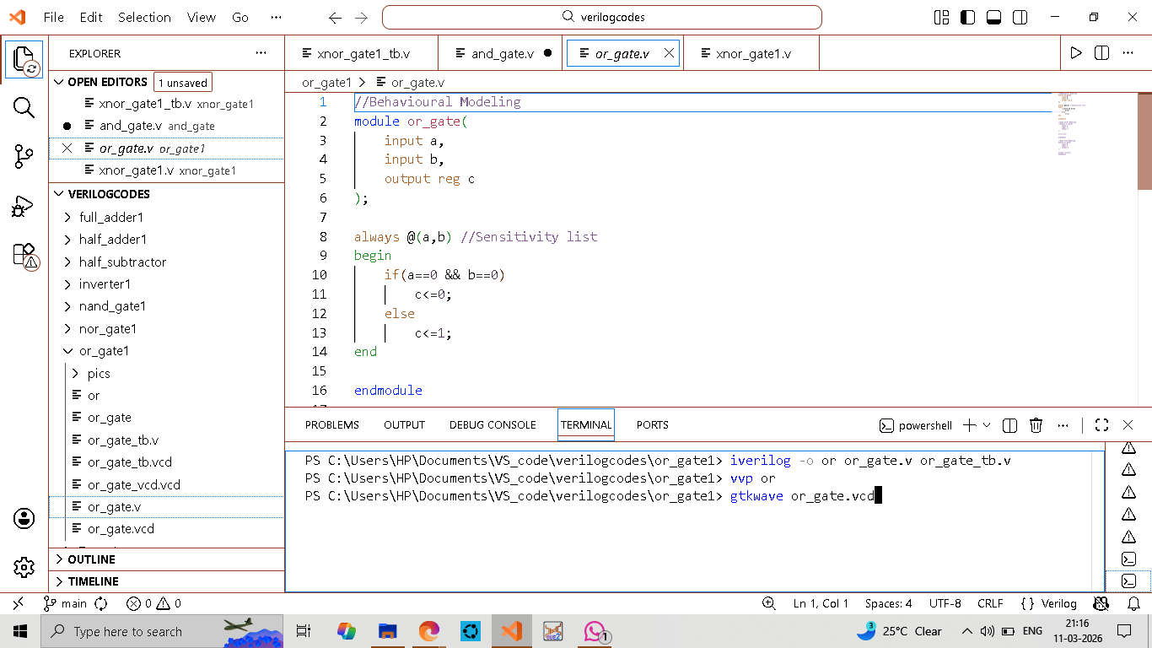
BEHAVIOURAL MODELING
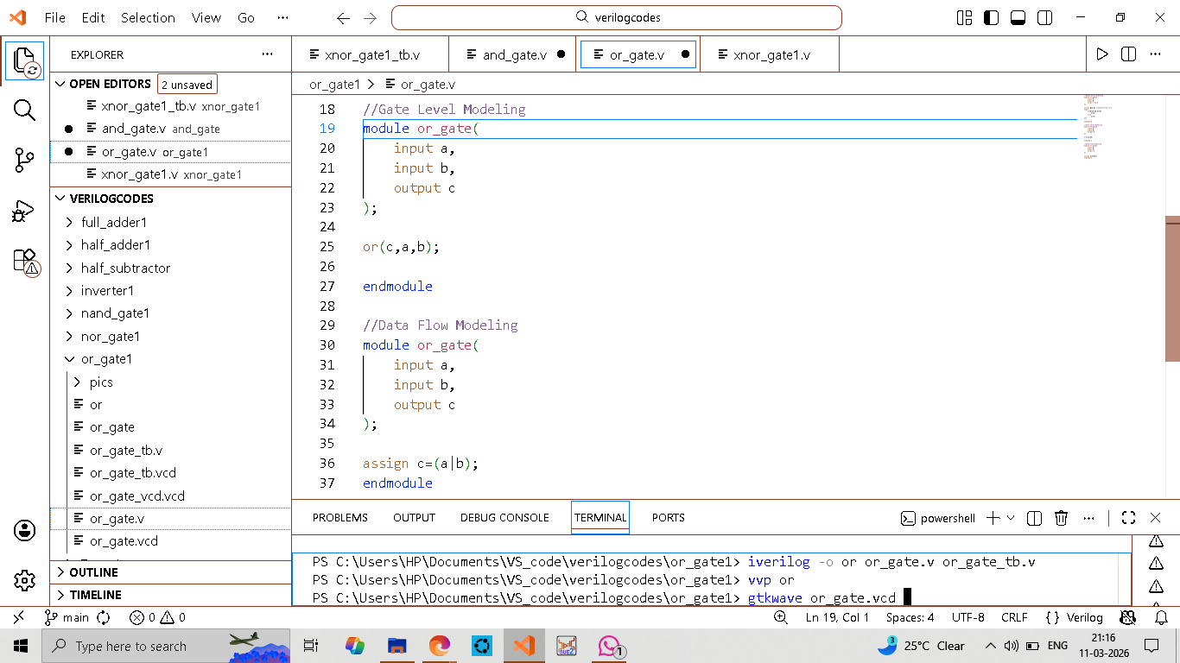
GATE LEVEL MODELING
&
DATAFLOW MODELING

Biswajeet Ganthia (ECE-A1; Roll-19)

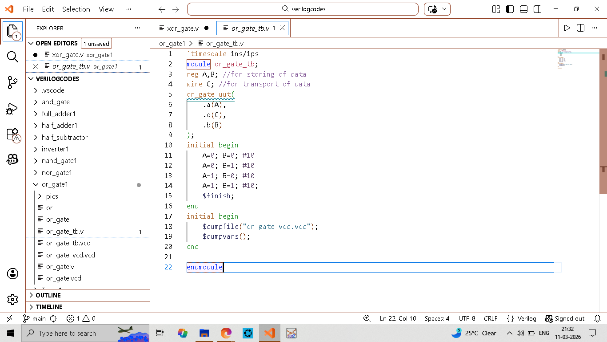
TESTBENCH
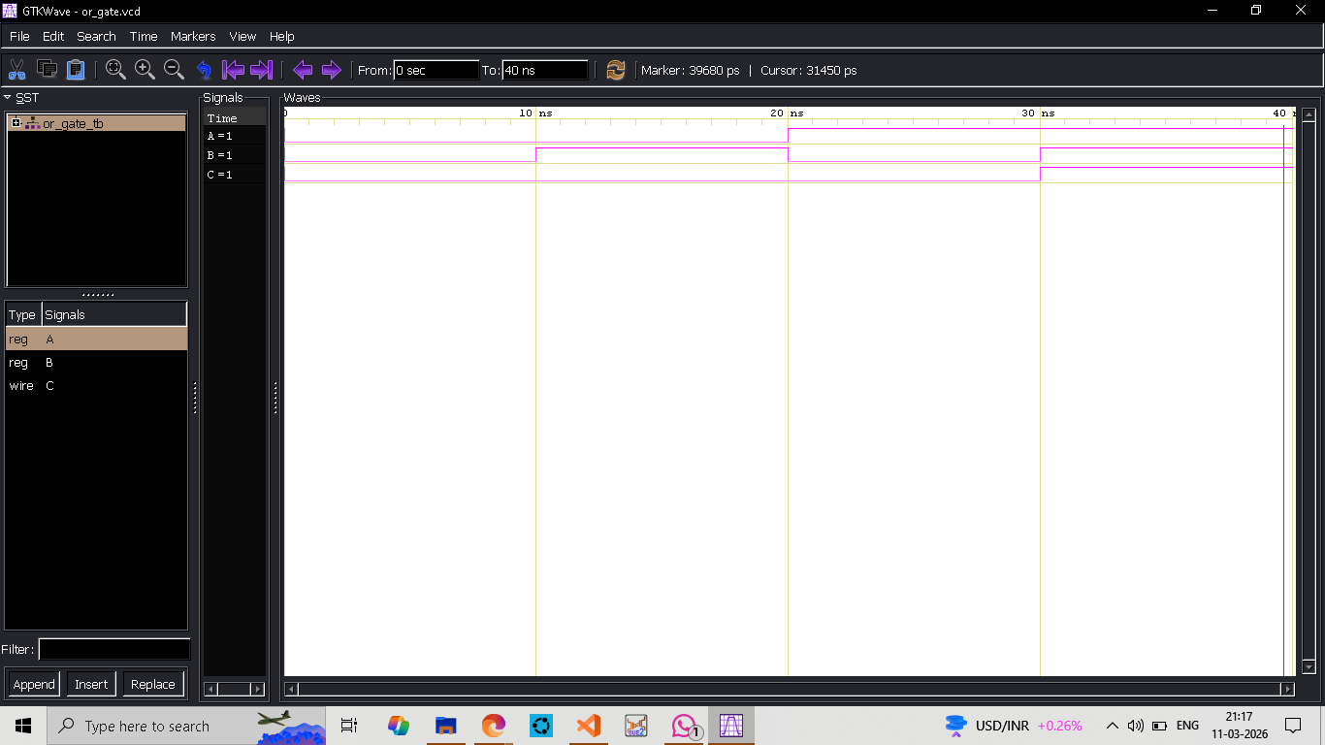
WAVEFORM

Biswajeet Ganthia (ECE-A1; Roll-19)
NAND GATE
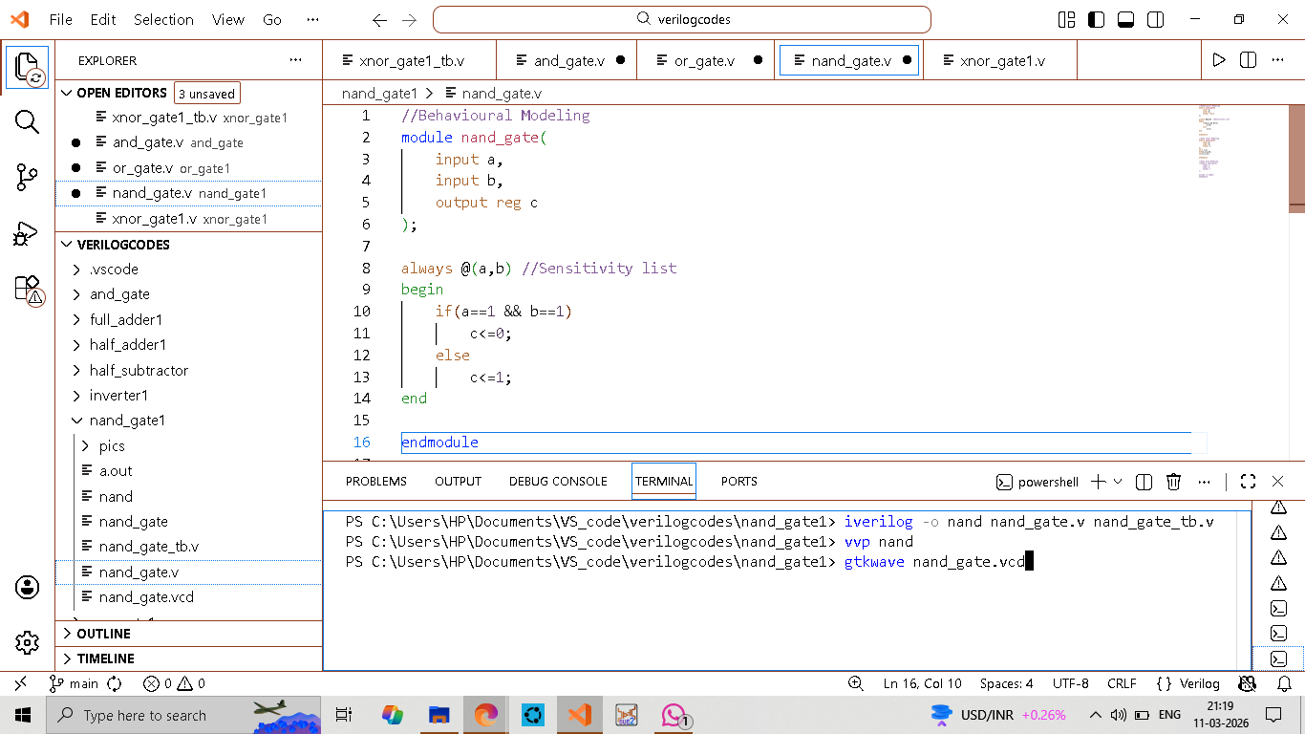
BEHAVIOURAL MODELING
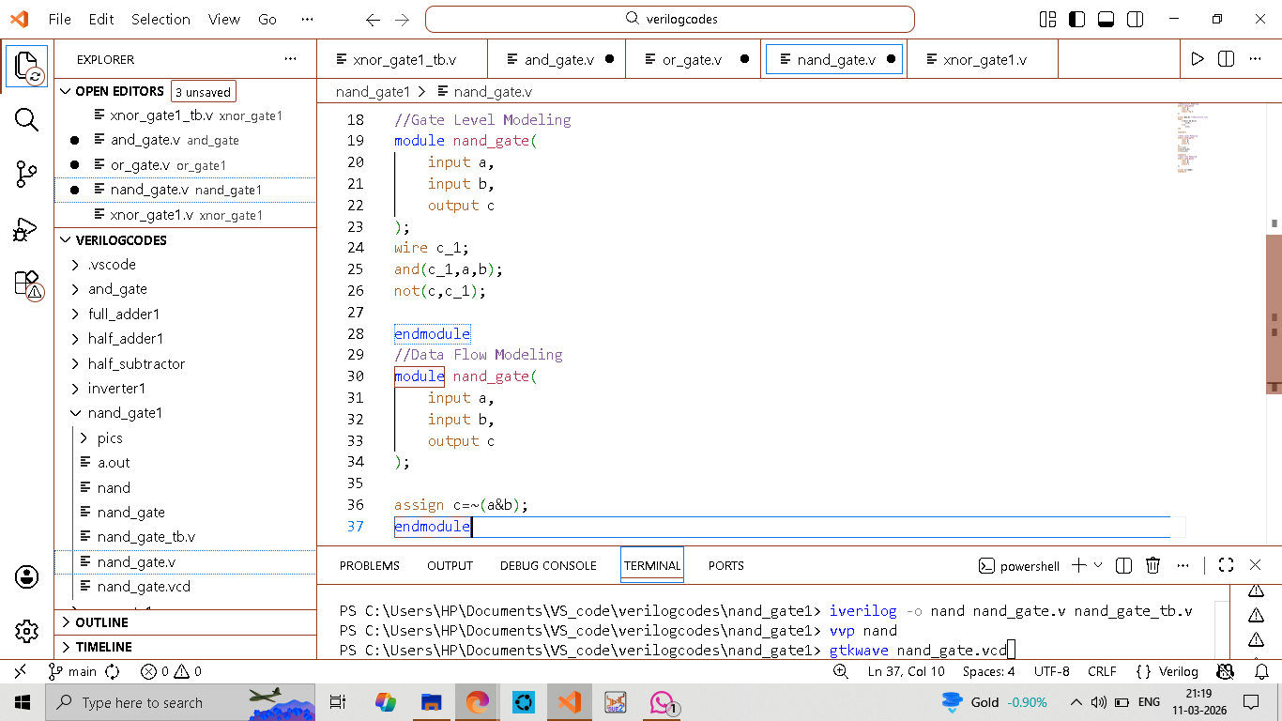
GATE LEVEL MODELING
&
DATAFLOW MODELING

Biswajeet Ganthia (ECE-A1; Roll-19)
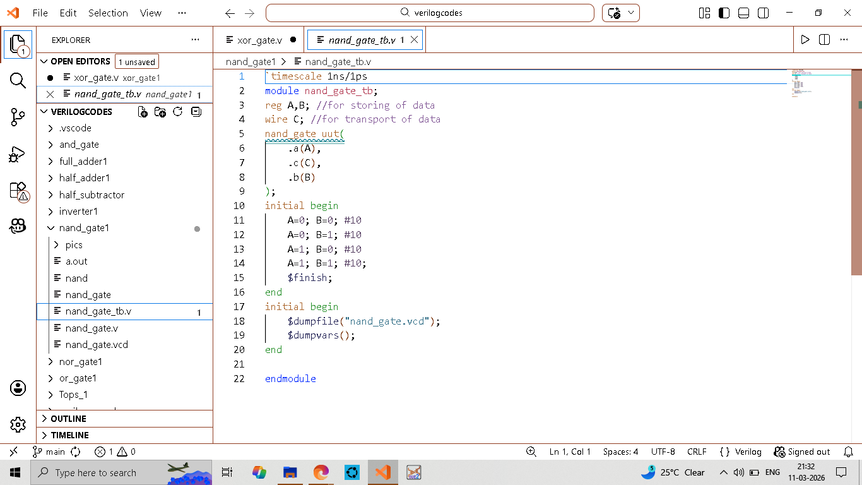
TESTBENCH

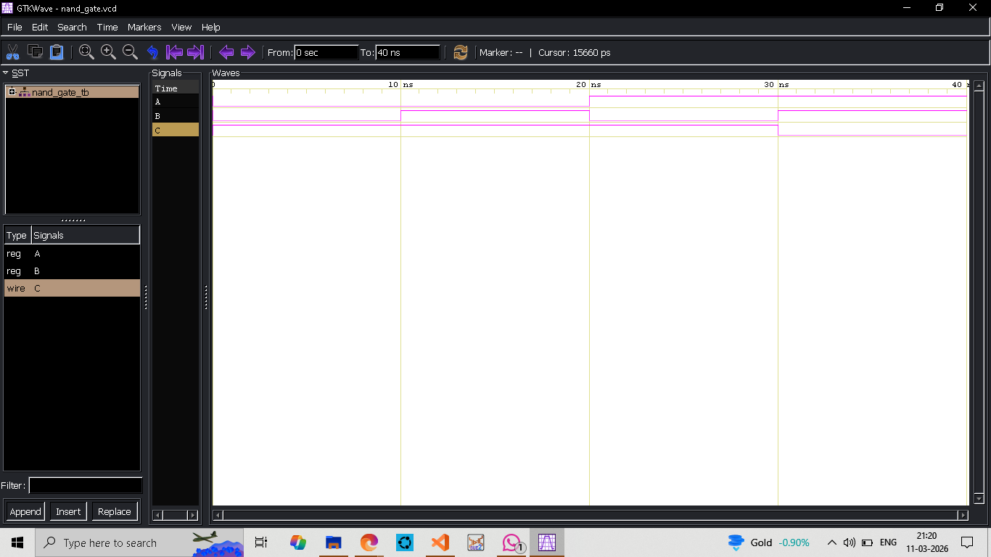
WAVEFORM

Biswajeet Ganthia (ECE-A1; Roll-19)
NOR GATE
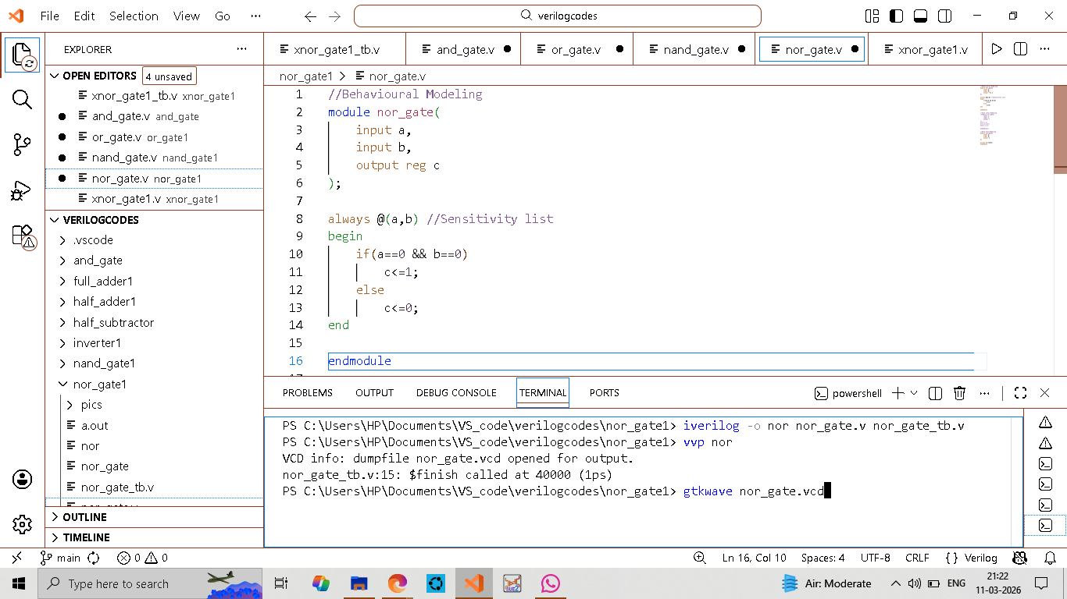
BEHAVIOURAL MODELING
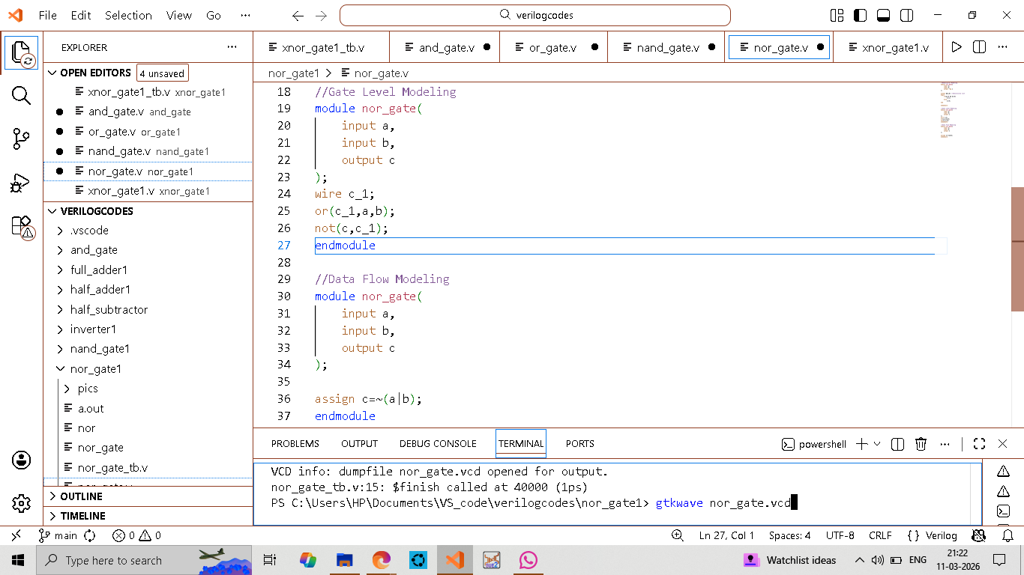
GATE LEVEL MODELING
&
DATAFLOW MODELING

Biswajeet Ganthia (ECE-A1; Roll-19)
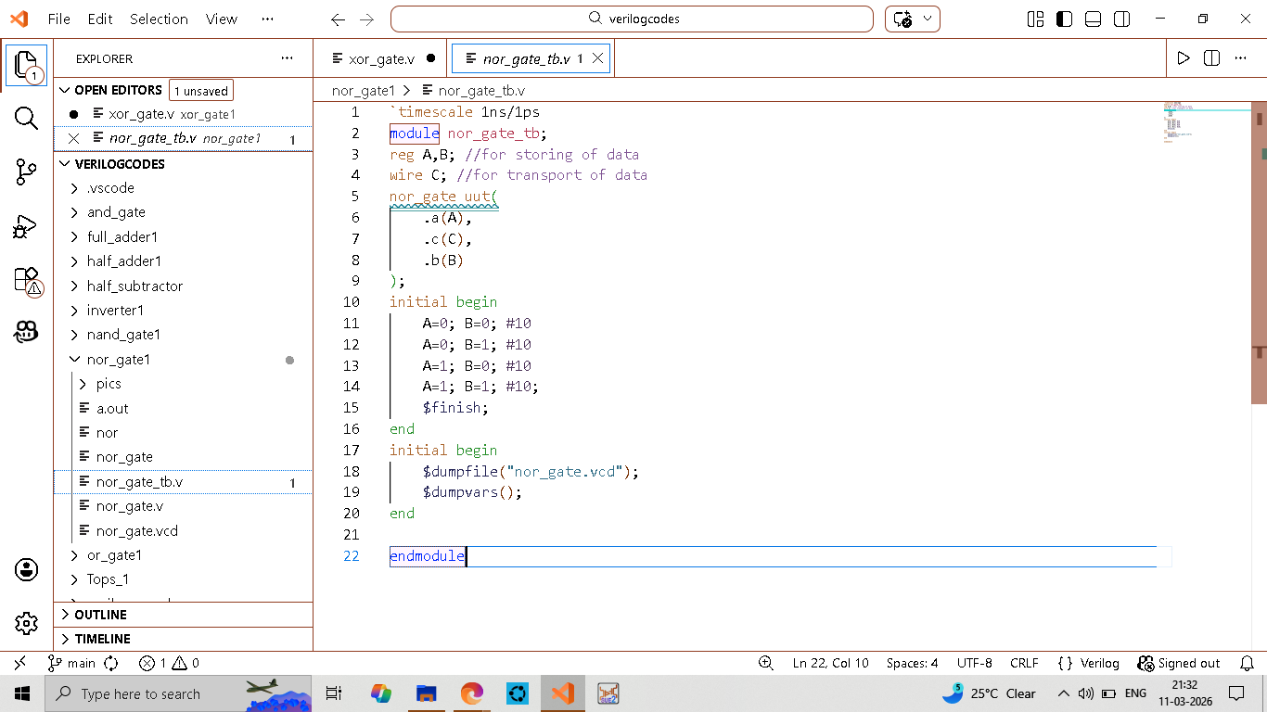
TESTBENCH

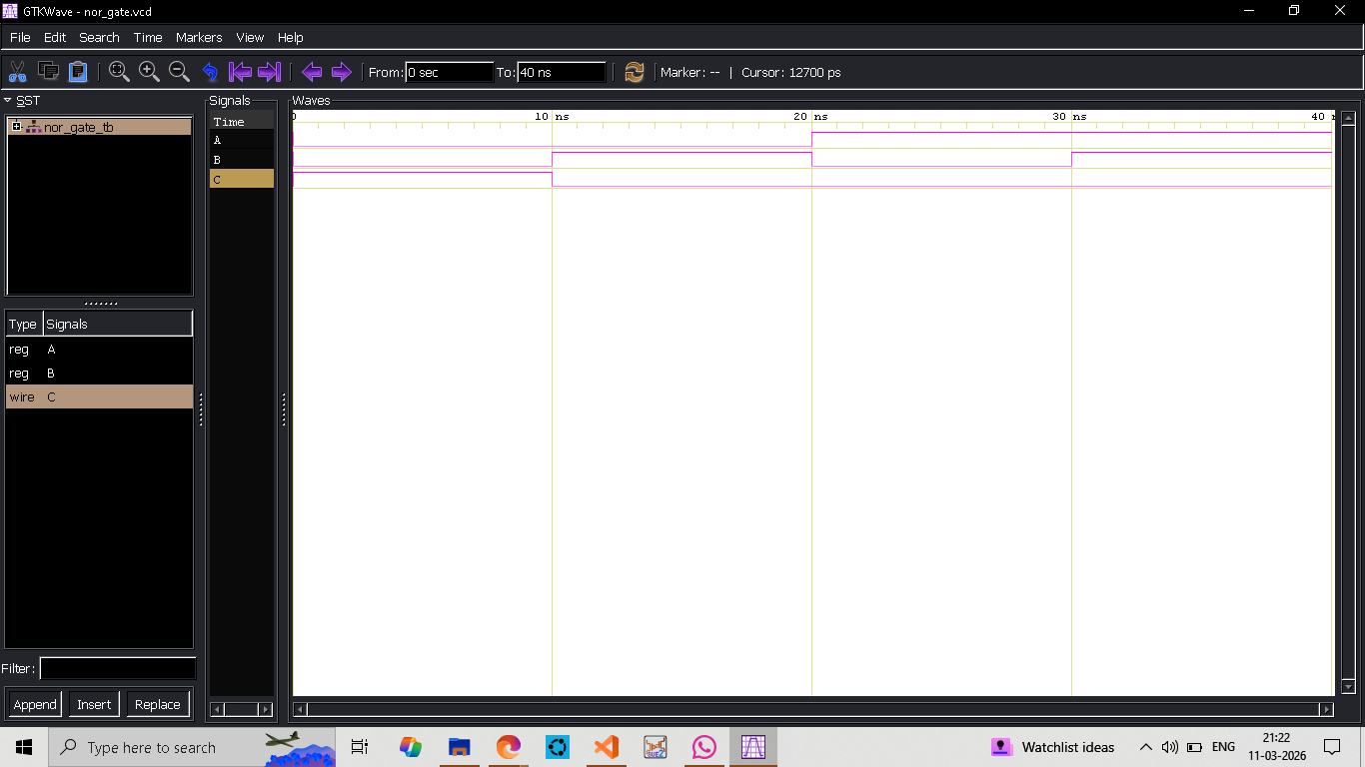
WAVEFORM

Biswajeet Ganthia (ECE-A1; Roll-19)
XNOR GATE
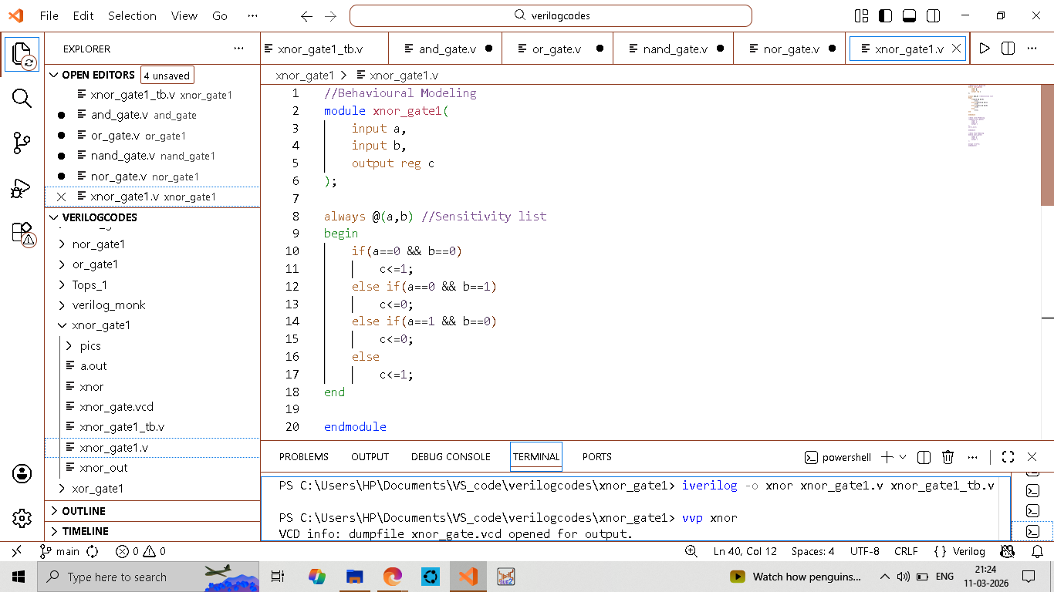
BEHAVIOURAL MODELING
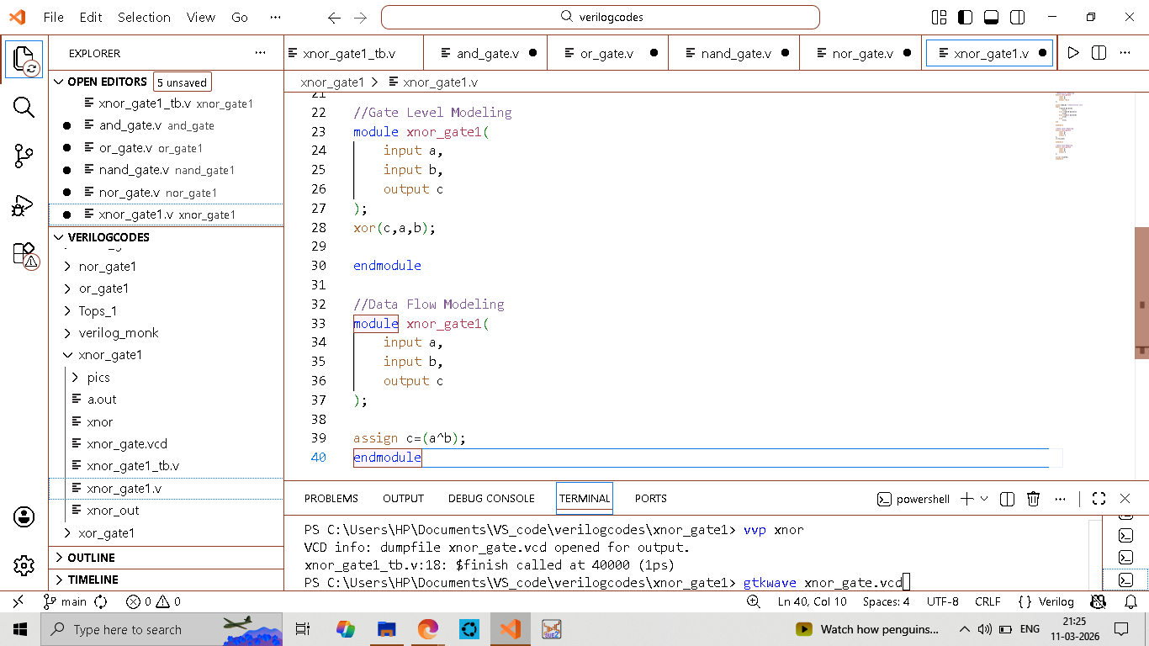
GATE LEVEL MODELING
&
DATAFLOW MODELING

Biswajeet Ganthia (ECE-A1; Roll-19)

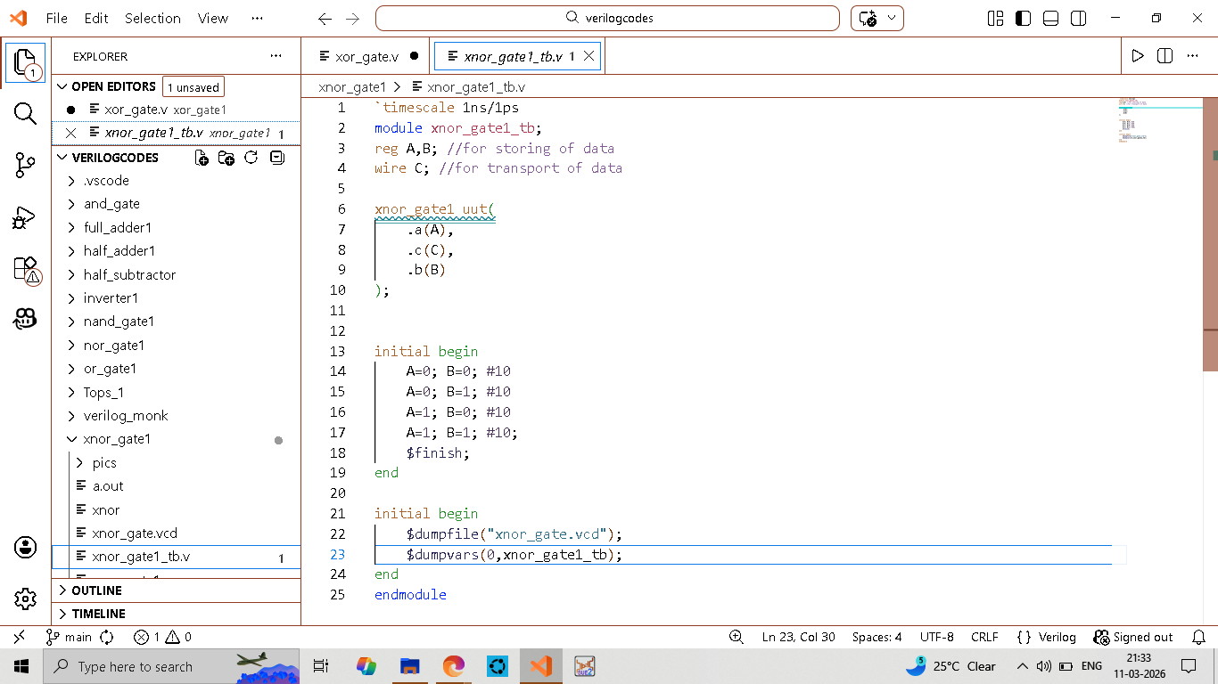
TESTBENCH
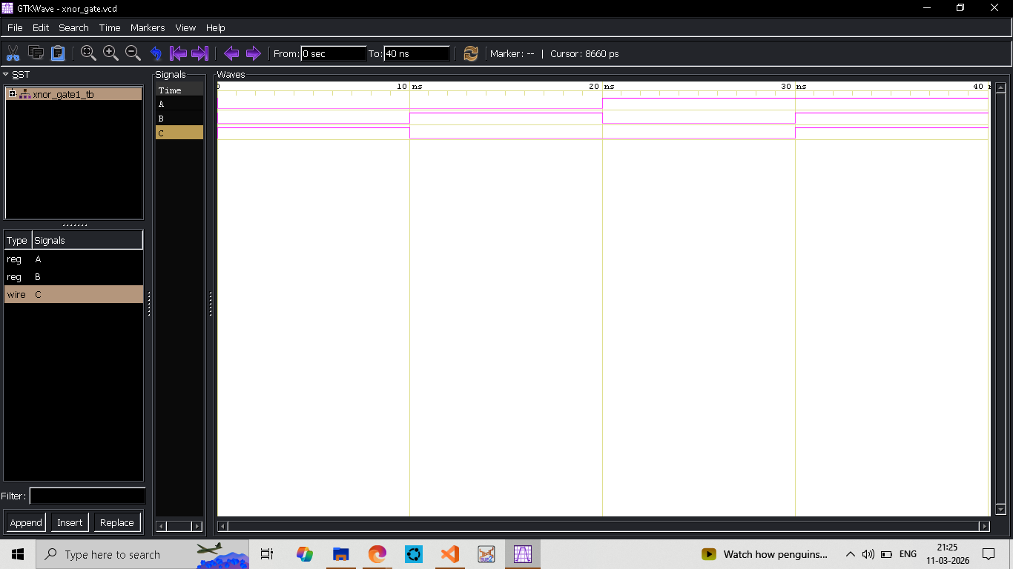
WAVEFORM

Biswajeet Ganthia (ECE-A1; Roll-19)
XOR GATE
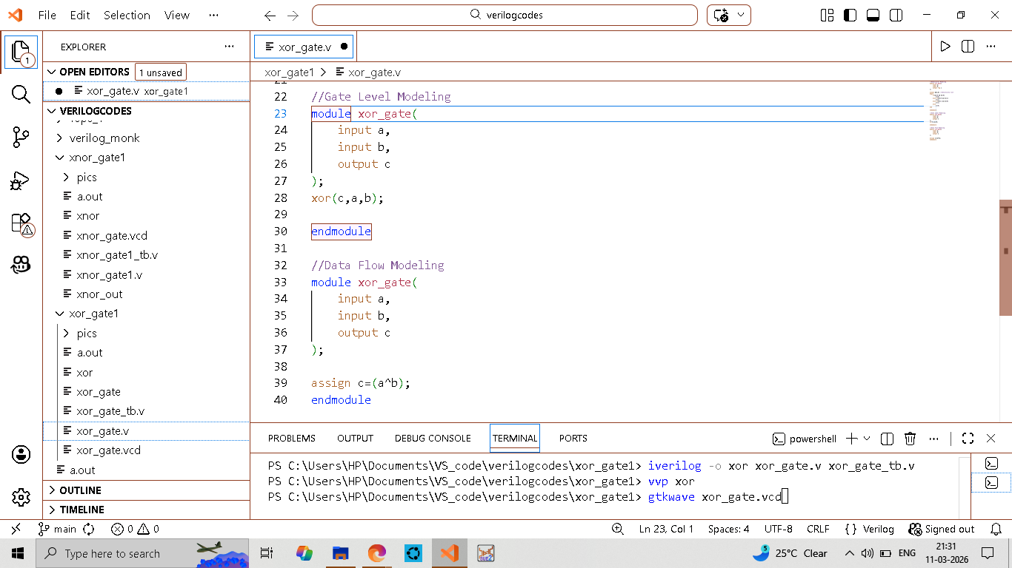
BEHAVIOURAL MODELING
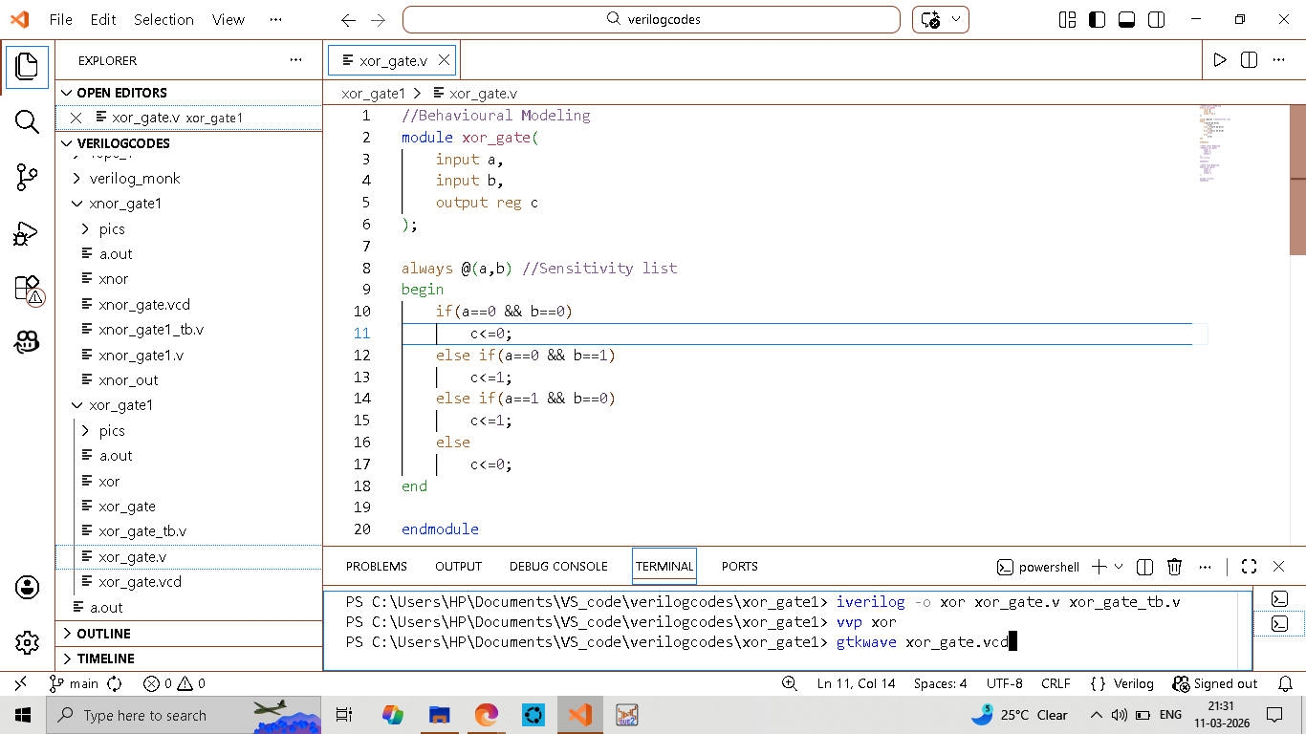
GATE LEVEL MODELING
&
DATAFLOW MODELING

Biswajeet Ganthia (ECE-A1; Roll-19)
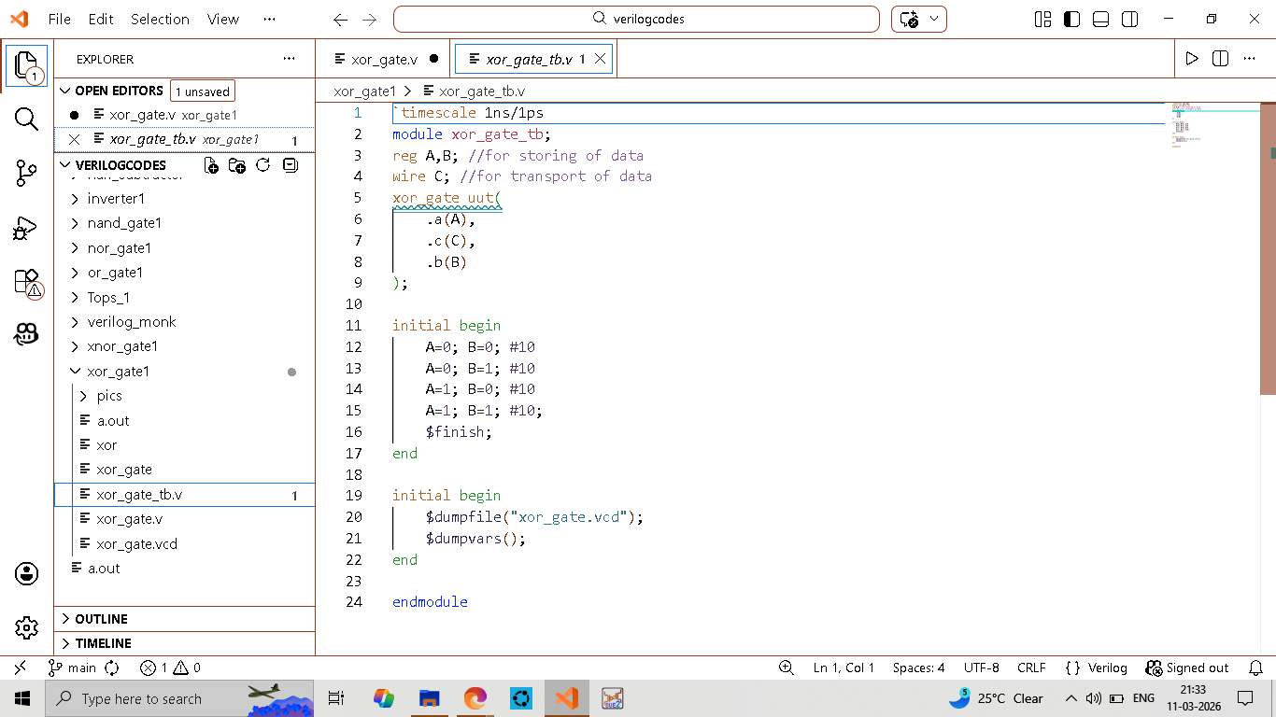
TESTBENCH

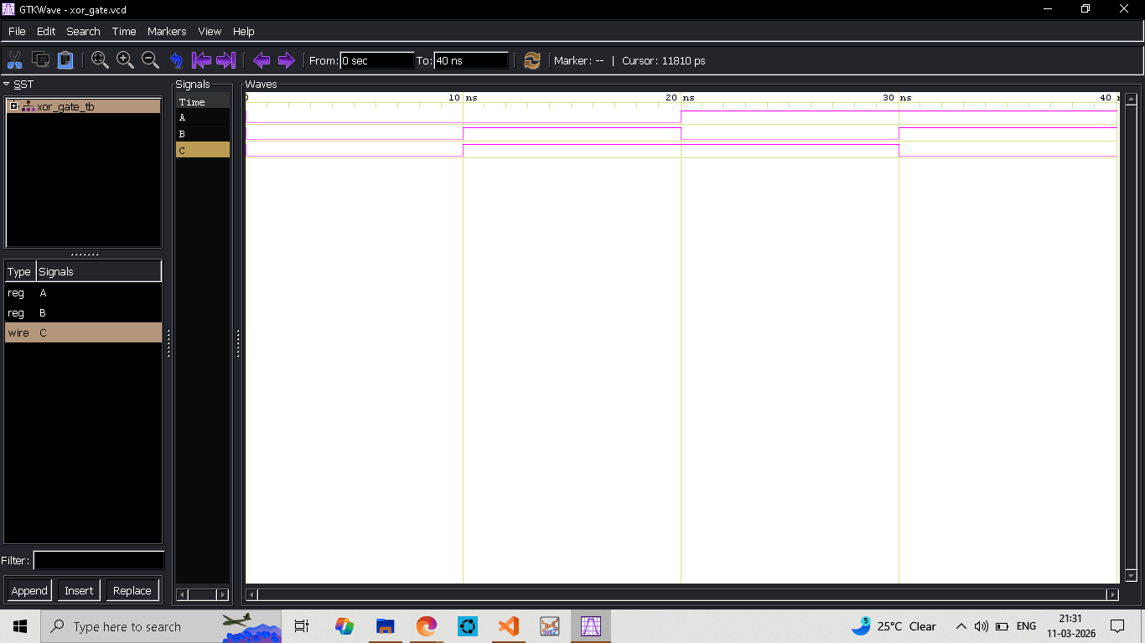
WAVEFORM

Biswajeet Ganthia (ECE-A1; Roll-19)

