HALF ADDER
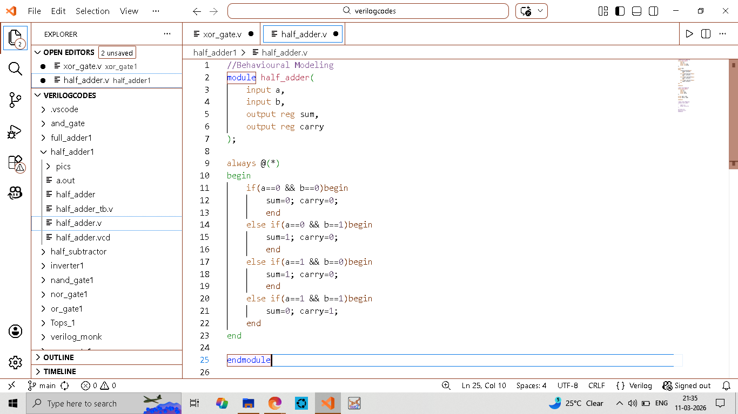
BEHAVIOURAL MODELING
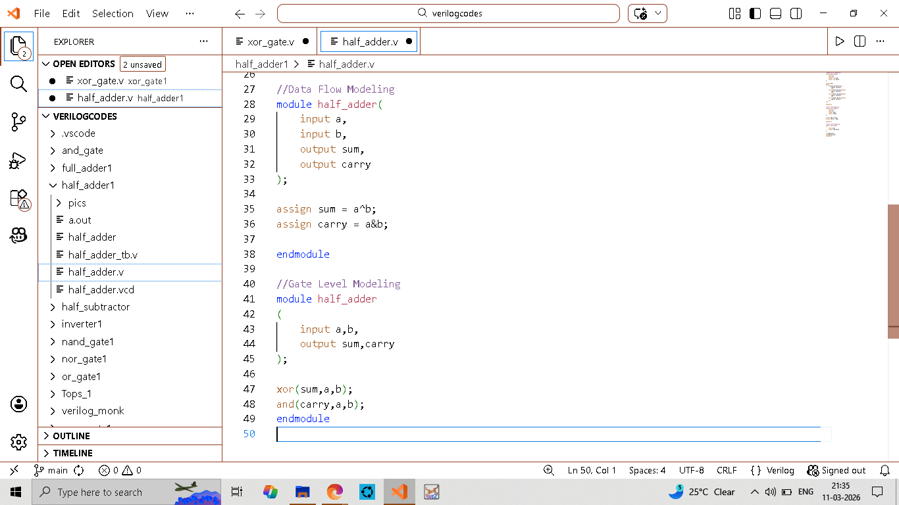
GATE LEVEL MODELING
&
DATAFLOW MODELING

Biswajeet Ganthia (ECE-A1; Roll -19)
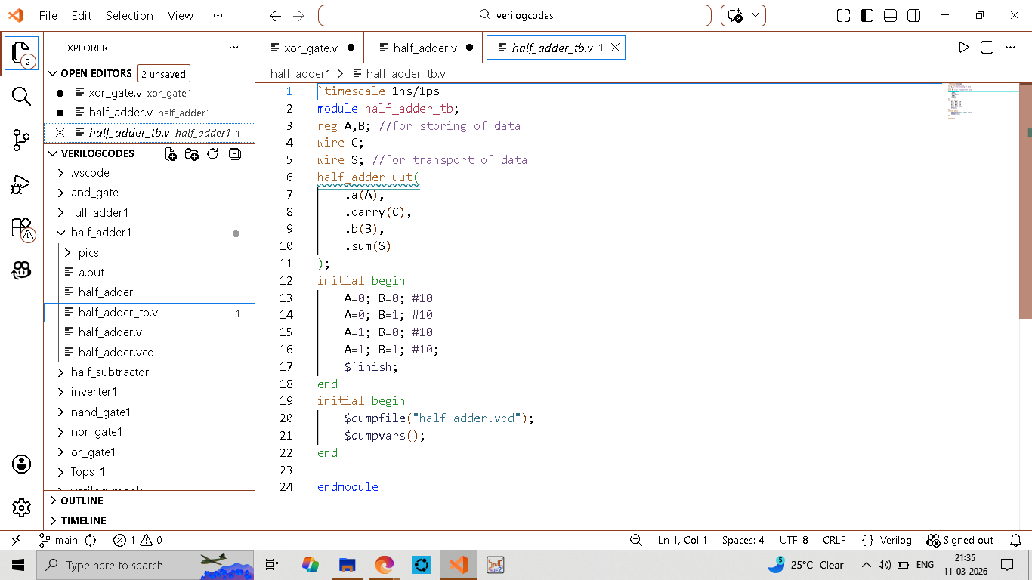
TESTBENCH
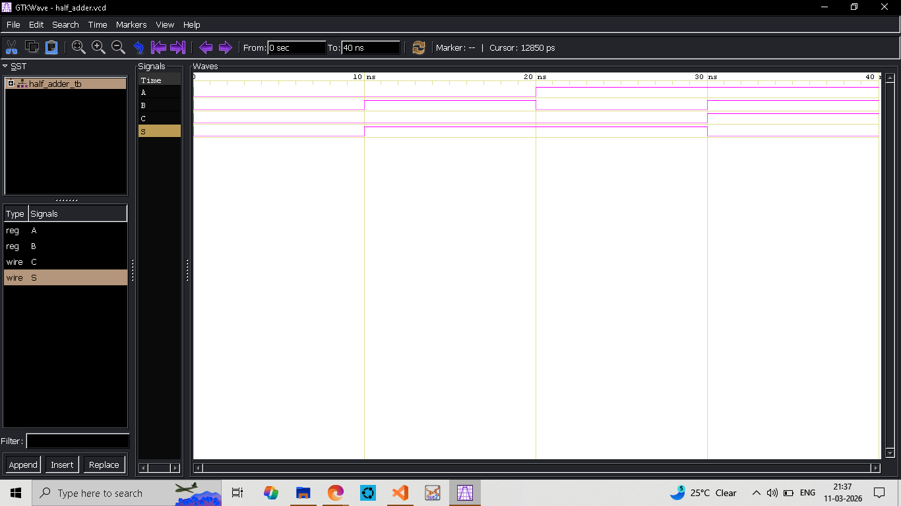
WAVEFORM

Biswajeet Ganthia (ECE-A1; Roll -19)
HALF SUBTRACTOR
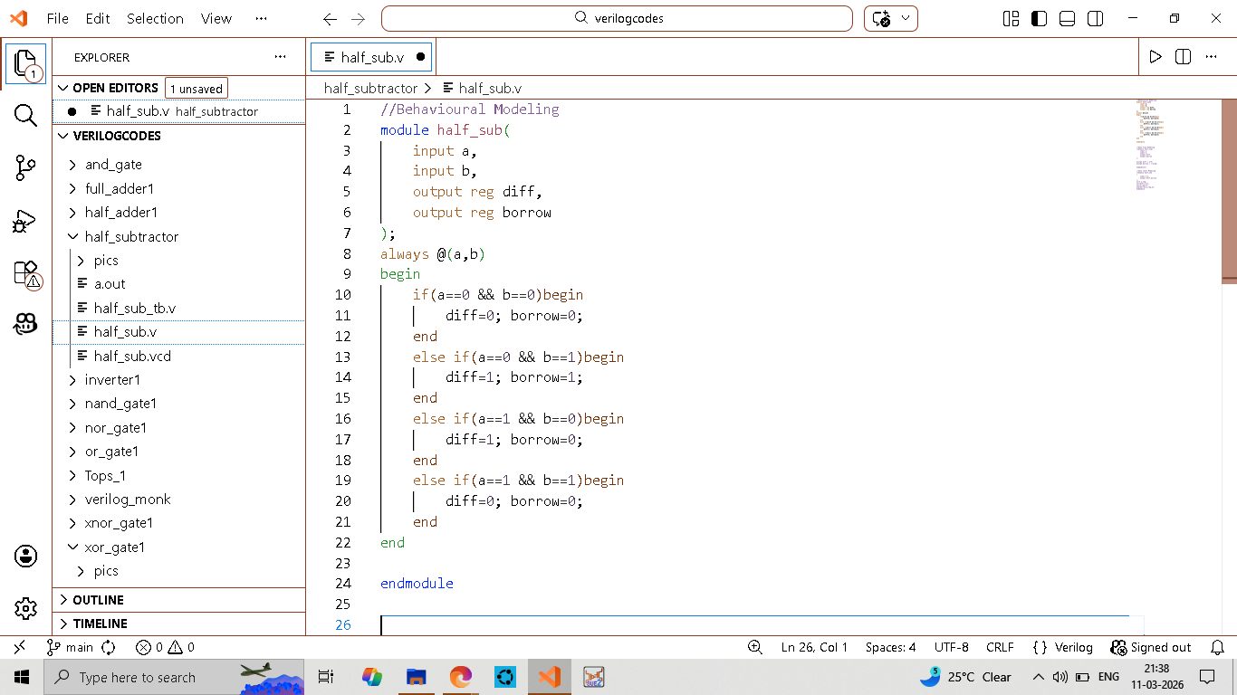
BEHAVIOURAL MODELING
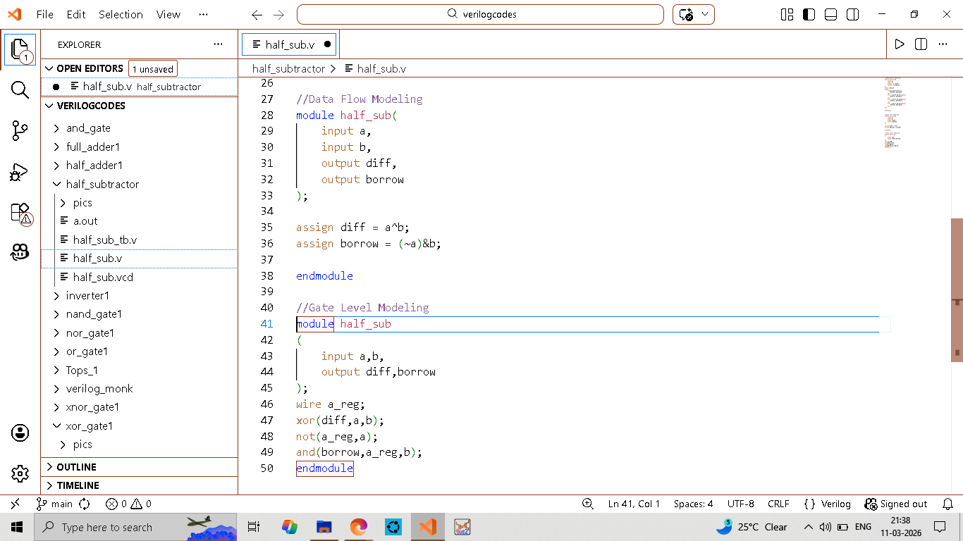
GATELEVEL MODELING
&
DATAFLOW MODELING

Biswajeet Ganthia (ECE-A1; Roll -19)
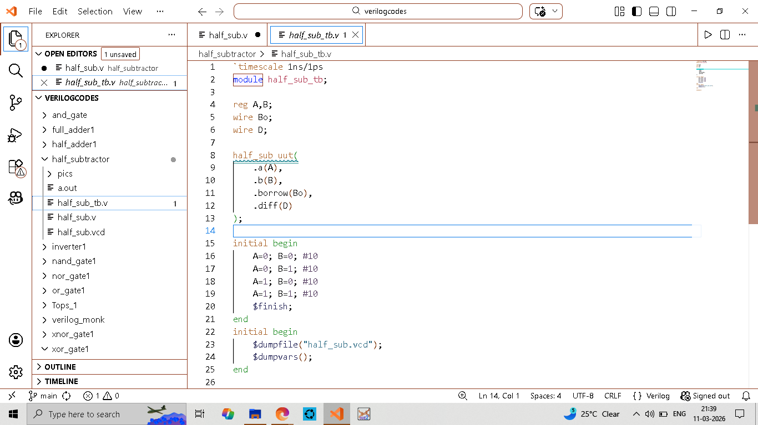
TESTBENCH
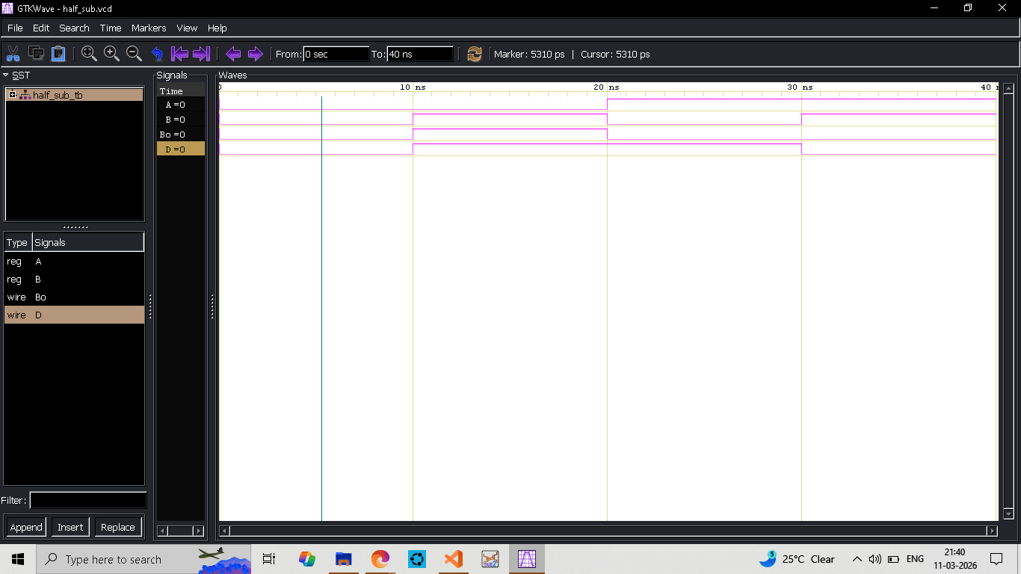
WAVEFORM

Biswajeet Ganthia (ECE-A1; Roll -19)

