Term Project Milestone 5

Biswajit Sharma

Bellevue University

DSC 640 Data Presentation and Visualizations

Prof. Catherine Williams

November 15, 2024

# Introduction

Childcare price in the United States is rising at an unprecedented rate which is not only putting financial strain on families, but also causing a cascade of other socio-economic problems. The skyrocketing childcare cost coupled with inflation is driving women out of workforce, reducing overall family income and also hurting the economy. Gonzales (2024) claims that “The US economy loses an estimated $237 billion per year due to women reducing their hours to care for children”. As a larger share of income is spent on childcare, families have less disbursable funds to spend on other essential areas such as healthcare, education and better quality of life. Fortunately, the government and lawmakers can formulate policies, invest in childcare and stabilize childcare prices to address this issue. However, there needs to be strong appeal and push from the public to apprise the lawmakers and government about the detrimental effect of the rising childcare cost so that they can implement reforms and solutions.

# Summary of Analysis

***Findings***

The childcare prices have been increasing at a fast pace as shown in Figure 1. National average of center based childcare price increased by 22% while home-based child care prices rose by 19% from 2008 to 2018 (refer Figure 2).

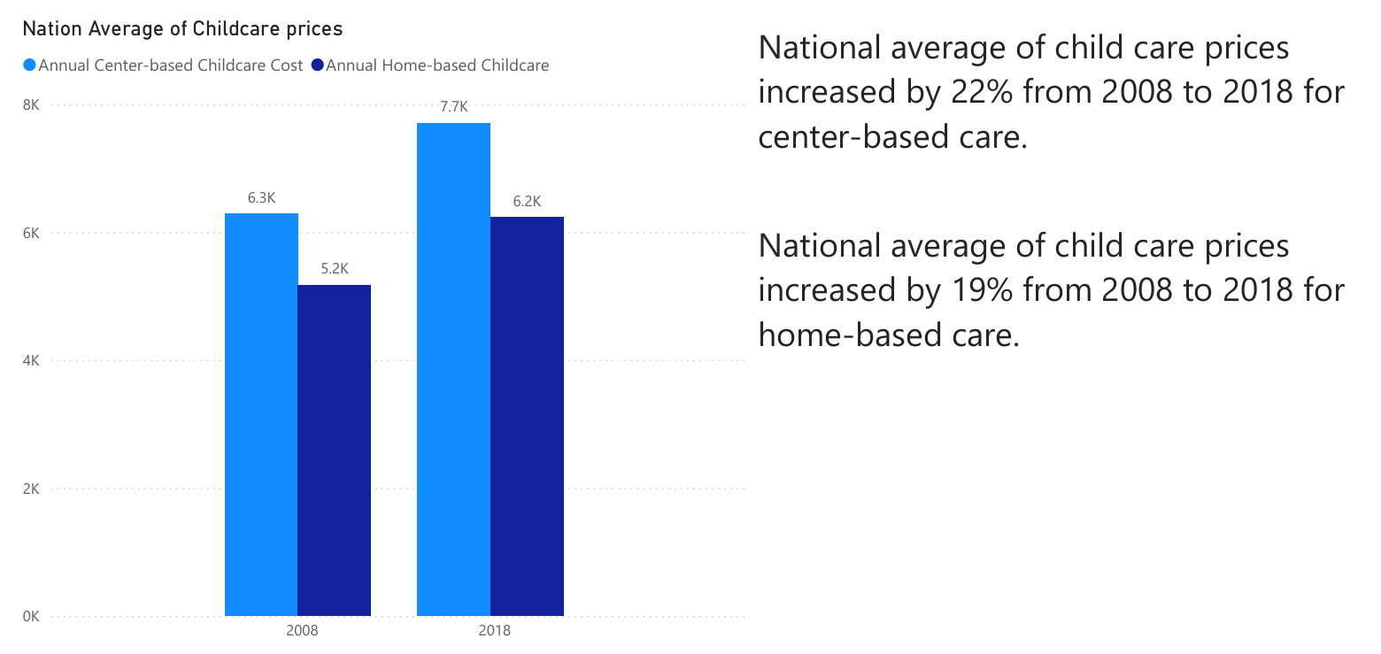

*Figure 1. Childcare prices from 2008 to 2018*

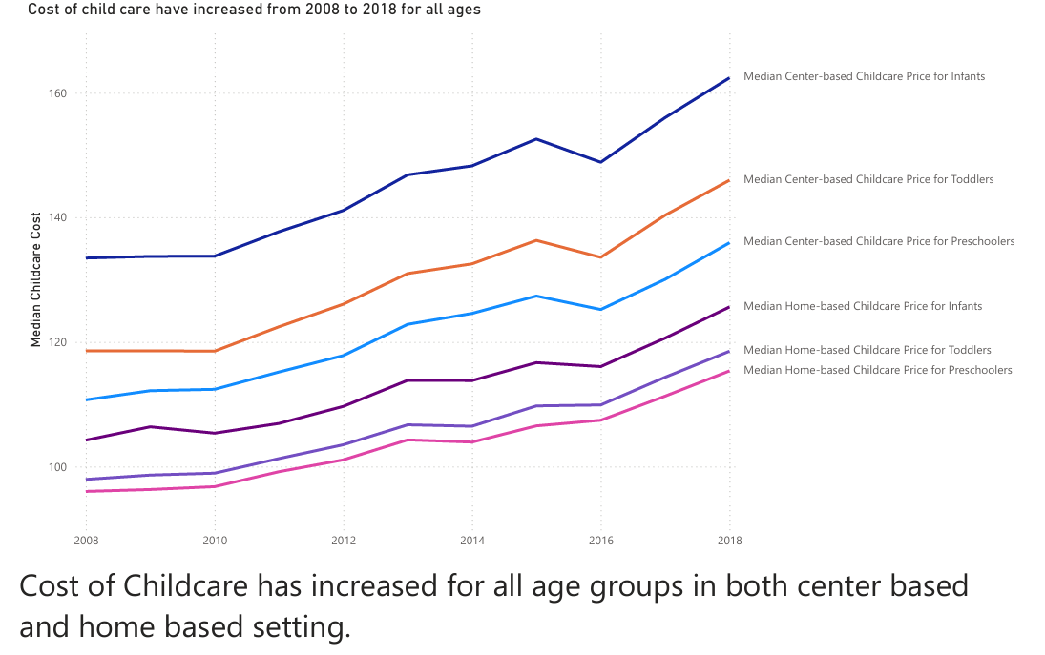

*Figure 2. National Average of Weekly Childcare prices from 2008 to 2018*

According to Figure 3, the participation of women in workforce has been decreasing over time, while the childcare cost has been increasing during this period. This may indicate that women are leaving their jobs or working reduced hours as families are not able afford the rising cost of childcare. Similarly, Figure 4 shows that the women’s participation in workforce is less than the males, which may be due to women are staying back home to provide child and dependent care.

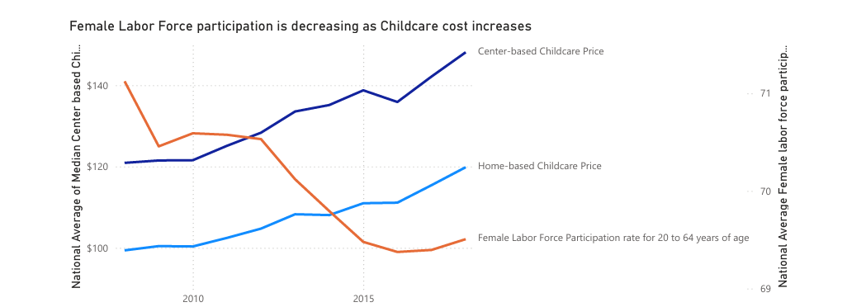

*Figure 3. Female Labor Force Participation is Decreasing as Childcare cost increases*

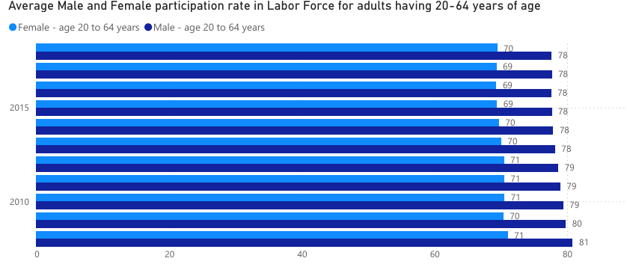

*Figure 4. Male and Female Labor Force Participation*

Figure 5 shows that income and earnings of people are growing at a slower rate compared to the childcare prices which means the share of income to be spent on childcare is increasing year on year. This puts financial strain on families and reduces their ability to afford childcare.

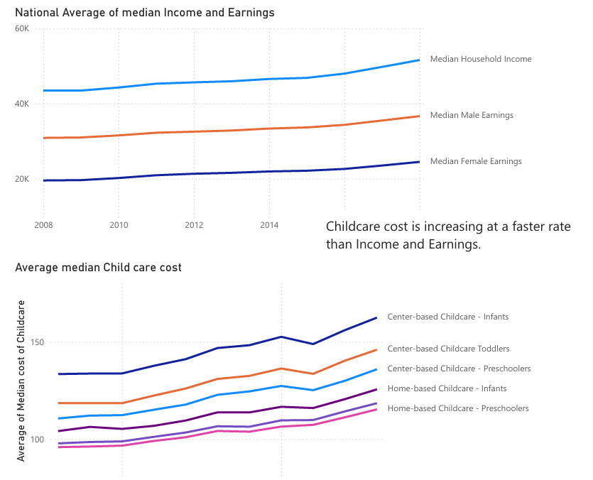

*Figure 5. Childcare prices are increasing at a Faster Rate than Income and Earnings*

Childcare prices are very high in states like Washington DC, Massachusetts, Rhode Island, Connecticut, New York, California. Policies or reforms to deal with such high cost of childcare are immediately needed for these states as compared to other states.

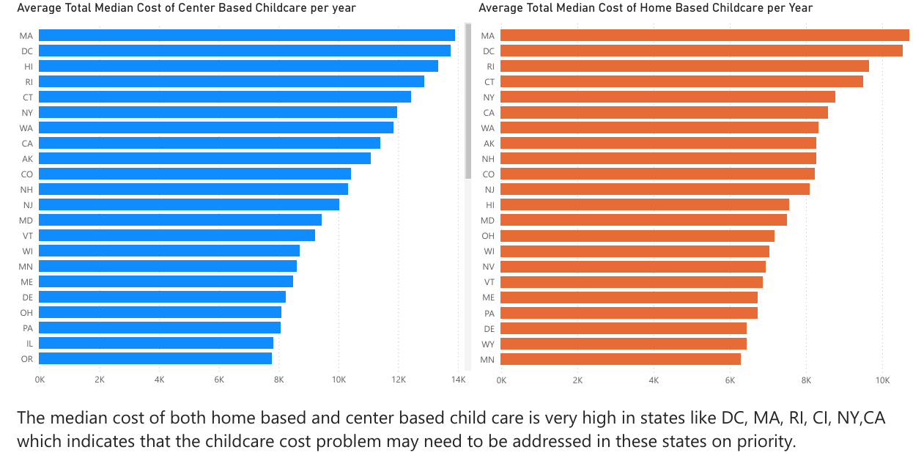

*Figure 6. Average annual Child care cost by State*

***Assumptions***

In this study, the increasing cost of childcare has been assumed to the primary reason for decrease in women’s participation in workforce. Women are staying back home or working reduced hours as they are not able afford childcare cost is the thought process behind the above assumption.

# Direction of Story / Message

The childcare prices have been rising, which can have cascading impact on both people and the economy. The increased childcare cost causes financial burden on families and reduces their capability to spend on essential areas like healthcare, nutrition, and education. High childcare cost hinders individuals, particularly women from participating in the workforce, which causes reduction in household income and quality of life. Reduction in workforce and household income also has a detrimental effect on the economy as this results in reduced consumer spending, more dependence, and utilization of social welfare programs. The government must intervene to address this issue by bringing policies and reforms such as providing subsidiaries, higher tax credits for child and dependent care, and expansion of publicly funded childcare programs, essentially making it more affordable for all families and individuals.

# Target Audience

This story is aimed at ***policymakers*** and the ***general public***. It is essential to raise awareness among the public regarding the impacts of rising childcare costs and how their lives are being affected. Mass awareness is also crucial to add momentum to the issue. Similarly, it is crucial to voice the deep impact of the childcare cost on economy and general welfare of the people to lawmakers which will help them to acknowledge the problem quickly and formulate appropriate policies and reforms.

# Mediums

### Powerpoint presentation

Powerpoint presentation is identified as a medium to present the story to policymakers in Town Board meetings. The rising cost of childcare and its economic impact such as reduced women’s participation in workforce, reduced household income, increased utilization of welfare programs, and increased unemployment can be part of this medium. It may be difficult to access policymakers directly at state or federal level, but Town board meetings will be a good starting point.

### Billboard

Billboard is a good medium to target the general public and make them aware about the rising cost of childcare and its profound socio-economic impact. It will also serve an open invitation for public to the Town Board meeting for supporting the cause.

### YouTube video presentation

YouTube is a famous media platform with around 240 million users in the US. Sharing the story on YouTube will make the message reach and easily accessible to *general public*. The nationwide support and push are crucial to compel the lawmakers in bringing reforms to make childcare more affordable. Callout to people into the realization that the issue of rising child care cost is broader than just a monetary problem, it has deep rooted impact on society and welfare of the state. Ask public to raise their voices to the lawmakers for formulating reforms and providing affordable childcare throughout the country.

# Design Decisions

***Organization***

The story in the mediums is organized following the general storytelling guidelines; introduction to the problem, adding another perspective to the problem and a call to action for resolution of the problem.

***White Spaces***

White spaces were used strategically to make the charts more aesthetic and reduce clutter. There is sufficient white spaces left in the charts so that it doesn’t appear overwhelming to the audience. Gap is kept between the Title and the plot so that there is natural attention to the title before audience starts looking at the actual chart.

***Color***

Color was sparingly used to draw attention to the message that needs to be conveyed. Shades of **Gray** were used to mute unimportant information and push those to background. While **Blue** and **Black** were used for highlighting the main idea or drawing attention to particular area/information.

***Text***

Chart titles were colored black with larger font size to convey the main idea of each plot. Axis titles were hidden wherever unnecessary to keep less information and reduce clutter. Axis titles were colored light Gray to push it in background and have audience focus on Black and Blue texts. Chart borders were hidden to make the actual plot more prominent and reduce any distraction. Chart titles and texts are left aligned for aesthetic and match the natural (zig-zag) order of English reading habits.

***Plots***

Horizontal bar plots were preferred because it is easy for audience to navigate from top to bottom and left to right while reading. Line plots were used to display continuous data that changes over time. A forecast line with 95% confidence interval was added in blue color to draw attention to the trend that can be expected in future years, while rest of the line plot is kept grey to show the data in the past years but with less focus. A darker shade of gray was used to make the plot stand out from the lighter gray colored axis and labels.

# Ethical Considerations

The dataset used in this study is publicly available data from US Department of Labor and does not contain any confidential information (National Data base of Childcare Prices, n.d.). Hence there is no concern of data privacy using this dataset.

There was no transformation or imputation done to the dataset that have altered the childcare prices and outcomes. Assumption was made that the lower participation rate in workforce among women having childcare eligible kids is a strong indication that high childcare cost may be causing such women to stay back home, but there may be also other factors which might need further analysis and were not considered in this study. We will need further demographic and socio-economic data from households to identify such factors which was considered out of scope for this study. National average of childcare price was used as a primary measure in this study, however presence of outliers in the data for some locations/states might skew the average and the outcomes of this study must be used with this diligence.

# Lessons Learned

There were several learnings during this study. The primary learning was the “art of storytelling” using visualizations. Storytelling is different than just reporting the findings from the data (exploratory analysis). In story telling one must come up with a persuasive and compelling story from the findings of exploratory analysis. Choices are made to share only necessary information that is relevant to the story, rather than displaying every finding from the data.

It was a fundamental learning that one must keep “audience in mind” while sharing information in a story. The story must be clear, concise and comprehendible for the audience. Furthermore, this project helped to learn and apply Gestalt principles to draw attention to the specific parts of a visualizations using pre-attentive attributes like color, text and white spaces. Lastly, the approach about the organization and designing of a story to make it coherent for the audience was also an important lesson learned in this project.

# Conclusion

The analysis performed in this study demonstrates the fast rise in childcare price which has harmful impacts: reduced household income; driving women to stay home and not participate in workforce; billion dollars loss in economy; general welfare of people. Various *mediums* were created as part of this project to raise awareness among general public about this childcare cost crisis and appeal to lawmakers and government to bring reforms for addressing the crisis.

References

Gonzales, Matt. (2024, February 6). *Soaring Child Care Costs Are Burdening Working Parents.* SHRM.

**https://www.shrm.org/topics-tools/news/inclusion-diversity/soaring-child-care-costs#:~:text=Costly%20Child%20Care%20Causing%20Women%20to%20Leave%20Workforce&text=Average%20day%20care%20fees%20worldwide,hours%20to%20look%20after%20children.**

National Database of Childcare Prices (n.d.). *U.S Department of Labor.*

**https://www.dol.gov/agencies/wb/topics/featured-childcare**