Technical Design Document

Project Name: **CULTUROFESTO**

* Saikrishna Panda(46299035)
* Biswajit Pradhan(46299036)
* Pranil Anand Kate(46300446)
* Vishwanath(46299033)
* Ankit Raj(46299034)
* Manisha Mandal(462929)

**Introduction:**

Cultrofesto is created to meet the needs of online event booking system, with 2 actors: Admin and Customer. The architecture implemented is Spring Boot Micro services.

**Functional Requirements:**

The functional requirements of the project are:

**For the Admin:**

* Login
* Add an event
* Delete/Cancel an event
* View events
* View Customers

**For the User:**

* Login/Register
* Search events
* Create Booking
* Make Payment
* View Bookings
* View Booking Details
* Cancel Booking
* Give Feedback

**Micro-Services**

The different micro-services in which this project is divided into are:

* **Customer Service:** Register a new account and login (as a customer) and login (as the admin)
* **Admin Service:** Insert a new event, cancel or delete an existing event
* **Booking Service:** Create a new booking, cancel an existing booking, download ticket
* **Search and View Service:** View customers (as the admin), view all events (as the admin), explore events (as a customer), view existing bookings, view booking details
* **Payment Service:** Make a payment for the booked tickets after validating credentials
* **Feedback Service:** Provide rating and feedback (as a customer)

**Overall Architecture Diagram:**

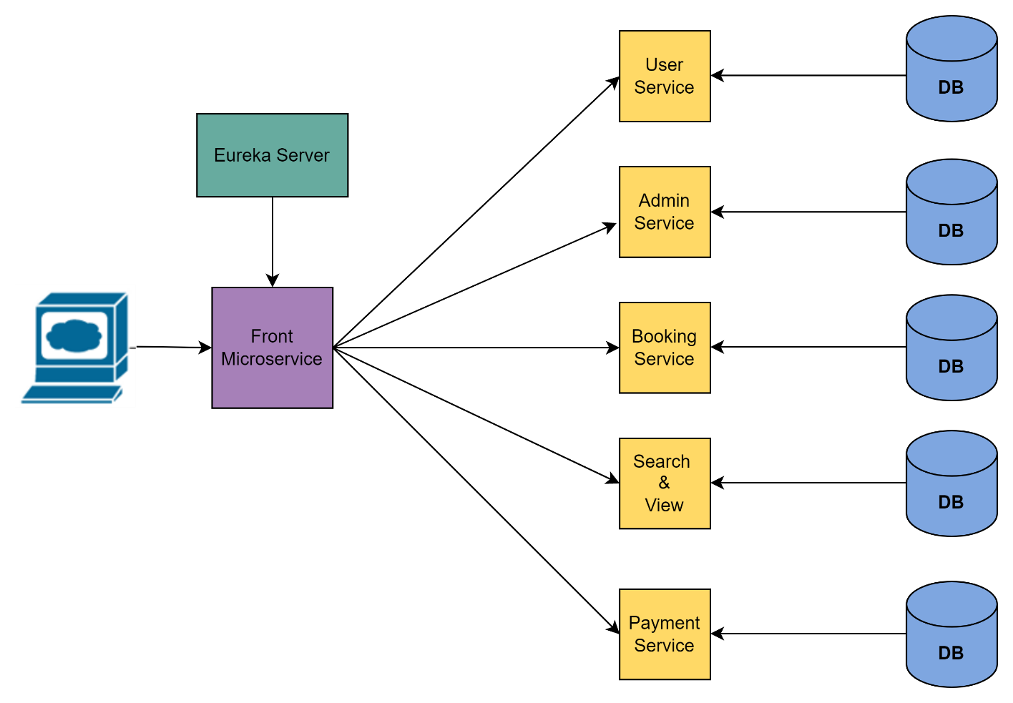

**Overall Entity Relationship Diagram:**

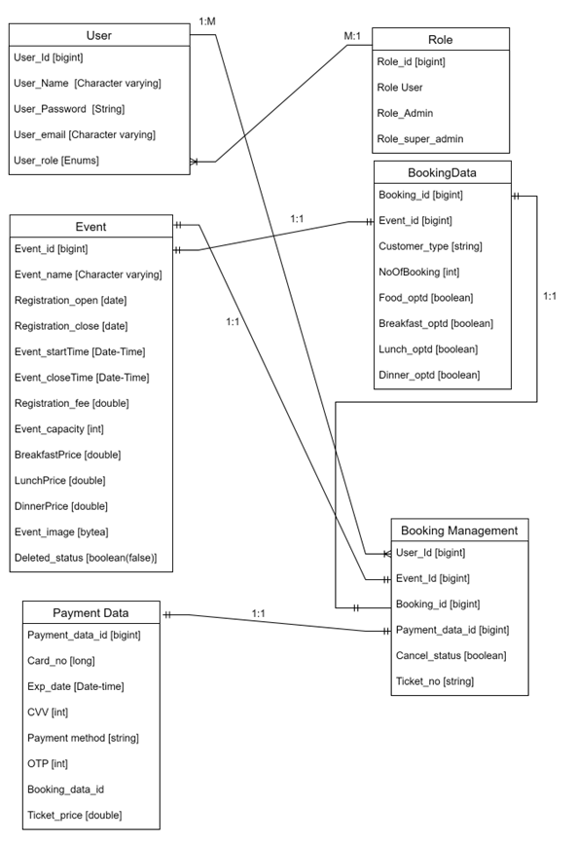

# Sequence Diagrams

**Customer Service:**

**Login –**

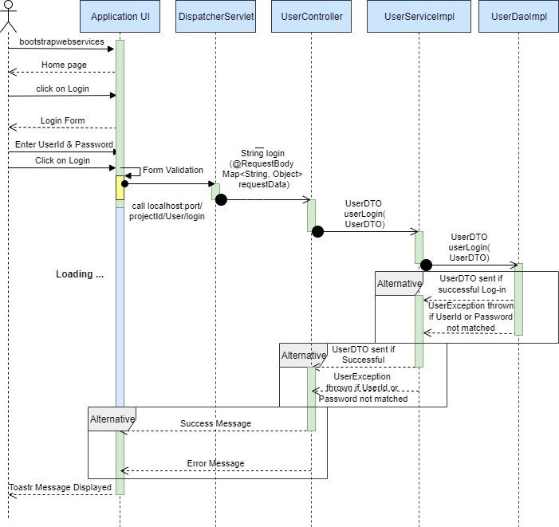

**Registration of new User -**

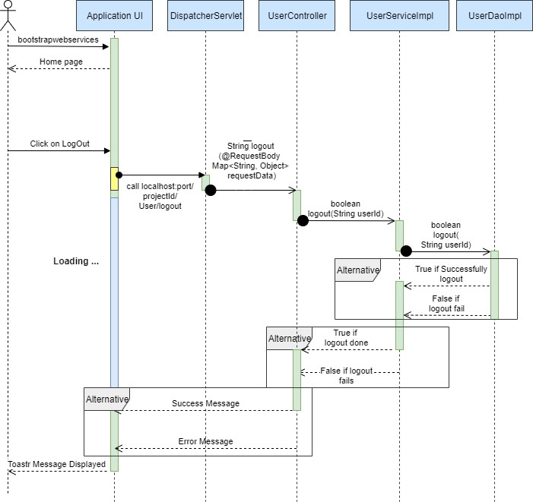

**Logout -**

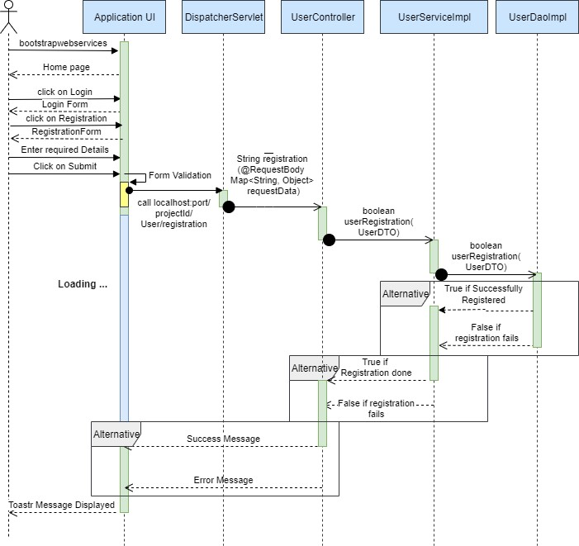

**Insert and Delete Event:**

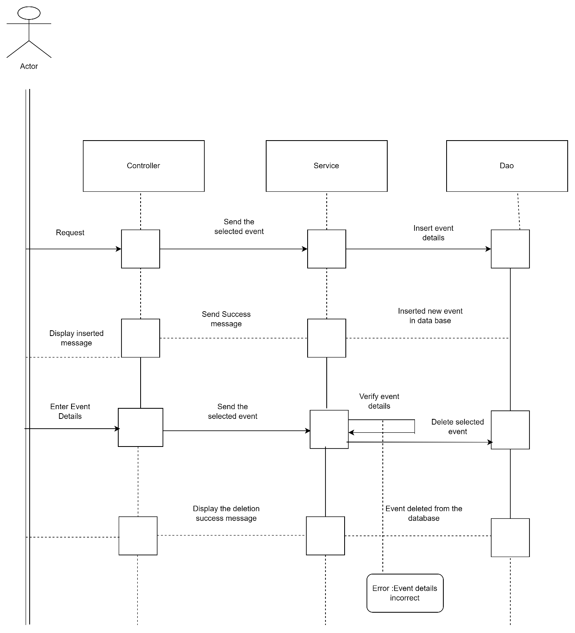

**Booking Service:**

**Create booking, cancel booking, and download ticket:**

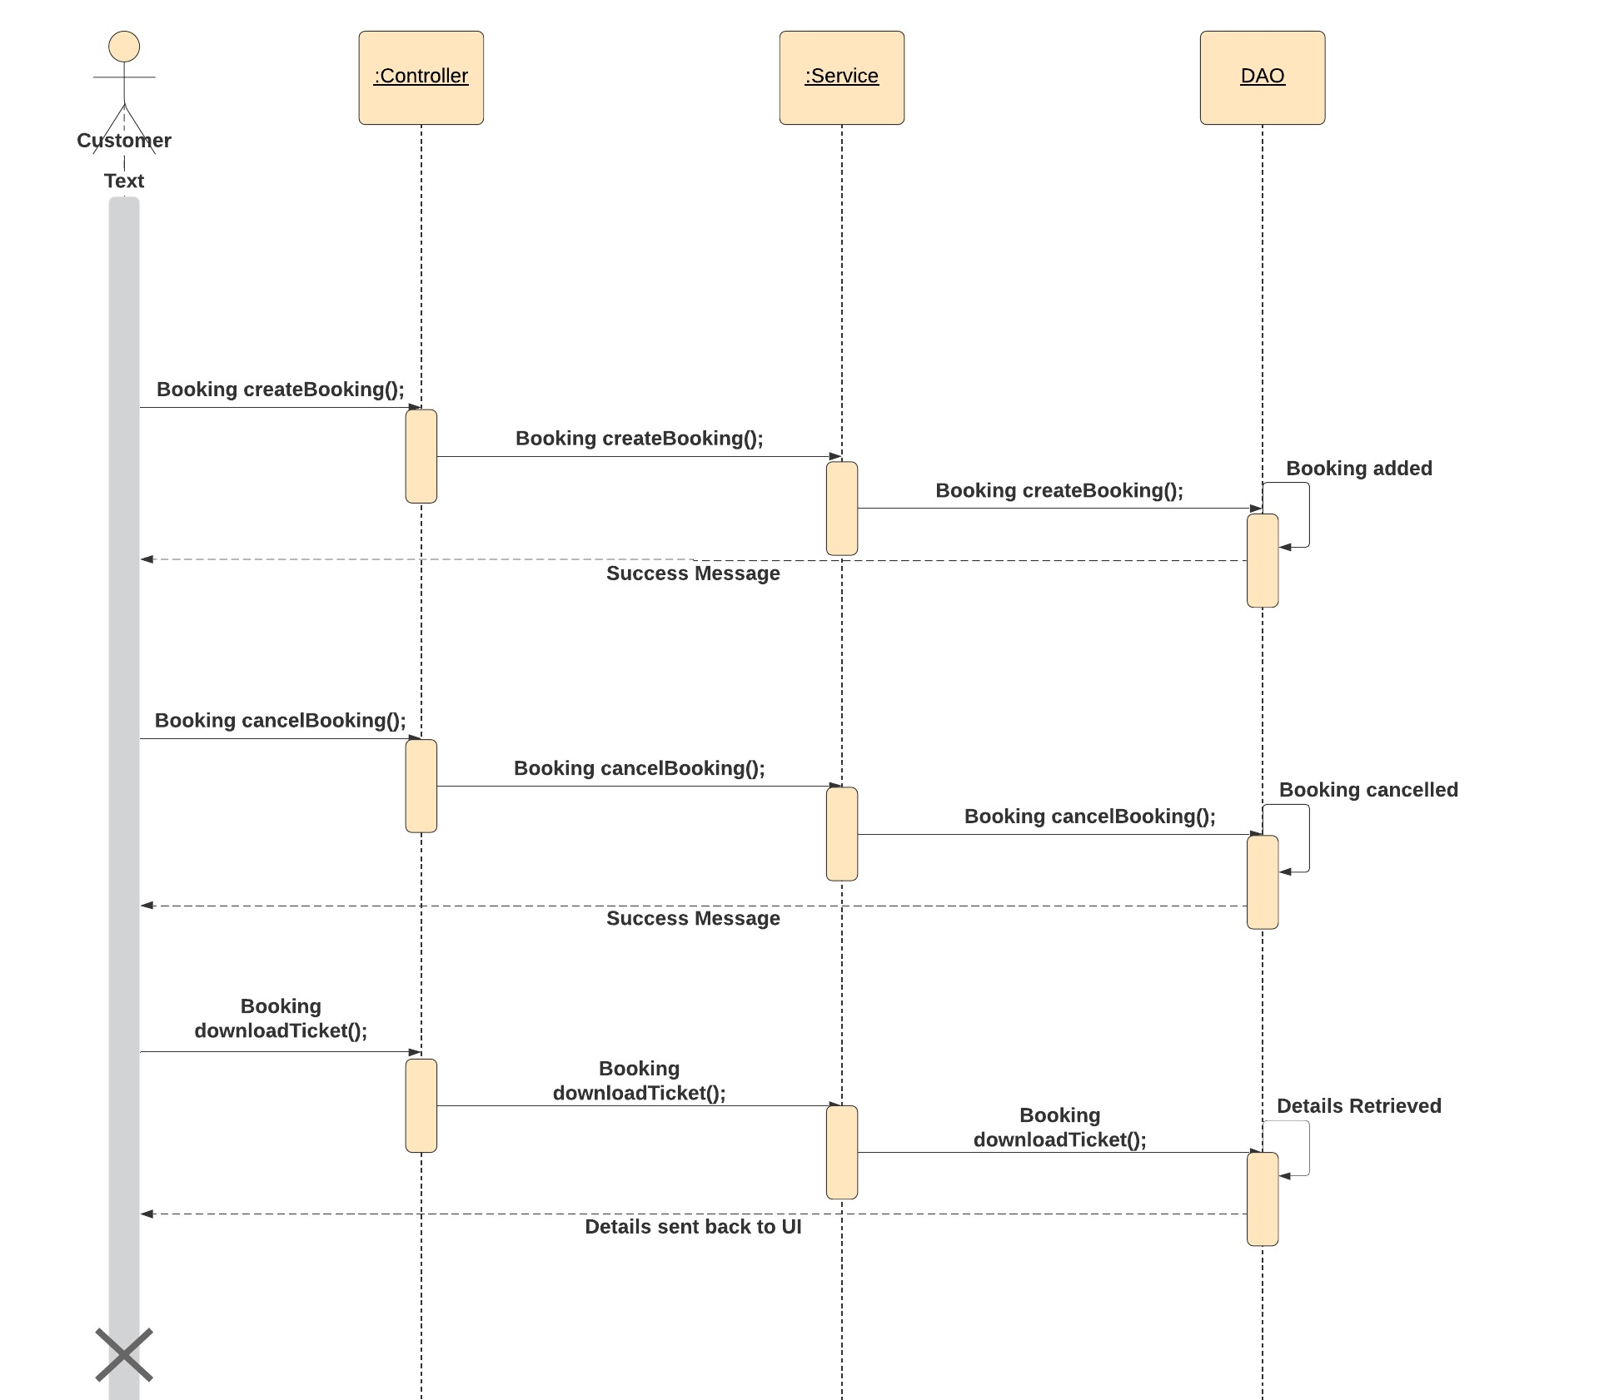

**Search and View Service:**

**For the Admin:**

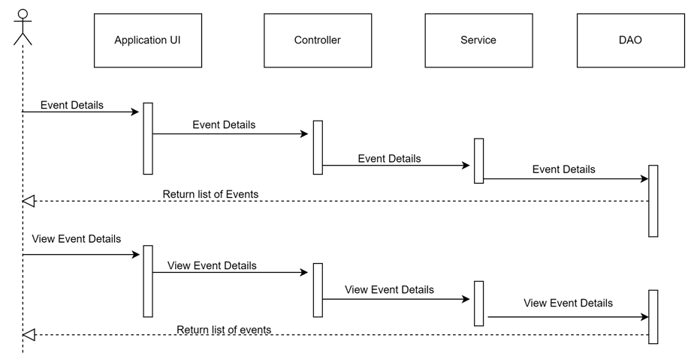

**For the customer:**

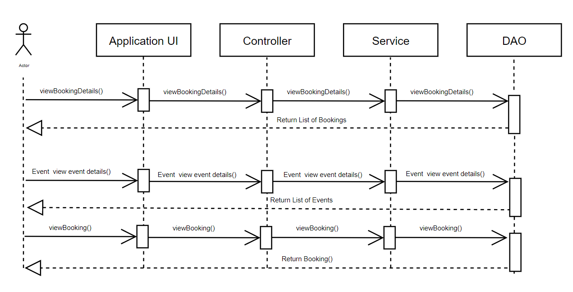

# Class Diagrams

Customer Service:

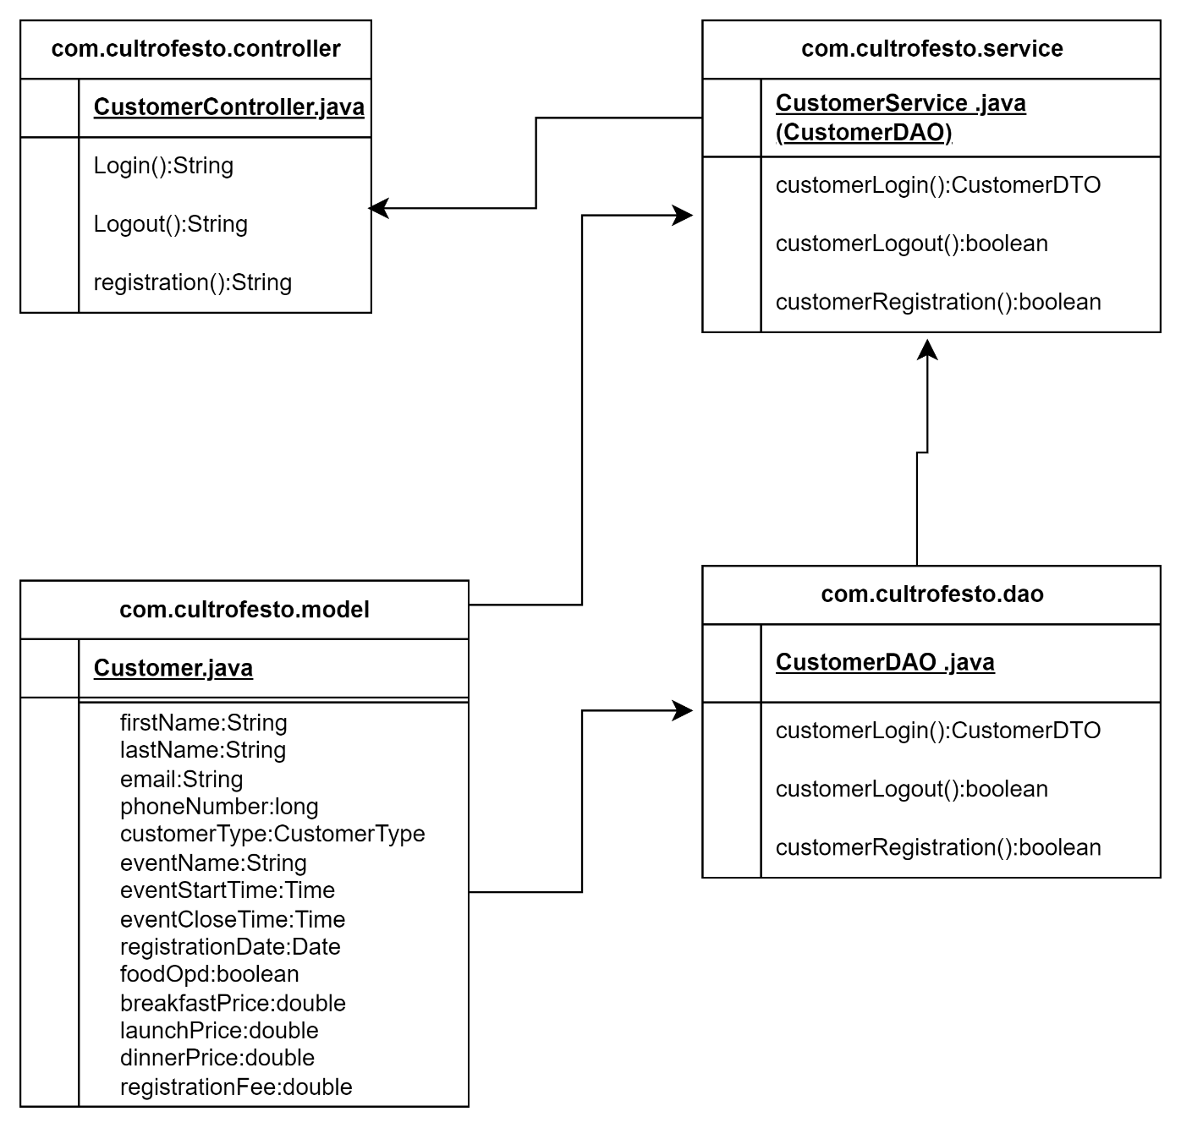

Booking Service:

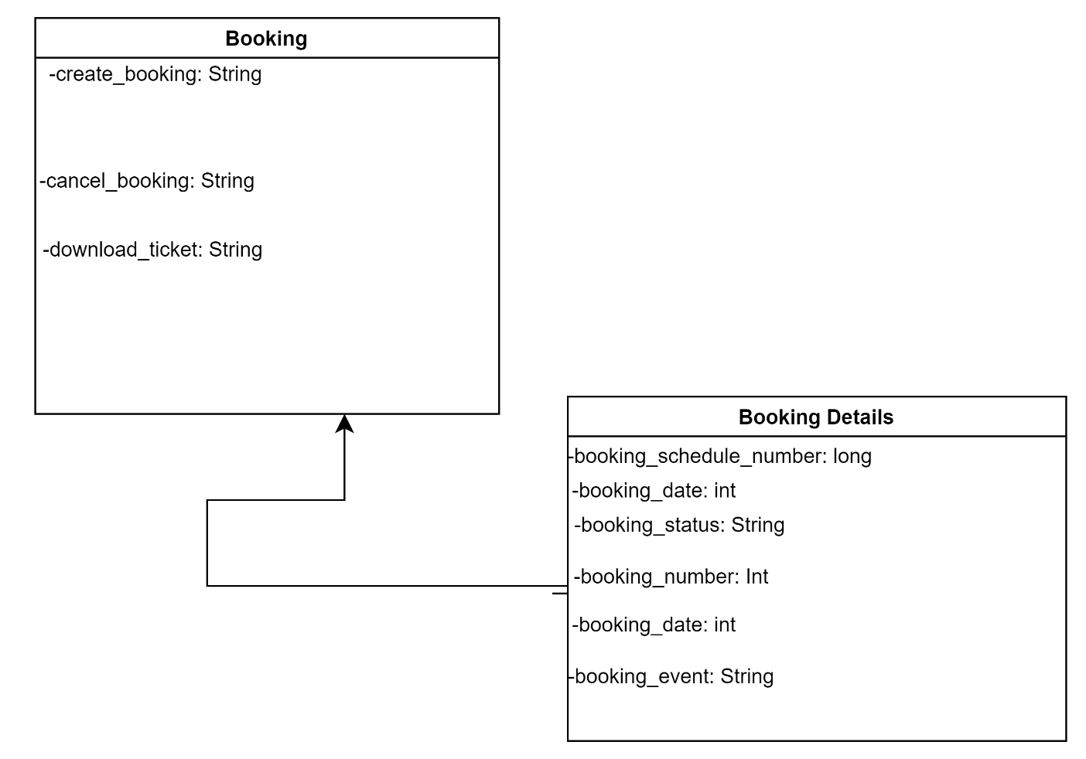

Search and View Service:

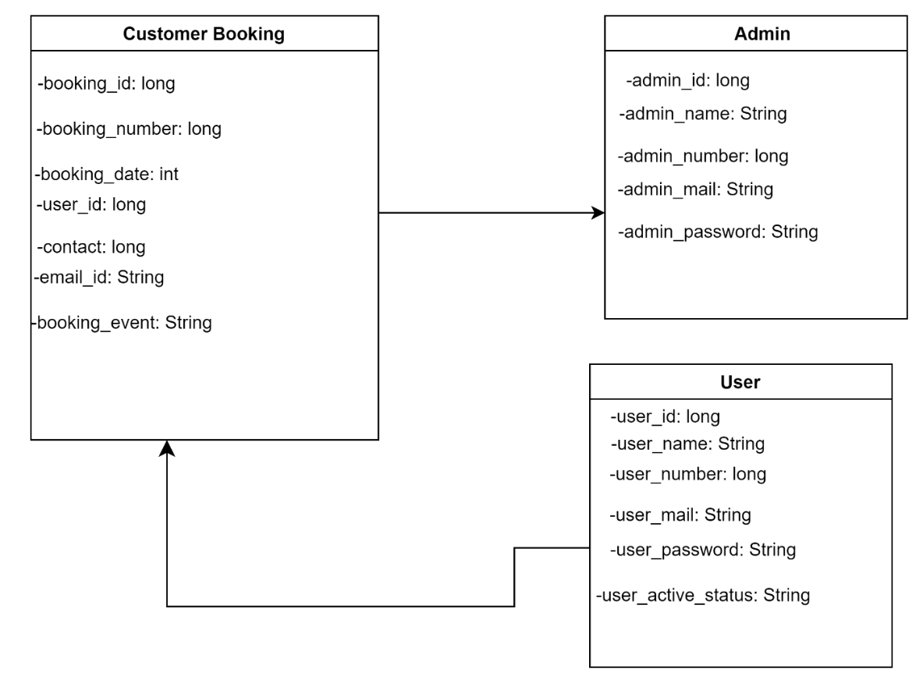

# Activity Diagrams

**Login:**

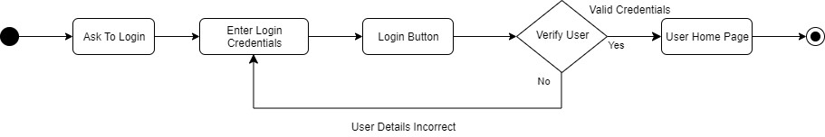

**Registration:**

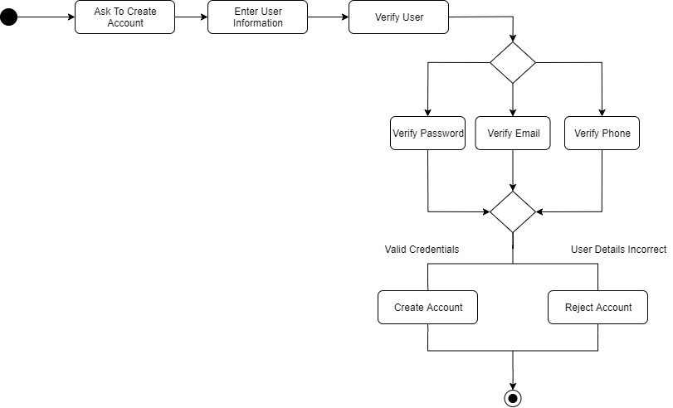

Booking Service:

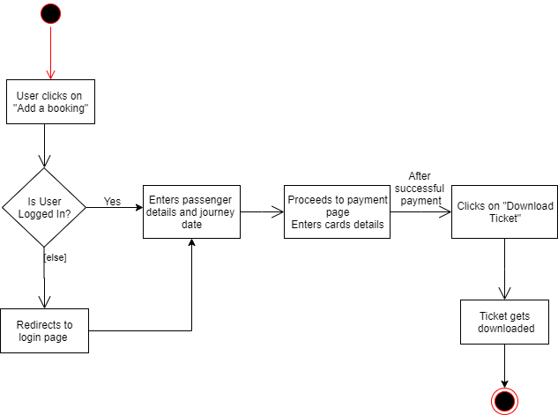

Search and View Service:

**View Users:**

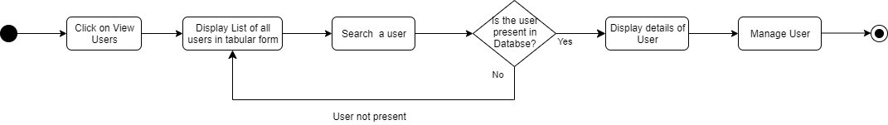

**View Event Details:**

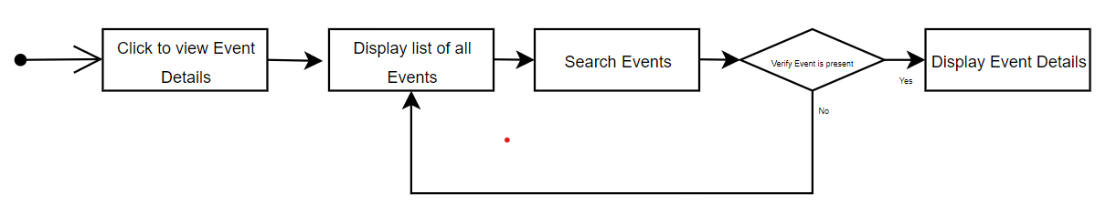

# Wireframes

**HomePage:**

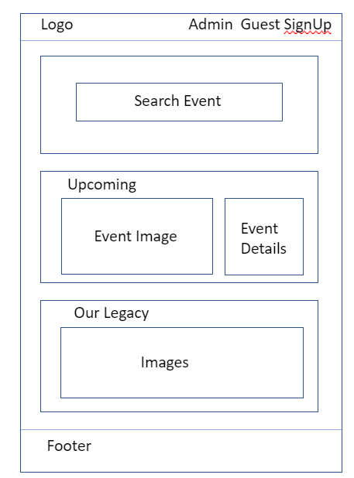

**Admin Login Page:**

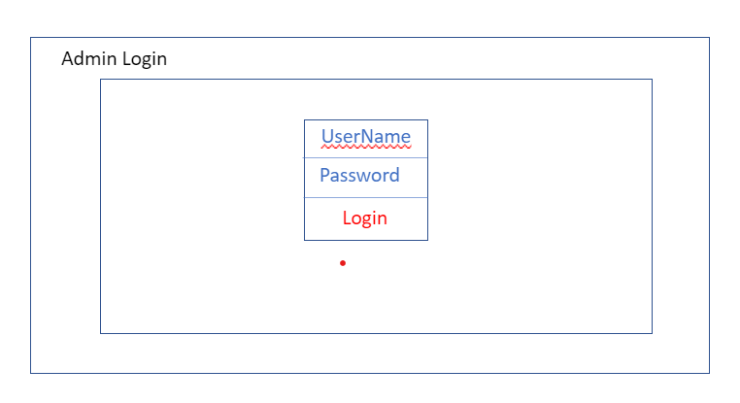

**Admin Create Event Page:**

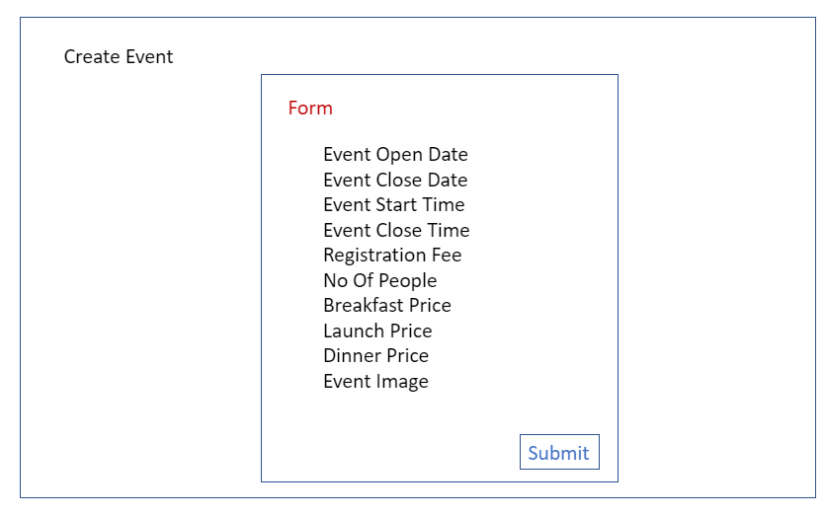

**Admin Event Details Page:**

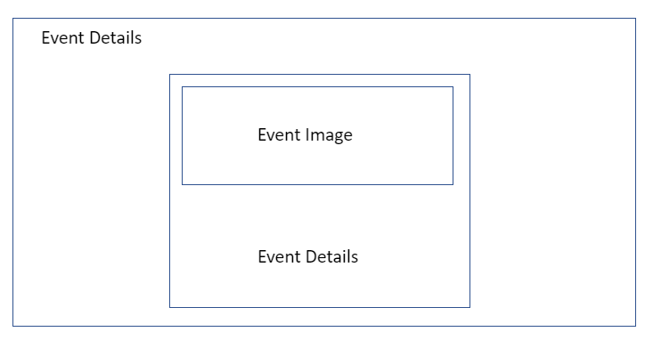

**Customer SignUp Page:**

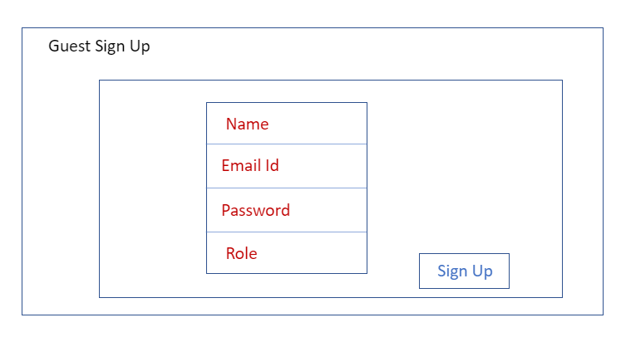

**Customer Login Page:**

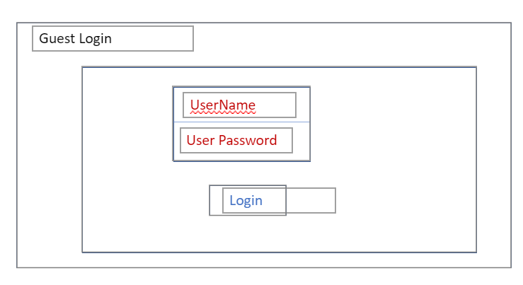

**Customer Profile Page:**

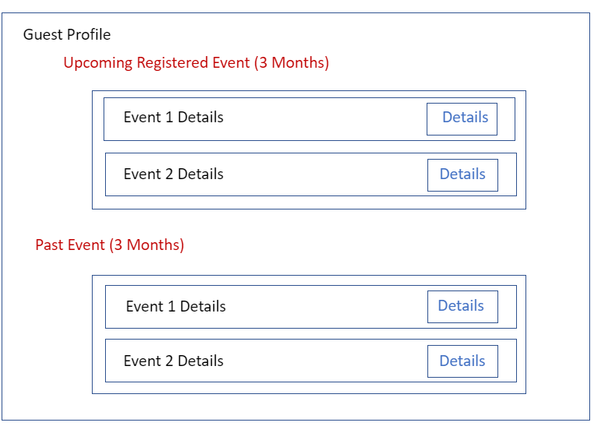

**Event Details and Payment Page:**

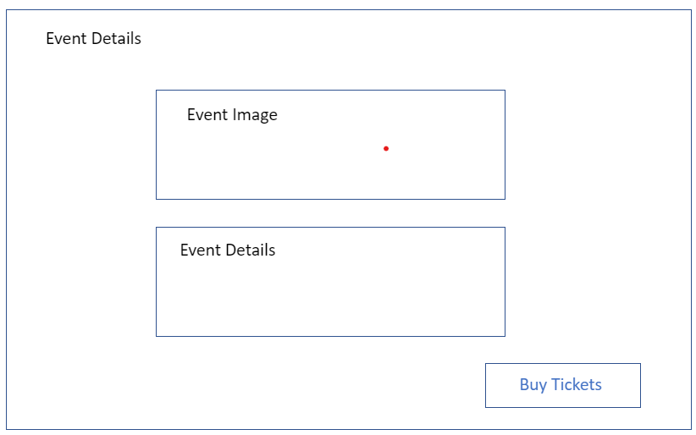

**Buy Tickets Page:**

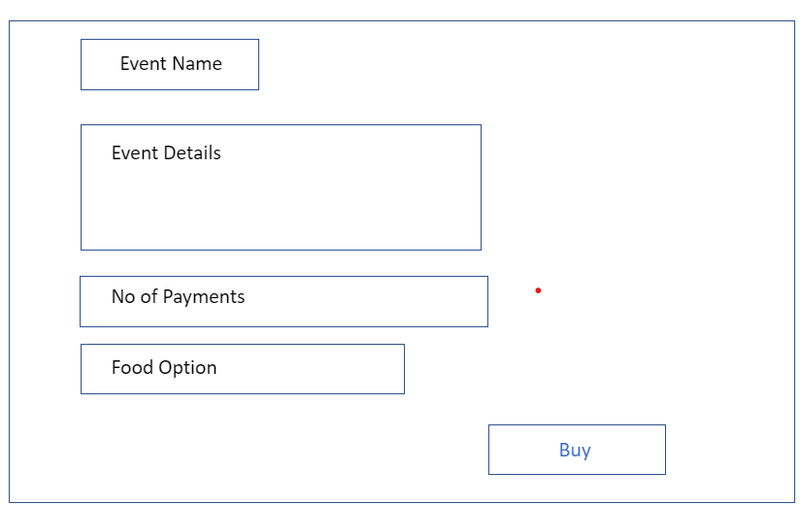

**Payment Page:**

