REAL-TIME INTRUSION
DETECTION SYSTEM
Machine Learning Architecture, Feature Engineering,
Live Inference Pipeline & Viva Preparation
Project technical notes prepared from the supplied project description and screenshots.

1. Architecture Summary — Explain This First
The project is described as using a two-tier model design, with a production model for live flow classification and a comparative model suite for experiments.

Production real-time engine
- A 24-feature, multi-class Random Forest classifier is described as being trained on the TON_IoT network dataset.
- The supplied project notes report 97.84% accuracy. Treat this as a reported result and verify it against the saved evaluation output before presenting it as a measured result.
- The classifier is intended to classify network flows into ten categories: normal, ddos, dos, scanning, backdoor, injection, xss, password, ransomware, and mitm.

Comparative deep-learning suite
- The comparison suite contains a 1D Convolutional Neural Network (1D-CNN), a hybrid CNN-LSTM, and Gradient Boosting.
- These models are intended to compare feature-pattern learning and sequence-oriented approaches. The exact training setup and output type should be checked in src/train_model.py.

Live detection engine
- The live pipeline converts observed traffic into flow-level metrics, passes the features to the trained model, estimates attack probabilities, and applies a threshold to decide whether to raise an alert.
- The dashboard is served locally by Flask at http://127.0.0.1:5000, according to the supplied terminal screenshot.
Viva-ready summary: “Our system uses flow metadata to classify network activity. A Random Forest is the production classifier, while CNN, CNN-LSTM, and Gradient Boosting models are used for comparison. The live engine extracts features, estimates the likelihood of non-normal traffic, applies a decision threshold, and displays monitoring information in a Flask dashboard.”

2. Production Model: Multi-Class Flow Classifier
File: src/train_flow_model.py
The following is the code snippet supplied in the project notes:
# 1. Stratified Train/Test Split (preserves class proportions)
X_train, X_test, y_train, y_test = train_test_split(
X, y, test_size=0.2, random_state=42, stratify=y
)
# 2. Production Random Forest Classifier
model = RandomForestClassifier(
n_estimators=200,
max_depth=25,
min_samples_leaf=2,
class_weight='balanced',
n_jobs=-1,
random_state=42
)
model.fit(X_train, y_train)
# 3. Evaluation on unseen test traffic
pred = model.predict(X_test)
acc = accuracy_score(y_test, pred)
macro_f1 = f1_score(y_test, pred, average='macro')

What the main settings mean
- stratify=y: Keeps the class proportions approximately consistent between the training and test sets. It does not guarantee that every rare class has enough examples for a reliable evaluation.
- test_size=0.2: Sets aside 20% of the available samples for testing and uses the remaining 80% for training.
- n_estimators=200: Builds an ensemble of 200 decision trees. Their combined predictions can be more stable than those of a single tree.
- max_depth=25: Limits each tree's depth, which can help control complexity and reduce overfitting.
- min_samples_leaf=2: Requires at least two training samples in a leaf node, adding a small regularization constraint.
- class_weight='balanced': Automatically gives greater weight to underrepresented classes during training. This can help with class imbalance but does not by itself guarantee strong rare-class performance.
- n_jobs=-1: Allows scikit-learn to use available CPU cores for parallel work where supported.
- random_state=42: Makes the randomized split/model behavior more reproducible.

Classes listed in the supplied notes
normal, ddos, dos, scanning, backdoor, injection, xss, password, ransomware, mitm.
Important verification note: the code and reported accuracy in these notes were provided in the prompt; they have not been independently verified against the actual project files. Before a viva or report submission, confirm the saved model, class labels, dataset split, and metric logs.

3. Feature Engineering: 24 Zeek-Style Features
File: src/flow_features.py
The model uses flow-level statistics and encoded connection metadata rather than requiring raw application payloads.
NUMERIC_COLS = [
'dst_port', 'duration', 'src_bytes', 'dst_bytes',
'src_pkts', 'dst_pkts', 'src_ip_bytes', 'dst_ip_bytes',
]
PROTOS = ['tcp', 'udp', 'icmp']
CONN_STATES = [
'S0', 'S1', 'S2', 'S3', 'SF', 'REJ', 'RSTO', 'RSTR',
'RSTOS0', 'RSTRH', 'SH', 'SHR', 'OTH',
]
# 8 numeric + 3 protocol + 13 state + 4 derived = 28
# NOTE: the supplied list totals 28 features, not 24.
FEATURE_NAMES = (
NUMERIC_COLS
+ [f'proto_{p}' for p in PROTOS]
+ [f'state_{s}' for s in CONN_STATES]
+ ['bytes_ratio', 'pkts_ratio', 'bytes_per_pkt', 'pkts_per_sec']
)
def build_features(df):
out = pd.DataFrame(index=df.index)
# ... one-hot encode protocols and TCP connection states ...
out['bytes_ratio'] = (out['src_bytes'] + 1) / (out['dst_bytes'] + 1)
out['pkts_ratio'] = (out['src_pkts'] + 1) / (out['dst_pkts'] + 1)
total_pkts = out['src_pkts'] + out['dst_pkts']
total_bytes = out['src_ip_bytes'] + out['dst_ip_bytes']
out['bytes_per_pkt'] = total_bytes / total_pkts.replace(0, np.nan)
out['pkts_per_sec'] = total_pkts / out['duration'].clip(lower=0.001)
return out[FEATURE_NAMES].astype('float32')

Feature groups
- Eight numeric fields: destination port, duration, source/destination bytes, source/destination packet counts, and source/destination IP-byte counts.
- Three protocol indicators: TCP, UDP, and ICMP.
- Thirteen connection-state indicators: S0, S1, S2, S3, SF, REJ, RSTO, RSTR, RSTOS0, RSTRH, SH, SHR, and OTH.
- Four derived metrics: byte ratio, packet ratio, bytes per packet, and packets per second.

What these features tell the model
- Packet and byte counts summarize how much traffic moved in each direction.
- Duration and packets-per-second can help describe traffic rate and burstiness.
- Protocol and connection-state indicators provide context about the connection behavior.
- Ratios can highlight directional imbalances, though they are not inherently malicious.

Important feature-count correction
The supplied feature list contains 8 numeric + 3 protocol + 13 connection-state + 4 derived features = 28 features, not 24. If the actual model is described as a 24-feature model, inspect the real FEATURE_NAMES list and the model's expected input shape, then update the code, documentation, or model consistently.

Flow metadata and encrypted traffic
A flow-based detector can use metadata such as ports, duration, packet counts, byte counts, and connection states without decrypting HTTPS payloads. This means it can still analyze some encrypted connections, but it cannot directly inspect encrypted application content; detection quality depends on the available metadata and model.

4. Deep-Learning Architectures
File: src/train_model.py

A. 1D Convolutional Neural Network (1D-CNN)
model = models.Sequential([
layers.Conv1D(32, kernel_size=kernel_size, activation='relu',
padding='same', input_shape=(self.n_features, 1)),
layers.BatchNormalization(),
layers.Conv1D(64, kernel_size=kernel_size, activation='relu',
padding='same'),
layers.BatchNormalization(),
layers.GlobalAveragePooling1D(),
layers.Dense(32, activation='relu'),
layers.Dropout(0.3),
layers.Dense(1, activation='sigmoid')
])
model.compile(optimizer='adam',
loss='binary_crossentropy',
metrics=['accuracy'])
Explanation: Conv1D filters learn local patterns across the ordered feature vector. Batch normalization can stabilize training, global average pooling reduces the feature-map dimensions, and dropout helps reduce over-reliance on particular activations.
Caution: this code has a single sigmoid output and binary cross-entropy, so as written it is a binary classifier. It is not a ten-class multi-class classifier unless the actual implementation uses a different output layer and loss.

B. Hybrid CNN-LSTM
model = models.Sequential([
layers.Conv1D(32, kernel_size=kernel_size, activation='relu',
padding='same', input_shape=(self.n_features, 1)),
layers.BatchNormalization(),
layers.LSTM(32, return_sequences=False),
layers.Dropout(0.3),
layers.Dense(16, activation='relu'),
layers.Dense(1, activation='sigmoid')
])
model.compile(optimizer='adam',
loss='binary_crossentropy',
metrics=['accuracy'])
Explanation: the CNN learns local feature patterns and the LSTM processes the resulting sequence representation. However, if the input is only a single flow's feature vector, the LSTM does not automatically model time across successive network flows. True temporal modeling generally requires a sequence of flows ordered over time.

C. Gradient Boosting
Gradient Boosting is listed in the comparative suite, but no code snippet was supplied. In general, gradient-boosted trees build an ensemble sequentially, with each stage trying to improve errors made by earlier stages. Use the project's actual implementation and evaluation output when describing the exact model.

5. Real-Time Live Inference Engine
File: src/live_detector.py
class FlowClassifier:
def __init__(self, path=None, threshold=0.75):
bundle = joblib.load(path)
self.model = bundle['model']
self.classes = list(bundle['classes'])
self.threshold = threshold
self.normal_idx = self.classes.index('normal')
def classify(self, records):
df = pd.DataFrame(records)
X = df[FEATURE_NAMES].astype('float32')
proba = self.model.predict_proba(X)
out = []
for i, p in enumerate(proba):
p_not_normal = 1.0 - float(p[self.normal_idx])
masked = p.copy()
masked[self.normal_idx] = -1
best_idx = int(masked.argmax())
best_class = self.classes[best_idx]
eff_threshold = self.threshold
dst_port = records[i].get('dst_port', 0)
if dst_port in (80, 443, 53, 853, 123):
eff_threshold = max(self.threshold, 0.85)
is_attack = p_not_normal >= eff_threshold
out.append({
'is_attack': bool(is_attack),
'attack_type': best_class if is_attack else 'normal',
'confidence': round(
p_not_normal if is_attack else 1.0 - p_not_normal, 4
),
})
return out

Step-by-step flow
- Load the saved model bundle and its class names.
- Convert each incoming record to a DataFrame and select the expected feature columns.
- Call predict_proba() to obtain a probability for each class.
- Calculate non-normal probability as one minus the model's probability for the normal class.
- Find the highest-probability non-normal class as the candidate attack type.
- Use the configured threshold: 0.75 by default, raised to at least 0.85 for destination ports 80, 443, 53, 853, and 123.
- Return a result indicating whether the record was flagged, the selected class, and a confidence value.

Interpretation and limitations
- A threshold is a decision rule, not proof that traffic is malicious. Raising a threshold can reduce some false positives but can also miss real attacks.
- Common ports are not automatically safe, and unusual ports are not automatically malicious. Port-aware thresholds should be validated using measured false-positive and false-negative rates.
- The code reports p_not_normal as attack confidence when flagged. This is the combined probability of all non-normal classes, not the probability of the selected attack_type specifically.
- The snippet assumes the model exposes predict_proba() and that the loaded class labels include 'normal'.
- Feature columns at inference must exactly match the feature schema used during training, including order and preprocessing.

6. Dashboard and Runtime Evidence
The supplied terminal screenshot shows the Flask dashboard starting at http://127.0.0.1:5000 and responding to requests for /, /api/interfaces, and /api/status.
The supplied dashboard screenshot displays:
- Network interface selection, including Wi-Fi and virtual adapters.
- Start Monitoring, Stop Monitoring, and Rescan Network controls.
- System status and device-protection indicators.
- Network overview with host name, local IP, packet count, and byte count.
- A Connected Devices & Traffic table with per-device traffic and threat/status fields.
- A Threat Simulation Demo selector and Simulate Attack button.
The terminal log also shows a 404 response for /favicon.ico. This is typically a missing browser-tab icon and does not by itself mean the dashboard is broken.
Operational note: the terminal reports Standard Mode (non-admin) and selects Local Area Connection* 2, which is shown with no IP address. For ordinary monitoring, select the active Wi-Fi interface shown in the screenshot (172.16.176.184) unless the project specifically needs another adapter. Packet-capture visibility can depend on privileges, the capture library, adapter support, and the selected interface. Run elevated only when required and authorized.
Figure 1. Terminal output while starting the IDS dashboard.
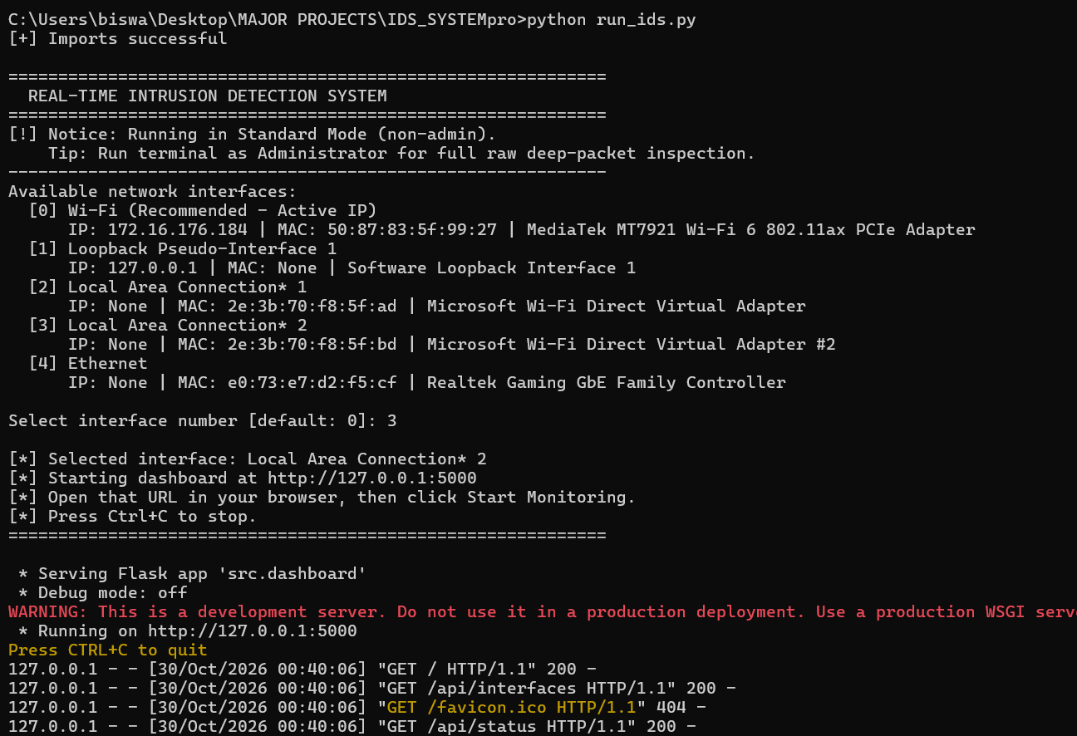
Figure 2. Real-Time Intrusion Detection System dashboard.
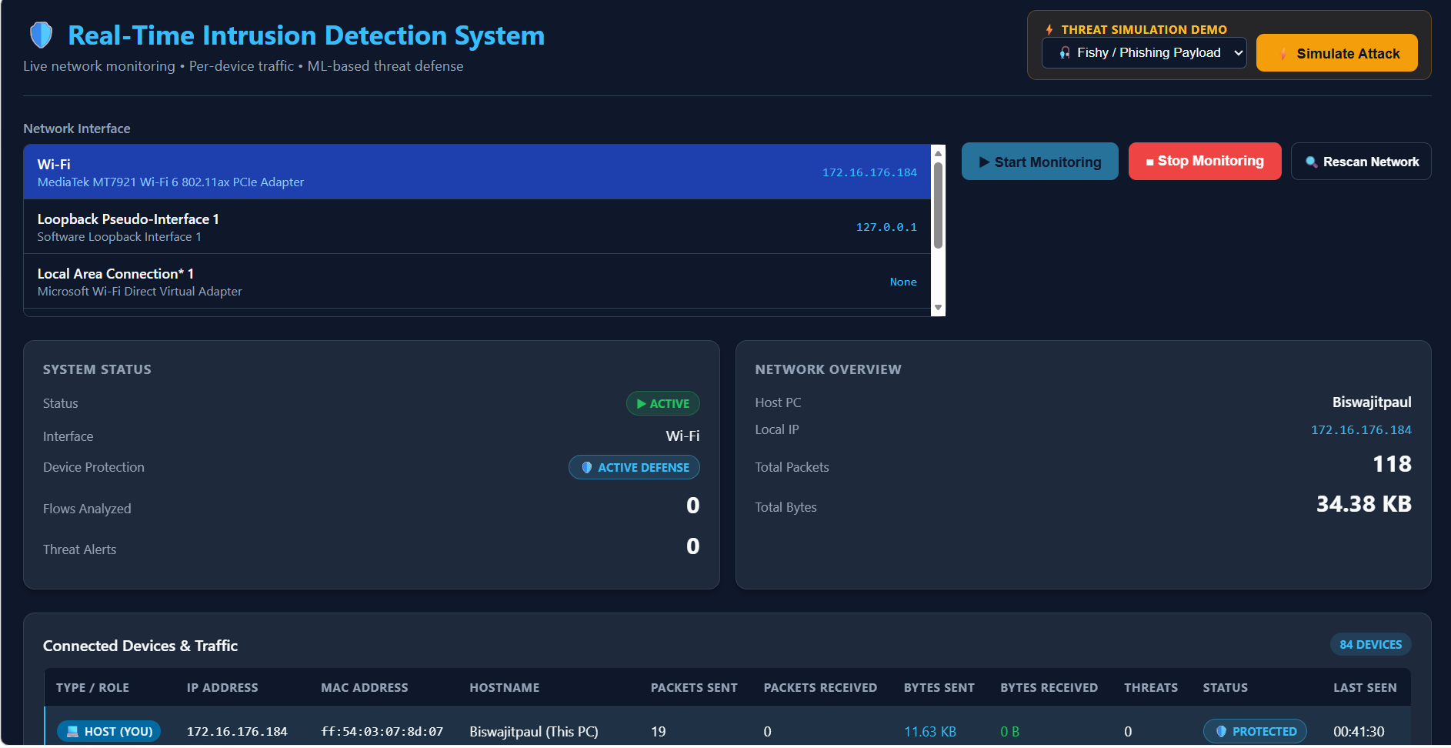

7. Viva Cheat-Sheet: Top Questions and Answers

1. Why use Random Forest for live detection instead of deep learning?
“Random Forest is a practical baseline for tabular flow features, often offering fast inference and straightforward deployment. We compare it with deep-learning models to measure the trade-off in accuracy, latency, and resource use.” Avoid claiming sub-millisecond latency unless it has been benchmarked on this system.

2. How can the model detect threats when traffic is encrypted over HTTPS?
“The model uses flow metadata such as ports, duration, packet counts, byte distributions, and connection states. It does not decrypt the payload, so it can analyze some traffic patterns even when application data is encrypted.”

3. How did you reduce overfitting?
“The supplied setup uses an 80/20 stratified split, limits tree depth, requires a minimum leaf size, and evaluates on held-out data. We should also check duplicate leakage and use a suitable split strategy so related flows do not appear in both training and test sets.”

4. Which dataset was used?
“The project notes identify the TON_IoT Network Dataset from the Cyber Range Lab at UNSW Canberra. I would confirm the exact subset, labels, preprocessing, and split used in our training run.”

5. What is Macro-F1, and why report it with accuracy?
“Macro-F1 computes the F1-score separately for each class and averages the scores equally. It helps show whether the model performs well on less frequent classes, whereas accuracy can be dominated by common classes.”

6. What is a network flow?
“A network flow is a summarized set of traffic associated with communicating endpoints and a protocol over a period or connection. Flow records can include duration, packet counts, byte counts, ports, and connection-state information.”

7. What is the purpose of feature engineering?
“Feature engineering converts raw or semi-structured traffic records into consistent numerical inputs the model can learn from, including protocol indicators and statistical ratios.”

8. What does the threshold do?
“It sets the minimum non-normal probability required before the system flags a record. The threshold controls the trade-off between false alarms and missed attacks and should be selected using validation data.”

9. What is the role of the dashboard?
“The dashboard provides a user interface to select an interface, start or stop monitoring, view system and traffic statistics, inspect device information, and demonstrate a simulated threat.”

10. What is the difference between binary and multi-class classification?
“Binary classification predicts one of two outcomes, such as normal versus attack. Multi-class classification chooses among multiple labels, such as normal, scanning, DDoS, or ransomware. The supplied CNN snippets have one sigmoid output and therefore appear binary.”

8. Technical Checks Before Faculty Evaluation
- ☐ Resolve the feature-count mismatch: the listed features total 28, while the architecture summary says 24.
- ☐ Confirm whether the saved Random Forest is truly multi-class and uses the ten stated labels.
- ☐ Confirm the reported 97.84% accuracy from actual test logs, and report macro-F1, per-class precision/recall, and a confusion matrix as well.
- ☐ Verify whether CNN and CNN-LSTM are binary or multi-class models. The supplied snippets show a single sigmoid output with binary cross-entropy.
- ☐ Ensure the inference preprocessing, feature order, and feature count exactly match training.
- ☐ Benchmark inference latency before claiming sub-millisecond performance.
- ☐ Validate the port-based threshold policy using a validation set; do not claim that it virtually eliminates false positives without measured evidence.
- ☐ Clarify whether live capture is packet-based, flow-based, or a mixture. The supplied feature list indicates flow-level classification.
- ☐ Use the active interface and confirm capture permissions and adapter support.
- ☐ Describe simulation results as demonstrations, not as proof that the system blocks real attacks, unless blocking functionality has been implemented and tested.

9. Short Final Explanation for a Viva
“Our Real-Time Intrusion Detection System monitors network activity and summarizes traffic into flow-level features such as duration, packet counts, byte counts, destination port, protocol, and connection state. The production Random Forest model classifies each flow into a normal or attack-related category. The live inference component uses the model's class probabilities and a configurable threshold to decide whether to raise an alert. A Flask dashboard presents interface status, traffic statistics, connected-device information, and a controlled threat-simulation demo. We also compare alternative models such as 1D-CNN, CNN-LSTM, and Gradient Boosting. Before reporting final performance, we validate the feature schema, class definitions, test split, and evaluation metrics.”

