we will be deploying a React Js Zomato-clone. We will be using Jenkins as a CICD tool and deploying our application on a Docker container. I Hope this detailed blog is useful.

**Steps:-**

Step 1 — Launch an Ubuntu(22.04) T2 Large Instance

Step 2 — Install Jenkins, Docker and Trivy. Create a Sonarqube Container using Docker.

Step 3 — Install Plugins like JDK, Sonarqube Scanner, Nodejs, and OWASP Dependency Check.

Step 4 — Create a Pipeline Project in Jenkins using a Declarative Pipeline

Step 5 — Install OWASP Dependency Check Plugins

Step 6 — Docker Image Build and Push

Step 7 — Deploy the image using Docker

Step 8 — Terminate the AWS EC2 Instances.

**Now, let’s get started and dig deeper into each of these steps:-**

**STEP1:Launch an Ubuntu(22.04) T2 Large Instance**

Launch an AWS T2 Large Instance. Use the image as Ubuntu. You can create a new key pair or use an existing one. Enable HTTP and HTTPS settings in the Security Group and open all ports for this demo purpose.

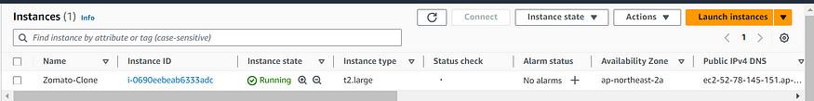

**Step 2 — Install Jenkins, Docker and Trivy**

**2A — To Install Jenkins**

Connect to your console, and enter these commands to Install Jenkins

vi jenkins.sh

#!/bin/bash  
sudo apt update -y  
#sudo apt upgrade -y  
wget -O - https://packages.adoptium.net/artifactory/api/gpg/key/public | tee /etc/apt/keyrings/adoptium.asc  
echo "deb [signed-by=/etc/apt/keyrings/adoptium.asc] https://packages.adoptium.net/artifactory/deb $(awk -F= '/^VERSION_CODENAME/{print$2}' /etc/os-release) main" | tee /etc/apt/sources.list.d/adoptium.list  
sudo apt update -y  
sudo apt install temurin-17-jdk -y  
/usr/bin/java --version  
curl -fsSL https://pkg.jenkins.io/debian-stable/jenkins.io-2023.key | sudo tee \  
 /usr/share/keyrings/jenkins-keyring.asc > /dev/null  
echo deb [signed-by=/usr/share/keyrings/jenkins-keyring.asc] \  
 https://pkg.jenkins.io/debian-stable binary/ | sudo tee \  
 /etc/apt/sources.list.d/jenkins.list > /dev/null  
sudo apt-get update -y  
sudo apt-get install jenkins -y  
sudo systemctl start jenkins  
sudo systemctl status jenkins

sudo chmod 777 jenkins.sh   
./jenkins.sh

Once Jenkins is installed, you will need to go to your AWS EC2 Security Group and open Inbound Port 8080, since Jenkins works on Port 8080.

<EC2 Public IP Address:8080>   
sudo cat /var/lib/jenkins/secrets/initialAdminPassword

Unlock Jenkins using an administrative password and install the suggested plugins.Jenkins will now get installed and install all the libraries.Jenkins Getting Started Screen.

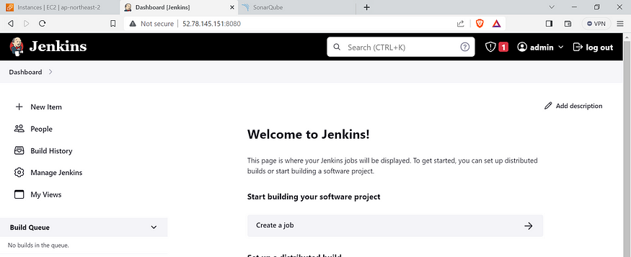

**2B — Install Docker**

sudo apt-get update   
sudo apt-get install docker.io -y   
sudo usermod -aG docker $USER   
newgrp docker   
sudo chmod 777 /var/run/docker.sock

After the docker installation, we create a sonarqube container (Remember to add 9000 ports in the security group).

docker run -d --name sonar -p 9000:9000 sonarqube:lts-community

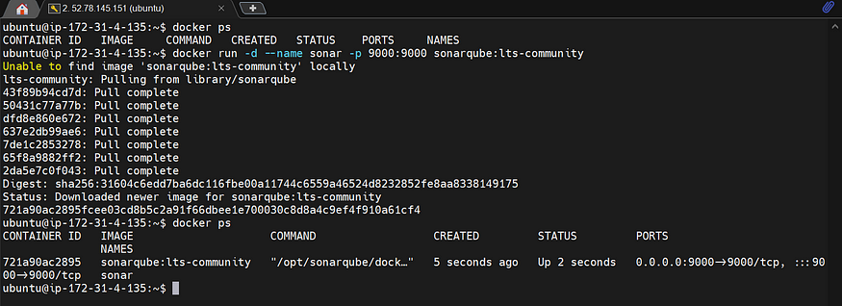

Now our sonarqube is up and running

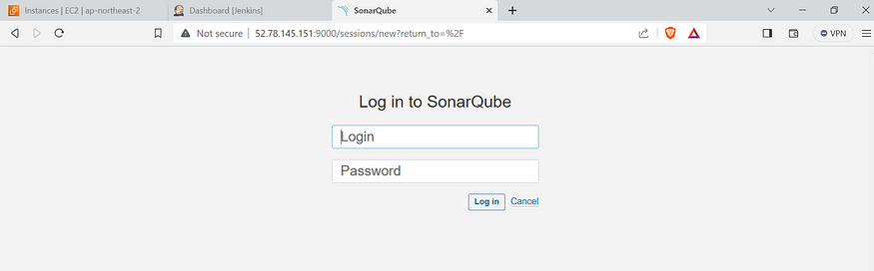

Enter username and password, click on login and change password

username admin   
password admin

Update New password, This is Sonar Dashboard.

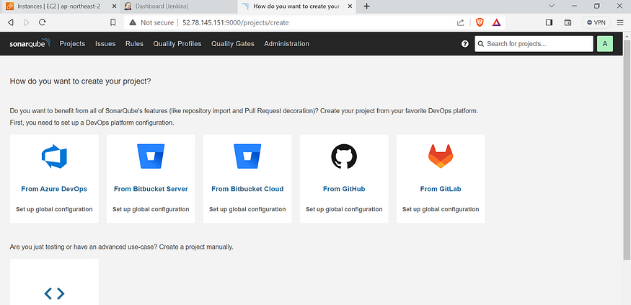

**2C — Install Trivy**

sudo apt-get install wget apt-transport-https gnupg lsb-release -y  
wget -qO - https://aquasecurity.github.io/trivy-repo/deb/public.key | gpg --dearmor | sudo tee /usr/share/keyrings/trivy.gpg > /dev/null  
echo "deb [signed-by=/usr/share/keyrings/trivy.gpg] https://aquasecurity.github.io/trivy-repo/deb $(lsb_release -sc) main" | sudo tee -a /etc/apt/sources.list.d/trivy.list  
sudo apt-get update  
sudo apt-get install trivy -y

Next, we will log in to Jenkins and start to configure our Pipeline in Jenkins

**Step 3 — Install Plugins like JDK, Sonarqube Scanner, NodeJs, OWASP Dependency Check**

**3A — Install Plugin**

Goto Manage Jenkins →Plugins → Available Plugins →

Install below plugins

1 → Eclipse Temurin Installer (Install without restart)

2 → SonarQube Scanner (Install without restart)

3 → NodeJs Plugin (Install Without restart)

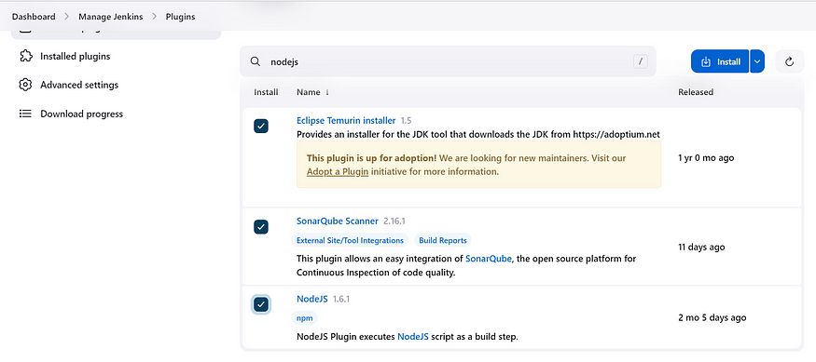

**3B — Configure Java and Nodejs in Global Tool Configuration**

Goto Manage Jenkins → Tools → Install JDK(17) and NodeJs(16)→ Click on Apply and Save

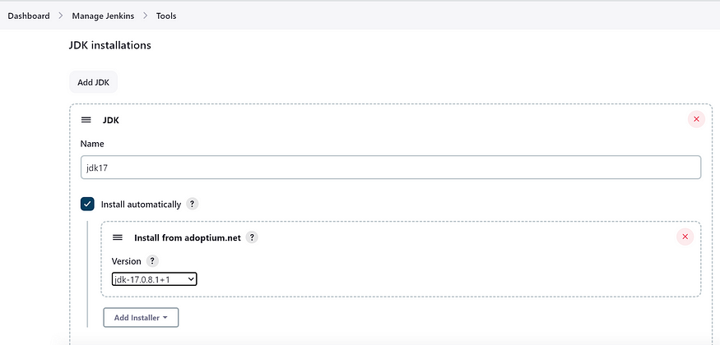

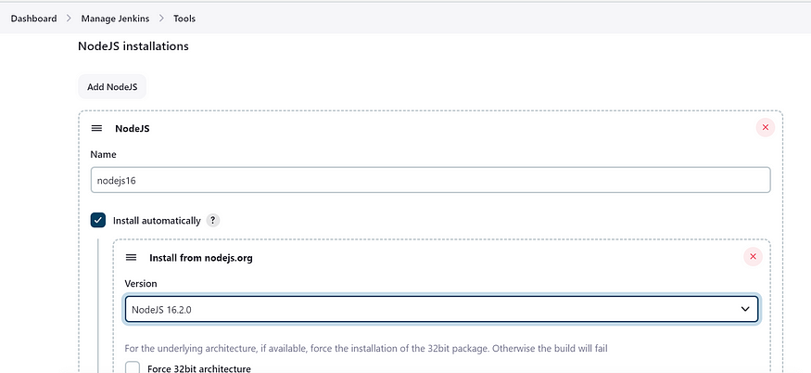

**3C — Create a Job**

create a job as Zomato Name, select pipeline and click on ok.

**Step 4 — Configure Sonar Server in Manage Jenkins**

Grab the Public IP Address of your EC2 Instance, Sonarqube works on Port 9000, so <Public IP>:9000. Goto your Sonarqube Server. Click on Administration → Security → Users → Click on Tokens and Update Token → Give it a name → and click on Generate Token

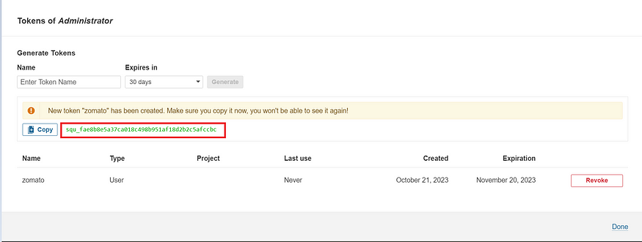

copy Token and Goto Jenkins Dashboard → Manage Jenkins → Credentials → Add Secret Text. It should look like this

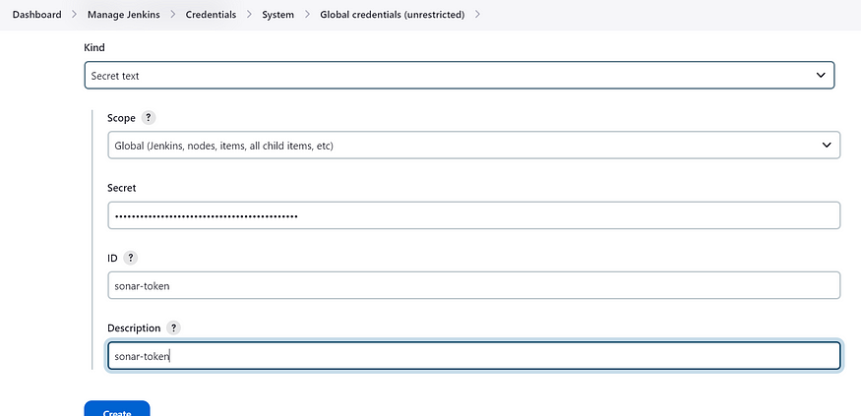

Now, go to Dashboard → Manage Jenkins → System and Add like the below image.

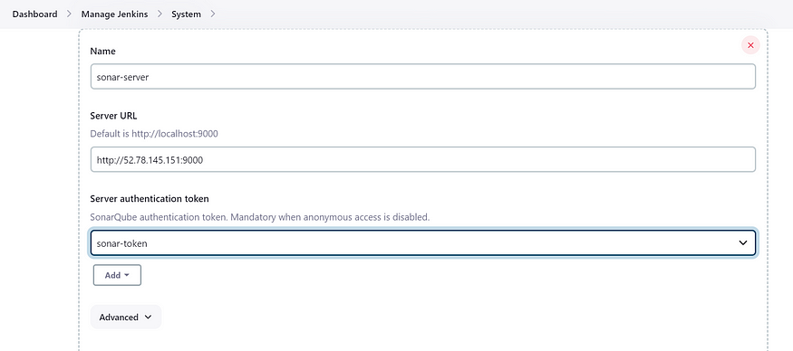

Click on Apply and Save . **The Configure System option** is used in Jenkins to configure different server . **Global Tool Configuration** is used to configure different tools that we install using Plugins

We will install a sonar scanner in the tools.

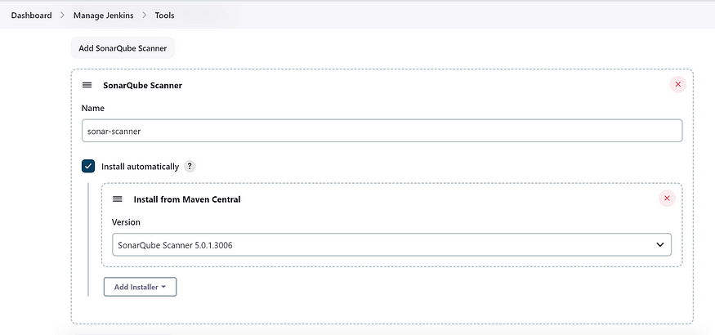

In the Sonarqube Dashboard add a quality gate also Administration → Configuration →Webhooks

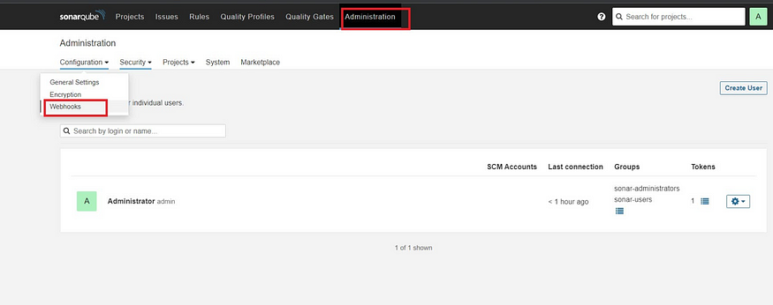

Click on Create and add details

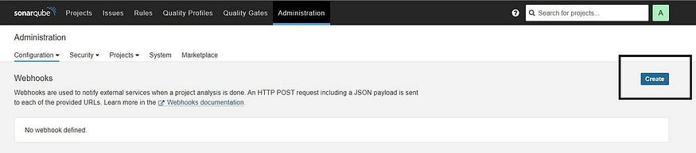

<http://jenkins-public-ip:8080>/sonarqube-webhook/

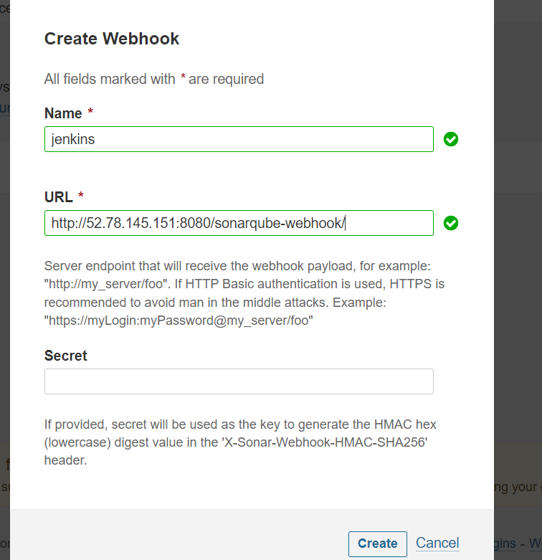

Let’s go to our Pipeline and add the script in our Pipeline Script.

pipeline{  
 agent any  
 tools{  
 jdk 'jdk17'  
 nodejs 'node16'  
 }  
 environment {  
 SCANNER_HOME=tool 'sonar-scanner'  
 }  
 stages {  
 stage('clean workspace'){  
 steps{  
 cleanWs()  
 }  
 }  
 stage('Checkout from Git'){  
 steps{  
 git branch: 'main', url: 'https://github.com/Aj7Ay/Zomato-Clone.git'  
 }  
 }  
 stage("Sonarqube Analysis "){  
 steps{  
 withSonarQubeEnv('sonar-server') {  
 sh ''' $SCANNER_HOME/bin/sonar-scanner -Dsonar.projectName=zomato \  
 -Dsonar.projectKey=zomato '''  
 }  
 }  
 }  
 stage("quality gate"){  
 steps {  
 script {  
 waitForQualityGate abortPipeline: false, credentialsId: 'Sonar-token'   
 }  
 }   
 }  
 stage('Install Dependencies') {  
 steps {  
 sh "npm install"  
 }  
 }  
 }  
}

Click on Build now, you will see the stage view like this

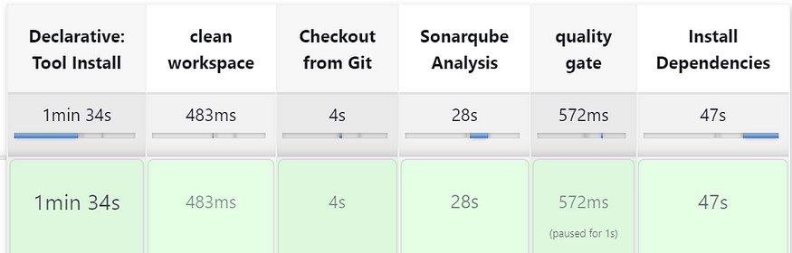

To see the report, you can go to Sonarqube Server and go to Projects.

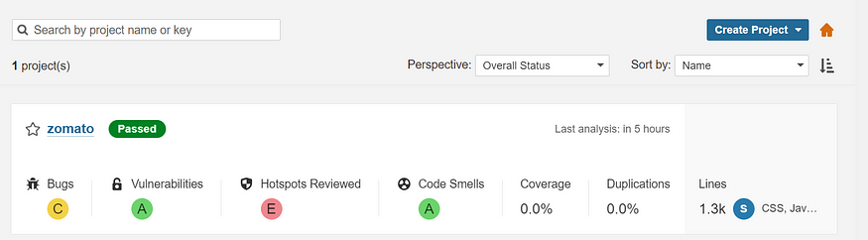

You can see the report has been generated and the status shows as passed. You can see that there are 1.3k lines. To see a detailed report, you can go to issues.

**Step 5 — Install OWASP Dependency Check Plugins**

GotoDashboard → Manage Jenkins → Plugins → OWASP Dependency-Check. Click on it and install it without restart.

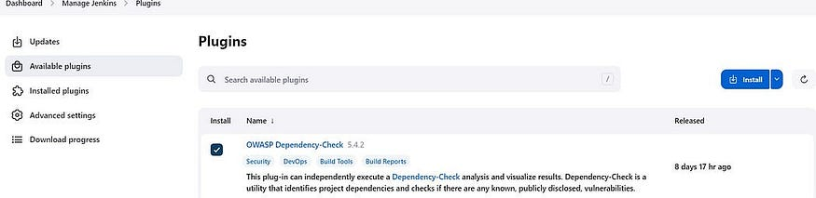

First, we configured the Plugin and next, we had to configure the Tool

Goto Dashboard → Manage Jenkins → Tools →

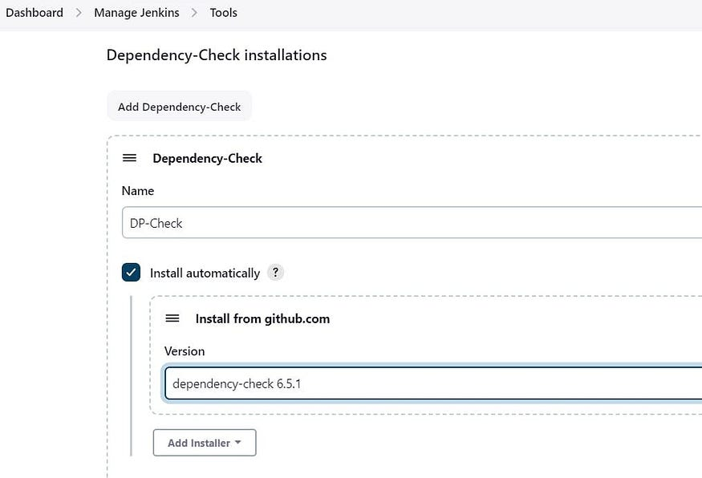

Click on Apply and Save here.

Now go configure → Pipeline and add this stage to your pipeline and build.

stage('OWASP FS SCAN') {  
 steps {  
 dependencyCheck additionalArguments: '--scan ./ --disableYarnAudit --disableNodeAudit', odcInstallation: 'DP-Check'  
 dependencyCheckPublisher pattern: '**/dependency-check-report.xml'  
 }  
 }  
 stage('TRIVY FS SCAN') {  
 steps {  
 sh "trivy fs . > trivyfs.txt"  
 }  
 }

The stage view would look like this,

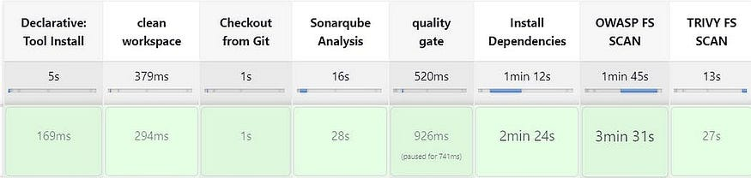

You will see that in status, a graph will also be generated and Vulnerabilities.

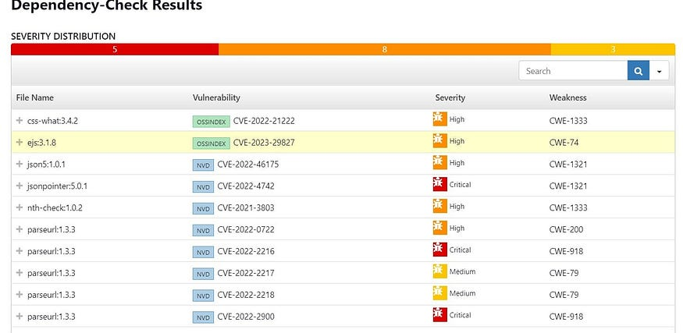

**Step 6 — Docker Image Build and Push**

We need to install the Docker tool in our system, Goto Dashboard → Manage Plugins → Available plugins → Search for Docker and install these plugins

Docker

Docker Commons

Docker Pipeline

Docker API

docker-build-step

and click on install without restart

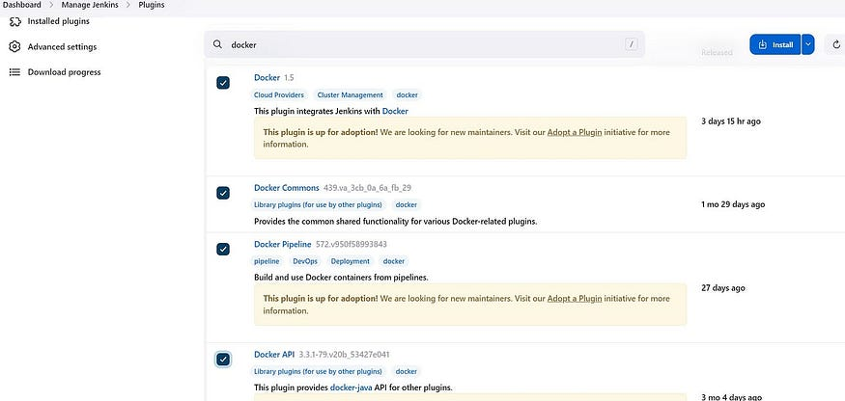

Now, goto Dashboard → Manage Jenkins → Tools →

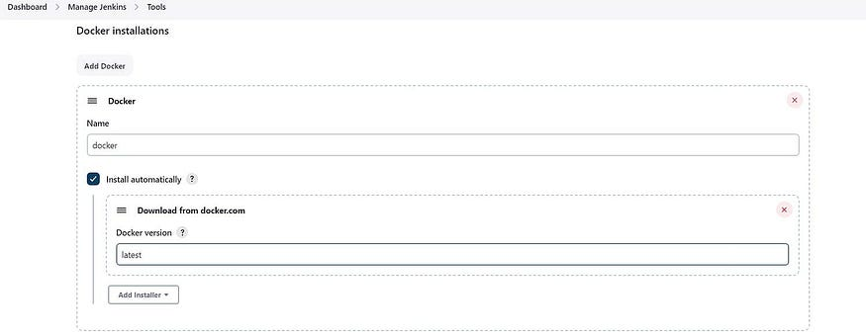

Add DockerHub Username and Password under Global Credentials

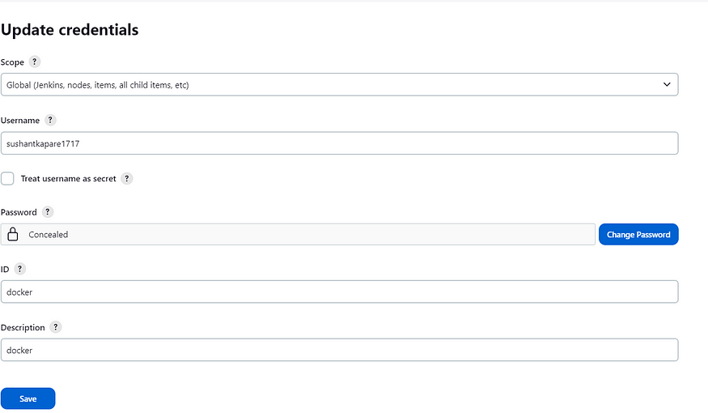

Add this stage to Pipeline Script

stage("Docker Build & Push"){  
 steps{  
 script{  
 withDockerRegistry(credentialsId: 'docker', toolName: 'docker'){   
 sh "docker build -t zomato ."  
 sh "docker tag zomato sushantkapare1717/zomato:latest "  
 sh "docker push sushantkapare1717/zomato:latest "  
 }  
 }  
 }  
 }  
 stage("TRIVY"){  
 steps{  
 sh "trivy image sushantkapare1717/zomato:latest > trivy.txt"   
 }  
 }

you will see the image pushed to dockerhub

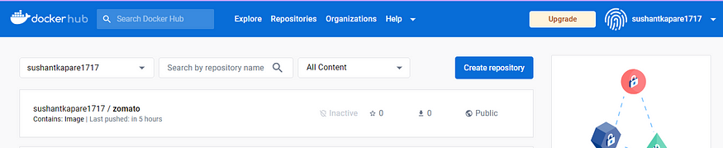

You will see the output below, with a dependency trend.

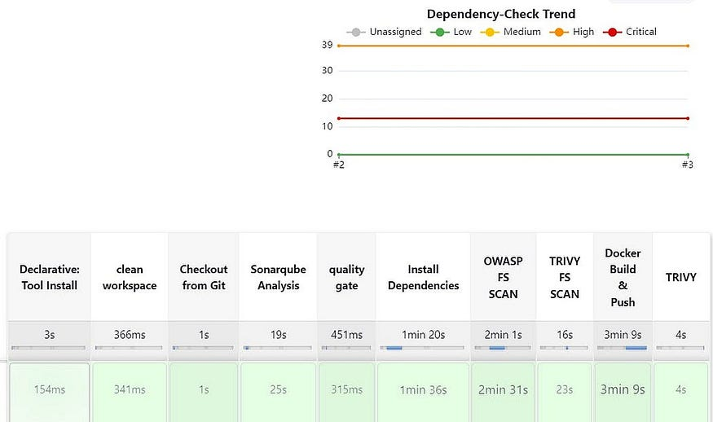

When you log in to Dockerhub, you will see a new image is created

Now Run the container to see if the app coming up or not by adding the below stage

stage('Deploy to container'){  
 steps{  
 sh 'docker run -d --name zomato -p 3000:3000 sushantkapare1717/zomato:latest'  
 }  
 }

stage view

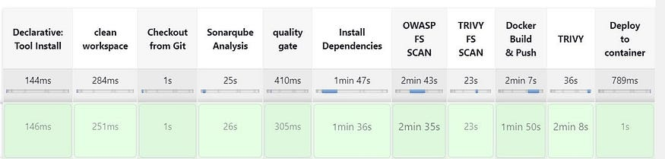

You will get this output

<Jenkins-public-ip:3000>

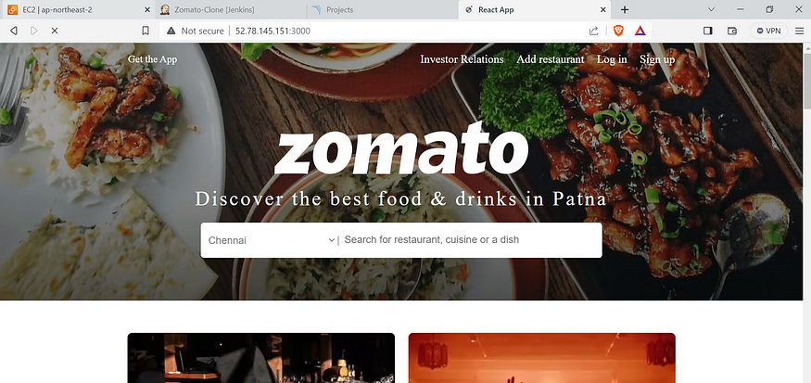

**Step 8: Terminate instances.**

**Complete Pipeline**

pipeline{  
 agent any  
 tools{  
 jdk 'jdk17'  
 nodejs 'node16'  
 }  
 environment {  
 SCANNER_HOME=tool 'sonar-scanner'  
 }  
 stages {  
 stage('clean workspace'){  
 steps{  
 cleanWs()  
 }  
 }  
 stage('Checkout from Git'){  
 steps{  
 git branch: 'main', url: 'https://github.com/SushantOps/Zomato-Clone.git'  
 }  
 }  
 stage("Sonarqube Analysis "){  
 steps{  
 withSonarQubeEnv('sonar-server') {  
 sh ''' $SCANNER_HOME/bin/sonar-scanner -Dsonar.projectName=zomato \  
 -Dsonar.projectKey=zomato '''  
 }  
 }  
 }  
 stage("quality gate"){  
 steps {  
 script {  
 waitForQualityGate abortPipeline: false, credentialsId: 'Sonar-token'   
 }  
 }   
 }  
 stage('Install Dependencies') {  
 steps {  
 sh "npm install"  
 }  
 }  
   
 stage('OWASP FS SCAN') {  
 steps {  
 dependencyCheck additionalArguments: '--scan ./ --disableYarnAudit --disableNodeAudit', odcInstallation: 'DP-Check'  
 dependencyCheckPublisher pattern: '**/dependency-check-report.xml'  
 }  
 }  
 stage('TRIVY FS SCAN') {  
 steps {  
 sh "trivy fs . > trivyfs.txt"  
 }  
 }  
   
 stage("Docker Build & Push"){  
 steps{  
 script{  
 withDockerRegistry(credentialsId: 'docker', toolName: 'docker'){   
 sh "docker build -t zomato ."  
 sh "docker tag zomato sushantkapare1717/zomato:latest "  
 sh "docker push sushantkapare1717/zomato:latest "  
 }  
 }  
 }  
 }  
 stage("TRIVY"){  
 steps{  
 sh "trivy image sushantkapare1717/zomato:latest > trivy.txt"   
 }  
 }  
   
 stage('Deploy to container'){  
 steps{  
 sh 'docker run -d --name zomato -p 3000:3000 sushantkapare1717/zomato:latest'  
 }  
 }  
 }  
}

**If this post was helpful, please do follow and click the clap 👏 button below to show your support.**