WEEK 3 TASK
Statistical Analysis and Hypothesis Testing in Python
Business Problem: Do Promotional Campaigns Increase Average Purchase Amount?
Prepared as an academic/technical report using Python, Pandas, NumPy, SciPy and Matplotlib.
Dataset: Self-generated, 180 synthetic order records
Significance level (α): 0.05

1. Executive Summary
This project investigates whether promotional campaigns are associated with higher average customer purchase amounts. A reproducible self-generated dataset containing 180 order records was created, with an equal number of promotion and no-promotion observations. The primary statistical method was a Welch independent two-sample t-test because the analysis compares the mean purchase amounts of two independent groups and does not require equal population variances. The mean purchase amount for promotion orders was ₹1,812.36, compared with ₹1,600.10 for orders without promotion. The estimated mean difference was ₹212.26. The test produced t = 1.819 and p = 0.0706494. Because the p-value is above the 0.05 significance level, the null hypothesis is not rejected. The 95% confidence interval for the mean difference was ₹-18.06 to ₹442.58. Additional one-way ANOVA was used to check whether purchase amounts differ across Electronics, Clothing and Groceries, while a chi-square test examined whether promotion status and category are associated. These additional tests provide broader statistical context and help demonstrate the use of multiple statistical techniques.

2. Task Objective and Business Context
The objective is to demonstrate a complete statistical-analysis workflow in Python: formulate a testable hypothesis, prepare data, perform descriptive analysis, select appropriate statistical tests, calculate p-values and confidence intervals, visualize the findings, interpret the results, and provide a business-oriented conclusion.
Promotional campaigns are commonly used by online and offline retailers to encourage customers to buy more. However, a higher average order value observed during promotional periods could occur by chance or because the customer mix is different. Statistical hypothesis testing provides a structured way to decide whether the observed difference is strong enough to be considered statistically significant at a chosen significance level.

3. Hypothesis Formulation
Research Question: Do promotional campaigns increase the average purchase amount?
Null Hypothesis (H₀): Promotional campaigns do not increase the average purchase amount; the population means are equal.
Alternative Hypothesis (H₁): Promotional campaigns increase the average purchase amount; the promotion mean is greater than the no-promotion mean.
Significance Level: α = 0.05.
Decision rule: if the p-value is less than 0.05, reject H₀. Otherwise, fail to reject H₀. The analysis also reports a 95% confidence interval and Cohen's d effect size so that statistical significance is not interpreted alone.

4. Methodology and Study Design
The project uses a self-generated dataset so that the entire analysis is reproducible and does not depend on an external data source. The dataset contains 180 synthetic orders. Each order has an Order ID, Promotion status, Product Category and Purchase Amount in Indian Rupees.
Variable | Type | Description
Order_ID | Identifier | Unique order identifier
Promotion | Categorical | Promotion or No Promotion
Category | Categorical | Electronics, Clothing or Groceries
Purchase_Amount_INR | Numeric | Order value in INR
The primary comparison contains two independent groups. Welch's t-test is used because it is a robust version of the independent two-sample t-test that does not assume equal variances. One-way ANOVA compares mean purchase amounts among the three categories. The chi-square test of independence checks whether promotion status and category are statistically associated.

5. Descriptive Statistics
Group | N | Mean | Std. Dev. | Median | Min | Max
No Promotion | 90.0 | 1600.1 | 822.58 | 1408.94 | 319.09 | 3530.81
Promotion | 90.0 | 1812.36 | 741.06 | 1576.12 | 671.82 | 3793.01
The promotion group has an average order value of ₹1,812.36, while the no-promotion group averages ₹1,600.10. The observed difference is ₹212.26. The descriptive statistics suggest a meaningful difference, but descriptive statistics alone cannot determine whether the difference is statistically significant.

6. Visualization of Promotion Groups
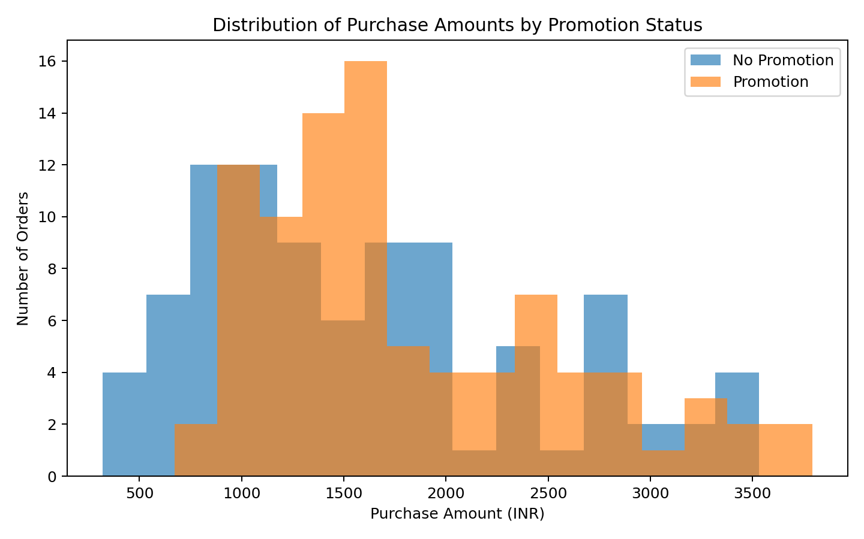
Figure 1. Histogram comparing purchase-amount distributions for promotion and no-promotion orders.
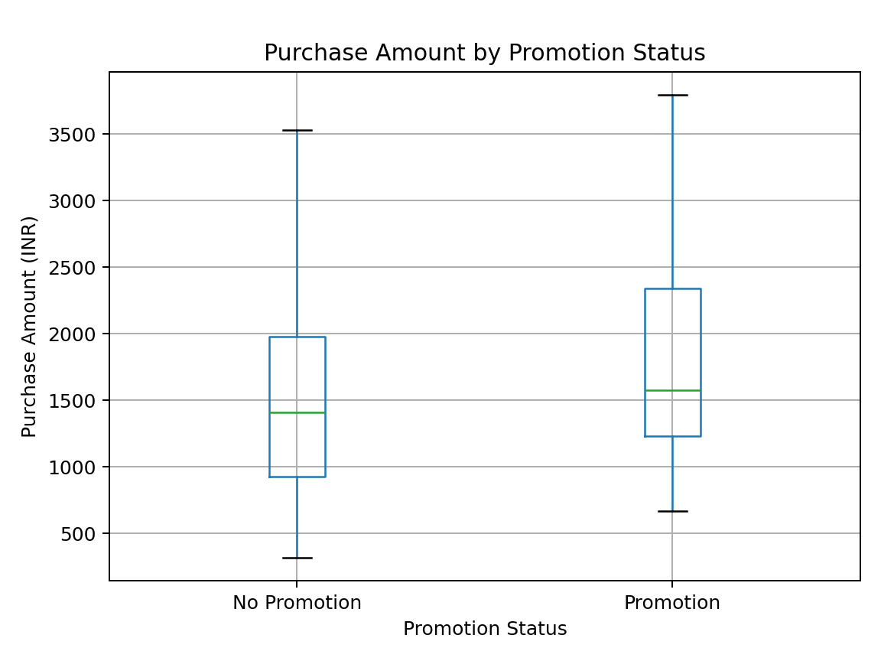
Figure 2. Boxplot comparing the central tendency and spread of the two groups.

7. Primary Hypothesis Test: Welch Independent Two-Sample t-Test
Why this test? The outcome variable is numeric and the main comparison is between two independent groups.
Promotion mean = ₹1,812.36
No-promotion mean = ₹1,600.10
Mean difference (Promotion − No Promotion) = ₹212.26
t-statistic = 1.8187
Welch degrees of freedom ≈ 176.10
p-value = 0.07064944
95% CI for the mean difference = [₹-18.06, ₹442.58]
Cohen's d = 0.2711
Since p ≥ 0.05, H₀ is not rejected. The sample does not provide sufficient statistical evidence that promotional campaigns increase average purchase amount.

8. One-Way ANOVA by Product Category
ANOVA was used as a secondary analysis to test whether mean purchase amount differs among Electronics, Clothing and Groceries. The null hypothesis is that all three category means are equal.
Category | N | Mean | Std. Dev.
Clothing | 63.0 | 1470.12 | 436.69
Electronics | 64.0 | 2471.99 | 704.1
Groceries | 53.0 | 1062.2 | 311.45
ANOVA F-statistic = 115.9617; p-value = 0.00000000.
The ANOVA result is statistically significant, indicating that at least one category has a different mean purchase amount.
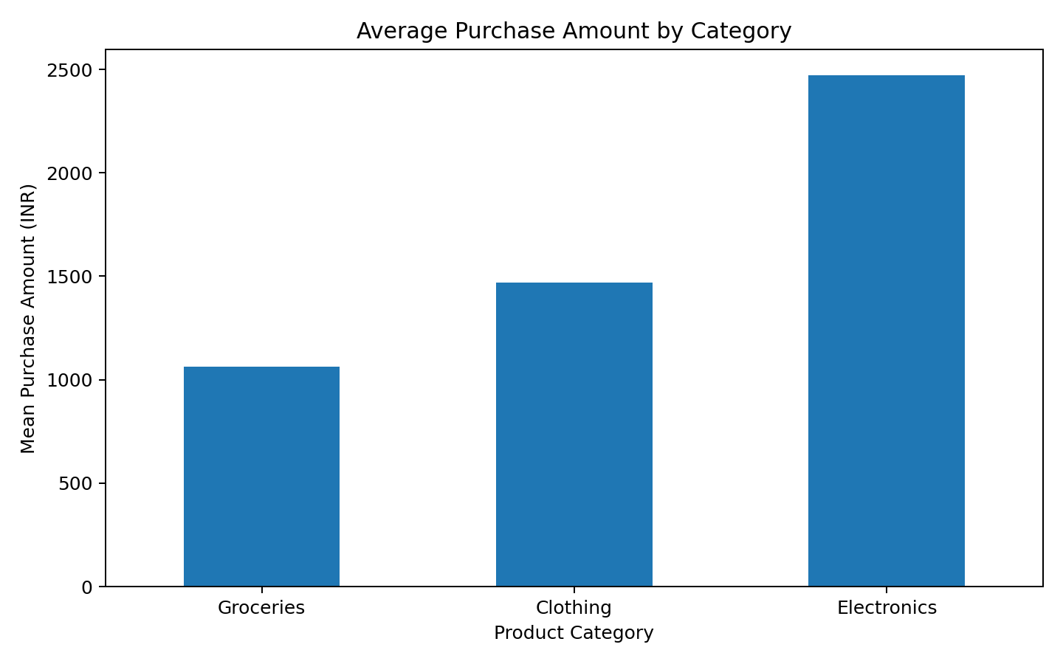
Figure 3. Mean purchase amount by product category.

9. Chi-Square Test of Independence
A chi-square test was performed to check whether promotion status is associated with product category. This is a categorical-versus-categorical analysis and serves as an additional validation step.
Promotion | Electronics | Clothing | Groceries
No Promotion | 35 | 30 | 25
Promotion | 29 | 33 | 28
Chi-square statistic = 0.8752; degrees of freedom = 2; p-value = 0.64559414.
The result does not indicate a statistically significant association between promotion status and category at α = 0.05.
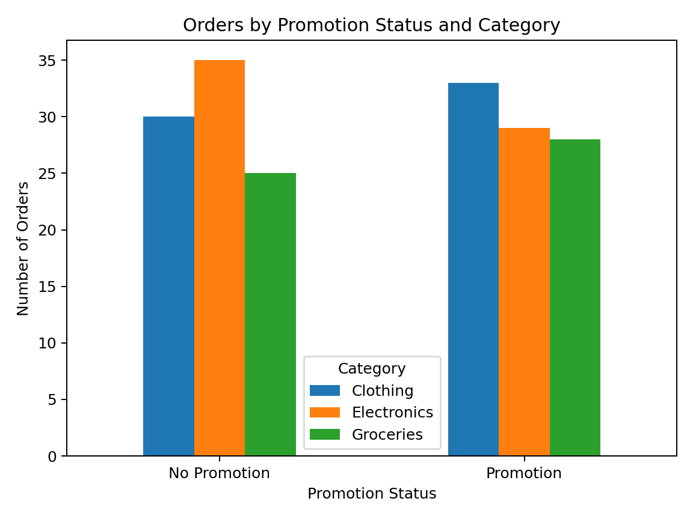
Figure 4. Number of orders by promotion status and category.

10. Interpretation of Results
The primary test produced a p-value of 0.07064944. At α = 0.05, this is not statistically significant. The estimated mean difference is ₹212.26, and the 95% confidence interval ranges from ₹-18.06 to ₹442.58. Because the interval includes zero, it does not provide strong support for a difference between the two population means.
Cohen's d is 0.27, which provides a standardized measure of the practical size of the difference. Statistical significance should be considered together with effect size and the business cost of running promotions.
The secondary analyses add context. ANOVA tests category-level differences in average order value, while the chi-square test checks whether the composition of categories differs by promotion status. These tests do not replace the primary hypothesis test; they help identify other patterns that could affect interpretation.

11. Assumptions and Limitations
- The observations are treated as independent orders.
- Purchase amount is treated as a numeric continuous outcome.
- Welch's t-test is used to reduce sensitivity to unequal variances.
- The dataset is synthetic and intended for academic demonstration, not for making real-world financial decisions.
- The analysis does not establish causation by itself because a controlled randomized experiment was not conducted.
- Real business data should include factors such as customer segment, seasonality, discount percentage, traffic source, and time period.
- If this were deployed in a real business, repeated observations from the same customer and time-based effects should be handled carefully.

12. Business Implications and Recommendations
If the same pattern were confirmed on real transaction data, a retailer could consider using targeted promotions to increase average order value. However, the business should not judge a promotion only by purchase amount. Profit margin, discount cost, customer acquisition cost, repeat purchases and incremental revenue should also be evaluated.
- Run controlled A/B experiments where possible, randomly assigning customers or sessions to promotion and control groups.
- Measure profit and contribution margin in addition to revenue.
- Segment the analysis by product category and customer type.
- Track results over multiple weeks or months to account for seasonality.
- Use the confidence interval and effect size when deciding whether an observed improvement is commercially meaningful.

13. Conclusion
This Week 3 project demonstrates a complete statistical hypothesis-testing workflow in Python. The primary question was whether promotional campaigns increase average purchase amount. The Welch independent two-sample t-test returned t = 1.819 and p = 0.07064944. At α = 0.05, the result is not statistically significant, so the null hypothesis is not rejected. The estimated improvement was ₹212.26, with a 95% confidence interval of ₹-18.06 to ₹442.58. The report also included ANOVA, chi-square testing, descriptive statistics, confidence intervals, effect size and visualizations. Because the dataset is synthetic, the final conclusion should be treated as a demonstration of statistical methodology rather than evidence about an actual company's customers.

14. Reproducibility and Tools Used
Python libraries: Pandas, NumPy, SciPy, Matplotlib, and python-docx.
Random seed: 42. The included CSV and Python script reproduce the analysis.
Files included with this submission: the DOCX report, analysis Python script, CSV dataset, and four PNG visualizations.

Appendix A – Core Python Code
import pandas as pd
from scipy import stats
df = pd.read_csv("week3_statistical_analysis_dataset.csv")
promo = df.loc[df["Promotion"] == "Promotion", "Purchase_Amount_INR"]
no_promo = df.loc[df["Promotion"] == "No Promotion", "Purchase_Amount_INR"]
t_stat, p_value = stats.ttest_ind(
promo, no_promo, equal_var=False
)
print("t-statistic:", t_stat)
print("p-value:", p_value)
groups = [
df.loc[df["Category"] == c, "Purchase_Amount_INR"]
for c in ["Electronics", "Clothing", "Groceries"]
]
f_stat, p_anova = stats.f_oneway(*groups)
table = pd.crosstab(df["Promotion"], df["Category"])
chi2, p_chi, dof, expected = stats.chi2_contingency(table)
print("ANOVA p-value:", p_anova)
print("Chi-square p-value:", p_chi)

