WEEK 2 INTERNSHIP REPORT
Advanced Data Visualization and Storytelling with PythonDataset: UCI Wine Recognition Dataset
1. Introduction
Data visualization transforms numerical information into a form that can be understood quickly by both technical and non-technical audiences. The objective of this project is to build a coherent visual story from a public wine chemistry dataset. Instead of presenting isolated charts, the analysis progresses from a basic overview of the samples to deeper comparisons of chemical characteristics and relationships between variables.
2. Dataset Description
This analysis uses the Wine Recognition dataset associated with the UCI Machine Learning Repository. It contains 178 wine samples belonging to three classes and includes 13 numerical chemical measurements, such as alcohol, malic acid, flavanoids, color intensity and proline. The dataset is useful for demonstrating how visual techniques can reveal group differences, correlations and multivariate patterns.
3. Methodology
The dataset was loaded into a Pandas DataFrame using the Scikit-learn dataset interface. Initial checks were performed for data structure, descriptive statistics and missing values. The storytelling sequence was designed as: Who is in the dataset? → How do major characteristics differ? → Which variables are related? → How do multiple characteristics combine into recognizable class profiles? No missing values were found.
4. Visualization 1: Distribution of Wine Samples
This chart establishes the starting point of the story by showing how many observations belong to each wine class. It gives the audience context before interpreting chemical differences.

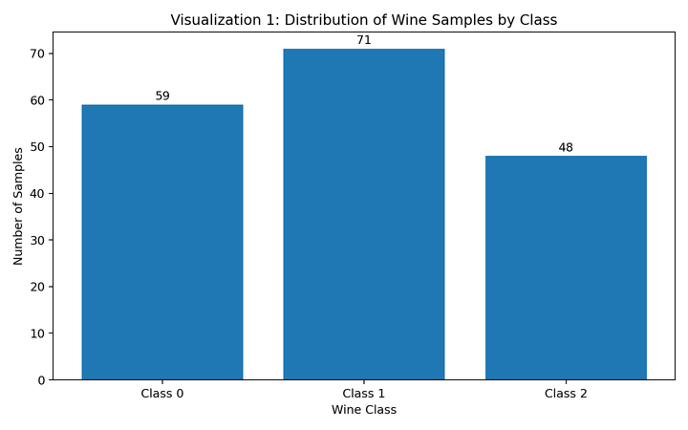

5. Visualization 2: Alcohol and Color Intensity
The scatter plot shows how two important chemical characteristics vary together. The separation and overlap of class groups provide an intuitive explanation of why multiple measurements can distinguish wine types.

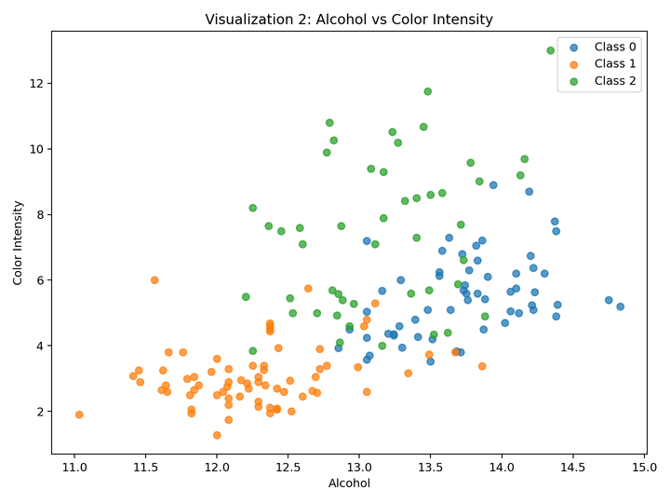

6. Visualization 3: Flavonoid Distribution Across Classes
The box plot communicates median values, spread and possible outliers. It highlights differences in flavonoid levels between the wine classes.

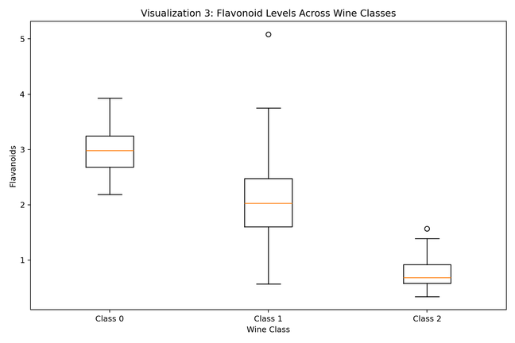

7. Visualization 4: Correlation Heatmap
The heatmap summarizes relationships among many variables in one compact view. Strong positive or negative relationships can support scientific investigation and future feature selection.

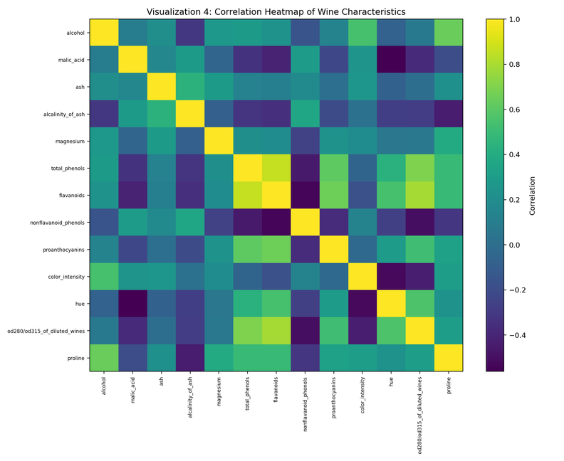

8. Visualization 5: Multivariate Class Profiles
A scatter plot can display only a few variables. The parallel-coordinate visualization allows several normalized measurements to be examined simultaneously and shows broader multivariate chemical signatures.

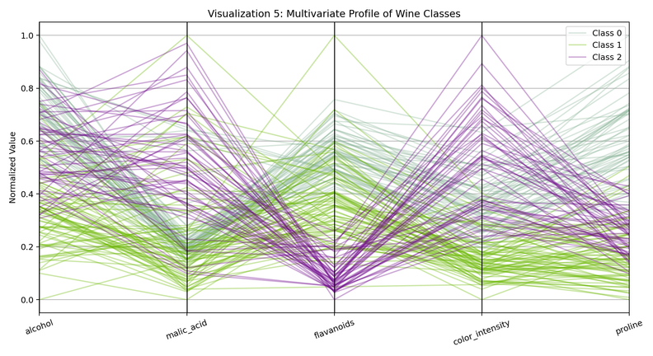

9. Visualization 6: Comparative Chemical Profiles
This grouped profile summarizes relative class averages for important characteristics. It provides a simple final comparison for a non-technical audience.

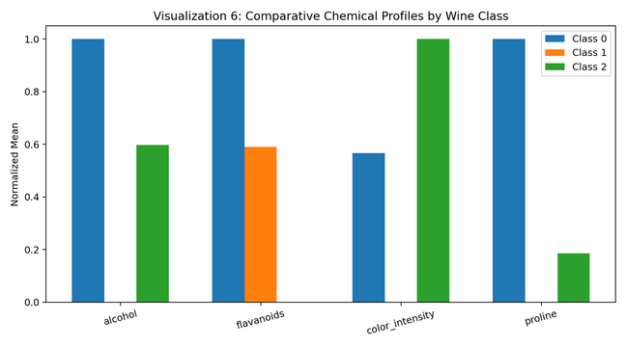

10. Key Insights and Data Story
The visual narrative begins with dataset composition and gradually moves toward increasingly complex comparisons. The three wine classes differ across several chemical characteristics. Alcohol, flavanoids, color intensity and proline provide useful information for comparing groups. The main storytelling lesson is that complex data becomes easier to understand when the audience is guided through a logical sequence.
11. Potential Business and Scientific Implications
From a business perspective, similar visualization techniques could support product classification, quality control and management reporting. From a scientific perspective, correlation analysis can identify related measurements while group comparisons can suggest characteristics worthy of further investigation. These visual methods can also support future classification or prediction models, although visualization alone does not establish causation.
12. Conclusion
This project demonstrates advanced data visualization and storytelling with Python. Six complementary visualizations were developed to communicate distributions, group differences, pairwise relationships, correlations and multivariate profiles. Each visualization was selected for a specific purpose within a coherent narrative, making a complex dataset easier for a non-technical audience to understand.
13. Tools and Libraries Used
Python, Pandas, Matplotlib, NumPy and Scikit-learn.

