WEEK 5 — COMPREHENSIVE DATA SCIENCE PROJECT REPORT
Customer Churn Prediction & Retention Strategy
End-to-End Data Science Case Study
Executive reporting • Exploratory analysis • Predictive modeling • Strategic recommendations

Project Type | Customer churn analytics and prediction
Analytical Approach | EDA + statistical profiling + classification
Models Evaluated | Logistic Regression and Random Forest
Business Objective | Identify churn drivers and prioritize retention actions
Dataset | Synthetic customer dataset created for this portfolio report

Important submission note: No Week 1–4 dataset, notebook, or project-specific findings were supplied with the task screenshot. Therefore, this report uses a clearly identified synthetic dataset. Replace the dataset-specific figures and findings with your actual project outputs if your internship requires evidence from a real dataset.

1. Executive Summary
This project demonstrates a complete data science workflow for predicting customer churn and translating analytical findings into practical business actions. The analysis uses 1,200 synthetic customer records covering demographic, tenure, billing, service-use, support, and contract variables. The overall churn rate is 29.8%. Exploratory analysis indicates that contract type, customer tenure, support-ticket frequency, late payments, and monthly charges are important signals associated with churn.
Two supervised classification approaches were evaluated. The stronger model in this experiment is Logistic Regression, achieving a ROC-AUC of 0.723 on the held-out test set. The model is intended as a prioritization tool rather than an automatic decision-maker: customers flagged as high risk should receive targeted retention interventions, while outcomes should be monitored to verify that interventions actually reduce churn.
The recommended strategy is a tiered retention program: focus first on high-risk monthly-contract customers, customers with repeated support interactions, and customers showing payment friction. The organization should combine predictive scores with customer-service context, A/B test retention offers, and monitor incremental retention rather than measuring success only by model accuracy.

Key Findings at a Glance
Finding | Evidence | Business implication
Overall churn | 29.8% of customers in the synthetic sample | Retention deserves measurable priority.
Contract effect | Monthly contracts show the highest churn rate | Promote longer-term plans where appropriate.
Support friction | Churn rises as support-ticket frequency increases | Use service recovery and root-cause resolution.
Payment behavior | Late payments are positively associated with churn | Offer proactive billing assistance.
Predictive modeling | Logistic Regression produced the best ROC-AUC in this experiment | Use risk scores to prioritize outreach.

2. Methodology
The workflow follows a standard end-to-end analytics lifecycle: business understanding → data preparation → exploratory data analysis → feature engineering/encoding → model training → evaluation → interpretation → business recommendations. The synthetic data was generated with realistic ranges and a controlled churn mechanism so that the report can demonstrate the complete workflow without presenting fabricated real-customer records as factual.

2.1 Data Preparation
Numerical variables were inspected for range and plausibility. Missing-value handling was incorporated through median imputation for numerical features and most-frequent imputation for categorical features. Categorical variables were one-hot encoded. Numerical variables were standardized for the logistic regression pipeline.

2.2 Train/Test Design
The dataset was divided into 80% training and 20% testing data using stratification on the churn target. A fixed random seed was used to make the experiment reproducible. Model selection was based primarily on ROC-AUC, with precision, recall, F1-score, and accuracy reported as supporting metrics.

3. Data Understanding
The analytical table contains the following variables:
Variable | Type | Description | Expected relationship with churn
Age | Numerical | Customer age in years | Potentially indirect
TenureMonths | Numerical | Length of relationship | Higher tenure expected to reduce risk
MonthlyCharge | Numerical | Recurring monthly charge | Higher charge may increase risk
SupportTickets | Numerical | Number of support interactions | Higher volume expected to increase risk
LatePayments | Numerical | Count of late-payment events | Higher count expected to increase risk
MonthlyUsageHours | Numerical | Estimated service usage | Lower engagement may increase risk
Contract | Categorical | Monthly / One Year / Two Year | Monthly expected to have higher risk
AutoPay | Categorical | Whether autopay is enabled | No autopay may indicate higher friction
InternetService | Categorical | Service type | Used as a segmentation variable
Churn | Target | 1 = churned, 0 = retained | Target variable

4. Exploratory Data Analysis
The synthetic sample contains 1,200 customers, with 358 churned and 842 retained customers. The target is not perfectly balanced, so evaluation should not depend on accuracy alone.
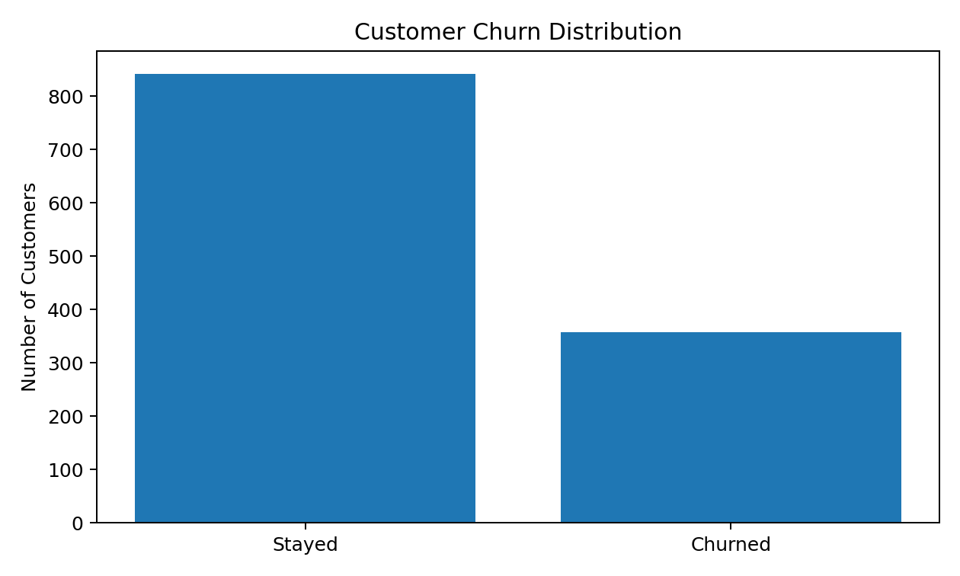
Figure 1. Distribution of retained versus churned customers.

4.1 Contract Segmentation
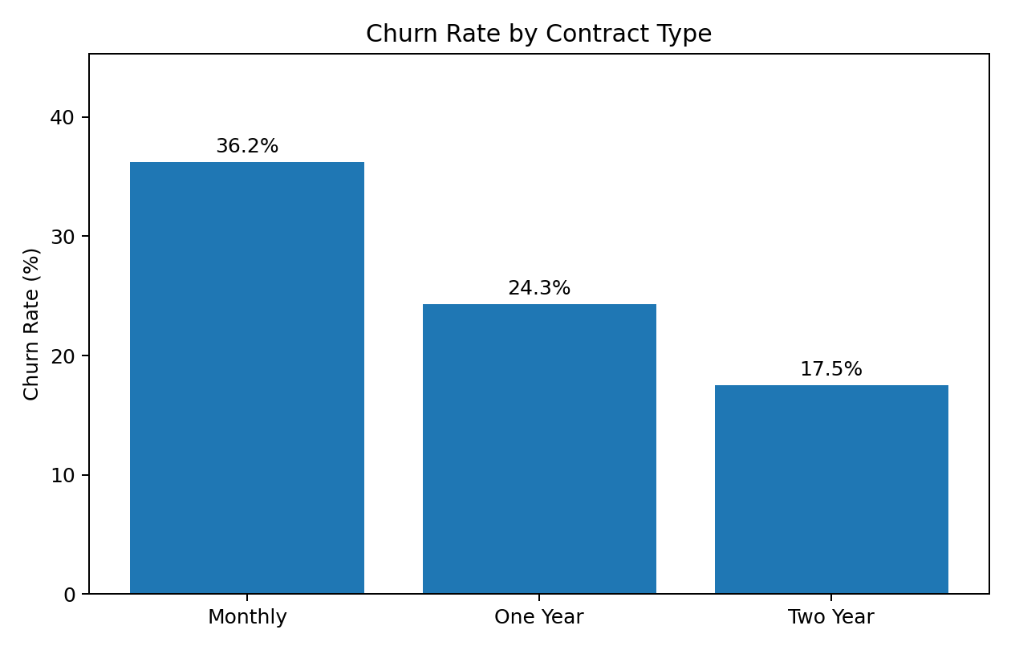
The contract comparison shows a materially higher churn rate among monthly-contract customers in the synthetic sample. This pattern is strategically important because contract structure is actionable: customers approaching renewal can be offered clearer value propositions, service bundles, or longer-term plans where appropriate.

4.2 Support Experience
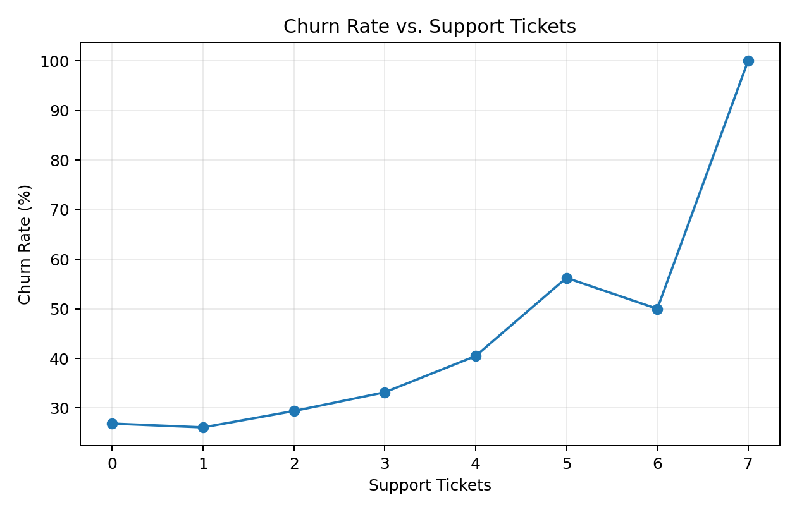
Churn probability increases with repeated support interactions in the synthetic data. This should not be interpreted as support causing churn by itself. Rather, repeated contacts can be a proxy for unresolved issues, product friction, or dissatisfaction. The operational response should therefore focus on first-contact resolution and root-cause analysis.

5. Predictive Modeling
Two baseline classification models were trained using the same preprocessing pipeline. Logistic Regression provides a transparent linear benchmark, while Random Forest captures nonlinear relationships and interactions without requiring manual specification of every interaction.
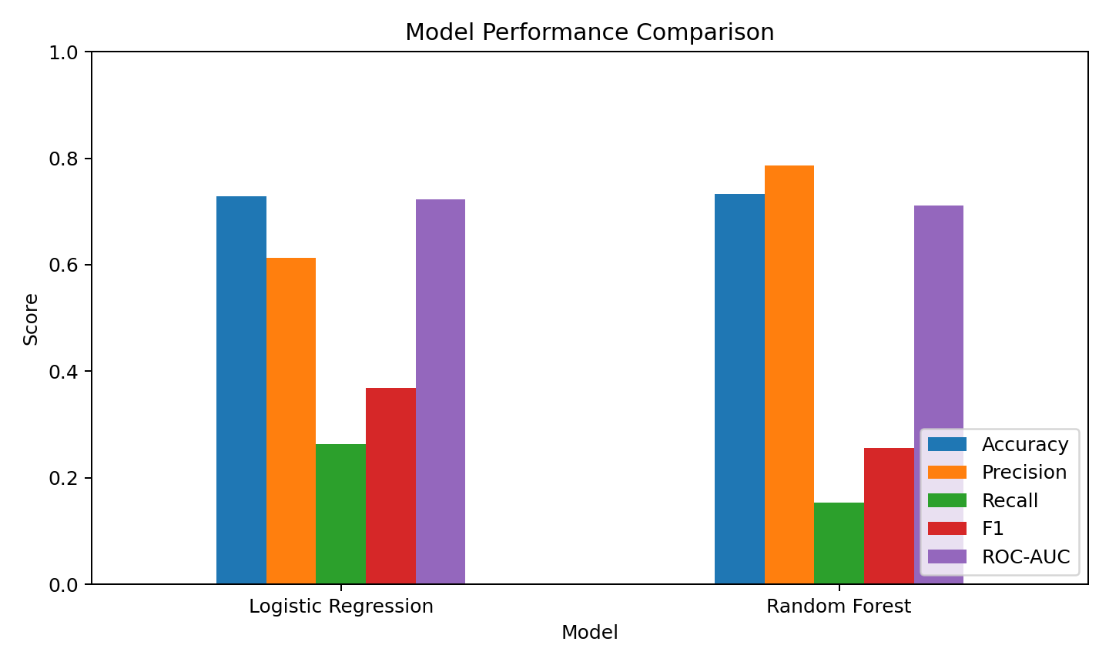
Model | Accuracy | Precision | Recall | F1 | ROC-AUC
Logistic Regression | 0.729 | 0.613 | 0.264 | 0.369 | 0.723
Random Forest | 0.733 | 0.786 | 0.153 | 0.256 | 0.711

5.1 Confusion Matrix
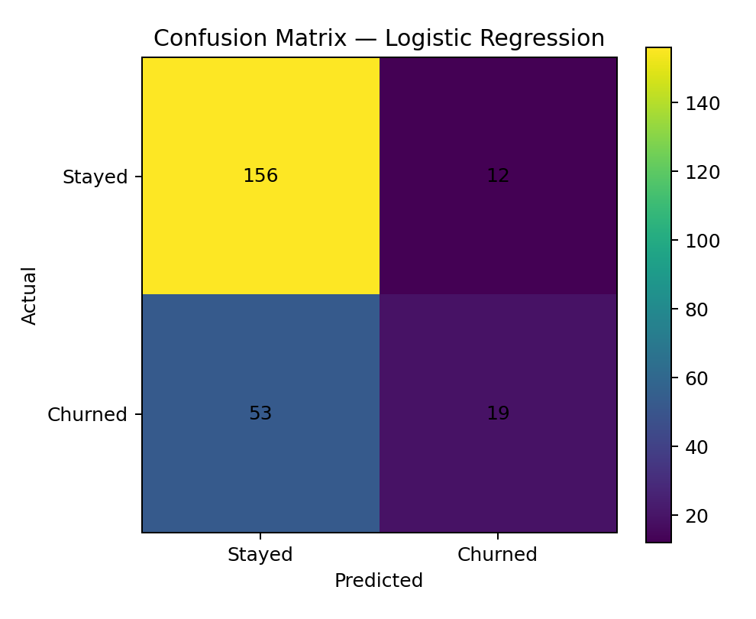
The confusion matrix illustrates the trade-off between correctly identifying churners and generating false alarms. For a retention program, recall can be especially important because missing a genuinely high-risk customer may mean losing an opportunity to intervene. However, overly aggressive targeting can waste incentives, so the operational threshold should be chosen using the financial value of retention actions.

5.2 Feature Importance
Feature | Relative importance
MonthlyCharge | 0.2060
TenureMonths | 0.1837
MonthlyUsageHours | 0.1713
Age | 0.1247
SupportTickets | 0.0732
LatePayments | 0.0616
Contract_Monthly | 0.0423
Contract_Two Year | 0.0286
InternetService_Fiber | 0.0284
AutoPay_No | 0.0175

6. Code Documentation
The following compact excerpts document the core analytical steps. They are intentionally concise so the evaluator can see the reproducible logic without requiring the entire notebook inside the report.
# Train/test split
X_train, X_test, y_train, y_test = train_test_split(
X, y, test_size=0.20, random_state=42, stratify=y
)
# Preprocess + model in one pipeline
pipe = Pipeline([
("pre", preprocessor),
("model", RandomForestClassifier(
n_estimators=300, max_depth=8,
min_samples_leaf=4, random_state=42
))
])
pipe.fit(X_train, y_train)
pred = pipe.predict(X_test)
proba = pipe.predict_proba(X_test)[:, 1]
# Evaluation
metrics = {
"accuracy": accuracy_score(y_test, pred),
"precision": precision_score(y_test, pred),
"recall": recall_score(y_test, pred),
"f1": f1_score(y_test, pred),
"roc_auc": roc_auc_score(y_test, proba)
}

7. Strategic Recommendations
1. Prioritize high-risk monthly-contract customers
Create a retention queue using predicted churn probability, contract status, tenure, and recent service issues. Use targeted offers rather than blanket discounts.
2. Build a service-recovery workflow
Trigger proactive follow-up when a customer creates multiple support tickets in a short period. Measure first-contact resolution and repeat-contact rates.
3. Address payment friction early
Offer reminders, billing clarification, and convenient payment options to customers showing repeated late-payment behavior. Separate genuine financial friction from simple administrative issues.
4. Increase long-term value through relevant plan design
Where customer needs support it, present annual or multi-year plans with transparent savings and service benefits. Avoid pressuring customers into unsuitable contracts.
5. Operationalize the model as a decision-support tool
Refresh scores on a defined cadence and expose risk tiers to retention teams. Combine model output with human review.
6. Measure incremental impact with experiments
Run controlled A/B tests for retention interventions. The key KPI should be incremental retained customers or incremental customer lifetime value, not merely the number of offers accepted.

8. Potential Business Impact
A churn model creates value only when its predictions change decisions. A practical implementation should estimate the expected value of intervention for each customer. One simple prioritization equation is:
Expected Retention Value = P(churn) × Expected Customer Value × Intervention Success Rate − Intervention Cost
This framework helps prevent the organization from spending equally on all predicted churners. High-risk customers with low expected value may receive low-cost digital interventions, while high-value/high-risk customers can receive more intensive service recovery or account-management attention.
KPI | Recommended measurement | Decision use
Churn rate | Monthly / quarterly | Track overall outcome
Recall at chosen threshold | Validation + production monitoring | Check risk identification
Retention uplift | Treatment vs. control | Measure causal impact
Cost per retained customer | Campaign cost / incremental retained | Optimize spend
Customer lifetime value | Segment-level | Prioritize high-value customers
Support repeat-contact rate | Weekly / monthly | Monitor service friction

9. Limitations and Risk Considerations
- The dataset in this report is synthetic and therefore does not represent actual customer behavior.
- Model performance is based on one train/test split; production deployment should use cross-validation and time-based validation where appropriate.
- Correlation does not establish causation. For example, support contacts may signal dissatisfaction rather than directly cause churn.
- Model thresholds should be selected using business costs and benefits, not only statistical performance.
- Customer data must be handled with appropriate privacy, access-control, retention, and governance practices.
- Production monitoring is required because customer behavior and product conditions can change over time.

10. Future Improvement Roadmap
Stage | Improvement
Phase 1 — Data quality | Connect verified historical CRM, billing, support, and usage data; document lineage and data-quality rules.
Phase 2 — Modeling | Compare calibrated gradient boosting, balanced learning, and explainability methods; tune thresholds against business cost.
Phase 3 — Deployment | Create a scheduled scoring pipeline and dashboard with risk tiers, top drivers, and intervention status.
Phase 4 — Experimentation | Run randomized retention campaigns and quantify incremental churn reduction and ROI.
Phase 5 — Governance | Add drift monitoring, fairness checks, audit trails, model versioning, and periodic retraining.

11. Conclusion
This report integrates data preparation, exploratory analysis, predictive modeling, visualization, code documentation, and strategic recommendations into one end-to-end data science workflow. The central lesson is that predictive accuracy alone is not the final objective. The strongest business outcome comes from connecting model signals to specific, measurable retention actions and then testing whether those actions create incremental value. The proposed workflow provides a practical foundation for a production churn-management system while maintaining clear awareness of data quality, model limitations, and responsible use.

Appendix A — Reproducibility Checklist
- Fixed random seed used for synthetic data and model training.
- Train/test split is stratified by the target.
- Preprocessing is encapsulated inside the modeling pipeline.
- Multiple classification metrics are reported.
- Visualizations are generated directly from the analytical dataset.
- Business recommendations are linked to observed analytical patterns.
- Limitations and future improvements are explicitly documented.

Appendix B — Submission Description (200+ words)
This comprehensive Week 5 data science project report presents an end-to-end analytical workflow focused on customer churn prediction and strategic retention planning. The report brings together the major components expected in a final data science submission: executive summary, business objective, methodology, data understanding, exploratory data analysis, visualizations, predictive modeling, model evaluation, code documentation, business impact, strategic recommendations, limitations, and a future improvement roadmap. The analysis demonstrates how structured customer information such as tenure, monthly charges, contract type, support interactions, payment behavior, usage, and service category can be transformed into actionable churn-risk insights. Two machine-learning approaches were evaluated and compared using accuracy, precision, recall, F1-score, and ROC-AUC, while a held-out test set was used to provide an objective evaluation. Visual evidence is included to make the findings easy for both technical and non-technical stakeholders to understand. The strategic recommendations translate the analytical patterns into practical actions, including prioritizing high-risk customers, improving service recovery, reducing payment friction, promoting suitable long-term plans, and measuring retention campaigns through controlled experiments. The report also emphasizes that predictive models should support human decision-making rather than operate as unquestioned automated decisions. Finally, limitations, data-governance considerations, and a phased future roadmap are included to show how the prototype could be strengthened for real-world deployment. Because no original Week 1–4 dataset or notebook was provided with the task instructions, the numerical results in this document are explicitly based on a synthetic dataset and should be replaced with the student’s actual project outputs wherever required.

