**Sasken Website- Fresher’s Hiring module**

**Introduction**

Develop a webpage which will take the input from fresher and send email in response with message like “Your application is received” and if the candidate will satisfy the hiring criteria then email the candidate details to HR.

**Tools and Technologies**

**Server-side technologies**

* Spring Boot
* JDK 1.8
* Spring Framework
* Hibernate
* Spring Data JPA

**Front end technologies**

* Angular 7
* npm
* HTML
* CSS

**Tools**

* Maven
* IDE- Eclipse
* VSC - Visual Studio Code
* Angular CLI

**Functionality**

1. Fresher will fill the below details through website

* First name
* Last name
* Email
* Date of birth
* Mobile No
* Project details
* Upload resume

Education Details

|  |  |  |
| --- | --- | --- |
| 10th | Percentage/CGPA | Year of passing |
| 12th | Percentage/CGPA | Year of passing |
| BE/B.Tech | Percentage/CGPA | Year of passing |
| M.tech/MS | Percentage/CGPA | Year of passing |
| PhD | Percentage/CGPA | Year of passing |

Competitive Exams

|  |  |  |  |
| --- | --- | --- | --- |
| GATE | Marks | Rank | Year appeared |
| JEE | Marks | Rank | Year appeared |

(Provieded options to add more competitive exams)

1. Once User submit the form he will received a message you application submitted successfully
2. When user submit the request he will received an email with message like “Your application is received”.
3. When user submit the request HR will received an email if candidate will meet some specified criteria.
4. Store candidate data in database for future reference.
5. Store candidate resume in file system for future reference.

**Database Tables**

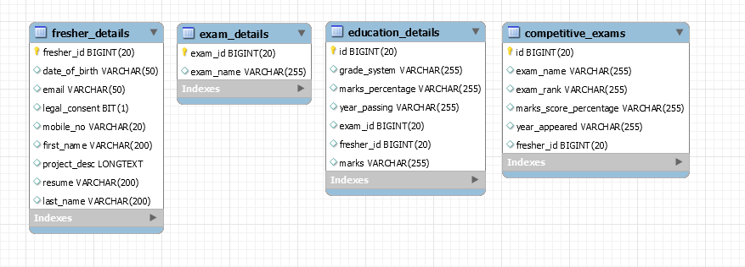

**Spring Boot CRUD Rest APIs**

We will build a **CRUD RESTFul APIs**for Sasken Website - Fresher’s Hiring module using Spring Boot 2 JPA and MySQL. Later we will consume these Rest APIs using Angular 7 client application. Following are

REST APIs (Controller handler methods) are created for Fresher Hiring module.

|  |  |  |  |  |  |
| --- | --- | --- | --- | --- | --- |
| **Sr No** | **API name** | **HTTP Method** | **Path** | **Status code** | **Description** |
| 1 | Get All Freshers | GET | /api/vi/freshers | 200  (OK) | All freshers fetched |
| 2 | POST Fresher details with file upload(Resume) | POST | /api/vi/ fresher | 201  (Created) | A new fresher details created |

