TASK: FILE ORGANIZER AUTOMATION SCRIPT
Introduction
This project is a Python-based File Organizer Automation Script. The program automatically sorts files into folders based on their file extensions such as Images, Videos, Documents, PDFs, Audio, Code files, and more.
The project demonstrates automation using Python with file handling, OS operations, exception handling, and user interaction.

Objective
Create an automation script that performs:
- File operations
- File sorting
- Automatic organization
- Cleaning tasks

Features
- Automatically organizes files into categories
- Supports multiple file formats
- Prevents duplicate file overwriting
- User input support for selecting folders
- Exception handling for errors
- Uses OS module and shutil module
- Easy command-line interface

Technologies Used
- Python
- OS Module
- Shutil Module
- Pathlib
- Exception Handling

Working Process
- User selects a folder path
- Script scans all files
- Files are categorized by extension
- New folders are created automatically
- Files are moved into proper folders

Code Snippet
folder_name = EXT_MAP.get(f.suffix.lower(), "Others")
dest_dir = target_path / folder_name
dest_dir.mkdir(exist_ok=True)
shutil.move(str(f), str(dest_file))
print(f"Moved: {f.name} -> {folder_name}/")

Sample Input
1. Organize a Folder
0. Exit

Enter folder path:
C:\Users\Desktop\TestFolder

Sample Output
Processing 15 files...

Moved: photo.jpg -> Images/
Moved: report.pdf -> PDFs/
Moved: song.mp3 -> Audio/

Successfully organized 15 files.

Exception Handling
The project uses try-except blocks to handle:
- Invalid folder paths
- File moving errors
- Duplicate file names

GitHub Repository Link
https://github.com/biswalanuj2006-droid/INTERNSARK.TASK-2

Screenshots
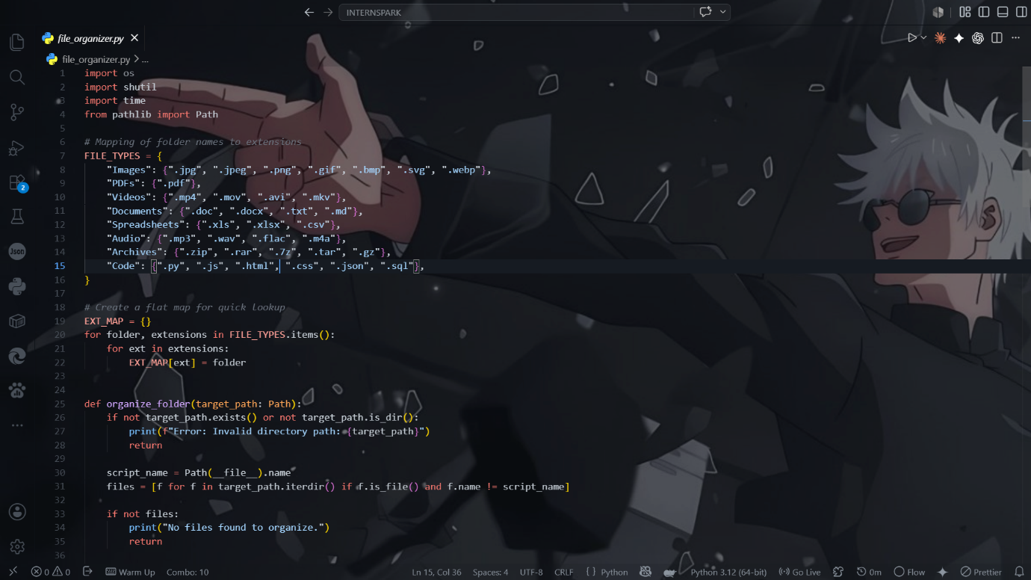

Conclusion
This project demonstrates automation using Python for file management and organization. It improves productivity by automatically sorting files into categorized folders efficiently.

