**PMS**

PMS – Policy Management System- it stores data coming from Duck Creek.

Only after issuing the policy data will move to XML (an intermediate between Duck creek and PMS). XML converts the DC coverages in a coded form which passes to PMS in EPF screens (EISA, EIBC, EUIT screens). After the batch runs data will move from EPF screen to PUFA screens (PISA, PIBC and PUIT screens).

If any policy fails with an Integration error, it won’t come to PMS. Sometimes it fails if you will issue the policy during Batch run or sometimes it fails due to premium mismatch i.e. extra coverage gets added or deleted in XML.

To perform any transaction on the policy, it is important that the policy should successfully passes through nightly cycle and all the data should move from EPF screen to PUFA screen.

If there is no change in the premiums after any transaction, then EISA screen won’t reflect any data but transaction can be performed on this policy only after the batch runs.

Interestingly policy can be reissue after Pro-rata/Flat cancellation but data for reissue won’t reflect in EISA screen whereas, it will directly show you in PISA screen. In this case, you can see cancellation transaction data in EISA screen but not in PISA screen

This is the main login screen and the application is “gateg1”.

Type “gateg1” and press <Enter>.

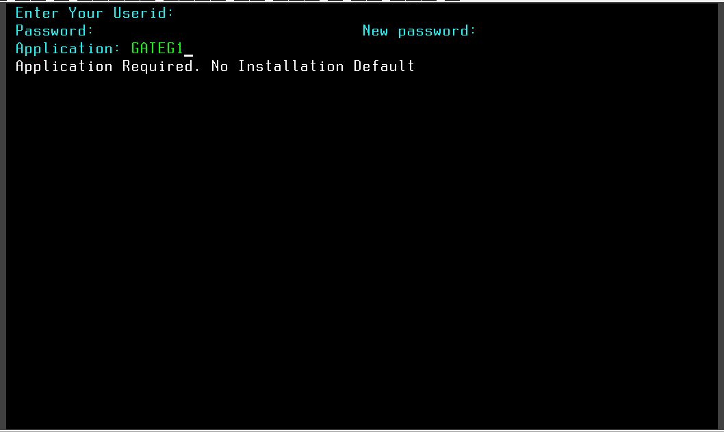

Enter 7 letters User id followed by Password and press <Enter>.

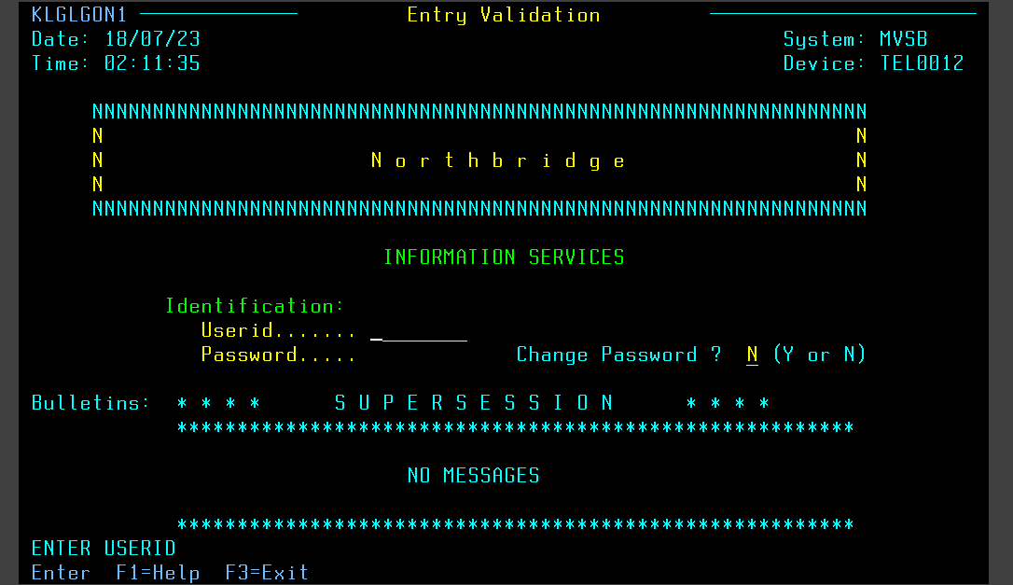

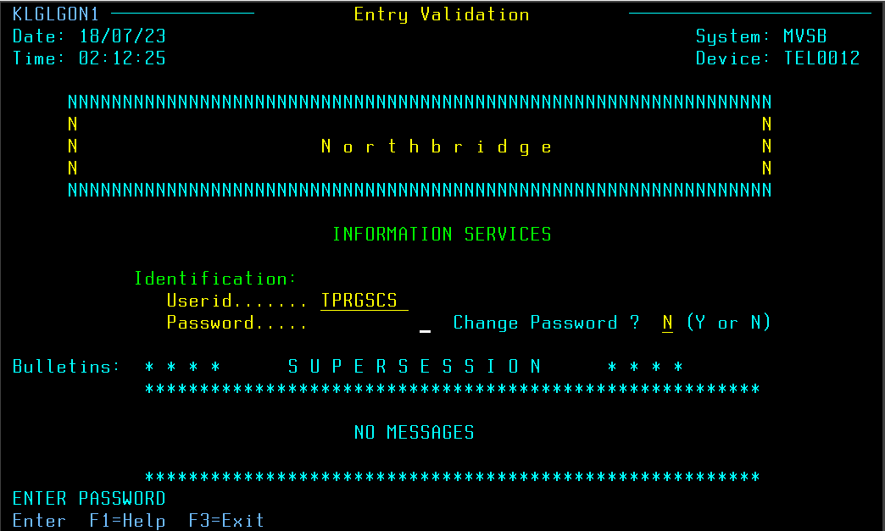

Then you will navigate to next screen “Main Menu”.

To select <SYSTEM TEST> type “S” in front of < SYSTEM TEST> and press <Enter>.

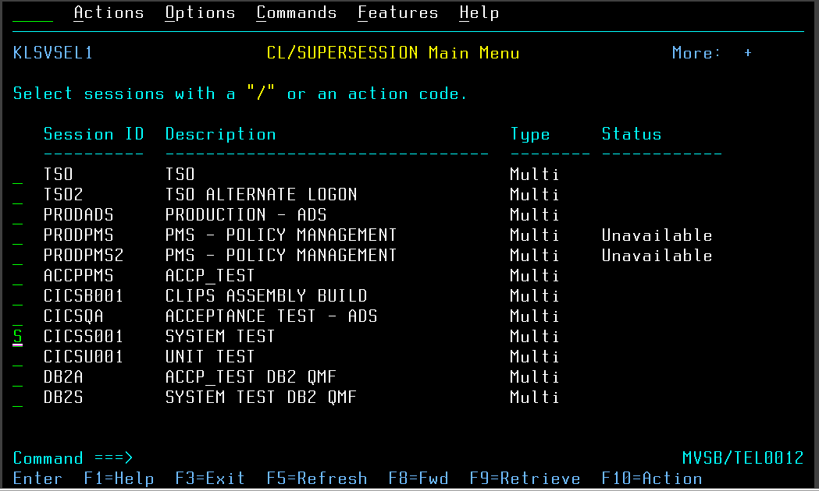

Press ‘8’ at <TESTFILE ID> field and press <Enter>.

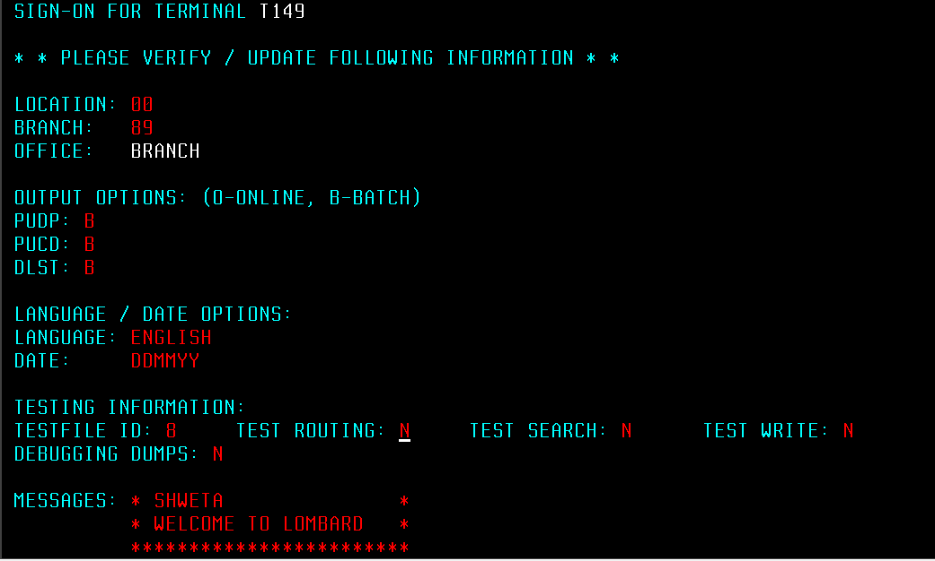

To clear the screen press <Pause/Break> from Keyboard.

From Laptop – select <Show keypad> and select <Clear> to clear the screen.

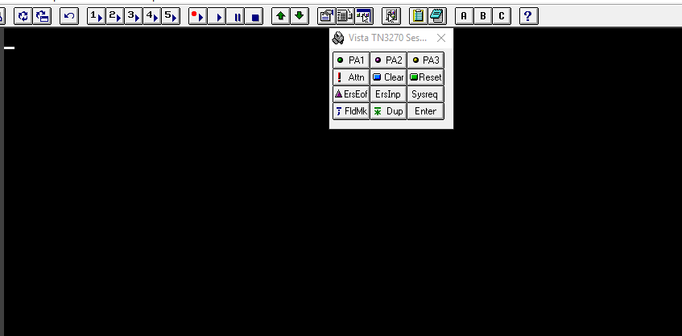

Type <PIBC> Space < > Policy number up to 7th place <7654321> and press <Enter>.

Policy number consist of one alphabet ’P’ followed by eight-digit number.

If the policy number is P87654321, then enter 7654321 as policy number in PMS.

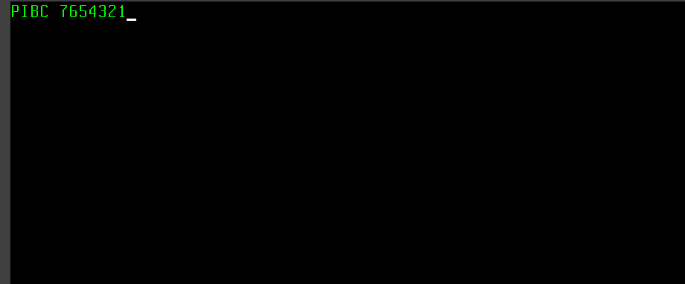

PIBC screen contains basic contract information about Insured and policy such as Insured name, place, address, postal code, policy effective and expiry date, agent number, seven digit customer number etc.

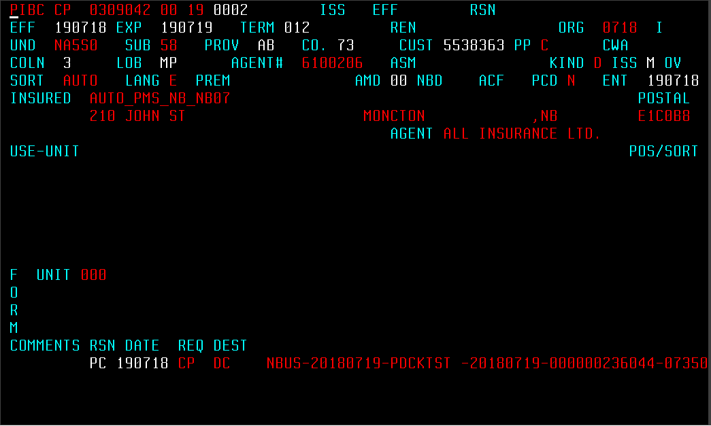

PISA screen contains information of coverages those are selected in Duck Creek. Basically, three lines of business you can see in PMS- property, liability and automobiles.

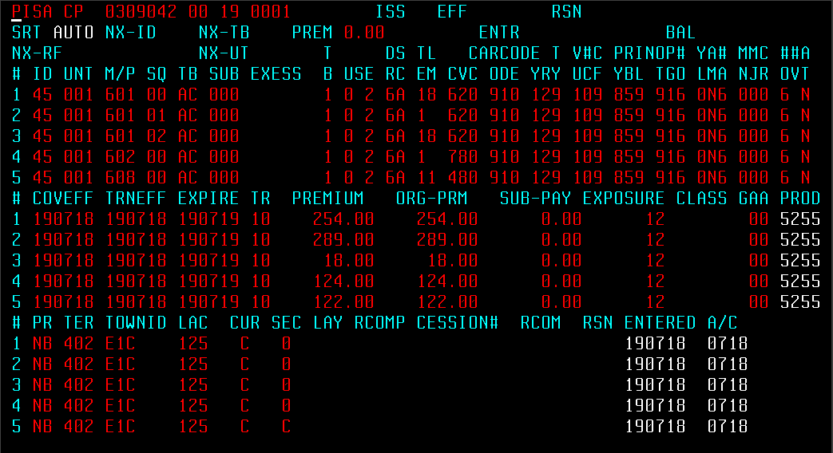

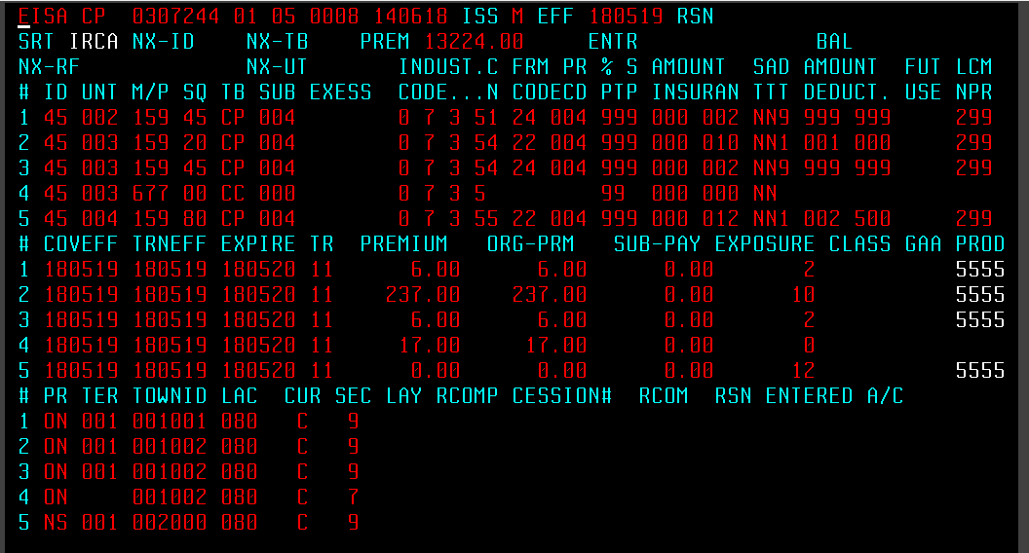

PUIT screen contains information of vehicle and the driver associated to it.

Such as vehicle year, vehicle id, type (private or commercial), driver name, license number etc.

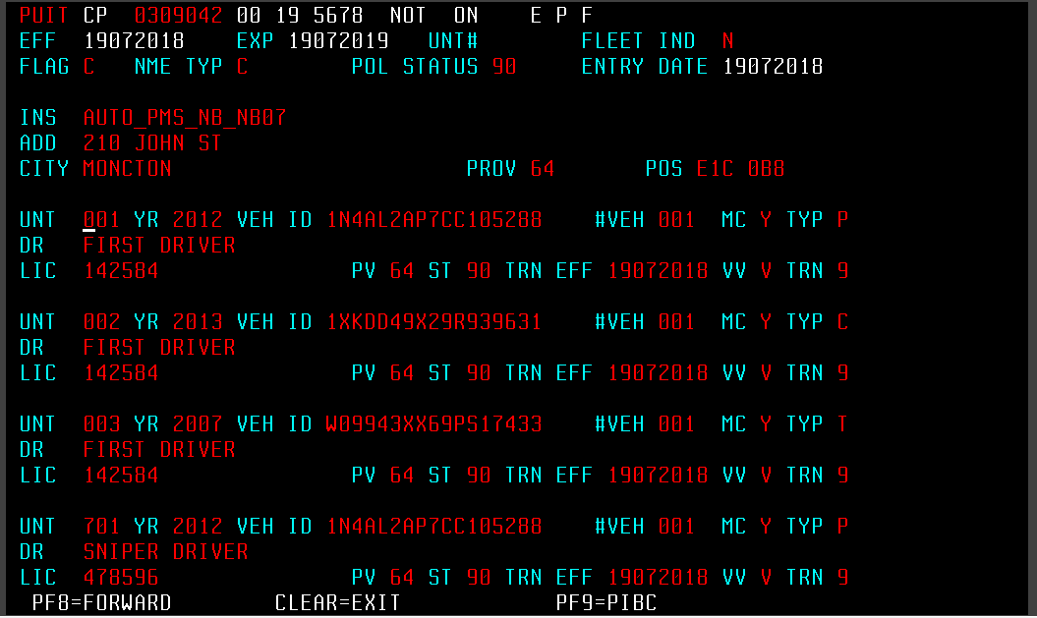

**PISA screen**

**Some important fields are mentioned below for Auto**

**SYMBOL** CBC Business Choice, Manufacturer’s Choice, Farm Choice,

Transportation, Builders’ Choice

CP Duck Creek Policies

**MODULE** 2-digit number. This number shows the number of times policy renewed or reissued.

For New Business Module is 00

For first renew/ reissue Module will be 01

ISS

EFF

ID Identification number. 45 is default.

UNIT 3-digit number. 001 for first vehicle, 002 for second vehicle and

so on

M/P Major Peril. It indicates the type of policy coverage

SQ Sequence number. Each coverage type has a sequence number

which helps to identify the coverage.

* For each coverage, there is a coverage code associated with it. On combining both M/P and SQ it forms a coverage code and thus each Policy coverage has a unique Coverage Code.

TB Type Bureau. It indicates the line of business

e.g.- AC -automobile

LC – liability

CP – commercial property

CP – inland marine

CC - boiler

USE Vehicle use or Vehicle Class. Please refer “Vehicle class mapping

Sheet” for PPV and “IRCA Vehicle class” for CA.

D 2-digit number mapped from Duck-Creek.

R

S Sub Class. It is represented by an alphabet associated to Vehicle

C Class depending on the type of vehicle is used. Example: A, G etc.

L Limits and Deductibles. Refer to CBC auto sheet for Auto.  
M

CV For each coverage there is a coverage code if limits and deductibles are associated to it. For more details please refer to “CBC auto” sheet for Auto.

CODE First four digit of car code is populated in PMS.

For trailer- if trailer price is 1000 then Car Code for Trailer will populated as T001. i.e. T followed by 1st, 2nd and 3rd position number of trailer cost after dividing it by 1000.

YR Vehicle Year. Last two digit of vehicle manufacture year.

Example: if vehicle manufacture year is 2001 then it maps to PMS as 01.

T Type of vehicle

Y PPV - 9 Default

CA - Light - 4

Heavy - 6

Tractor - 8

Trailer - 9

V Vehicle Use. This field is only for Private Vehicle

U PPV- 1 (Pleasure: if % of driving for Business Use = 0)

2 (Commute)

3 (Business)

# Number of Claims. It shows the number of chargeable claims on

C a vehicle. Example: 0, 1, 2, ….., 9 for nine or more claims. Claim date should be 36 months prior from policy effective date. Then only it will consider as a claim.

C Claim free years of Vehicle

F Claim free years depend upon the province and DC logic.

YBL principle driver’s year of birth and years licensed for PPA.

YB – last two digit of the year. E.g.- 2001 will map as 01 in PMS

L - number of years licensed. 0, 1, 2, ..., 9 for nine or more years.

TGO Principal driver’s training, gender and number of operators

T : 0 – no driver training and licensed less than 36 months

1 – driver training and licensed less than 36 months

9 – with or without driver training but licensed more than 36

months

G : 1 - male, 2 - female

O : number of unrated operators.

M Minor conviction

N

M Major Conviction

J

C Critical Conviction (serious conviction)

R

*Above three are the type of convictions. In PMS screen number of convictions will mapped in the respective type of conviction field. Conviction date should be 36 months prior from policy effective date. Then only it will consider as a conviction.

COVEFF Effective Date of the Coverage

TRNEFF Transaction Effective Date on the coverage.

EXPIRE Expiry Effective Date of the Coverage. On this day the coverage

is going to expire.

TR Transaction. It populates the type of transaction done on the

policy coverage.

10 – new business

11 – renewal

12 – endorsement

15 – reinstate

20 – flat cancellation

23 – pro rate cancellation

PREMIUM This is the final premium generated after calculating flex,

Discount or surcharge.

ORG-PRM Original Premium is same as Premium for new business. But on

performing any transaction, premium will change. And the

difference of the premium changed will reflect on PMS as

Original Premium.

SUB-PAY default value is 0.00

EXPOSURE For auto it shows the number of months

CLASS Default fields

GAA Default fields

PROD 5255 for monoline Auto policy and 5555 for packaged policy

PR Province code

AB - Alberta

NB - New Brunswick

NL – Newfoundland and

NS – Nova Scotia

ON - Ontario

PE – Prince Edward Island

PQ - Quebec

TER Territory. For each TOWNID there is a territory code. For more

For more detail please refer to “Stat terr mapping” sheet.

TOWNID It is a postal code

LAC Commission.

If commission % = 12.5 then 125 will populate in PMS.

CUR Currency (Canadian or US)

RSN Reason code. It populates the type of transaction done on the

Coverage.

AC - Add Coverage

DC – Delete Coverage

CC – Change Coverage

PIO – Flat Cancel

PRW – Cancel and Replace

OY - Reinstatement

ENTERED DDMMYY policy request date for new business or transaction.

A/C MMYY It is the month and year when accounting on the respective

coverage is going to effect.

**PUIT SCREEN**

INS Insured name

ADD Address of Insured

CITY Insured City

PROV Province Code

POS Postal Code

UNIT Unit Number

YR Vehicle Manufactured Year

VEH ID Vehicle Identity Number (VIN)

#VEH Number of Vehicle. It is the sequence number of the vehicle in

policy.

MC

TYP Type of Vehicle

P – Private Vehicle

C – Commercial Vehicle

DR Driver’s name

LIC License Number of the Driver

PV Province Code

ST

TRN EFF Transaction Effective Date

VV

TRN