- Copy .pem file from local to Ansible Master server
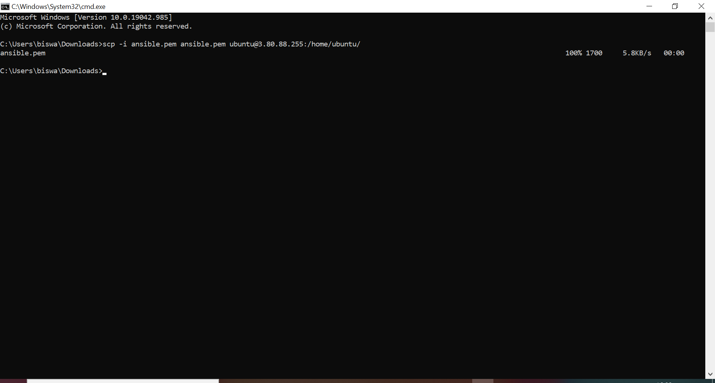

- Changed host name
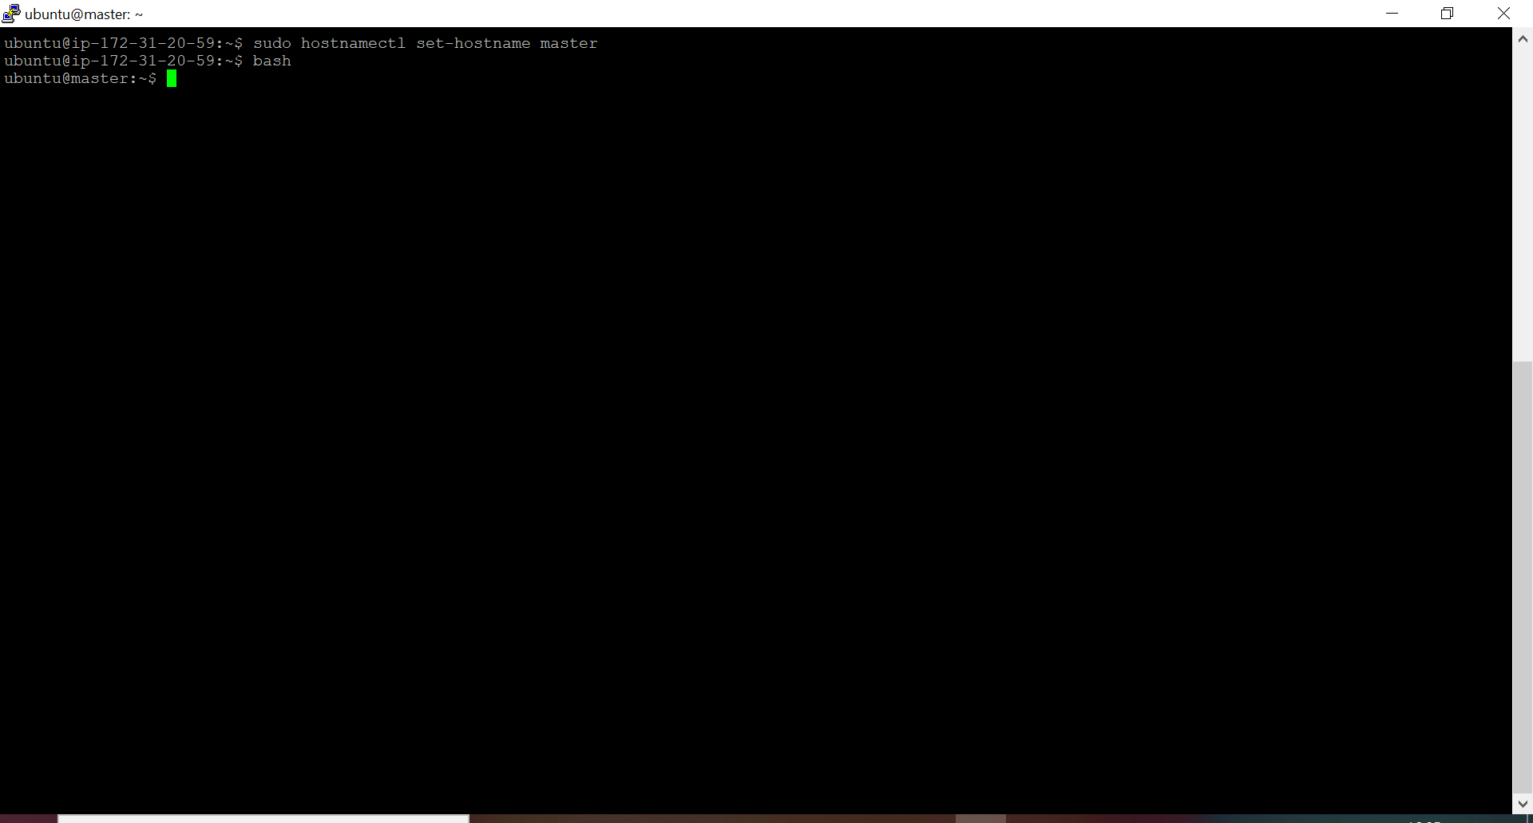

- long listing of files
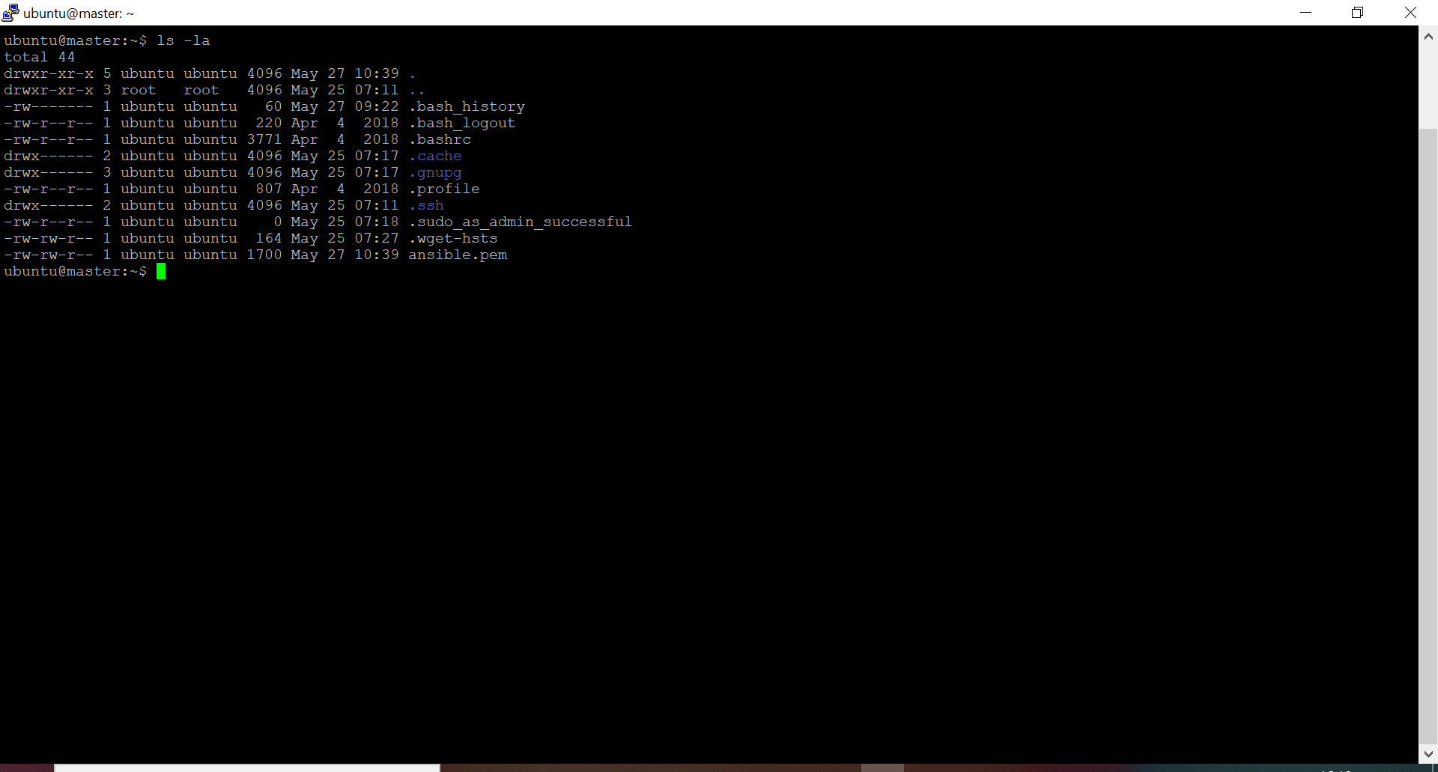

- Start ssh service and add ssh-agent
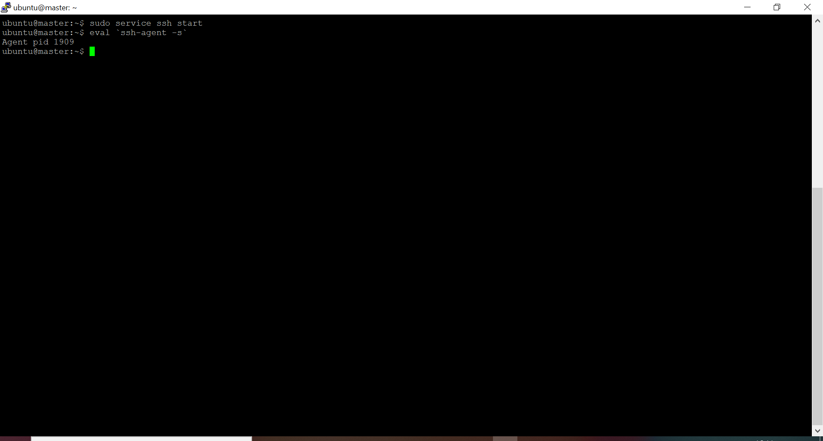

- Change read-write permission of .pem file and change permission of users to /home/ubuntu folder
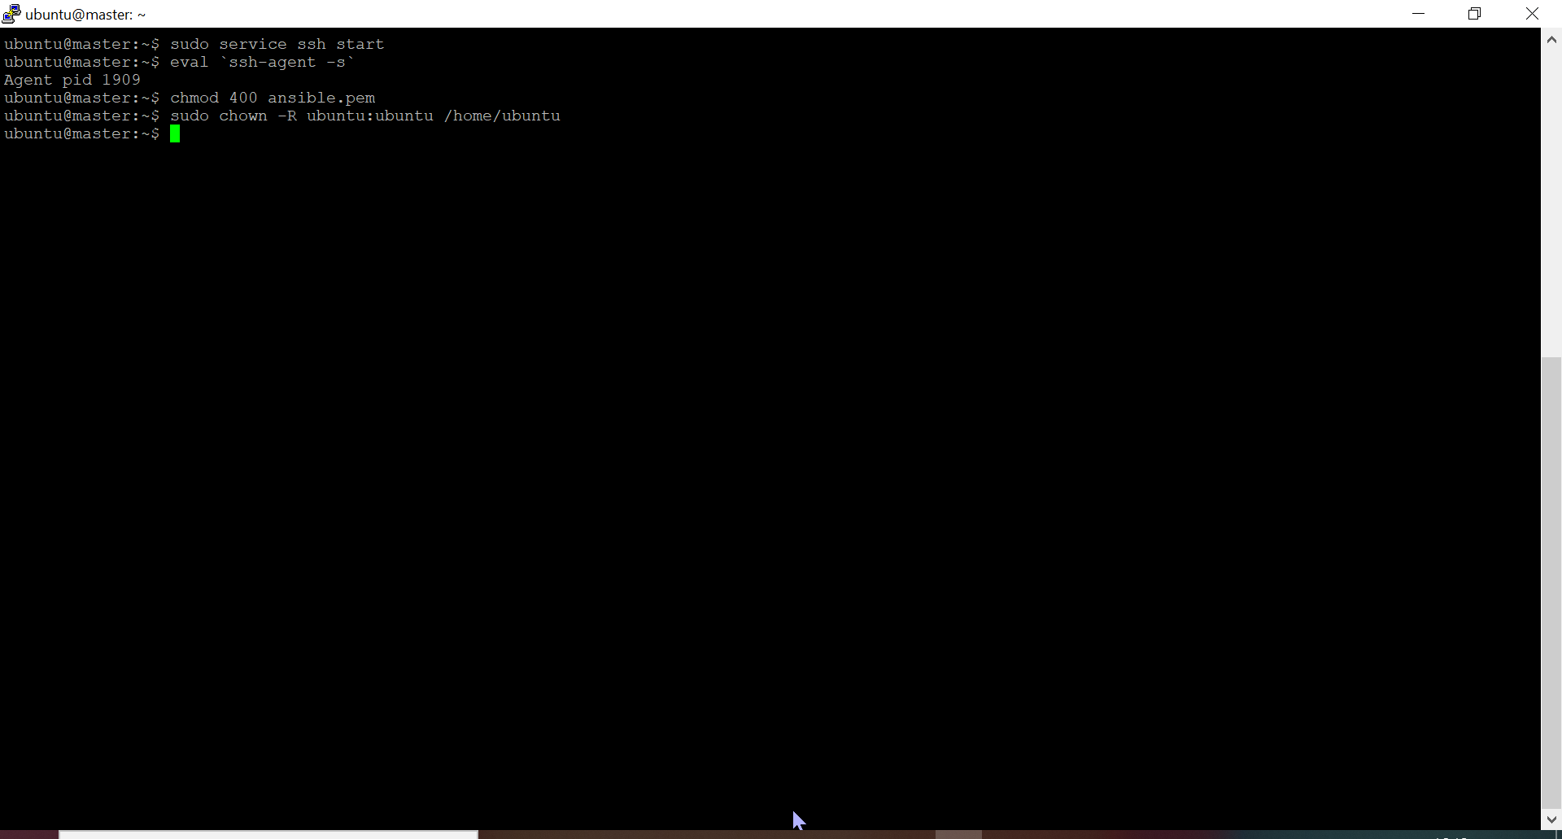

- Abled to logging into Client machine using ssh
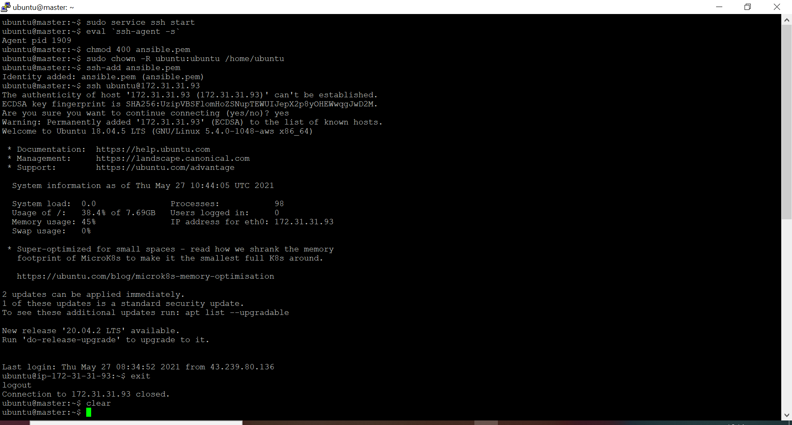

- Added the following 2 lines to .bashrc of Master
  - eval `ssh-agent -s`
  - ssh-add ansible.pem
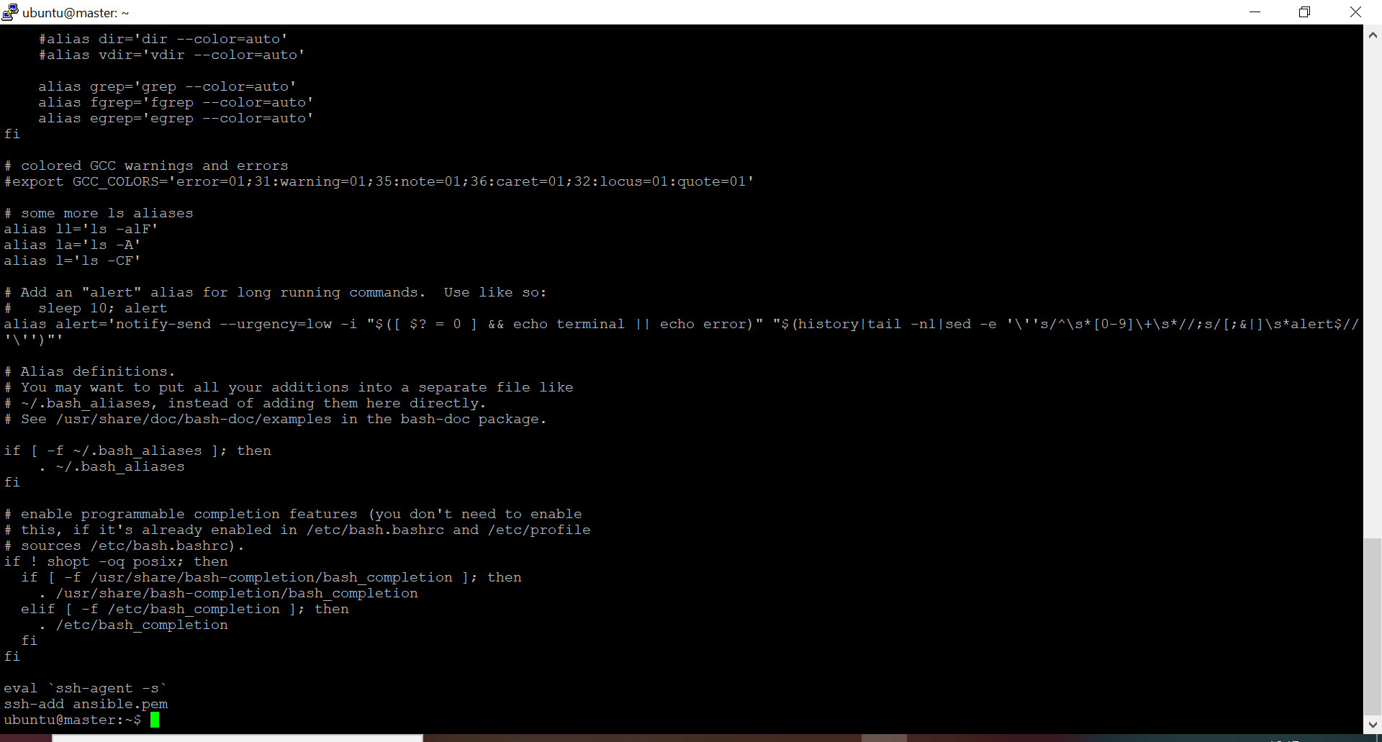

- Installed Ansible
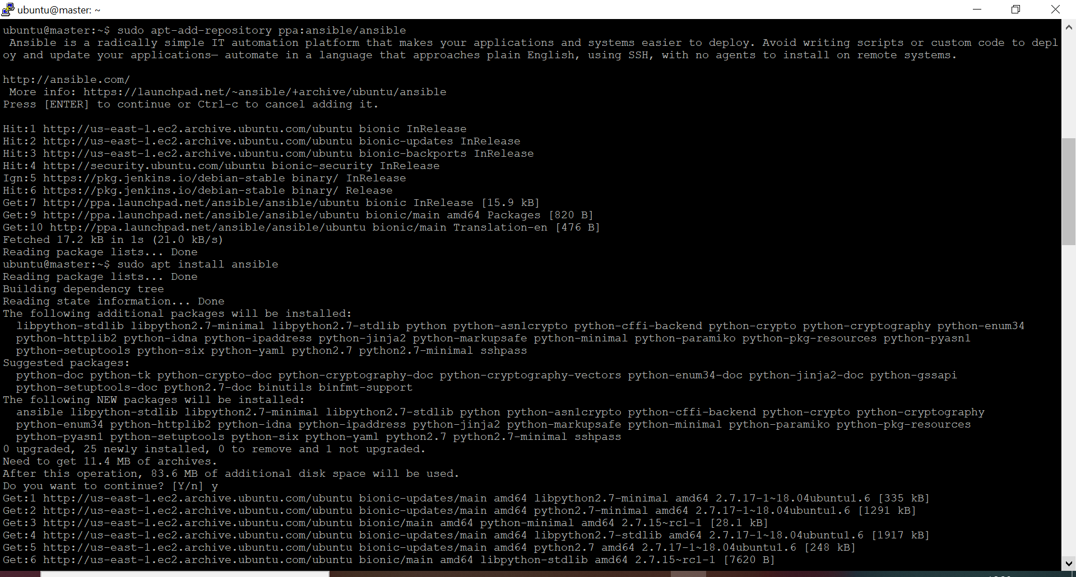

- Added private ip of client machine in /etc/ansible/hosts file
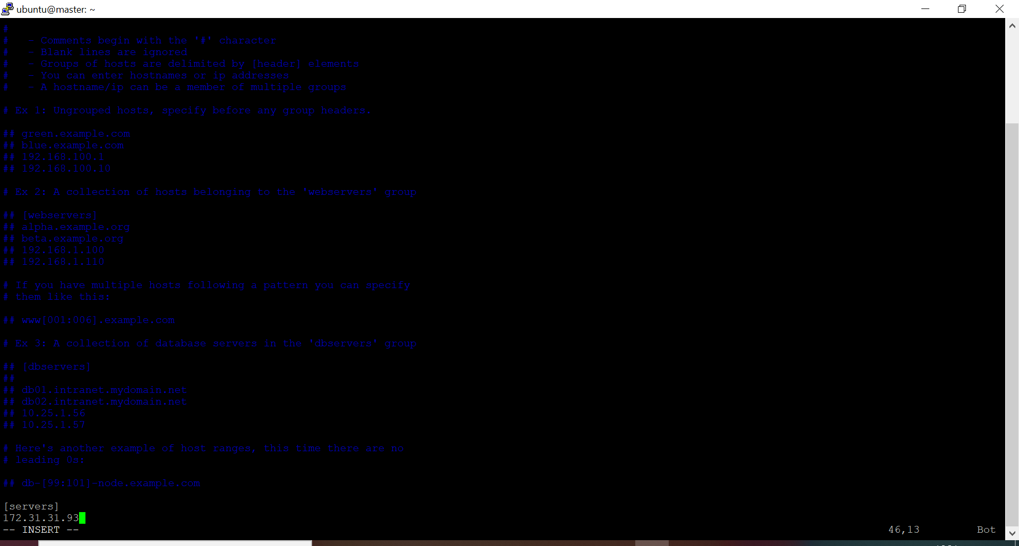

- Pinged Client machine from Master using ansible ping command
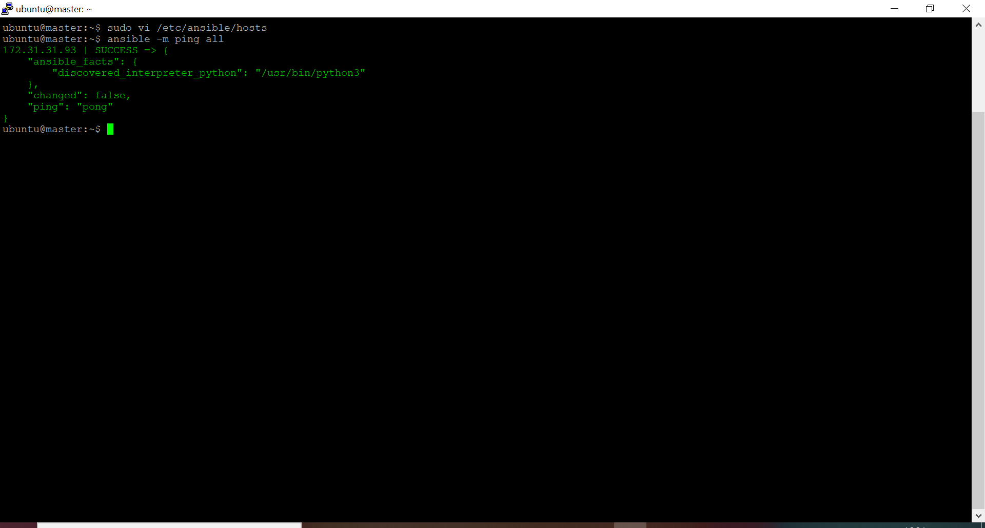

- Created playbook to install packages and to run docker image
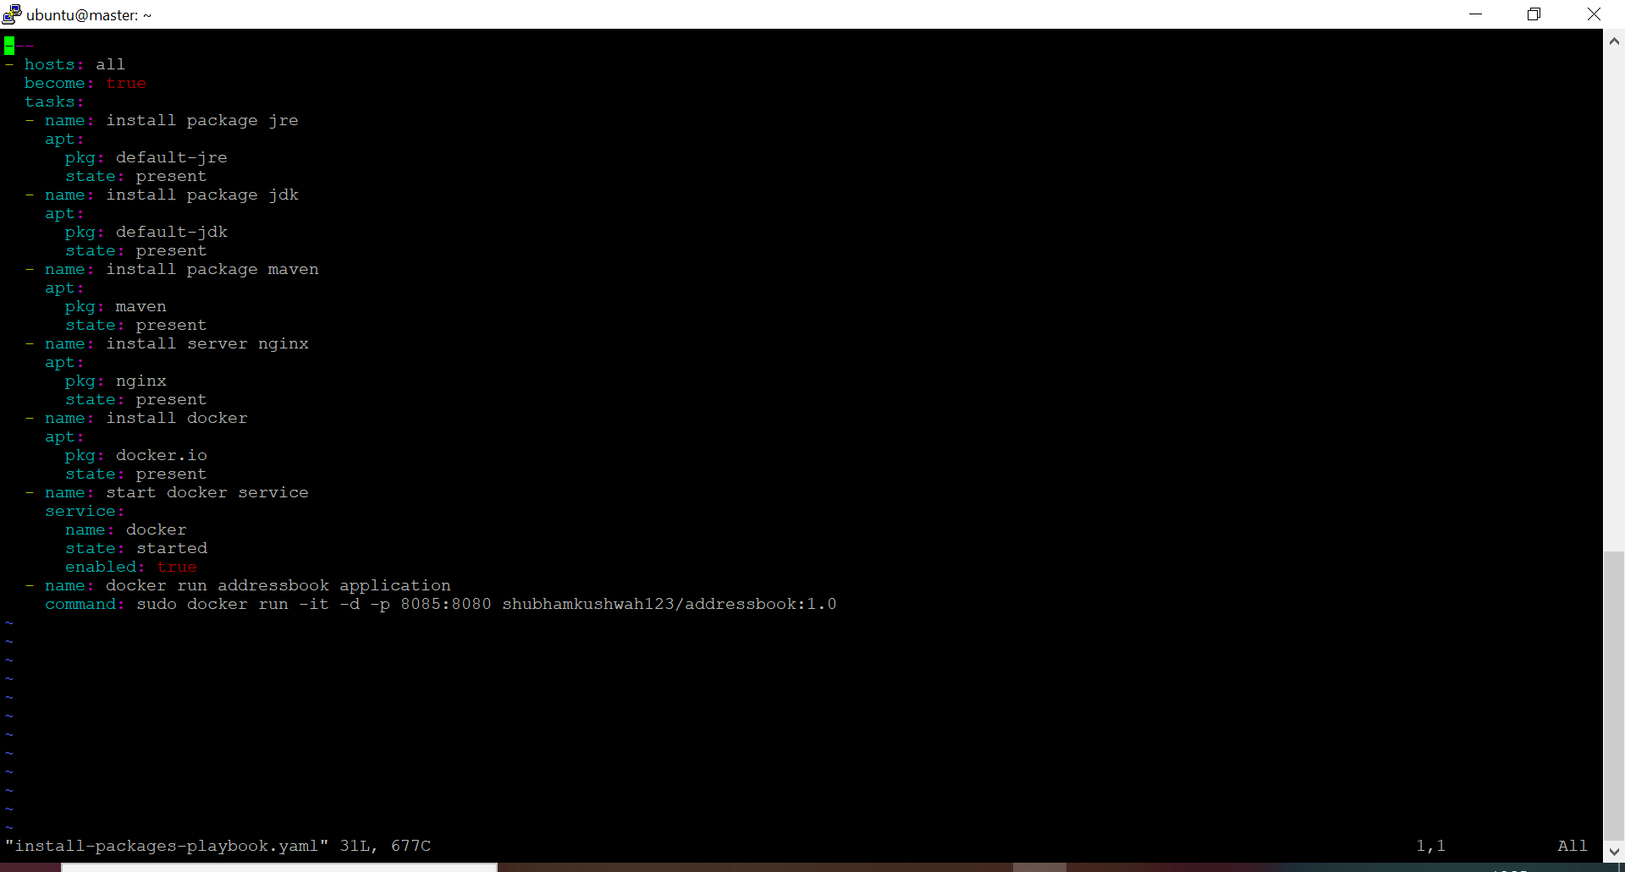

- Ran playbook
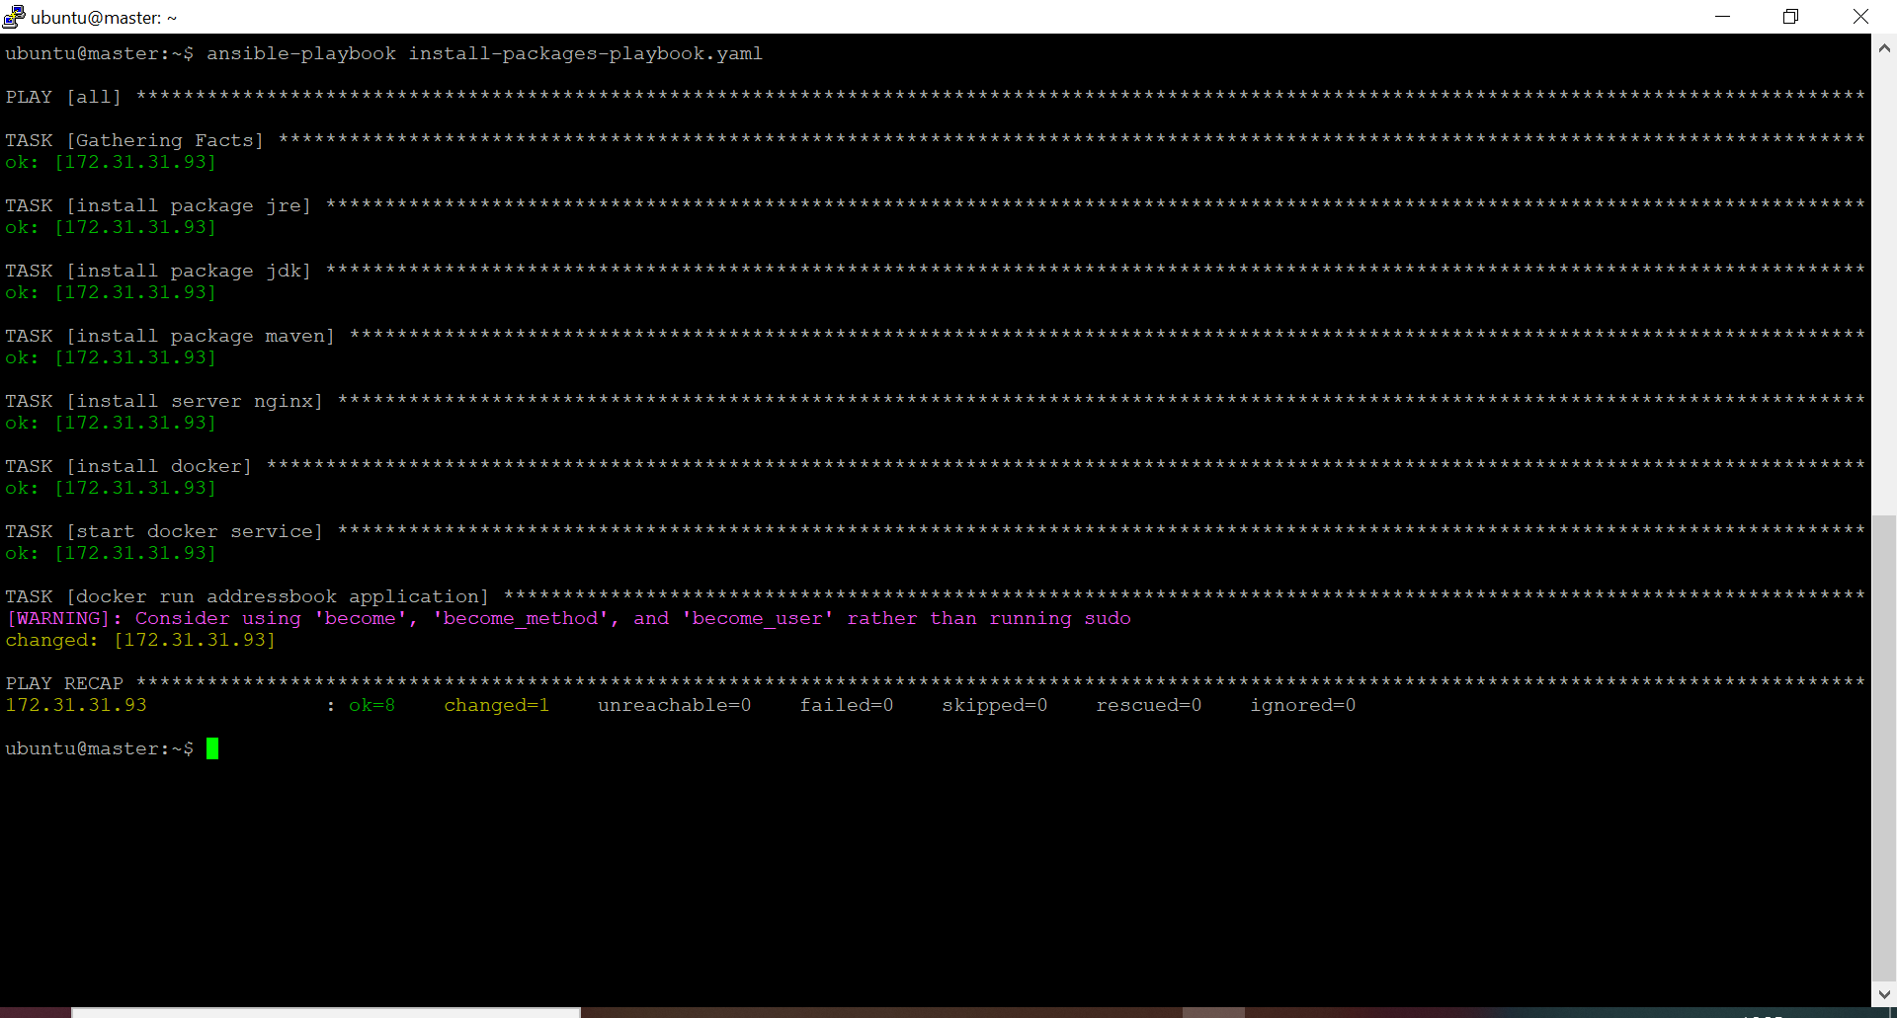

- Accessed the site from Client’s public ip
