Assignment – 1

- Creating Docker file
  - From base image nginx with latest tag
  - add index.html to /usr/share/nginx/html directory
  - expose port 8080 to get accessed from outside (browser)
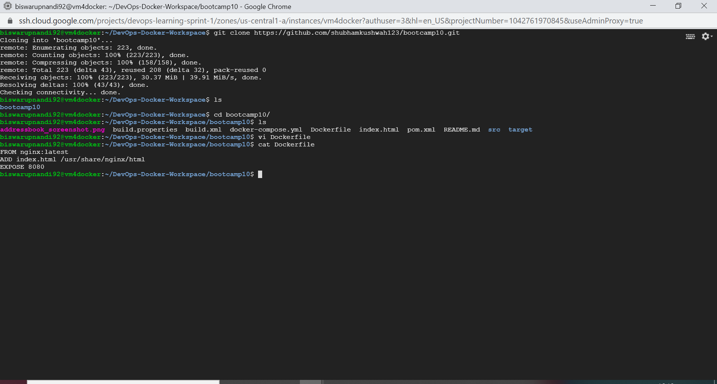

- Building image (biswa539/nginx-index:1.0.1) using docker build command
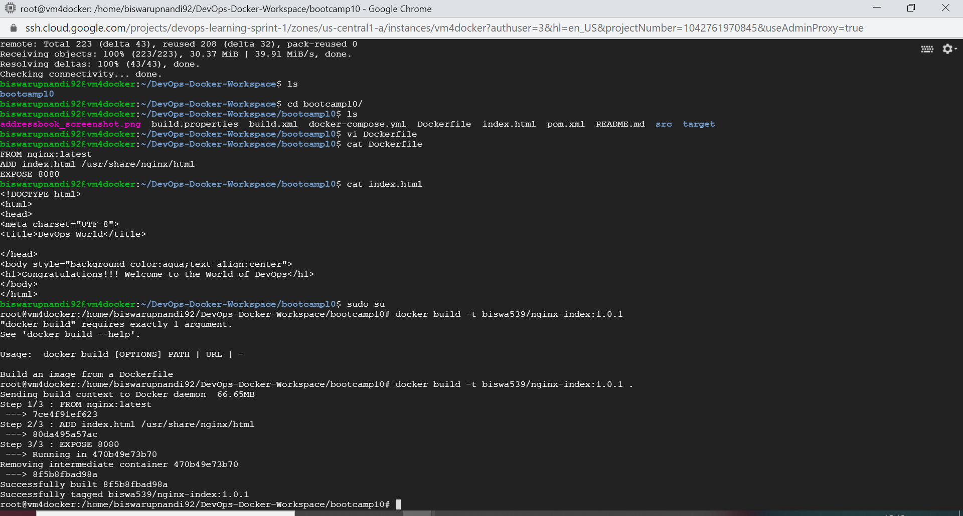

- Logging into docker using docker login command and pushed the image to docker hub using docker push command
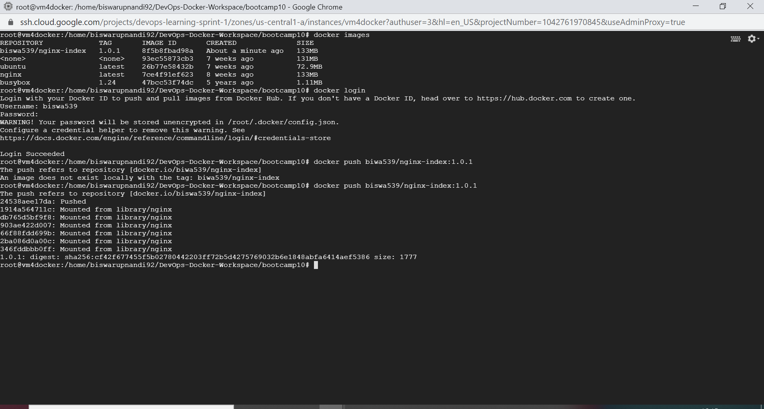

- Checking whether the image has been pushed successfully
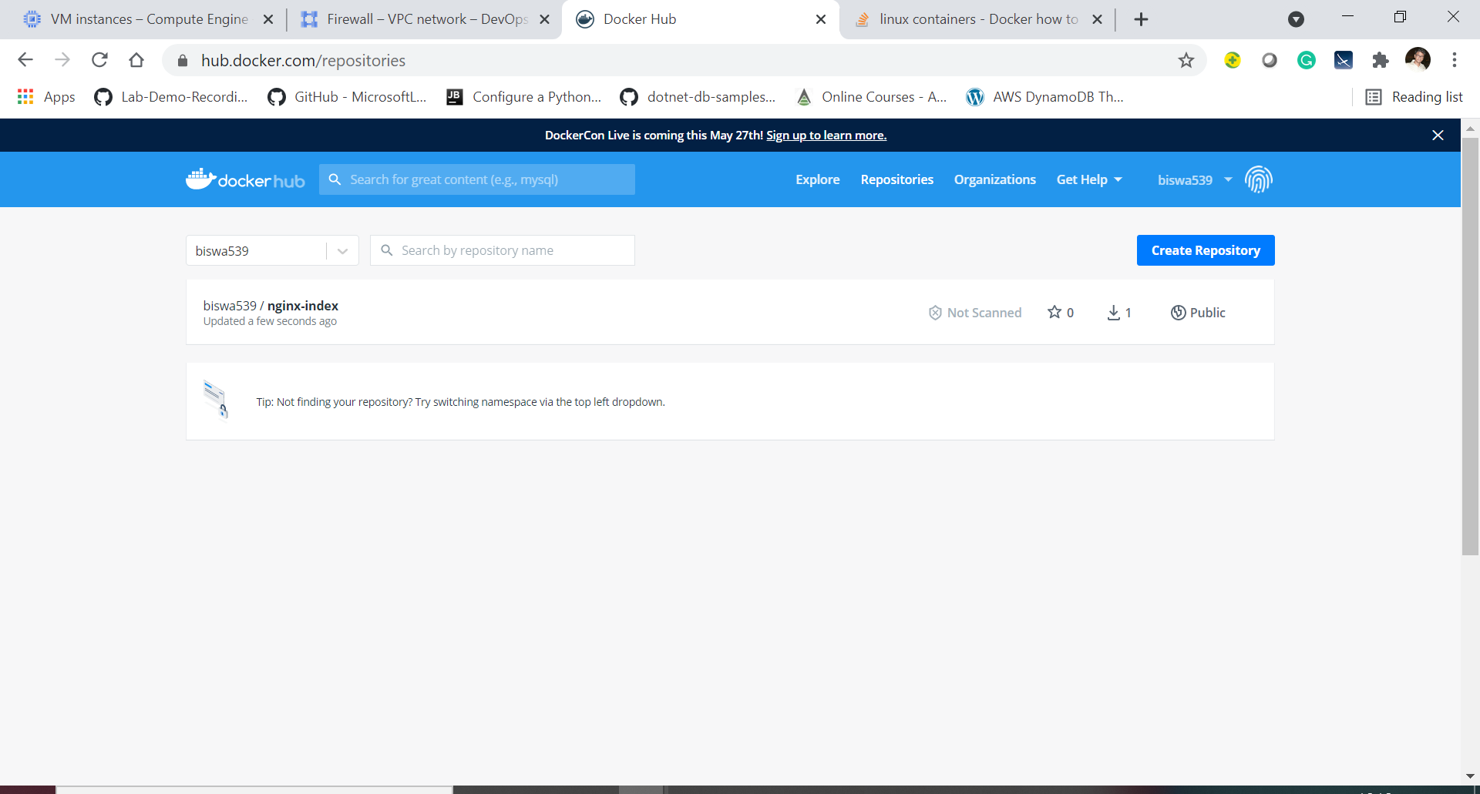

- Deleted images from local
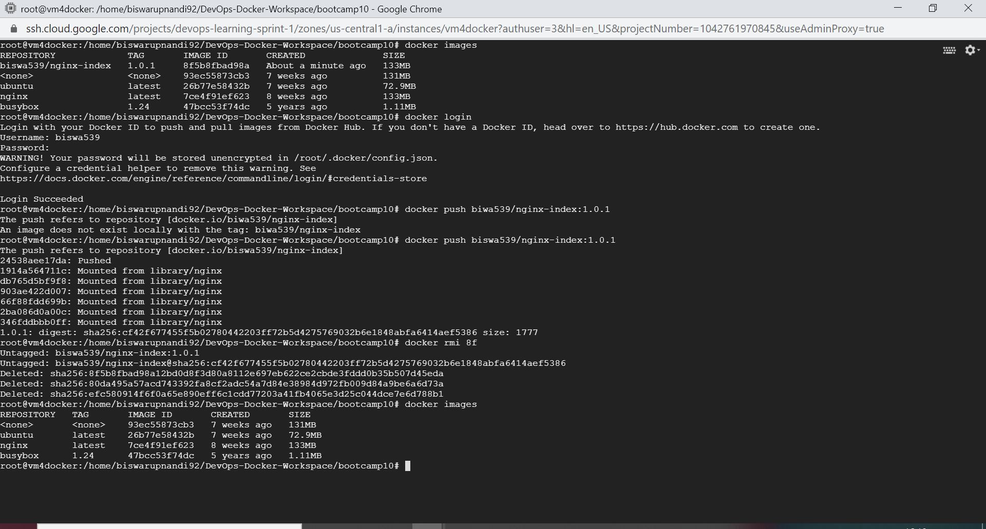

- Logged in to separate VM and pull the image from docker hub
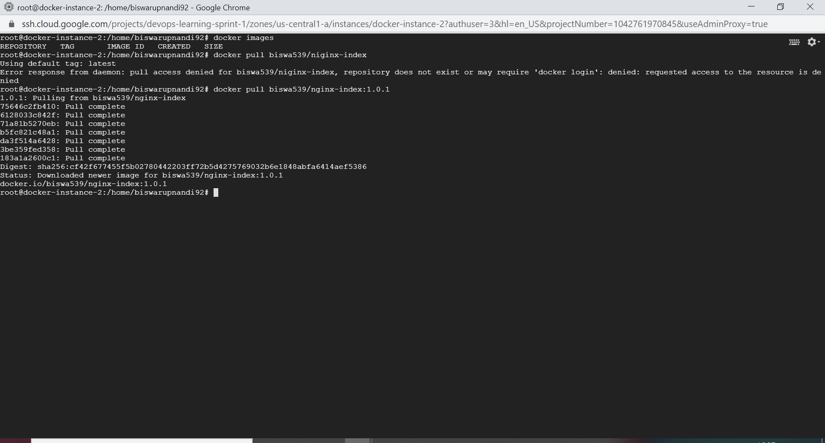

- Run the image using port mapping (8080:80) using docker run command
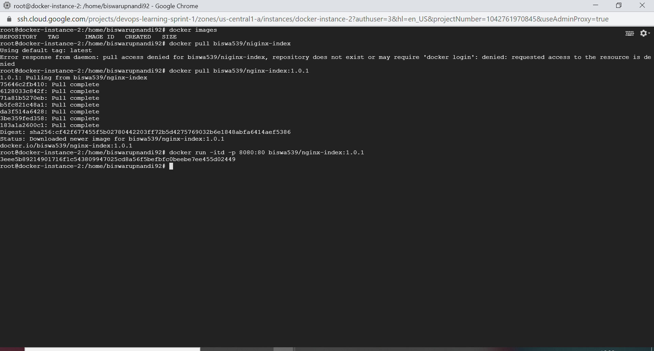

- Page is opening
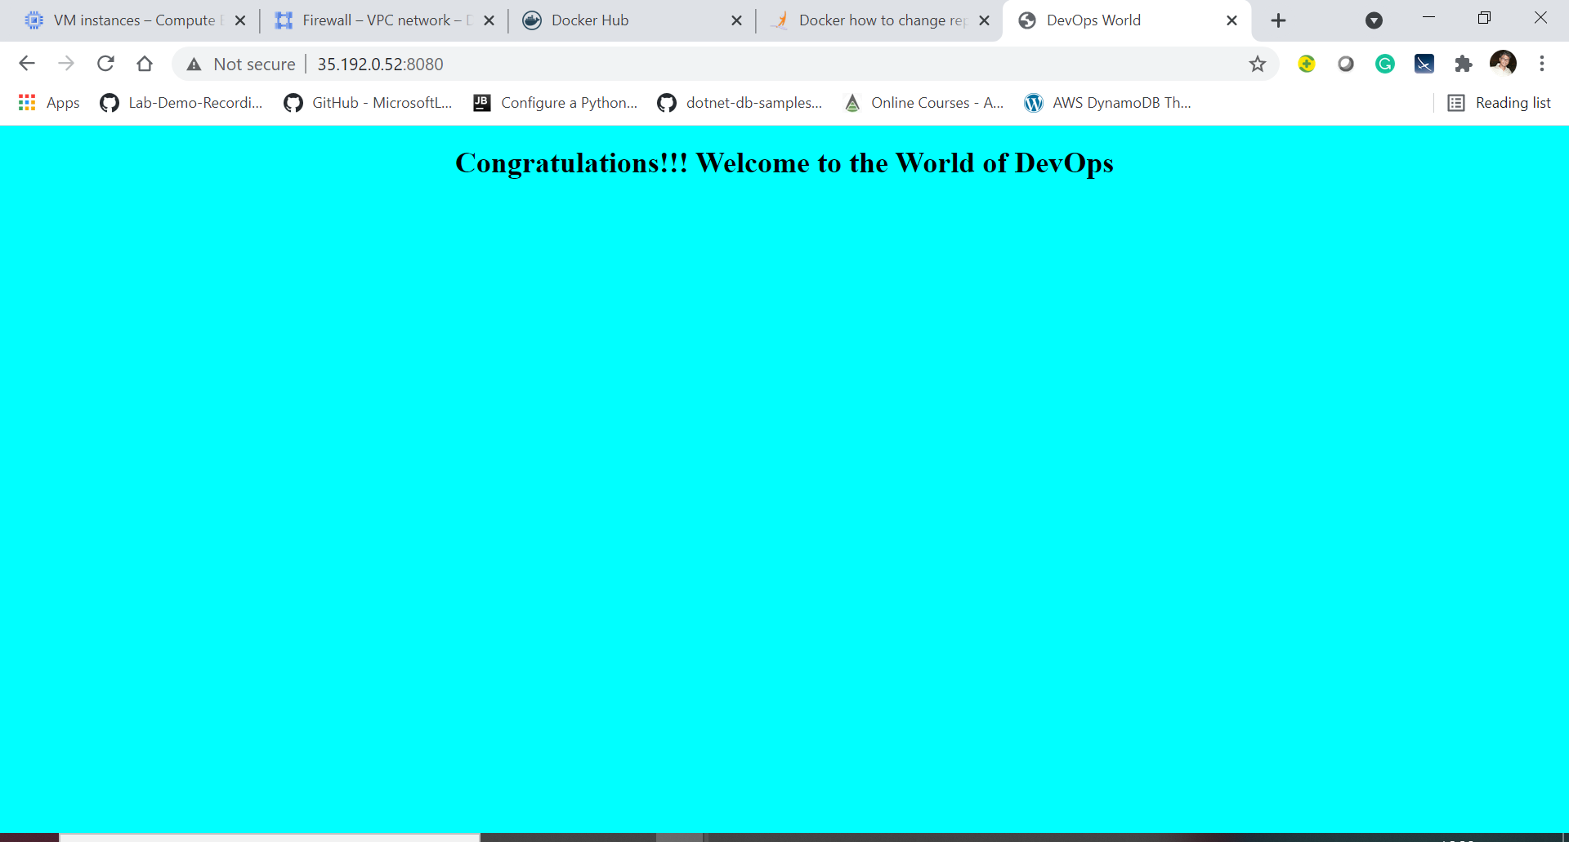

Assignment – 2

- Created 2 services in docker-compose.yml
  - pull biswa539/nginx-index:1.0.1 from docker hub and port mapped 8080:80
  - pull mysql:lates from docker hub, port mapped 3306:3306, set environment for username and password
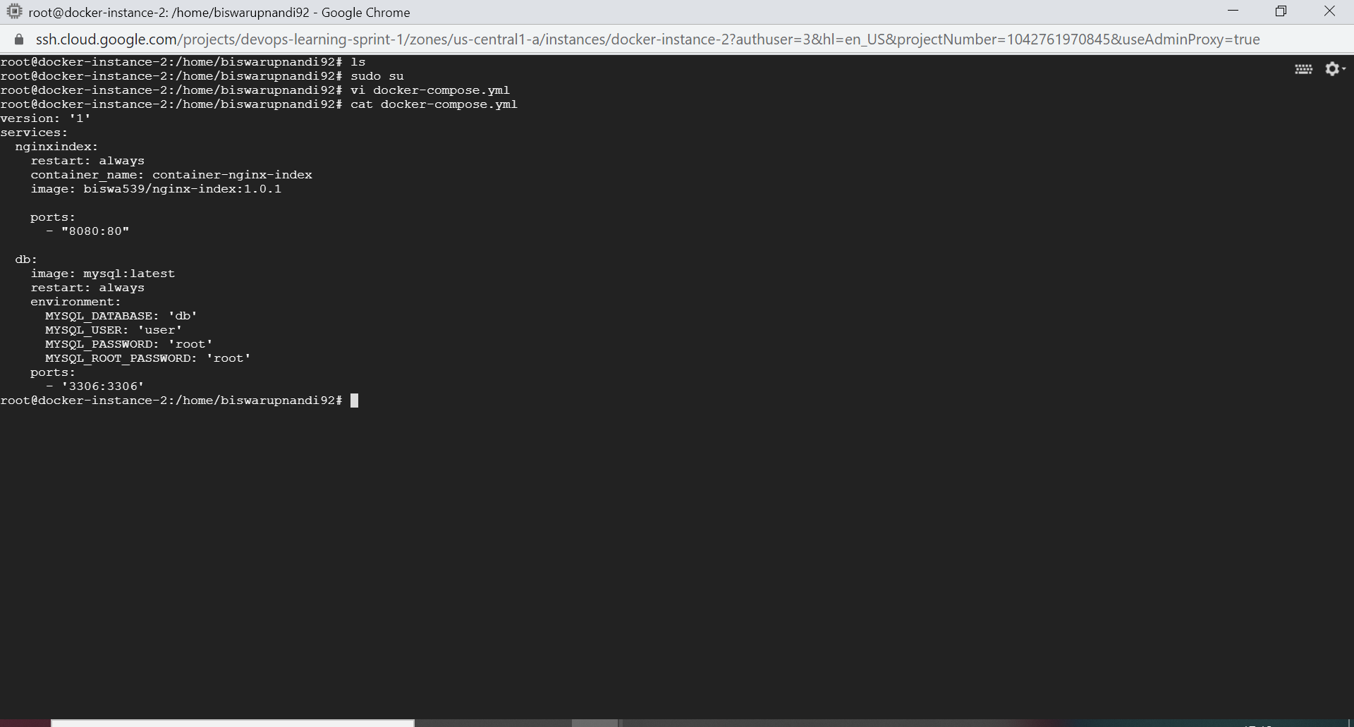

- Fixed version name issue
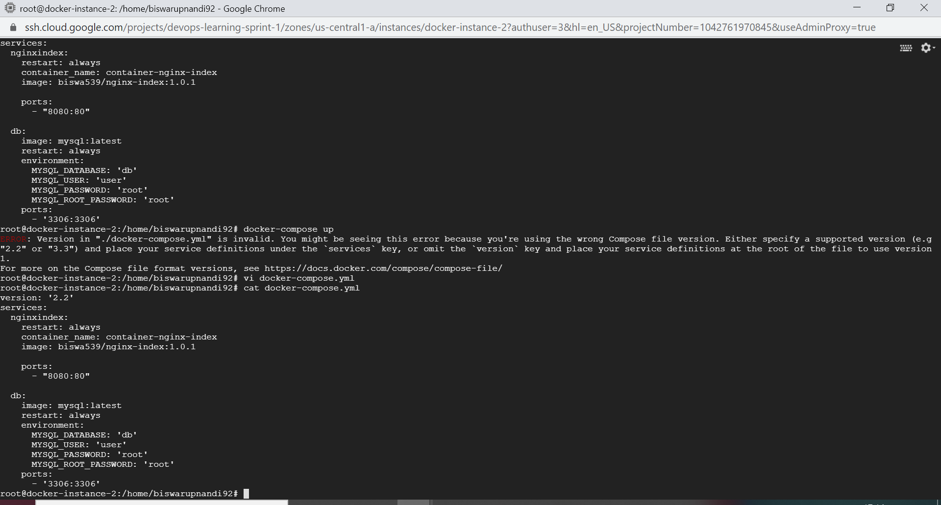

- Ran docker-compose up command to up the services
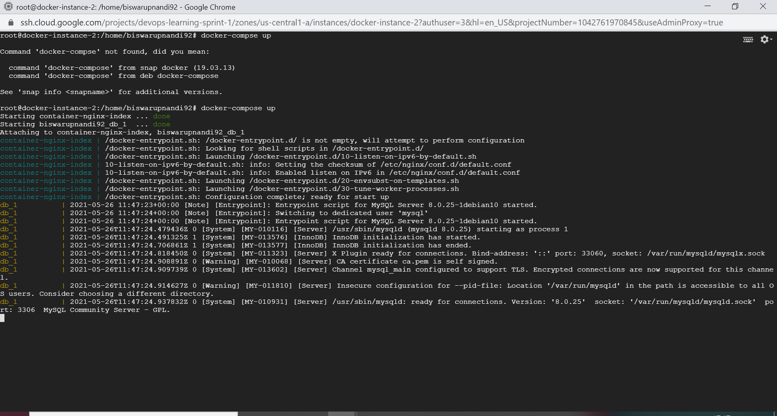

- Containers for biswa539/nginx-index:1.0.1 and mysql:latest are running
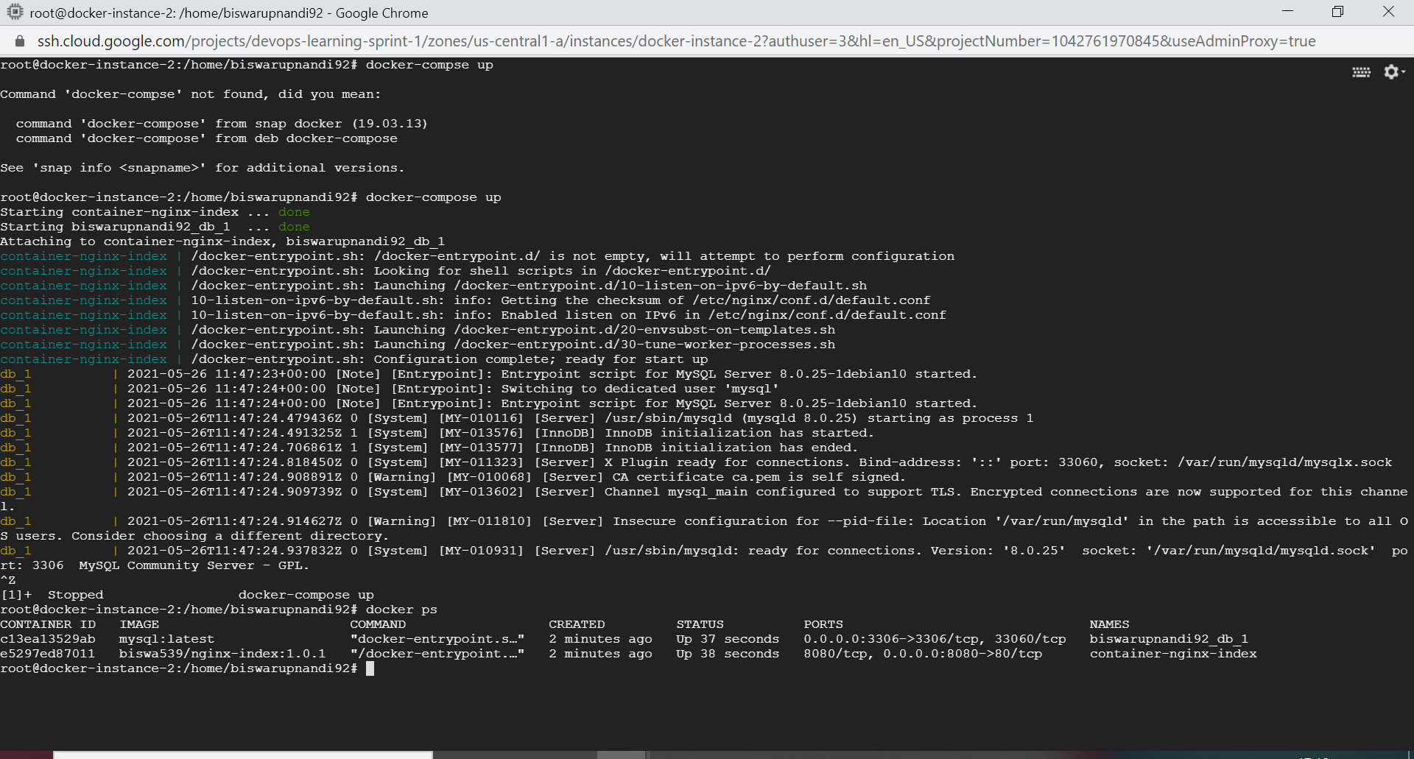

- Web application in nginx is running in port 8080
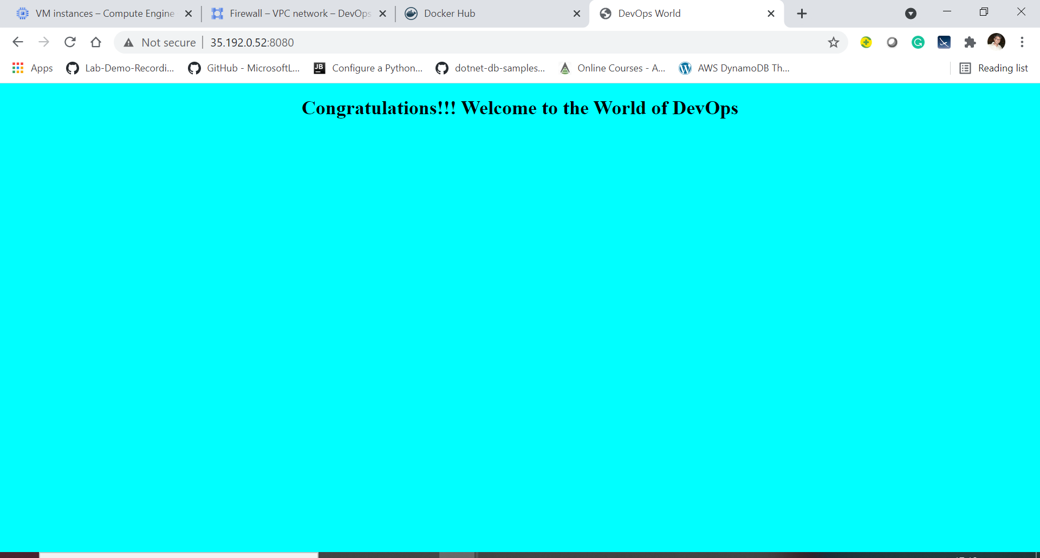

- Executed mysql container bash
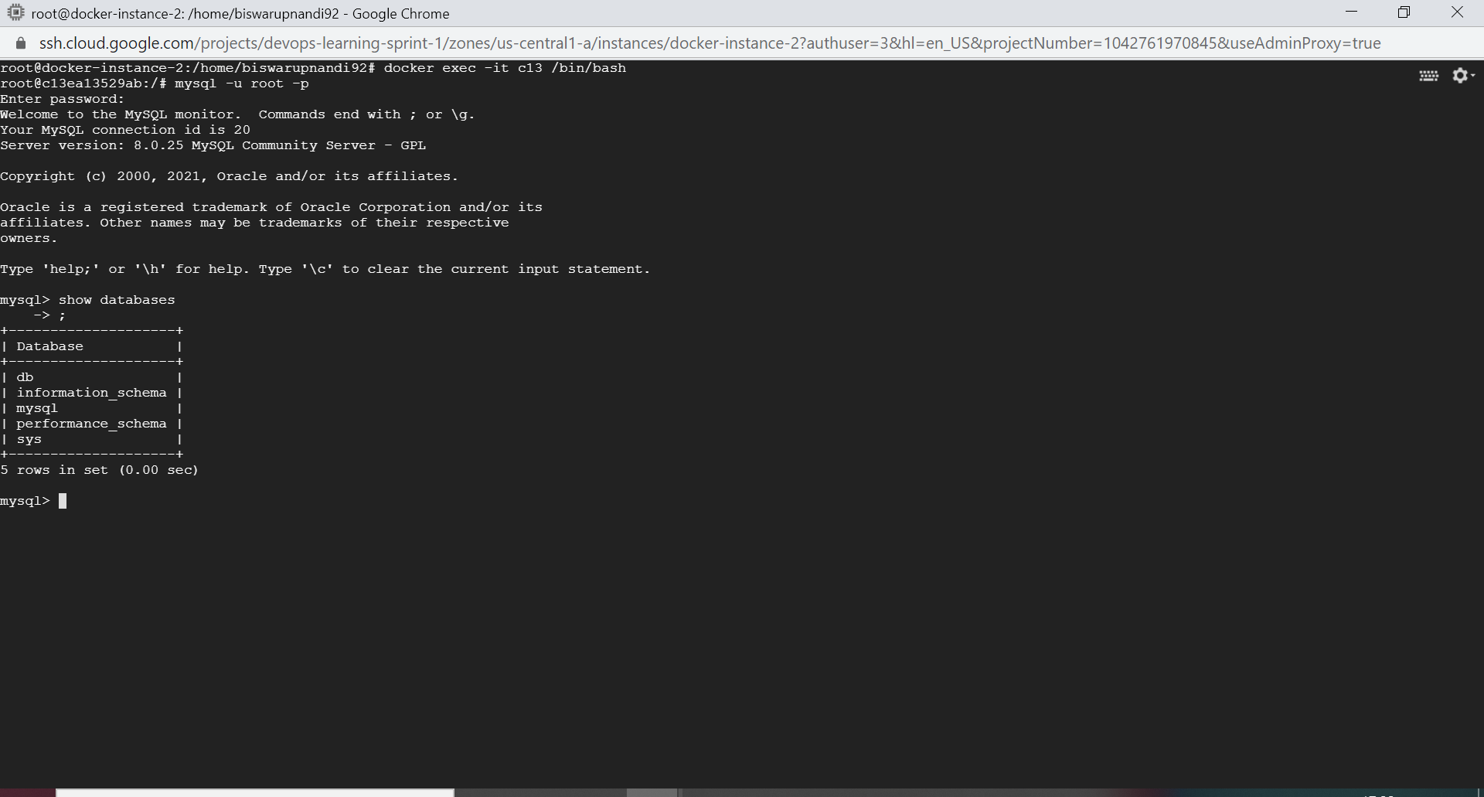

- Ran few DB commands
