Early Risk Signals - Credit Card Delinquency Watch
Complete System Documentation
Submitted By: Biswanath Tudu
Roll. No: AEC.24

Documentation Contents:

Documentation Contents: 2
1. Executive Summary 3
2. Project Structure & Architecture 4
3. API Documentation 5
4. Risk Signals & ML Model 6
6. Dashboard Features 8
7. Configuration Management 9
8. Developer Guide 10
9. Architecture & Design Patterns 11
10. System Architecture 12
11. Data Pipeline 12
12. Support & Additional Resources 13
Conclusion 14

1. Executive Summary

The Credit Card Delinquency Watch system is a comprehensive machine learning solution designed to predict and monitor credit card delinquency risk. The system has been restructured from a monolithic architecture to a scalable, modular 3-layer design with clear separation of concerns.

Key Features:
- Gradient Boosting ML model with 5 engineered behavioral signals
- Real-time risk scoring and portfolio analysis
- RESTful API endpoints for flexible integration
- Interactive web dashboard with 3 analytical tabs
- Centralized configuration for easy parameter management
- Comprehensive documentation for team collaboration

Technology Stack:
- Backend: FastAPI, scikit-learn, pandas, numpy
- Frontend: HTML5, CSS3, JavaScript, Chart.js
- Configuration: Pydantic for data validation

2. Project Structure & Architecture

Folder Organization:
The system is organized into three main layers following the separation of concerns principle:

Backend Layer (backend/app/)
- core/ - Core ML and data processing
  - config.py: Centralized configuration (20+ parameters)
  - data_loader.py: Data loading and feature engineering
  - model_trainer.py: ML model training and predictions

- api/ - REST API endpoints
  - routes.py: 8 endpoints with dependency injection

- services.py - Business logic layer
  - RiskScoringService
  - InterventionService
  - CustomerService

- models/ - Data validation schemas
  - Pydantic models for request/response validation

- main.py - Application factory and initialization

Frontend Layer (frontend/public/)
- index.html: Interactive dashboard with 3 tabs (600 lines)
  - Dashboard tab: Portfolio statistics and visualizations
  - Customers tab: Customer search and filtering
  - Scoring Tool: Individual customer risk assessment

Configuration & Entry Points
- run.py: Main entry point for starting the application
- requirements.txt: Python package dependencies

Documentation (docs/)
- 8 comprehensive markdown guides covering all aspects
- Architecture diagrams and design patterns
- Setup, deployment, and developer guides

3. API Documentation

The system provides 8 RESTful endpoints for portfolio analysis, customer scoring, and intervention recommendations. All endpoints are accessible at http://localhost:8000/api/v1/

Endpoint | Method | Purpose
/portfolio-summary | GET | Overall portfolio statistics
/signals | GET | Risk signal effectiveness analysis
/feature-importance | GET | ML model feature importance
/risk-distribution | GET | Risk tier distribution
/score-customer | POST | Score individual customer
/customers | GET | List all customers with scores
/dashboard-stats | GET | Complete dashboard statistics

API Features:
- Automatic Swagger/OpenAPI documentation at /docs
- CORS enabled for cross-origin requests
- Dependency injection for service abstraction
- Pydantic validation for request/response data
- Comprehensive error handling
- Health check endpoint at /health

4. Risk Signals & ML Model

The system uses 5 engineered behavioral signals to predict delinquency risk. These signals are derived from customer spending patterns and are normalized before being fed into the ML model.

ML Model Details:
- Algorithm: Gradient Boosting Classifier
- Parameters: n_estimators=100, learning rate=0.1
- Features: 5 engineered behavioral signals
- Output: Delinquency probability (0-1 range)
- Risk Classification: HIGH (3), MEDIUM (2-2.99), LOW (<2)

5. Quick Start and Setup Guide

Local Development Setup (5 minutes):

# Step 1: Create Virtual Environment
Python -m venv .venv

#Step 2: Activate Virtual Environment
Windows: .venv\Scripts\activate
Linux/Mac: source .venv/bin/activate

# Step 3: Install Dependencies
pip install -r requirements.txt

# Step 4: Run Application
python run.py

# Step 5: Access Dashboard
Open browser: http://localhost:8000

# Step 6: View API Documentation
Visit: http://localhost:8000/docs

Common Tasks:

Change Risk Threshold:
Edit backend/app/core/config.py  RISK_HIGH_THRESHOLD

Add New Signal:
- Add to data_loader.py engineer_signals() method
- Define threshold in config.py
- Retrain model

View API Docs:
Navigate to http://localhost:8000/docs in browser

6. Dashboard Features

Tab 1: Portfolio Dashboard
  - Total customers and delinquency rate
  - Risk tier distribution (pie chart)
  - Score distribution (bar chart)
  - Key performance indicators

Tab 2: Customer Management
  - Search customers by ID or name
  - Filter by risk tier (HIGH, MEDIUM, LOW)
  - View detailed customer information
  - Sort by risk score

Tab 3: Risk Scoring Tool
  - Input customer metrics (spending, utilization, etc.)
  - Real-time risk calculation
  - Detailed risk assessment report
  - Signal contribution analysis

7. Configuration Management

All system parameters are centralized in backend/app/core/config.py for easy management without modifying code. Key configuration areas:

Risk Thresholds:
  - RISK_HIGH_THRESHOLD = 3.0
  - RISK_MEDIUM_THRESHOLD = 2.0

Signal Thresholds:
  - SPEND_DECLINE_THRESHOLD = -10%
  - UTILIZATION_THRESHOLD = 80%
  - PAYMENT_DECLINE_THRESHOLD = -50%
  - CASH_SURGE_THRESHOLD = 30%

Intervention Costs:
  - High-risk intervention: $20
  - Medium-risk intervention: $7.50
  - Low-risk intervention: $0.50

Model Parameters:
  - n_estimators = 100
  - learning_rate = 0.1

8. Developer Guide

Adding a New Signal:
- Define signal calculation in data_loader.py
- Add threshold to config.py
- Include in engineer_signals() method
- Update feature list in model_trainer.py
- Retrain model

Adding a New API Endpoint:
- Create service method in services.py
- Add route in api/routes.py
- Define Pydantic models if needed
- Update API documentation
- Test with /docs interface

Updating the Dashboard:
- Modify frontend/public/index.html
- Update JavaScript functions for API calls
- Add Chart.js visualization if needed
- Test in browser at http://localhost:8000

Code Style Guidelines:
  - Follow PEP 8 conventions
  - Use type hints for functions
  - Write docstrings for modules and classes
  - Keep functions focused (single responsibility)
  - Use configuration for magic numbers

9. Architecture & Design Patterns

Modular 3-Layer Architecture:

Layer 1 - API Routes (api/routes.py)
Handles HTTP requests and responses. Uses FastAPI for automatic documentation and dependency injection.

Layer 2 - Services (services.py)
Implements business logic. Three service classes isolate different concerns:
  - RiskScoringService: Portfolio and individual scoring
  - CustomerService: Customer data management

Layer 3 - Core (core/)
Manages data processing and ML operations:
  - config.py: Configuration management
  - data_loader.py: Feature engineering
  - model_trainer.py: Model training and predictions

Design Patterns Used:
  - Dependency Injection: Services receive dependencies in init
  - Factory Pattern: create_app() and create_routes() functions
  - Separation of Concerns: Each module has single responsibility
  - Configuration Management: Centralized config.py
  - Data Validation: Pydantic models for request/response

10. System Architecture

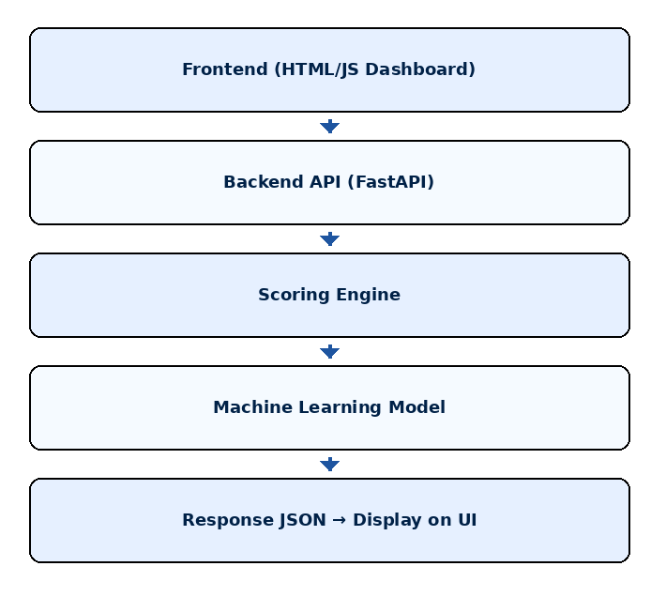

Components:
- Frontend Dashboard – User inputs data & views results
- FastAPI Backend – Hosts model and scoring logic
- Model Loader – Loads trained ML model
- Scoring Service – Computes signals, risk score
- API Router – Defines endpoints

11. Data Pipeline

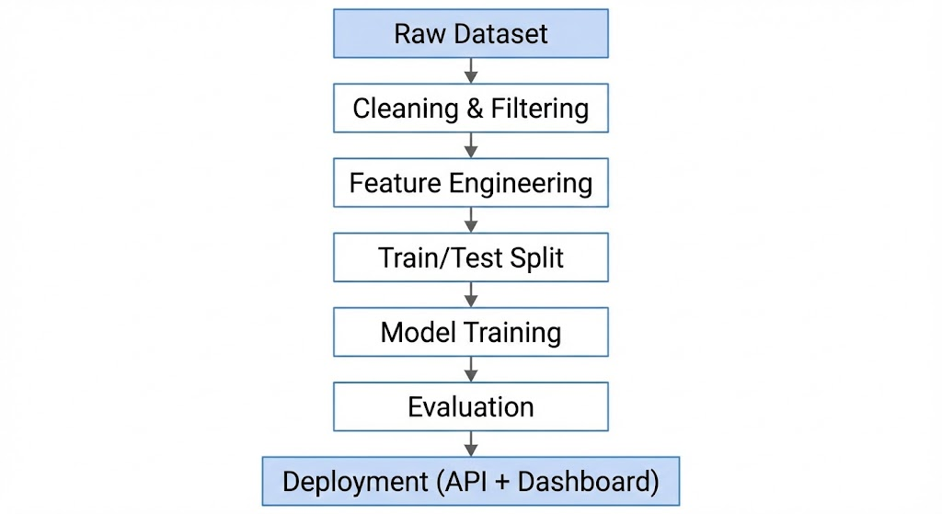

12. Support & Additional Resources

Documentation Files (in docs/ folder):

  - QUICK_REFERENCE.md
Quick lookup for commands and common tasks

PROJECT_STRUCTURE.md
Detailed architecture and component descriptions

API_DOCUMENTATION.md
Complete API reference with request/response examples

SETUP_AND_DEPLOYMENT.md
Local development and production deployment guides

DEVELOPER_GUIDE.md
How to add features, test, and debug

ARCHITECTURE_DIAGRAM.md
Visual representations of system flow and components

DOCUMENTATION_INDEX.md
Navigation guide to all documentation

Technology References:
  - FastAPI: https://fastapi.tiangolo.com
  - scikit-learn: https://scikit-learn.org
  - pandas: https://pandas.pydata.org
  - Chart.js: https://www.chartjs.org

Troubleshooting:
  - Port 8000 in use? Change in run.py: uvicorn.run(..., port=8001)
  - Import errors? Reinstall: pip install -r requirements.txt
  - Data issues? Verify csv_path in config.py

Conclusion

The Credit Card Delinquency Watch system is now fully restructured into a production-ready, scalable architecture. The modular design enables easy maintenance, testing, and extension. With comprehensive documentation and clear design patterns, the system is ready for team collaboration and future development.

Next Steps:
- Review the project structure in the backend/ folder
- Explore the API at http://localhost:8000/docs
- Interact with the dashboard at http://localhost:8000
- Read DEVELOPER_GUIDE.md to understand how to extend the system

For Questions:
Refer to the comprehensive documentation in the docs/ folder. Each guide covers specific aspects of the system with examples and best practices.

