

1. Login

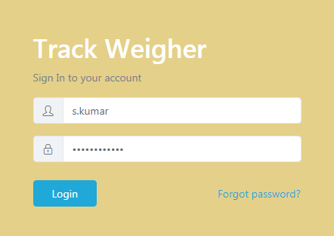

1. Dashboard

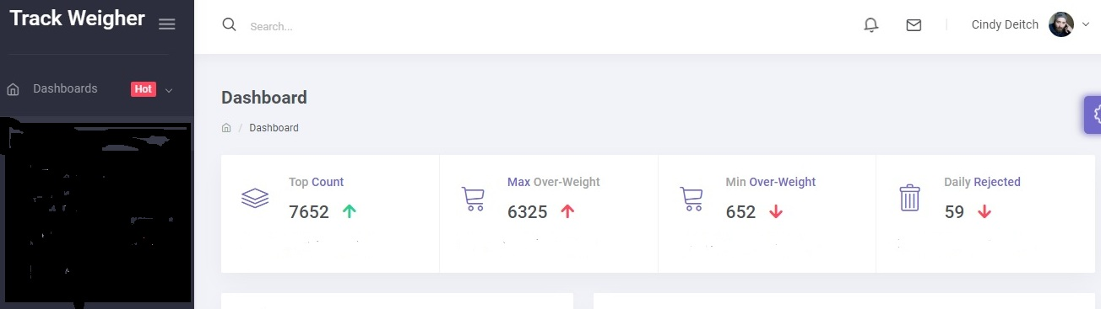

Production Line

Production Statistics

Current Line Status

**Custom**

**Last Month**

**Last Week**

**Today**

**Hour**

|  |  |  |  |  |  |
| --- | --- | --- | --- | --- | --- |
| Unit Name | Count | Over/wt | Under/wt | Rejected | On Target |
| SKU1 | 1843 | 455 | 445 | 29 | 84% |
| SKU2 | 567 | 444 | 545 | 22 | 98% |
| SKU3 | 2015 | 250 | 422 | 20 | 99% |

3. Production Data

1. Time Wise
2. SKU Wise.
3. Only Rejects.
   1. Overweight Rejects
   2. Underweight Rejects

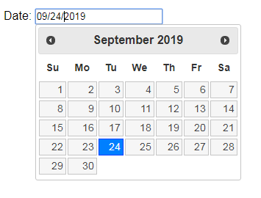

|  |  |  |  |
| --- | --- | --- | --- |
| Time | SKU | Weight Difference | Rejection Status |
| 08:23:00 | 2 | 120 | P |
| 08:23:10 | 3 | -67 | P |
| 08:23:20 | 2 | 110 | P |
| 08:23:30 | 2 | -82 | R |



4. Production Statistics

