**CSE 5382 - Secure Programming**

**Assignment 2**

Submitted by: Biswa Ranjan Nanda (1001558251)

**Project Introduction:**

The goal of this assignment is to produce a program that validates its input using regular expressions.

**Tool Choices/Versions:**

1. IntelliJ IDEA 2018.2.3 (Ultimate Edition)
2. JRE: 1.8.0_152-release-1248-b8 x86_64

**Instructions:**

1. Open IntelliJ IDEA, then go to Open and select the source file to open
2. Go to Run and run the program

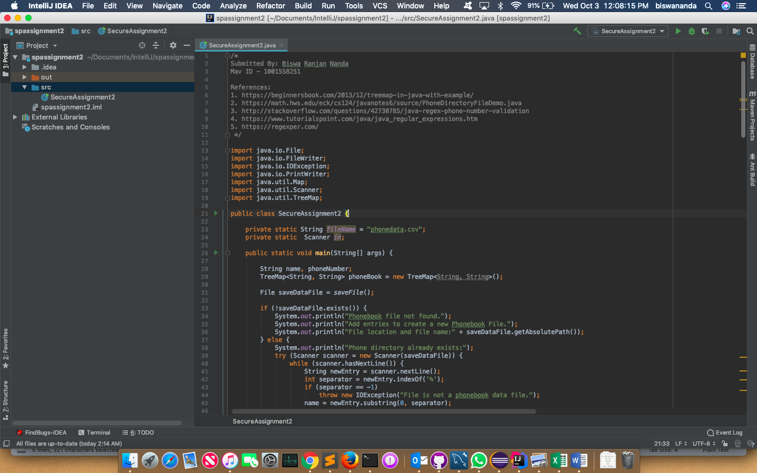

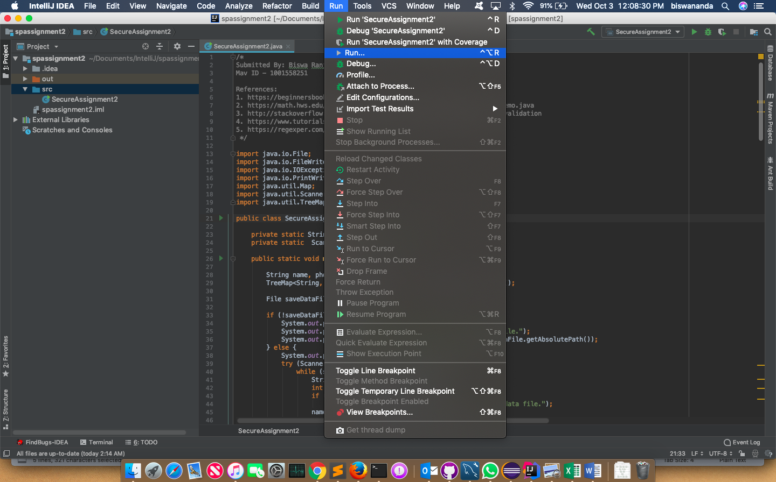

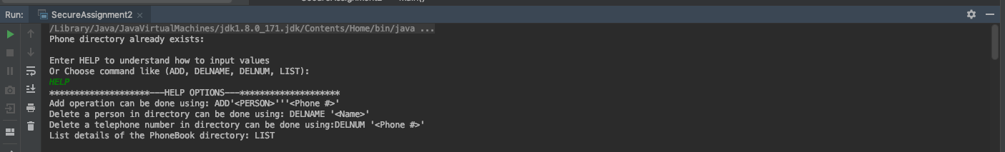

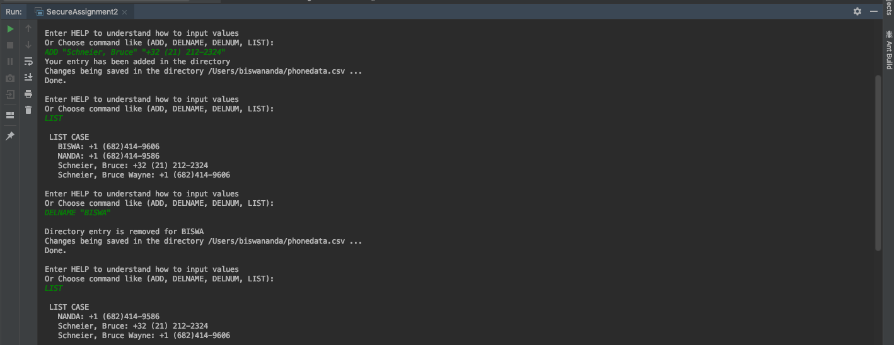

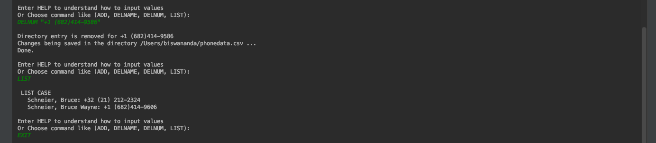

Alternative to IntelliJ tool is using Command line in windows or terminal in Mac OS

1. Open CMD/Terminal at the directory.
2. Compile by typing in *javac SecureAssignment2.java*
3. Run by typing in *java SecureAssignment2*

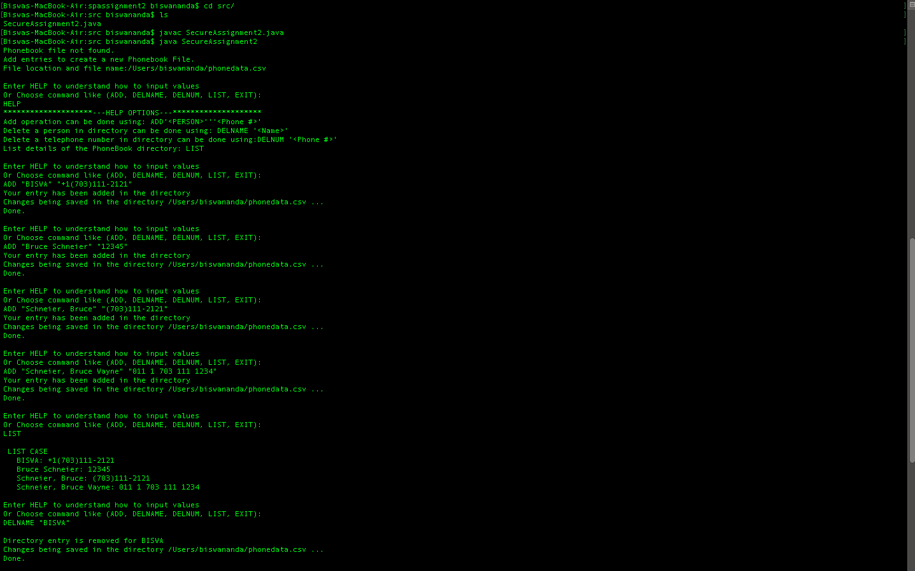

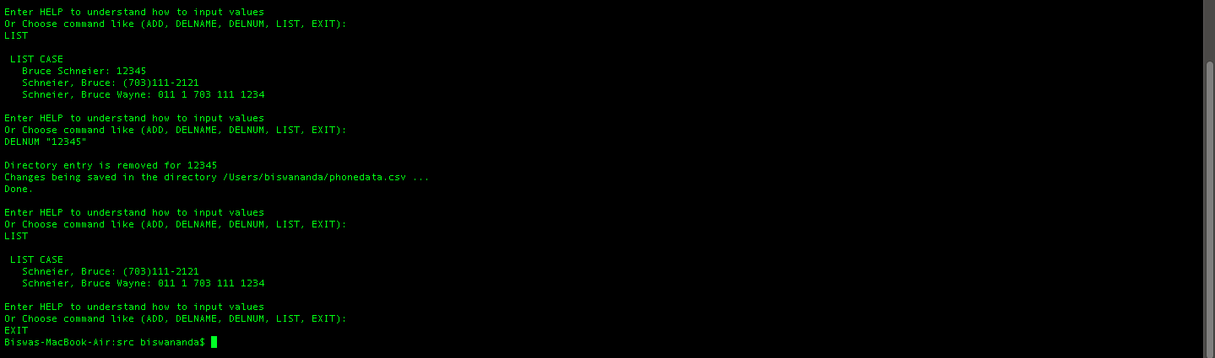

**Help options:**

********************---HELP OPTIONS---********************

Add operation can be done using: ADD “<PERSON>” “<Phone #>”

Delete a person in directory can be done using: DELNAME “<Name>”

Delete a telephone number in directory can be done using: DELNUM “<Phone #>”

List details of the PhoneBook directory: LIST

**Assumptions:** The entry of names and numbers will only follow the format given in the assignment. User would have to input the name for deletion in same the exact same format with which was entered to add previously since the names are case sensitive.

**Pros/Cons of my approach:**

Pros:

* Easy implementation using java.
* Proper working of creation of the phonebook directory (csv file) using the commands specified in the assignment.

Cons:

* User has to enter the exact same name format as added in the directory as it is case sensitive.
* Only those entries will work as mentioned in the assignment, non-other type will be added to the directory.

**Regular Expression Grouping:**

Name grouping:

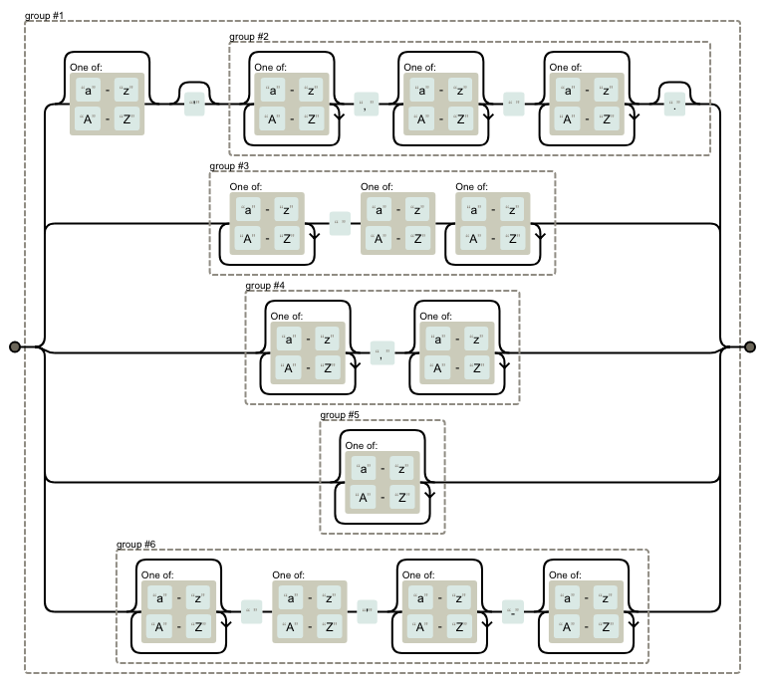

Number grouping:

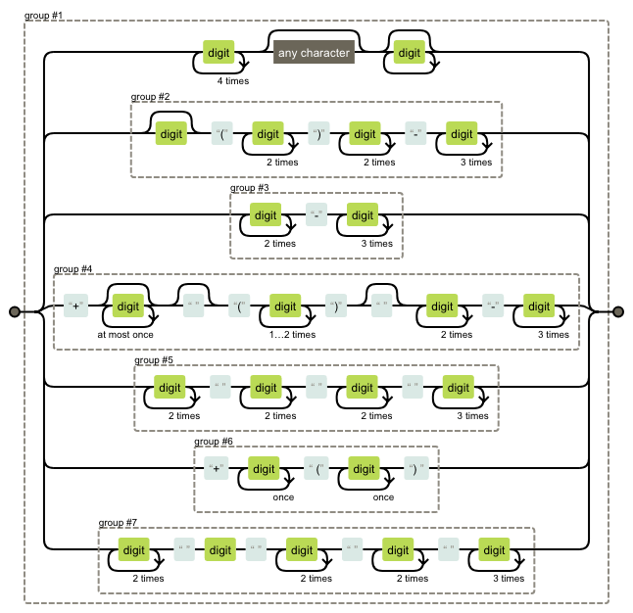

**References:**1. https://beginnersbook.com/2013/12/treemap-in-java-with-example/  
2. https://math.hws.edu/eck/cs124/javanotes6/source/PhoneDirectoryFileDemo.java  
3. http://stackoverflow.com/questions/42730785/java-regex-phone-number-validation  
4. https://www.tutorialspoint.com/java/java_regular_expressions.htm  
5. https://regexper.com/