**Introduction to Computer Graphics**

**(Assignment on DVST Monitor)**

**Name – Biswarup Das.**

**Roll Number – DC2020BCA0055.**

**Direct View Storage Tube:**

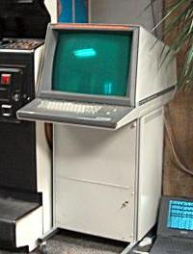

Direct View Storage Tube (DVST) resembles CRT as it uses electron gun to draw picture and phosphor coated screen to display it. The phosphor used in this is of high persistence. DVST does not use refresh buffer or frame buffer to store picture definition. Picture definition is stored in inside CRT in form positive charged distribution. Because of this reason DVST is knows as Storage Type CRT. In DVST no refreshing is required as result picture drawn on DVST will be seen for several minutes before fading.

**Various components of DVST:**

**1 - Electron guns –**

Two electron guns are used in DVST: Primary Gun and Flood Gun. Primary gun is used to store picture pattern. Flood gun is used to maintain picture display on phosphor coated screen.

**2 - Phosphor Coated Screen –**

In DVST the inner surface of CRT is coated with phosphor crystals is of high persistence that emit light when beam of electrons strike them.

**3 - Storage Mesh –**

It is thin and high quality wire that is coated with dielectric and is located just behind phosphor coated screen. Primary gun deposits pattern of positive charge on this grid and it is transferred to phosphor coated screen by continuous flood of electrons produced by flood gun. Thus Storage Mesh stores picture to be displayed in form of positive charge distribution.

**4 - Collector –**

This grid is located just behind storage mesh and purpose of this negatively charged grid is to smooth out flow of flood electrons.

**Working principle of DVST:**

In DVST similar with CRT electron gun and phosphor coated method is used. But in this no electron beam is used to directly writing pictures on screen, but instead of this we can used Storage mesh wire grid is used it is just located behind phosphor coated screen. There is also another grid located just behind storage mesh is called Collector and this purpose is to smooth out flow of flood electrons. The flood gun produce large number of electrons, this negatively charged grid reduces speed of these electrons. Then electrons pass through collector at low velocity and attracted by positive charged portions of storage mesh and strike at portions of phosphor coated screen to display picture. Some electrons get repelled by other portions of mesh that are negatively charged.

Since the collector has slowly down electrons, in this way they not able to produce sharpened images. So to reduce this problem, screen itself is maintained at a high positive potential by means of voltage applied to thin aluminum coating between tube face and phosphor.

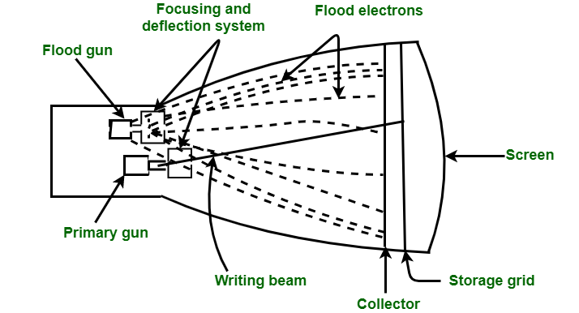**DVST Figure –**

**Advantages of DVST:**

* For picture display it does not require refreshing.
* Display complex pictures at high resolution without any flicker.
* No use of frame buffer or refresh buffer.

**Disadvantages of DVST:**

* Not used for dynamic graphic such as animation.
* These systems do not display colors.
* To erase selected part of an image, entire screen needs to be erased and modified pictures needs to be redrawn.