Site Information -

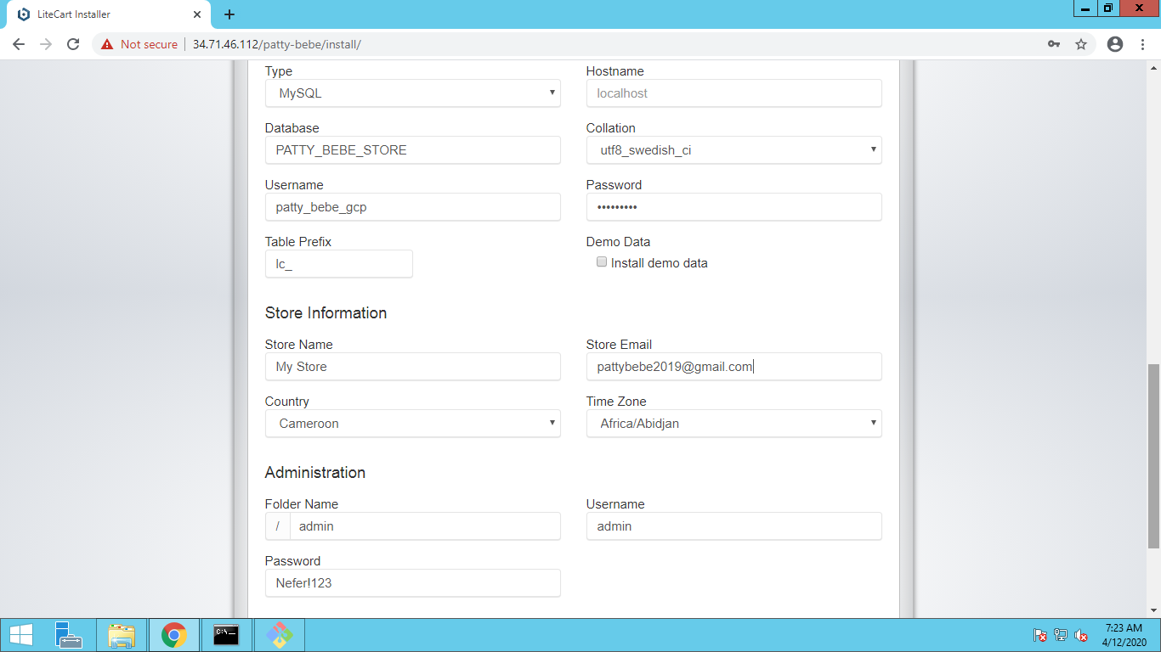

Rome Desktop –

Host – 34.71.46.112

patty_bebe_gcp / 8Ad5%${>tb{.fxe

admin / Nefer!123

Git repository - <https://github.com/biswarup81/patty-bebe>

PHPMYadmin – root/welcome1