1. Install Node (<https://nodejs.org/en/>)

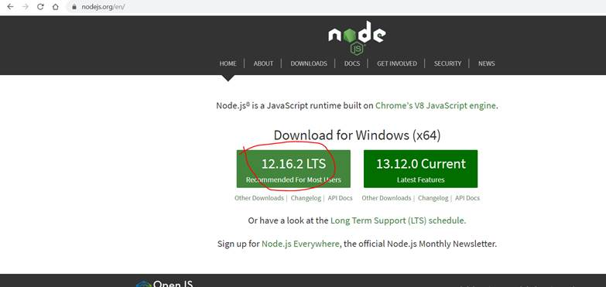

1. Install Visual Studio Code (<https://code.visualstudio.com/download>)
2. Install Git (<https://git-scm.com/download/win>)
3. Setup Nodejs application from Git ( <https://github.com/biswarup81/yield-predictor-app.git> )
4. Run the application in Local Desktop/Laptop