Healthcare Data Visualization Report
Patient demographics, diagnosis patterns, and procedure usage | 10-patient dataset

Dataset overview
Source: uploaded healthcare analytics workbook, Final_Joined_Report. Each record represents one patient claim (n = 10). The visualizations show counts within this small sample and should not be interpreted as population-level disease prevalence.

1. Disease distribution
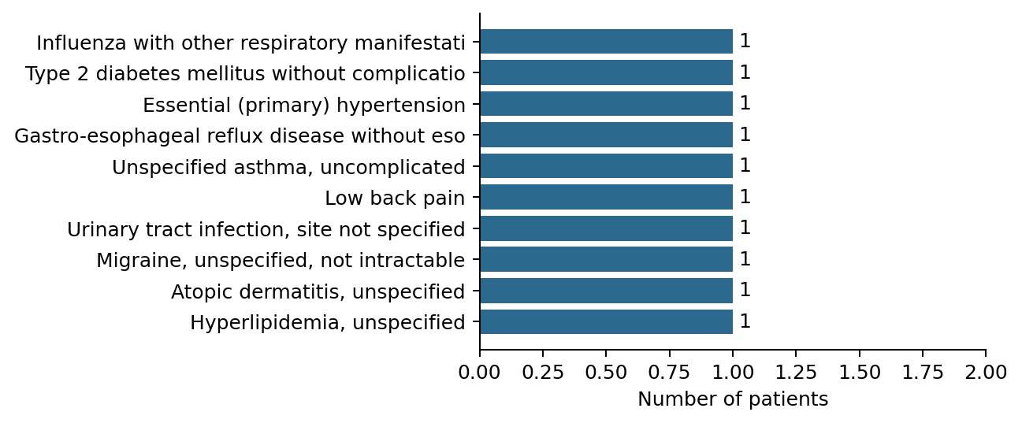

2. Age distribution
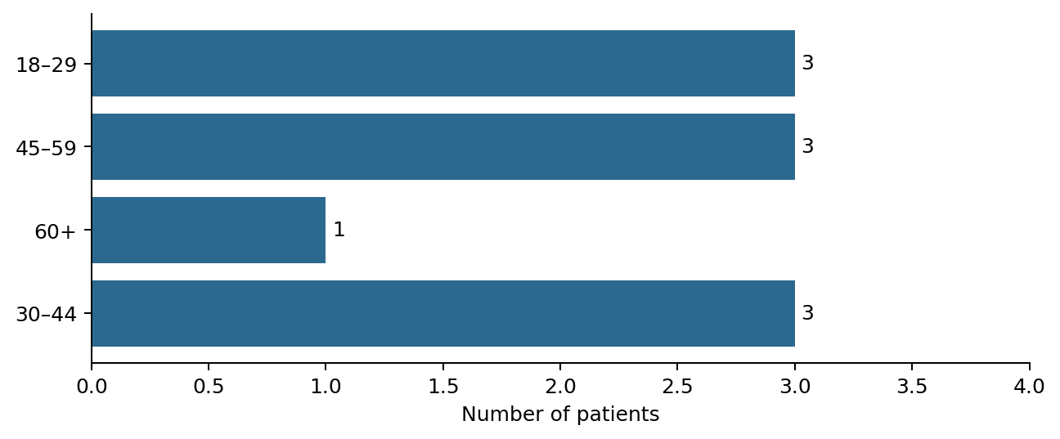

3. Gender ratio
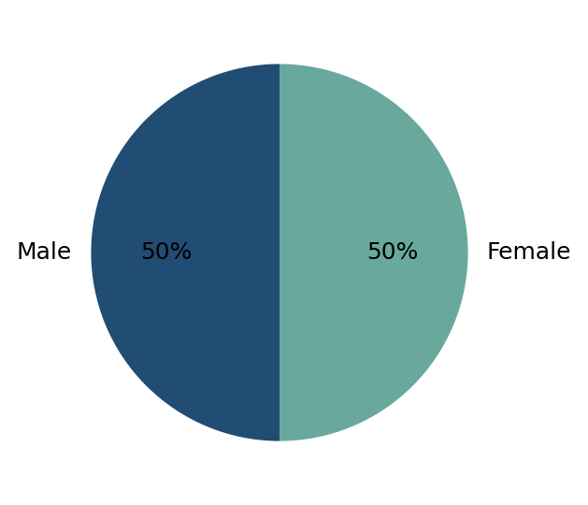

4. Procedure usage (available proxy)
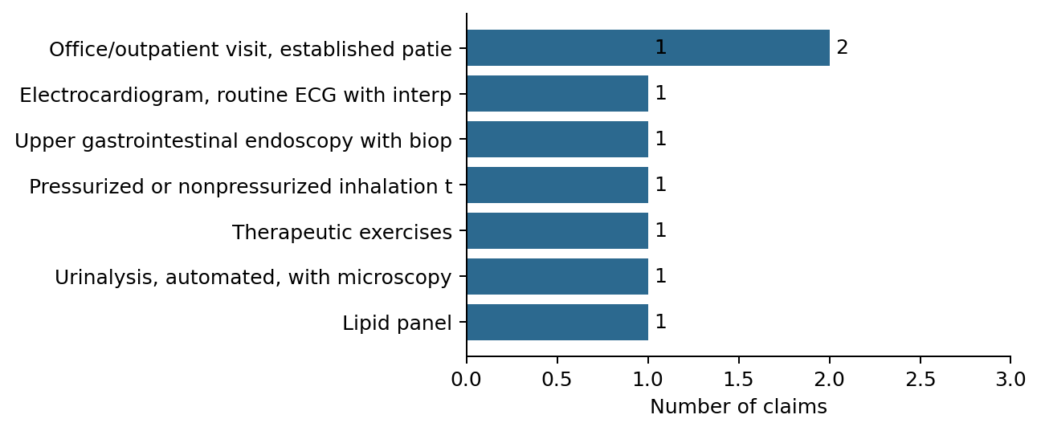

Medication usage: data limitation
The source workbook has no medication name, prescription, or drug-utilization field. Medication usage cannot be visualized reliably. The procedure-usage chart above is included as an available healthcare-service measure; procedures are not medications.

Interpretation
The dataset includes 10 patients; gender counts are Male: 5, Female: 5. Diagnoses are counted by recorded diagnosis description. These descriptive summaries are intended for demonstration and exploratory review.

